Looking after how you are feeling after a natural disaster
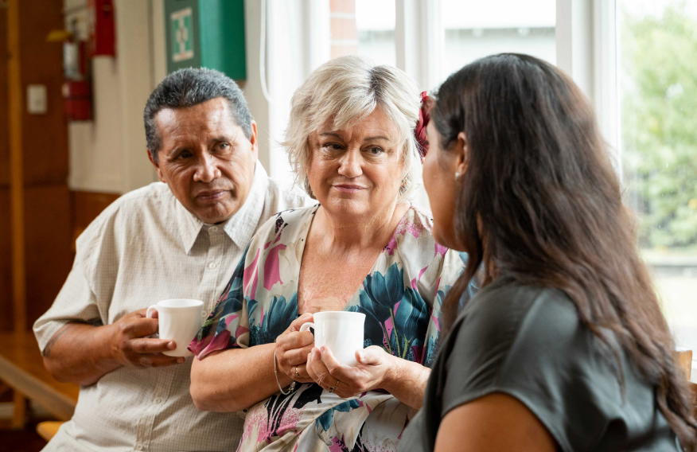

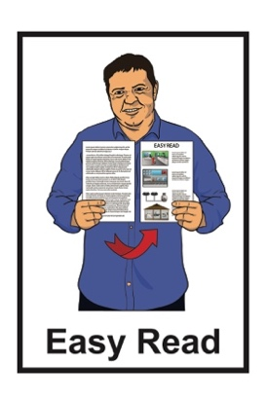
Published:
September 2023

Contents page

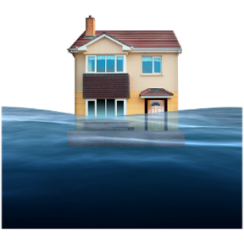
Page number:

What this document is about 3

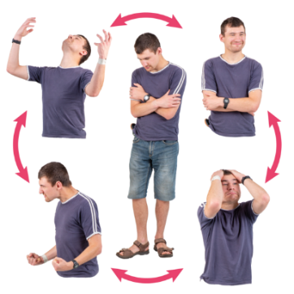
How you might be feeling 6

Things to watch out for 8
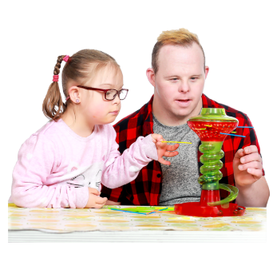

Things to do to make you feel
better 11

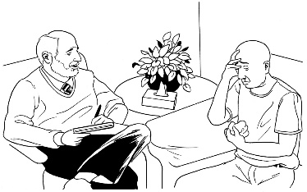
Getting extra support for how
you are feeling 19

Page number:
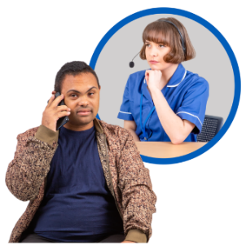

Helplines to support how you
are feeling 27

Free mental wellbeing apps 39

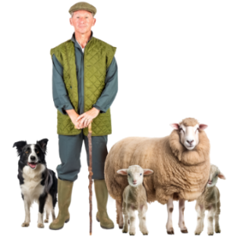
Support for rural / farming
communities 42

What this document is about

Easy Read uses plain words and pictures to explain information.

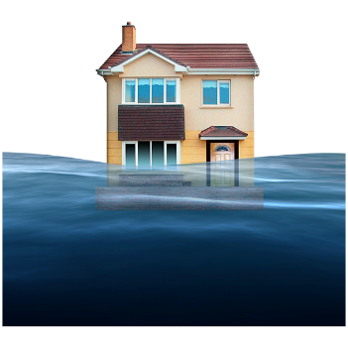
This Easy Read document is about how you might be feeling after a natural disaster.

Natural disasters are events like:
floods
earthquakes
fires
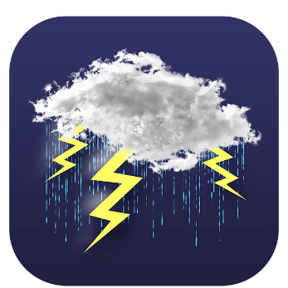
cyclones
volcanic eruptions
landslides.
You can find more Easy Read information about natural disasters on the Get Ready website:

www.getready.govt.nz/en/
alternate-formats/easy-read

This Easy Read document about looking after how you are feeling after a natural disaster has been put together with information from:
Te Whatu Ora - Health New Zealand
Te Aka Whai Ora – Māori Health Authority
Mental Health Foundation of New Zealand.

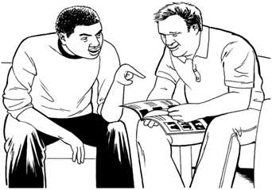
You may want to read this information with support from a:
whānau / family member
friend
support worker.

How you might be feeling

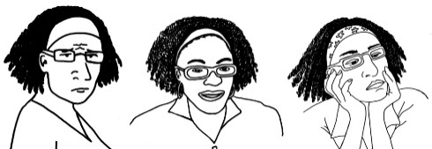
Looking after your mental wellbeing is about taking care of how you are feeling.

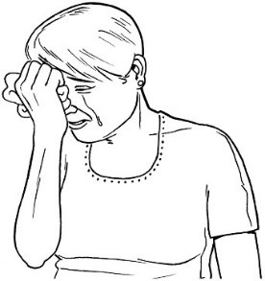
When there has been a natural disaster your life may change.

When there has been a natural disaster you may feel:
overwhelmed
angry
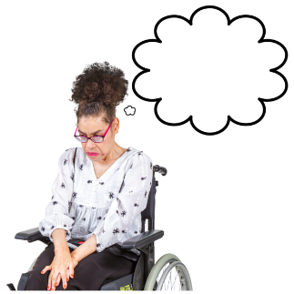
frustrated
tired
anxious.

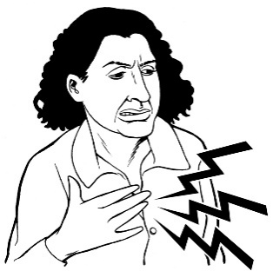
If you are feeling anxious you might:
feel your heart beating faster
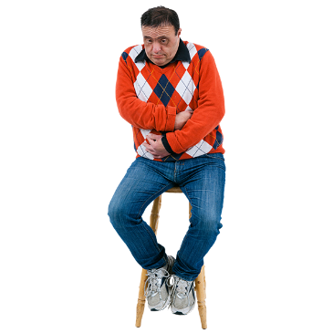
breathe faster
feel butterflies in your tummy or feel sick
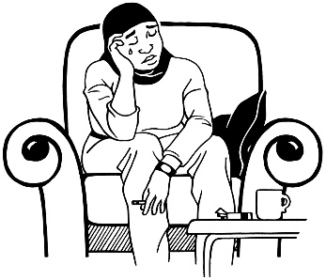
have trouble sleeping / bad dreams
feel moody / grumpy.

Things to watch out for

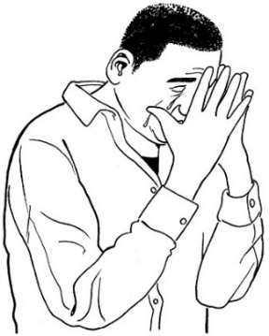
You might need extra support for your mental wellbeing after a natural disaster if you:
feel hopeless / worthless / useless
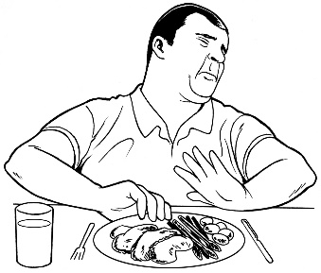
are very tired
have changes in behaviour like:
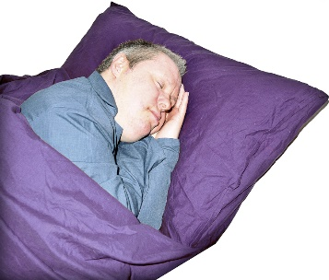
- eating less / more
- sleeping less / more.

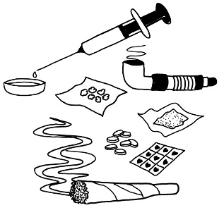
You might need extra support for your mental wellbeing after a natural disaster if you turn to:
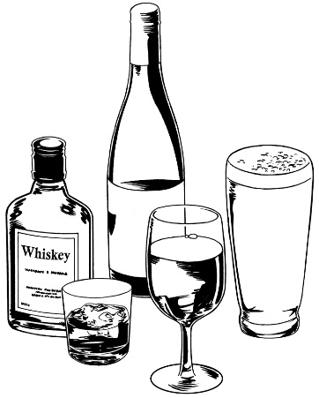
taking drugs
drinking lots of alcohol like:
- beer
- wine
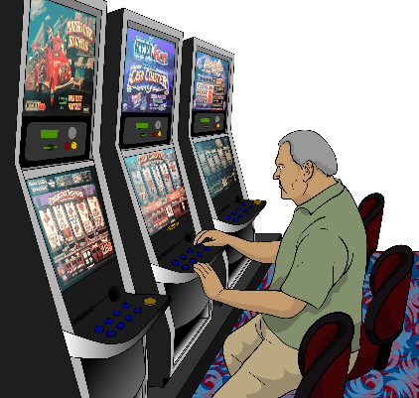
- spirits
gambling.

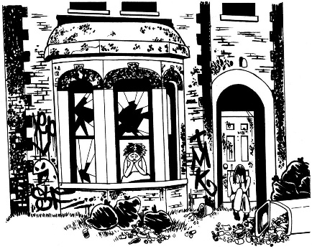
You might need extra support for your mental wellbeing after a natural disaster if you:
have to stay somewhere different because your home is damaged
are separated / away from your family / loved ones
are not able to do the things you used to enjoy
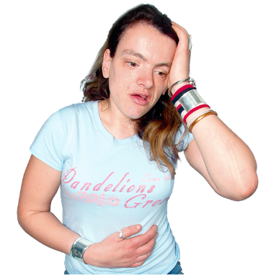
feel unwell with:
- headaches
- stomach aches.

Things to do to make you feel better

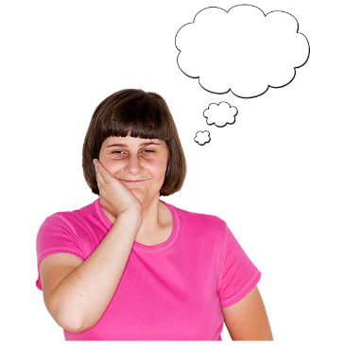
There are things you can do to look after how you are feeling.

Take some time to think about how you are feeling.

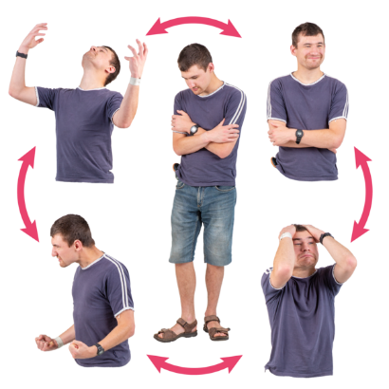
You may feel:
anxious
overwhelmed
on edge.

Feeling on edge means feeling nervous.

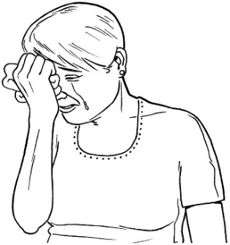
Being on edge means you are worried / afraid about what might happen.

If you feel like crying that is okay.

Feeling all sorts of things is a part of getting better.

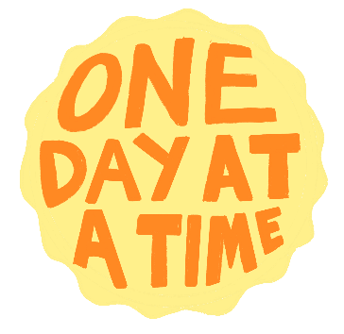
Another thing you can do to look after how you are feeling is take it 1 day at a time.
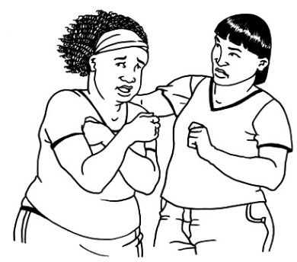

When things are hard you may feel overwhelmed.

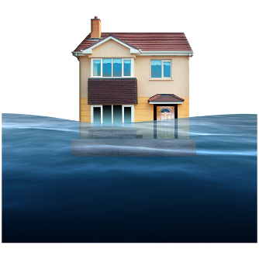
You may be thinking about:
what was lost in the natural disaster
how you do not know what is going to happen in the future.

The future is a time that has not happened yet.

Taking things day by day is okay.

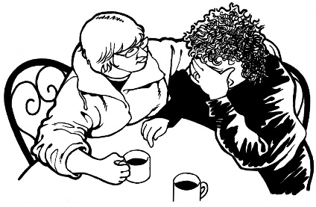
Another thing you can do to look after how you are feeling is have a kōrero / talk with someone.
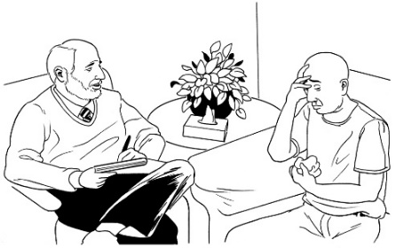

Other people you know may be feeling the same things.

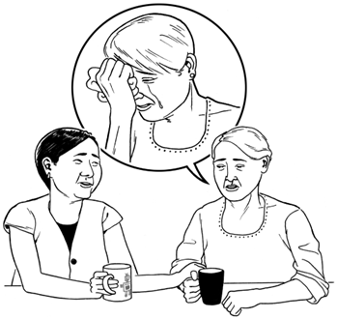
You can talk to:
whānau / family
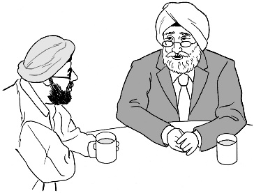
friends
neighbours
other people in your community.
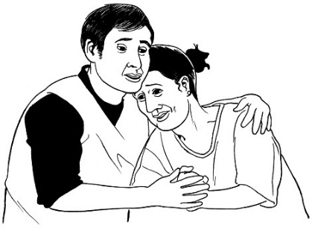

Sharing a problem can make it easier to deal with.

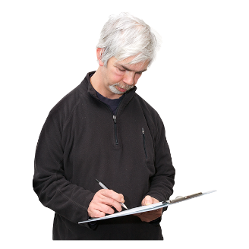
Another thing you can do to look after how you are feeling is to know what you can control.

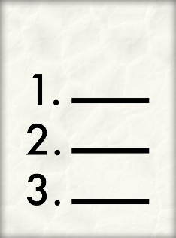
Make a list of everything you are thinking about to do with the natural disaster.

You might want to ask a friend or family member to support you with this.

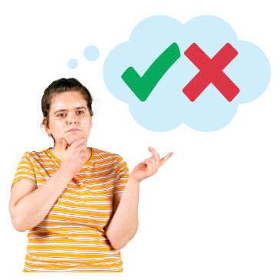
From your list decide what you:
can control
cannot control.

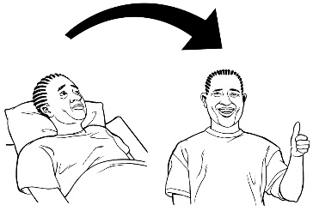
Doing the things from your list you can control will support you in feeling better.

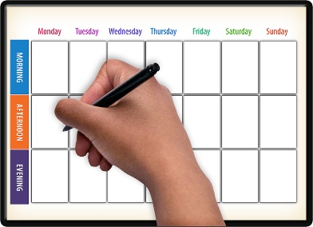
Another thing you can do to look after how you are feeling is build a routine.

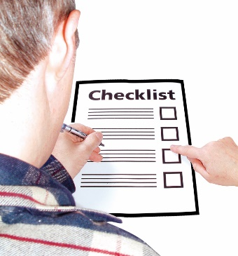
A routine is doing the same activities at the same time every day.

Your routine may include:
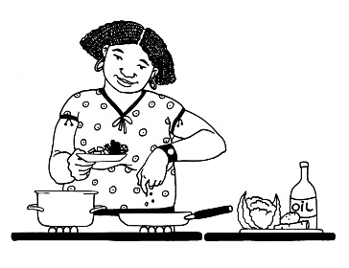
going to bed at the same time every night
planning meals
spending time with your tamariki / children.

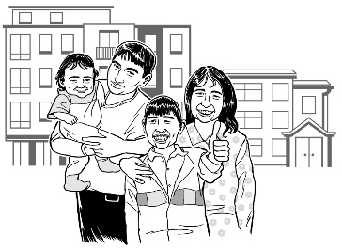
Another thing you can do to look after how you are feeling is do things you enjoy.

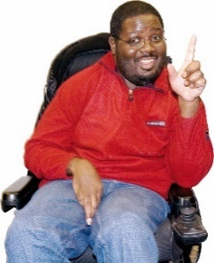
Try to do things that you enjoy every day.

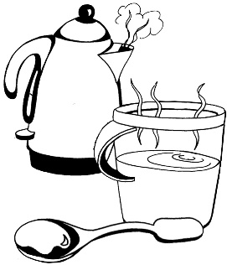
The things you enjoy can be small things like:
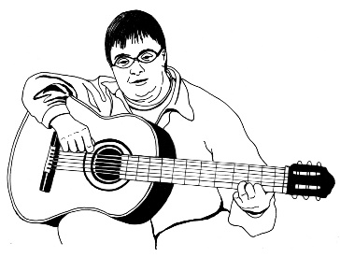
drinking a hot cup of coffee / tea
going fishing
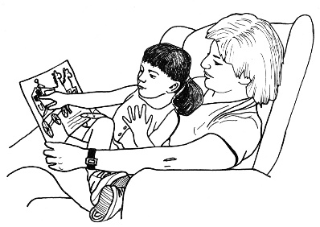
exercising
listening to music
resting.
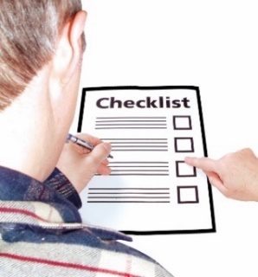

Keep doing the things you enjoy every day as best you can.
Another thing you can do to look after how you are feeling is keep up hope.

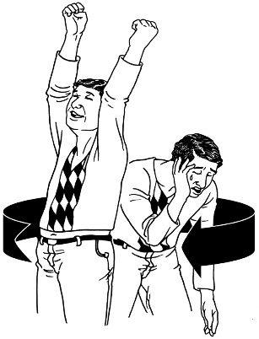
You may not be feeling great right now.

These bad feelings will not last forever.

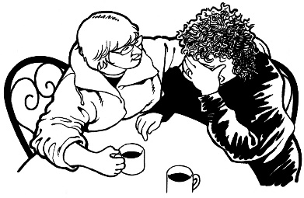
It is important to reach out for support if you feel like you cannot cope with these feelings.

Getting extra support for

how you are feeling

You are not alone.

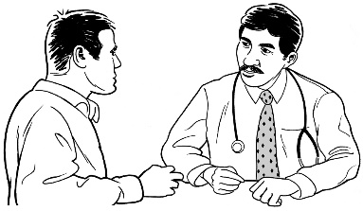
You can start by talking to your doctor.

Your doctor is trained to work out what you need.

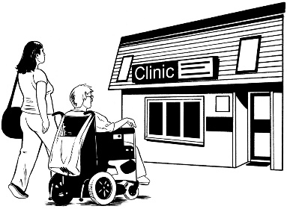
Your doctor can tell you about support services that are in your area.

Your doctor can tell you about the Access and Choice programme.

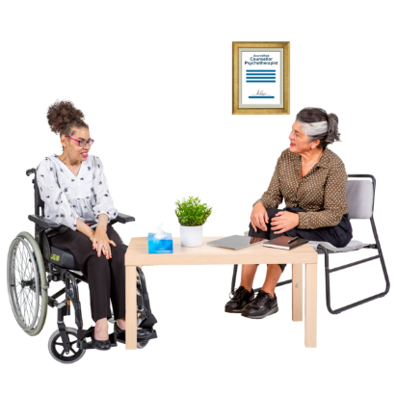
The Access and Choice programme:
- has 4 types of services that can support your mental wellbeing
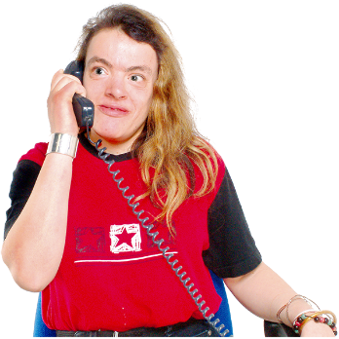
- is free / does not cost any money

- allows you to self-refer yourself to their services.
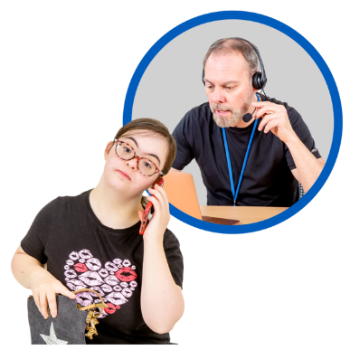
Self-refer means you can contact / talk to the service yourself to book in an appointment.

You do not need a referral / letter from your doctor.

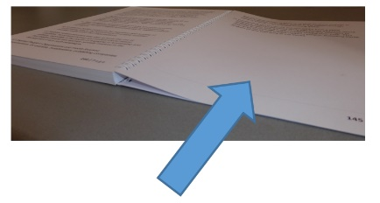
You can find more information about the 4 types of services on pages 21 to 26 of this document.

These 4 Access and Choice programme services are:

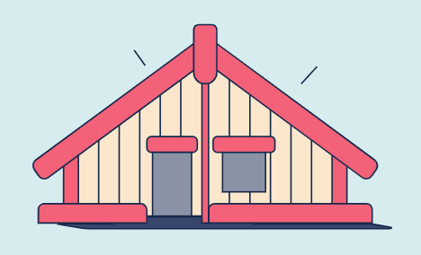
- Kaupapa Māori wellbeing services
These services are:
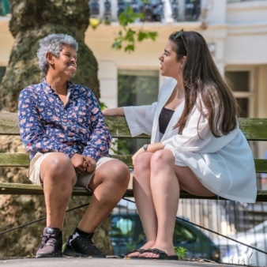
- for tāngata whaiora / person seeking support
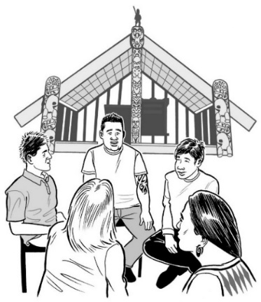
- for whānau / family
- for all ages
- run by Māori services.

You can find more information about Kaupapa Māori wellbeing services on this website:

https://tinyurl.com/3mcczsa6

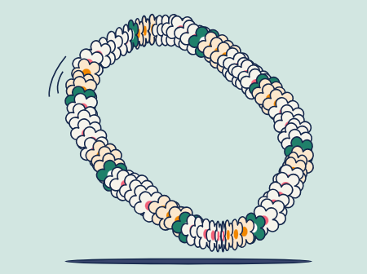
- Pacific-led wellbeing services

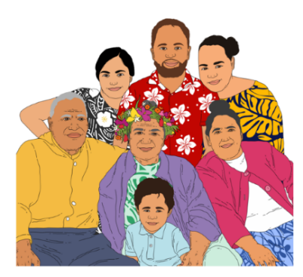
These services are for:

- Pacific people of all ages

- aiga / family.

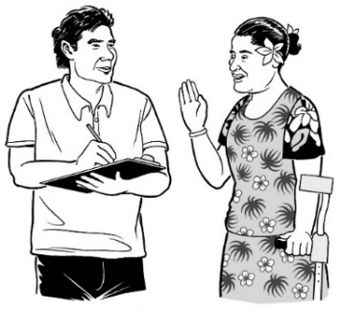
The services are run by Pacific services.

You can find more information about Pacific-led wellbeing services on this website:

https://tinyurl.com/3k4uzexz

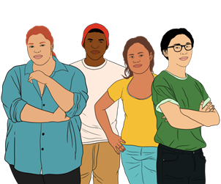
- Youth wellbeing services

These services are for young people 12 to 24 years old.

Youth services also includes rainbow youth services.

Rainbow people means people who are LGBTTIQ+.

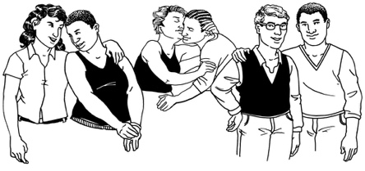
LGBTTIQ+ stands for people who are:
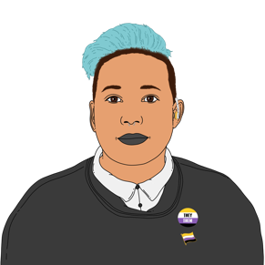
- lesbian
- gay
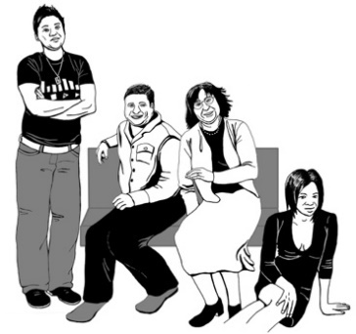
- bisexual
- transgender.
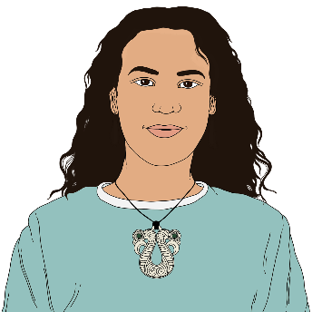
LGBTTIQ+ also stands for people who are:
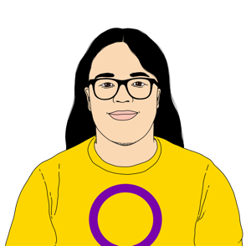
- takatāpui
- intersex
- queer
- others such as asexual.

You can find more information about Youth wellbeing services on this website:

https://tinyurl.com/36e8v5h2

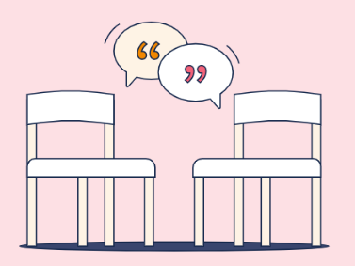
- Wellbeing services in general practices

A general practice is where you see your doctor or nurse.
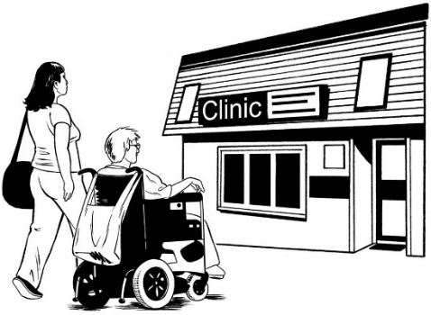

Your general practice has people trained to support you / your whānau to improve:

- your mental wellbeing
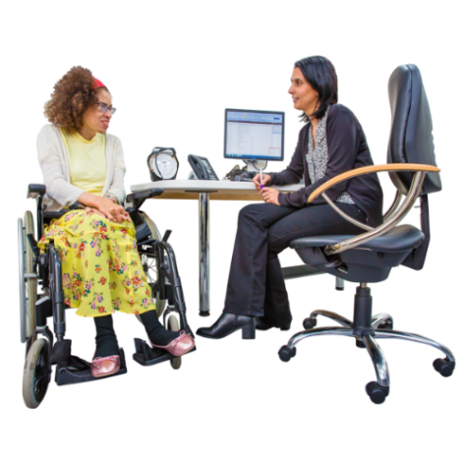
- physical wellbeing.

The doctor or nurse can refer you to the Access and Choice programme.

You can find more information about Wellbeing services in general practices on this website:

https://tinyurl.com/3mk8cc6r
You can find more information about the Access and Choice programme on this website:
www.wellbeingsupport.health.nz/available-wellbeing-support
The information on the website is not in Easy Read.

Helplines to support how you are feeling

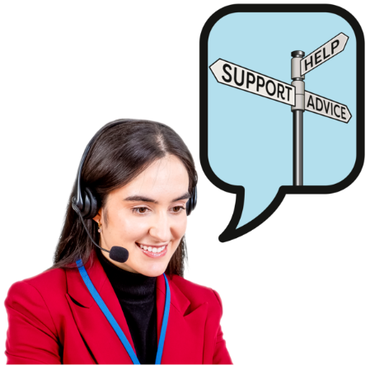
Helplines are services that you can contact for advice / support.

Most of the places will have a trained counsellor that you can talk to.
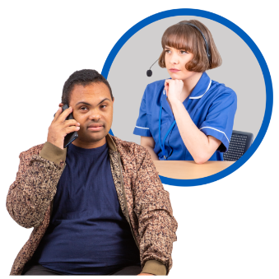

A trained counsellor is someone who can help you talk about your feelings.

If you are Deaf / cannot speak on the phone you can use the NZ Relay Service:

www.nzrelay.co.nz

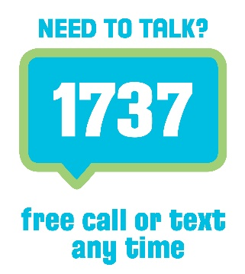
- 1737: Need to Talk

Phone: 1737

Text: 1737
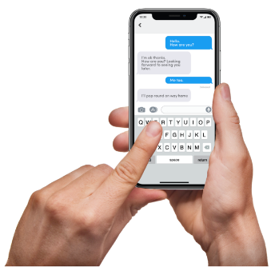

At 1737: Need to Talk you can talk to a trained counsellor.

1737: Need to Talk is free to call or text.

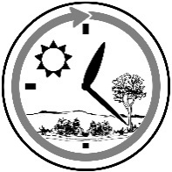
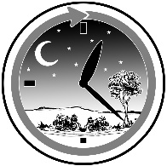
1737: Need to Talk is open all day / night.

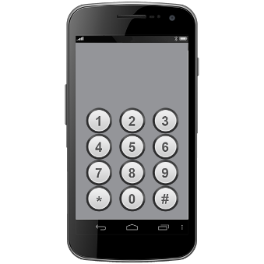
If the 1737 number does not work from your phone you can call this number:

0800 1737 1737
You can find out more about 1737: Need to Talk on this website:

www.1737.org.nz
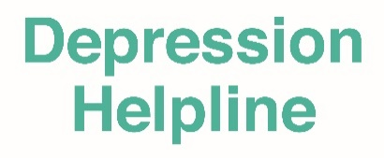
2. The Depression Helpline

Phone: 0800 111 757

Text: 4202

At the Depression Helpline you can talk to a trained counsellor.

The Depression Helpline is free to call or text.

The Depression Helpline is open all day / night.

You can find out more about the Depression Helpline on this website:

www.depression.org.nz

3. Youthline

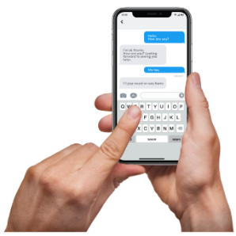
Phone: 0800 376 633

Text: 234

Email: talk@youthline.co.nz
Website: www.youthline.co.nz

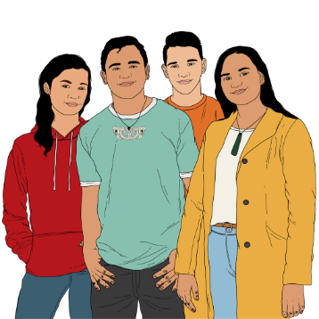
Youthline supports young people 12 to 24 years old who are finding things hard going.

At Youthline you can talk to a trained counsellor.

Youthline is free to call / text / email / chat.
Youthline is open all day / night.
On the Youthline website there is webchat.

Webchat means you can chat online to a counsellor by typing into the webchat box.

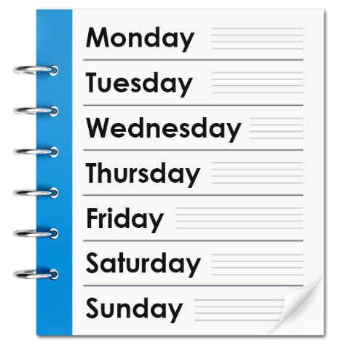
The Youthline webchat is open:

- Monday 4.30 pm to 10 pm

- Tuesday 10 am to 10 pm

- Wednesday 10 am to 10pm

- Thursday 10 am to 10pm

- Friday 10 am to 10 pm

- Saturday 4.30 pm to 10pm

- Sunday 4.30 pm to 10pm.

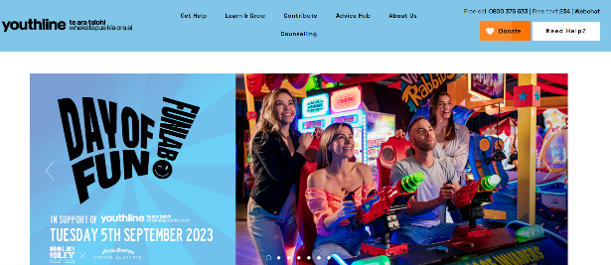
To get the Webchat:
- Go the website: www.youthline.co.nz
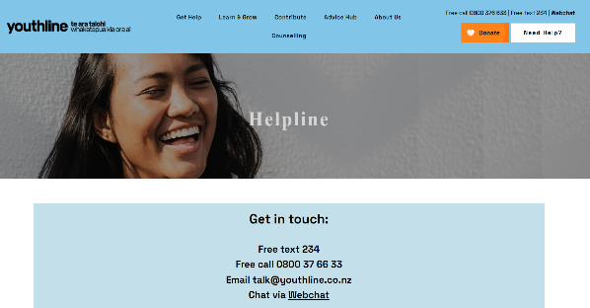
- Click on the Need Help? box on the top right of the screen
- Click on Chat via Webchat
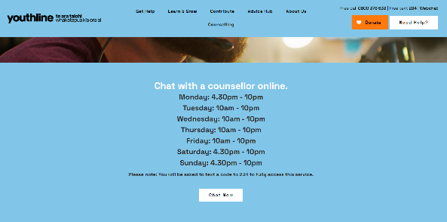
- Click on the Chat Now box
- Type in what you want to say
- Someone will reply / start to chat with you.

.

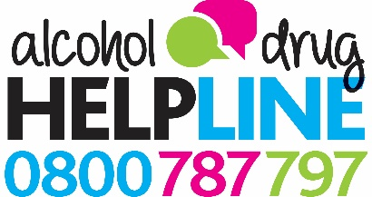
4. Alcohol Drug Helpline

Phone: 0800 787 797

Text: 8681
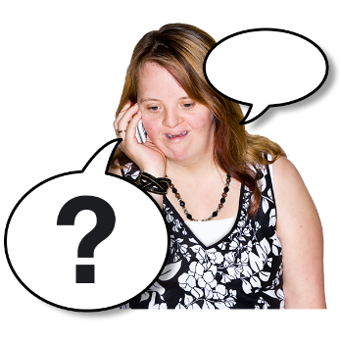

At Alcohol Drug Helpline you can talk to a trained counsellor.

Alcohol Drug Helpline can give you:
information / support about alcohol addiction
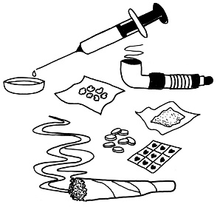
information / support about drug use
confidential advice.

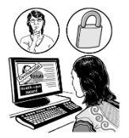
Confidential means what you say will not be told to everyone / to people who do not need to know.

Alcohol Drug Helpline is free to call or text.

Alcohol Drug Helpline is open all day / night.

You can find out more about Alcohol Drug Helpline on this website:

www.alcoholdrughelp.org.nz

5. Disability Helpline: Whakarongorau Aotearoa New Zealand Telehealth Services

Phone: 0800 111 213

Text: 8988

The Disability Helpline is free to call / text.

The Disability Helpline is open all day / night.

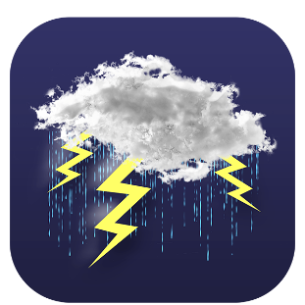
The Disability Helpline can:
give you information / support about natural disasters
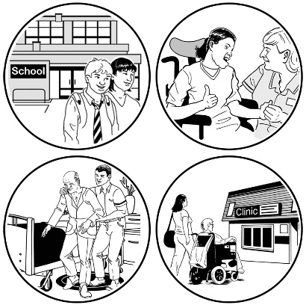
help if a support worker / carer is not available or has not arrived
answer any general health questions you have.

All Sorts website
Website:

www.allsorts.org.nz

The All Sorts website is made by the Mental Health Foundation of New Zealand.

The All Sorts website can give you information / ideas on how to look after your mental wellbeing.

Free mental wellbeing apps

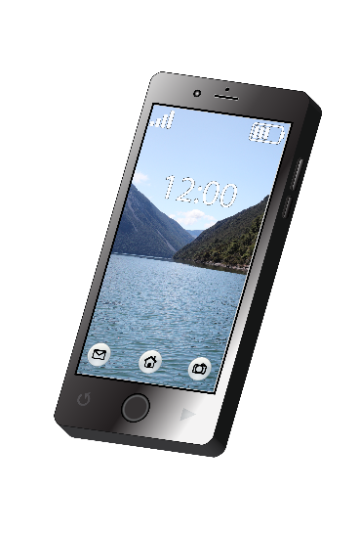
There are free wellbeing apps you can use to get support for your mental wellbeing after a natural disaster.

App is short for application.

An app is a piece of software that lets you use social media on a mobile phone or tablet.

You can download wellbeing apps onto your phone / tablet from:
Google Play
the App Store.

- Groov

Groov is an app to support people to manage their mental wellbeing.
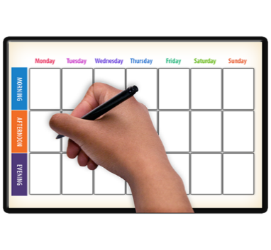

You can use the Groov app:
every day
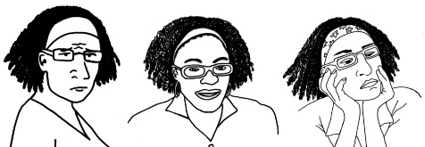
when your feelings gets worse.

- Headstrong

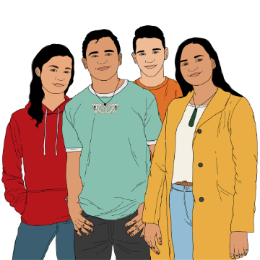
Headstrong is an app to support the mental wellbeing of rangatahi / young people.

Headstrong was made by people in Aotearoa New Zealand.

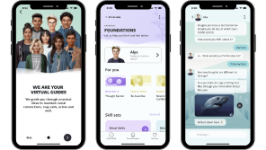
Headstrong has a chat function that makes rangatahi / young people feel like they are talking to a friend.

Support for rural / farming communities

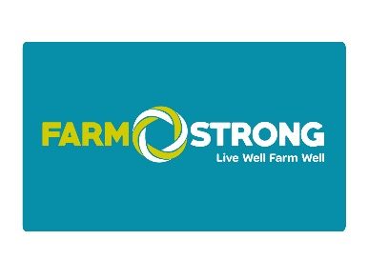
- Farmstrong

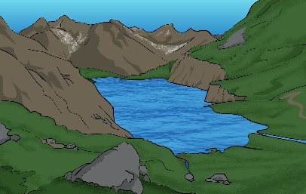
Farmstrong is a wellbeing programme for the rural community.

Rural means in the countryside.

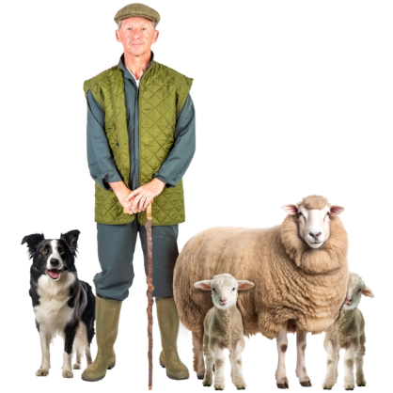
Farmstrong supports farmers to live well so they can do their job well.

There is information to support farmers to manage stress / pressure.

You can find out more about Farmstrong on this website:

www.farmstrong.co.nz
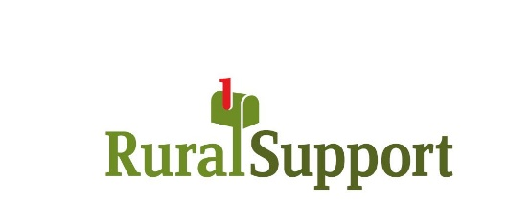
- Rural Support Trust

Phone: 0800 787 254

Rural Support Trust supports farming families / rural communities.

Rural Support Trust is run by local people in the community they support.

Your talk with Rural Support Trust is confidential.

Rural Support Trust is free to call.

You can find out more about Rural Support Trust on this website:

www.rural-support.org.nz
This information has been written by:
- Te Whatu Ora – Health New Zealand
- Te Aka Whai Ora – Maori Health Authority
- Mental Health Foundation New Zealand.

It has been translated into Easy Read by the Make it Easy Kia Māmā Mai service of People First New Zealand Ngā Tāngata Tuatahi.
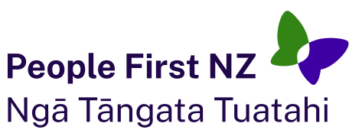
The ideas in this document are not the ideas of People First New Zealand Ngā Tāngata Tuatahi.
Make it Easy uses images from:
- Changepeople.org
- Photosymbols.com
- SGC Image Works
- Huriana Kopeke-Te Aho
- T. Wood.
All images used in this Easy Read document are subject to copyright rules and cannot be used without permission.

