
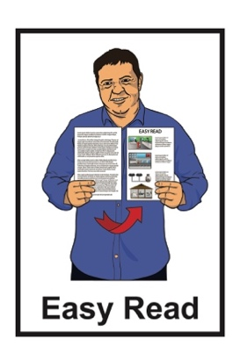

Support to make a complaint about Conversion Practices


Published: June 2025

Before you start

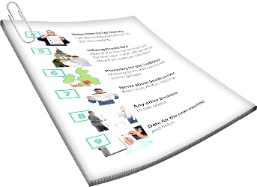
This information may upset some people when they are reading it.

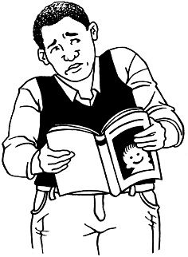

This information is not meant to scare anyone.

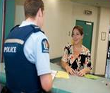
If you do not feel safe right now call the Police on 111.


If you are upset after reading this document you can talk to your:
whānau / family
friends.

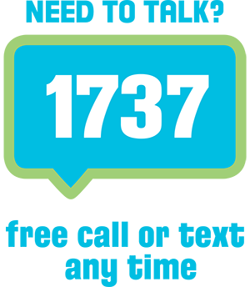
You can also contact Need to Talk by:
calling 1737
texting 1737



It does not cost any money to call / text 1737.


This is a long document.

It can be hard for some people to read a document this long.

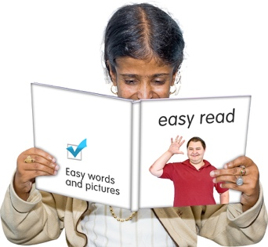
Some things you can do to make it easier are:
read it a few pages at a time
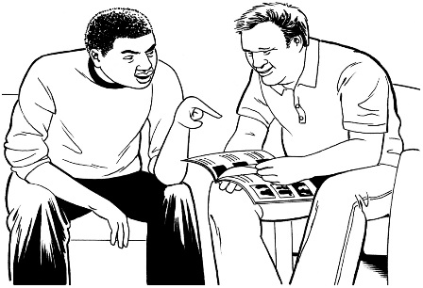
set aside some quiet time to look at it
have someone read it with you to support you to understand it.

What is in here

Page number:

About this Easy Read 5


What are conversion practices? 10

About the Conversion Practices
Prohibition Act 2022 20
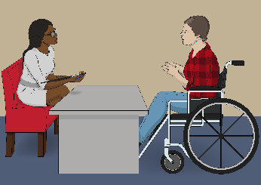

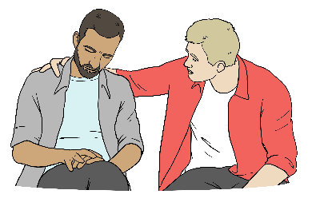
What you can do if you have
experienced conversion practices 23

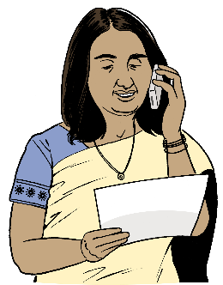
Support to make a complaint about conversion practices 37

More information 58

About this Easy Read

This Easy Read document is about making a complaint about conversion practices.

It tells you about:
conversion practices
the ways to make a complaint if you have experienced conversion practices
who can support you to make a complaint.

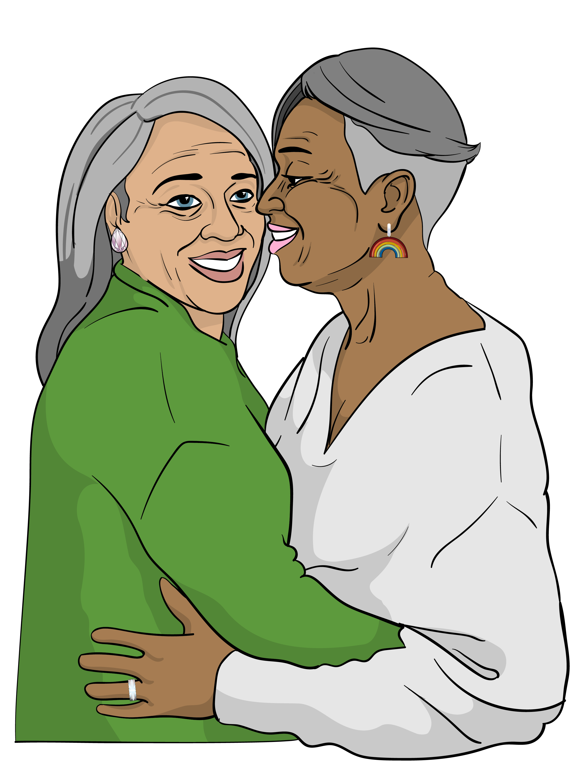
Conversion practices are when someone tries to change things about a person like:
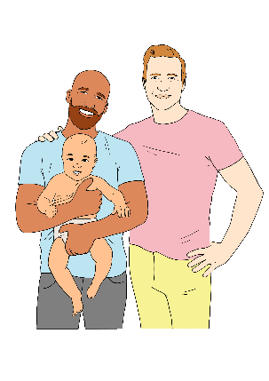
who they are
who they want to be in a relationship with.


You can find more about the things some people try to change using conversion practices on page 10.

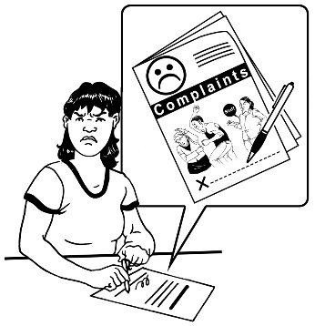
A complaint means telling someone about something bad that happened.

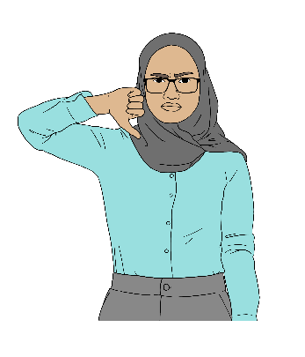
Making a complaint means you can get support to try to fix the bad thing that happened.


This Easy Read was written by
Te Kāhui Tika Tangata | Human Rights Commission.
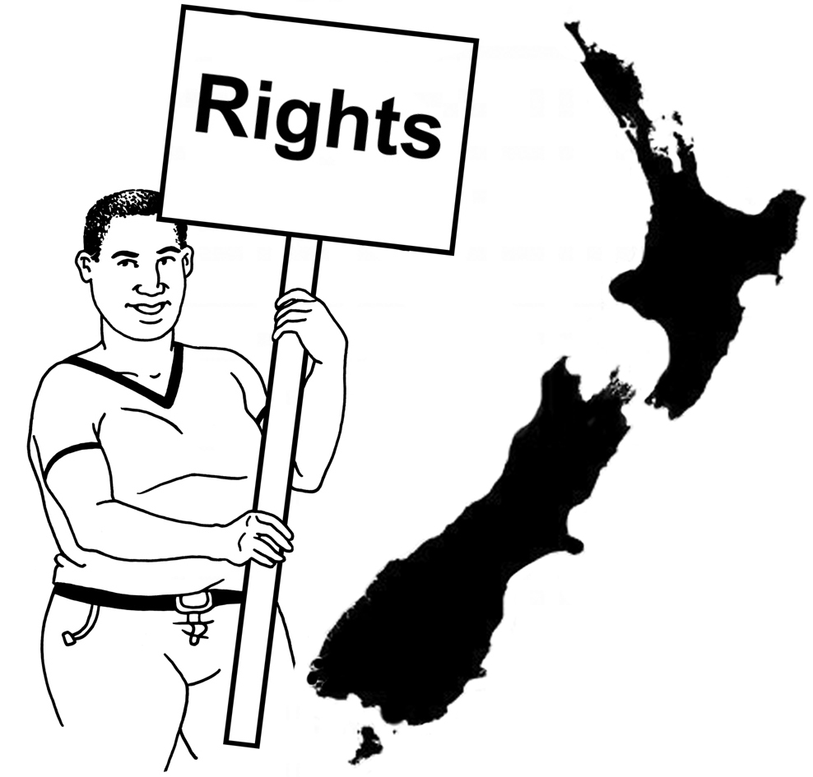

Te Kāhui Tika Tangata | Human Rights Commission protects the human rights of everyone in Aotearoa New Zealand.

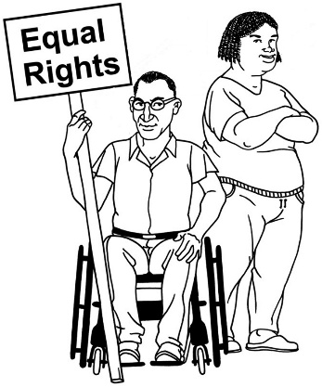
Human rights are important things every person should:
have
be able to do.
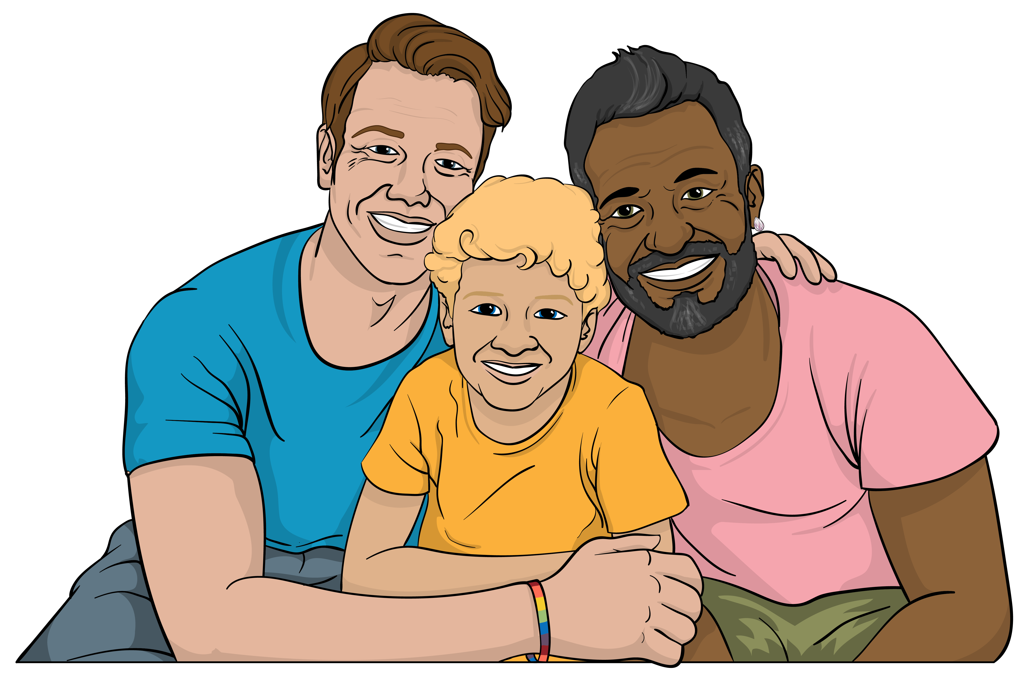

Some examples of human rights are the right to:
get married

have a job
go to school.
When you see the words the Commission in this Easy Read they mean Te Kāhui Tika Tangata | Human Rights Commission.

When you see the words
us / we / our it means the Commission.

This Easy Read is:
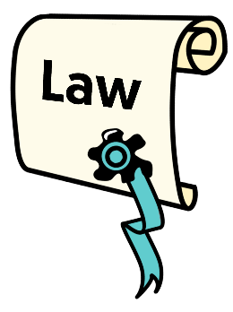

- mainly about making a complaint to the Human Rights Commission
- is not legal advice
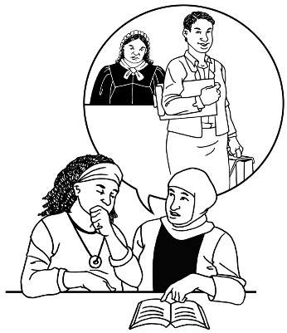

Legal advice is when you ask someone for information about things to do with the law.

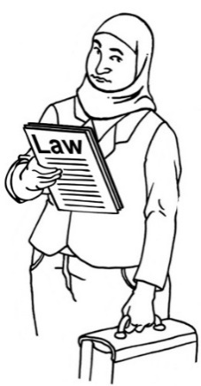
You can get legal advice from somebody like a lawyer.

A lawyer is a person:
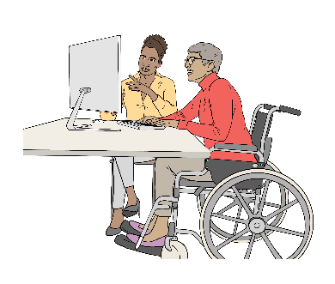
who has trained to be a lawyer
gives legal advice.

What are conversion practices?

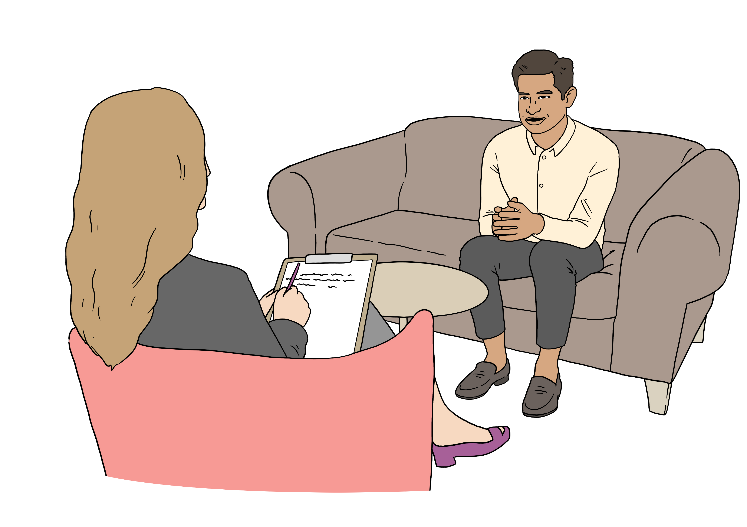
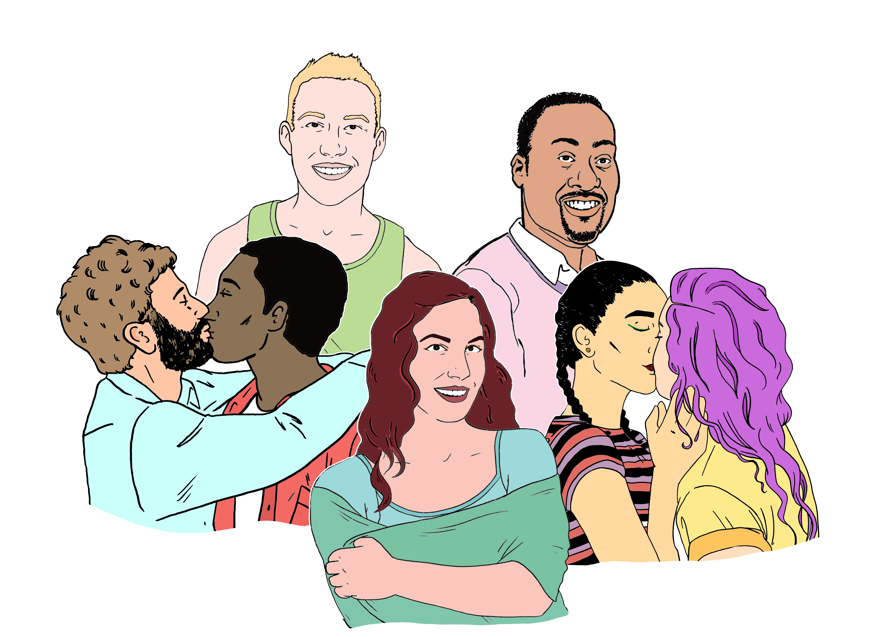
Conversion practices are when someone tries to change something important about another person.

It can be things like:
sexual orientation
gender identity
gender expression.

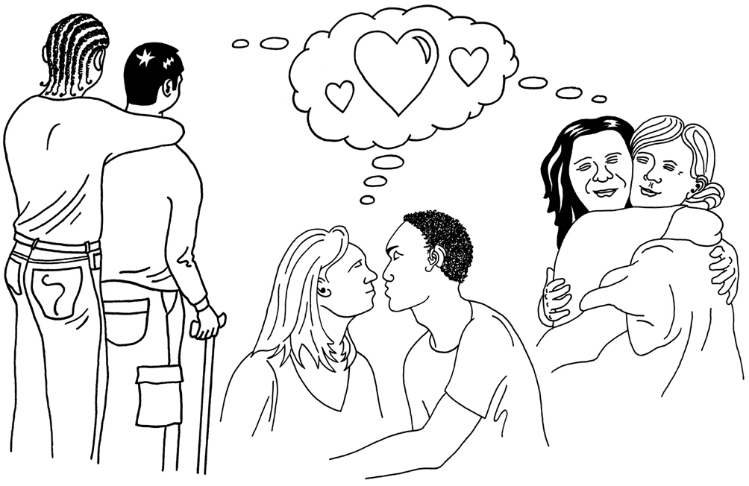
Sexual orientation is things like:
who you are attracted to

who you want to be in a relationship with
choosing if you want to be in a relationship.


Some examples of sexual orientation are:
straight
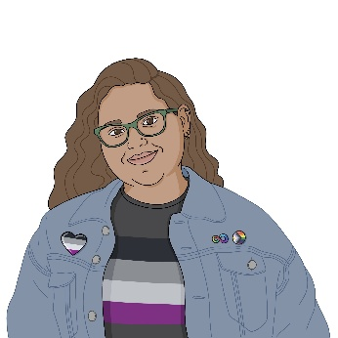
gay
bisexual
asexual.


Here when you are attracted to someone it means things like you:

like them in a sexual way
want to date them / have a relationship with them.


Gender is if you are:
a boy or man
a girl or woman
another gender like non-binary.

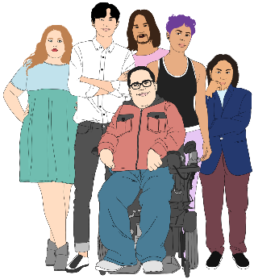
Gender expression means things you do that tell other people about your gender like:
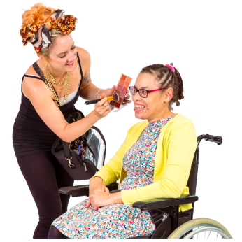
having short hair
wearing makeup
wearing a dress.

Straight people are:
men who are only attracted to women
women who are only attracted to men.


Gay people are:
men who are attracted to men
women who are attracted to women.


Bisexual people are attracted to people who are:
the same gender as them
and
different genders to them.

Asexual people are not sexually attracted to anyone.


Conversion practices are usually done to Rainbow people.


Rainbow is another word for LGBTTQIA+ people.

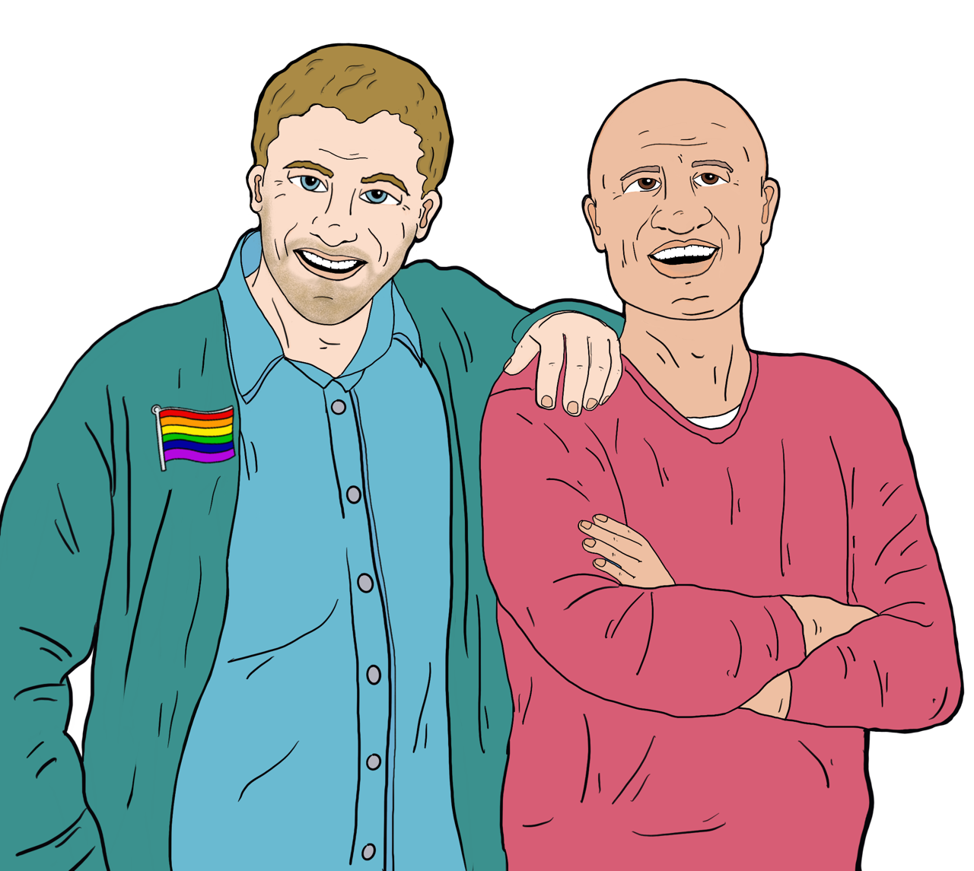
For example conversion practices might be done to a gay man who is only attracted to men.

The conversion practices try to make him:
not be gay
only be attracted to women.



There is no information to say conversion practices:
work
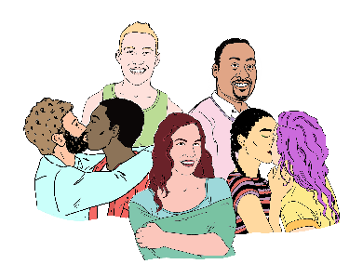

are good for people
change something like the sexual orientation of someone.


Examples: Things that are conversion practices


Conversion practices can be things like:
making you feel bad about being who you are
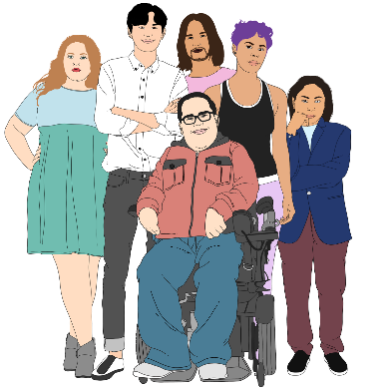
trying to change your gender
telling you something like your sexuality is wrong
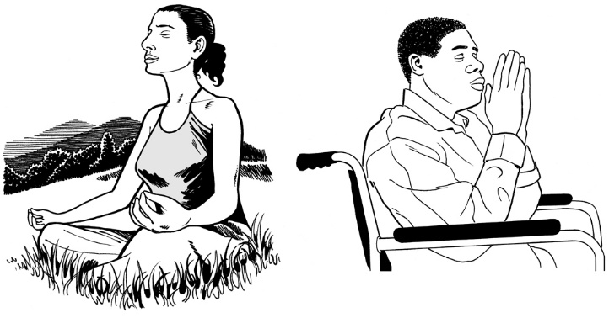
doing something to do with religion like saying a prayer to try to change you like your:
- sexual orientation

- gender identity
make you do something to change who you are.


Examples: Things that are not conversion practices

It is not conversion practice if:

- a parent / guardian is talking with their child in a respectful way about things like:
- sexuality
- gender
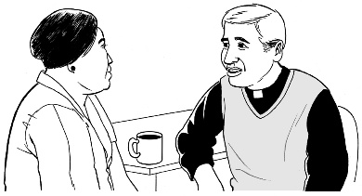
- you talk to a religious person in a respectful way about something like your sexuality / gender.
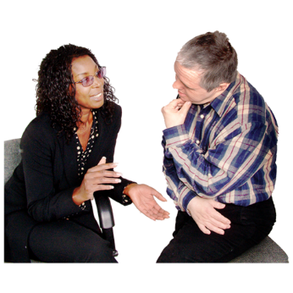

Here respectful means listening and talking to someone in a way that:
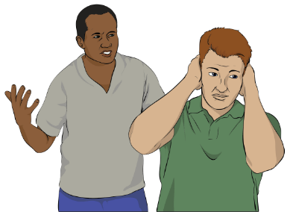

accepts them for who they are
does not try to change the way a person thinks.
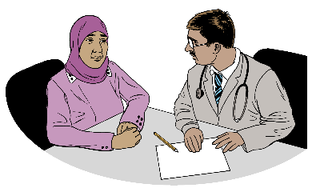
You can ask a medical practitioner to support you to understand something like your sexuality / gender.

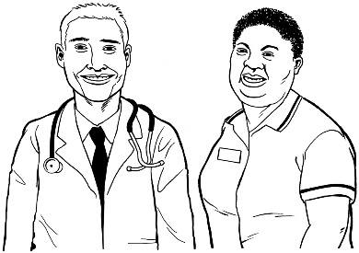
A medical practitioner is somebody like a doctor or a nurse.

It is also not conversion practice when someone:
- supports you if you are changing your gender
- supports you to express / say your:
- gender

- identity
- accepts you for who you are.
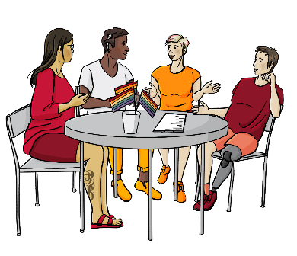
It is also not conversion practice when someone supports you to:
cope with being you
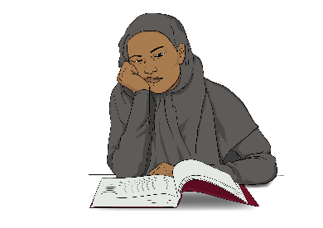
become who you are
learn what it means to be who you are
get support from other people in the Rainbow community.

About the Conversion Practices Prohibition Legislation Act 2022

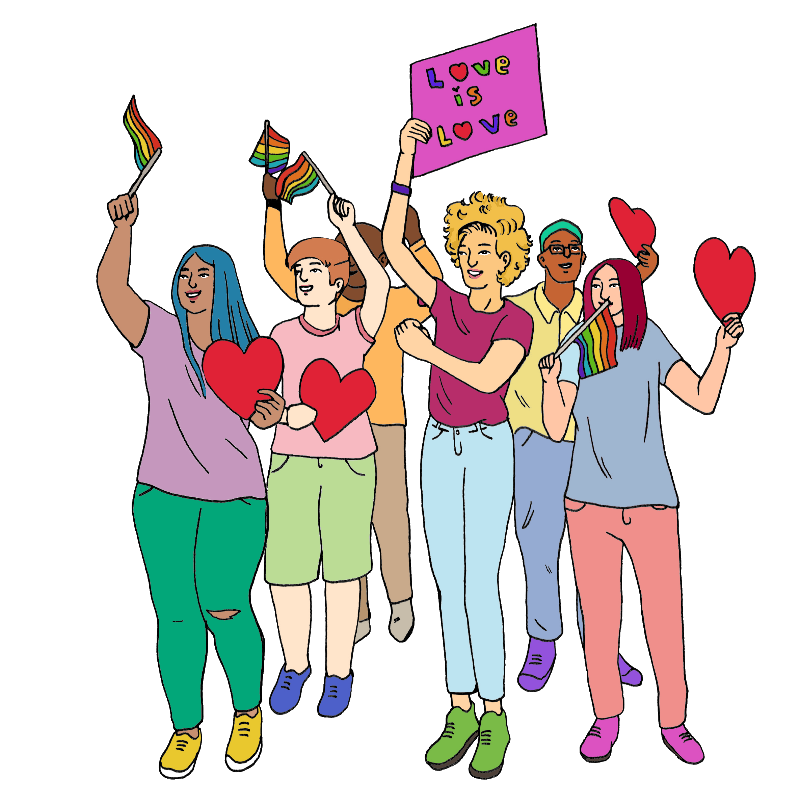
Rainbow people spent years asking the Government to make a law to stop conversion practices.

A law is a rule made by the Government that everybody must follow.


The Government made a law in 2022.

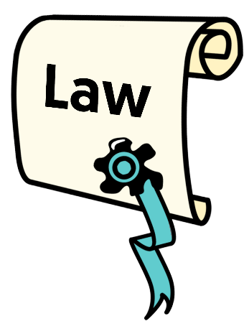
This law is called the Conversion Practices Prohibition Legislation Act 2022.

It is called the Act for short in this Easy Read.

The Act makes doing some conversion practices a crime.

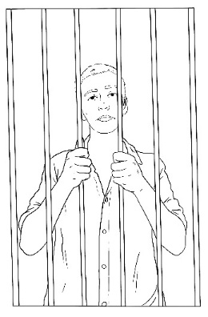
A crime is when someone:
breaks the law
and
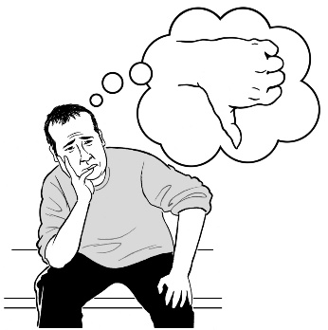
is punished for the crime like going to jail.

This means people doing conversion practices may be breaking the law.

You can make a complaint if you have experienced conversion practices.


If you have questions about something you do that might be a conversion practice you can:
- call us on:
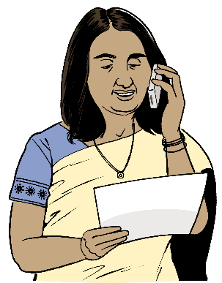
0800 496 877
This does not cost you money
or

- email us at:
infoline@hrc.co.nz
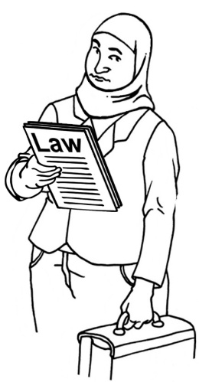

You may also need to get legal advice to find out if you are following the law.

What you can do if you have experienced conversion practices

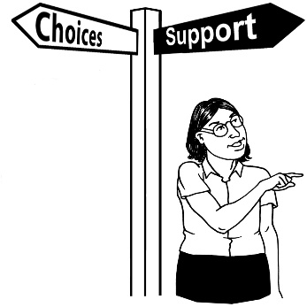
There are 3 organisations you can make a complaint to about conversion practices to.

Each organisation can support you with your complaint.

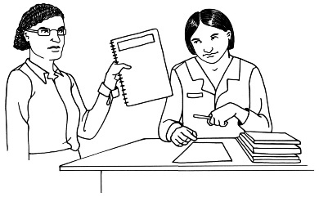
When you make a complaint:
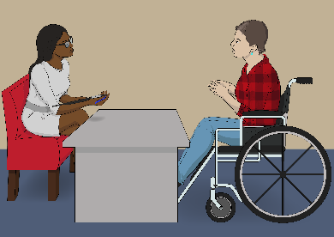
your information will only be shared if you say yes
you will be told what is happening about your complaint

you will be told if your complaint needs to be given to a different organisation to sort out.

Human Rights Commission

The Commission works under the law called the Human Rights Act 1993.


The Act also changed the
Human Rights Act.

These changes let us set up a conversion practices response service.

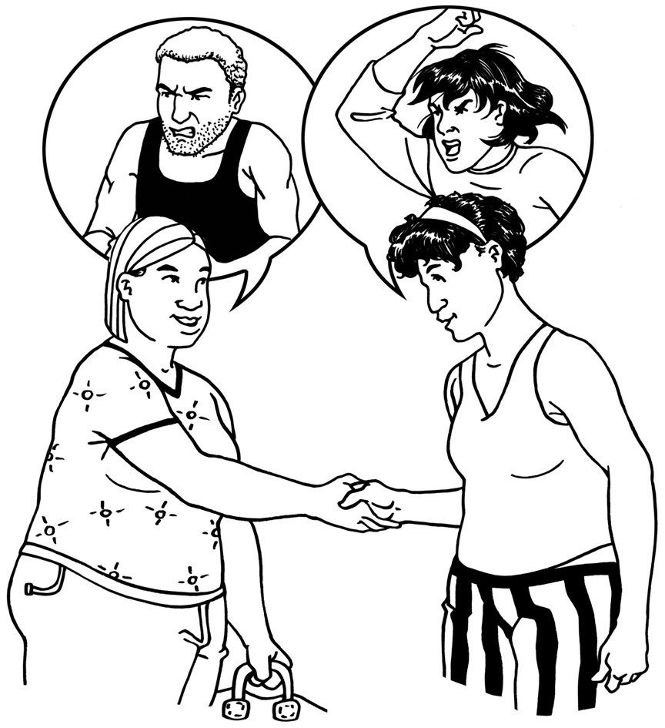
Our conversion practices response service supports people who have had experienced conversion practices.

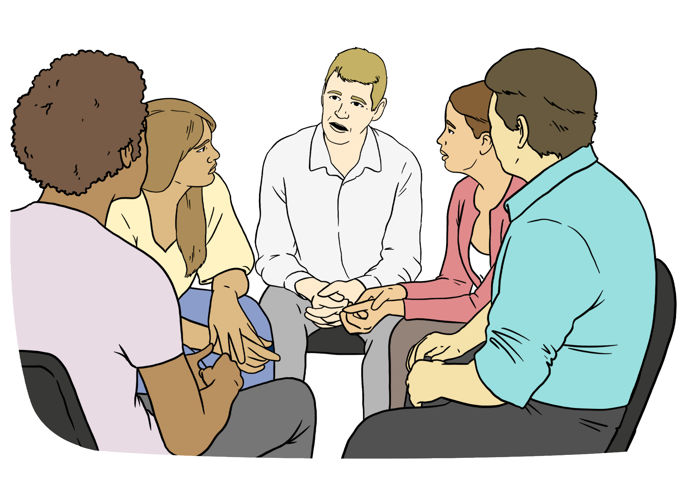
The conversion practices response service can support you with
dispute resolution.

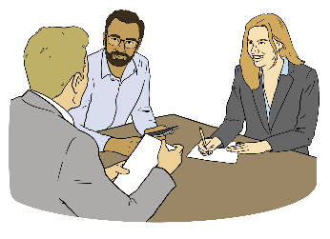
Dispute resolution is when you talk to the person who hurt you to try to make things better.


The conversion practices response service can tell the Human Rights Review Tribunal about your complaint.


The Human Rights Review Tribunal can:
hear about what happened
decide how to fix what happened.

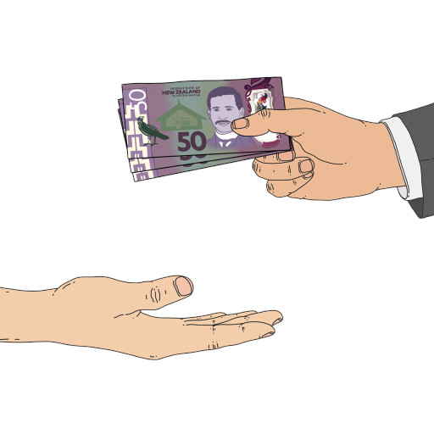
For example the Human Rights Review Tribunal can tell the person who hurt you to pay you money to make up for hurting you.

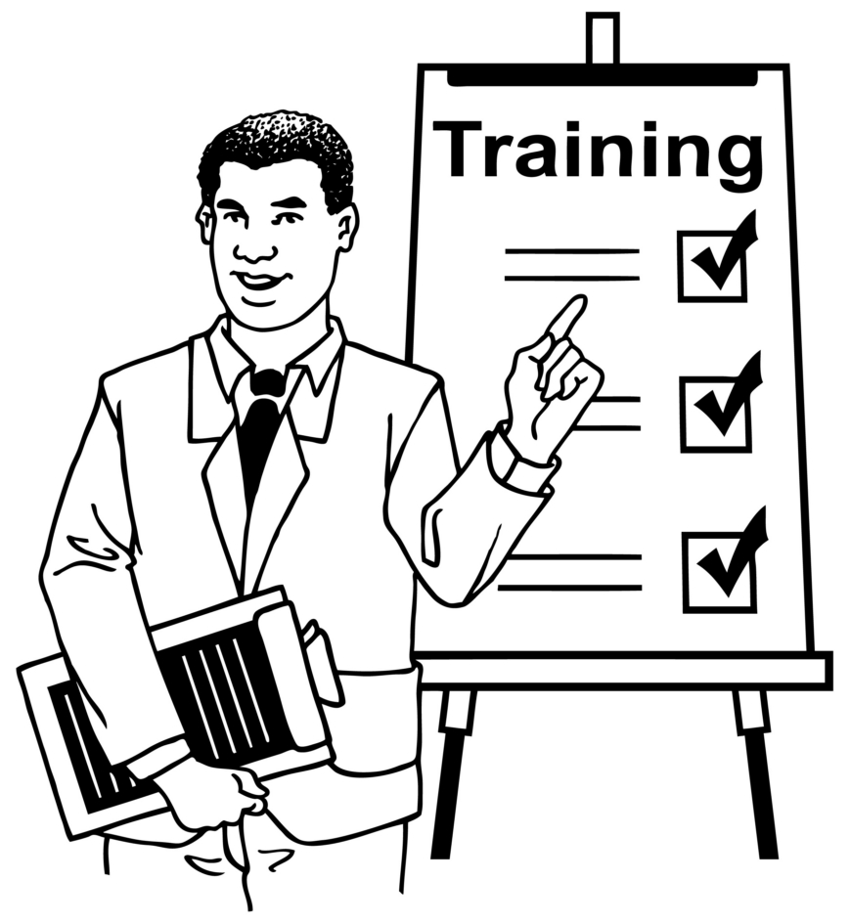
The Commission also:
teaches people about conversion practices

works to stop conversion practices from happening.

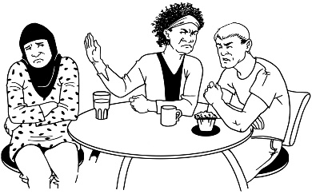
The Commission also has a service to support people who have experienced unlawful discrimination.
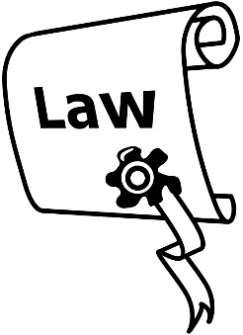

Unlawful means doing something that is breaking the law.


Discrimination is when a person is treated:
differently to other people
unfairly.



When you make a complaint to the Commission it is:
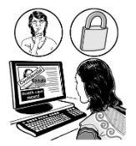
free / does not cost you money
informal / relaxed
confidential.
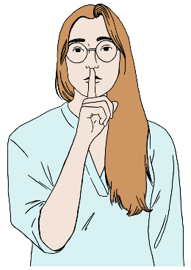

Here confidential means we do not tell anyone else what happens when we meet / talk with you.

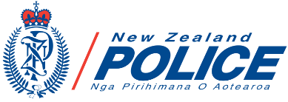
We will tell you to contact the Police if we think what has happened to you has broken the law.
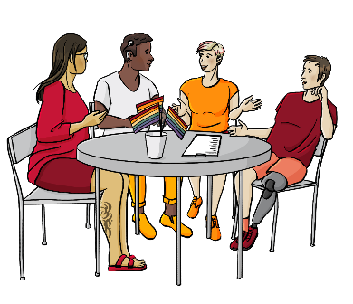
You can find out more about how dispute resolution works at our website:

https://tinyurl.com/bdevb9vp

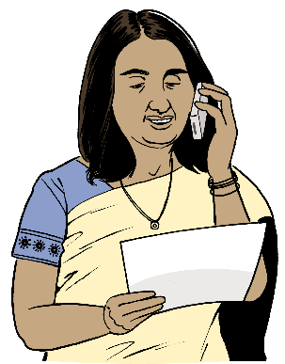
You can contact the Commission by:
phone:
0800 496 877
email:
infoline@hrc.co.nz


visiting our website at:
www.hrc.co.nz

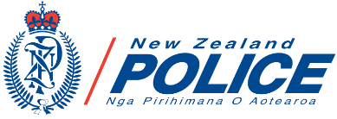
New Zealand Police

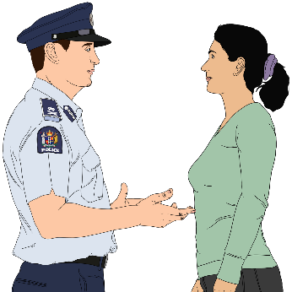
You can use the crime pathway if what has happened to you has broken the law.

Here pathway means the path / steps you should follow to do something.

The Police manage this pathway.

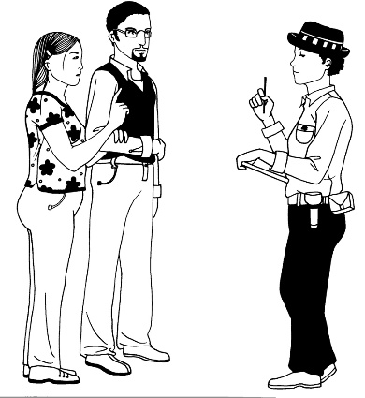
You can make a complaint to the Police if you think what has happened to you has broken the law.

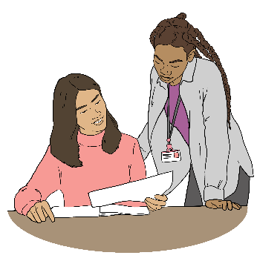
The Police will look at the information about your complaint to see if criminal charges should be made.

Here a criminal charge is when the Police find that:your complaint is:
your complaint true
what happened to you has broken the law.

They can tell you if the conversion practice you experienced is a crime.

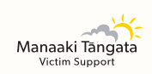
The Police can tell you about groups like Victim Support that can support you.
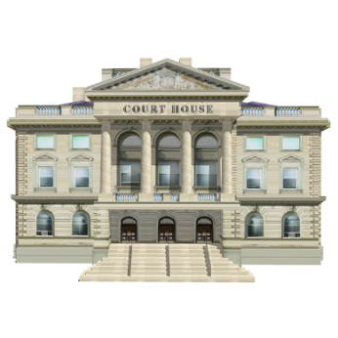

You may have to start to deal with your complaint through the courts.
To do this you will need to get legal advice from someone like a lawyer.


It will usually cost you money to get legal advice.

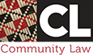
Community Law centres can give you some legal advice for free.


For more information about a Community Law centre near you visit this website:

https://communitylaw.org.nz

Here are ways you can contact the Police.


Call 111 if:
someone is in danger now
a crime is happening now.
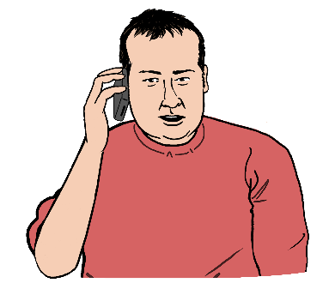
Call 105 if:
the crime has already happened
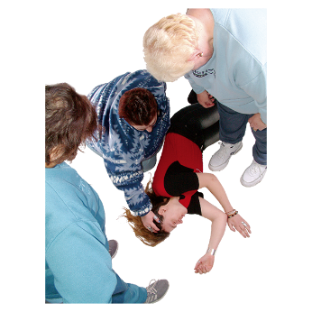
and
no one is in danger now.


You can also make your complaint online by visiting this website:

https://www.police.govt.nz/use-105

Health and Disability Commissioner

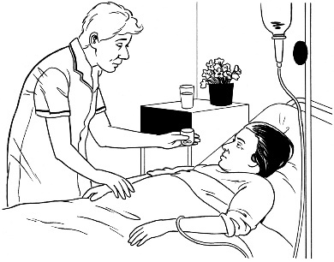
You can make a complaint to the Health and Disability Commissioner if what happened to you took place at a:
health service
disability service.

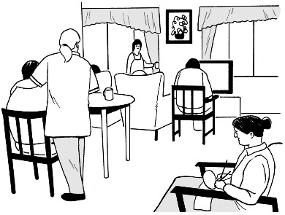
The Health and Disability Commissioner protects people who use health and disability services.

We call the Health and Disability Commissioner HDC for short in this Easy Read document.


All health and disability services should follow the rules in the Code of Health and Disability Services Consumers Rights.

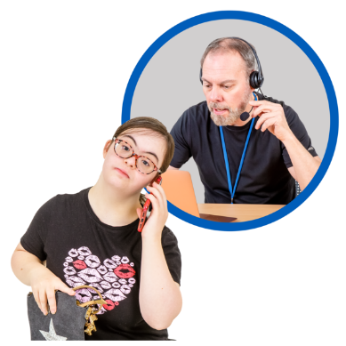
You can contact HDC if you have experienced conversion practices in a health / disability service by:
phone:
0800 11 22 33
email:
hdc@hdc.org.nz
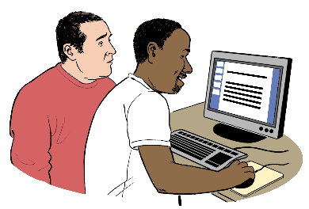
using their online form at this website:
https://tinyurl.com/bdh5uvs9

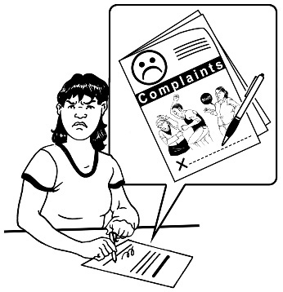
You can find out more about making a complaint to HDC at their website:

https://tinyurl.com/mtr5jp6h
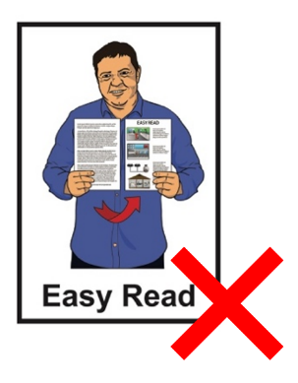

These websites are not in Easy Read.


If you are not sure who can support you talk to the:
Commission
or
Police.

They can:
tell you the right organisation to support you

give you more information to support you to make a complaint.

Support to make a complaint about conversion practices

Making a complaint about conversion practices can be very hard.


We think it is a good idea you get support to make your complaint

You can talk about it with someone you trust.


It is also a good idea to keep records about:
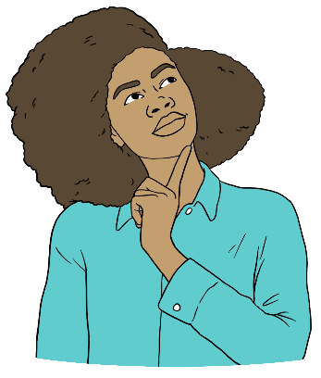
- what happened
- when it happened
- the people who were doing the conversion practices.


Here records are keeping information about things that have happened.

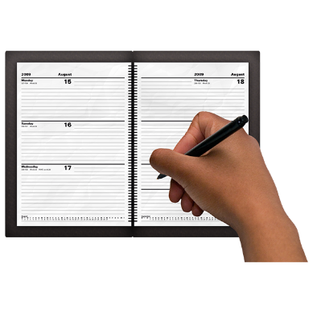

This can be doing something like writing down what has happened.

Keeping records can support you to make your complaint.


You do not have to keep records.
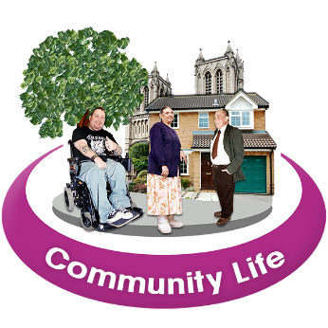
You can also find support at places in your community.


We have listed some of these places here.

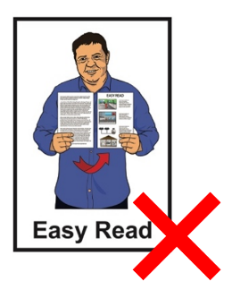
None of these websites are in Easy Read.

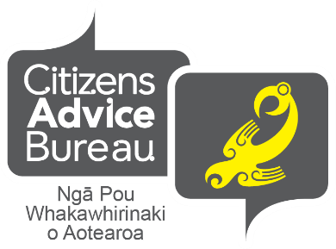
- Citizens Advice Bureau (CAB)

CAB support people to
know / understand their rights.


You can find more information on their website:

www.cab.org.nz

Community Law Centre

Community law centres give free legal support to people who do not have much money.

You can find more information on their website:

www.communitylaw.org.nz

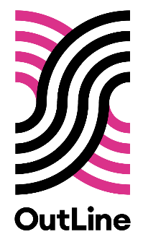
OutLine

OutLine supports people of any age with their mental health like the:
Rainbow community
and
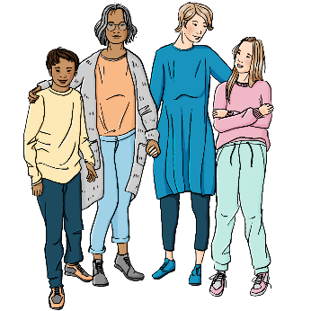
allies of the Rainbow community like their:
- friends
- whānau / families.
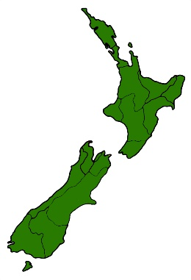

OutLine work with people all around the country.


Their services do not cost you money.

Outline services are things like:
a support line you can call

an online chat support service open:
- everyday
- from 6pm to 9pm.
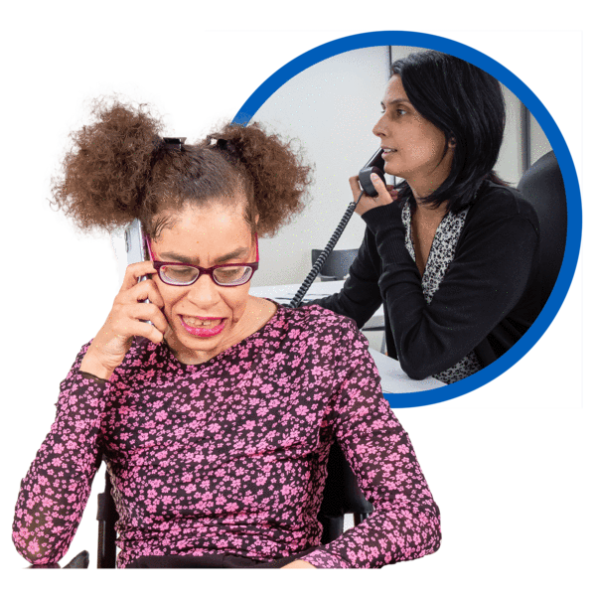
give peer support for trans /
non-binary people in Tāmaki Makaurau Auckland
give support to people who have experienced conversion practices.

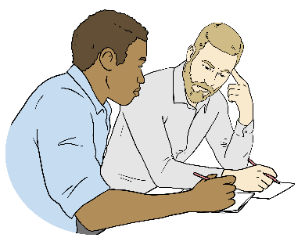

Here peer support is when you get support from somebody you can trust in the Rainbow community.
You can phone Outline on:

0800 688 5463

It does not cost you money to call.

You can find more information on their website:

www.outline.org.nz

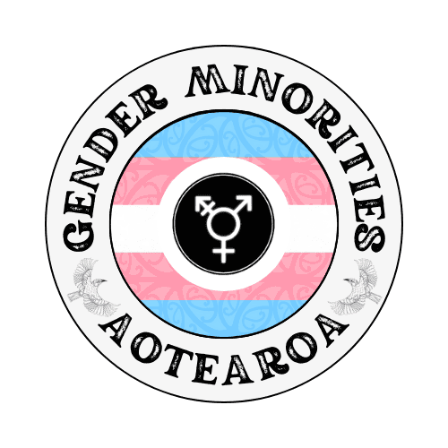
Gender Minorities Aotearoa

Gender Minorities Aotearoa is a transgender organisation run by transgender people for:
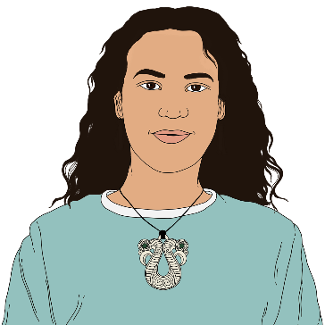
transgender people
irawhiti
takatāpui
intersex transgender people.

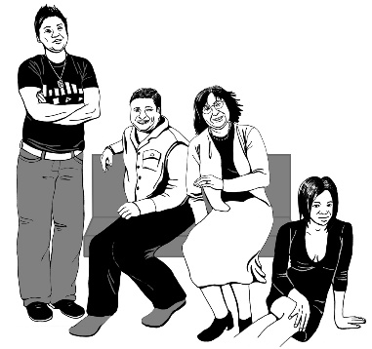
Transgender people have a different gender to the 1 people thought they had when they were born.

Irawhitu / takatāpui are the words Māori use to say if they:
have a Rainbow identity
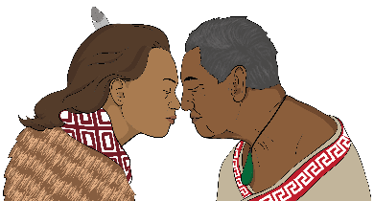
have a similar identity but in a Māori way

The words irawhitu and takatāpui are only used for Māori.

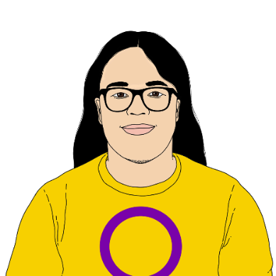
Intersex people are people whose bodies are not like what people usually think of as:
- female bodies
- male bodies.

Gender Minorities Aotearoa support transgender people of all ages.

You can find more information on their website:

www.genderminorities.com


RainbowYOUTH

RainbowYOUTH provide services for:
Rainbow young people aged from 13 to 27 years old
and
their communities.


Their services are things like giving:
support
information
advocacy.
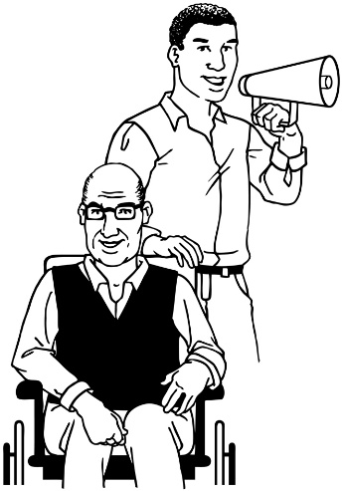

Advocacy is where someone supports you to say what you want to say.

You can find more information on their website:

www.ry.org.nz


InsideOUT
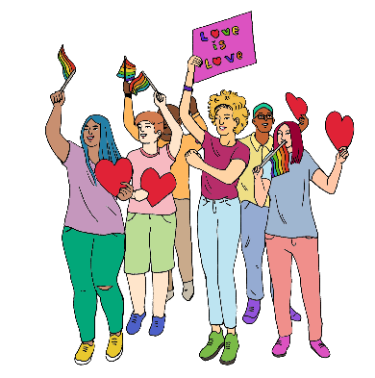
InsideOUT is a national charity that supports Rainbow communities.

Their services are things like:
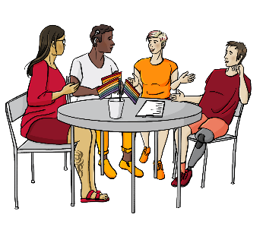
resources / information
workshops
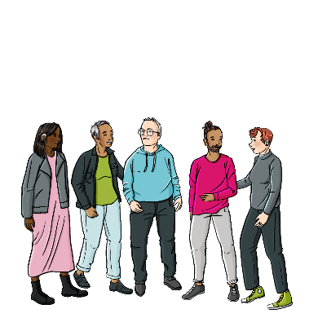
advocacy
support for anything to do with Rainbow communities.

You can find more information on their website:

www.insideout.org.nz



Intersex Aotearoa (IA)

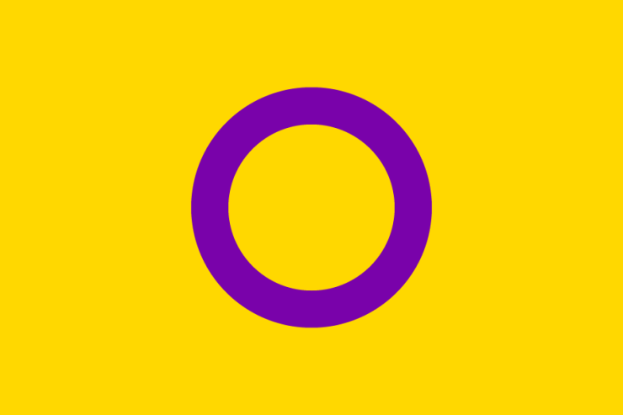
IA supports advocacy led by intersex people in Aotearoa.

IA works with government to support New Zealand Aotearoa to be safe for intersex people.

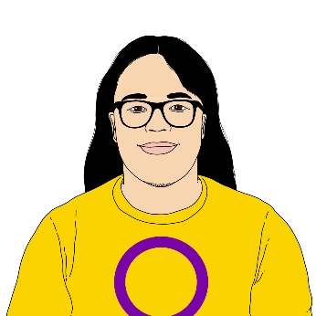
IA welcome all:
intersex people in New Zealand Aotearoa
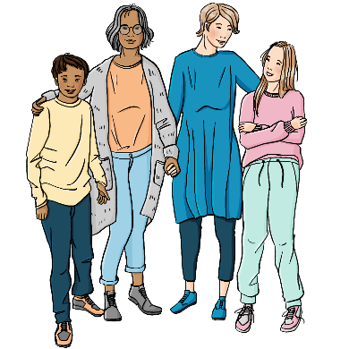
and
their:
- whānau / families
- friends.

You can find more information on their website:
www.intersexaotearoa.org


Rainbow Path Aotearoa

Rainbow Path is an advocacy and support group for Rainbow:
refugees
asylum seekers.

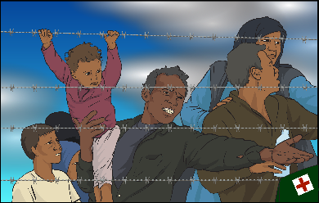
A refugee is someone who:
is not safe in their own country
moves to another country to be safe
is protected by the law called the United Nations Refugee Convention.

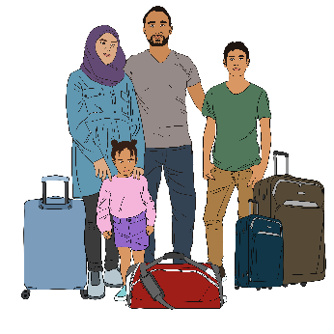
An asylum seeker is someone who has left their own country to live in a country where they are safe.

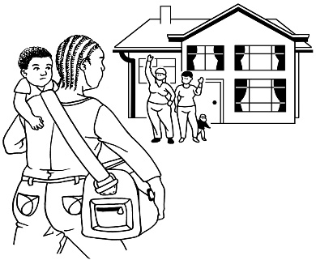
They are waiting to be seen as refugees by the country they have moved to.

You can find more information on their website:

www.rainbowpathnz.com

- Diverse Church

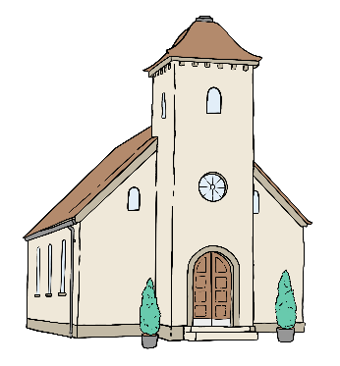
The Diverse Church is a group of churches that welcome Rainbow Christians from around
New Zealand Aotearoa.

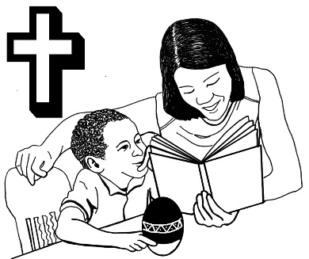
Christians are people who believe:
in Jesus Christ
Jesus Christ is the Son of God.

They want to see churches become safe places to make sure LGBTQIA+ people can take part.

You can find more information on their website:

www.diversechurch.co.nz

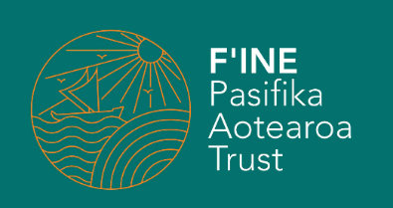
F’INE Pasifika

F’INE Pasifika is an Auckland organisation supporting:
MVPFAFF+
Pacific LGBTQI+
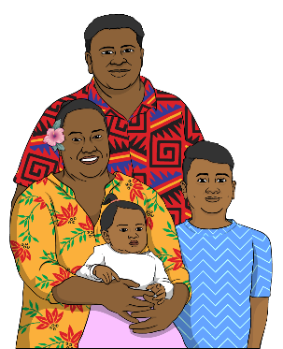
Rainbow / Queer people
the whānau / families of Rainbow / Queer people.
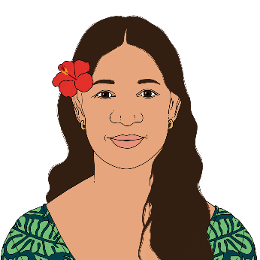

MVPFAFF+ are the Rainbow identities of Pacific communities.

You can find more information on their website:

www.finepasifika.org.nz


- Tīwhanawhana Trust

The Tīwhanawhana Trust is a takatāpui community group in Wellington.

It welcomes people of different:
sexualities
gender identity.

You can find more information on their website:

www.tiwhanawhana.com

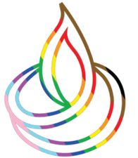
Indian Origin Pride NZ

Indian Origin Pride NZ is an organisation for:
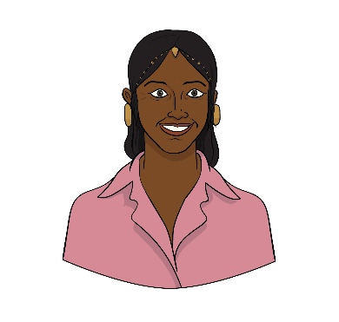
- LGBTQIA+ Indians
and
- their whānau / families.


They want people in their community to be proud of who they are.

You can find more information on their website:

www.iopnz.org

More information

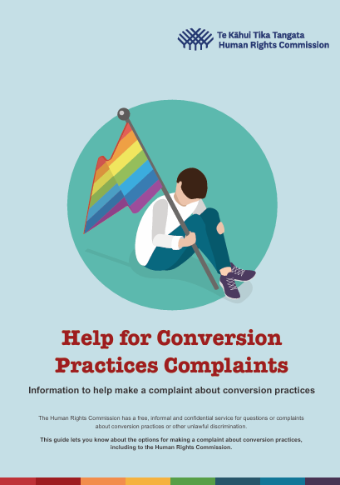
You can read the full guide of
Help for Conversion Practices Complaints at this website:

https://tinyurl.com/HelpforCP

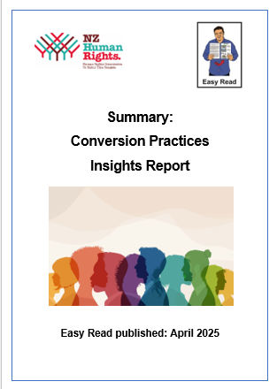
You can find out more by reading the Easy Read Summary: Conversion Practices Insights Report at this website:

https://tinyurl.com/ConPracReport


You can contact us if you have any questions about conversion practices.

You can contact us by:
phone:
0800 496 877
email:
infoline@hrc.co.nz

You can also find out more about
conversion practices at our website:

https://tinyurl.com/mpkcmn5m

This website is not in Easy Read.
This information has been written Te Kāhui Tika Tangata | Human Rights Commission.

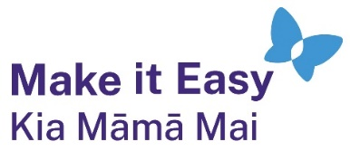
It has been translated into Easy Read by the Make it Easy Kia Māmā Mai service of People First New Zealand Ngā Tāngata Tuatahi.
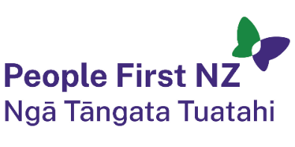
The ideas in this document are not the ideas of People First New Zealand Ngā Tāngata Tuatahi.

All images used in this Easy Read document are subject to copyright rules and cannot be used without permission.


Make it Easy uses images from:

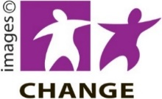
- Photosymbols

- Change Images


- Huriana Kopeke-Te Aho

- SGC Image Works

- T Wood


- Studio Rebeko

- Inga Kramer.

