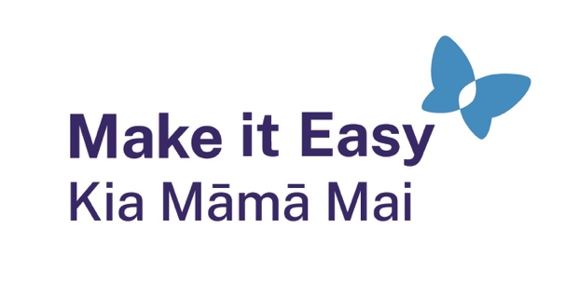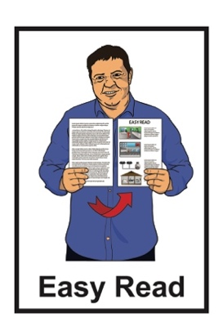

What is Easy Read?

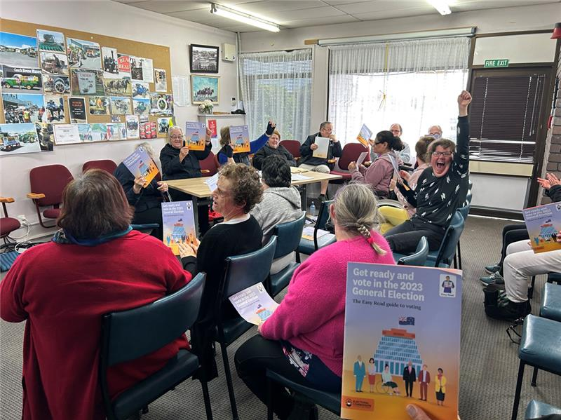

Published: August 2025

# What you will find in here

**Page number:**

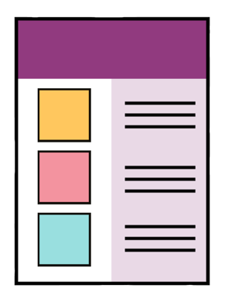

What this Easy Read is about 2

What is Easy Read 4

Who uses Easy Read 9

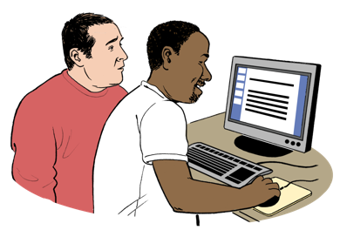How to use Easy Read 11

Where to find Easy Read 16

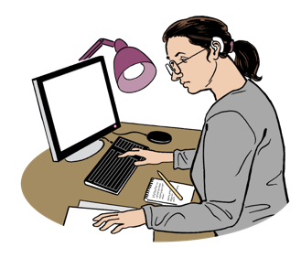

How Easy Read is made 19

More information 21

# What this Easy Read is about

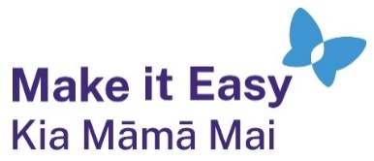

This Easy Read is from **Make it Easy Kia Māmā Mai**.

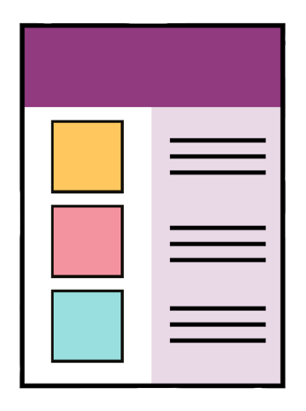

**Make it Easy Kia Māmā Mai** is a service that **translates** documents into Easy Read.

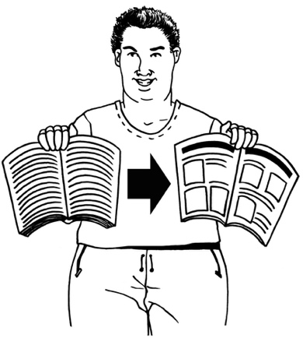Here **translate** means to write Easy Read documents from information that is not in Easy Read.

In this Easy Read we will call Make it Easy Kia Māmā Mai **Make it Easy**.

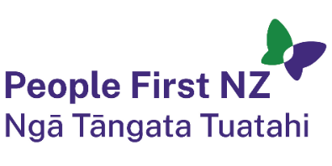Make it Easy is part of **People First New Zealand Nga Tāngata Tuatahi.**

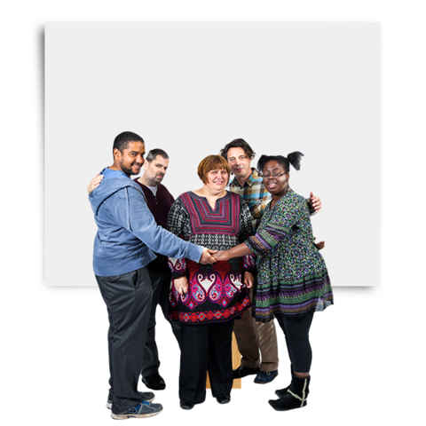

**People First New Zealand Ngā Tāngata Tuatahi** is a Disabled People’s Organisation which is:

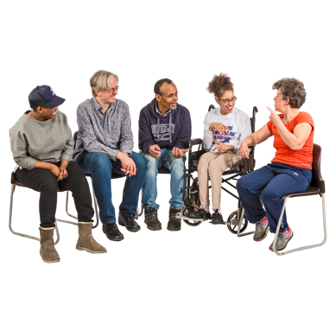for people with learning disability

run by people with learning disablity.

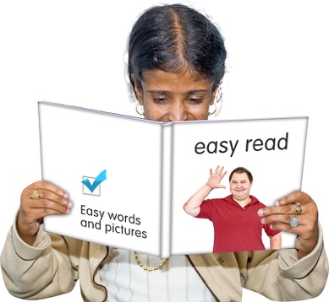

This Easy Read has information about:

what Easy Read is

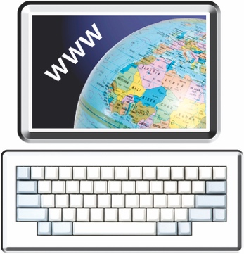how to use Easy Read documents

where to find Easy Read information.

# What is Easy Read

Easy Read is a way of writing information that is easy to:

read

understand.

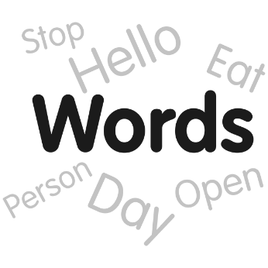

Easy Read uses:

short sentences

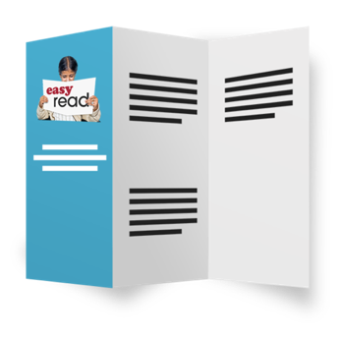easy words

big writing

lists.

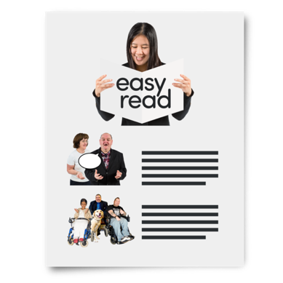

Easy Read also uses pictures to make the words easier to understand.

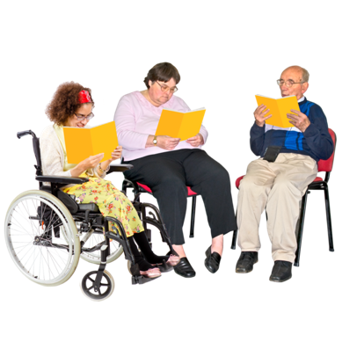Easy Read is important because everyone has the **right** to get the information they need.

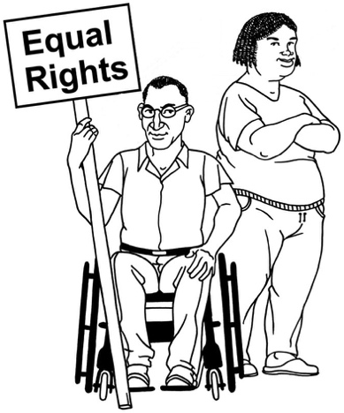

A **right** is something everyone should be able to:

do

have.

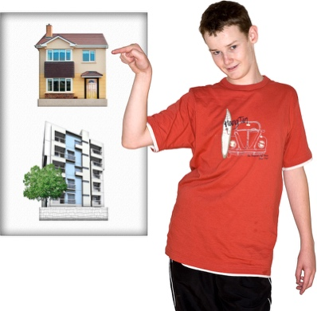Rights are things like:

having information you can understand

being able to choose where you live.

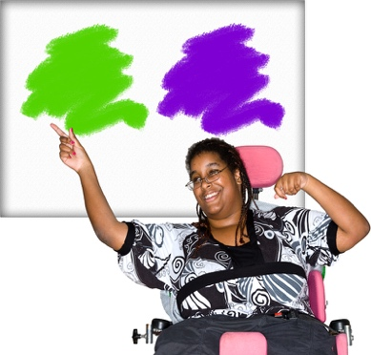Having information means people can:

make their own choices

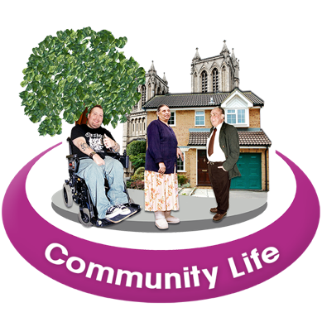know how to keep themselves safe

be part of their community.

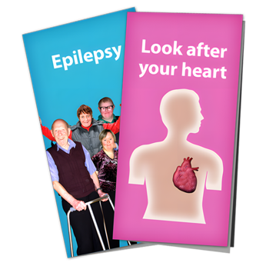Some types of information you will find in Easy read are:

health information

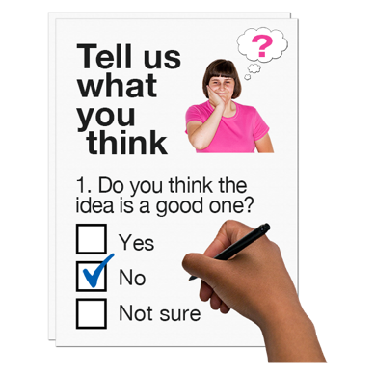how to manage your money

how to have your say about things that matter to you.

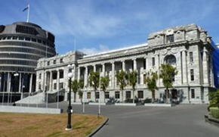Easy Read information can be from:

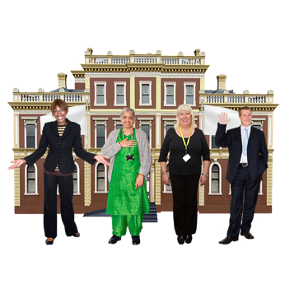the Government

city councils

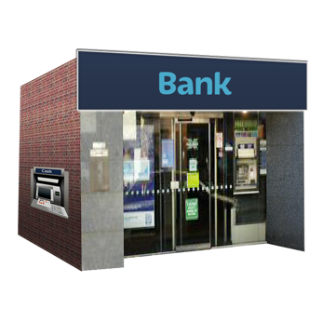disability support organisations

people doing **research**

businesses.

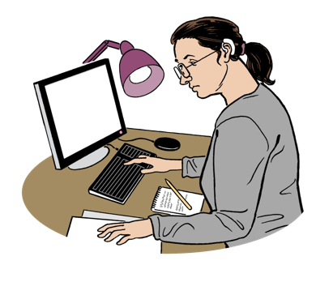**Research** is when someone:

looks at what is happening

tries to find ways to do things better.

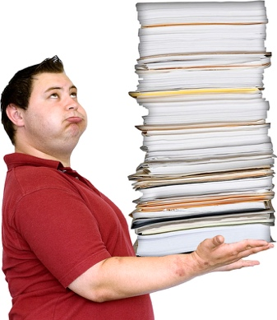Often just the **summary** of a long document is translated into   
Easy Read.

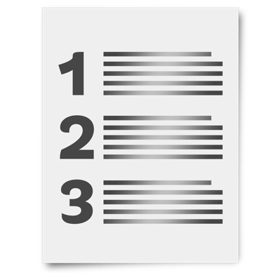A **summary**:

is shorter than the full document

tells you the main ideas.

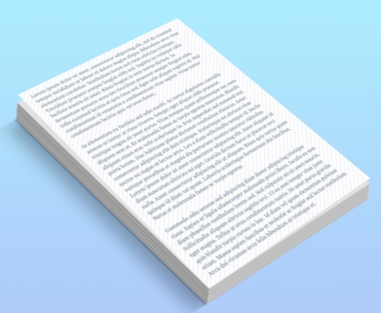

When an Easy Read is a summary it will usually say where to find the full document.

# Who uses Easy Read

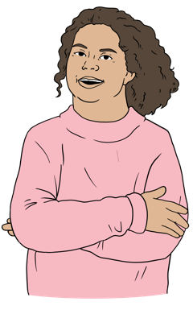

Easy Read is mostly written for people with learning / intellectual disability.

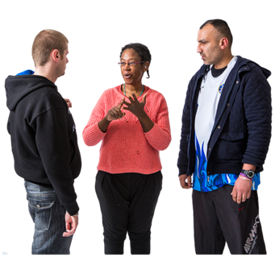Lots of other people also use Easy Read such as people who:

* are deaf / Deaf

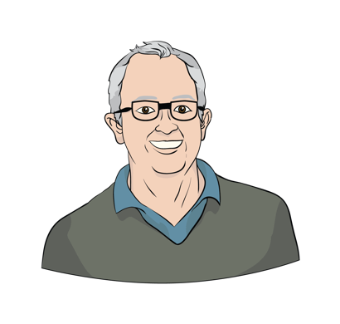find it hard to read

are learning to speak English

are older.



Easy Read is for anyone who wants information that is easy to understand.

# How to use Easy Read

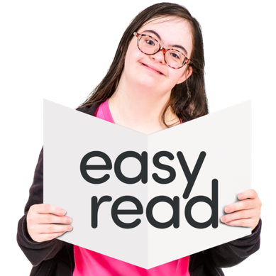

You may be able to read Easy Read by yourself.

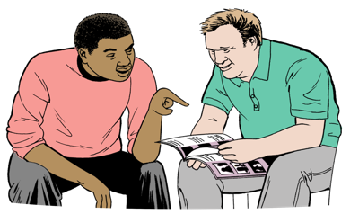You may be able to read Easy Read with support from someone like a:

friend

whānau / family member

support worker / carer.

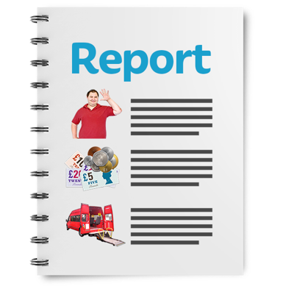Some Easy Reads can:

be long

have a lot of information.

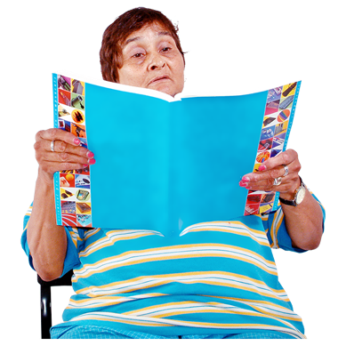You can:

read a little bit at a time

only read the parts of the Easy Read you need.

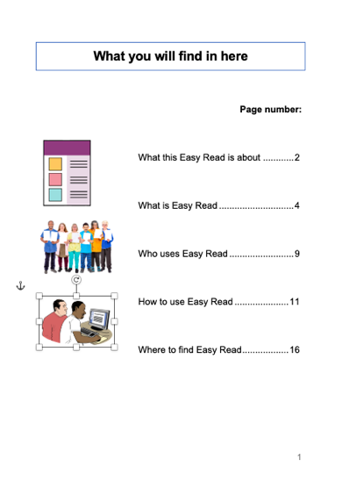Longer Easy Reads will have a contents page near the start.

The contents page is usually called something like **What you will find in here**.

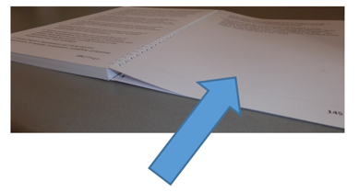

It tells you what page you can find different bits of information on.

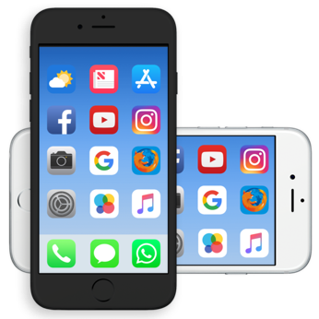It can be hard to read Easy Read on a small screen like a phone.

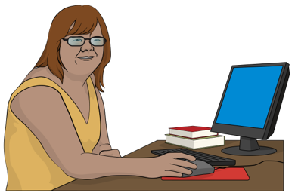You can use a:

computer

tablet / iPad.

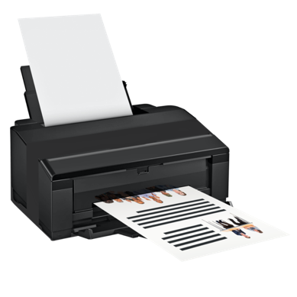

Some people like to print Easy Read out onto paper.

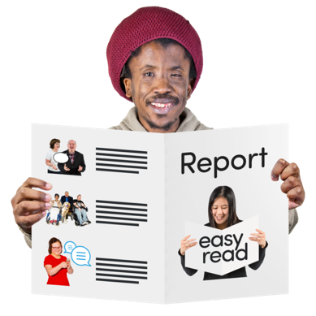When you read an Easy Read look out for words in **bold type**.

**Bold type** is writing that looks   
darker / bigger than the rest.

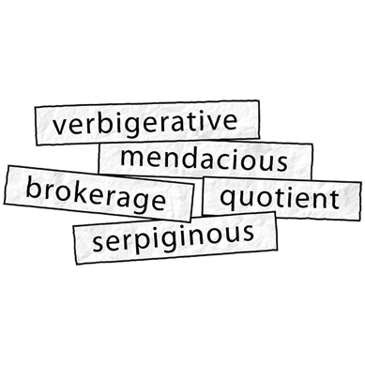Most of the words in bold type are hard words.

This is a coloured box.

Hard words will have an explanation in a coloured box just after them.

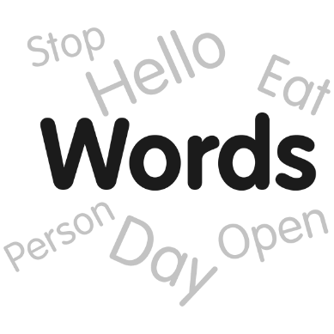

Sometimes other words are in bold type too.

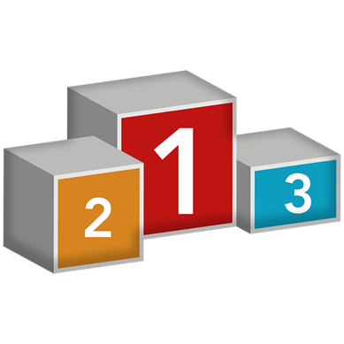

The bold type tells you those words are important.

Remember to look at the pictures beside the writing in an Easy Read.

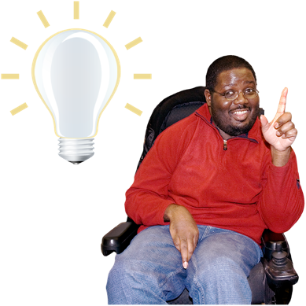The pictures can:

make the words easier to understand

give you more information.

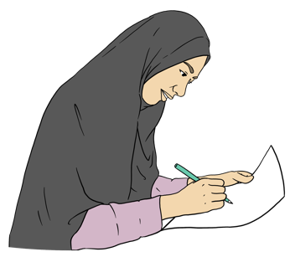

The pictures in Easy Read can be:

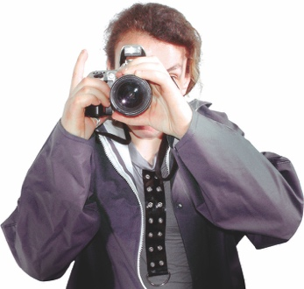drawings

photos.

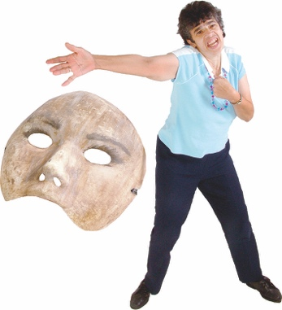The people in the photos are almost always actors.

They are pretending to do things for the photo.

# Where to find Easy Read



You can find Easy Read in a lot of places.

On a website you may find Easy Read where it says  
**alternate formats**:

in the menu

at the bottom of the page.

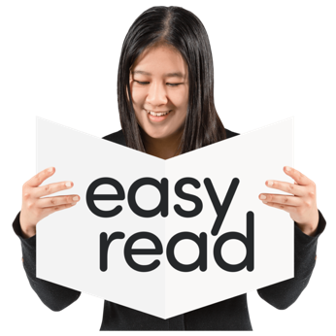

**Alternate formats** are things like:

Easy Read

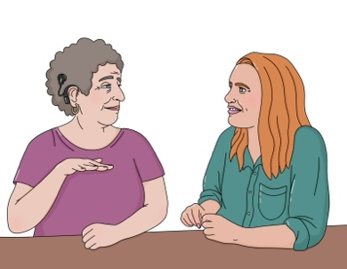Braille

New Zealand Sign Language.

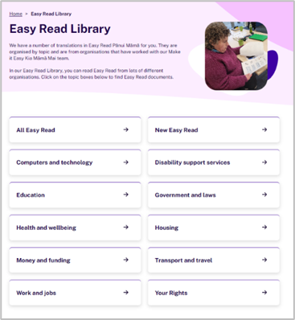You can find a lot of Easy Reads in the **Easy Read Library** on the People First Ngā Tāngata Tuatahi **website** at:

[**www.peoplefirst.org.nz/easy-read-library**](http://www.peoplefirst.org.nz/easy-read-library)

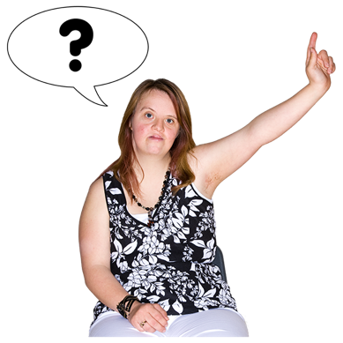

You can ask Make it Easy to support you to find the Easy Read information you need.

There is information about how to get in touch with Make it Easy at the end of this Easy Read.



The people who work for Make it Easy can find a lot of Easy Read information.

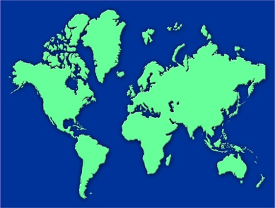

Sometimes they may find Easy Read information from other countries.

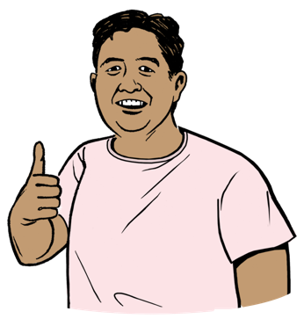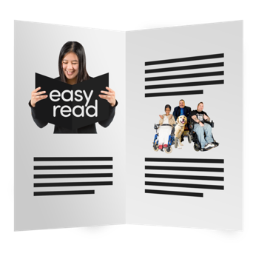Easy Read information from other countries may not look the same as Easy Read information from Aotearoa New Zealand.

It will still be easy to read.

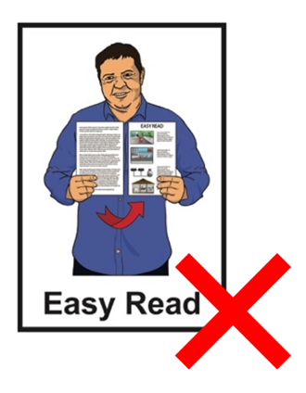

There may be some information you need that has not been translated into Easy Read.

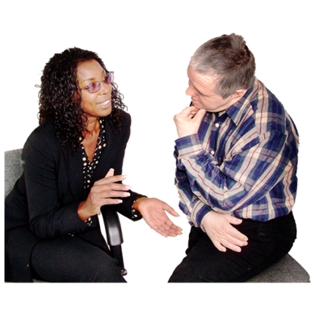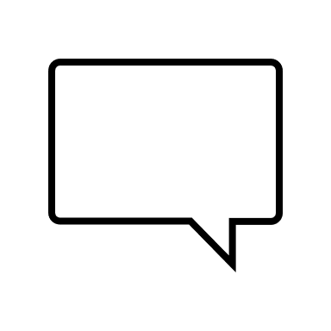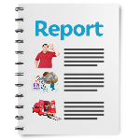

You can talk about the Easy Read information you need with:

people you know

organisations / services you use.

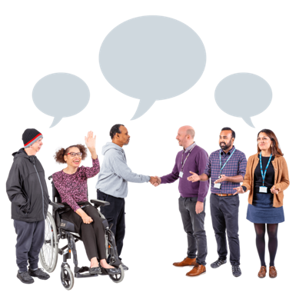

If a lot of people say they need Easy Read more information might get translated.

# How Easy Read is made

Most Easy Reads start when someone brings the information they want translated to Make it Easy.

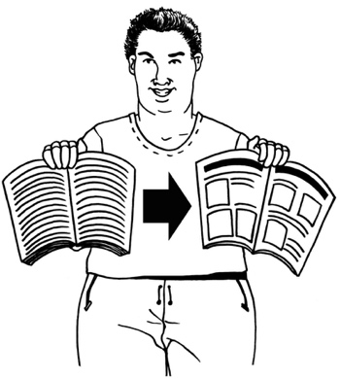The person who wants their information translated is called a client.

A Make it Easy translator turns the information into Easy Read.

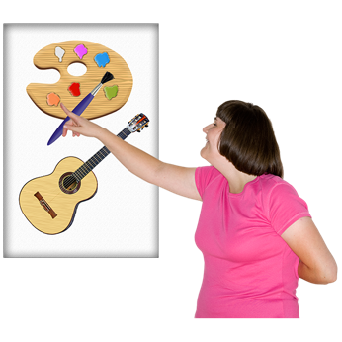

The translator chooses pictures to go with the words.

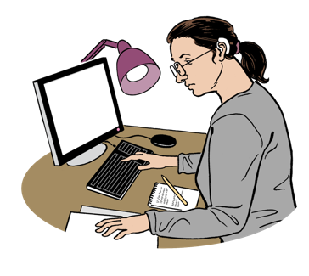

Another translator checks the Easy Read to make sure it is good.

The Easy Read is sent to the client to check.

When everyone is happy with the Easy Read the client can:

put in on their website

print it to send / give to people.

# More information



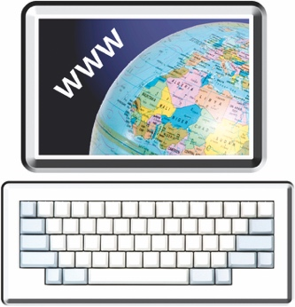You can find out more information about Easy Read on the   
Make it Easy **website** at:

[**www.makeiteasy.org.nz**](http://www.makeiteasy.org.nz)

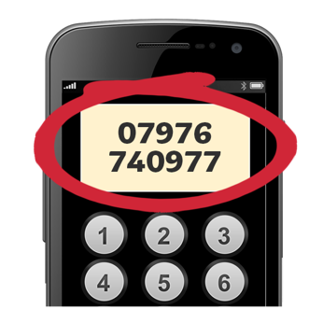You can phone Make it Easy on:

**0800 20 60 70**

This phone number is also for People First New Zealand Ngā Tāngata Tuatahi.

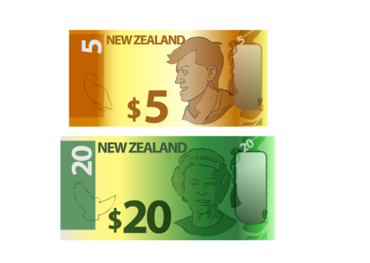

It does not cost money to phone this number.

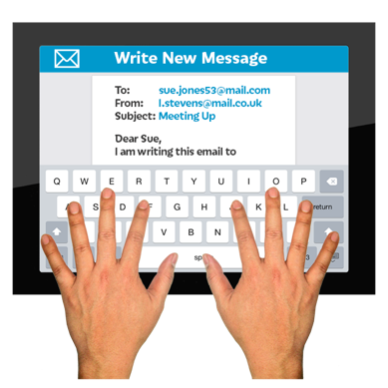You can **email** Make it Easy at:

[**makeiteasy@peoplefirst.org.nz**](mailto:makeiteasy@peoplefirst.org.nz)



You can find out more about People First New Zealand Ngā Tāngata Tuatahi on their **website**:



[**www.peoplefirst.org.nz**](http://www.peoplefirst.org.nz)

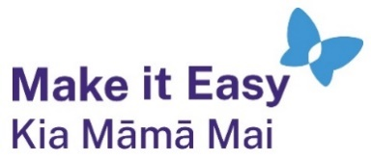This information has been written by Make it Easy Kia Māmā Mai.



Make it Easy Kia Māmā Mai is a service of People First New Zealand Ngā Tāngata Tuatahi.



All images used in this Easy Read document are subject to copyright rules and cannot be used without permission.

Make it Easy uses images from:

* 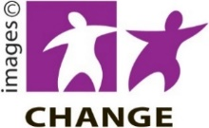Photosymbols
* Change Images
* 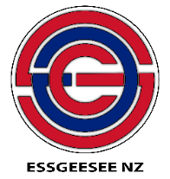Huriana Kopeke-Te Aho

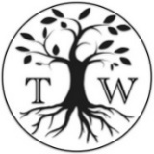

* SGC Image Works
* T Wood
* A logo for a school

  Description automatically generatedStudio Rebeko
* Inga Kramer.