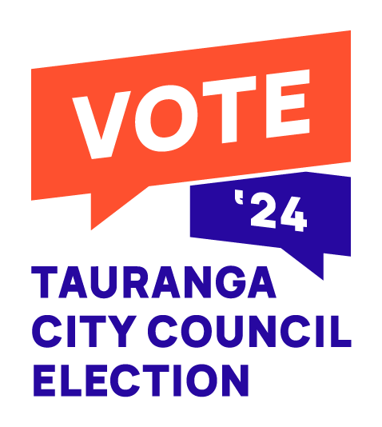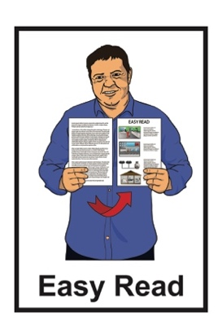

Voting in the

Tauranga City Council election

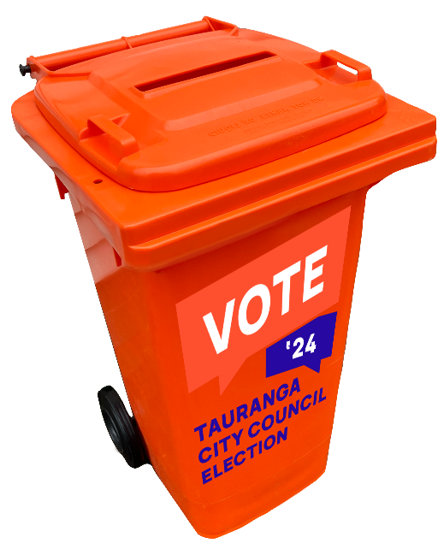



Published: June 2024

# What is this document about?

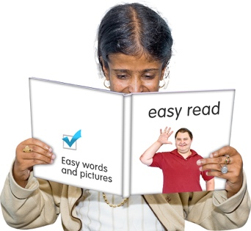This Easy Read document is about the 2024 **Tauranga City Council** **election**.

The **Tauranga City Council** makes decisions about how Tauranga City is run.

A council **election** is the time when you can votefor the people you want to make important decisions about:

* things that affect how you live
* the city you live in.

This document tells you:

* what you need to know about the election
* how to vote in the election.

# What is the election about?



The Tauranga City Council election will choose who will lead the city.

There are 10 jobs on the council being voted on which are:

* the mayor
* 8 general ward **councillors**
* a councillor for the new **Māori ward** called Te Awanui.



The **mayor** is the person who leads the city council.

A city **councillor** is a person who represents a part of the city on the council.

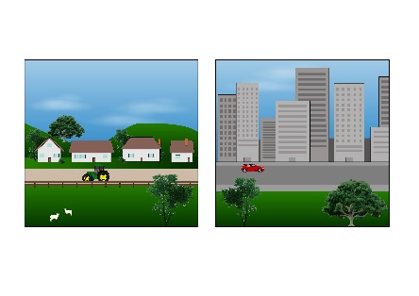

A **ward** is the voting area of the city like your suburb.



A **Māori ward** is the voting area people on the **Māori electoral roll** can vote in.

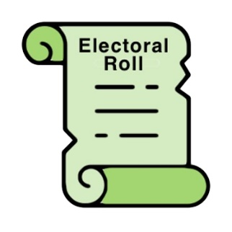

The **electoral roll** is a list of all the people in New Zealand who have enrolled to vote**.**

The electoral roll is split into 2 lists:

* the **Māori roll** that is open to voters who are Māori
* the general roll that is open to all voters.

Māori can:

* choose to go on the Māori roll



* choose to go on the general roll
* move between the rolls.

# How to vote

You can vote in the Tauranga City Council election if you:

18

* are at least 18 years old
* have lived in New Zealand for more than 1 year at some time in your life
* have lived at your Tauranga address for at least 1 month
* are:



* a **New Zealand citizen**

**or**



* a **New Zealand permanent resident.**

A **New Zealand citizen** is someone who can get a New Zealand passport.

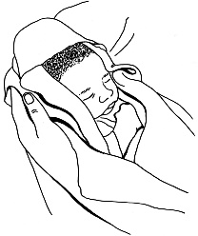

Most New Zealand citizens were born in New Zealand.



A **New Zealand permanent resident** is someone who:

* is not a New Zealand Citizen.
* has been told by the government they can live in New Zealand all the time.

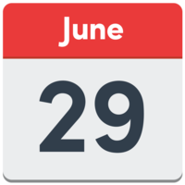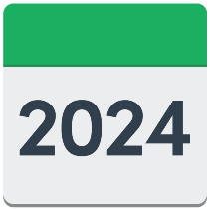

You will get a **voting pack** in the mail from **29 June 2024**.

A **voting pack** has:

* information on how to vote
* the form to put your vote on.

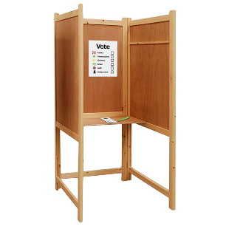

If your voting pack does not arrive you can do a special vote.

**

The Tauranga City Council can tell you how to do a special vote.

To get information on how to do a special vote you can:

* **email**:

**election24@tauranga.govt.nz**

* **phone**:

**07 577 7000**

# When to vote

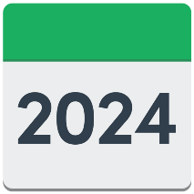Election day for the Tauranga City Council election is **Saturday   
20 July 2024.**



Voting closes at 12 midday.

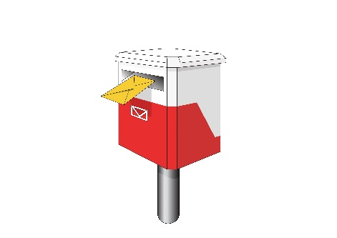When you have filled in your voting form you can:

* post it

or

* 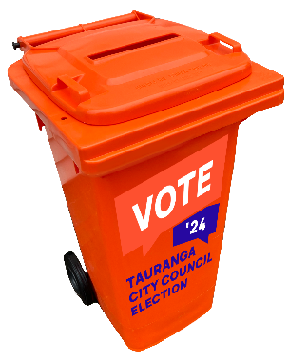put it in the orange voting bins.

If you are **posting** your voting form put it in the mail by **Wednesday   
17 July 2024.**

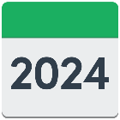

If you are putting your voting form in an **orange voting** **bin** do it by

**12 midday Saturday 20 July 2024**.

You can find a list of where the orange voting bins are on the Tauranga City Council **website**:

[**www.tauranga.govt.nz/elections**](https://www.tauranga.govt.nz/elections)



This website is not in Easy Read.

# Where to get more information

You can contact the Tauranga City Council by:

* **email**:

**election24@tauranga.govt.nz**

* **phone**:

**07 577 7000**

You can find more information about the Tauranga City Council election at this **website**:

[**www.tauranga.govt.nz/elections**](https://www.tauranga.govt.nz/elections)

**This information has been written by Tauranga City Council.

It has been translated into Easy Read by the Make it Easy Kia Māmā Mai service of People First New Zealand Ngā Tāngata Tuatahi.

The ideas in this document are not the ideas of People First New Zealand Ngā Tāngata Tuatahi.

Make it Easy uses images from:

* Photo SymbolsChangepeople.org

Photosymbols.com

* SGC Image Works
* Huriana Kopeke-Te Aho
* T. Wood.

  
All images used in this Easy Read document are subject to copyright rules and cannot be used without permission.