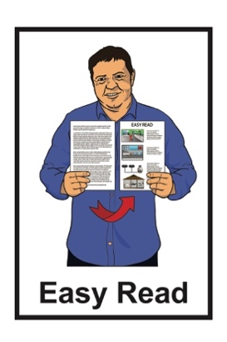
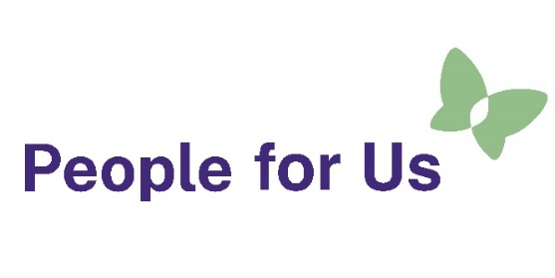

Job advertisement:

People for Us –

Kaiārahi / Peer Worker
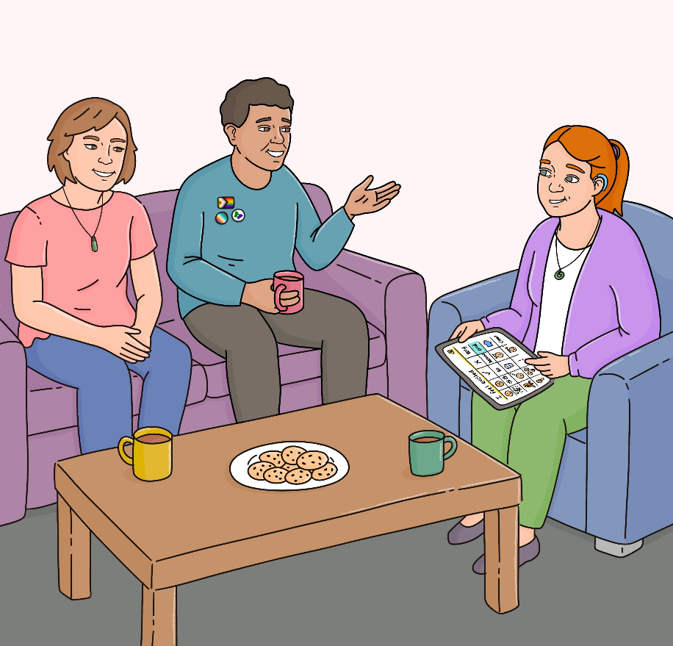


Published: April 8 2026

About this Easy Read
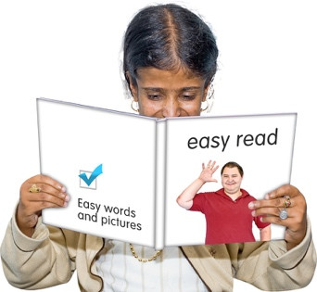

This Easy Read is a job advertisement.


A job advertisement tells people an organisation wants to hire someone to work for them.

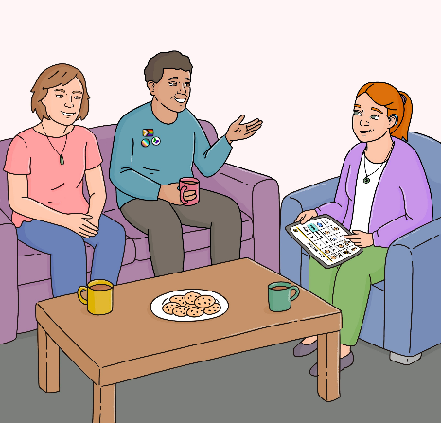
This job advertisement is for the job of Kaiārahi / Peer Worker for
People for Us.

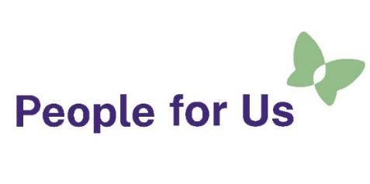
People for Us is a new service being run by People First New Zealand Ngā Tāngata Tuatahi.


People First New Zealand Ngā Tāngata Tuatahi is a Disabled People’s Organisation which is:

for people with learning disability
and
led by people with learning disability.


Where you see we / our / us in this document this means People for Us.

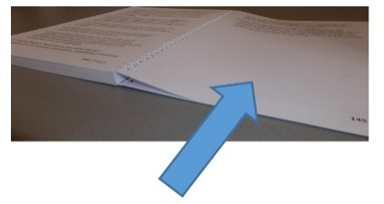
There is more information about People for Us on pages 3 to 4.

What is People for Us?


People for Us is a service that is:
all over Aotearoa New Zealand
run by disabled people.

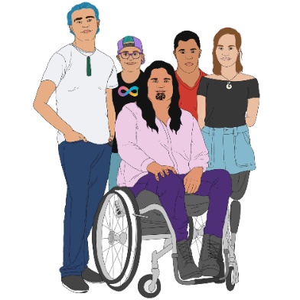
People for Us works with people who live in community residential support services who are:
disabled
tāngata whaikaha Māori.

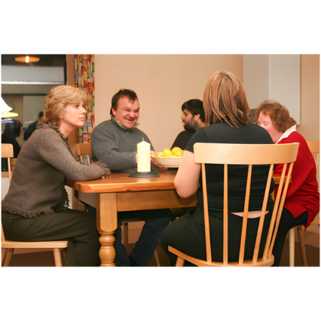
A community residential support service is where a disabled person:
lives in a home with other disabled people
gets support from staff.

People for Us works to make sure people who are getting disability support services are:
safe

living a good life they choose
getting very good support.


We think it is very important to make good changes to disability support services in Aotearoa New Zealand.

About the Kaiārahi / Peer Worker role
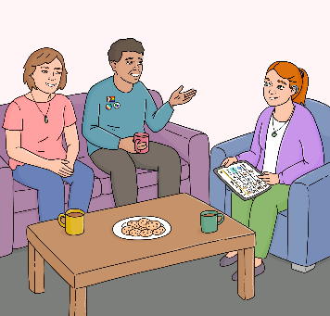

This job advertisement is for the job of Kaiārahi / Peer Worker.

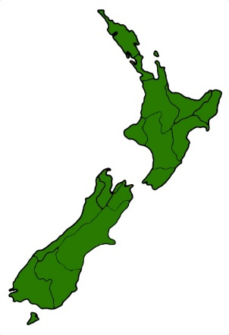
We are looking for Kaiārahi in Hamilton


Kaiārahi / Peer Workers will be employed as:
Permanent part time employees

Here being a permanent part time employee means you:
work 10 hours each week
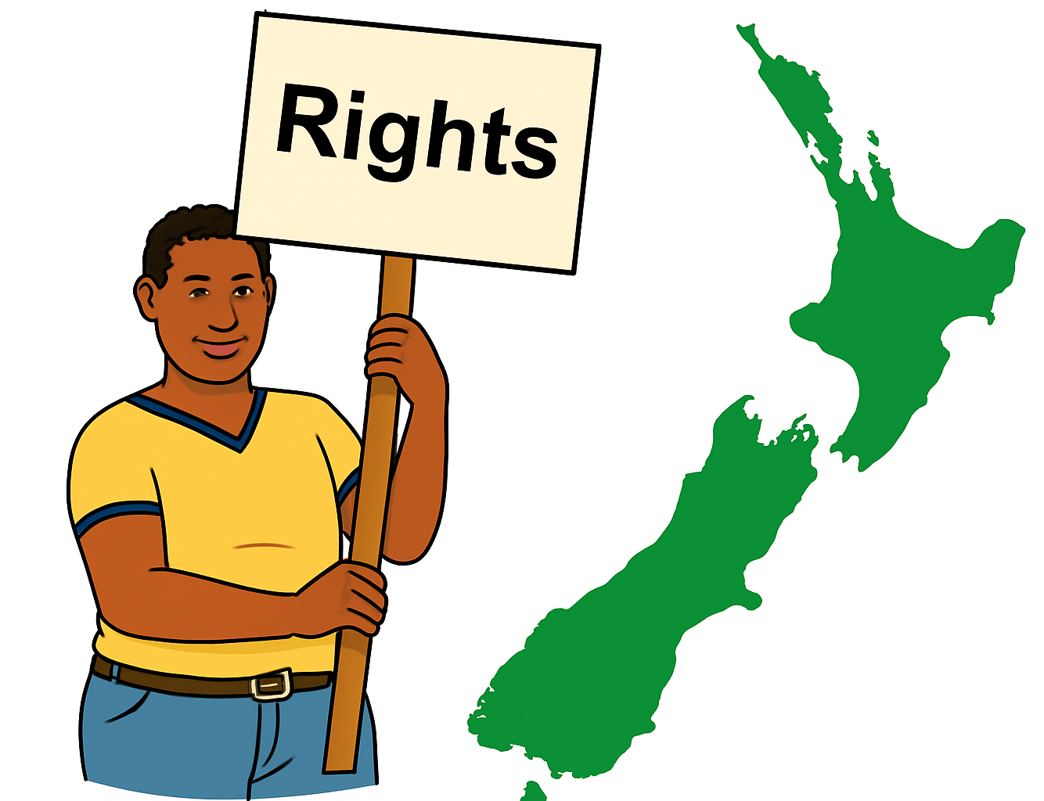
work the same number of hours each week
have the same work rights as full time employees.

being a casual employee means:
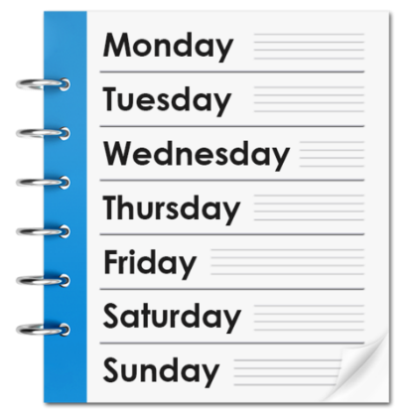
your work hours change depending on how much work there is
you can choose if you want to do the work.

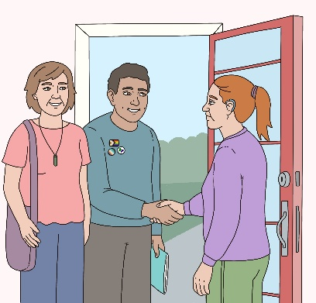
As a Kaiārahi / Peer Worker you will work with a Kaiāwhina / Assistant to visit disabled people in their homes.


You will talk with disabled people about:
safety

good support
what a good life means for them.

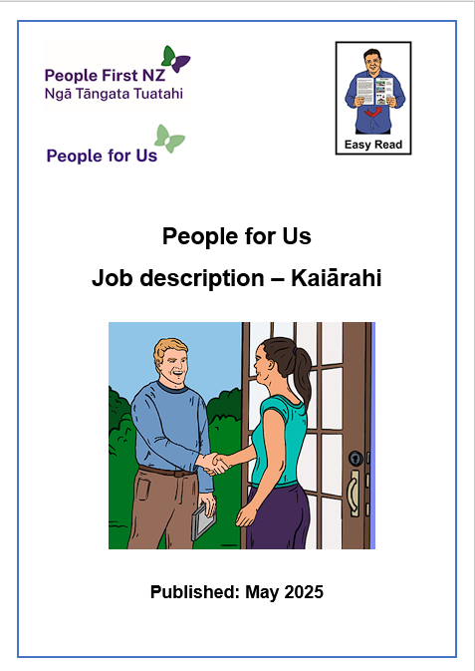

You can find out more about what a Kaiārahi does in the Easy Read document called:

Job description: People for Us
– Kaiārahi / Assistant.


You can find this Easy Read at:

https://www.peoplefirst.org.nz/join-us

Who can be a Kaiārahi?

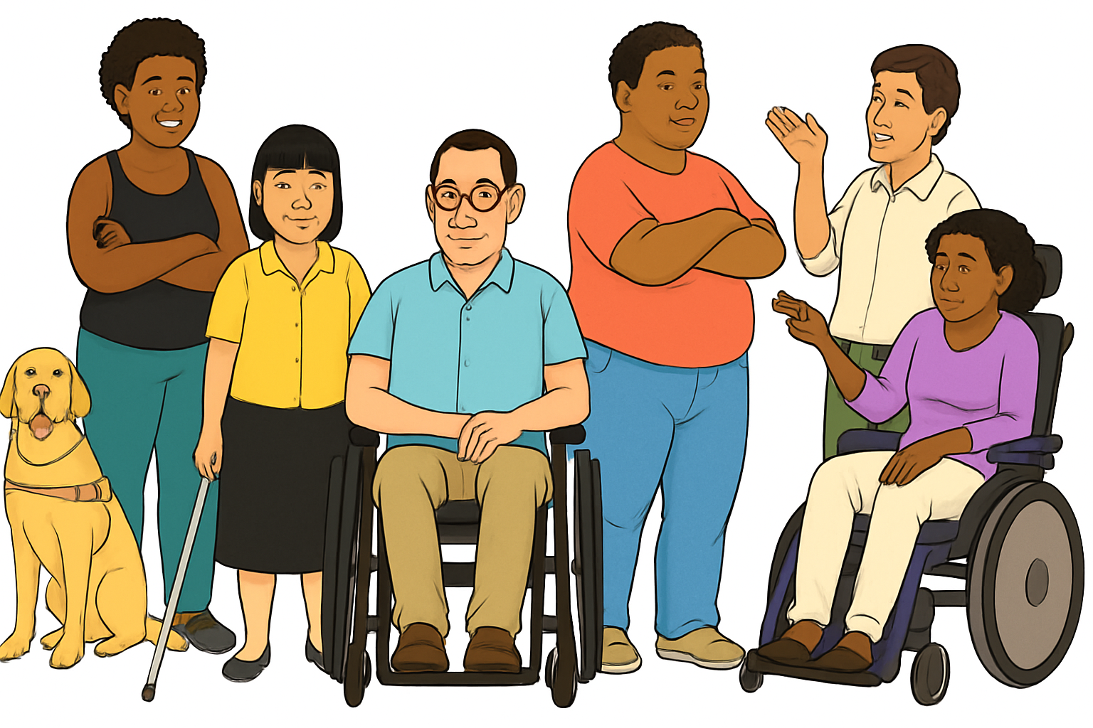
To become a Kaiārahi / Peer Worker you will need to:
be a disabled adult
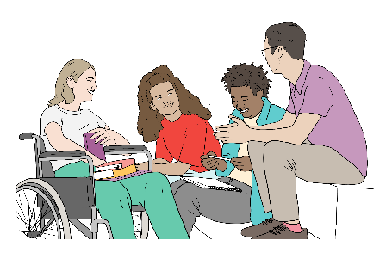
have a good understanding of the experiences of disabled people
get along with other people

be good at communicating / talking with others
want to make sure disabled people / tāngata whaikaha Māori:
- have good lives

- have good services / support
- are safe.

What you get as part of the job

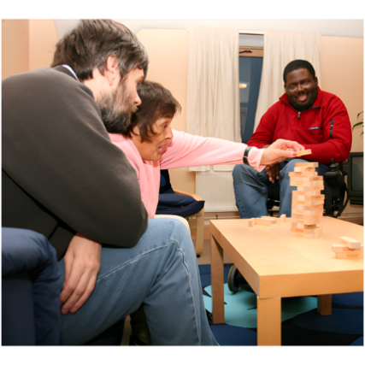
You will make a big difference to keeping disabled people in residential homes safe.

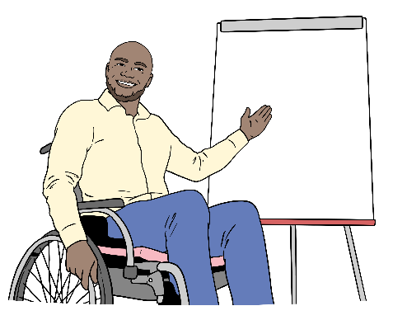
People for Us will make sure you get:
a lot of training
chances for professional development which means learning new things to do with your job.


You will be paid well for your work.

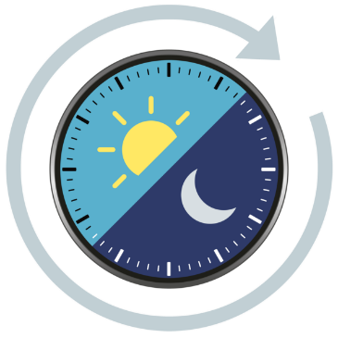
People for Us can work with you to make sure the hours you will be working meet your needs.

You will get supervision / support through talking with your manager about your work often.

You will have access to an Employee Assistance Programme.

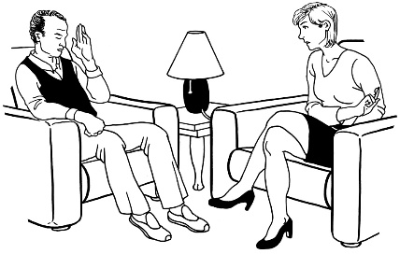
An Employee Assistance Programme is a free service for employees where you can talk to a counsellor.


You can talk to the counsellor about:
your work
your life.

How to apply for the job


You need to submit your application by:

4pm - 24 April 2026


You will need to apply online for the job through seek


If you have any questions, you can email us to
info@peopleforus.org.nz

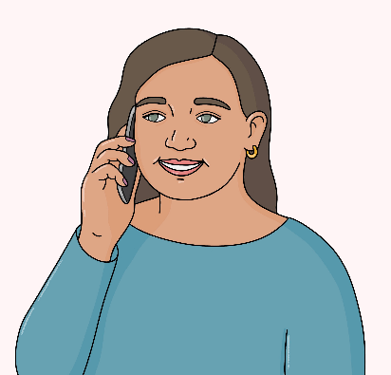
You could also contact us on phone for any information:

0800 241 241
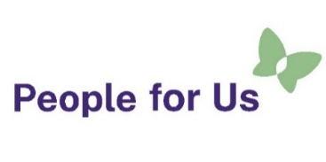
This information has been written by People for Us.

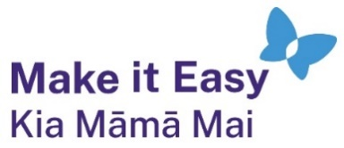
It has been translated into Easy Read by the Make it Easy Kia Māmā Mai service of People First New Zealand Ngā Tāngata Tuatahi.

All images used in this Easy Read document are subject to copyright rules and cannot be used without permission.


Make it Easy uses images from:

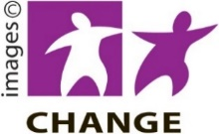
- Photosymbols

Change
Make it Easy uses images from:

- Photosymbols

- Change Images


- Huriana Kopeke-Te Aho

- SGC Image Works

- T Wood

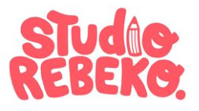
- Studio Rebeko

- Inga Kramer.

