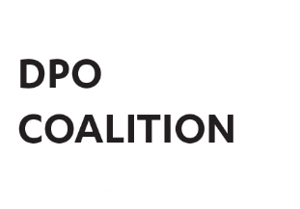
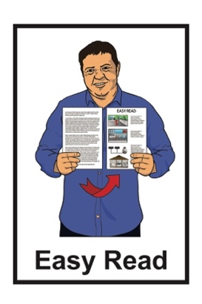

Disabled People’s Organisations Coalition: Key Messages November – December 2024
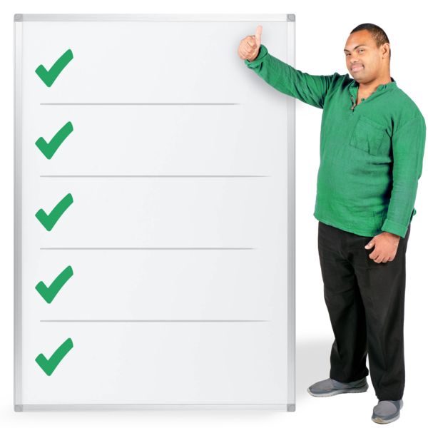

Published: March 2025

What is in this document

Page number:
The Disabled People’s
Organisations Coalition 4

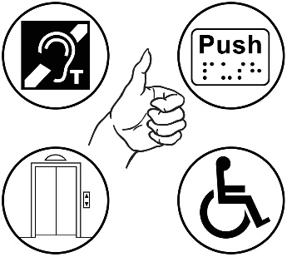
What this document is about 7

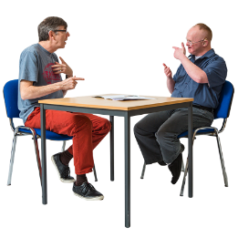
New Zealand Sign Language Board 9

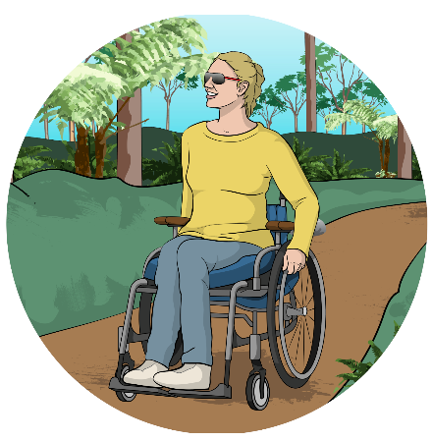
Disability Rights Commissioner 10

Sport Integrity Commission 12

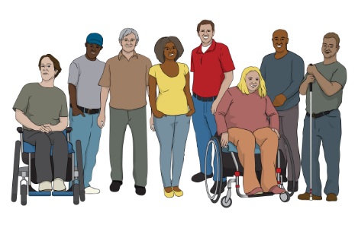
Health and Disability
Commissioner 14

Page number:

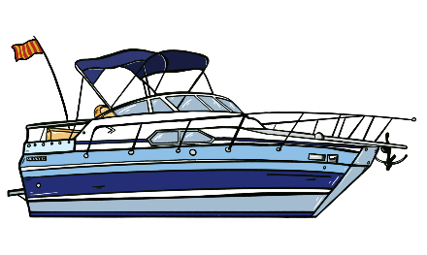
Maritime New Zealand 16

I.Lead 18


Payments NZ 19

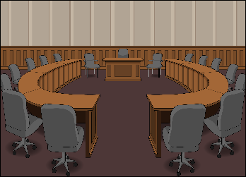
Local Government New Zealand 20

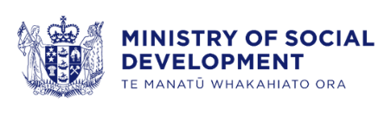
Disability Support Services
Taskforce – Ministry of Social Development 21

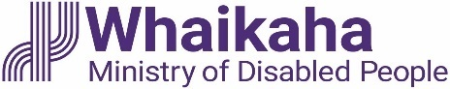
Whaikaha – Ministry of
Disabled People 24


Te Whatu Ora – Health NZ 26
Page number:

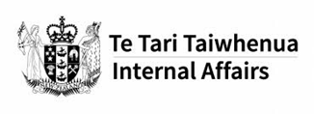
Department of Internal Affairs 28

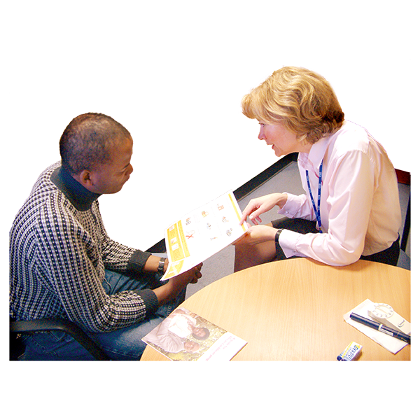
Health Quality and Safety
Commission 30

Voice of disabled people 31

The Disabled People’s
Organisations Coalition



The Disabled People’s Organisations Coalition is a group of people who come from different disability organisations.

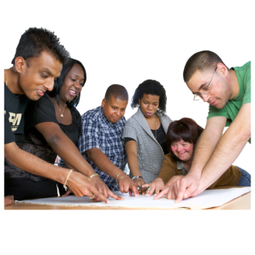
A coalition is a group of organisations that work towards shared goals.

The Disabled People’s Organisations Coalition is also called the DPO Coalition.

When you see the words we / us in this document it means the DPO Coalition.

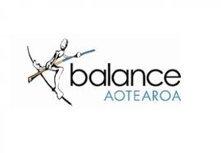
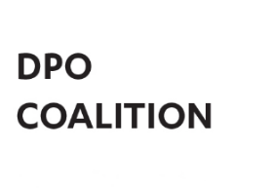
The DPO Coalition is made up of members from these 7 disability organisations:
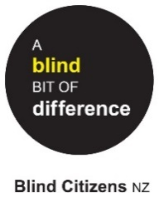
Balance Aotearoa
Blind Citizens New Zealand
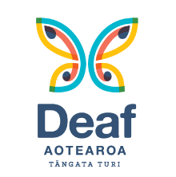
Deaf Aotearoa
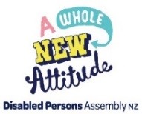
Disabled Persons Assembly NZ
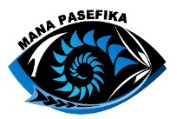
Mana Pasefika
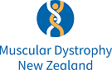
Muscular Dystrophy Association of New Zealand
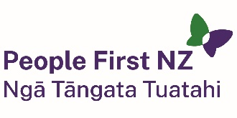
People First New Zealand – Ngā Tāngata Tuatahi.


The DPO Coalition meets about every 6 weeks to talk about important things.

The DPO Coalition speaks up about disabled people getting their human rights.

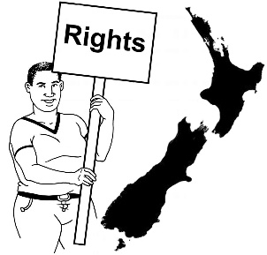
Human rights are things that the law says every person should:
have
be able to do.

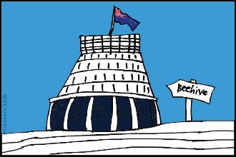
The DPO Coalition talks with the Government about things to do with disability.

What this document is about

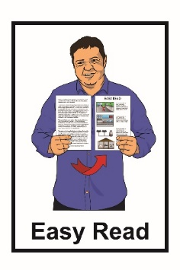
This is an Easy Read document about some of the key messages from the DPO Coalition meetings in:
November 2024
December 2024.


During these meetings the DPO Coalition met with lots of:
government agencies
other community organisations.

The meetings are to make sure the lives of disabled people in New Zealand are getting better.

2 important subjects that are talked about often are:
accessibility
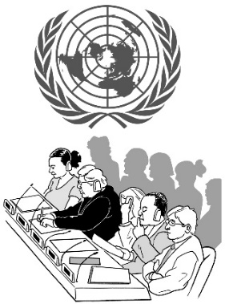
upholding the rights of disabled people under the United Nations Convention on the Rights of Persons with Disabilities.
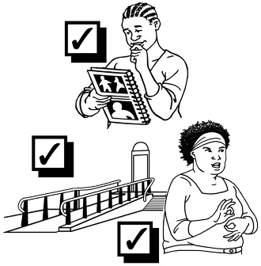

Accessibility means making things easy / safe for everyone to use.

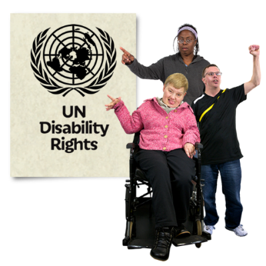
The United Nations Convention on the Rights of Persons with Disabilities is a law lots of countries have agreed to.

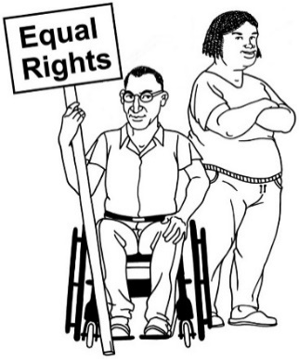
It says what governments must do to make sure disabled people get the same rights as everybody.

New Zealand Sign Language Board

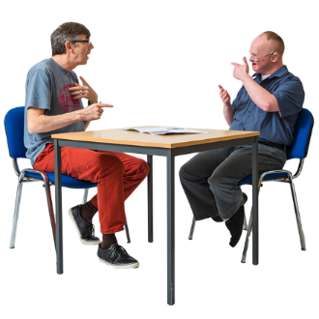
We talked to the New Zealand Sign Language Board about:
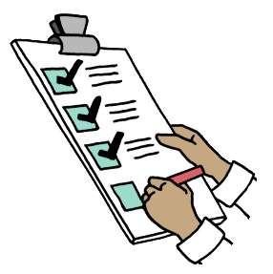
working together in the future
some of the things we both work on that we think are important.


A board is a group of people who make big decisions for a
company / organisation.


Future is a time that has not happened yet.

We look forward to meeting with the New Zealand Sign Language Board regularly in the future.

Disability Rights Commissioner


We met with:
Prudence Walker – Disability Rights Commissioner
Frances Anderson – Principal Advisor Human Rights Commission.

We talked about the Conference of the States Parties meeting that will happen in:
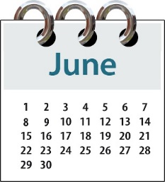
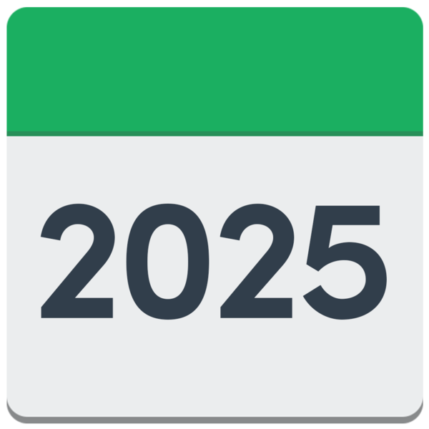
New York
June 2025.

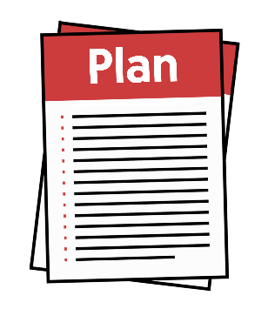
Prudence gave us an update on some plans from the Human Rights Commission.
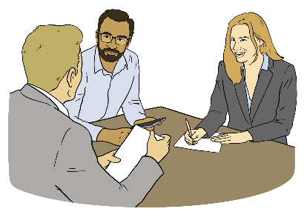
Prudence also talked to us about the disability issues that were talked about at the Commonwealth Heads of Government Meeting.


More information about the Commonwealth Heads of Government Meeting can be found on their website here:

thecommonwealth.org/chogm
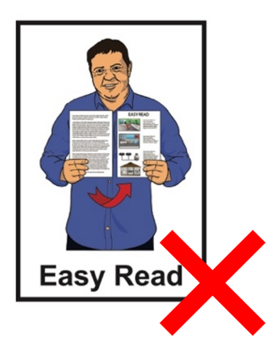

This information is not in Easy Read.

Sport Integrity Commission

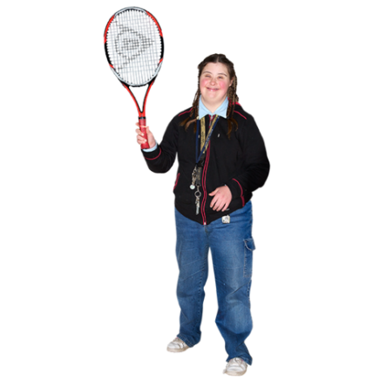
We met with 3 people from the Sport Integrity Commission.

The Sport Integrity Commission makes sure that people are able to take part in sports / recreation in
New Zealand in a way that is:
safe
fair.


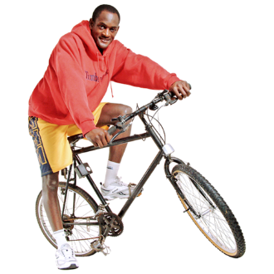
Recreation means physical activities you do for fun like:
swimming
riding a bike.

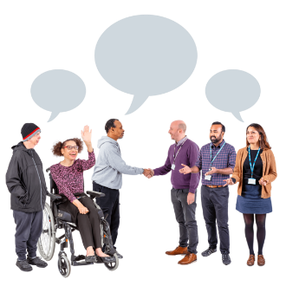
We plan to work with the Sport Integrity Commission more in the future.

Health and Disability Commissioner


We met with:
Rose Wall – Deputy Commissioner Disability
Esther Woodbury – Principal Advisory Disability.

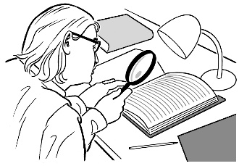
We talked about the process for the review of the:
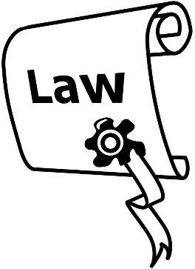
Health and Disability Commissioner Act 1994
Code of Rights 1996.

The review reports will be available on the Health and Disability Commissioner website soon.

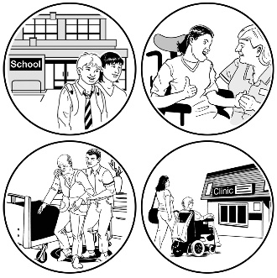
We brought up our worries again about how disability support services are delivered.

Maritime New Zealand

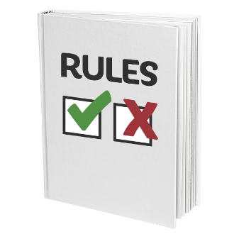
We met with Maritime New Zealand to talk about the work they are doing on their rules for domestic commercial vessels.

Domestic commercial vessels are ships that are used to transport commercial items around
New Zealand.

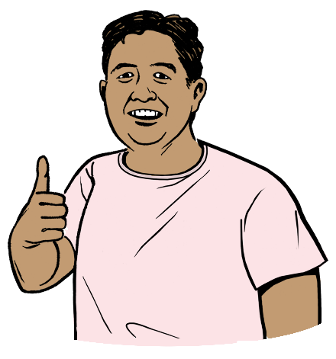
The changes to the rules are about making it better for disabled people using domestic commercial vessels.

We were happy with the work done by Maritime New Zealand.


We look forward to continuing working with them on this project.

I.Lead

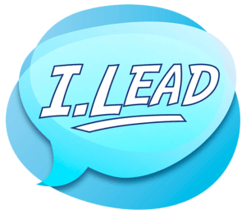
We met with 3 people from the I.Lead Committee.

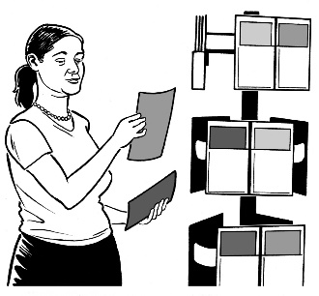
I.Lead is a disabled youth movement led:
by youth
for youth

They told us about their disabilty report cards.

These report cards are available on the I.Lead website here:

www.ilead.org.nz

Payments NZ


Payments NZ looks after standards to do with payments in New Zealand.

Standards are like rules.

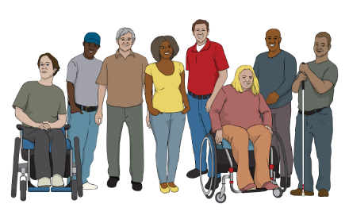
In our meeting we talked about ways Payments NZ can work with the disability community in the future.

We are looking forward to the workshop with Payments NZ in early 2025 where we will talk about:
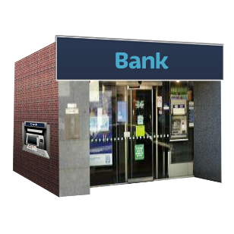
things that make it hard for people to make payments
things that make banking services hard for people to use.

Local Government New Zealand

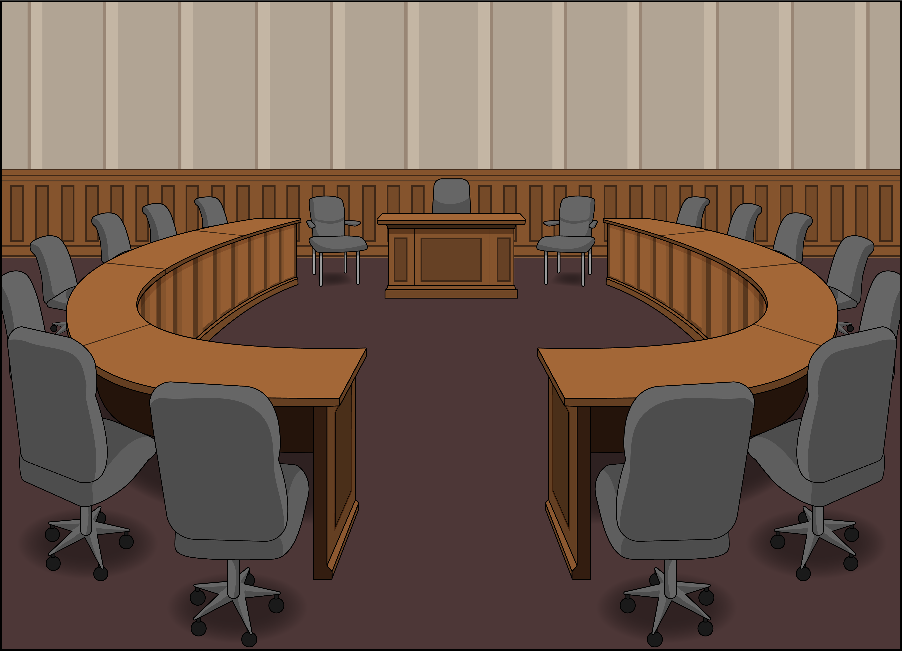
We met with:
the Nelson City Mayor Nick Smith
people from Local Government New Zealand.

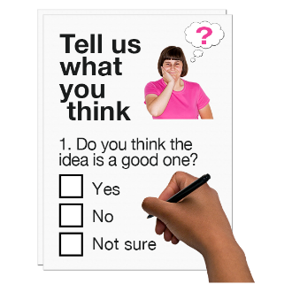
Local Government New Zealand were looking for feedback on how to make the election processes easier for local government.

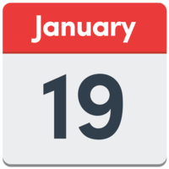
People were able to send in their opinions until 19 January 2025.

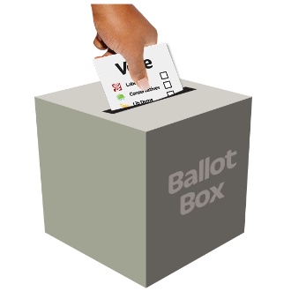
We focused on things that make it hard for disabled people to take part in elections like people knowing how important voting online is.

Disability Support Services Taskforce – Ministry of Social Development

We met with:
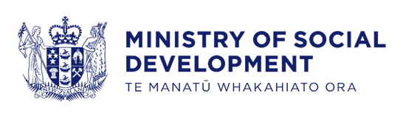
Chris Bunny – Deputy Chief Executive Disability Support Services
Kat Norman – Communications Lead for Ministry of Social Development.
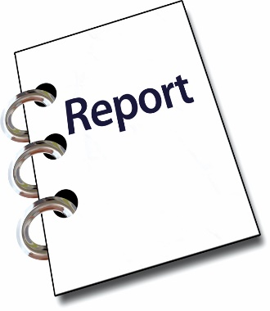

We talked about the Disability Support Services review.

More information about the Disability Support Services review can be found on the Disability Support website here:

shorturl.at/3W5jc

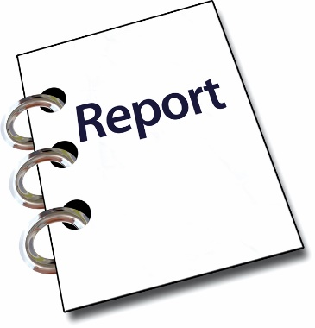
We talked about how we could assist with the recommendations of number 5 and number 6 of the Disability Support Services review.

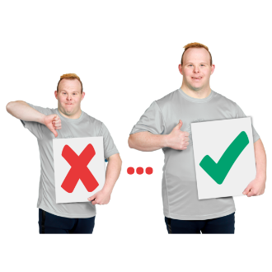
A recommendation is a suggestion on how to make something better.

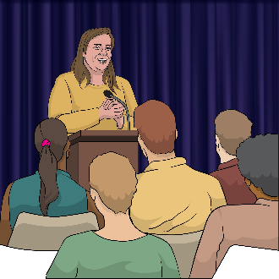
We planned a workshop with the Disability Support Services Taskforce in February 2025 to talk about this more.

Whaikaha – Ministry of Disabled People

We met with Whaikaha in:
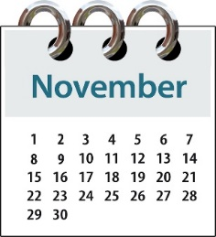
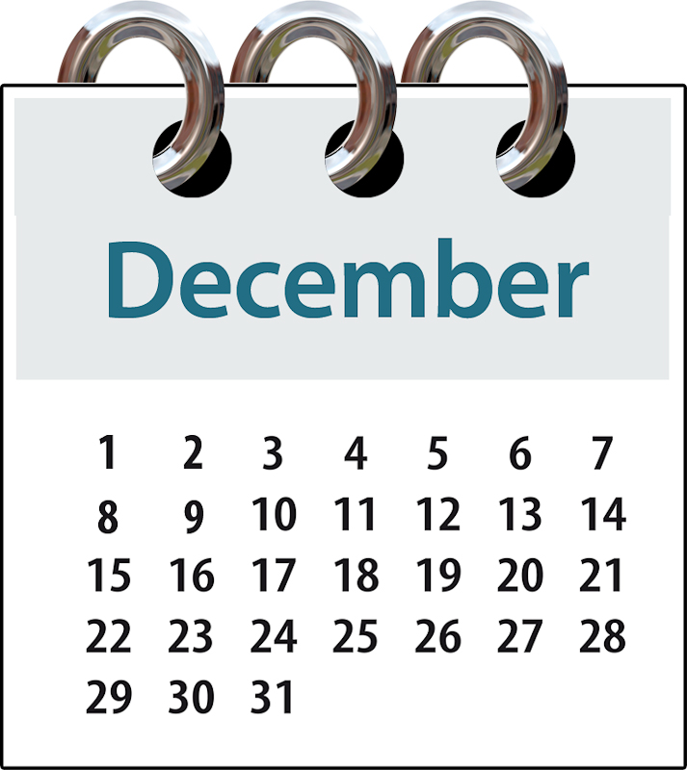
November 2024
December 2024.

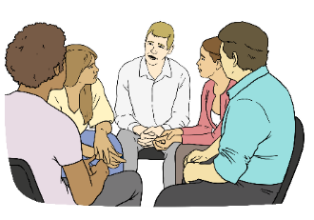
We talked about a lot of things.


1 of the main things we talked about was a new Cabinet Paper that will be available in early 2025.

A Cabinet paper is a document:
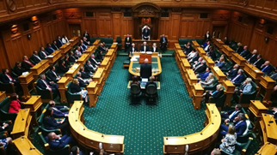
from a minister
asking Cabinet to agree to something.

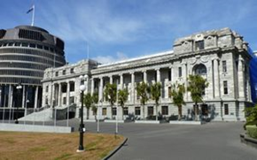
A minister is an important person who works in government.

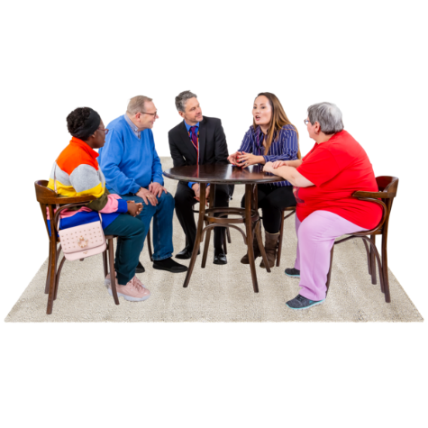
Cabinet is a group of ministers that meet to make decisions.

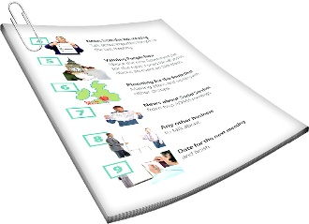
We are looking forward to learning about:
what happens after the Cabinet Paper is made available
when the Cabinet Paper will be available.

Te Whatu Ora – Health NZ

We met with Rachel Noble – Head of Disability in the Office of the Chief Executive.

We also met with 3 people from
Te Whatu Ora:
Karen Bartholomew
Leo Goldie-Anderson
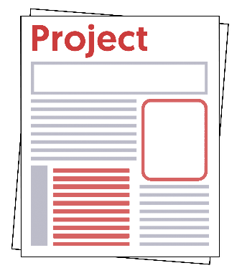
Leisa Epplett.

We talked about the Patient Profile National Health Index project.


This project looks at making disability information easier to access.

We are excited about how well this project is going.

We look forward to seeing how this project will assist the disabled community.

Department of Internal Affairs

We met with:
Alanna Irving
Aya Morris.

We talked about the Lottery Grant.


The Lottery Grant gives money to communities.

The money comes from the money made from lotteries like Lotto.

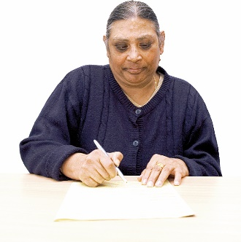
Lots of people are applying for the Lottery Grant.

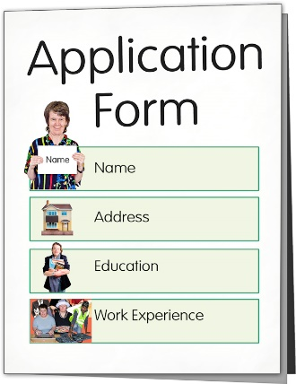
The Lottery Grant needs more money to be able to accept all the applications.


The Lottery Grants Board is going to talk to the Government on ways they can change how much money they are getting.

Health Quality and Safety Commission


We met with Carl Shuker to talk about their their new research idea called a Window on Disability.

We look forward to working with the Commission in the future.

Voice of disabled people
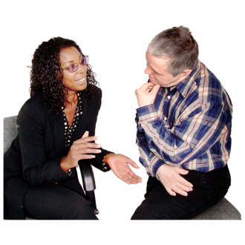
The Government meets with the DPO Coalition so disabled people are able to have a say in the decisions being made.
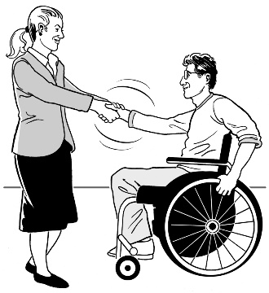

The DPO Coalition is always looking for new organisations to join us.

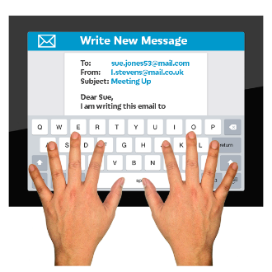
You can contact us by emailing us:

us-dpo@groups.io

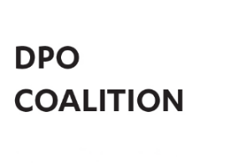
This information has been written by the Disabled People’s Organisations Coalition.

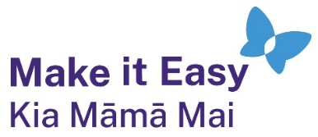
It has been translated into Easy Read by the Make it Easy Kia Māmā Mai service of People First New Zealand Ngā Tāngata Tuatahi.
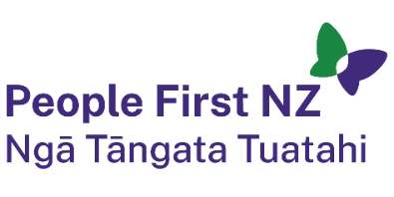
The ideas in this document are not the ideas of People First New Zealand Ngā Tāngata Tuatahi.

All images used in this Easy Read document are subject to copyright rules and cannot be used without permission.


Make it Easy uses images from:

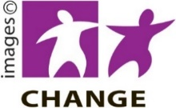
- Photosymbols

- Change Images


- Huriana Kopeke-Te Aho
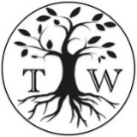
- SGC Image Works

- T Wood


- Studio Rebeko

- Inga Kramer.

