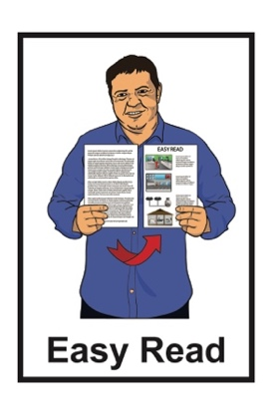

Easy Read Individual Employment Agreement
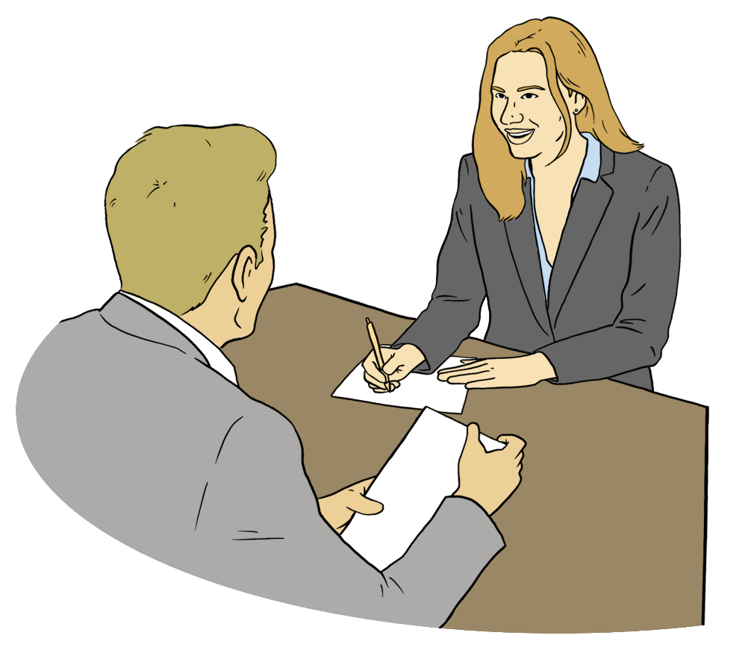

Published: August 2025

What is this Easy Read about?

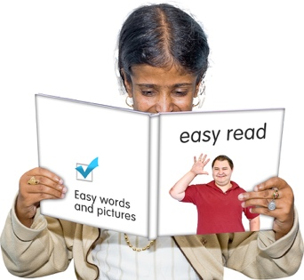
This Easy Read is an Individual Employment Agreement.


An Individual Employment Agreement is a legal contract between:
the employer who is the person hiring someone to do the work
the employee who is the person doing the work.

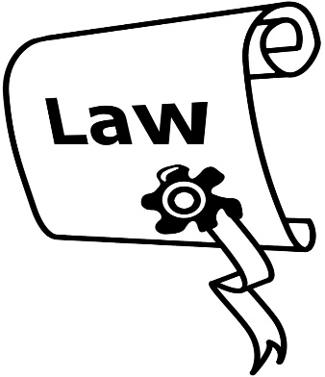
Here a legal contract is a document about work that explains:
what the law says
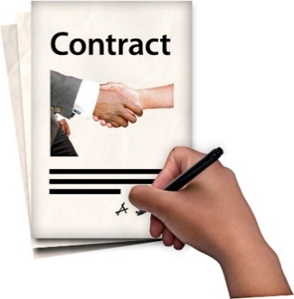
what agreements have been made between the:
- employer
- employee.


In this document the employer will be called the manager.


In this document the employee will be called the worker.

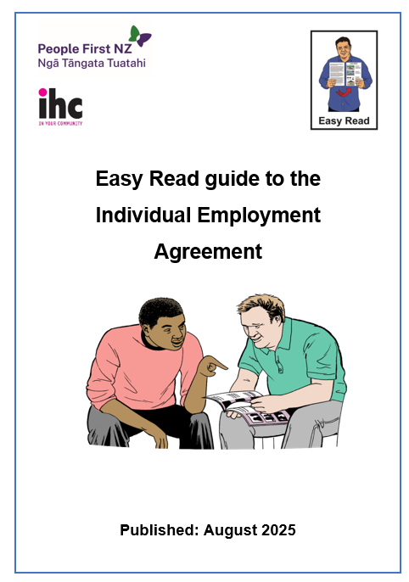
There is more information about the Individual Employment Agreement in the Easy Read guide to the Individual Employment Agreement at:

www.peoplefirst.org.nz/easy-read-library/resource/employment-guide


There are boxes in this document for things to be written by the:
manager
worker.


The boxes where things will be written look like this:

You can write things in the box.

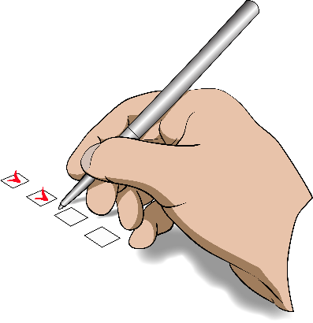
There are boxes in this document where the manager can tick the right answer.

The tick boxes look like this:

Tick box

Type of job

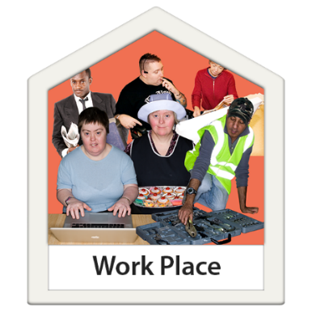
The name of the workplace is:


This employment agreement is for:

permanent employment


fixed term employment

casual employment.


The manager will fill in the correct details about the type of employment on 1 of the next 3 pages.


Permanent employment

This is a permanent employment agreement.


The job will start on this date:

The job has no end date.

Fixed term employment

This is a fixed term employment agreement.


The job will start on this date:


The job will end on this date:

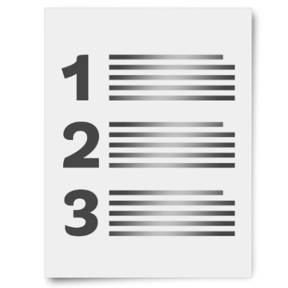
The reason the job will end on this date is:

Casual employment

This is a casual employment agreement.


This casual employment agreement means:
the worker will be asked to work when they are needed

the worker can choose if they want to do the work
there is no promise the job will last for a long time.


The casual employment agreement starts from this date:

This agreement has no end date.

Trial period

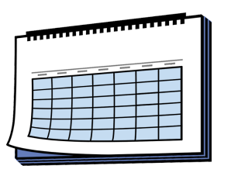
A job can have a trial period:
which goes from the start of the job
for up to 90 days.

Does this job have a trial period?

Yes

No

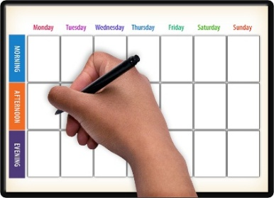
The number of days in the trial period is:

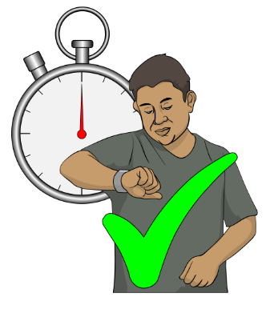
The manager can end this agreement during the trial period.


If the agreement ends during the trial period the manager will tell the worker this many days before the job finishes:

About the job


The job is called:

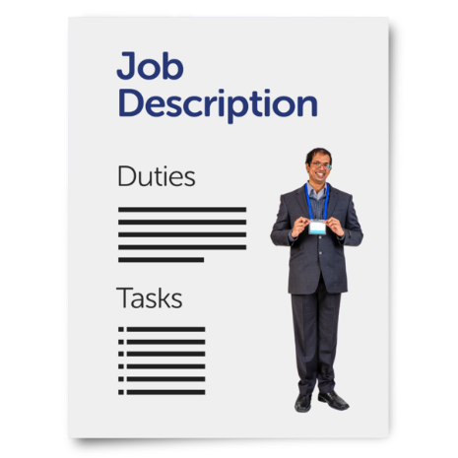
The things the worker will do are:

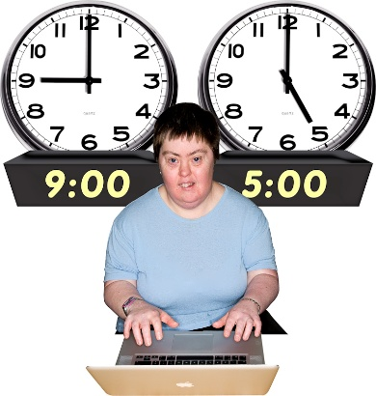
The number of hours each day the worker will work are:

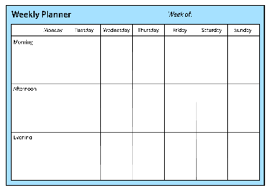
The number of hours each week the worker will work are:
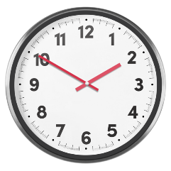

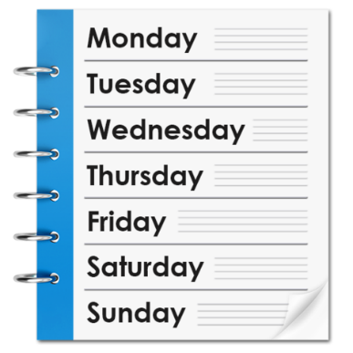
The days of the week the worker will work are:



The start time each day is:

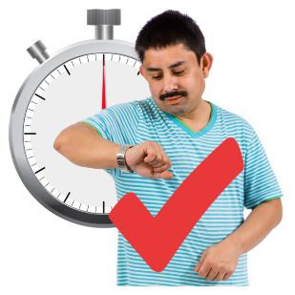

The finish time each day is:


The place where the worker will do the job is:


Getting paid

The manager will fill in the correct details about the type of pay on 1 of the next 2 pages.


Wage

The worker will be paid a wage.

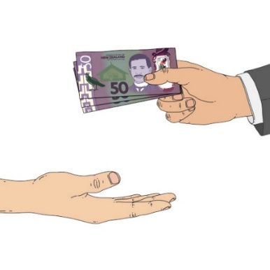
A wage means how much a worker gets paid each hour.

In Aotearoa New Zealand there is a minimum wage a worker must be paid each hour by law.

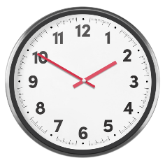
The worker will be paid this wage each hour:
$$

Salary

The worker will be paid a salary.

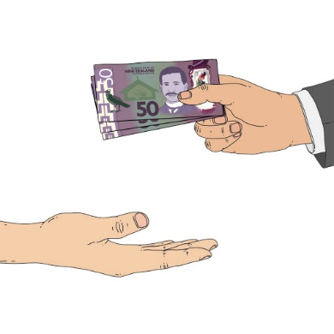
A salary means how much a worker gets paid each year.


The manager and worker will agree on a salary using information like:
the skills the worker has

the education the worker has like school
what other people doing the same type of job get paid.

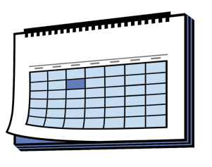
The worker will be paid this salary each year:
$$$$

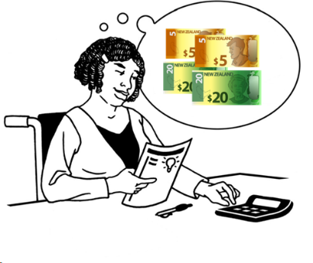
Tax

The workplace will take out the tax before the worker is paid.


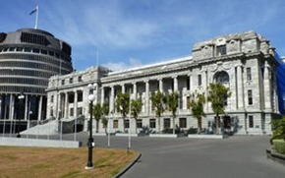
Tax is a percentage of money taken out of pay to give to the Government.

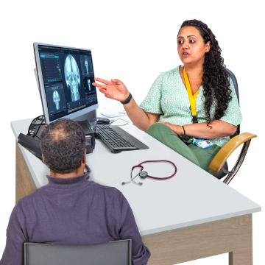
The Government uses tax money to pay for things like:
the health system
disability support systems
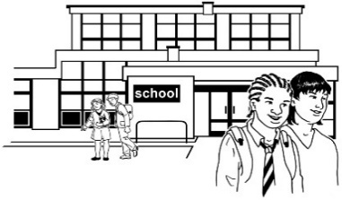
education / schools.


Here a percentage is a number of cents out of every 1 dollar.

For example 10 percent means
10 cents out of every 1 dollar.

KiwiSaver

KiwiSaver is a system in Aotearoa New Zealand where people save money for their retirement.


People can choose to opt out
of / stop using KiwiSaver.

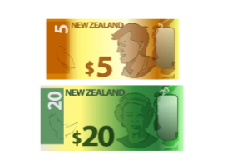

The amount put into the KiwiSaver account of the worker is a percentage of what the worker gets paid.
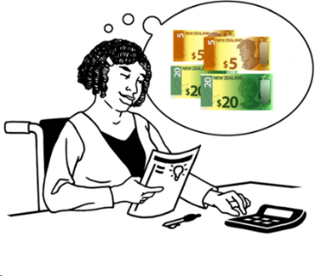
The workplace will pay into the KiwiSaver account of the worker:
the amount the worker has decided they want to pay
the amount the workplace must add to it.

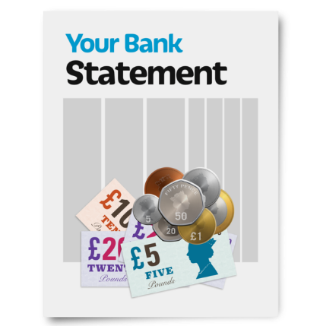


The workplace will put this amount from the pay into the KiwiSaver account of the worker:

Breaks


This workplace has set break times:

Yes

No

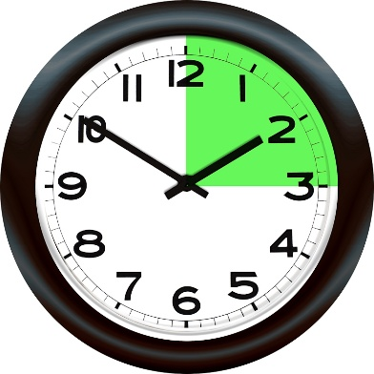
The morning break is at:

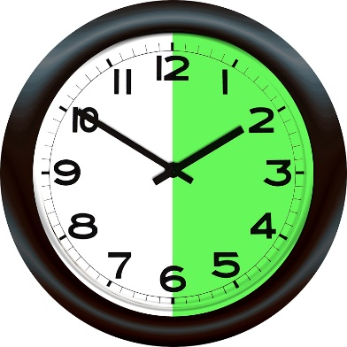
The lunch break is at:

The afternoon break is at:

Giving notice


Giving notice means ending the job.

The job can be ended by the:
manager
worker.

The manager giving notice
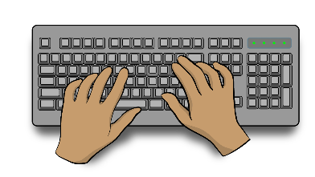
If the manager wants to end the job they must write a letter to the worker to say why the job is ending.


The manager must give notice to the worker this number of days before the job ends:


The worker giving notice

If the worker wants to leave the job they must tell the manager in writing.


The worker must give notice to the manager this number of days before they leave:

Changes at work


The manager must tell the worker about changes before they happen:
at the workplace
to the job.

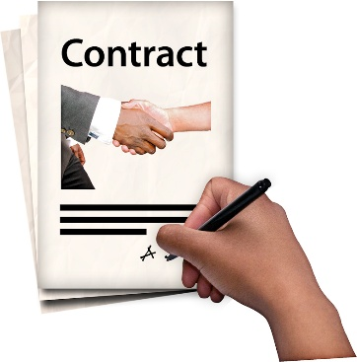
Changes to the employment agreement

If any changes are made to this employment agreement they must be:
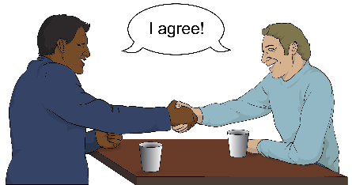
agreed to by the:

- manager
- worker
written down.


Redundancy

Redundancy means the workplace does not need the job any more.


Redundancy is not because of something the worker does wrong.


If a worker is being made redundant the manager must:
talk to them about it

tell them when the job ends
write the information down.


The manager must tell the worker of a redundancy this number of days before the job ends:

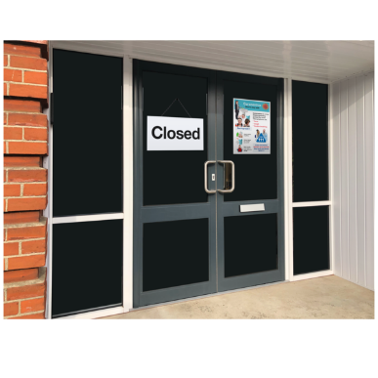
Changes to who runs the business

There are rules about the job if:

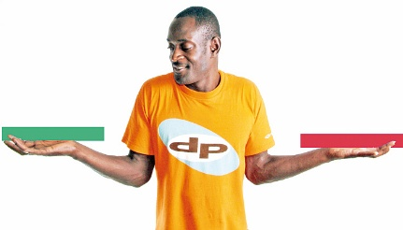
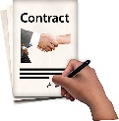
the business is sold
someone else takes over the contract the worker is working on.

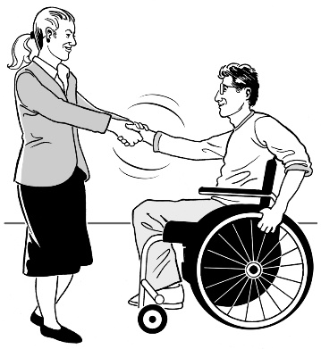
If the business is sold the manager will try to keep the worker in the job using this same agreement.


If the new owners do not have a job for the worker then the worker is made redundant.


If a worker is made redundant these places may be able to advise them:

People First New Zealand

your union if you are a member
Employment New Zealand
Community Law
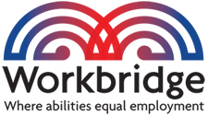
Workbridge.

Problems at work


If the worker has a problem at work they will tell the manager as soon as they can.


The worker can bring someone they trust to support them at a meeting like:
someone from their union
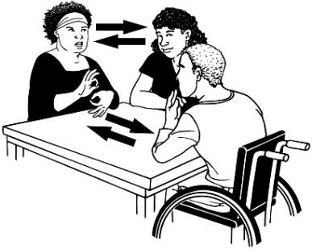
a support worker
a family member
a friend.

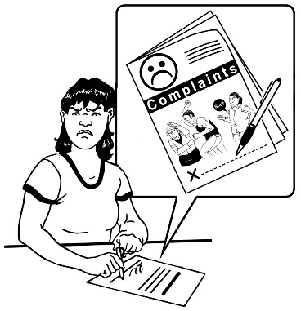
Personal grievance

A personal grievance is the worker making a formal complaint about a problem at the job.



A complaint is telling someone about a problem.

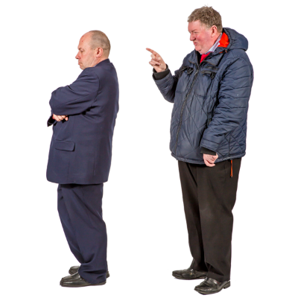
A personal grievance can be about the worker:
losing their job for no good reason
being treated unfairly
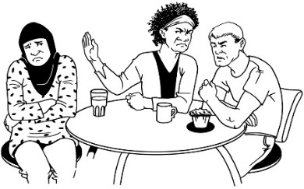
being told they must not join a union.


The worker must tell the manager about the personal grievance within 90 days of the problem happening.

If the personal grievance cannot be fixed the worker can get support from:
Employment New Zealand mediation
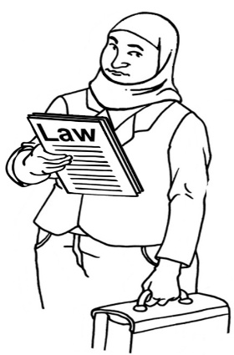
a union
Community Law
a lawyer.

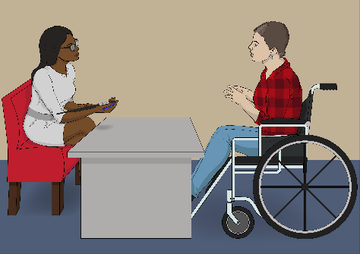
Problems with how the worker is doing the job

If there is a problem with how the worker is doing their job the manager must:
tell them
talk about fixing the problem.


The worker must be given the chance to:
say what is going on
fix the problem.


Not turning up to work

If the worker cannot go to work they must tell the manager.


If the worker does not go to work for 3 days without saying anything the manager can take steps to give notice to / fire the worker.

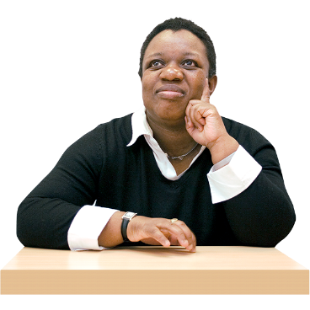

The manager must try to find out why the worker is not coming to work before they give notice to / fire the worker.


Being suspended
90


Being suspended is when the worker is told not to come to work because they have:
behaved badly
done something seriously wrong.


The manager must write down:
why the worker has been suspended
how long it will last.
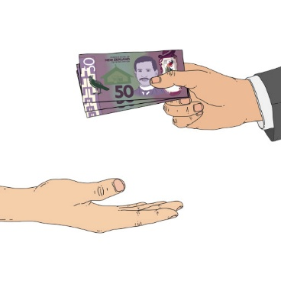

If the worker is suspended they will still get paid.

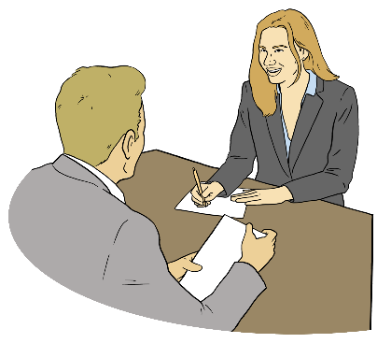
The manager will have a meeting with the worker about what happened.

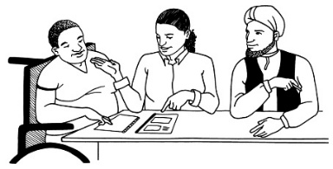
The worker can have someone they trust to support them at the meeting like someone from their union.

The manager might:

work with the worker to sort out the problem
give the worker a warning
fire the worker.


Here a warning is an official message from the workplace to the worker about what the worker has done wrong.

Leave

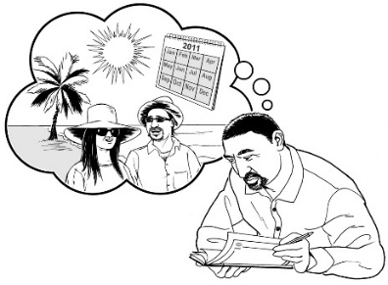
This section talks about:
holiday leave
public holidays
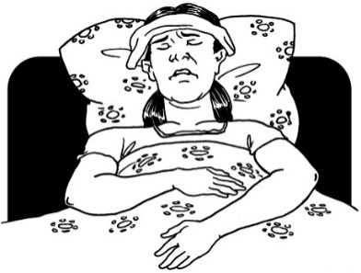
sick leave
bereavement leave / time off when someone dies.

Holiday leave
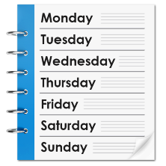
The worker gets 4 weeks of holiday leave every year.

The worker must do the job for 12 months before they get the 4 weeks of holiday leave.
The worker must ask for their holiday leave this amount of time before they take it:


The manager might agree to give the worker holiday leave:
before the worker has done the job for 12 months
by talking about it with the worker.


Public holidays

There are 12 public holidays each year:
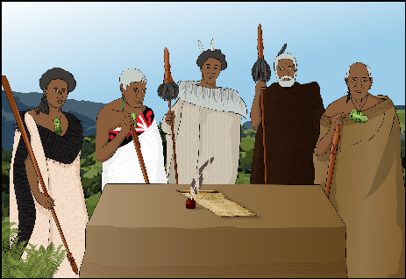
New Years Day
Day after New Years Day
Waitangi Day

Good Friday
Easter Monday
ANZAC Day

Kings Birthday
Matariki
Labour Day

Christmas Day
Boxing Day
Anniversary Day of the region the worker lives in.


If the public holiday is a day the worker usually works they will get:
the day off
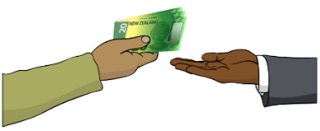
paid their usual amount.

If the worker has to work on a public holiday they will get:
$$
an extra day of paid leave
paid this amount per hour:


The worker will get paid extra money if they work on a public holiday.

This extra pay is called time and a half.


Sick leave

The worker gets paid sick leave:

for 10 days each year
after working for 6 months.


The worker can take sick leave if:
they are sick
they are injured

they need time off for mental health
they are looking after a sick partner
someone they care for is sick.

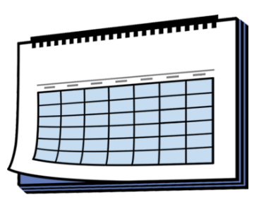
If the worker does not use all their sick leave it will be added to the sick leave in the next year.


If the worker needs more sick leave they can ask the manager.

They may be able to:


use some holiday leave
take some extra leave which they do not get paid for.

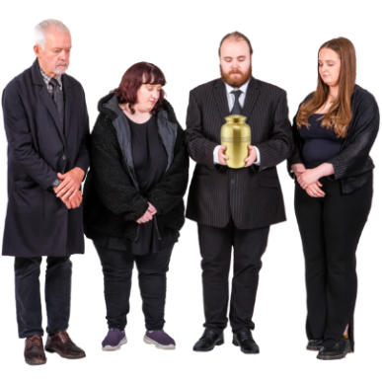
Bereavement leave

Bereavement leave is taking time off when someone close to you dies.

The worker will get 3 days of paid bereavement leave after working for 6 months.

The worker will get 3 days of paid bereavement leave when 1 of these people close to them dies:
parent
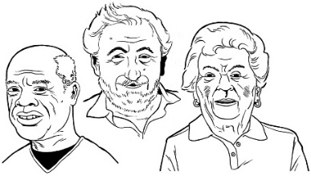
grandparent
sibiling which is a brother / sister
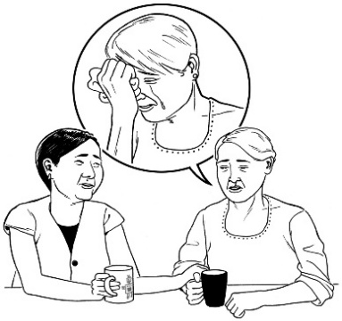
child
grandchild
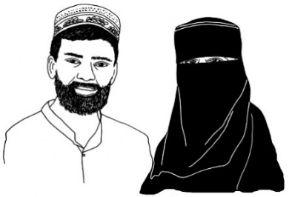
partner or someone they are married to
the parent of their partner.


The worker can ask the manager for 1 day of paid leave if a close friend dies.

Health and safety

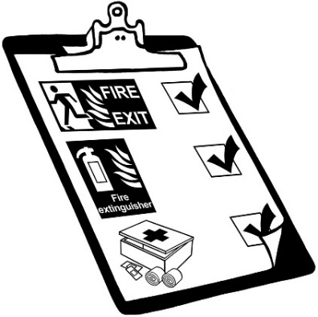
There are laws about work:
health
safety.


The manager will give the worker the health and safety information for the workplace.


If the worker gets hurt at work they must:
tell the manager
fill out an Accident Compensation Corporation / ACC form.

Workplace rules

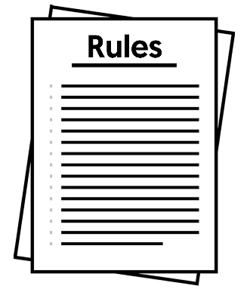
The workplace might have policies.

Policies are like rules that say how things should be done at the workplace.


Has the manager given the worker any policies for the workplace?

Yes

No


The manager will let the worker know if the workplace rules change.

Performance review


A performance review is the manager meeting with the worker to talk about how well the job is going.


This will happen at least 1 time every year.

The worker can bring someone they trust to support them at the meeting like:
someone from their union
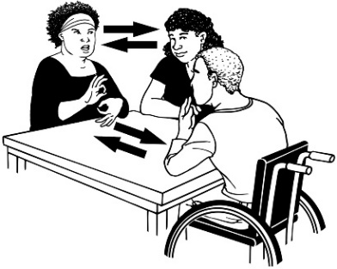
a support worker
a family member
a friend.

The things talked about in a performance review will be:
what is going well
what is not going well
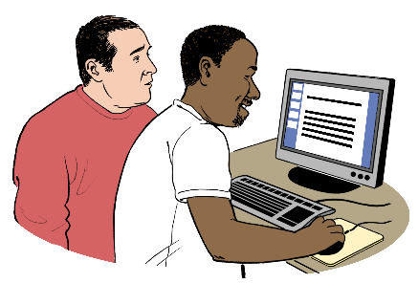
support for the worker to do their job better
anything else to do with the job.

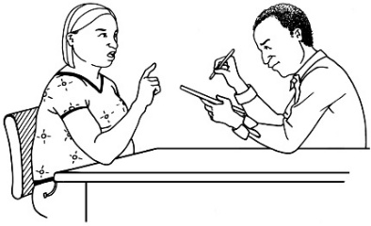
What is talked about at the performance review will be written down.


The worker will be given a copy of what is written down in the performance review.

The agreement


The worker

I agree that:
I was given enough time to read through this employment agreement
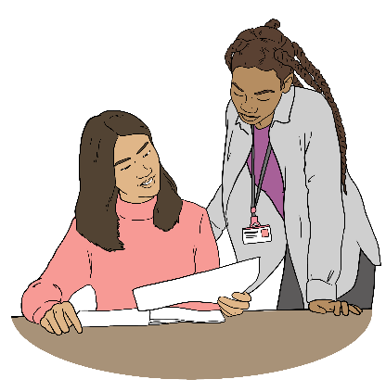
I know I can get someone I trust to support me to understand this employment agreement
I have been given a copy of this employment agreement

I understand the information in this employment agreement
I agree to this employment agreement.


My name is:

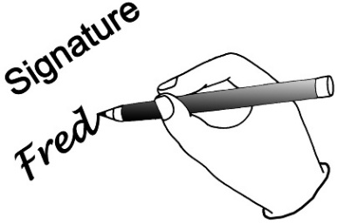
My signature is:


The date I signed this agreement is:

The manager
My name is:

My signature is:


The date I signed this agreement is:


This information has been written by:


- the Make it Easy service of People First New Zealand Ngā Tāngata Tuatahi

- IHC - Nicolina Newcombe.


All images used in this Easy Read document are subject to copyright rules and cannot be used without permission.

Make it Easy uses images from:

- Photosymbols

- Change Images

- Huriana Kopeke-Te Aho


- SGC Image Works

- T Wood
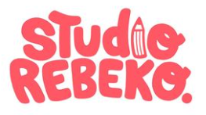
- Studio Rebeko

