

Local Group Assistant
Manawatū
Part-time role – 8 hours a month
Are you interested in self-advocacy for people with a learning (intellectual) disability?
People First Manawatū is looking for an assistant to work alongside people with learning disability to:
- hold monthly meetings in Palmerston North
- perform the functions of a committee
- encourage learning about self-advocacy
- assist members to represent their peers in community forums
- promote the local group within the community.
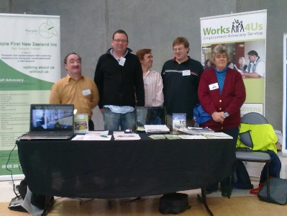
With your assistance, members will be able to:
- gain self-determination
- advocate for themselves
- develop leadership skills
- get involved in their community
- be a contributing member of New Zealand society.
For more information and to apply
Contact Elizabeth Bennett, Central Region Coordinator: elizabethbennett@peoplefirst.org.nz
The job description is online at:
http://www.peoplefirst.org.nz under Join Us
Applications close: Monday 15th May 2023

