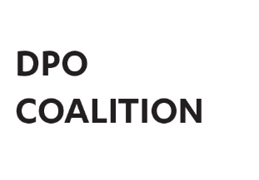
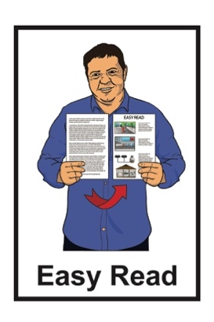

Disabled People’s

Organisations Coalition:

Key Messages February 2025
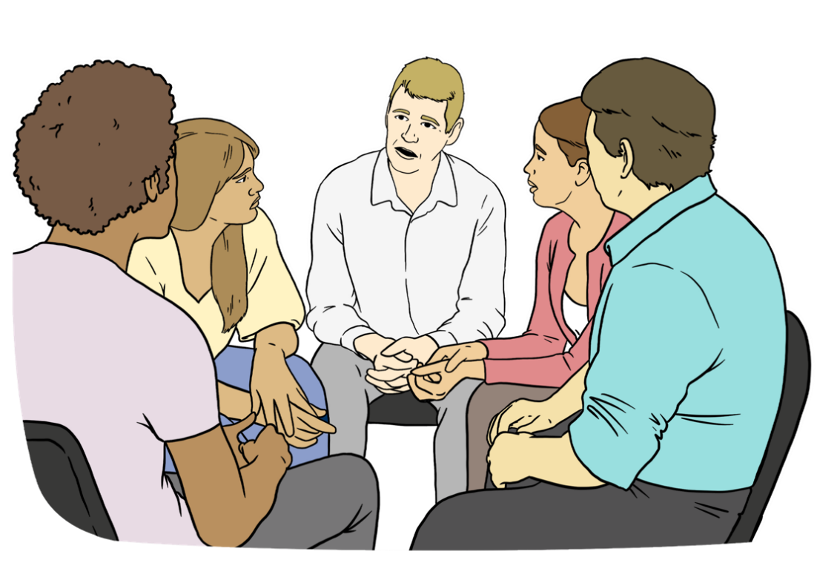

Published: April 2025

What is in this document

Page number:

The Disabled People’s
Organisations Coalition 3

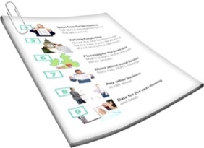
What this document is about 6

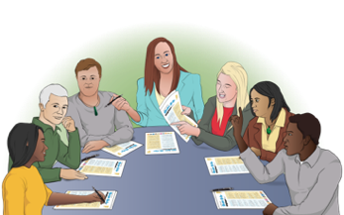
Disability Support Services Taskforce –Ministry of Social Development 8

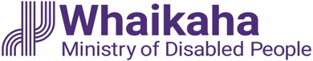
Whaikaha – Ministry of
Disabled People 13
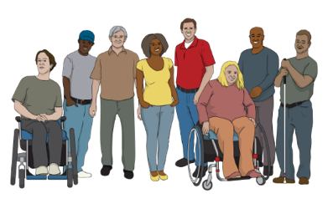

Disability Rights Commissioner 17

Page number:

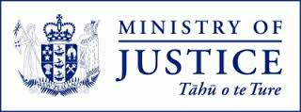
Ministry of Justice 19
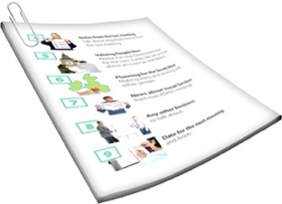

Donald Beasley Institute 21


Law Commission 22

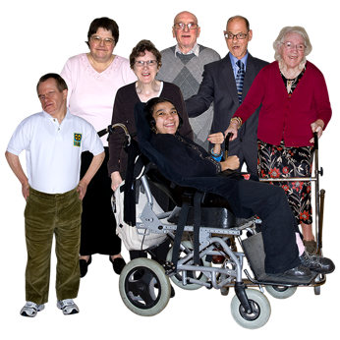
DPO Coalition Representatives
on National Enabling
Good Lives / NEGL 24

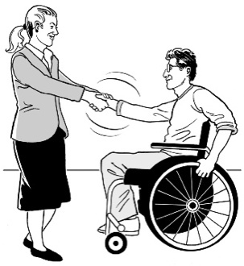
Independent Monitoring
Mechanism / IMM 26

Voice of disabled people 28

The Disabled People’s
Organisations Coalition

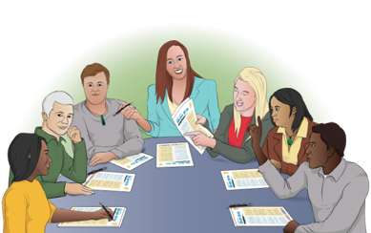
The Disabled People’s Organisations Coalition is a group of people who come from different disability organisations.


A coalition is a group of organisations that work towards shared goals.

The Disabled People’s Organisations Coalition is also called the
DPO Coalition.

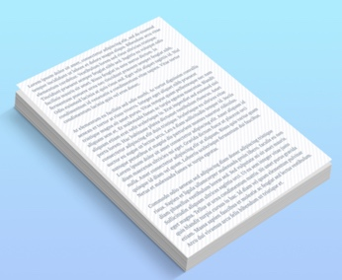
When you see the words we / us in this document it means the
DPO Coalition.

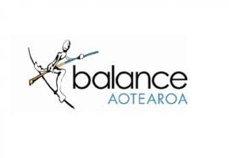
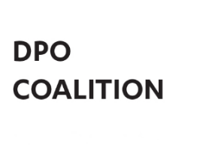
The DPO Coalition is made up of members from these 7 disability organisations:
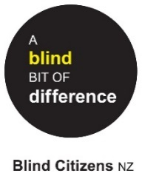
Balance Aotearoa
Blind Citizens New Zealand
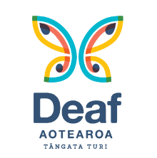
Deaf Aotearoa
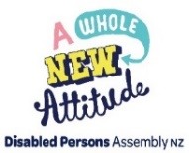
Disabled Persons Assembly NZ
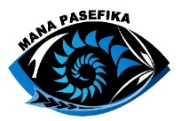
Mana Pasefika
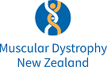
Muscular Dystrophy Association of New Zealand
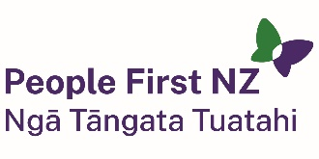
People First New Zealand – Ngā Tāngata Tuatahi.


We meet about every 6 weeks to talk about important things.

We speak up about disabled people getting their human rights.

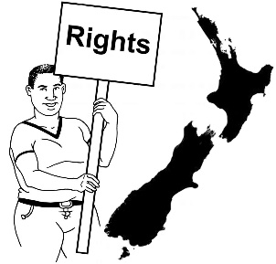
Human rights are things that the law says every person should:
have
be able to do.

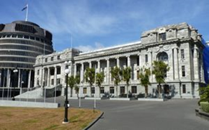
We also talk with the Government about things to do with disability.

What this document is about
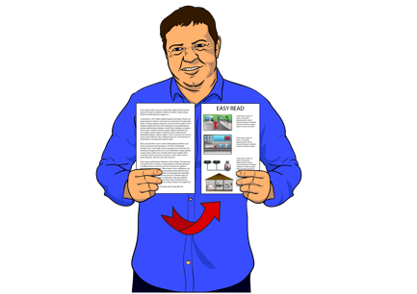

This is an Easy Read document.

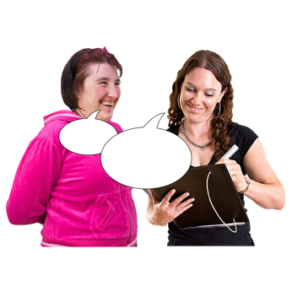
It tells you about some of the key messages from the DPO Coalition meetings we had in February 2025.


During these meetings we met with lots of:
government agencies
other community organisations.

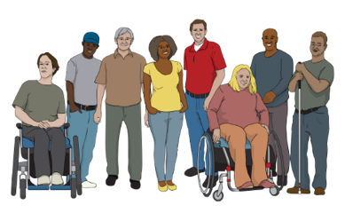
These meetings are to make sure the lives of disabled people in
New Zealand are getting better.

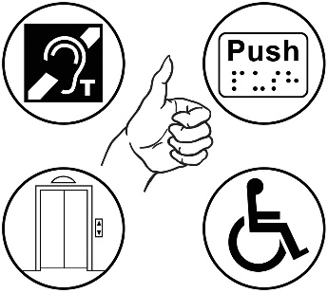
2 important subjects talked about often are:
accessibility
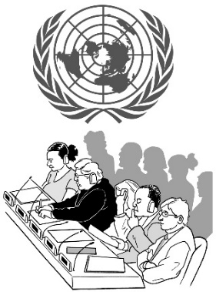
the rights of disabled people in New Zealand under the United Nations Convention on the Rights of Persons with Disabilities.
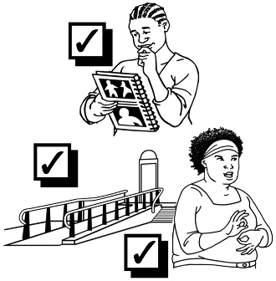

Accessibility means making things easy / safe for everyone to use.

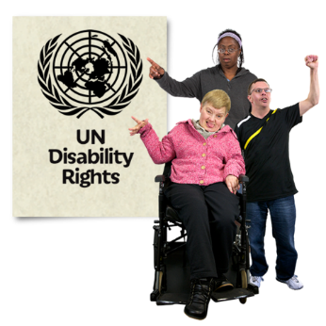
The United Nations Convention on the Rights of Persons with Disabilities is a law lots of countries have agreed to.
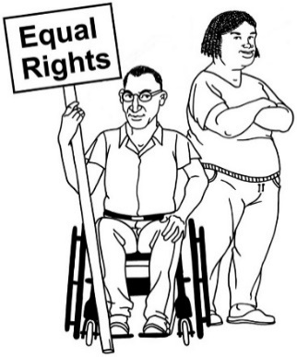

It says what governments must do to make sure disabled people get the same rights as everybody.

Disability Support Services Taskforce –Ministry of Social Development

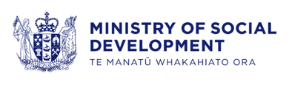
We met with:
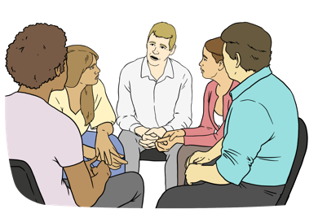
Chris Bunny – Deputy Chief Executive Disability Support Services
members of the Disability Support Services Taskforce.

We call Disability Support Services DSS for short in this document.

We talked about the DSS review.


Here a review is looking at something to see what needs to be changed to make it work better.
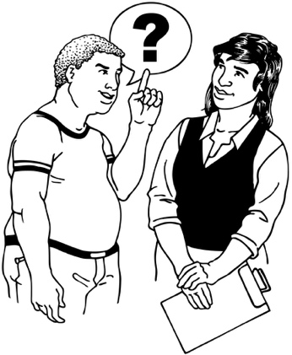
Consultation for the DSS review is happening now.

Here consultation is where we find out what people think about the DSS review.

This meeting is 1 of the ways we told the DSS Taskforce what we think about the DSS review.

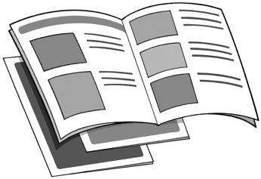

We also told the DSS Taskforce we are worried the consultation process is not accessible.
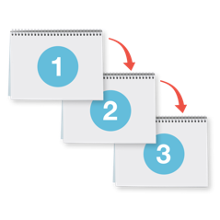

Here process means the steps to take to do something.


We are worried that some disabled people may not able to take part in the consultation process.

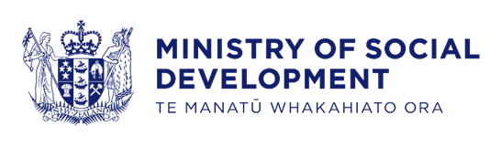
We also asked the Ministry of Social Development to think of accessible ways to work with:
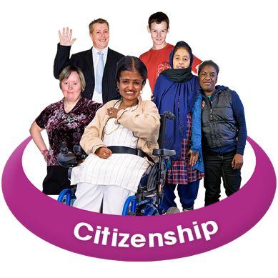
communities
different groups of people.


At this meeting we also talked about:
assessment
flexible funding.
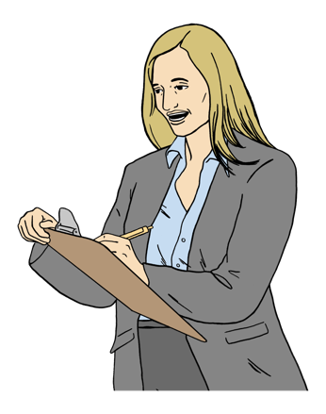

Here assessment is the process of finding out what your support needs are.

Here flexible funding:
is the money you get from DSS
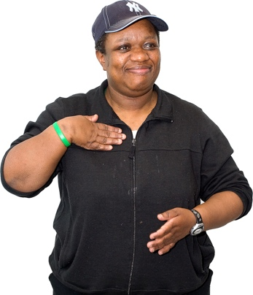
and
means you have more control over how you spend the money to support your needs.

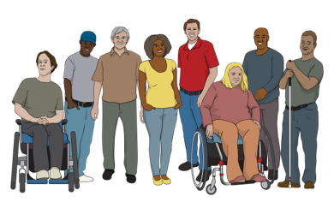
We also talked about how important it is to build up trust with:
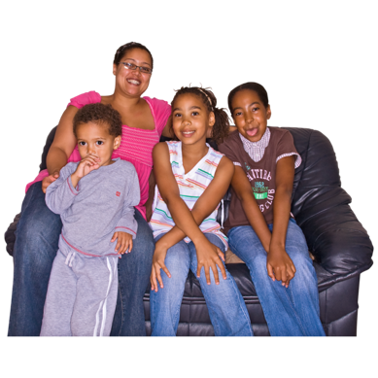
disabled people
and
their whānau / families.


It was a good meeting.


More information about the DSS review can be found on the Disability Support Services website here:

www.disabilitysupport.govt.nz
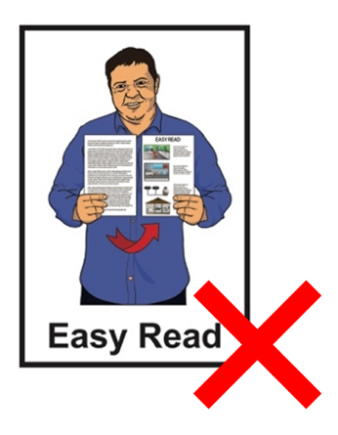

This website is not in Easy Read.

Whaikaha – Ministry of Disabled People

The DPO Coalition met with staff from Whaikaha:
Ben O’Meara
Sheryl Pinckney
Pauline Melham.
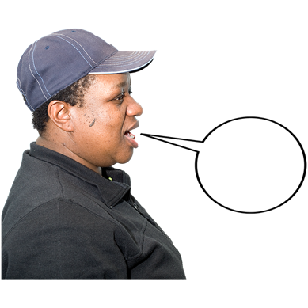

We talked about the New Zealand Disability Strategy review.


There will be 5 priority areas of work in the new Disability Strategy.

Here priority means the most important areas of work.

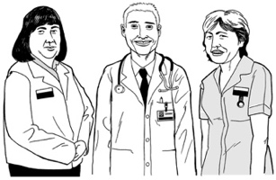
These priority areas are:
health
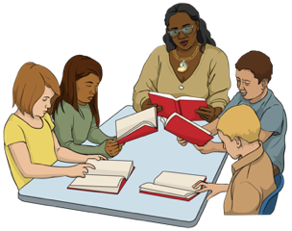
justice
education
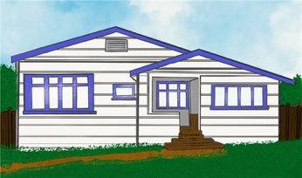
employment
housing.

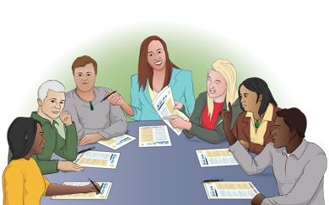
For each priority area there will be:
an advisory group
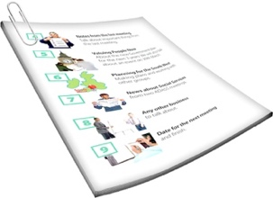
a discussion paper.

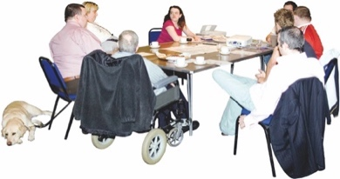
Here an advisory group is a group of people that:
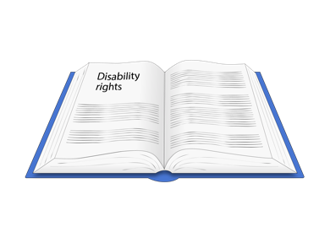
know a lot about:
- disability rights
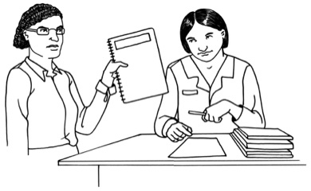
- a priority area
give advice to Whaikaha.


We are pleased to hear the number of disabled people on each of the 5 advisory groups is now 3.
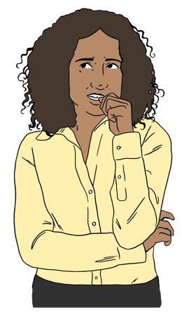

We were worried the
DPO Coalition does not have a place on each of these advisory groups.


We agreed to the DPO Coalition having 2 places on the
selection panel.


Here a selection panel is a group of people that choose who will be part of each advisory group.

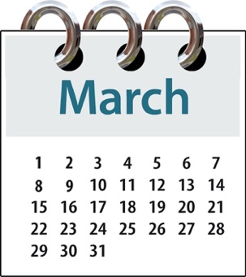
We will talk about the discussion papers at our next meeting with Whaikaha in March.

Disability Rights Commissioner

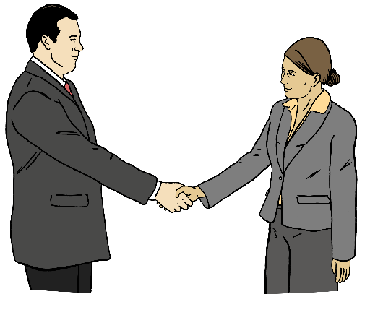
We met with:
Prudence Walker – Disability Rights Commissioner
Frances Anderson – Principal Advisor Human Rights Commission.

We talked about getting ready for the meeting with the Human Rights Commissioners in March 2025.

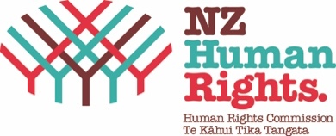
We also talked about the submissions made by the Human Rights Commission about government policies.

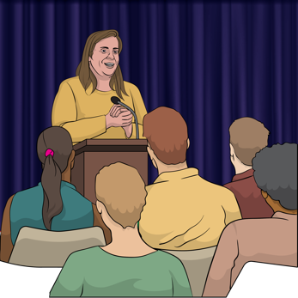
Here a submission is how people tell the Government what they think about things like a:
bill
change to a law.

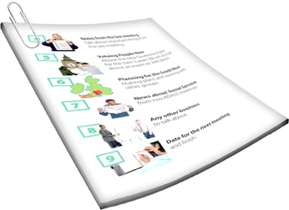
Here a bill means the first drafts of a new law before it is agreed to.
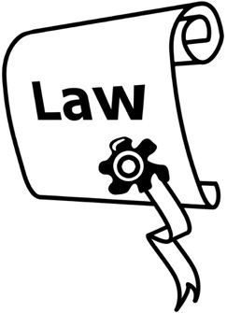

A law is a rule made by the Government that everyone must follow.
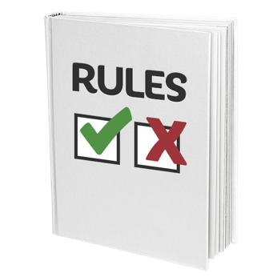

Policies are like sets of rules that need to be followed to do something.

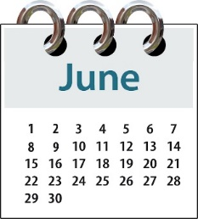
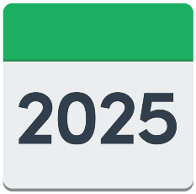
Prudence told us she and her team are going to the Conference of State Parties / CoSP in New York in June 2025.

Ministry of Justice

We met with staff from the Ministry of Justice.

We told them what we thought about the Fifth Periodic Report to the United Nations Committee on Economic, Social and Cultural Rights.

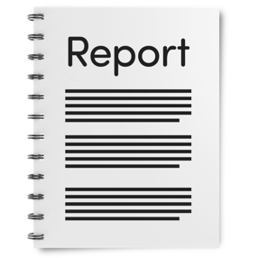
Here a periodic report is a report New Zealand gives to a United Nations Committee:
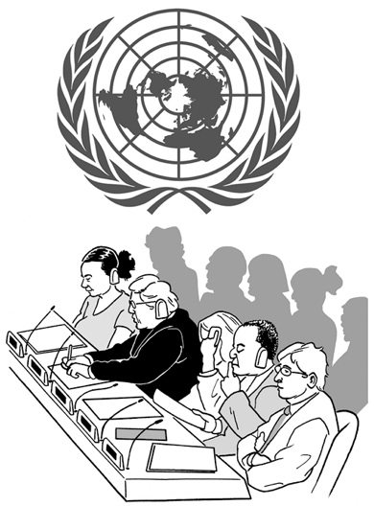
at regular times like once every
5 years
and
that tells them what New Zealand is doing about what a United Nations convention says.
This report will be made public after it has been given to the United Nations Committee on Economic, Social and Cultural Rights.

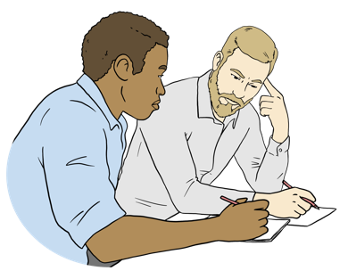
Here made public means when a report / document can be seen / read by everyone.

Donald Beasley Institute

We talked about when the latest disabled person led monitoring reports will be made public.

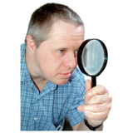
Here monitoring is when something is being looked at closely to find out:
how well it is working
if things need to be changed to make it work better.

We will share these monitoring reports with you when they are made public in:
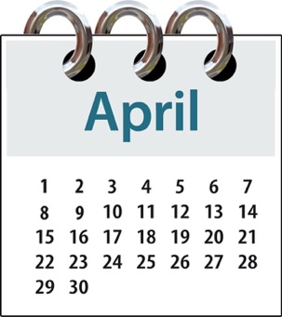
March 2025
and
April 2025.

Law Commission

The Law Commission is finding out what people think about the hate crime law review they are doing.

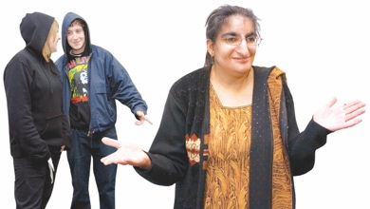
A hate crime is when someone does a crime because of hate to a group of people who have something in common.

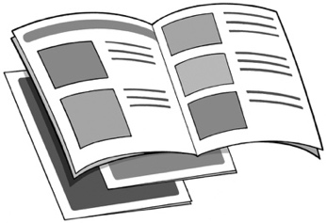
We are very happy all the information people need to give their feedback is in accessible formats.
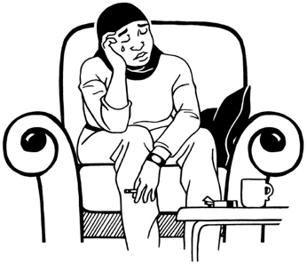

Some of the things we talked about were things like what:

hate crime is
hate speech is.

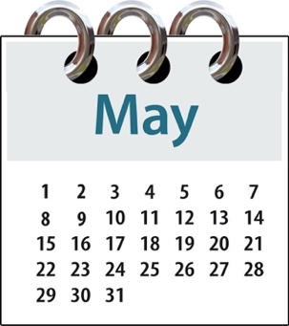
We will meet with the Law Commission again in May 2025.

DPO Coalition Representatives on National Enabling Good Lives / NEGL

Here a representative is the
person or persons:
from the DPO Coalition
we chose to speak for us at the NEGL meetings.


We had a very good meeting with our 2 NEGL representatives.

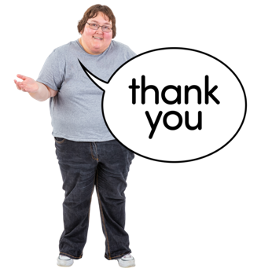
We thanked them both for their work.

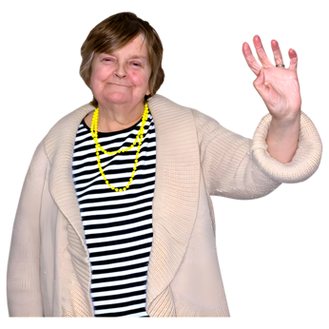

Gerri Pomeroy has been working with NEGL for over 7 years.

She has decided to stop being an NEGL representative.


We thanked Gerri for all the work she did over this time.


Ollie Goulden is still our NEGL representative.

Independent Monitoring Mechanism / IMM

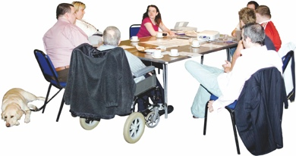
We talked about who will represent us at the IMM meetings.


We decided Kera Sherwood-O’Regan will take the place of Rachel Hargreaves on the IMM.

We decided the 4 DPO Coalition members on the IMM are:
Alexia Black
Jonathan Godfrey
Kera Sherwood-O’Regan
Rose Wilkinson.

Our 2 DPO Coalition representatives on the IMM Working Group will be:
Kera Sherwood-O’Regan
Rose Wilkinson.

Voice of disabled people

The Government meets with the DPO Coalition so disabled people can have a say in the decisions being made about them.
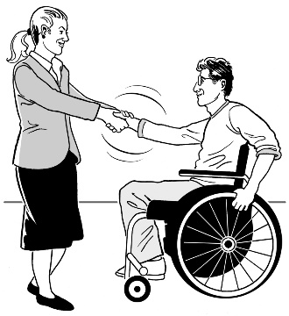

The DPO Coalition is always looking for new organisations to join us.

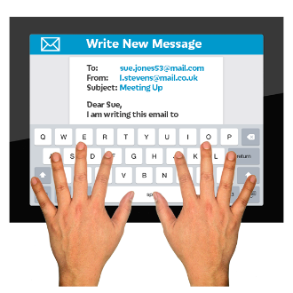
You can contact us by emailing us:

us-dpo@groups.io

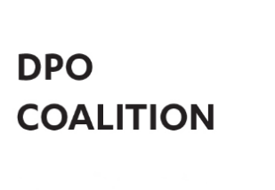
This information has been written by the
Disabled People’s Organisations Coalition.

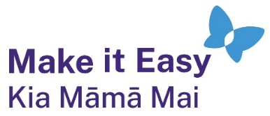
It has been translated into Easy Read by the Make it Easy Kia Māmā Mai service of People First New Zealand Ngā Tāngata Tuatahi.
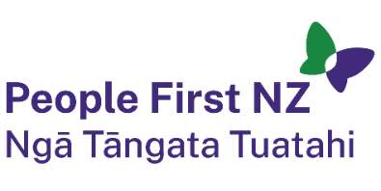
The ideas in this document are not the ideas of People First New Zealand Ngā Tāngata Tuatahi.

All images used in this Easy Read document are subject to copyright rules and cannot be used without permission.


Make it Easy uses images from:

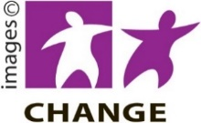
- Photosymbols

- Change Images


- Huriana Kopeke-Te Aho
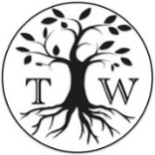
- SGC Image Works

- T Wood


- Studio Rebeko

- Inga Kramer.

