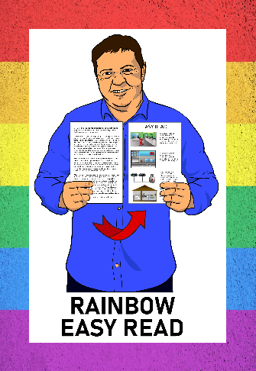



Rainbow Easy Read:
Coming out
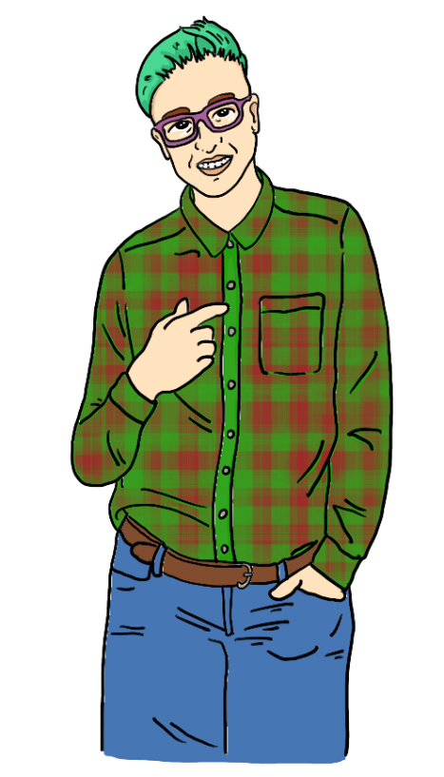



Published: February 2025

Before you start


This is a long document.


It can be hard for some people to read a document this long.


Some things you can do to make it easier are:
read it a few pages at a time
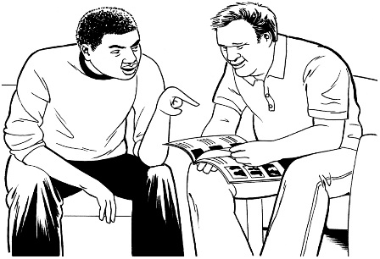
set aside some quiet time to look at it
have someone read it with you to support you to understand it.

What is in here


Page number:

About this Easy Read 4




What is coming out? 8

Planning to come out 13


Who do you want to come
out to? 15



When to come out 18


Where to come out 20


Page number:

How do you want to come out? 23



What you might tell people 24

What people might say 29


Safety and looking after yourself 32

Finding support 38


More information 40


Thank you 42

About this Easy Read


This is a guide to coming out as a rainbow person.


Rainbow is also a word for people who are LGBTQIA+.

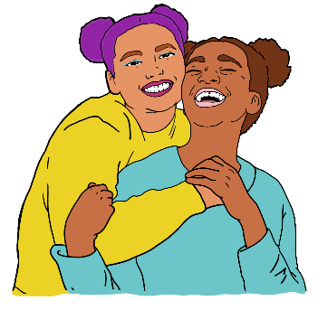
LGBTTQIA+ stands for people who are:
- lesbian
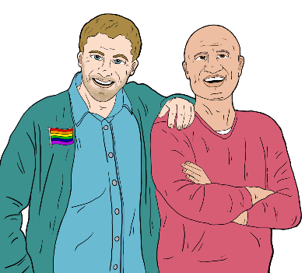
- gay
- bisexual

- transgender
- takatāpui.

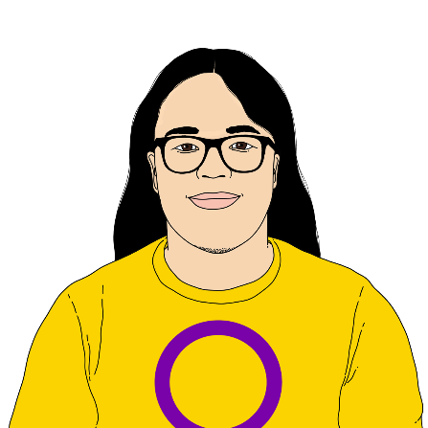
LGBTTQIA+ also stands for people who are:
- queer
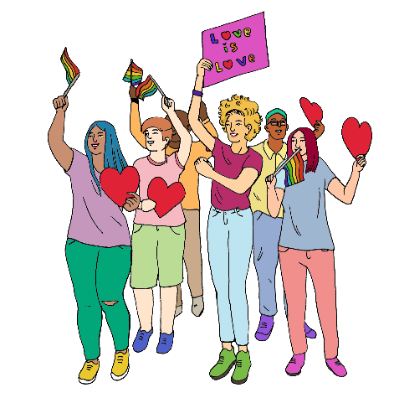
- intersex
- asexual
- + is for other people who fit in similar groups.


Words for rainbow people change all the time.
I
I AM ME

You might:
have another word you like to use for yourself
not be sure what word fits you yet.

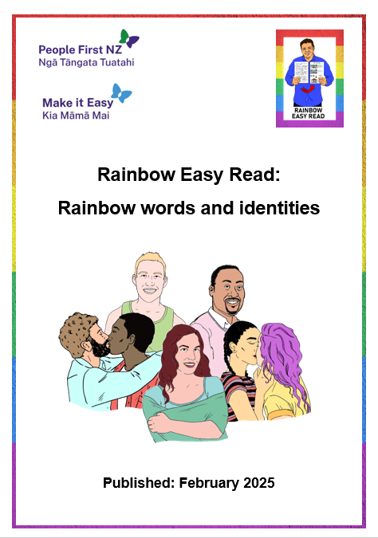
You can read more about what LGBTTQIA+ means in:

Rainbow Easy Read: Rainbow words and identities


You can find this Easy Read at:

https://tinyurl.com/RERidentities

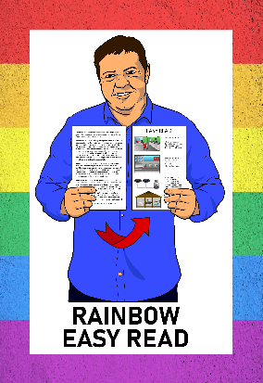
This guide is part of the Rainbow Easy Read Project.

The Rainbow Easy Read Project is a group of Easy Reads for:
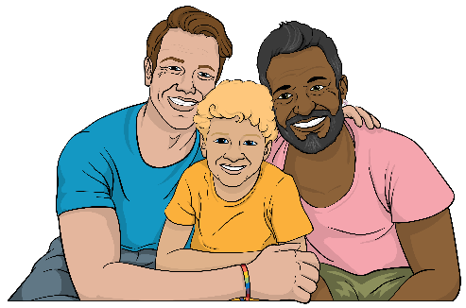
people in the rainbow community
their friends

their whānau / families
people who support them.


You can find all the Rainbow Easy Reads at:

linktr.ee/rainboweasyread

What is coming out?




Coming out is telling people about your:
gender
or
sexuality.

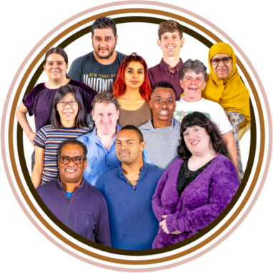
Gender means different things:
to different people
in different cultures.

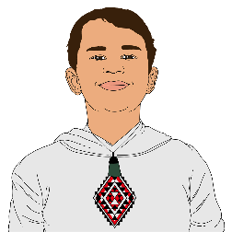
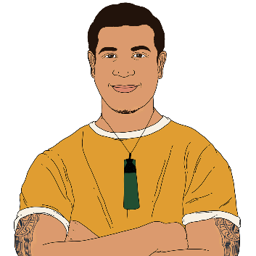
The genders we hear about most are:
boy or man
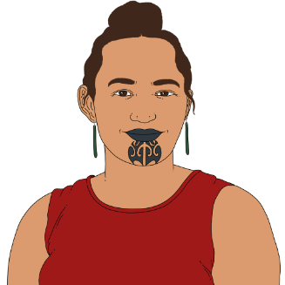
girl or woman.
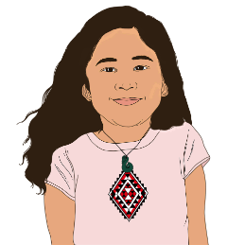

Some people are not just a man or a woman.
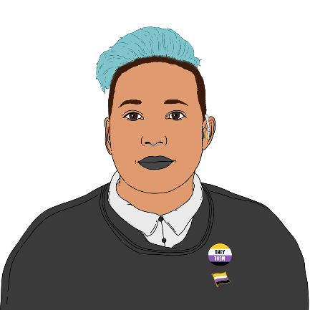

They may call themselves
non-binary.

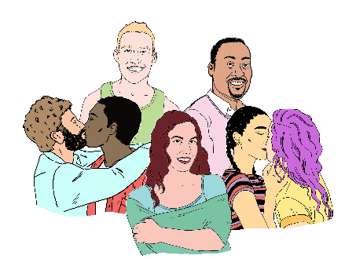
Sexuality is things like:
who you are attracted to
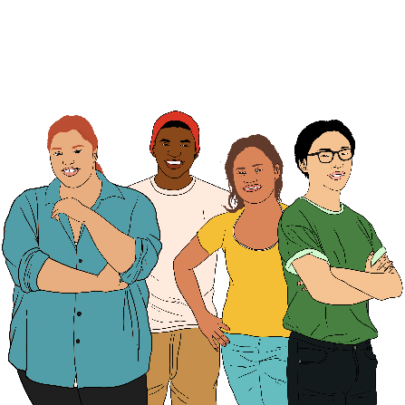

who you want to be in a relationship with

choosing if you want to be in a relationship.


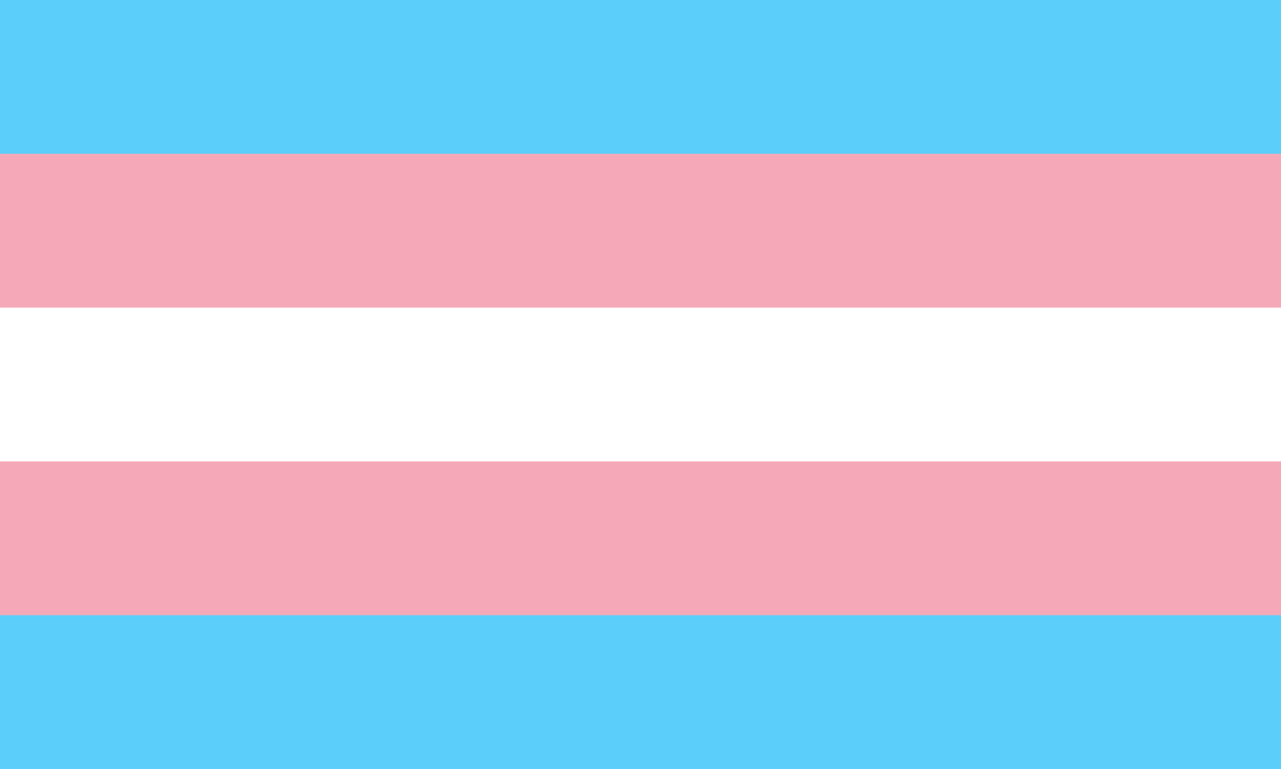
Coming out to people about your gender is telling them you are:

transgender
non-binary

takatāpui
another gender that is important to you.



Coming out to people about your sexuality is telling them you are:
gay
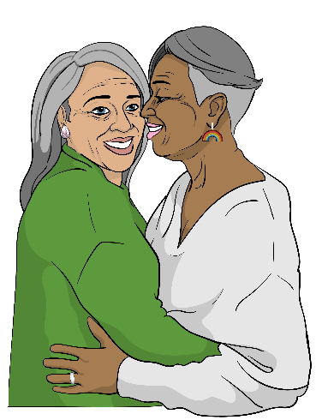
lesbian
bisexual
another sexuality that is important to you.

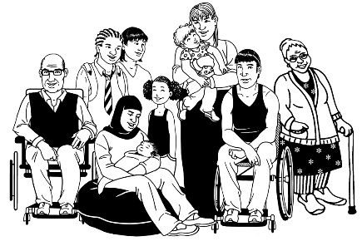
Rainbow people can come out at any time in their lives.

You come out when you are ready.


You might have decided to come out because you:

want to tell people how you feel
want people to know who you really are

are in a relationship that you want to tell people about
want to get support.


You might be feeling:
happy
excited

worried
scared
all sorts of feelings at once.


It is okay to feel like this.

This Easy Read has ideas to support you coming out.

Planning to come out


Making a plan to come out lets you

try out:
how you are going to do it
what you want to say.


You might want to make a list of:
people you want to tell
times you want to do it

places you would feel comfortable doing it
how you want to tell someone
what you want to say.


You can work out what you want to say by:
writing the words

saying the words to:
- yourself
- someone who supports you.

Who do you want to come out to?


It is your choice who you want to come out to.

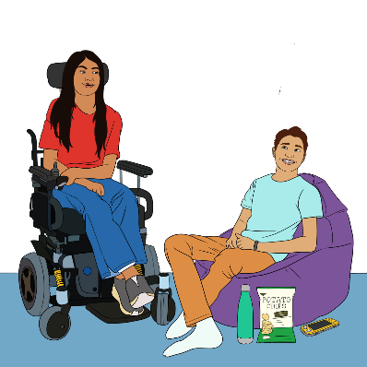

You can think about who might be supportive like:

how they talk about rainbow people
if they are part of the rainbow community
if they have rainbow friends
if they have rainbow family.


You might want to come out to:
your whānau / family

your friends
people at school
people at work

people at a club / organisation you are part of

someone who supports you like:
- a carer
- your doctor.

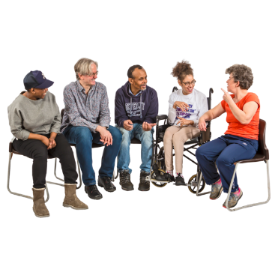
You might want to tell people:
1 by 1
in a group.



You can tell:

as many people as you want
as few people as you want.

When to come out



Choosing when to come out will be different for each person.


You can think about what time works best for:
you
the person you want to tell.


Some good times of the day to talk are:
when you are eating a meal
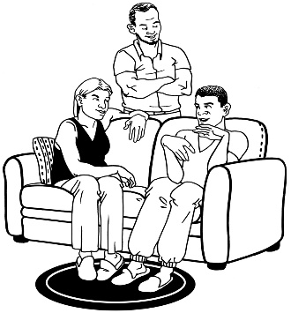
when people are not so busy like:
- after work or school
- at night.
Someone might:

guess about who you are
and
ask you before you planned to tell them.


It is your choice if you want to tell them then.

Where to come out


Choosing where to tell someone can make you feel:
comfortable.
safe.

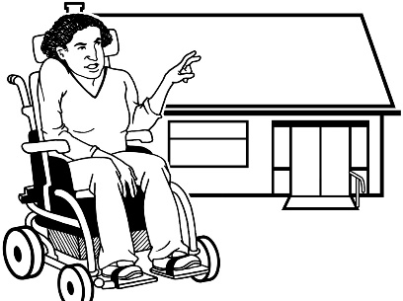
You might want to tell someone in private like at:
your house
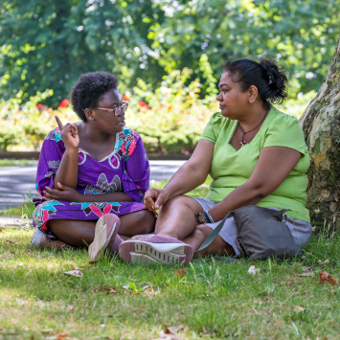
their house
a place that is special to you.

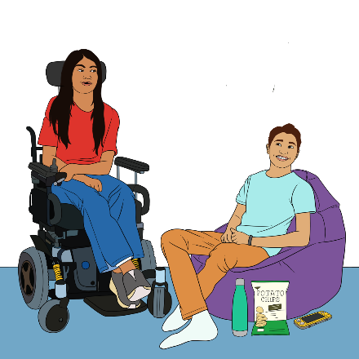
Telling someone in a private place means:
it will be quiet

no one will interrupt you / stop you from speaking
you can have a support person:
- with you
- nearby if you need them.

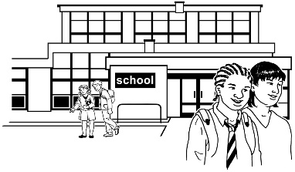
You might want to tell someone in a public place like at:
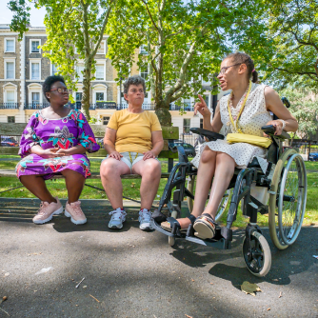
school
work
a park

a café or restaurant.


Telling someone in a public place means you can:
go somewhere else when you are done

have other people nearby for support.

How do you want to come out?


There are lots of different ways to come out to someone.


You can do it by:
talking face to face

phone
video call

writing a letter
text
email

sending a message like on Facebook.

What you might tell people




It is your choice what you want to tell people when you come out.


You might want to think about:
what is most important to tell someone

what you do not want to tell them
what you want them to keep private.




Private means not sharing information about you with other people.

Telling someone you are transgender
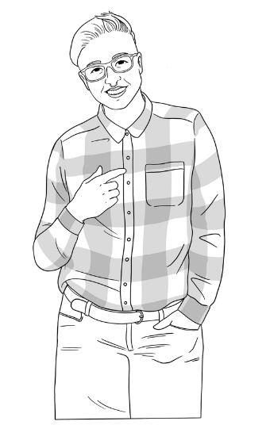


If you are transgender you might tell someone:
what your gender is
your name if you have changed it
your pronouns.

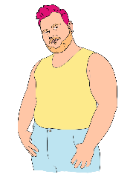
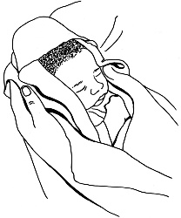
Transgender people have a different gender to the one people thought they had when they were born.


Pronouns are words used instead of names like:
she / her

they / them.


If you are transgender you might tell someone:
what clothes you will wear
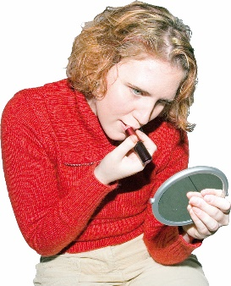
how you will do your hair
if you will wear make up.


If you are telling someone you trust with private information you might tell them:
if you are doing medical transition
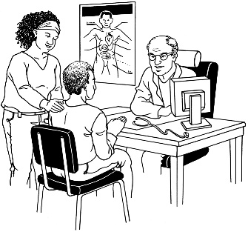
you would like their support for things like:
- coming out to others

- going to the doctor
- changing documents like your birth certificate.

Medical transition is when a transgender person changes their body to fit better with their gender.

This can be done in different ways like:
medication like hormones
surgery.



Each transgender person chooses what they want to do with their body.

Telling someone your sexuality

If you are coming out about your sexuality you might tell someone:
what your sexuality is


if you have a partner

you would like their support for things like:
- coming out to others
- going to rainbow groups

if you want them to keep information private.

What people might say


People you come out to might:
be happy for you
be unsure what to say
say mean things.


A person might need time to think about what you have said.


It might take more than once talking to them for them to understand.

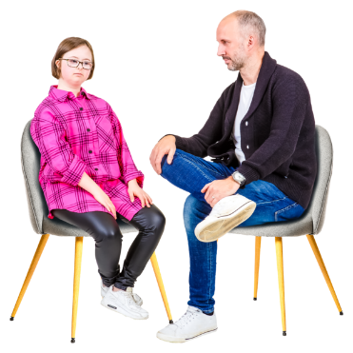
Sometimes you may need to give people time while they learn these things about you.


A person might have questions for you.

If is okay if you do not have the answers.


You might ask the person to:
learn these things with you



practise with you like:
- coming out to other people
- using new words like pronouns.


If the person you come out to is not nice you can:
tell them how you feel
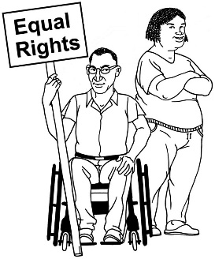
tell them it is important they respect your rights
tell them you are done talking to them for now
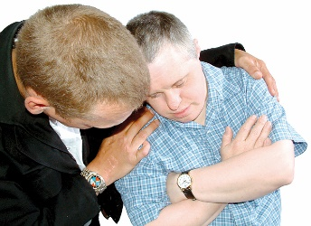
find someone to support you.

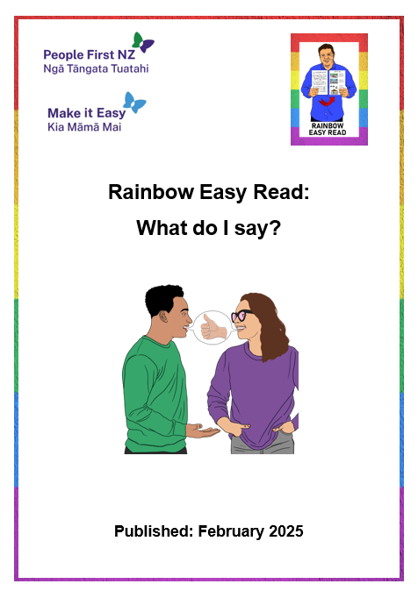
For more information about talking to people you can read:

Rainbow Easy Read: What do I say?

You can find this Easy Read at:

https://tinyurl.com/RERsay

Safety and looking after yourself
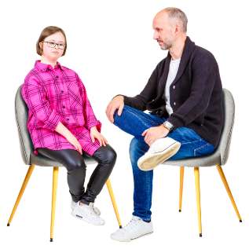

Coming out can be hard.

It is important to:

look after yourself
know your rights
be safe.

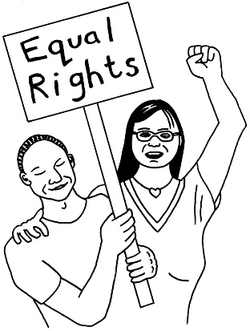
Here rights means:
being able to choose what to do with your body
the laws that keep you safe.


Look after your feelings

Take care of your feelings after you come out to someone.


You might choose to:
go somewhere quiet to think
eat or drink something you like
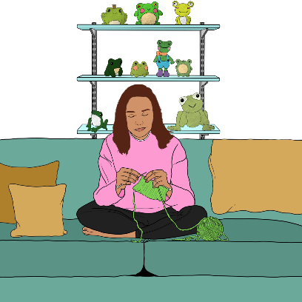
do something you enjoy like:
- play a game
- crafts

- listen to music
- watch TV
- read a book.


Another thing you might do to look after your feelings is talk to:
a support person

a friend
whānau / family
a rainbow support organisation.

Know your rights

Rainbow people have the right to be treated:
with respect
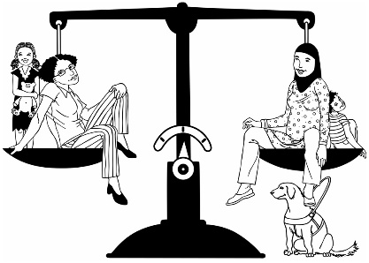
in a fair way
equally to other people.

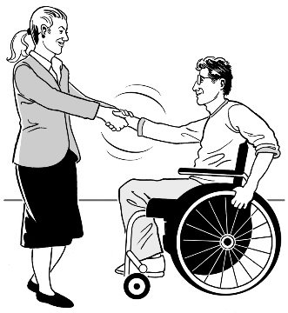
To respect someone means to take care of their:
feelings
rights.


The Human Rights Commission has information about the rights of LGBTQIA+ people at this website:

tikatangata.org.nz/rights-of-sexual-and-gender-minorities


This website is not in Easy Read.

Be safe
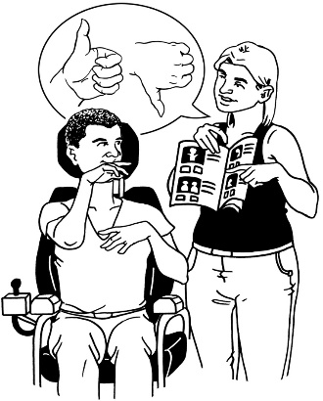
If your support worker does not support you being a rainbow person you might want to ask for someone else.

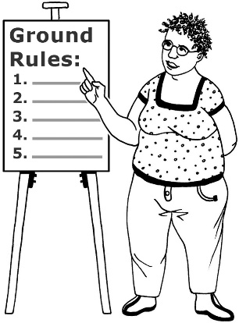
If a family member does not support you being a rainbow person you might want to think about things like:
making rules about how you talk together
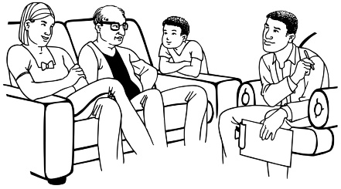
getting support from:
- other family
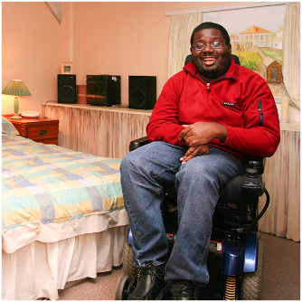
- friends
- a support worker
living somewhere else.

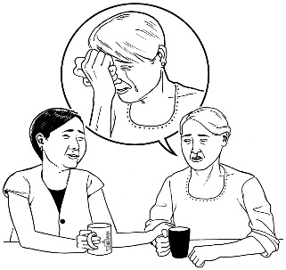
It can be hard to do these things because these people might be important to how you get support.


It is your choice if you want to make these changes.

Finding support

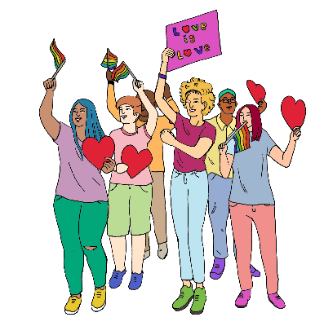
You are not alone.

There are lots of rainbow people in the world.


There are people who will support you to come out.

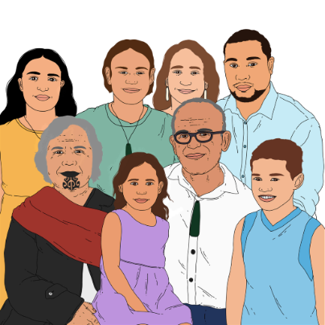
They might be:
whānau / family
friends

an organisation / group you are part of
rainbow organisations.


People might:
have information to support you

tell you what it was like coming out for them
tell you about rainbow organisations they know.

More information


You can contact OutLine for support if you:
are part of the rainbow community
think you might be part of the rainbow community.


You can contact OutLine every day between 6 pm and 9 pm in the evening:
by phone on:
0800 688 5463
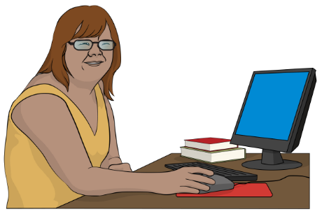
using the text chat on their website at:
outline.org.nz/chat
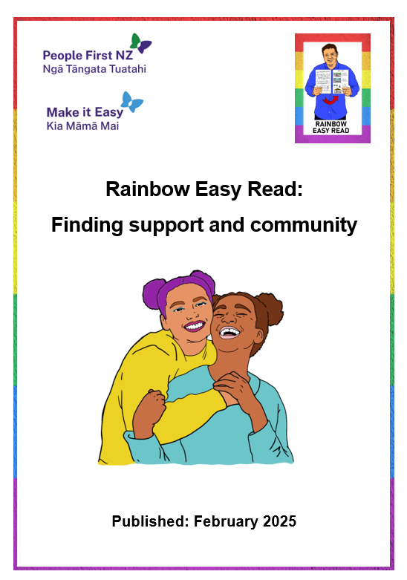
There is an Easy Read called:

Rainbow Easy Read: Finding support and community

It has information about more places you can contact for:

information
support.

You can find this Easy Read at:

https://tinyurl.com/RERcommunity

Thank you


Lots of people worked together on the Rainbow Easy Reads.


Thank you to the Rule Foundation for giving us the money to make them.


Thank you also to:
the People First NZ members who worked as advisors

the People First NZ staff who supported them
everyone who has supported this mahi / work.


This information has been written by Make it Easy Kia Māmā Mai.


Make it Easy is a service of People First New Zealand Ngā Tāngata Tuatahi.


All images used in this Easy Read document are subject to copyright rules and cannot be used without permission.


Make it Easy uses images from:


- Photosymbols


- Change Images

- SGC Image Works


- Huriana Kopeke-Te Aho


- T Wood

- Studio Rebeko

- Inga Kramer.

