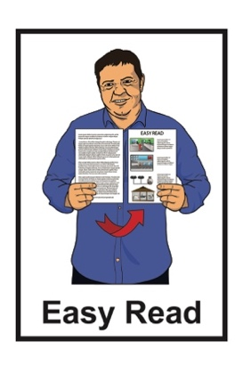

How to make a will

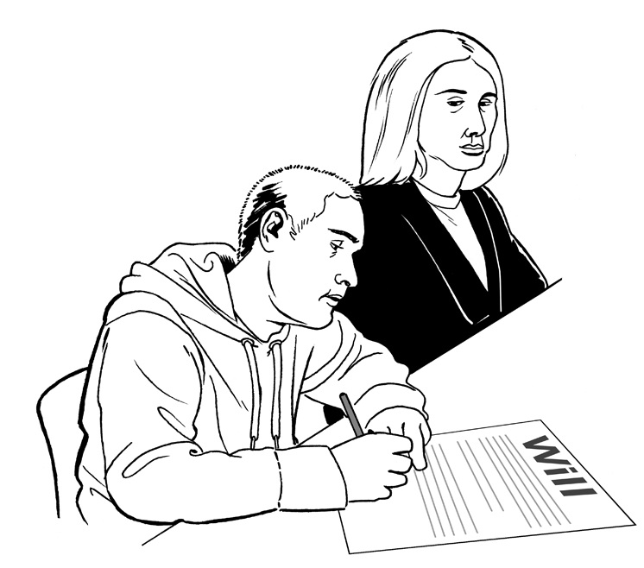

Published: May 2024

Before you start


This is a long document.

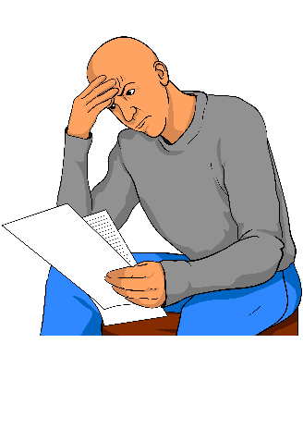
It can be hard for some people to read a document this long.

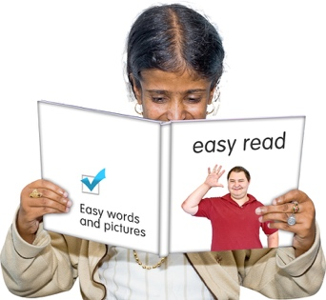
Some things you can do to make it easier are:
read it a few pages at a time
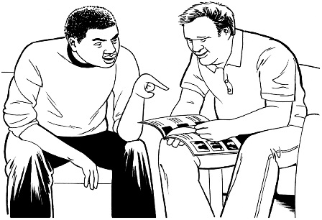
set aside some quiet time to look at it
have someone read it with you to support you to understand it.

This information may upset some people when they are reading it.

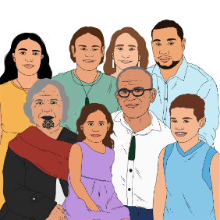
If you are upset after reading this document you can talk to your:
whānau / family
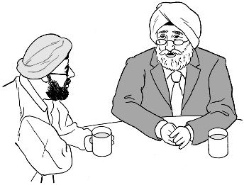
friends.

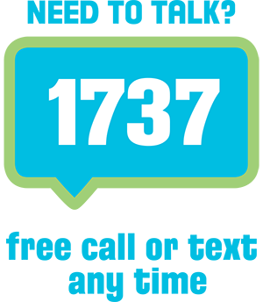
You can also contact Need to Talk by:
calling 1737
texting 1737



It does not cost any money to call / text 1737.

What you will find in here

Page number:


About this document 6


What is a will? 7
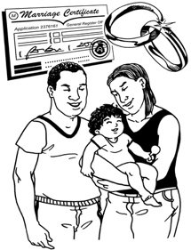

When should you make a will? 11


Who can make a will? 13

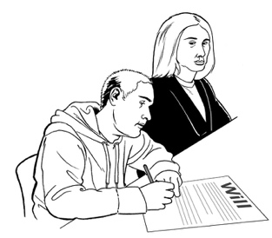
How to write a will 16


How does an estate work? 19

Page number:
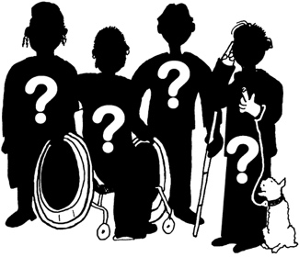

Who is the executor of a will? 22


What will happen to your children
after you die? 24


What will happen to your animals
after you die? 27


What if someone owes you
money? 28
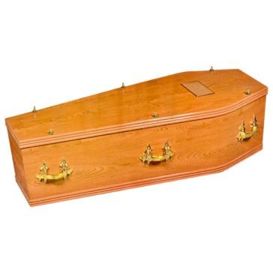

What do you want to happen to your body after you die? 30

Page number:
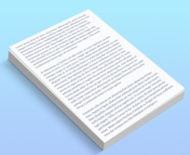

What to do if you want to change
your will 34
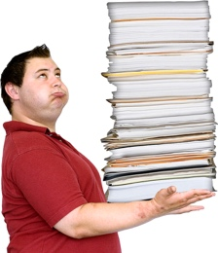

Where to keep your will 36


Where to find more information 37

About this document
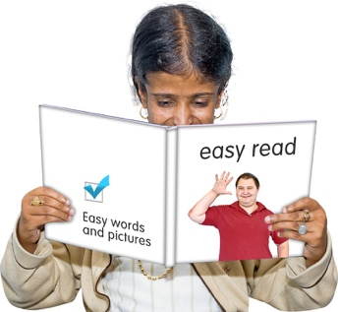

This is an Easy Read document about wills.


This document is for:
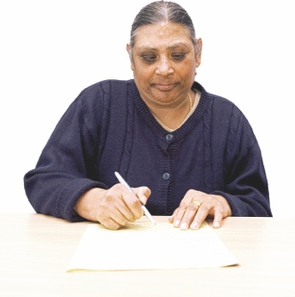
people who want to know what a will is
people who want to make a will

people who support others to make wills such as:
- lawyers
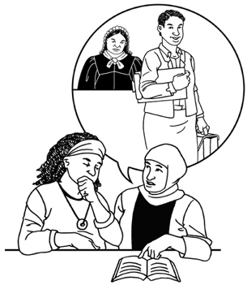
- other legal professionals.

What is a will?

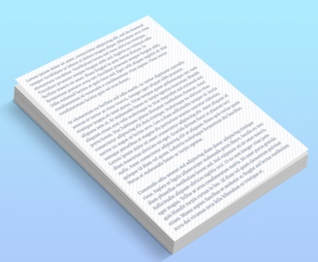
A will is a legal document that many people have.

A legal document is a document that:
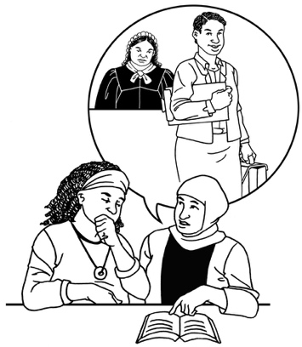
has special instructions in it
more than one person has signed
can be used in court.

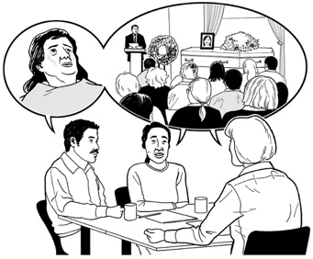
A will says what should happen to your important things after you die.


These things can be:

your belongings which means the things you own
your money

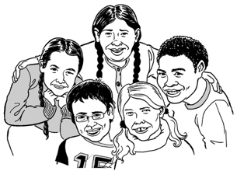
your children / pets

your business if you are a business owner
your intellectual property.

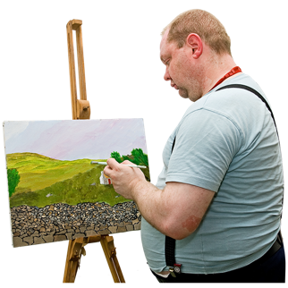
Intellectual property means ideas that you own such as:

copyright which is things like art / writing

patents which are things like inventions
trademarks which are things like registered business names.

All of these things together are called your estate.

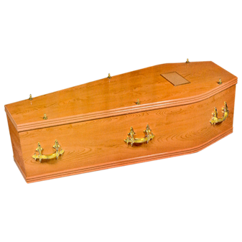
An estate is all the things that a person who has died owns.

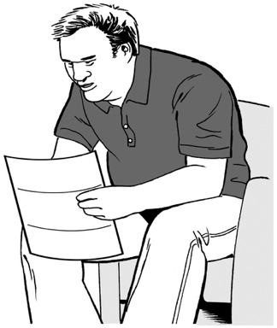
You can read more about how estates work on page 19 of this document.


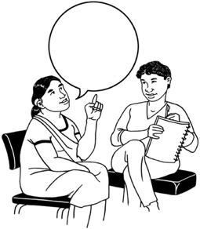
You can say what you want to happen to your estate in a will.

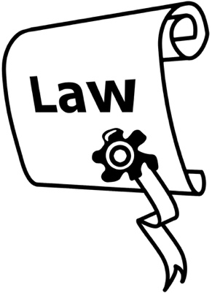
There is a law in New Zealand that says what will happen to your estate if you do not have a will.


A law is the rules that the New Zealand Government make for people to follow.

Making a will means that what happens to your estate is your choice.

When should you make a will?

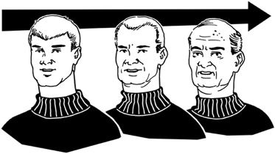
You can make a will at any time.


It is a good idea to make a will when you have:
money saved up
important things you want to go to a certain person such as:

- family heirlooms which means valuable things your family keeps through the years
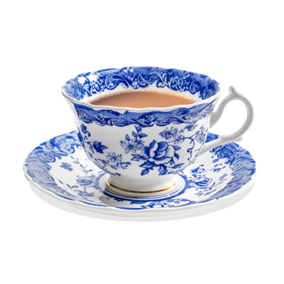
- mementos which means special things you hold onto because they remind you of special times
- rare belongings.

It is also a good idea to make a will when you have:
children who you want to be well taken care of
an expensive thing you own like a house.

Who can make a will?


To make a will you must be 18 years old or older.

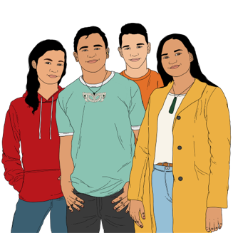
If you are younger than 18 years old a Family Court Judge may sometimes let you have a will.
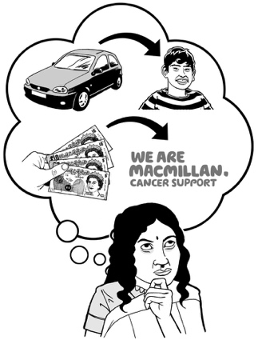


You must also know:
what things are part of your estate so you know what you can give away

what a will means for your estate.

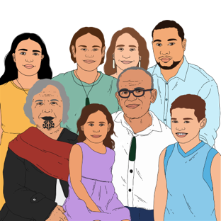
Think about who you want to leave your things to such as:
family

friends
charities / organisations that do important work that you care about.


You should also say who should get your estate if those people die before you.

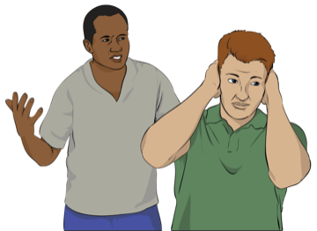
Thinking carefully about who to leave your things to can stop people arguing after you are dead.

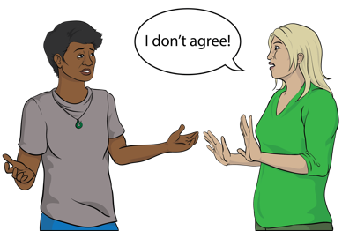
If you do not leave something for the important people in your life they may be able to go to court to say:

they do not think your will is fair
they want something of yours.

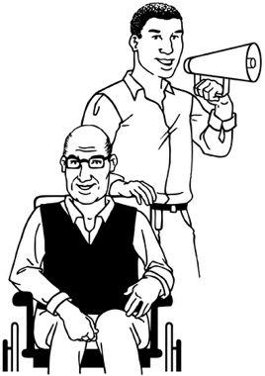
If you have a property manager under a law called the Protection of Personal and Property Rights Act you can still make a will.

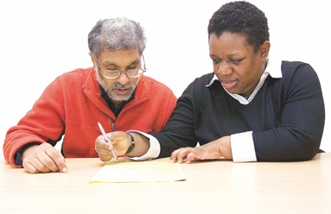
A property manager is someone who makes decisions about things you own when it is hard to make your own decisions.

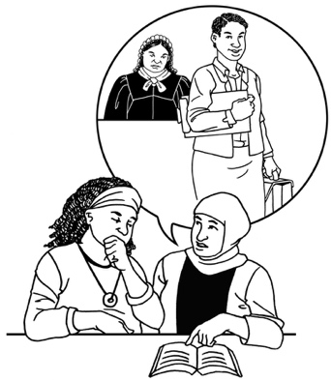
If a court has said you cannot make a will your property manager can ask the court to let you make one.

How to write a will


Get support to write a will from a:
lawyer
other person who works with legal documents.
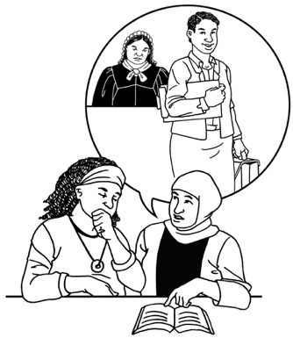

It is important to get advice about the law so you can be sure your will fits all the rules.


If your will does not fit the rules the court may decide to do something different to what you want.

When you make a will all the choices you make should be your own.

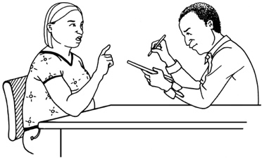
Other people should not try to make your choices for you.

Your will is about what you want to happen after you die to your:

money
important things
children

pets

business
intellectual property
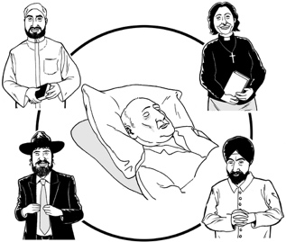
body.


Take your time thinking about these things because the decisions can be:
difficult
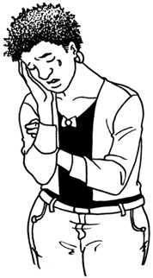
emotional
upsetting.


If you need to you can ask people you trust for their advice.


But the final choice about what to put in your will should be yours.

How does an estate work?

Your estate is all of your things added together such as:
your money
your property.


Some things will need to get paid from your estate like:
money that needs to be paid to lawyers to manage your estate

any bills you have that you did not pay before you died
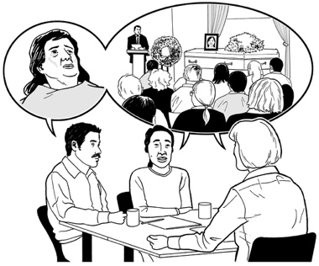
your funeral.


After these things have been paid for the rest of your estate goes to the people you chose to leave things to in your will.

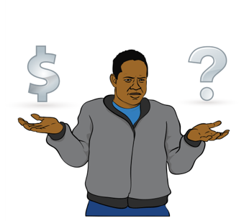
The people in your will can only get their share of your estate if there is still something left after your bills have been paid.

If you leave some of your estate to more than one person you have to say how much each person gets.


If you leave some of your estate to children they cannot get it until they are 20 years old.
20 years old

You can also say in your will that you want the children to be an age older than 20 before they get anything.
25 years old


You can also give some of your estate to:

a charity
a place such as a church
a family trust.


A family trust is a legal way of protecting things / money for a family so they:

do not belong to just one person
are safe if someone in the family has money troubles.

Who is the executor of a will?


Another important part of a will is the executor.

An executor is someone who makes sure that the instructions in the will are followed.


The executor of your will is the person who will make sure that your will is followed.


You can choose who will be the executor of your will.


You should choose someone you trust because it can be a big job.


It is a good idea to choose a backup executor in case the first executor cannot do it.

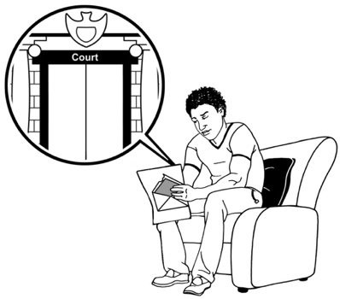
After you die the executor of your will has to:

get the court to say it is OK for them to be the executor
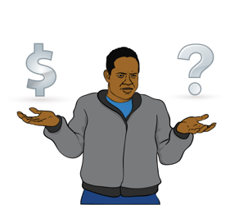
talk to all the people who are getting something from your will
collect all your things
sell your things if they need to for example your house
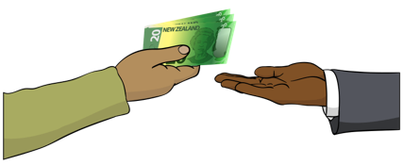
pay any money / bills that need to be paid.

What will happen to your children
after you die?

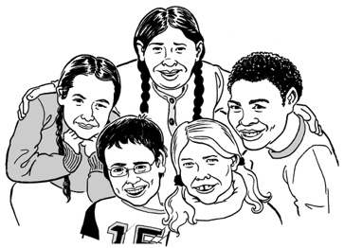
It is important to think about any children you have who are not yet grown up when making your will.


If the other parent of your children is still alive then the children will usually live with this person.


Also think about what you want to happen to your children if the other parent also dies.


In this case a guardian will need to look after your children until they grow up.

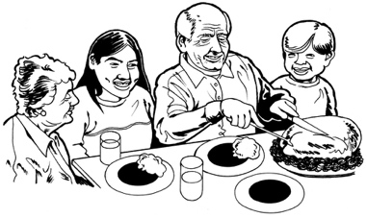
A guardian is someone who looks after a child even though they are not the parent.
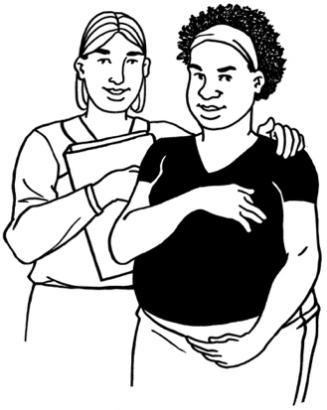

You can say in your will who you want to be the guardian of your children if they ever need one.


You must talk to the person you want to be the guardian before you put their name in your will.


Choose someone you would trust to look after your children well.

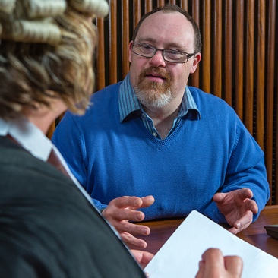
If someone thinks the guardian you have chosen is not the right person:
they can tell the court
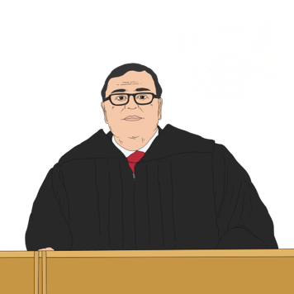
the court will look into this
the court may make a different decision than you to protect your children.

What will happen to your animals
after you die?

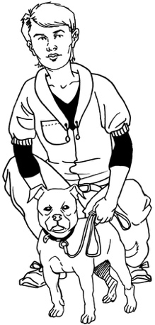
If you have pets you can say in your will who you want to take care of them after you die.


Talk to that person first before you put their name in your will.

What if someone owes you money?

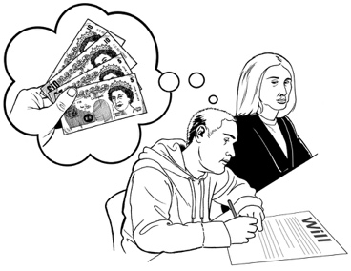
When you die you might still be owed money by:

people
companies
places.

You can say in your will that this money:
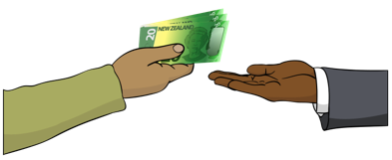
has to be paid back

or

does not have to be paid back any more.

If someone who owes you money is getting something in your will you can say:
they do not have to pay you back any more

or
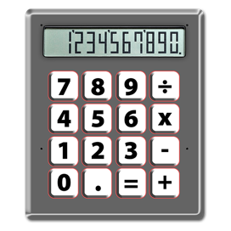
the amount they owe you will be taken off what they get from your will.

What do you want to happen to your body after you die?
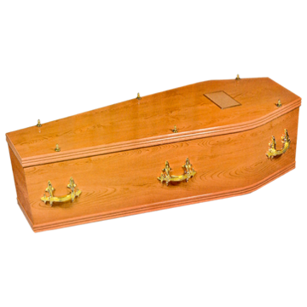

You can decide what you want to happen to your body after you die.


You can choose if you want to donate parts of your body to people who need them.

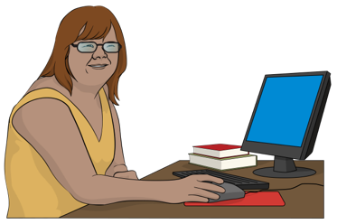
You can choose if you want to give your body to medical science for people to learn from.

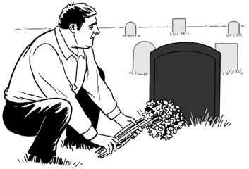
You can say if you want to be:
buried in a graveyard
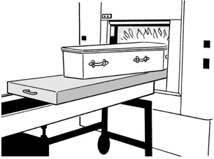
cremated which means turned into ashes.
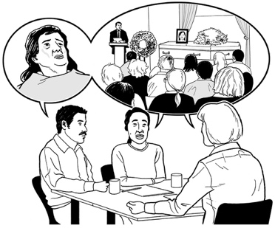
You can say what you want to be done for your:
funeral
burial
ashes.

Think about how your funeral will be paid for because funerals can cost a lot of money.

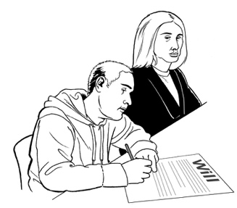
If you know what you want to happen to your body after you die you can:
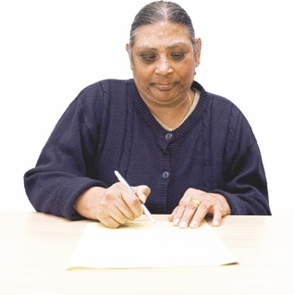
put it in your will
write it on another piece of paper that you keep safe
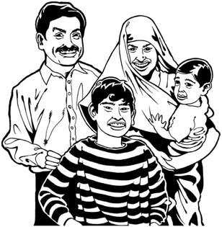
tell your family / friends what you want.


If you have your funeral instructions in your will it is a good idea to write them down on another piece of paper too.

Make sure this is the same as what is in your will.


This is because if your wishes are only in your will then people might only read them after the funeral.
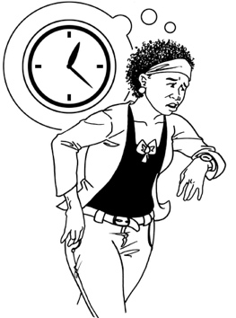

If this happens it will be too late for them to do what you wanted.


If you know what you want to happen to your body:
talk to your family / friends
let them know what you would want if you died.

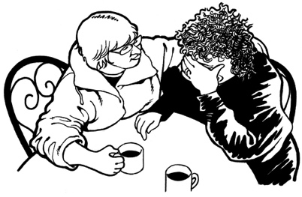
This conversation:
might be upsetting
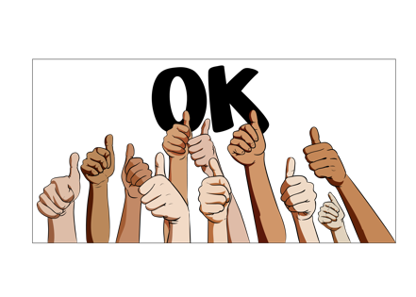
will help your important people to be sure they are doing the right thing for you.

What to do if you want to change your will


It is a good idea to look at your will from time to time to see if it is still how you want it.
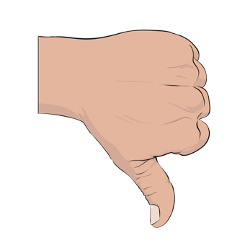

If not you might want to make a new will.

You can choose to make a new will at any time.

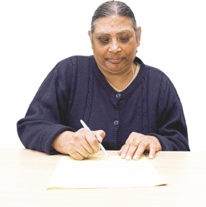
Do not make changes to a will you already have.

To make changes it is best to make a whole new will.
New


Reasons to make a new will include:
something in your life changed such as you:

- got married
- got divorced which means your marriage ended
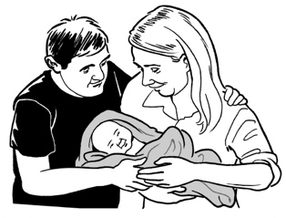
- had children
you have bought new things and you want to say what should happen to them

you have changed your mind about what you want to happen after you die.

In your new will it is important to say that any old wills you have are not to be used anymore.
Old

Where to keep your will

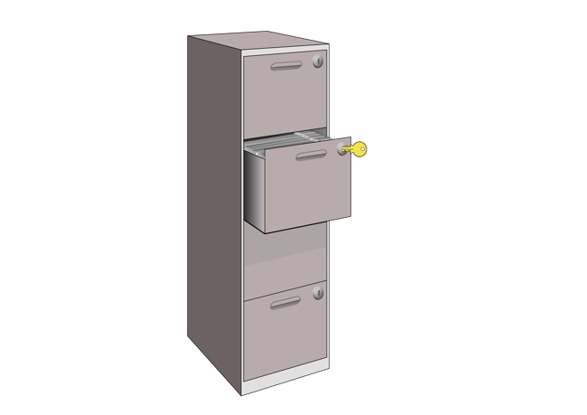
You need to keep your will somewhere that is:
safe
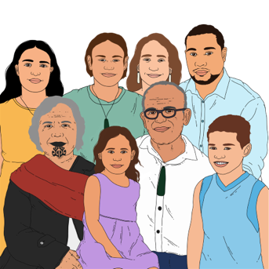
secure
in a place where your important people can find it.

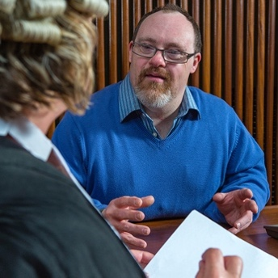
It is a good idea to ask your lawyer to keep your will for you.


You should tell your family / friends the name of the lawyer who is looking after your will.

Where to find more information


The New Zealand Law Society has more information about making a will at this website:

bit.ly/NZLS-makeawill
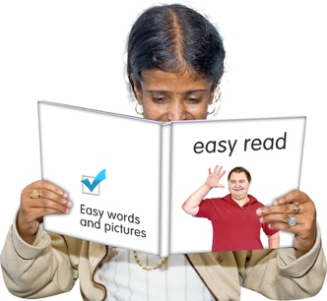

This information is not in Easy Read.


The Make it Easy Kia Māmā Mai service of People First New Zealand Ngā Tāngata Tuatahi uses images from:

- Changepeople.org



            - Photosymbols.com

- SGC Image Works

- Huriana Kopeke-Te Aho
- T. Wood.

All images used in this Easy Read document are subject to copyright rules and cannot be used without permission.

