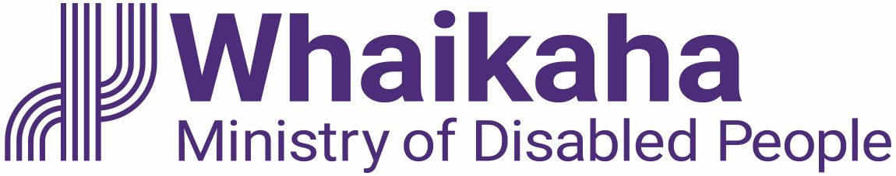

A guide for how you can use
disability funding

Published: August 2023

What you will find in here

Page number:

What this guide is about 3

What disability funding is for 4

How government disability
funding works 7

Individualised Funding Hosts 8

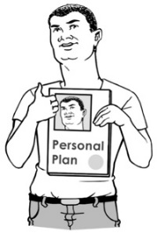
Individual Service Plans 10

Rules for spending disability
funding 12

Page number:

Things you cannot use the
funding for 16

Employing support workers 17

Examples of how to use
the funding 18

Where to find more information 25

What this guide is about

This Easy Read guide tells you the
purchasing guidelines for how you can use disability funding.

Purchasing guidelines are rules that say what people can buy with disability funding.

Purchase means to buy something.

Disability funding is money from the government to make sure that disabled people can live:
good lives
in the same ways non-disabled people live.

What disability funding is for

Disability funding is for some:
disabled people
tāngata whaikaha / Māori disabled people.
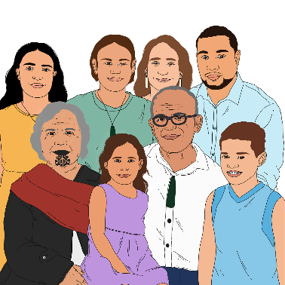

Disability funding can also be used to support the families / whānau of disabled people.

The funding can be used to:
give you more chances to live a good life
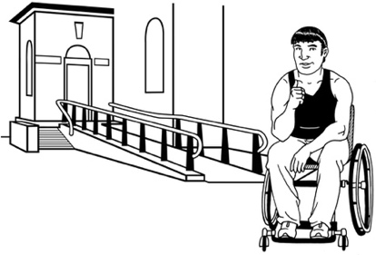
take away barriers that stop you from being able to do the things you want.

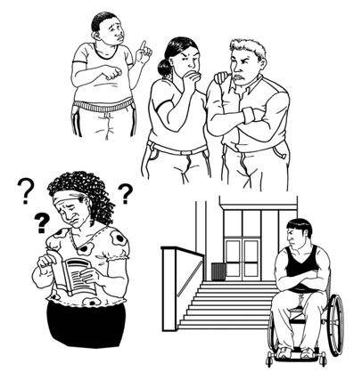
Barriers are things that make it harder for disabled people to live a good life like:
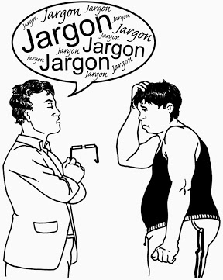
buildings that they cannot use / get into
information that is hard to understand
not being able to get the things / support they need to have a good life.

Disability funding can also be used for respite.

Respite is a way to give family / whānau a break from caring for someone.

You can find out more about respite on the webpage of Whaikaha – Ministry of Disabled People:

https://tinyurl.com/3sedk827

This information is not in Easy Read.

The kinds of funding you could get are called:
Individualised Funding called IF for short
Enhanced Individualised Funding called EIF for short
Carer Support.

How government disability funding works

Government disability funding only pays for costs that are about your disability.

It does not pay for all your living costs like:
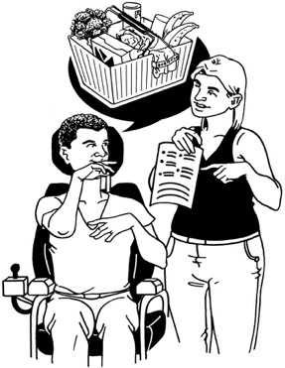
rent which is money you pay to a landlord to live in a house
food.

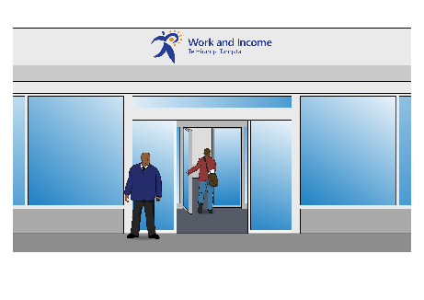
If you need money for rent or food you can ask Work and Income New Zealand if you can get:
a benefit which is money you can get if you cannot work
other money to support you.

Individualised Funding Hosts

Before you get your funding you will need to talk with:
a Needs Assessment Service Coordinator called NASC for short
or
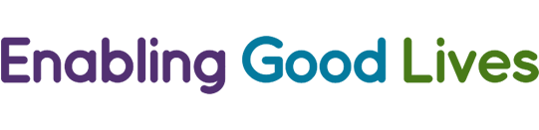
someone from the Enabling Good Lives team called EGL for short.

They can connect you with an Individualised Funding Host.

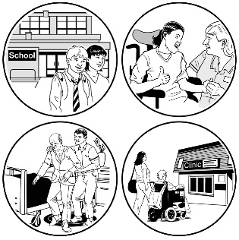
Individualised Funding Hosts are organisations that work for Whaikaha to support people getting funding.

Individualised Funding Hosts are sometimes called IF Hosts for short.

IF Hosts do not:
have any say in how much money you will get
tell you how to spend your money.
IF Hosts can work with you to make sure that the way you use your money:
is right for you as a person
follows the purchasing rules.

You do not need an IF Host to support you with funding for Carer Support.

Individual Service Plans
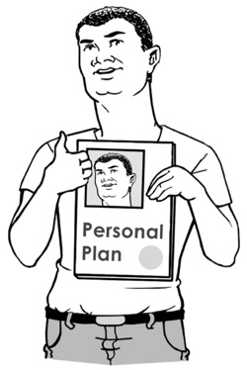

You will be asked to make an Individual Service Plan when you start to get individual funding.

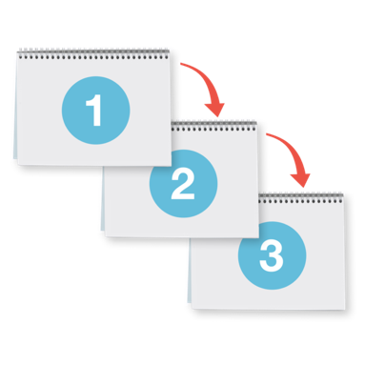
An Individual Service Plan is how you decide the way you want to use your disability funding.

It is called an ISP for short.

Having a clear ISP can help you to make good decisions about using your funding.

Your IF Host can help you write your ISP.

Your IF Host can also:
support you to change your plan if your needs change
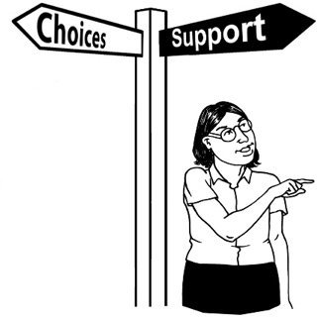
give you advice / guidance about how to make the most of your support.

You can also:
write your own plan
use your funding to pay someone to help you write your plan.

The best way to make sure you use the funding well is to:
be clear about what your plan is
use the rules in this guide before you buy anything.

Rules for spending disability funding

There are 4 rules that tell you how you can spend disability funding.

These rules are the same if you get:
IF / IEF
Carer Support.

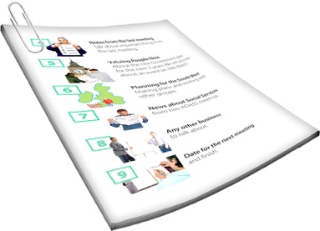
You must make sure the thing you want to buy fits the purchasing guidelines before you buy it.

Rule 1:
What you want to buy fits with the reasons you have the funding

and:
helps you live a good life
makes your life better.
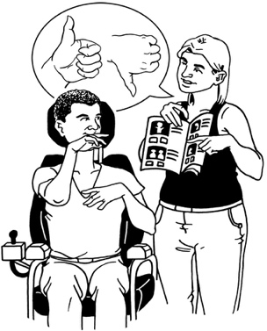

Rule 2:

It is a disability support.

This means that the funding is being used for something that you need because of your disability.

You cannot use the funding for something that you would still need if you were not disabled.

Rule 3:
The purchase must be:
reasonable
cost effective.

Reasonable means that:
the cost is usual / expected for the item
the item is a good use of the money.

Cost effective means something will
give good results without costing a lot of money.

Cost effective does not mean that the thing you buy must be cheap.
Sometimes it is better to buy something that will last a long time even if it costs more.

Rule 4:

It is something that you are allowed to buy.

This means that it is something that:
is not against the law like drugs
you have enough funding to buy
you cannot get other funding to pay for
follows the way you are supposed to do things like paying people to support you.

Things you cannot use the funding for

You cannot use disability funding for:
anything that is against the law
alcohol
tobacco / smoking products
gambling like buying a lottery ticket
things that are not a cost of disability
money for yourself
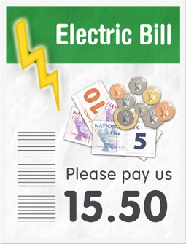
things that everyone else has to pay for like bills unless they are related to your disability.

Employing support workers

If you use the funding to employ support workers you must:
follow the laws about employment
be a good employer.
Employ means you pay someone for work they do.

You can talk to your Funding Host about how to do this properly.

Examples of how to use the funding

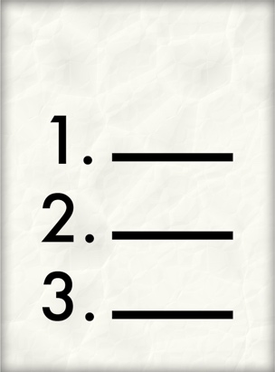
This part of the guide shows some examples of how you might use the funding.

Example 1:
Example 1 talks about a disabled person called Joelene.

Joelene has funding for:
personal care
respite.

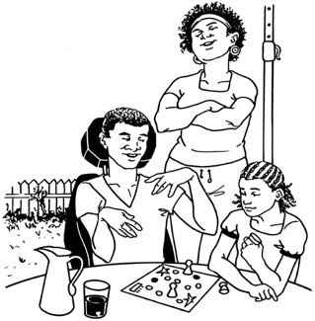
Joelene lives with her whānau / family who care for her.

In her plan Joelene says she wants to spend 1 weekend in every month at a hotel.

Joelene can use her respite funding to pay for her support worker to stay with her.

Joelene will have to use her own money to pay for other costs of going away like paying for:
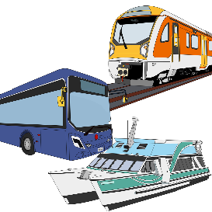
where she will stay
any transport she uses to get there like train / taxi.

This way of using her funding fits with the rules because it:
is individual which means it fits with what Joelene wants to do
means Joelene can spend time away from her family
is included in her plan
fits with why she has funding.

Example 2:

Example 2 talks about a person called Billie who has a sight disability.

Billie wants to be a photographer.

Billie goes to photography classes.

Billie needs to buy some technology to support her to see better.

Billie can use Rule 2 to purchase the technology because:
this is an extra cost
the extra cost is as a result of disability
the technology will make it possible for her to access information she needs.

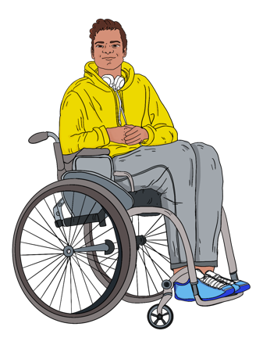
Example 3:

Example 3 talks about a person called Alex who has a physical disability.

Alex needs a new wheelchair that is lighter than the 1 he has.

His old wheelchair is too heavy for his support people to lift into their car.

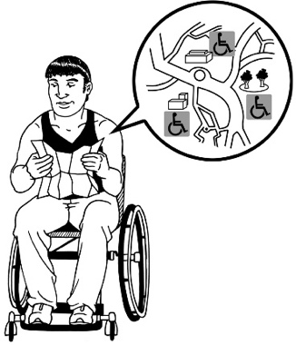
Alex needs to use a wheelchair to get into / around the community.

Alex has tried to get funding from:
lotteries that give money to New Zealand communities
other funding charities
Equipment Management Service called EMS for short.

Lotteries told Alex that he would have to wait 4 to 6 months to get any money.
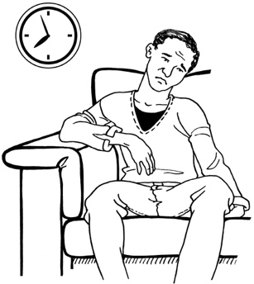

This is too long for Alex to wait.

EMS said they would pay for some of the cost of a new wheelchair.

Alex will use Individualised Funding to pay the rest of the cost.
Using the funding guidelines Alex can use disability funding to pay for the rest of the cost because:
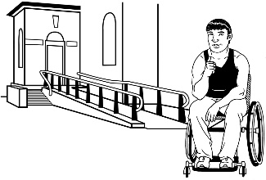
it fits with his plan to go into the community
it is a cost related to his disability
he has used other funding that will pay for part of it
it is a cost effective use of funds.

Where to find more information

If you have any questions about disability funding you can ask your:
IF Host
EGL team.

They will be able to support you by:
understanding your needs
working with you to decide what is best for you
changing your plan with you
checking that the choices you make fit with the purchasing guidelines.

If you have more questions about funding you can contact Whaikaha – Ministry of Disabled People by:
phone on:

0800 566 601
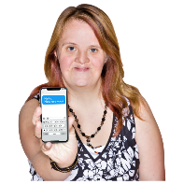
text message on:

4206
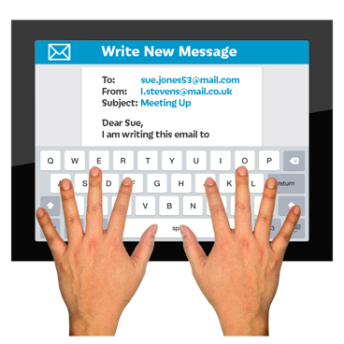
email at:

contact@whaikaha.govt.nz

Carers New Zealand can also answer any questions you have about disability funding.

You can contact Carers New Zealand by:
phone on:

0800 777 797
going to their website at:

https://carers.net.nz

Enable NZ has a website called Firstport that has lots of information on funding.
You can find the Firstport website at:
https://firstport.co.nz

This information has been written by Whaikaha – Ministry of Disabled People

It has been translated into Easy Read by the Make it Easy Kia Māmā Mai service of People First New Zealand Ngā Tāngata Tuatahi.
The ideas in this document are not the ideas of People First New Zealand Ngā Tāngata Tuatahi.
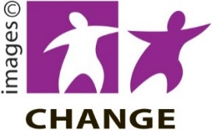
Make it Easy uses images from:

- Changepeople.org

- Photosymbols.com

- SGC Image Works

- Huriana Kopeke-Te Aho
- T. Wood.
All images used in this Easy Read document are subject to copyright rules and cannot be used without permission.

