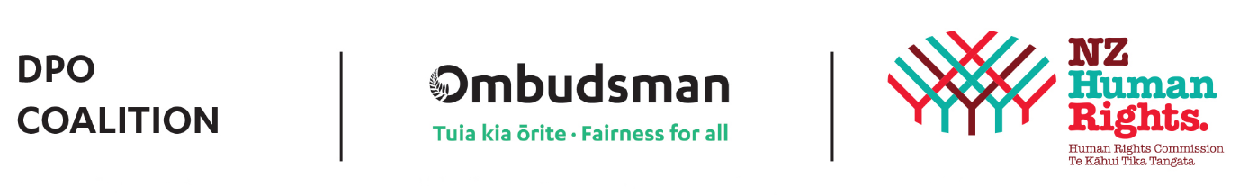
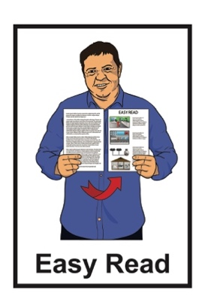

Disabled People’s Organisations Coalition: Key Messages from July 2024
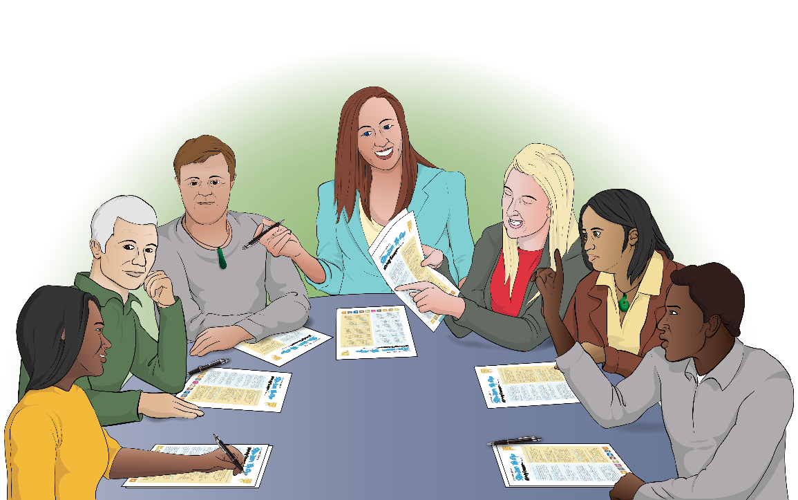

Published: October 2024

What you will find in this document

Page number:

The Disabled People’s
Organisations Coalition 3
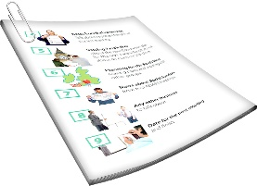

What is this document about? 6

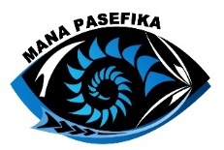
Welcome to Mana Pasefika 8

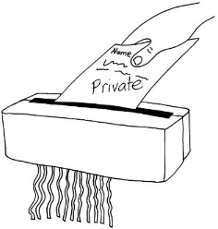
Archives New Zealand – Disposal
of Care Records Consultation 9

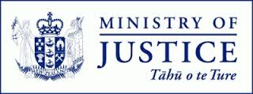
Ministry of Justice Human Rights
Policy Team 15

Page number:

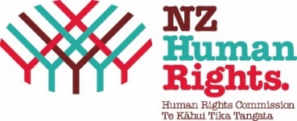
Disability Rights Commissioner 20


New Zealand Transport Agency –
Waka Kotahi 24

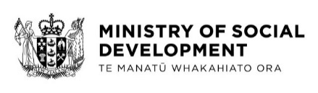
Ministry of Social Development 28


Ministry of Disabled People –
Whaikaha 33

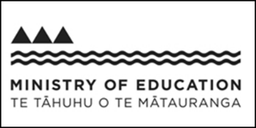
Ministry of Education and
Tūhono Collective 39

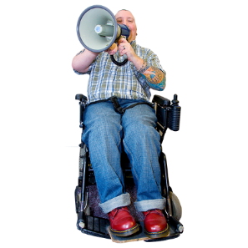
Voice of disabled people 44

The Disabled People’s Organisations Coalition


The Disabled People’s Organisations Coalition is a group of people who come from different disability organisations.


A coalition is a group of organisations that work towards shared goals.

The Disabled People’s Organisations Coalition is also called the DPO Coalition.


When you see the words we / us in this Easy Read it means the DPO Coalition.

The DPO Coalition is made up of members from these 7 disability organisations:
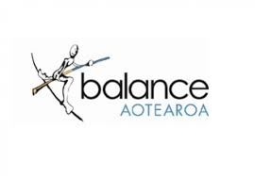
Balance Aotearoa
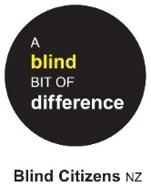
Blind Citizens New Zealand
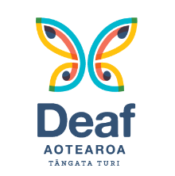
Deaf Aotearoa
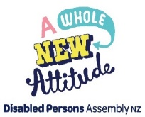
Disabled Persons Assembly NZ
Mana Pasefika
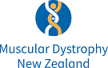
Muscular Dystrophy Association of New Zealand
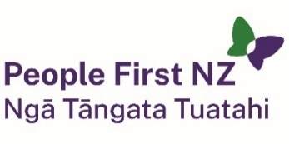
People First New Zealand – Ngā Tāngata Tuatahi.


The DPO Coalition meets about every 6 weeks to talk about important things.

The DPO Coalition speaks up about disabled people getting their human rights.

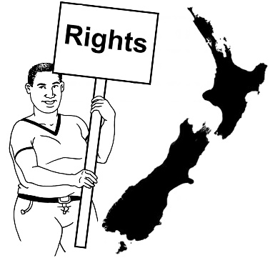
Human rights are things that the law says every person should:
have
be able to do.

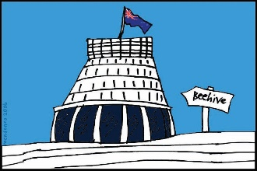
The DPO Coalition talks with the Government about things to do with disability.

What is this document about?
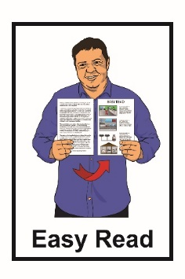

This is an Easy Read document about some of the key messages from the DPO Coalition meetings in July 2024.


During these meetings the DPO Coalition met with lots of:
government agencies
other community organisations.
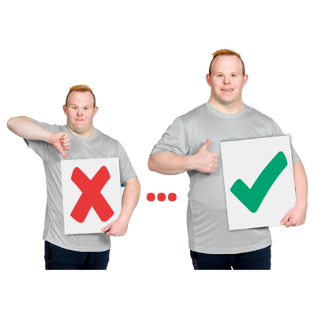

The meetings are to make sure the lives of disabled people in New Zealand are getting better.

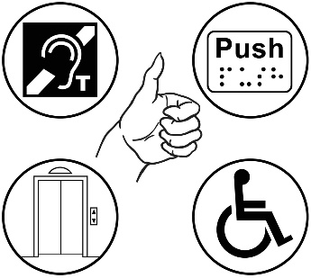
The 2 key things often talked about at DPO Coalition meetings are:
accessibility
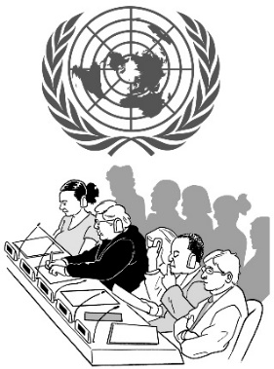
upholding the rights of disabled people under the United Nations Convention on the Rights of Persons with Disabilities.
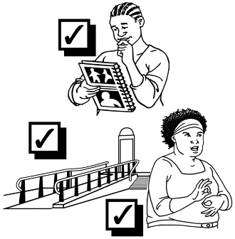

Accessibility means making things easier / safe for everyone to use.

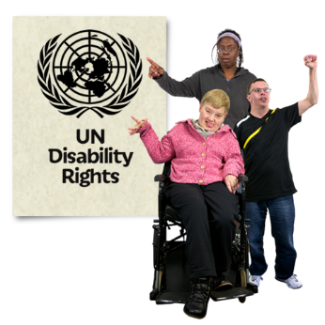
The United Nations Convention on the Rights of Persons with Disabilities / UNCRPD is a law lots of countries have agreed to.
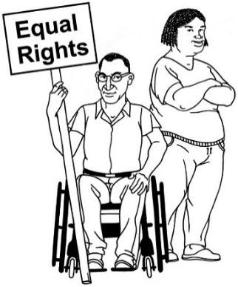

It says what governments must do to make sure disabled people get the same rights as everybody else.

Welcome to Mana Pasefika

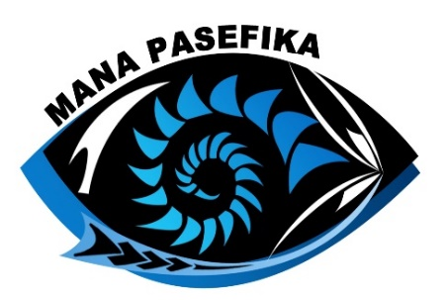
Mana Pasefika is a new member of the DPO Coalition.

The people from Mana Pasefika at the DPO Coalition meetings were:
Pati Umaga

LJ Apaipo.

The DPO Coalition do not usually take photos.

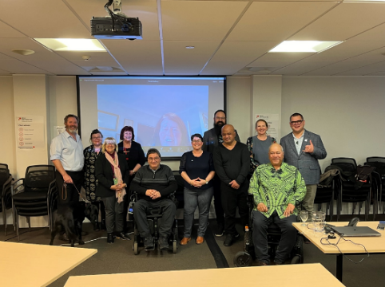
The DPO Coalition took a photo together because it was the first meeting Pati and LJ came to.

Archives New Zealand – Disposal of Care Records Consultation

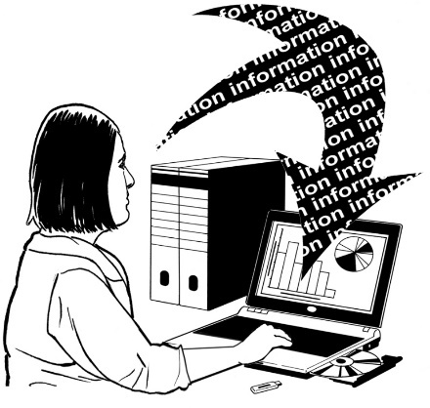
We met with 2 people from Archives New Zealand:
Susan Jenkins – Archivist
Belinda Battley – Principal Advisor.
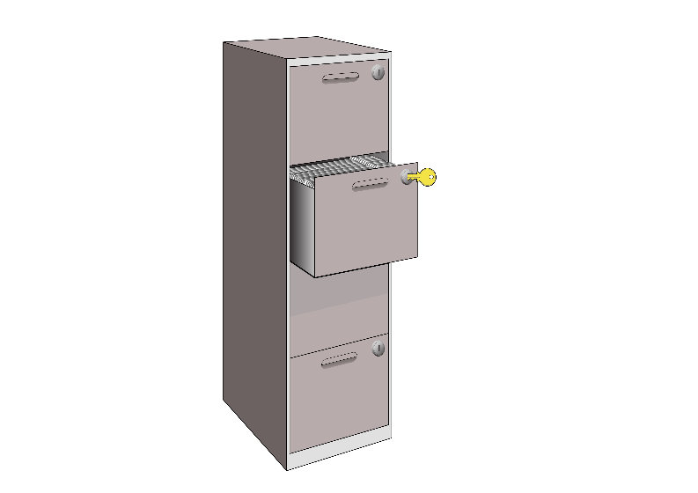

Archives New Zealand looks after important Government information.

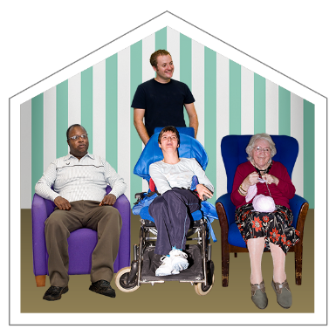
Archives New Zealand looks after information about people who were in state care.

State care is when the Government is in charge of looking after you.
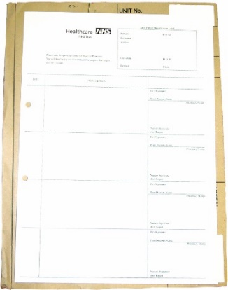
This information is called care records.

A record is written information about what happened to someone.

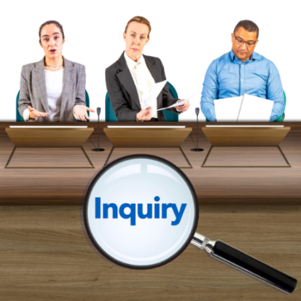
New Zealand has done a Royal Commission of Inquiry into Abuse in Care.

The Royal Commission of Inquiry into Abuse in Care is called the Royal Commission for short.

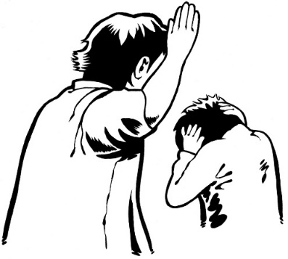
The Royal Commission found out information about how people were hurt in state care.

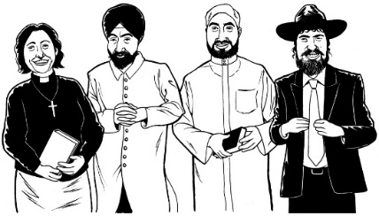
It also found out information about how people were hurt in faith-based care.


Faith-based care is when a religious group like a church is in charge of looking after you.


The Royal Commission said the Government needed to be careful about throwing away care records.


The Government needs to make sure they do not throw any care records away by accident.


The government needs to properly destroy care records if they do get thrown away.

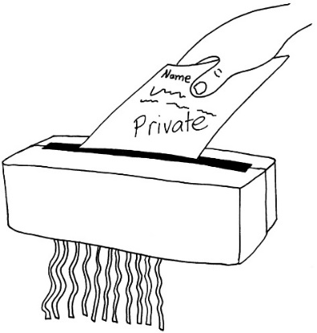
Properly destroying records makes sure that no one sees private information.

Archives New Zealand told us what they are doing to make sure the Government is looking after care records.


The Government can only throw care records away when they are sure they are allowed to.

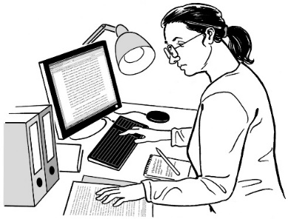
There is still a lot we need to learn before Archives New Zealand can be sure the government is being careful about throwing away care records.

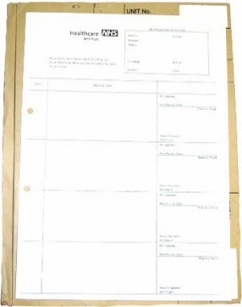
This meeting told the DPO Coalition more about what Archives New Zealand needs to learn.

Archives New Zealand only looks after original care records.


An original record is the first version of a record.


Sometimes people make copies of an original record.

We do not know who should be looking after copies of care records.


This makes it hard to know how to keep the information in copies of care records safe.

Archives New Zealand will need to keep the information in care records safe in lots of different ways.

Ministry of Justice
Human Rights Policy Team

We met with 2 people from the Ministry of Justice Human Rights Policy Team:
Anna Johnston
Carl Blackmun.

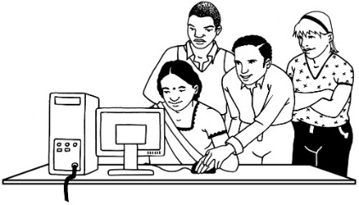
The Human Rights Policy Team makes sure New Zealand protects human rights.

Human rights are things that the law says every person should:
have
be able to do.
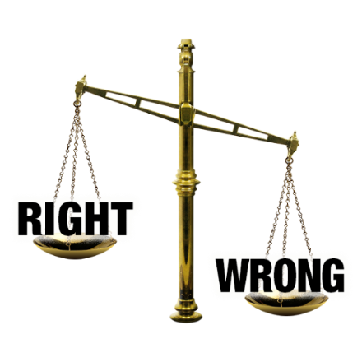
The Human Rights Policy Team protects human rights by making sure:
New Zealand laws about human rights are fair
New Zealand follows international laws about human rights.

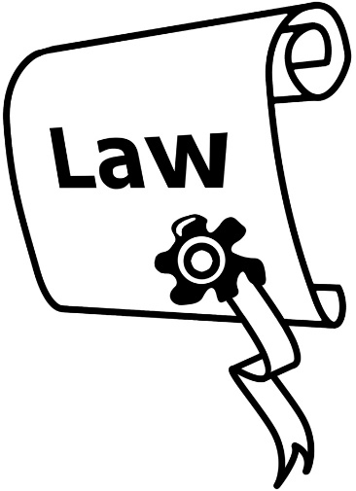
International laws are rules that all countries have to follow.

One international law about human rights is called the International Covenant on Economic, Social and Cultural Rights.

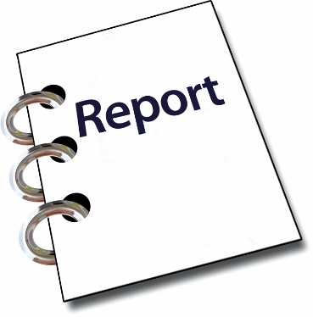
The Human Rights Policy team told us they are writing a report about the International Covenant on Economic, Social and Cultural Rights at the moment.

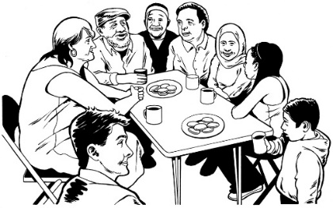
They told us they want to meet with people in the community more often.


Meeting with people in the community more often will mean they can:
build relationships
share information about human rights issues between the Government and the community.

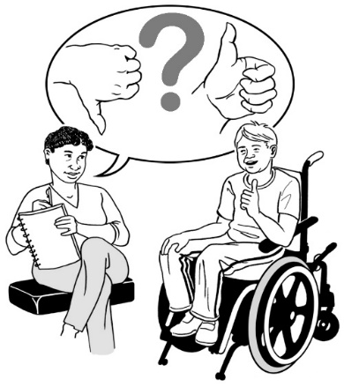
In the future the DPO Coalition will be able to tell the Ministry of Justice what we think about how other international human rights laws are working in New Zealand.

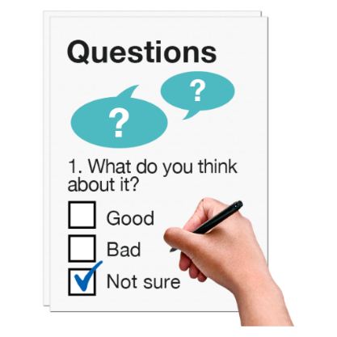
The DPO Coalition already tells the United Nations what we think about how New Zealand is following the United Nations Convention on the Rights of Persons with Disabilities.
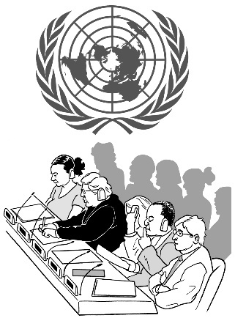

The United Nations is a group of different countries who work together to sort out problems.

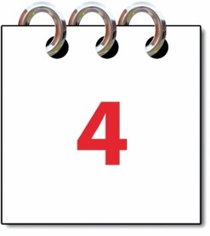
The United Nations only checks how New Zealand is following the United Nations Convention on the Rights of Persons with Disabilities every 4 years.

Talking to the Ministry of Justice means we can make sure New Zealand follows international human rights law all the time.

Disability Rights Commissioner

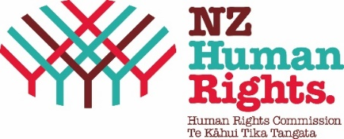
We met with 2 people from the Human Rights Commission:
Prudence Walker – Disability Rights Commissioner
Frances Anderson – Senior Human Rights Advisor.

The Human Rights Commission protects human rights in New Zealand.

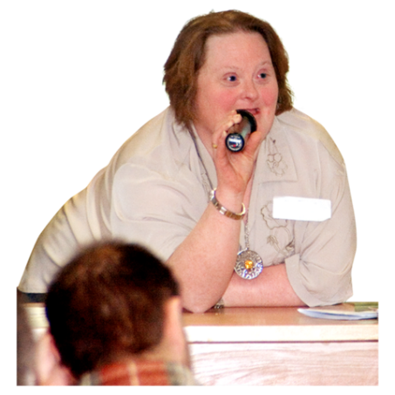
Human rights are things that the law says every person should:
have
be able to do.

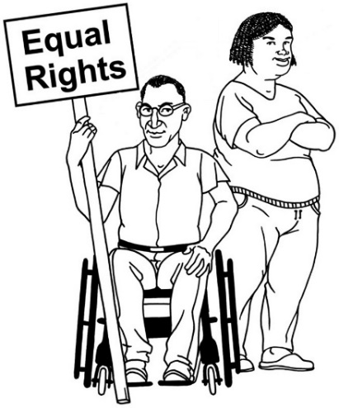
The Disability Rights Commissioner protects the rights of disabled people in New Zealand.

There has been lots of change at the Human Rights Commission.


There are only 2 Human Rights Commissioners at the moment.


There are usually 3 or 4 Human Rights Commissioners.

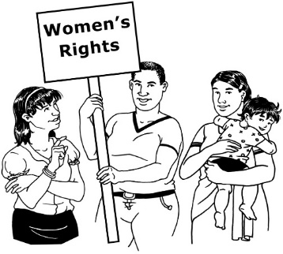
The Human Rights Commission told us they are doing some work on the Convention on Elimination of Discrimination Against Women.

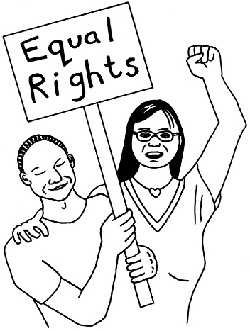
The Convention on Elimination of Discrimination Against Women is an international human rights law that works to stop women being treated unfairly.

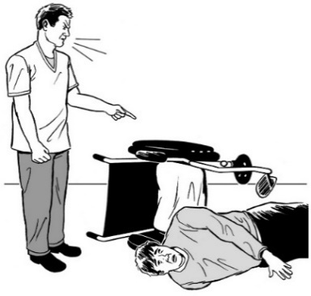
The Disability Rights Commissioner told us they had recently been to Thailand to do some work on the Optional Protocol to the Convention Against Torture.

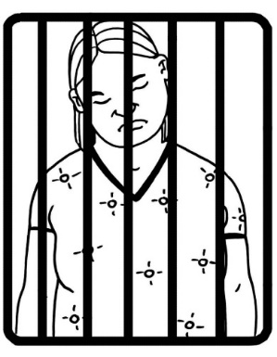
The Optional Protocol to the Convention Against Torture works to stop people in prison from being treated badly.

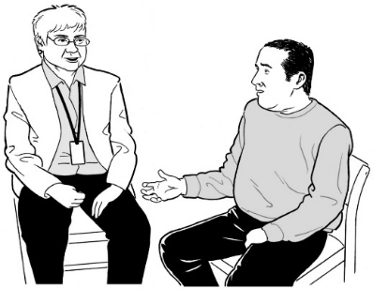
It makes sure independent people visit prisons regularly to make sure people are being treated well.


An independent person is someone who does not work at the prison they are visiting.

New Zealand Transport Agency – Waka Kotahi


We met with 2 people from the New Zealand Transport Agency – Waka Kotahi:
Freddie Engberts
Matt Waight.

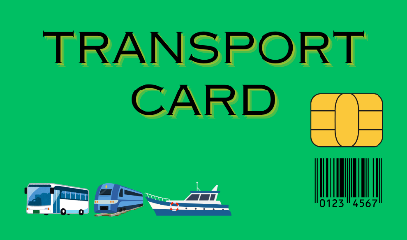
They told us about the National Ticketing Solution.

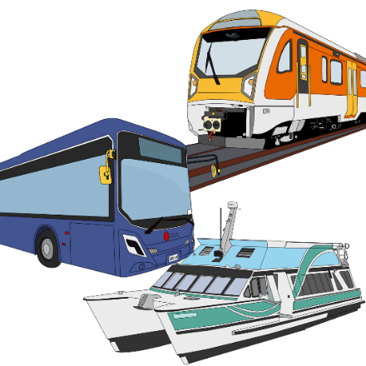
The National Ticketing Solution will mean everyone in New Zealand can pay for public transport like buses or trains the same way.

This means you will not need to buy a new card to pay for public transport if you go to a new city.
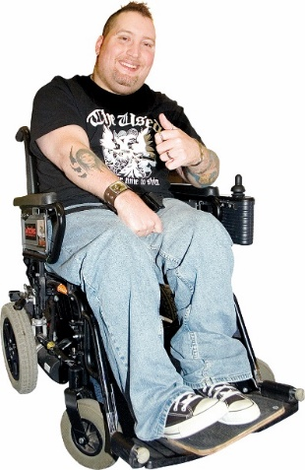

The New Zealand Transport Agency – Waka Kotahi wants to make sure the National Ticketing Solution is easy to use.


People will still be able to get concessions when they use the National Ticketing Solution.

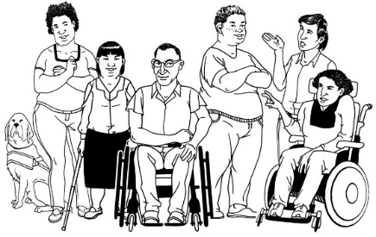
A concession is when you pay less for public transport because you:
- are disabled
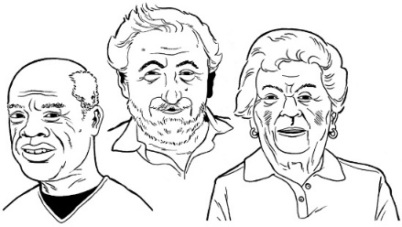
- are over 65 years old
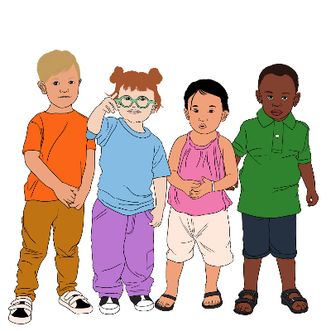
- have a Community Services Card
- are a student
- are a child.

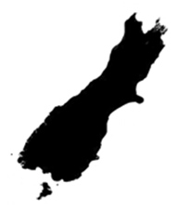
Timaru will start using the National Ticketing Solution in December this year.

Christchurch will start using the National Ticketing Solution in early 2025.

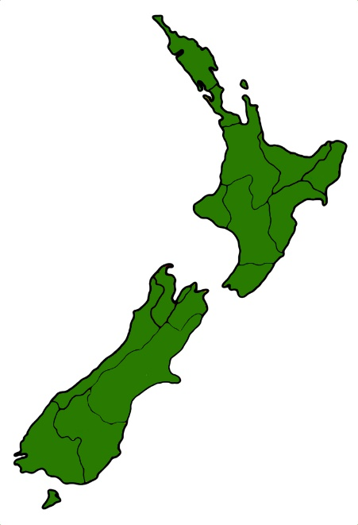
Other parts of New Zealand will start using the National Ticketing Solution next.

The last places to start using the National Ticketing Solution will be
Auckland
Wellington.

Ministry of Social Development

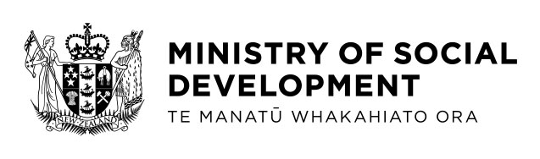
The Ministry of Social Development has done some research with:

disabled people
people with long-term health conditions.

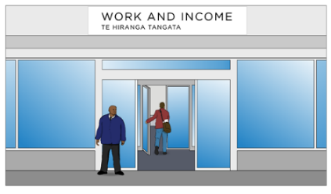
They looked at how people experience:
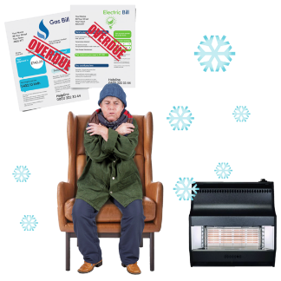
income support
material hardship.


Income support is money the government gives you if you:
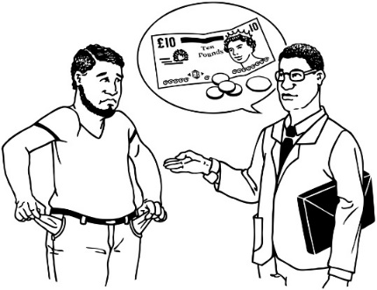
do not have a job
do not get enough money from your job to live.


Material hardship means not having enough money to pay for important things like:
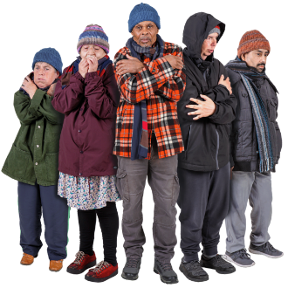
food
warm clothes
shoes.

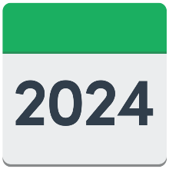

The Ministry of Social Development stopped getting money for this research on 30 June 2024.


We already know that:

disabled adults are over 3 times more likely to be in material hardship than non-disabled adults
disabled children are over 2 times more likely to be in material hardship than non-disabled children.
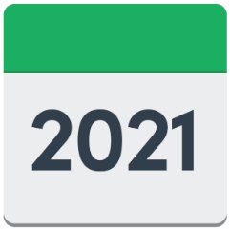

This information is from 2021.

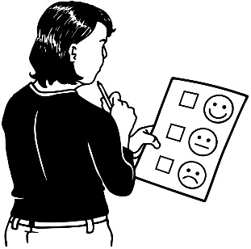
It comes a survey called the Household Economic Survey.

A survey is when you ask a lot of people questions to find out what they think about something.

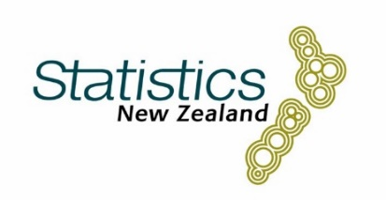
Statistics New Zealand runs the Household Economic Survey.

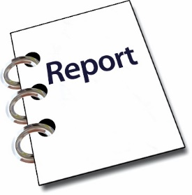
The Ministry of Social Development will write a report to explain what they found out in their research.
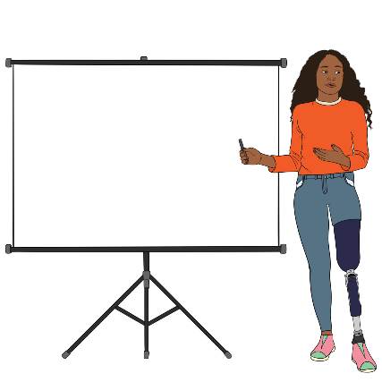

They will tell the Minister for Social Development what the report says.

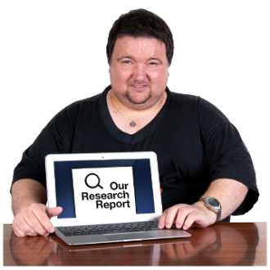
Everyone will be able to read the report on the Ministry of Social Development website.

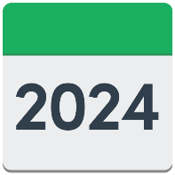

The report will be on the Ministry of Social Development website by the end of 2024.

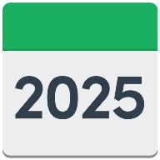
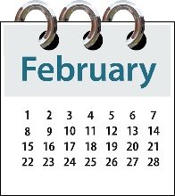
The report will be published in a journal in February 2025.

A journal is a magazine where you can read research.

Ministry of Disabled People – Whaikaha


We met with 2 people from the Ministry of Disabled People – Whaikaha:
Ben O’Meara – Deputy Chief Executive
Kerry Morgan – Senior Advisor.

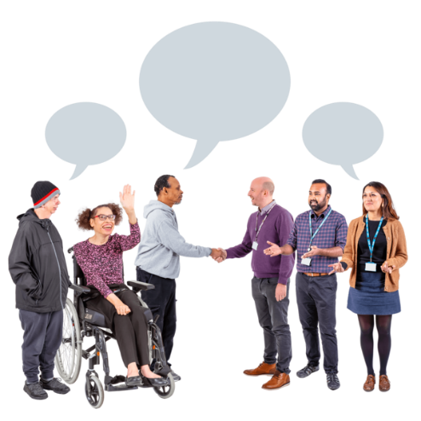
The Ministry of Disabled People – Whaikaha is also called MoDP for short.

We talked about lots of things with MoDP.

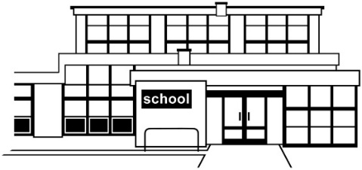
MoDP talked about:
Residential Special Schools
inclusive education.

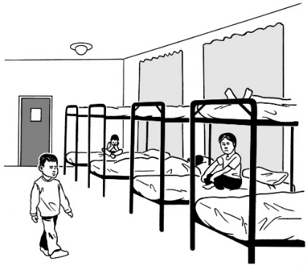
A Residential Special School is a type of school for disabled students.

Students at a Residential Special School live at school.

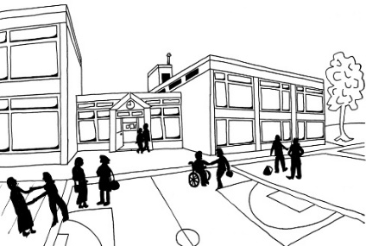
Inclusive education is when disabled children attend the same schools as other children.

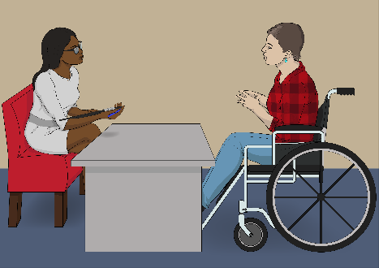
We talked about when the DPO Coalition will next meet with the Minister for Disability Issues.

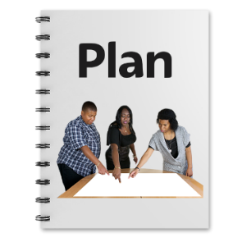
We talked about what is happening with the new Disability Action Plan.

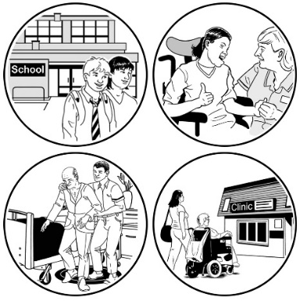
The Disability Action Plan tells the government how to make sure disabled people get the services they need in New Zealand.

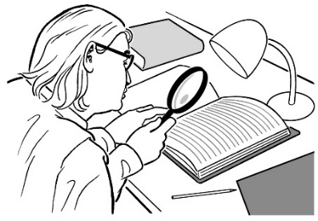
MoDP told us what was happening with the Independent Review – Disability Support Services.

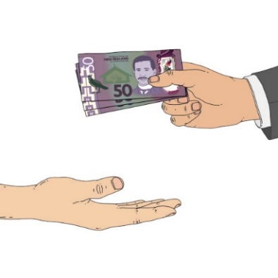
The Independent Review – Disability Support Services is about making sure disabled people can rely on support from the government.

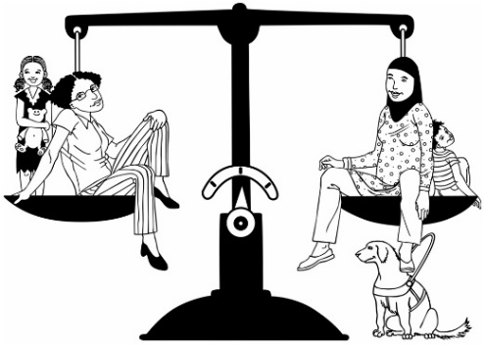
It is about making sure Disability Support Services:
keep going
are fair.

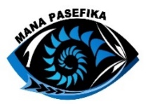
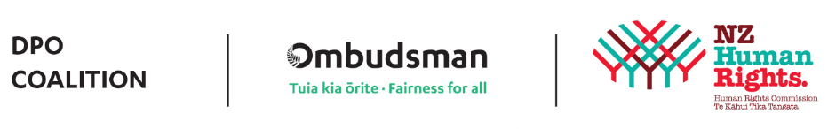
We told MoDP that Mana Pasefika has joined the DPO Coalition.

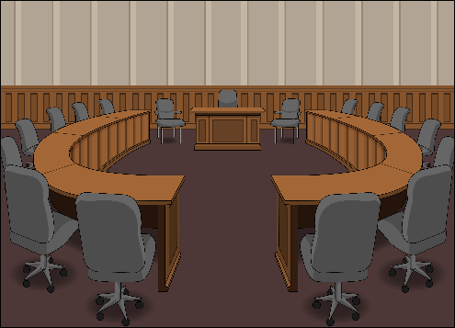
MoDP talked about the Commonwealth Heads of Government meeting.

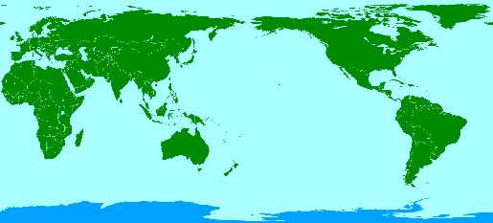
The Commonwealth is a group of 56 countries that work together.

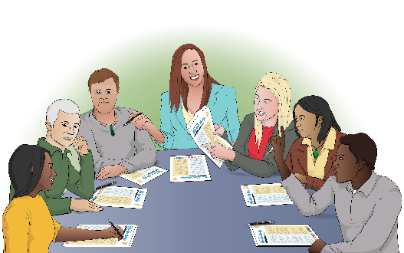
The Commonwealth Heads of Government meeting is where the Commonwealth countries meet to talk about the work they do together.

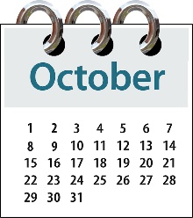
The Commonwealth Heads of Government meeting will be in Samoa in October 2024.


MoDP told us what is happening with My Home, My Choice.

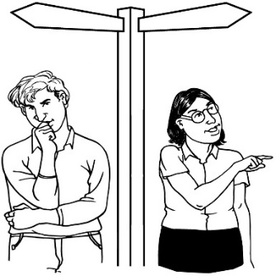
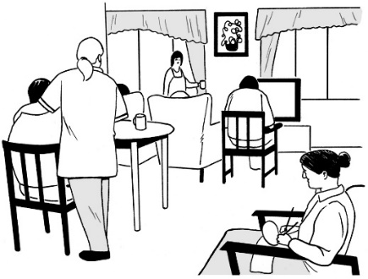
My Home, My Choice is about making sure people who live in homes for disabled people can live their lives with more:
choice
control.

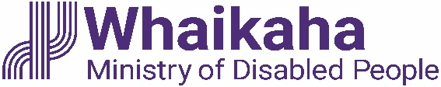
MoDP told us how they work with the Ministry of Justice to make sure disabled people have their human rights protected in New Zealand.

Ministry of Education and Tūhono Collective

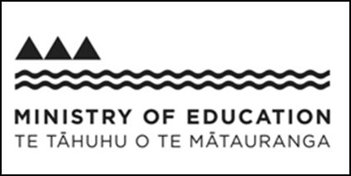
We met with people from:
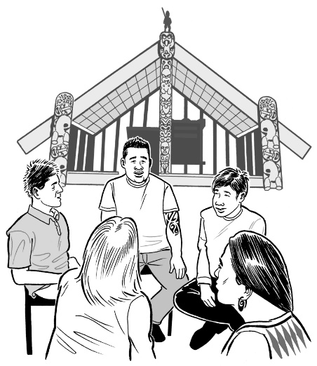
the Ministry of Education
the Tūhono Collective.

The Tūhono Collective supports people sort disputes using Māori:
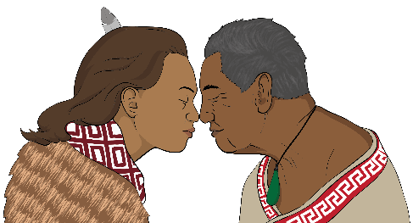
beliefs / ideas
ways of doing things.
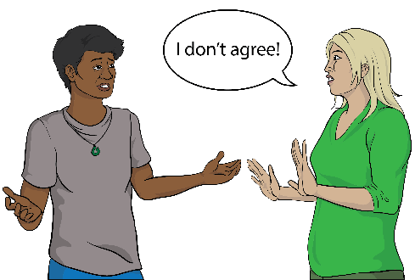

A dispute is when you disagree with someone.

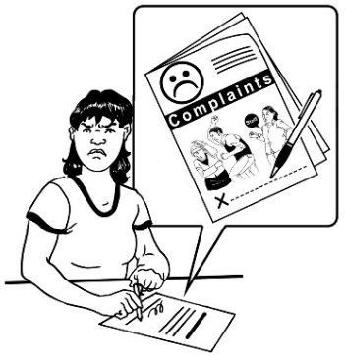
The Ministry of Education wants to create better ways of solving sensitive claims.

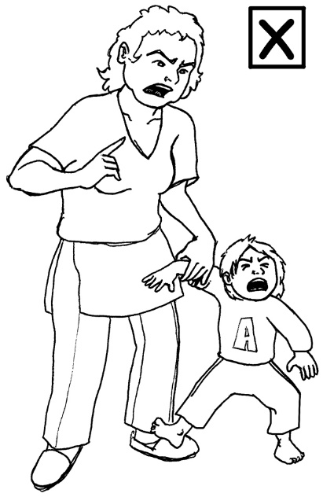
A sensitive claim is when:
someone was abused in a New Zealand state school
a person would like the Ministry of Education to do something to make up for the abuse.
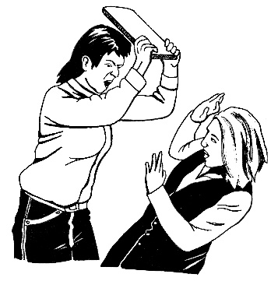

Abuse is when someone is badly hurt.

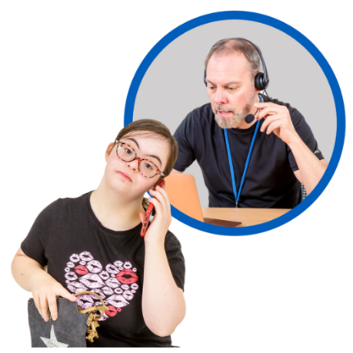
The Ministry of Education wants to make sure the way they sort out sensitive claims meets the needs of:
the person
their whānau / family.

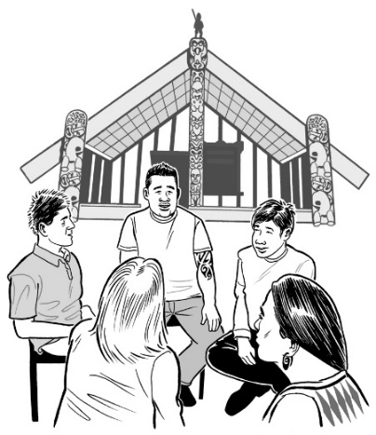
The Ministry of Education wants to sort out sensitive claims in a way that uses tikanga / Māori values and practices.

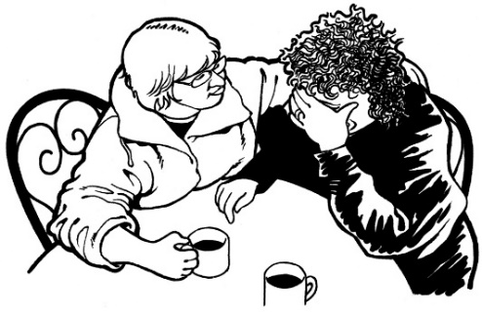
They want to make sure when people have a sensitive claim:
they can tell their story
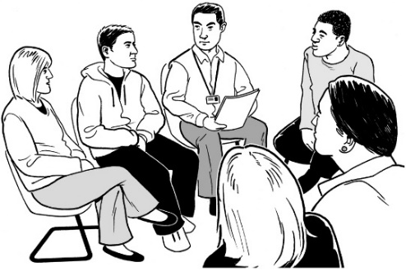
they get told sorry
they get something to make up for the abuse
they get support to be well.

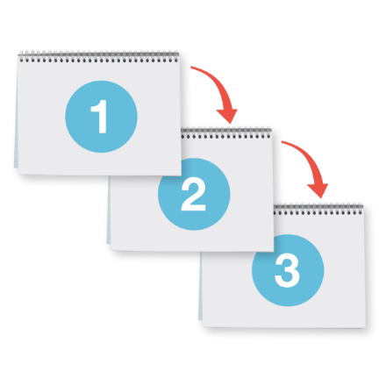
The Ministry of Education has asked the Tūhono Collective to help them find a good way to sort out sensitive claims.

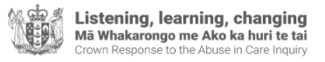
This is not the same as the work the Crown Response Unit is doing.

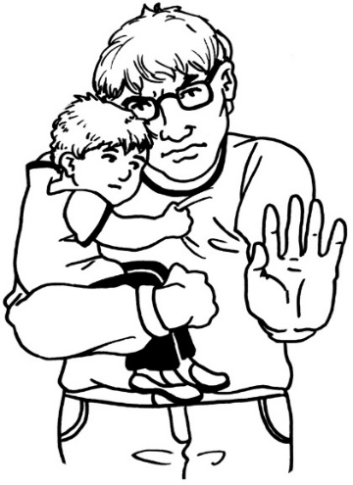
The Crown Response Unit is part of the Government set up to respond to the Royal Commission of Inquiry into Abuse in Care.

It works to make sure people are never hurt in state care again.

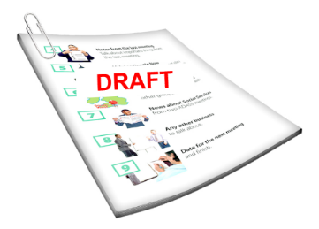
We talked to the Tūhono Collective about:
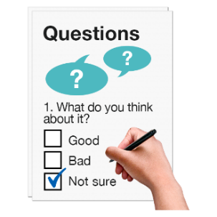
their draft process for sort out sensitive claims
how they will get feedback on their draft process.

Voice of disabled people

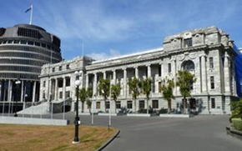
The DPO Coalition is the first place the Government goes to when they want to hear from disabled people.
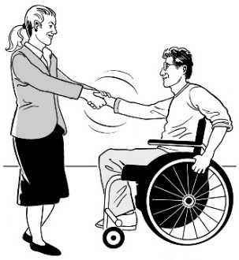

The DPO Coalition is always looking for new organisations to join us.
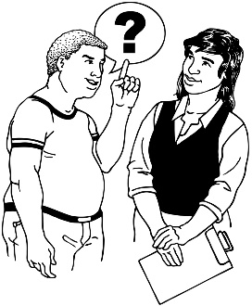

NO

New members must represent disabled people who are not already represented by another organisation.

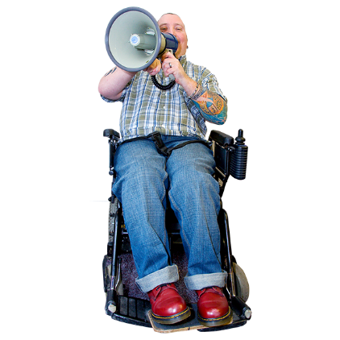
Represent means to speak up for a group of people about something important to them.

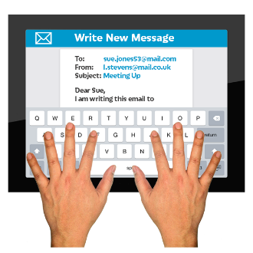
You can contact us by emailing us at:

us-dpo@groups.io

This information has been written by the DPO Coalition.

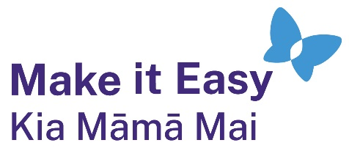
It has been translated into Easy Read by the Make it Easy Kia Māmā Mai service of People First New Zealand Ngā Tāngata Tuatahi.
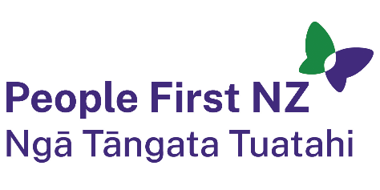
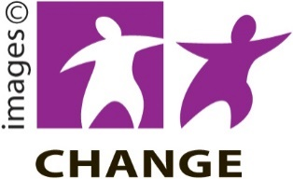
The ideas in this document are not the ideas of People First New Zealand Ngā Tāngata Tuatahi.

Make it Easy uses images from:


- Changepeople.org

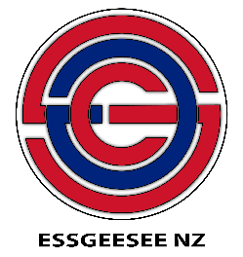
            - Photosymbols.com

- SGC Image Works
- Huriana Kopeke-Te Aho
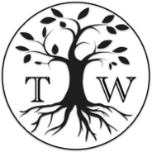
- T. Wood.

All images used in this Easy Read document are subject to copyright rules and cannot be used without permission.

