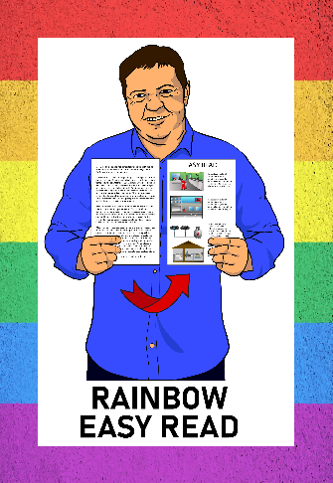
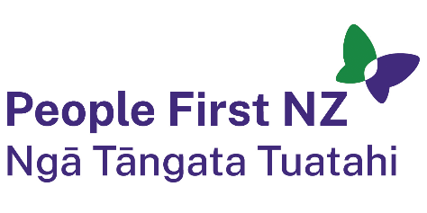
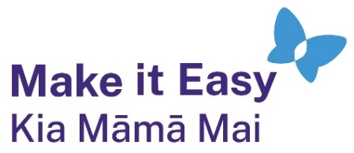

Rainbow Easy Read:

What do I say?
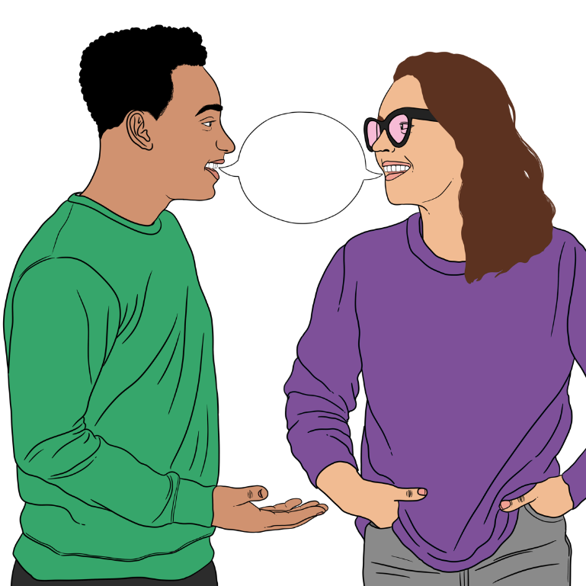


Published: February 2025

What you will find in here

Page number:

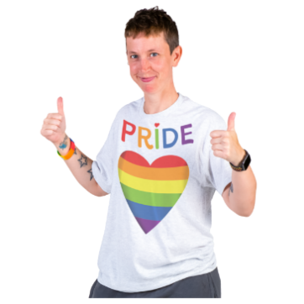
About this guide 3

What will people say to me? 6
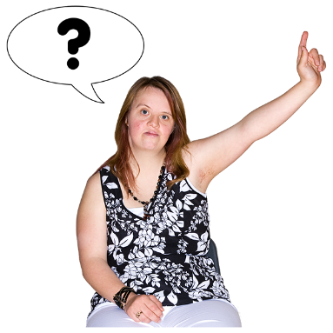

When friends and family ask
questions 13


When strangers ask questions 20

What to say to support your
rainbow friends 25

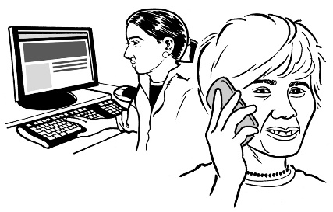
More information 29

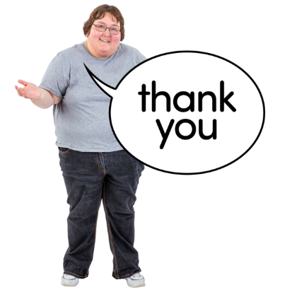
Thank you 31

About this guide

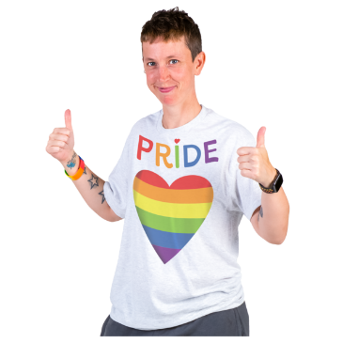
This is a guide to having some of the right things to say:
as a rainbow person
to people in the rainbow community.

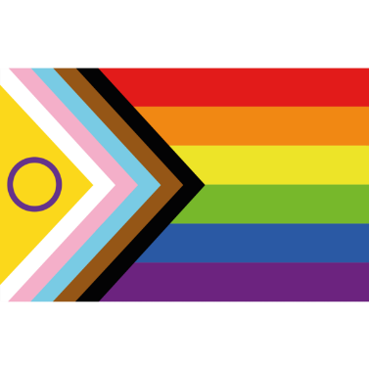
The rainbow community is also sometimes called the LGBTQIA+ community.

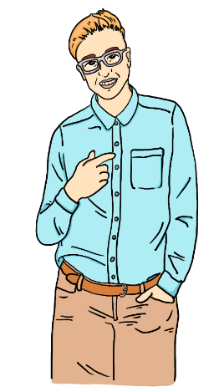
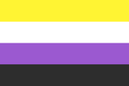
This document has stories.

Each story will talk about:
a rainbow person

and
how they deal with things people say to them.

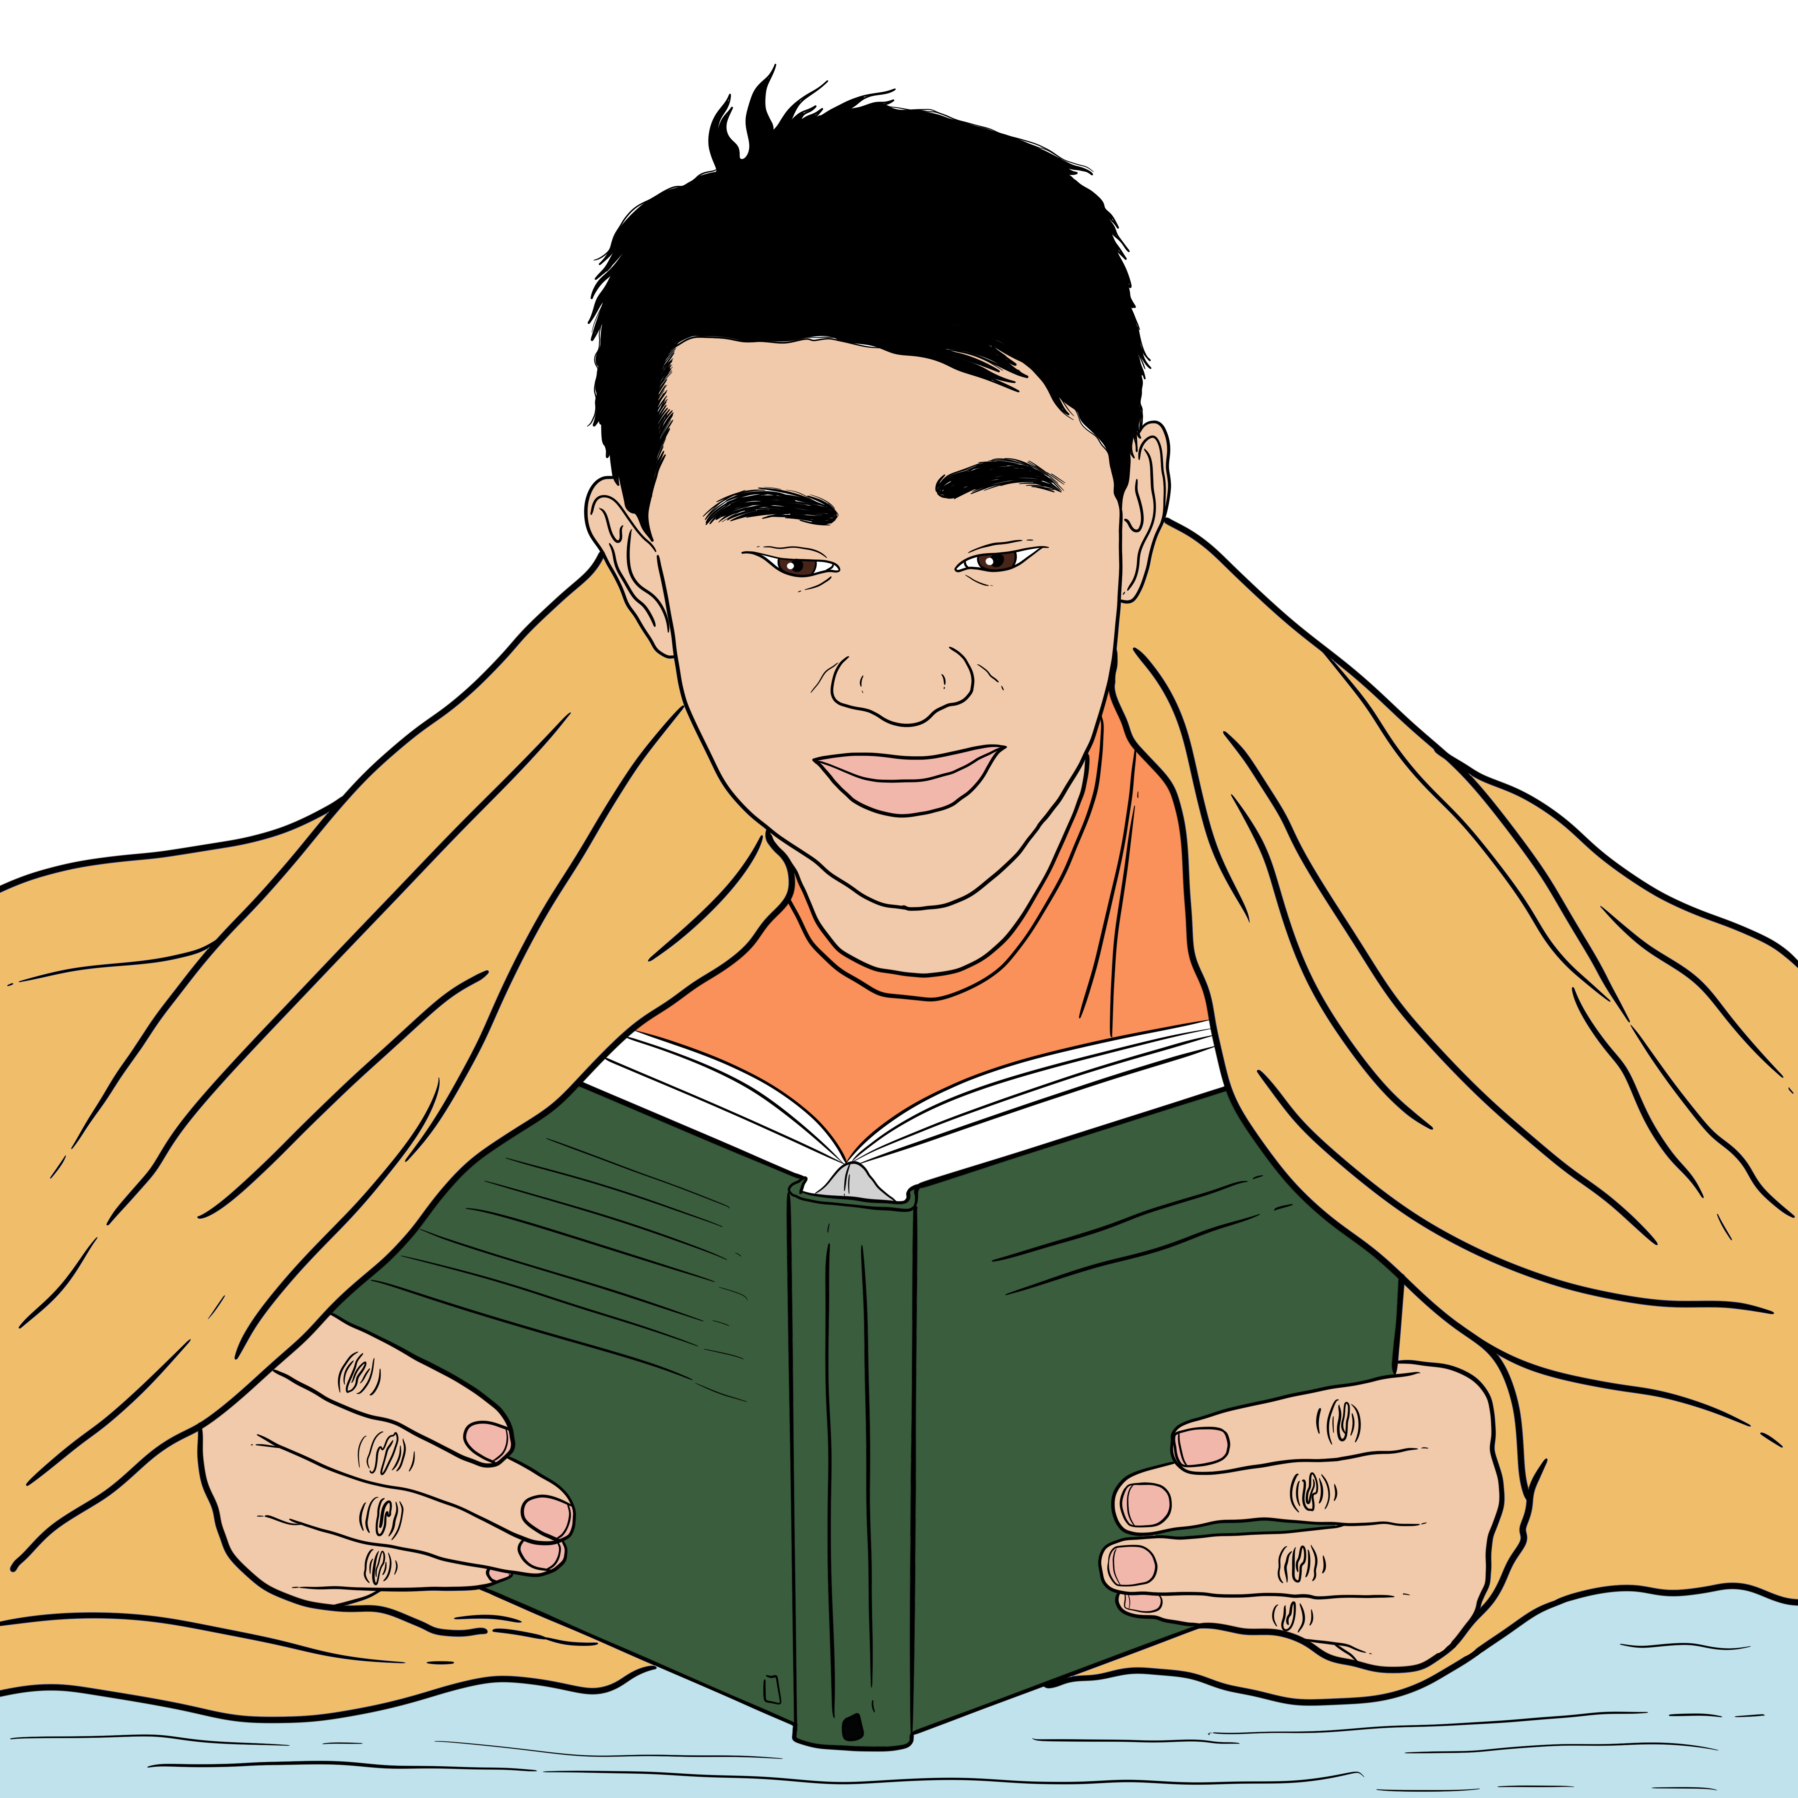
The stories are not about real people.

The stories will be in a yellow box
like this.

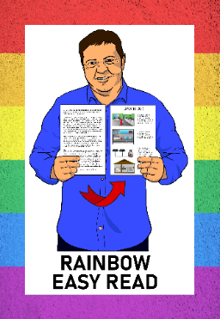
This guide is part of the Rainbow Resources Project.

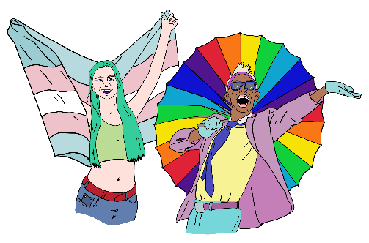
The Rainbow Resources Project is a group of Easy Reads for:
people in the rainbow community
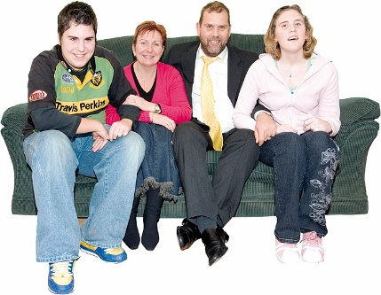
their friends
their whānau / families
people who support them.


You can find all the Rainbow Easy Reads at:

linktr.ee/rainboweasyread

What will people say to me?

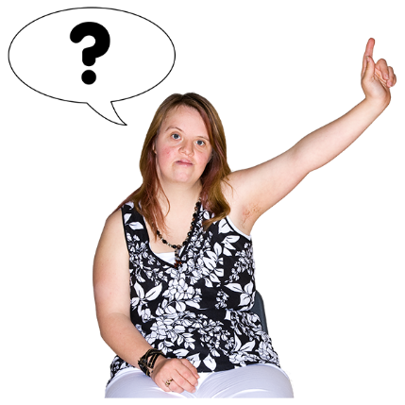
If you are a rainbow person you may get asked questions about your:
sexuality
gender.

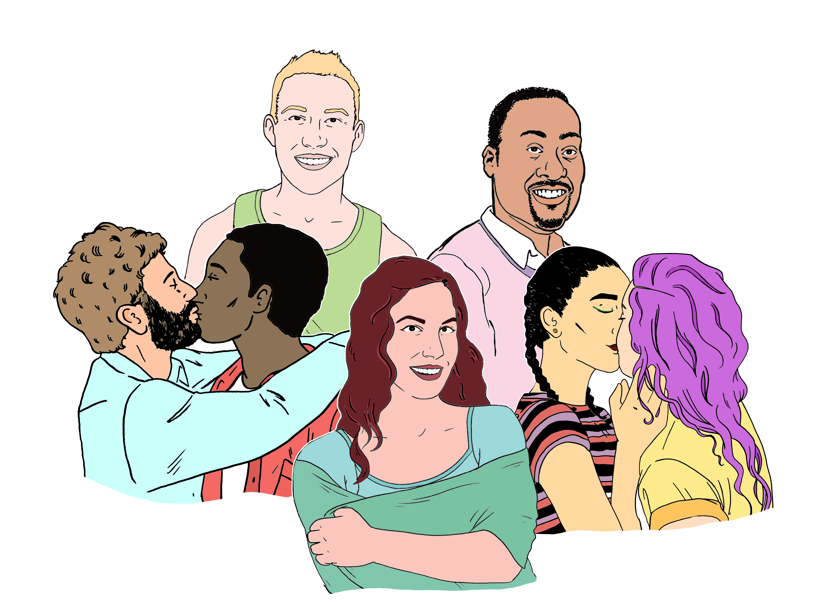
Sexuality is things like:
who you are attracted to
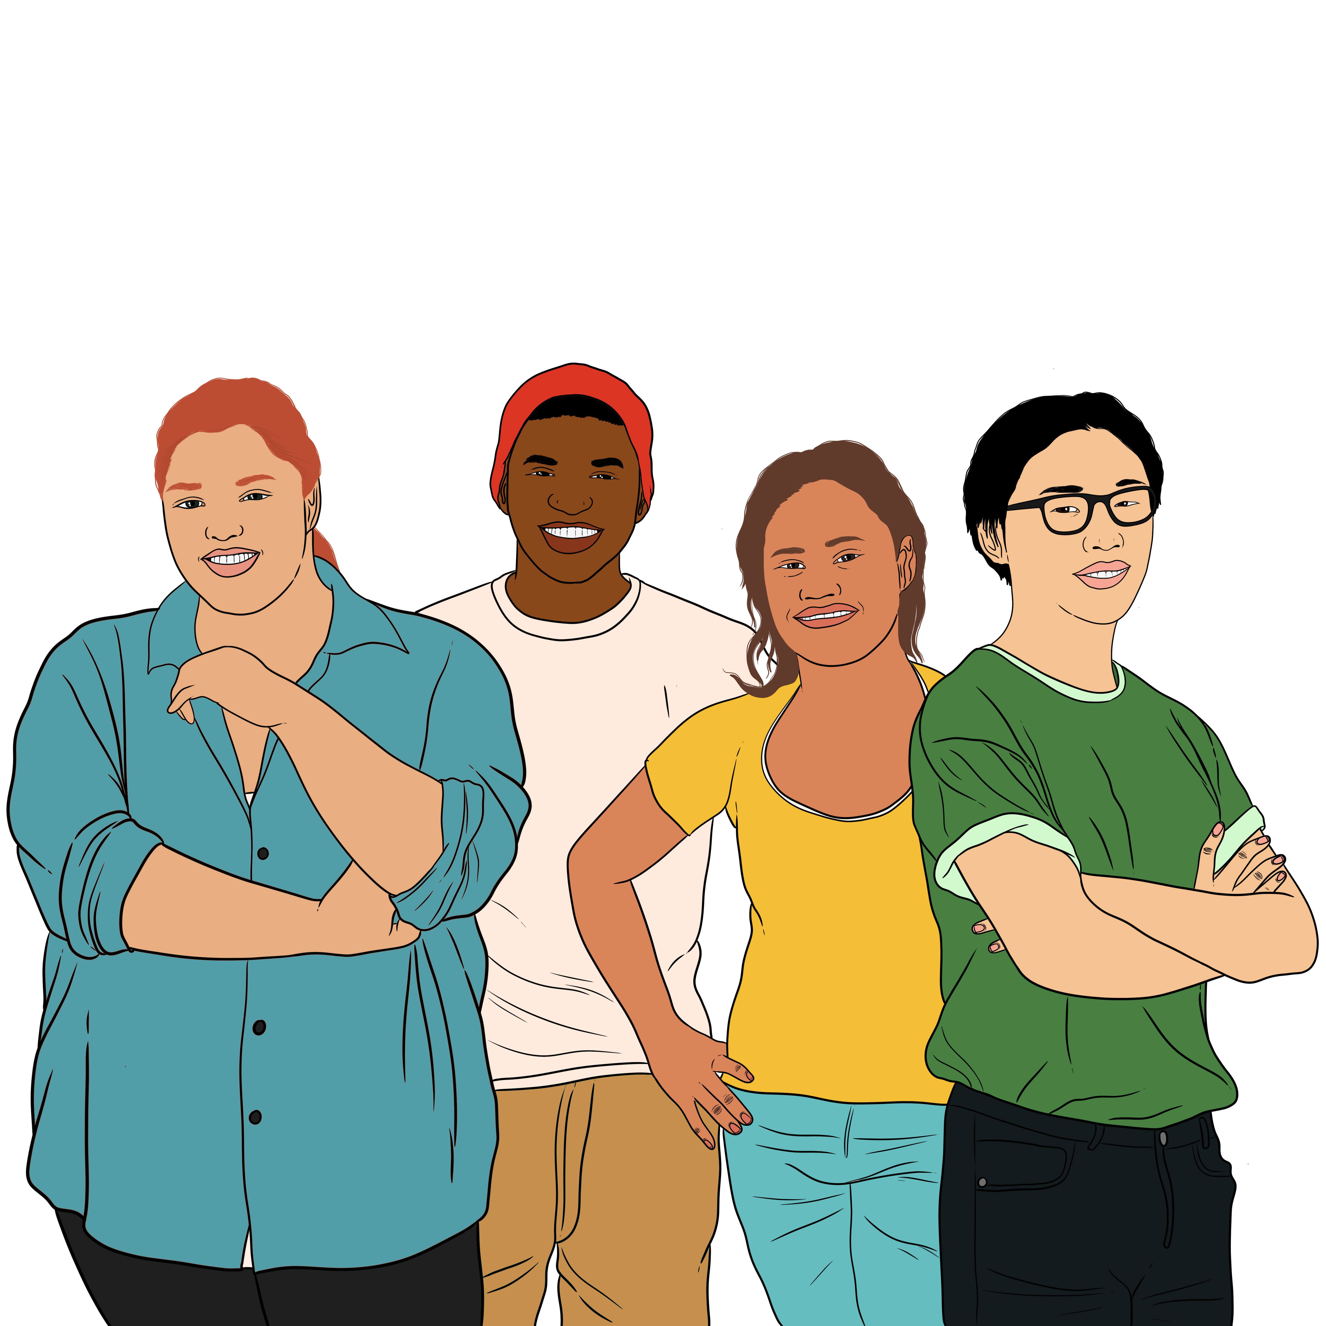
who you want to be in a relationship with
choosing if you want to be in a relationship.

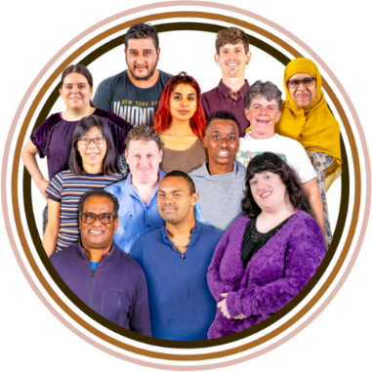
Gender means different things:
to different people
in different cultures.
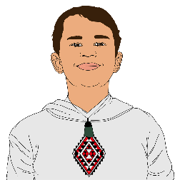
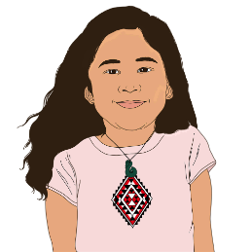
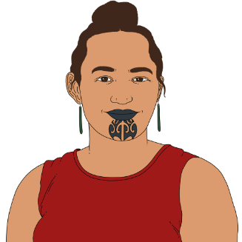
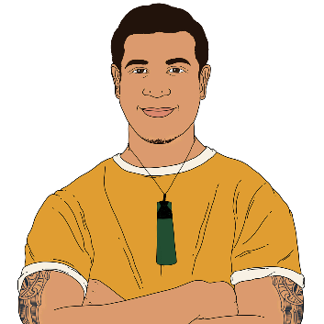
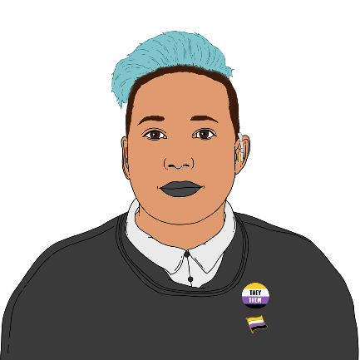

The genders we hear about most
are:
boy or man
girl or woman.

Some people are not a man or a woman.

They may call themselves
non-binary.

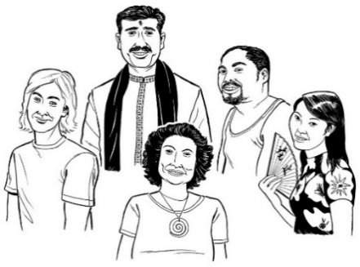
Culture is a way of:
thinking that a group shares
doing things as a group.


People might ask you questions because they want to:
get to know you better

know more about rainbow people
support you
show their love for you.

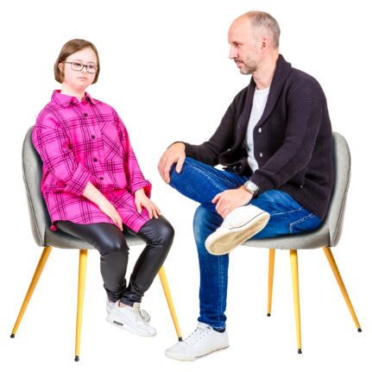
Sometimes it can be hard to talk to people even when they are being nice.


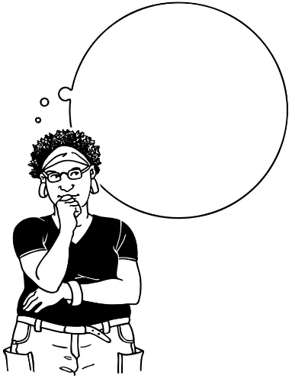
This might be because you do not have all the answers:
for yourself
to their questions.


You could ask them to:
learn about rainbow things together
give you time to find things out.

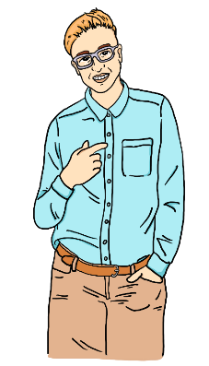
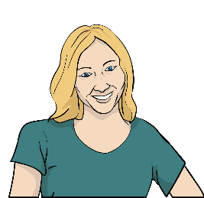
Ash is talking to their mum about
how to use pronouns correctly.

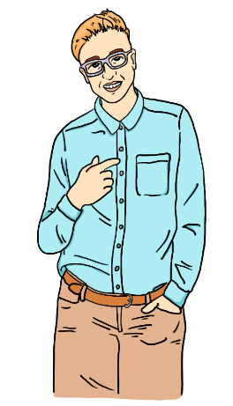
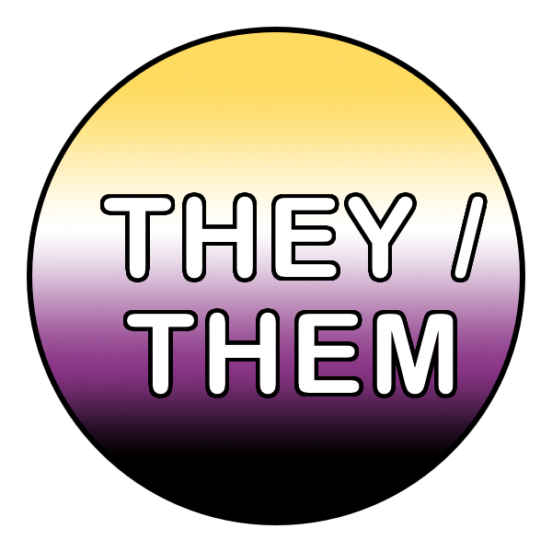
Ash says:

Pronouns are words we use instead of the name of a person.

My pronouns are they / them.
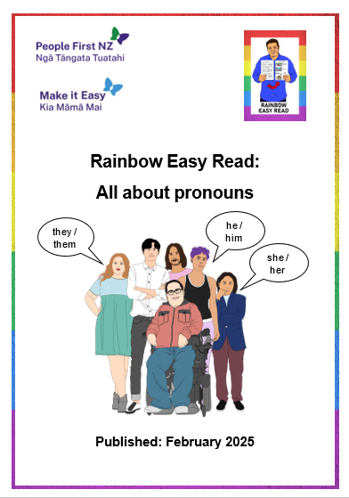

Ash and their mum read the Rainbow Easy Read about pronouns.

Mum practises using the pronouns.

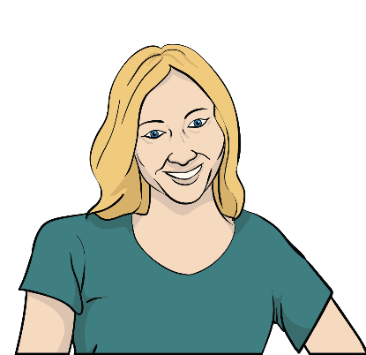
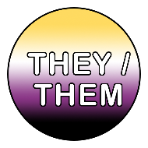

Mum says:

This is my child Ash.

They are non-binary.

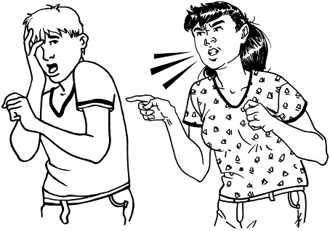
Sometimes people might say mean things because they:
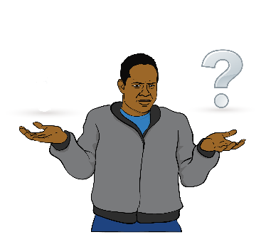
have learned wrong things about rainbow people

are unsure / afraid of rainbow people
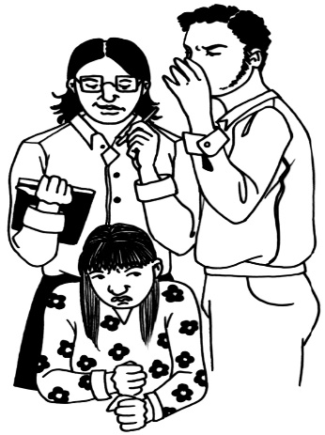
want to control:
- what people do
- who people are.


This can make you feel:
sad
uncomfortable
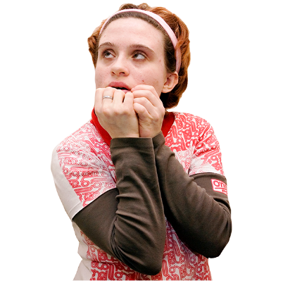
angry
not safe.

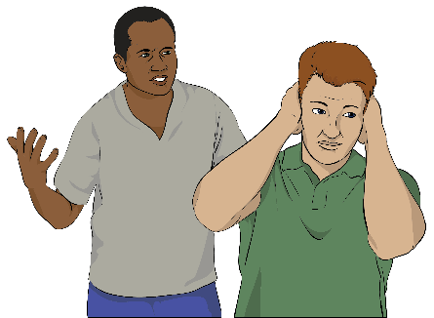
You could say something like:
That is not nice.
Go away!
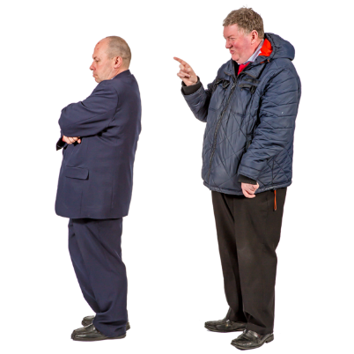
I am leaving now.
You should respect all people.

When friends and family ask questions

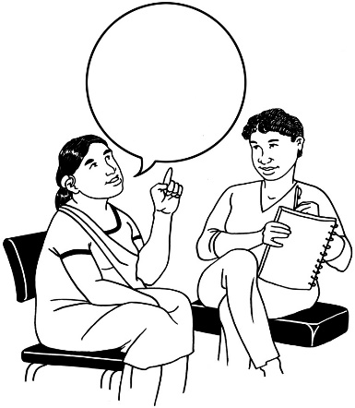
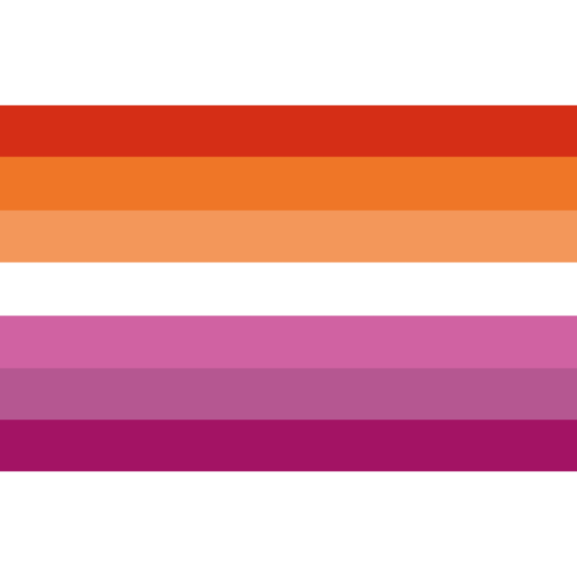

Coming out

Coming out means to tell someone about your:
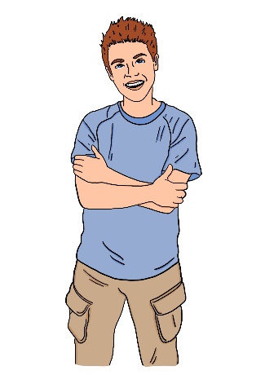
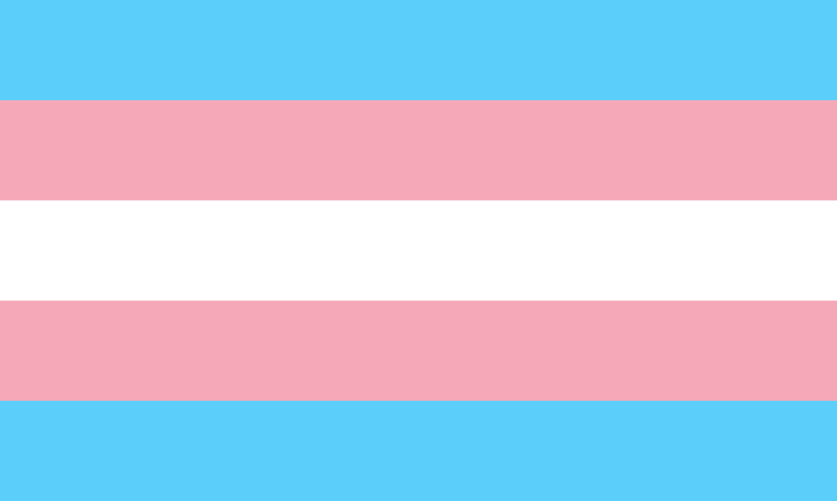
sexuality

or
gender.

Someone you know might ask you what your gender or sexuality is before you are ready to tell them.

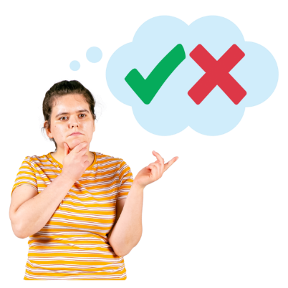
It is your choice if you want to come out to them.

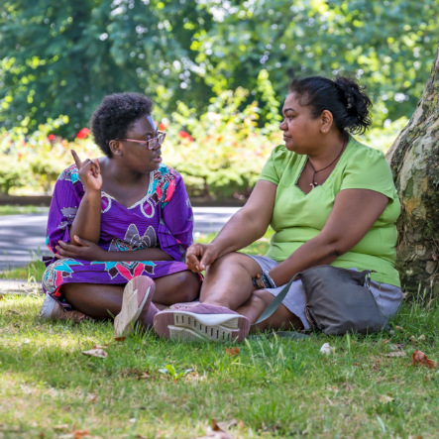
If you are ready to come out to someone you know you might say:
Let us go somewhere comfortable to talk about this.
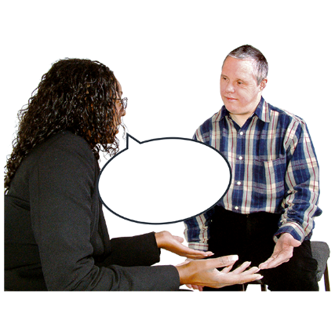
I would like someone to join me for support.

I like that you want to talk to me in a nice way about this.
I have practised words about this.

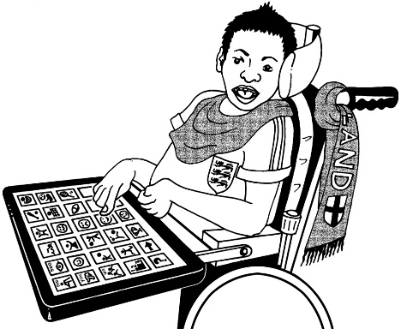
If you are not ready to come out to someone you know you might say something like:

No
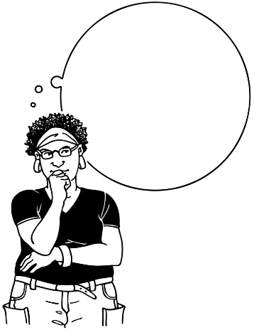

That is something I do not want to talk about.
?

I need to think about what those things mean.
Can we talk about this later?


If they keep asking you before you are ready it might make you feel:
bad
scared
like you must tell them.


Kaylee keeps asking her friend Rebecca if she is a lesbian.

Rebecca says:
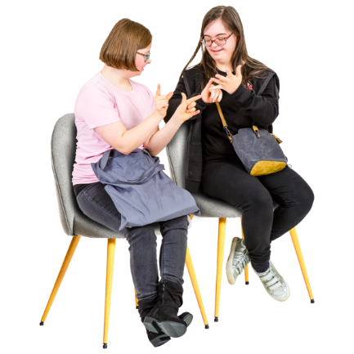

Stop asking me that.

Respect what I say.
I have a right to privacy.

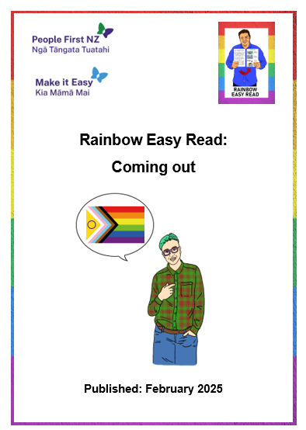
You can find out more about coming out in the Easy Read called:
Rainbow Easy Reads: Coming out:

You can find this Easy Read at:
https://tinyurl.com/RERout

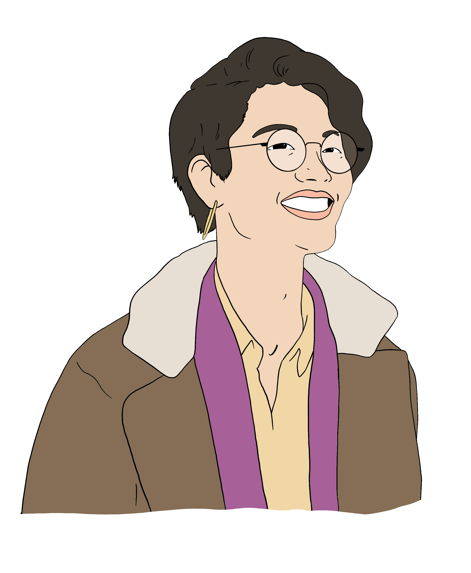

Being transgender

If you are transgender people you know might ask you questions about your body.

It is your choice what you tell people.

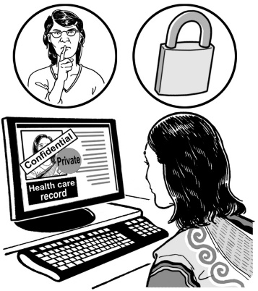
You might say:
There are some things I want to keep private.
Please do not share this information with other people.
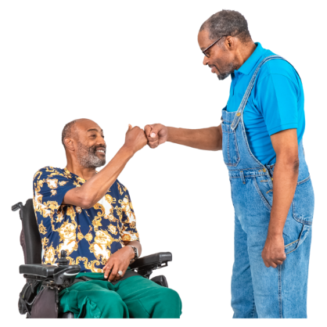
I am trying new things until I find what makes me happy.
I am glad you want me to be happy.

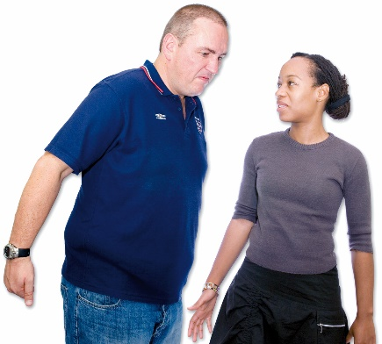
People you know might say they are worried:
that you will be bullied
it will be hard to change your:
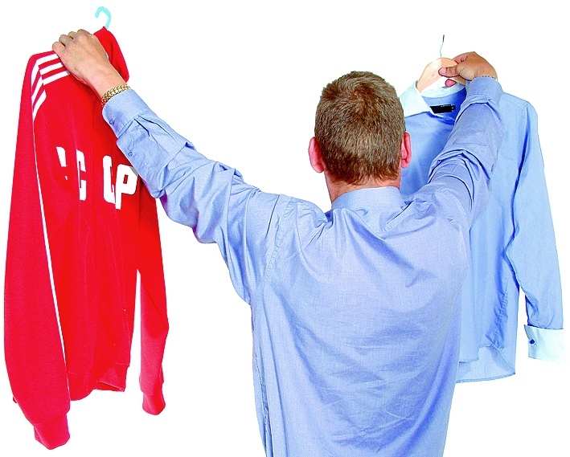
- body
- clothes
- important documents.

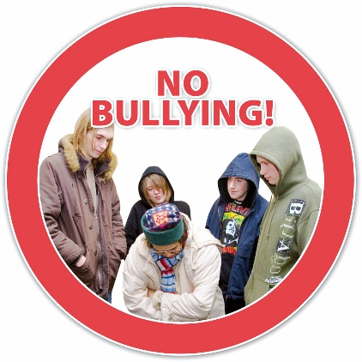
You might say things like:
We can stand up against bullies together.

Let us learn about changes together.
It is my decision what I do.
Your support is important to me.

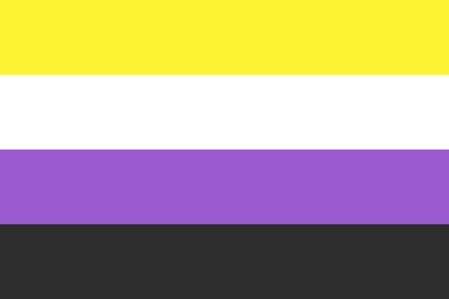


Charlie is a transgender man.
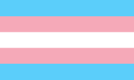

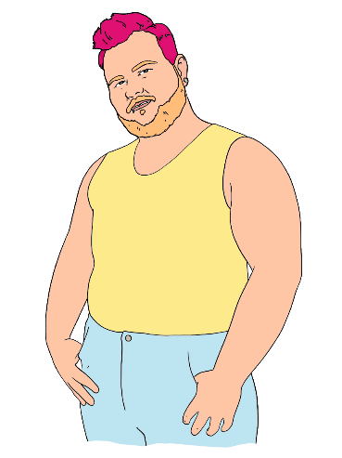
Charlie used to think he was:
a lesbian
then
non-binary.


His parents are worried he will change his mind again after
changing so much about himself.

Charlie says:

he is happy with who he is now
people explore who they are all the time
there is always new information about rainbow people to find out.

When strangers ask questions

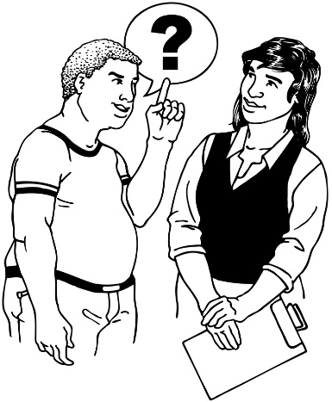
People you do not know might ask you questions because they are:
curious
interested.

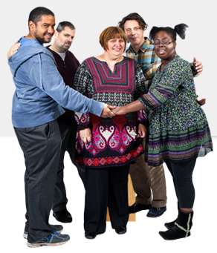
The most important thing is to be safe.

You might:
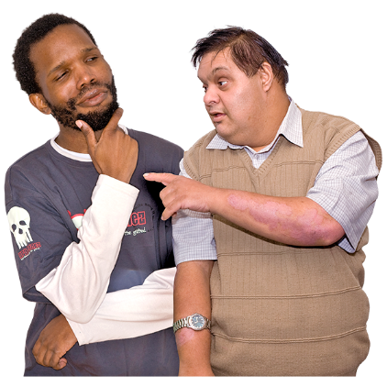
think about how the person has been speaking to you
think about if you are in a safe place
find someone to support you.

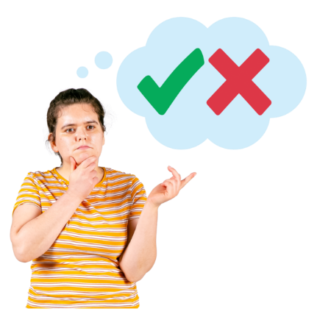
It is your choice what you tell someone.

If you are not comfortable answering their questions you might say:


I do not want to talk about this.

I do not give private information to someone I do not know.
I want to talk about something else.

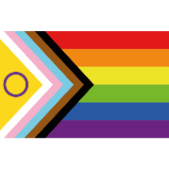
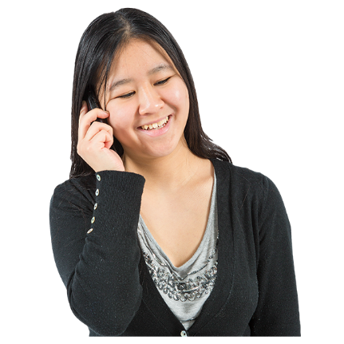
If you are comfortable answering their questions you might:
say things you have practised before with someone else
tell them only some things.

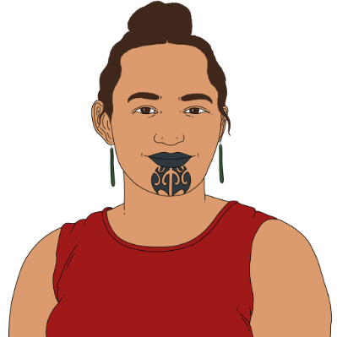
Aroha is whakawahine / a Māori
trans woman.

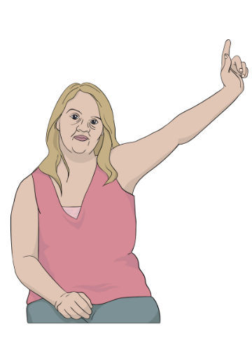
Aroha is at an event with lots of disabled people she has not met before.

Mary asks Aroha what takatāpui means.

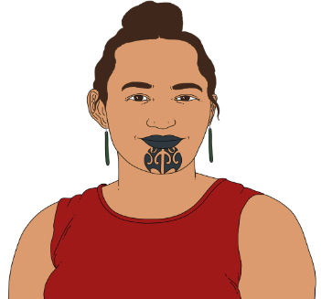


Aroha thinks about:
how her friends are nearby
how nice Mary has been.
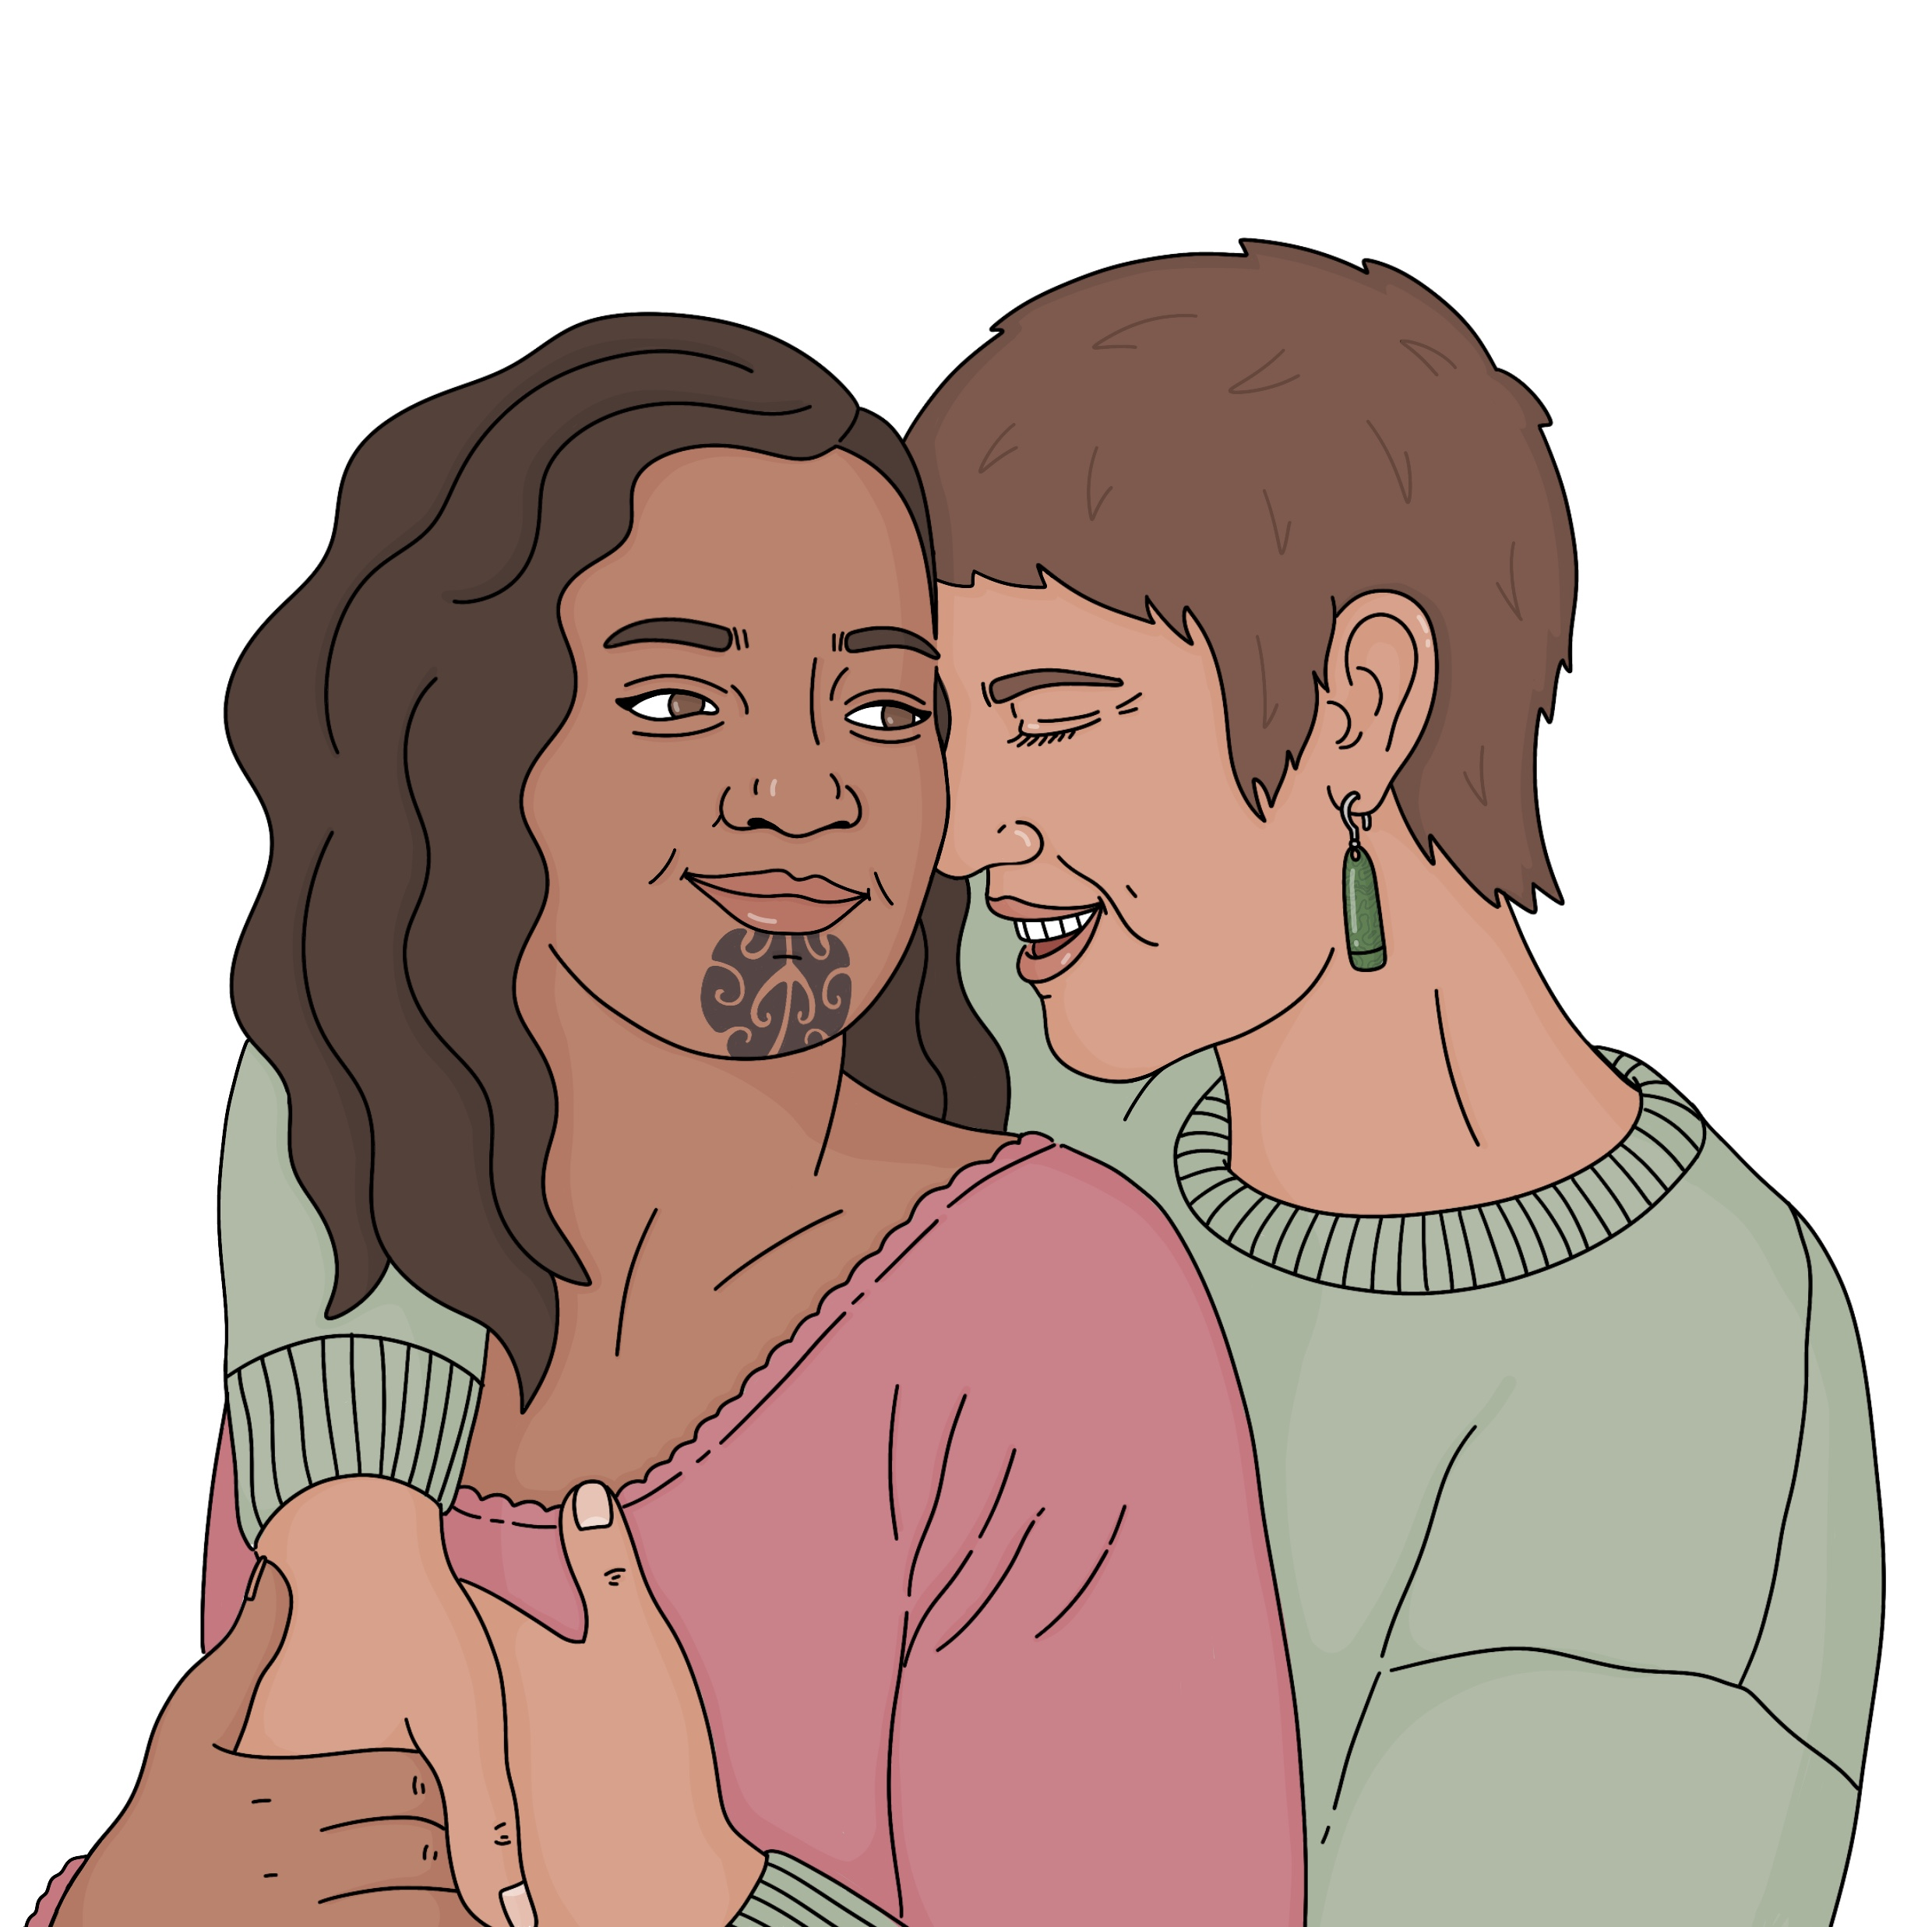

Aroha tells Mary that takatāpui is a word used to describe rainbow
Māori people.

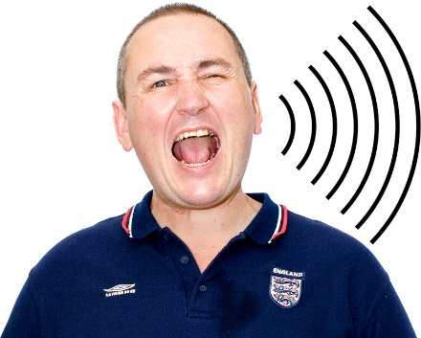
Sometimes people in public places might:
shout things at you
say mean things.


They might be:
confused
angry / mean.


It is best to:
keep yourself safe
ignore them
move away from them.

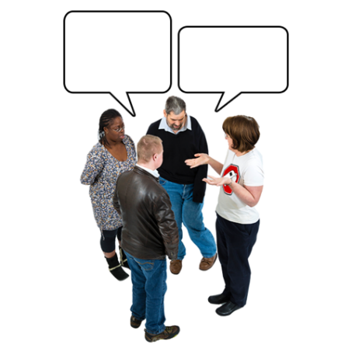
You might feel okay about saying something back if you are with someone who can support you.

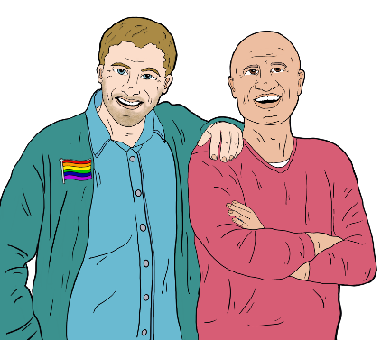
Simon and Kit are going down a street with other rainbow friends.

They are holding hands.

Someone yells at them:

Ew gay!
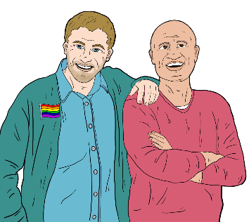
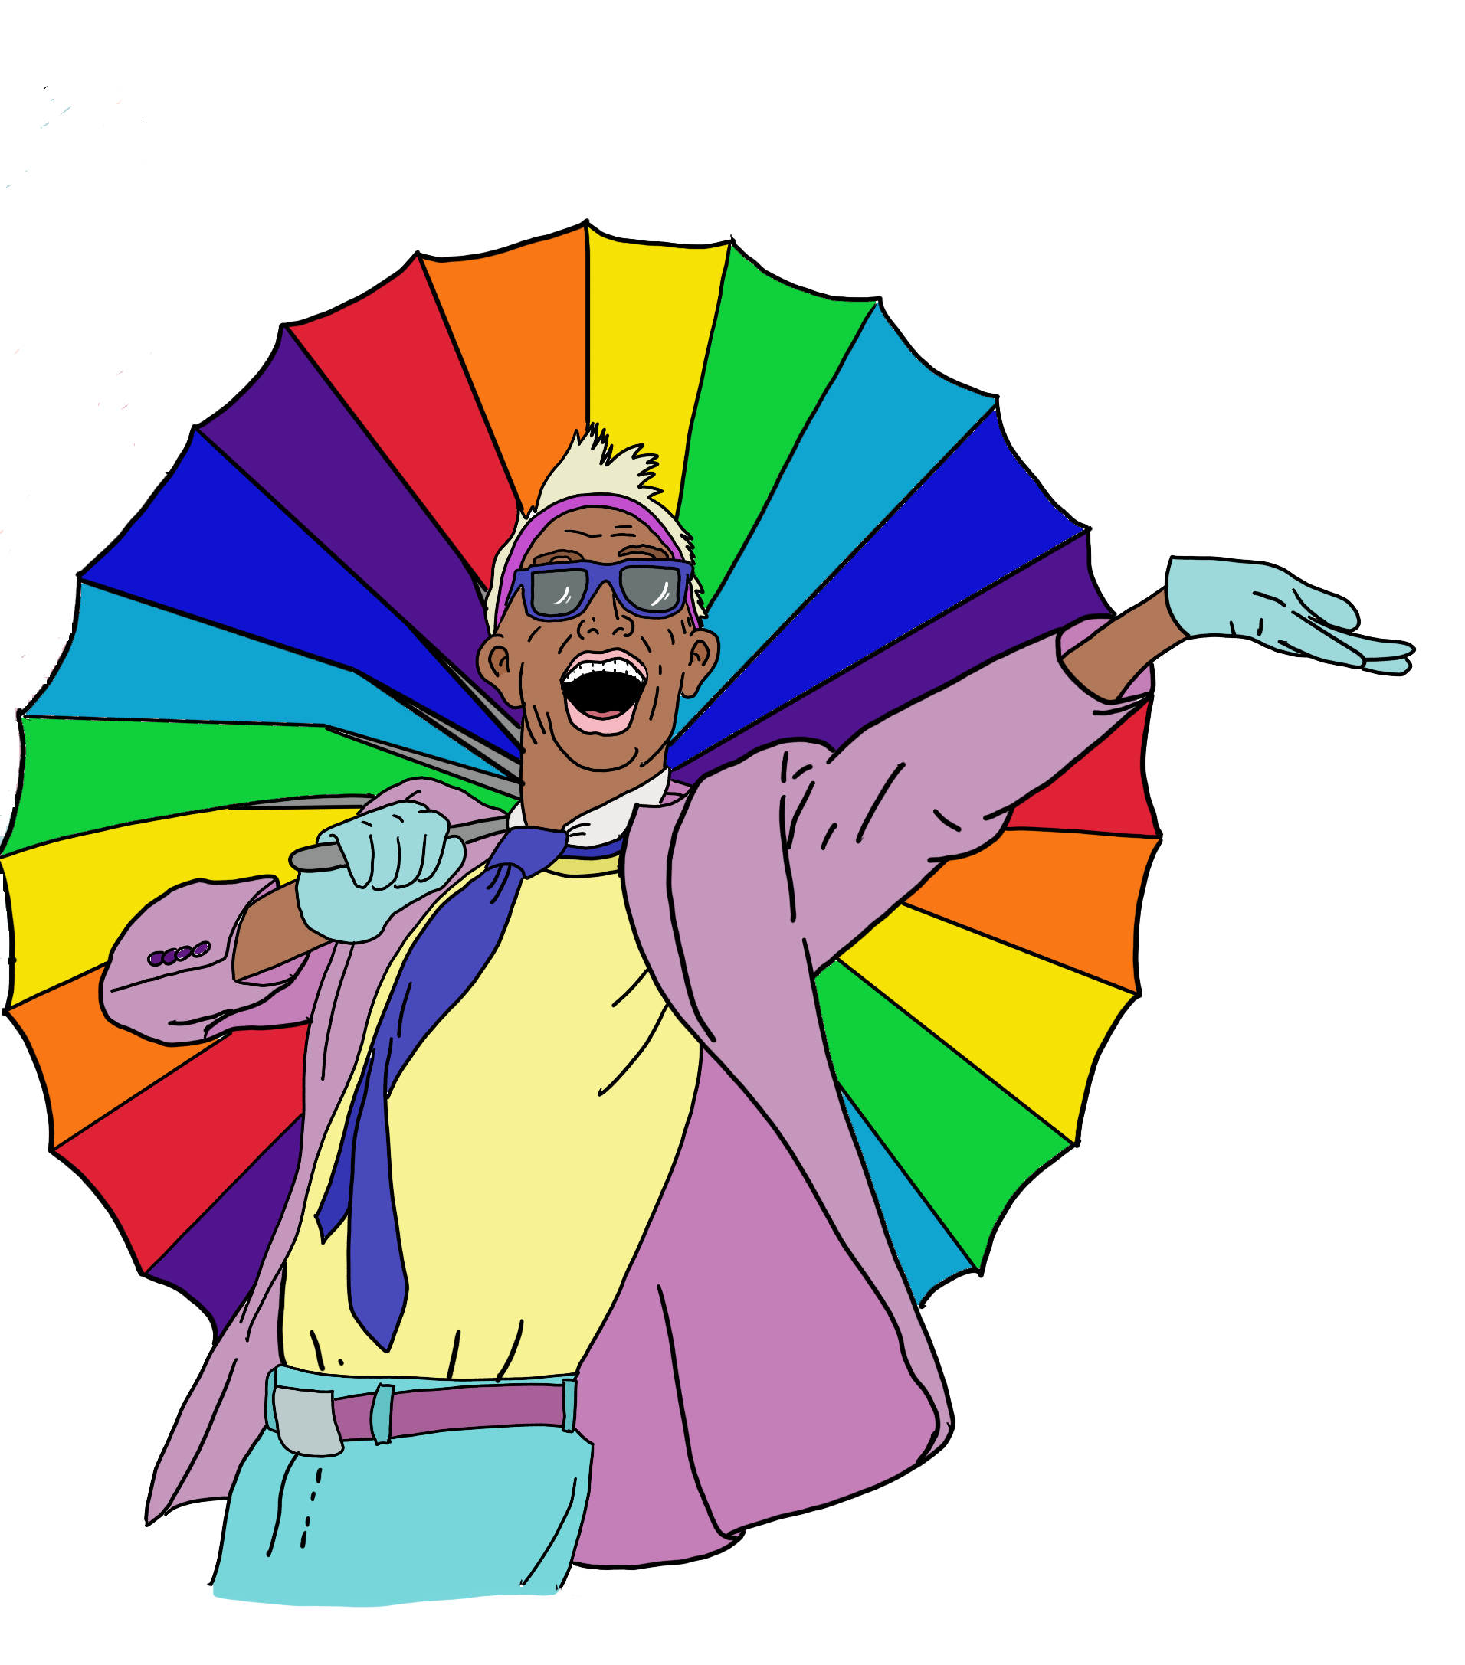

Kit says:

Gay is another word for happy and we are very happy.

What to say to support your rainbow friends


You might:
not be a rainbow person
but

want to say the right things to your rainbow:
- friends
- whānau / family.

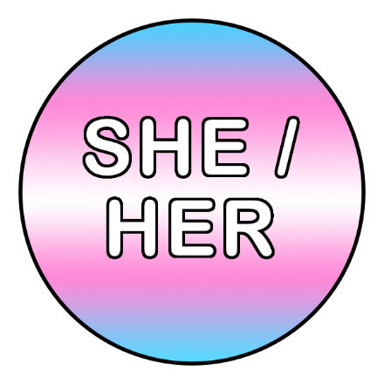
If they are transgender you can ask questions like:
What are your pronouns?
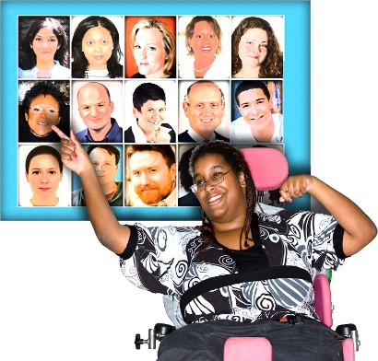
Do you want me to correct people when they get your gender or pronouns wrong?
Who is it okay to talk to about you being transgender?
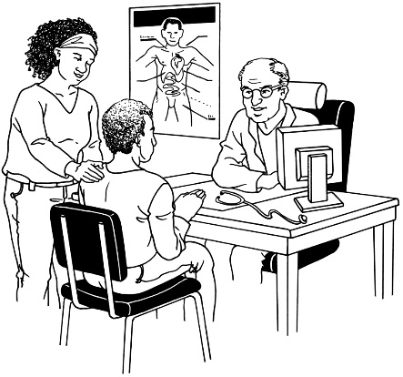
Do you want me to support you:
- coming out?
- going to the doctor?
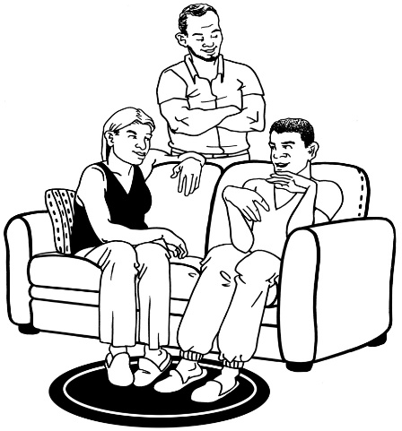
- talking to your whānau / family?
- talking to friends?

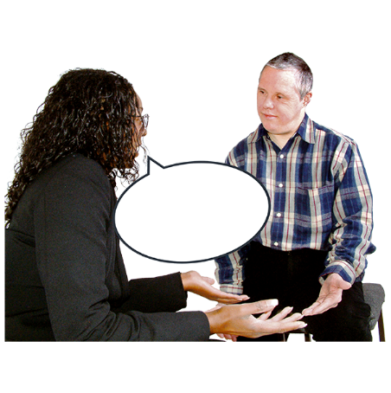

If you are talking to someone about their sexuality you might ask:
What do you want to tell me about your sexuality?
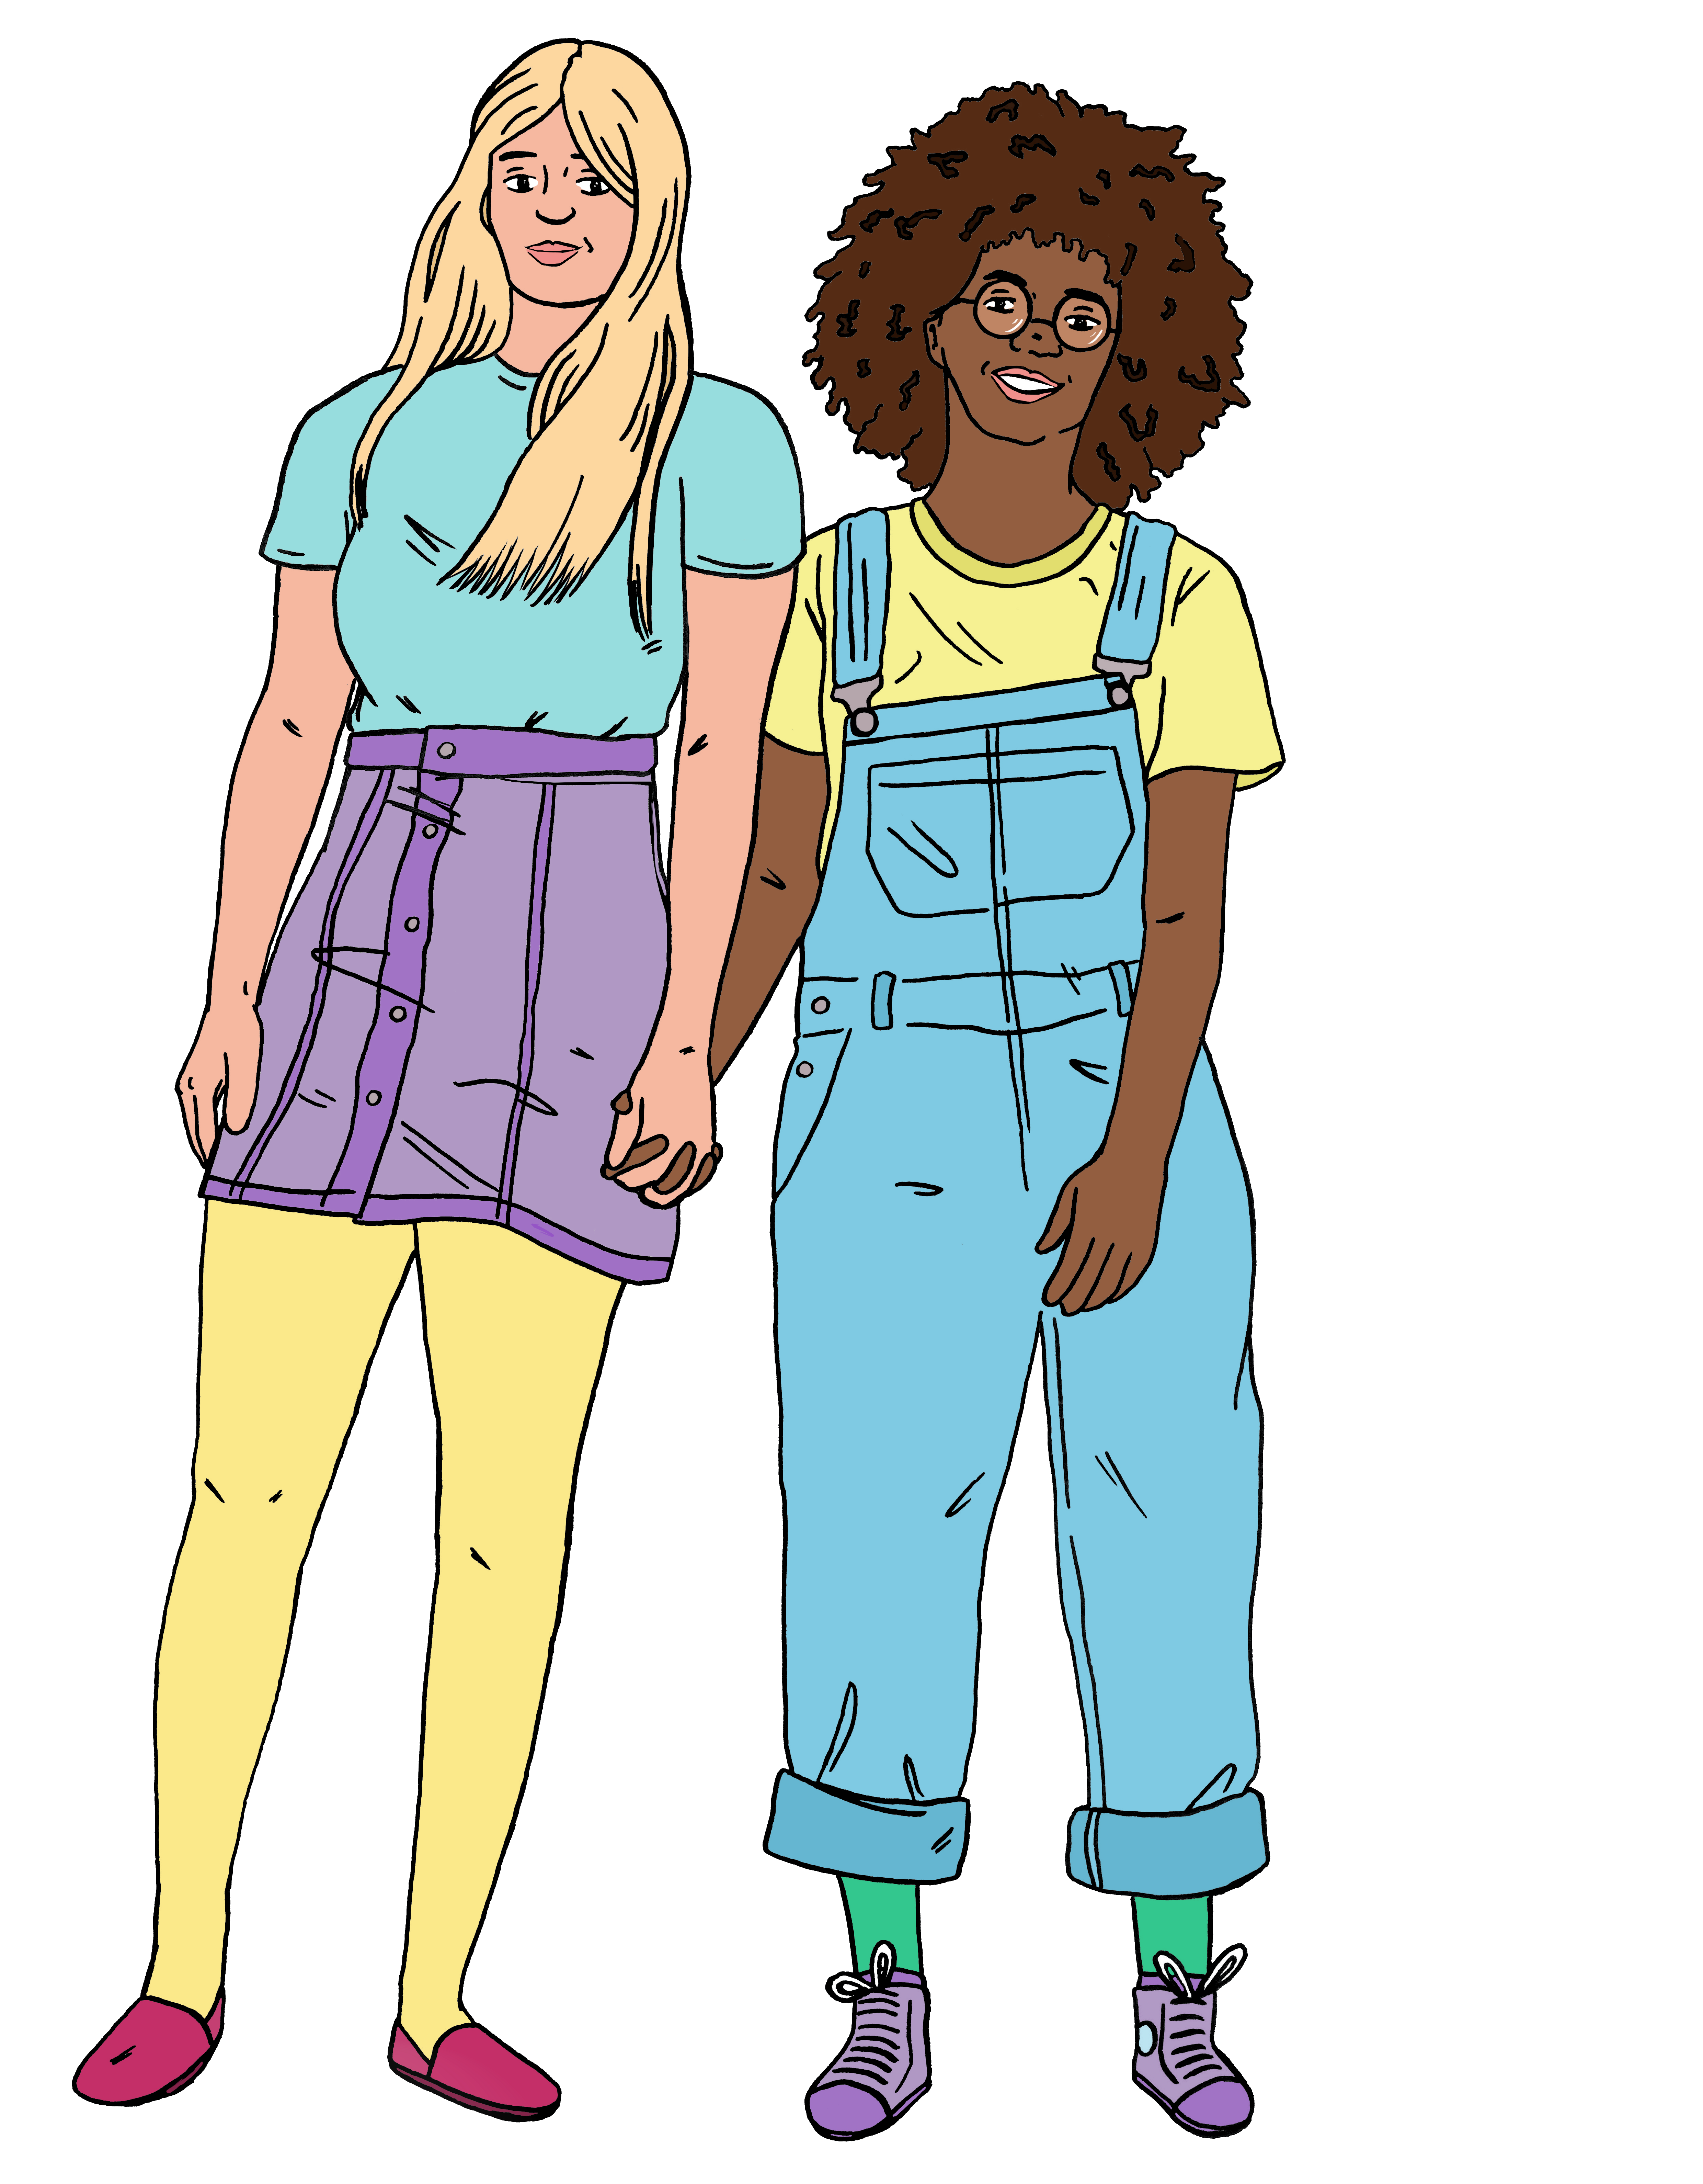
Are you dating anyone?
Do you want to be in a relationship?
Who is it okay to talk to about your sexuality?
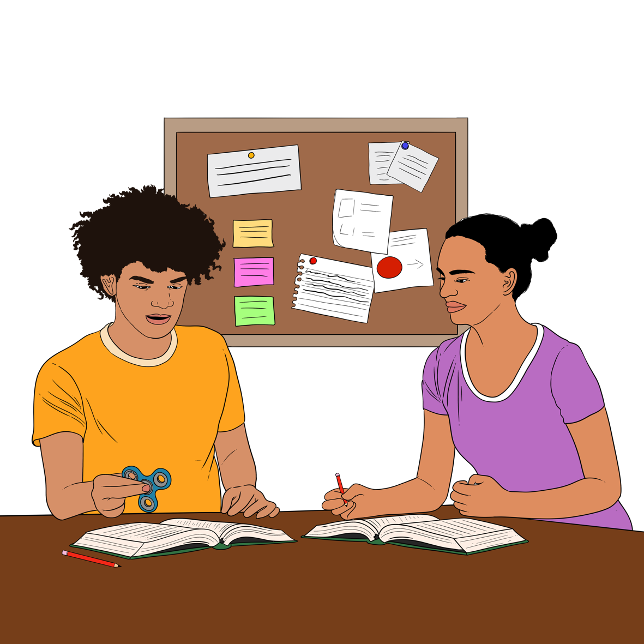
Do you want me to support you:
- coming out
- learning things
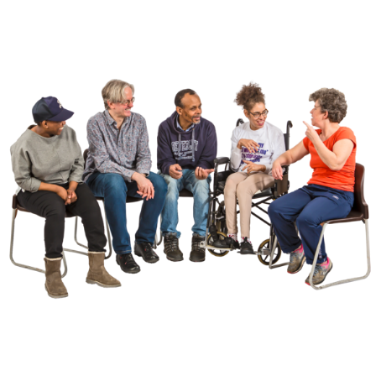
- talking to your
whānau / family
- talking to friends?

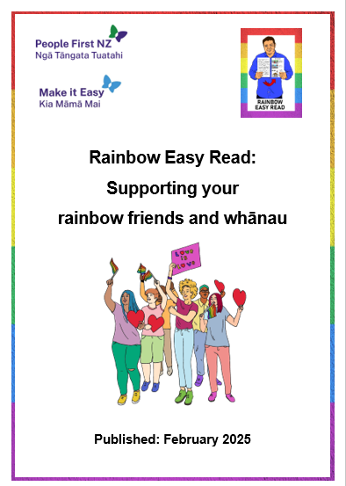
You can find out more about supporting rainbow people in the Easy Read called:
Rainbow Easy Reads: Supporting your rainbow friends and whānau:

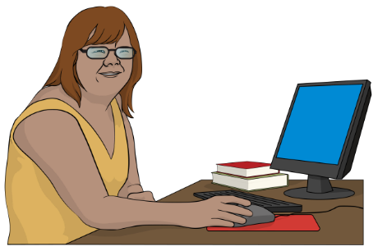
You can find this Easy Read at:
https://tinyurl.com/RERsupport

More information

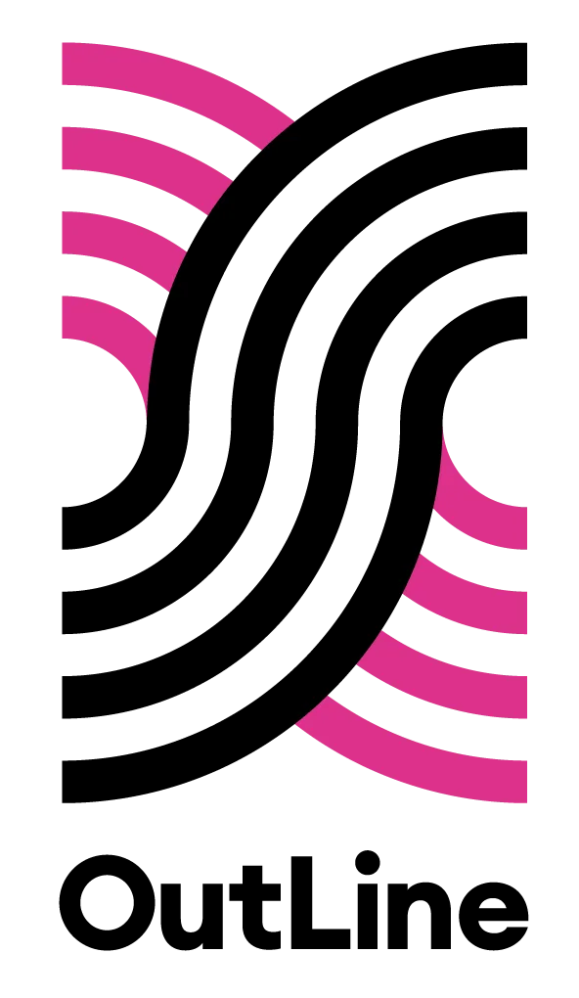
You can contact OutLine for support if you:
are part of the rainbow community
think you might be part of the rainbow community.

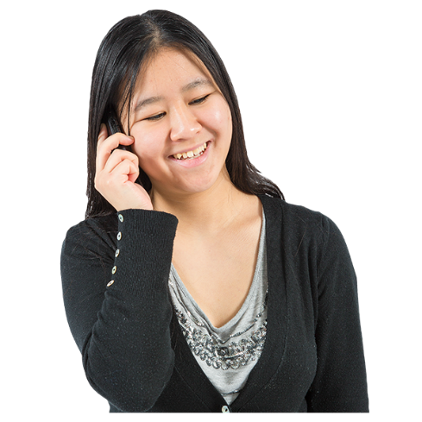
You can contact OutLine every day between 6 and 9 in the evening:
by phone on:
0800 688 5463
using the text chat on their website at:
outline.org.nz/chat

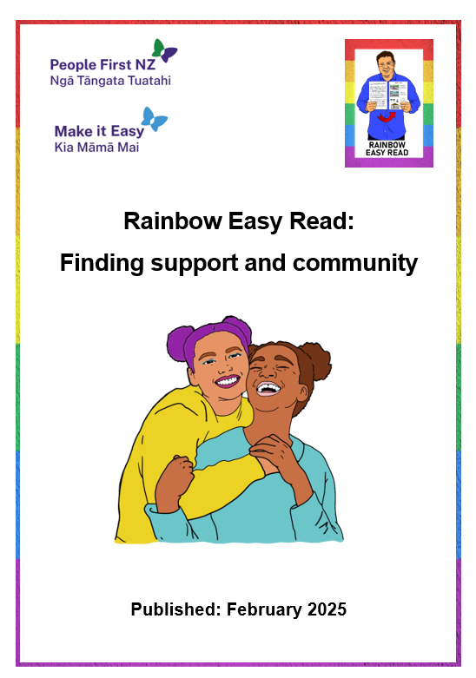
There is an Easy Read called:

Rainbow Easy Read: Finding support and community

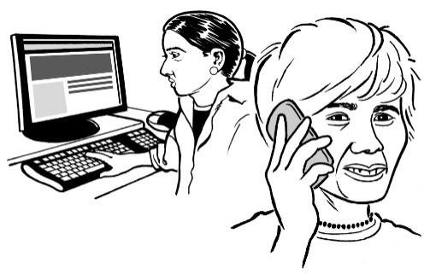
It has information about more places you can contact for:
information
support.

You can find this Easy Read at:

https://tinyurl.com/RERcommunity

Thank you

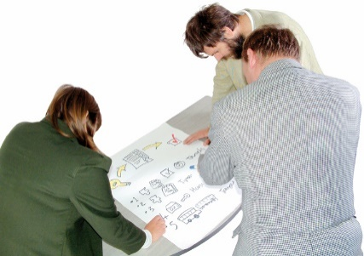
Lots of people worked together on the Rainbow Easy Reads.


Thank you to the Rule Foundation for giving us the money to make them.

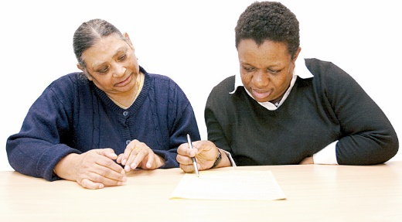
Thank you also to:
the People First NZ members who worked as advisors
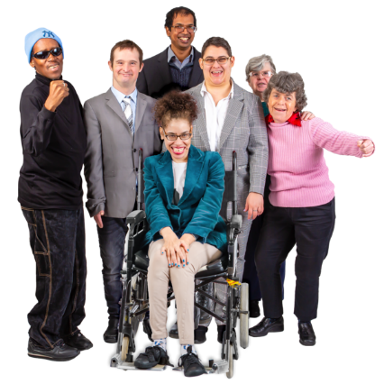
the People First NZ staff who supported them
everyone who has supported this mahi / work.

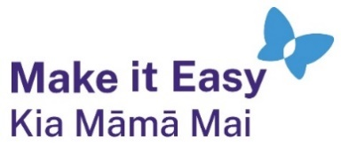
This information has been written by Make it Easy Kia Māmā Mai.

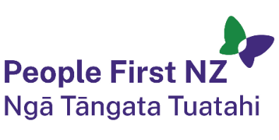
Make it Easy is a service of People First New Zealand Ngā Tāngata Tuatahi.


All images used in this Easy Read document are subject to copyright rules and cannot be used without permission.


Make it Easy uses images from:

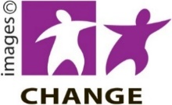
- Photosymbols


- Change Images

- SGC Image Works


- Huriana Kopeke-Te Aho

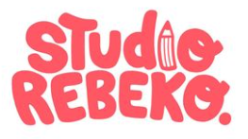
- T Wood

- Studio Rebeko

- Inga Kramer.

