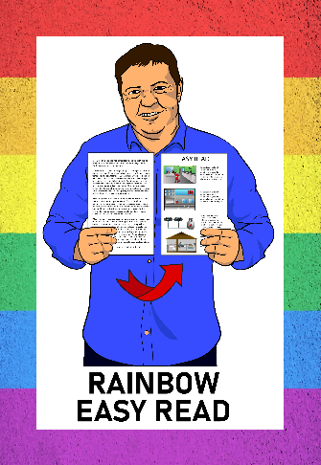
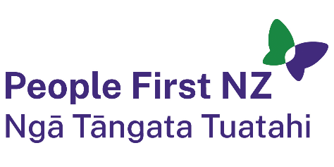
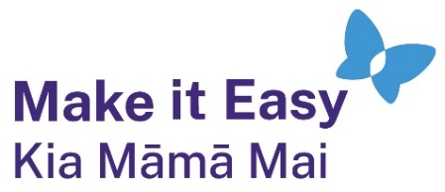

Rainbow Easy Read:
Your rights as a rainbow person
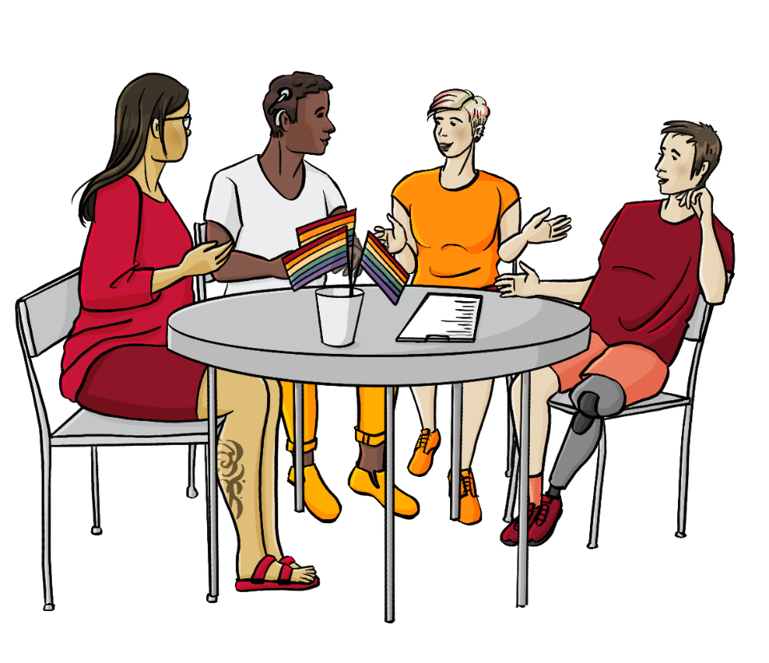

Published: February 2025

About this guide

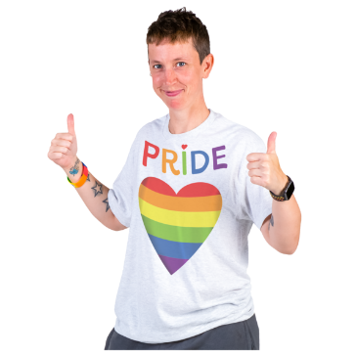
This is an Easy Read guide about your rights as a rainbow person.

Rainbow people are also sometimes called LGBTQIA+ people.
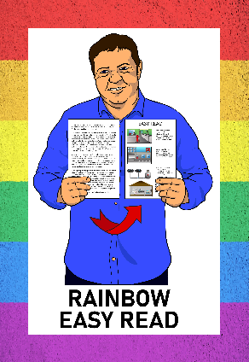

This guide is part of the Rainbow Resources Project.

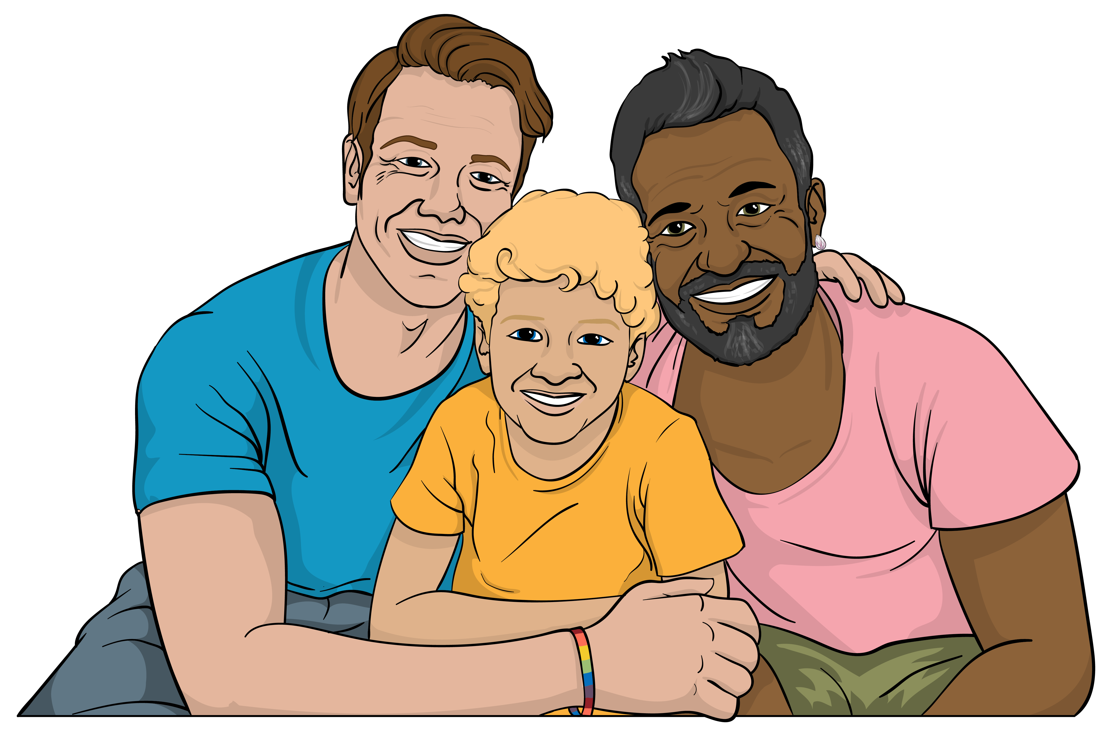
The Rainbow Easy Read Project is a group of Easy Reads for:
people in the rainbow community
their friends

their whānau / families
people who support them.

You can find all the Rainbow Easy Reads at:

linktr.ee/rainboweasyread

Your human rights as a rainbow person

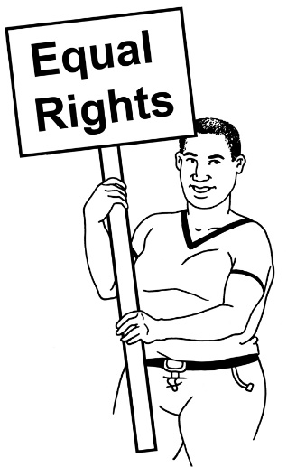
Human rights are things everyone should:
have
be able to do.


If you are a rainbow person you have the right to be treated fairly because of your:
gender identity
sexual orientation.

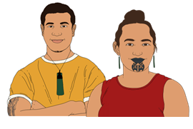
Gender is if you are a:
man
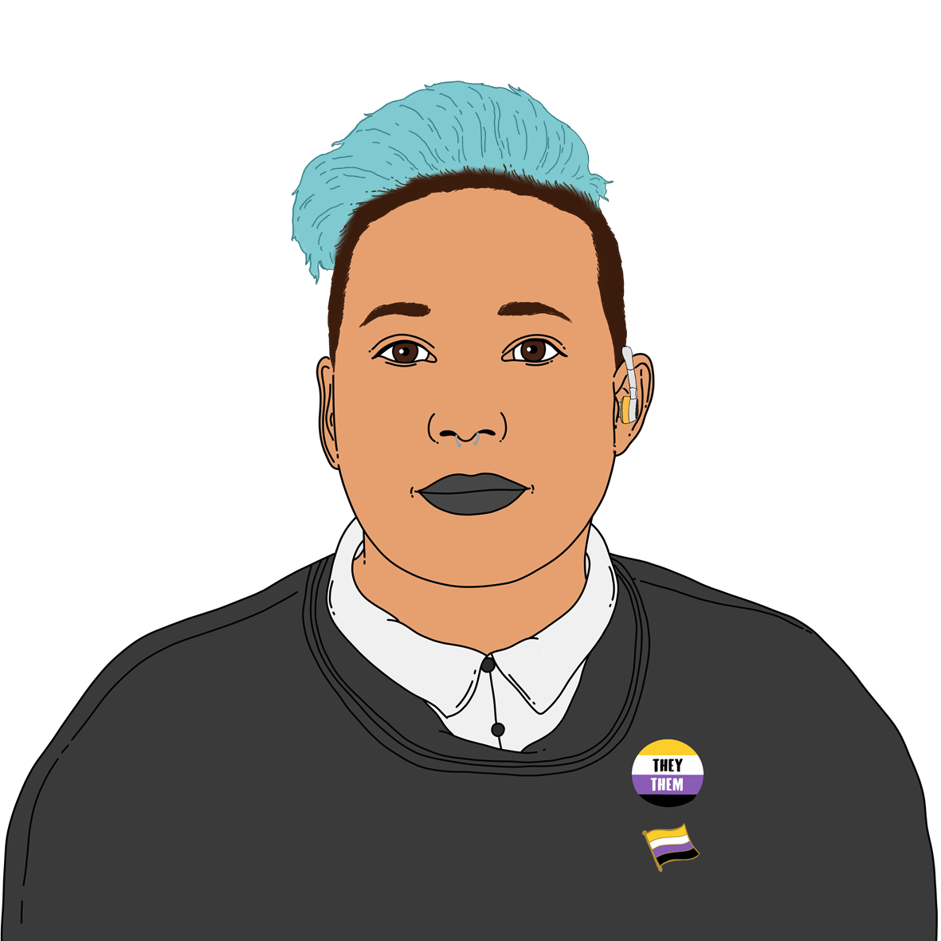
woman
another gender like non-binary.


I
I AM ME
Gender identity means:
how you feel about your gender
what it is like to live with your gender.

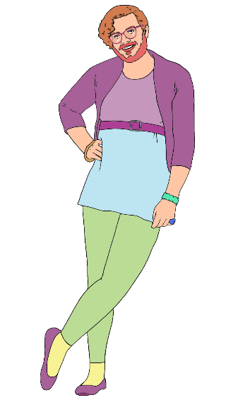
Non-binary is a term for people who are not just a:
man
or
woman.

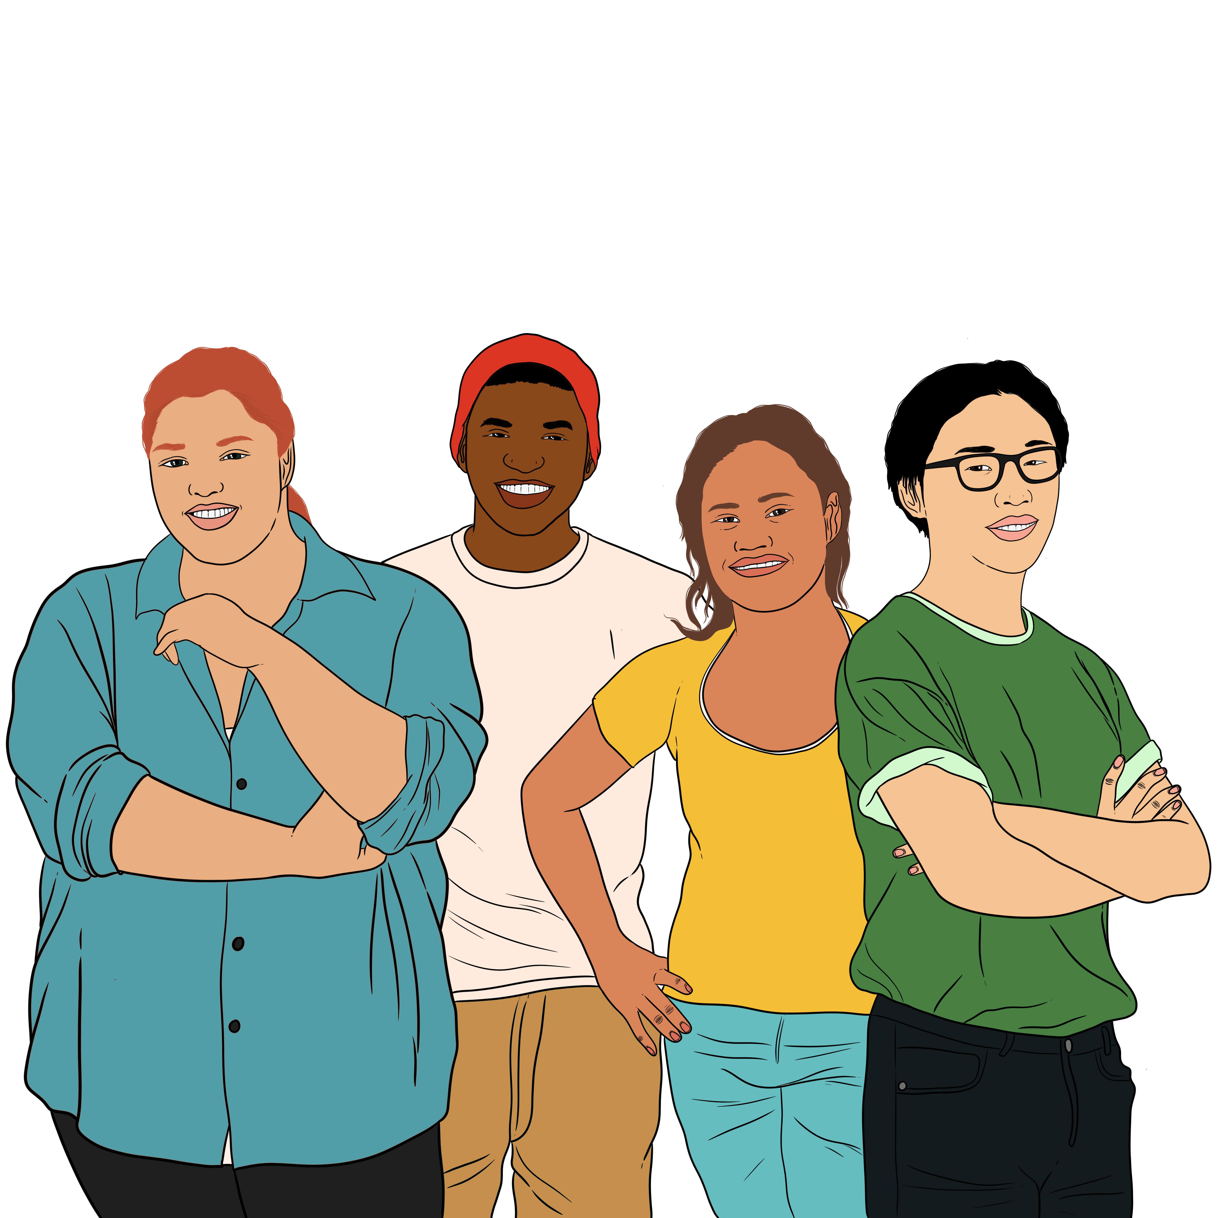

Sexual orientation is about the gender of the people you:

are attracted to
want to have sex with.
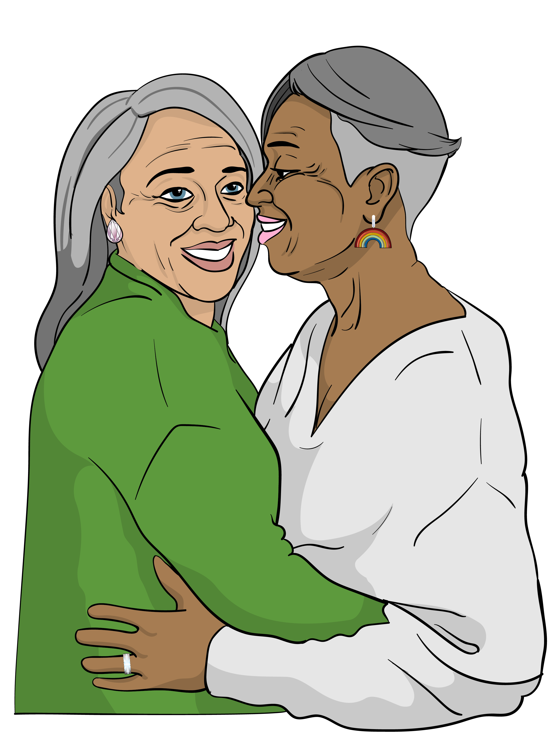

Some sexual orientations are:
gay / lesbian – being attracted to people who are the same gender as you
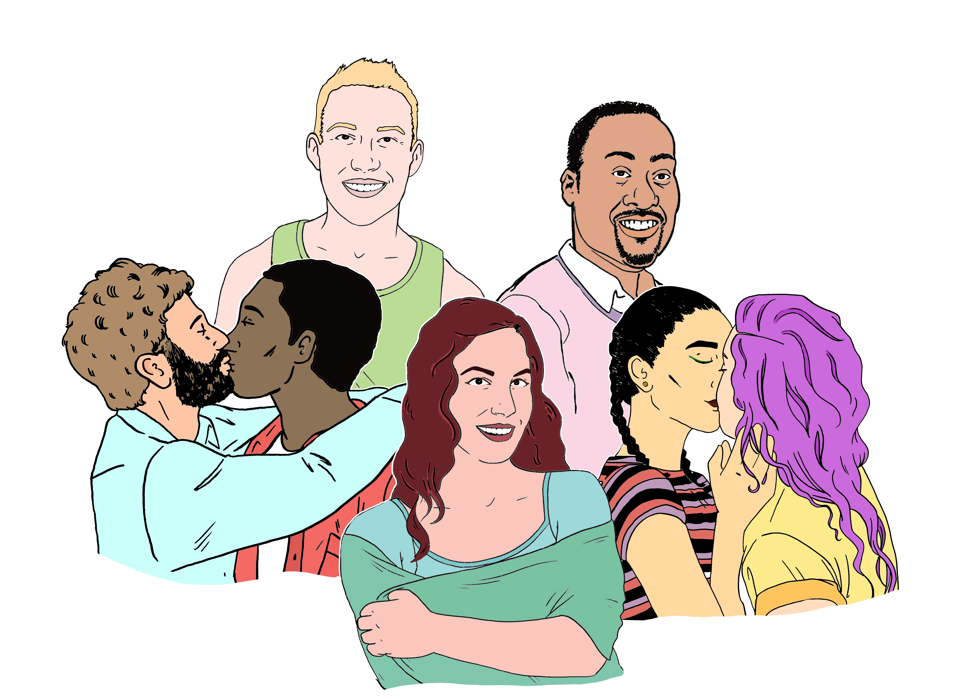
bisexual – being attracted to more than one gender
asexual – not being attracted to anyone.


Rainbow people sometimes experience discrimination against them like:
violence
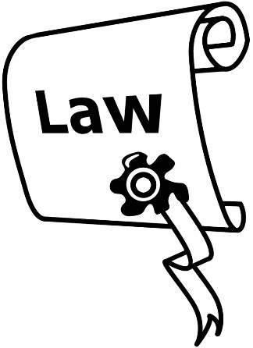
hate speech
laws against them
being treated unfairly at work
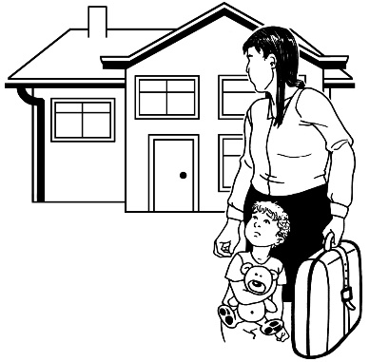
being treated unfairly where they live like by:
- their family
- a landlord.

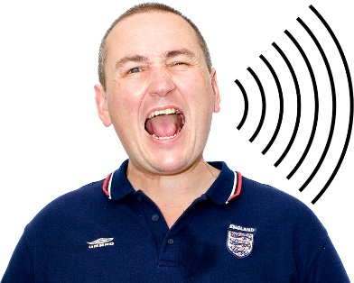
Hate speech is bad / wrong things said about a:
person
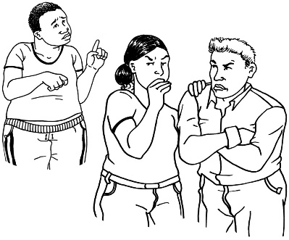
or
group of people.

You can find out what your rights are as a rainbow person from places like:

the Human Rights Commission
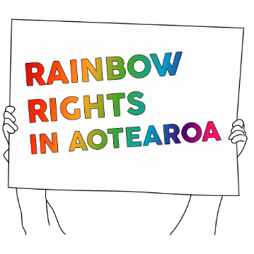
Rainbow Rights in Aotearoa.


The Human Rights Commission
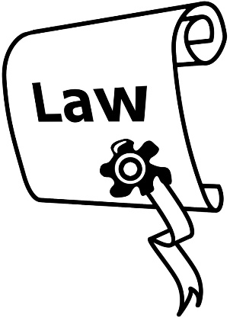
The Human Rights Commission has information about the laws in Aotearoa New Zealand that have to do with:
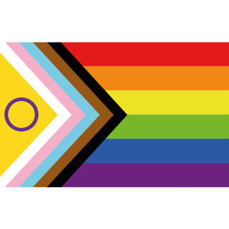
gender identity
sexual orientation.


These laws include:
how you can get married as a rainbow person
how you can change your birth certificate if you are transgender

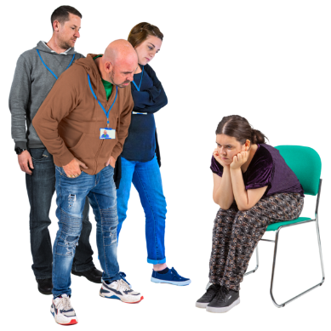
making conversion practices illegal
the Human Rights Act.
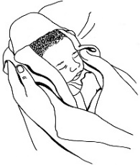
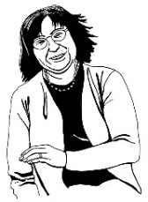
Transgender is a word for a person with a gender that is different from the gender they were given at birth.
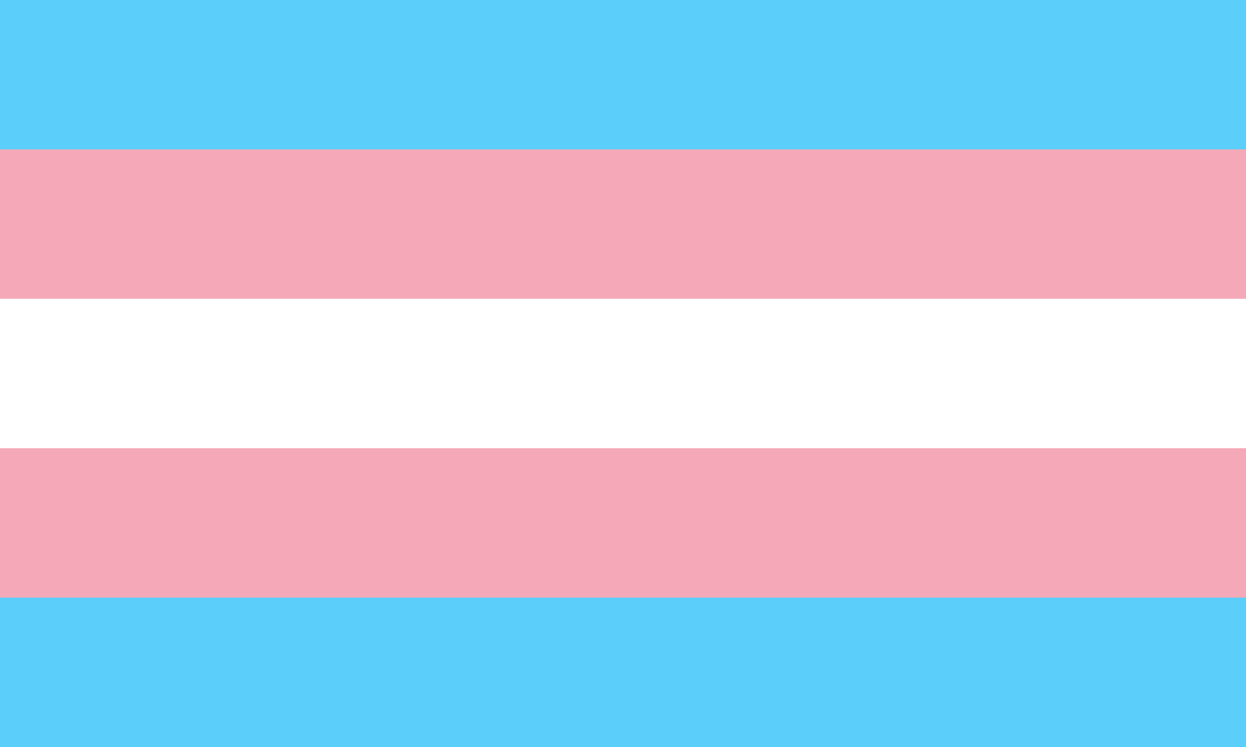

Sometimes the word transgender is shortened to trans.

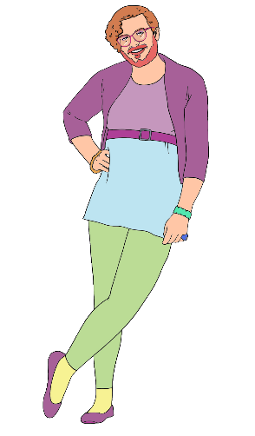
Conversion practices are things that are done to force a person to change their:
gender
sexual orientation.

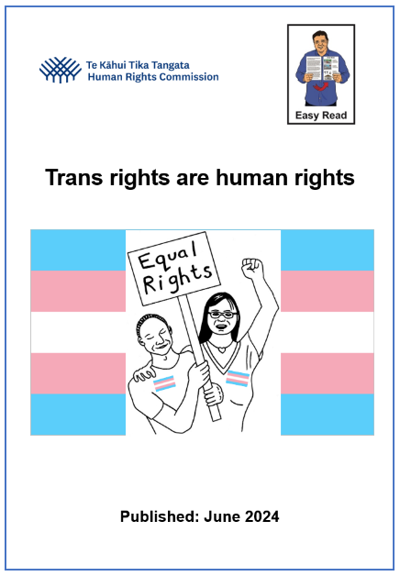
If you are a trans person you can read about your rights in the Easy Read called Trans rights are human rights:

www.peoplefirst.org.nz/
easy-read-library/resource/
trans-rights-are-human-rights


You can find out more about all your rights as a rainbow person at the Human Rights Commission website:

www.tikatangata.org.nz/
human-rights-in-aotearoa/
rights-of-sexual-and-gender-minorities
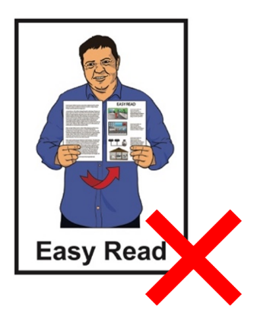

This website is not in Easy Read.


You can contact the Human Rights Commission by:
phone:
0800 496 877

email:
infoline@hrc.co.nz

Rainbow Rights in Aotearoa
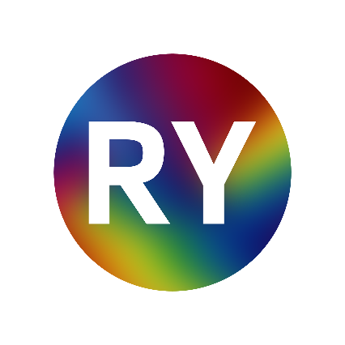
Rainbow Rights in Aotearoa is a website made by:
Rainbow Youth

YouthLaw.


Rainbow Rights in Aotearoa has information about your rights as a rainbow person:
at work
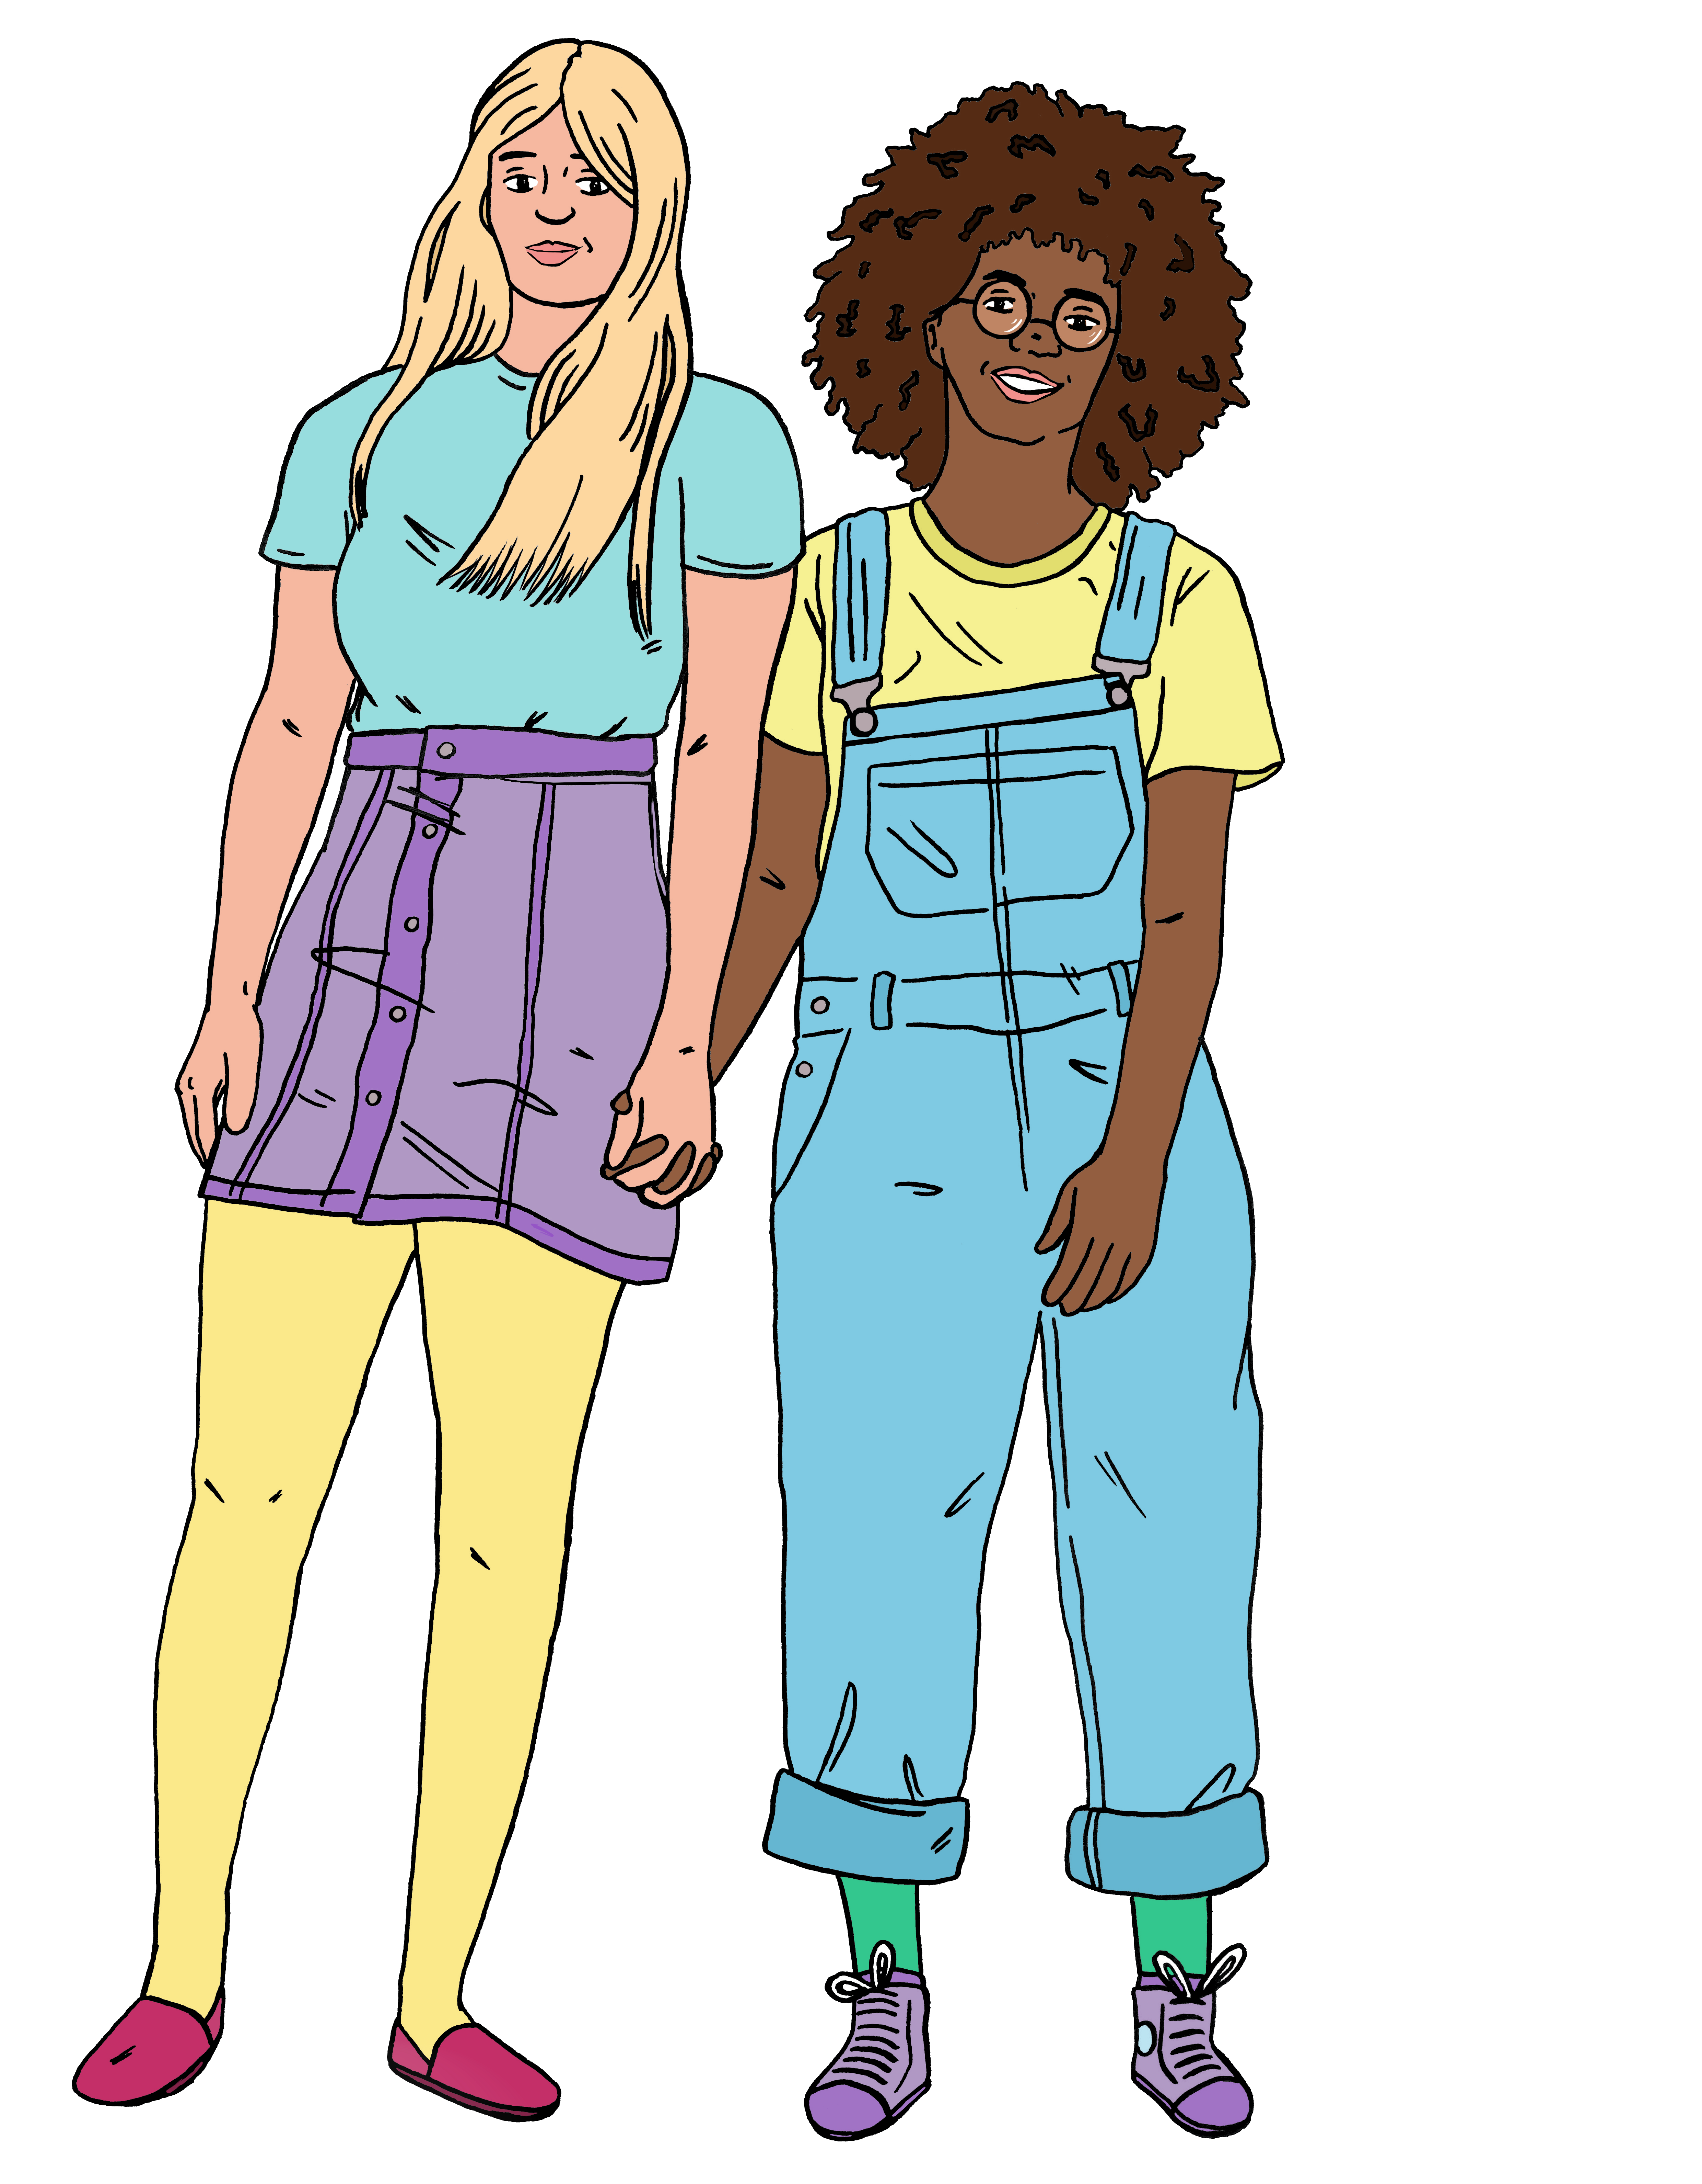
at home
at school
in your relationships like with your partner
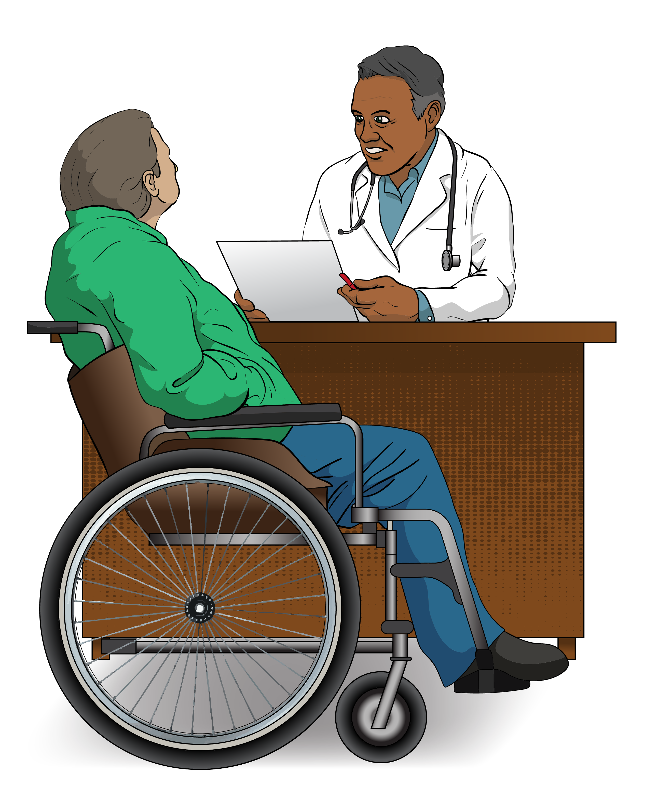
in the healthcare you get
when you do things on the internet

when you are in public places.


The Rainbow Rights in Aotearoa website is:

www.rainbowrights.nz

This website is not in Easy Read.

Thank you


Lots of people worked together on the Rainbow Easy Reads.


Thank you to the Rule Foundation for giving us the money to make them.


Thank you also to:

- the People First NZ members who worked as advisors

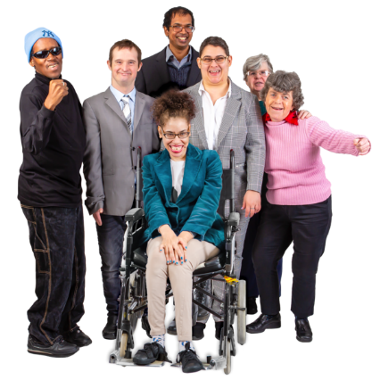
- the People First NZ staff who supported them

- everyone who has supported this mahi / work.

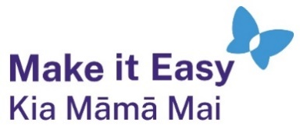
This information has been written by Make it Easy Kia Māmā Mai.

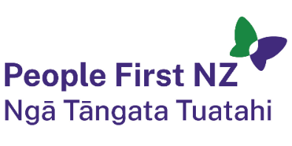
Make it Easy is a service of People First New Zealand Ngā Tāngata Tuatahi.


All images used in this Easy Read document are subject to copyright rules and cannot be used without permission.


Make it Easy uses images from:

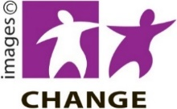
- Photosymbols

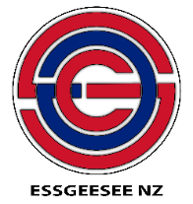
- Change Images

- SGC Image Works


- Huriana Kopeke-Te Aho

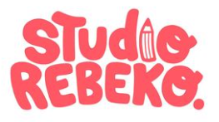
- T Wood

- Studio Rebeko

- Inga Kramer.

