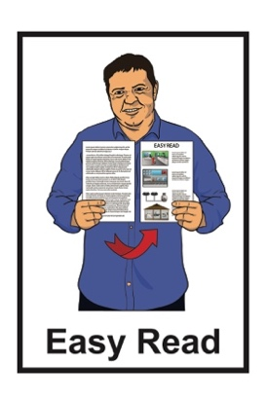

Housing Inquiry:

Homelessness and human rights
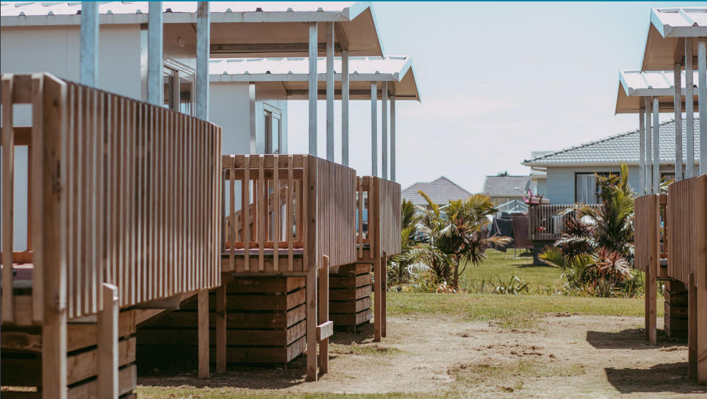

A review of emergency housing

Published: September 2023

Before you start
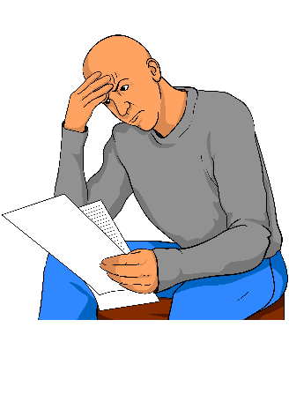

This is a long document.

Some things you can do to make it easier are:
read it a few pages at a time
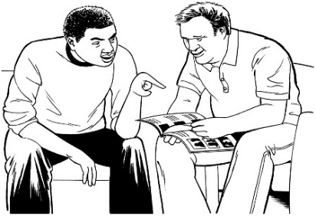
set aside some quiet time to look at it
have someone read it with you to support you to understand it.

What you will find in this document

Page number:

About this document 3

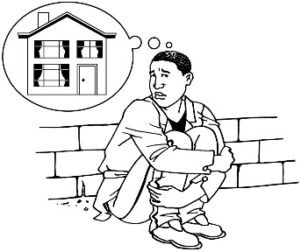
The housing crisis 8

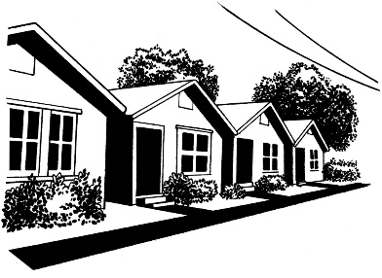
What is emergency housing? 11

What we found out about
emergency housing 15

Our recommendations 20

How to contact the Human
Rights Commission 25

About this document

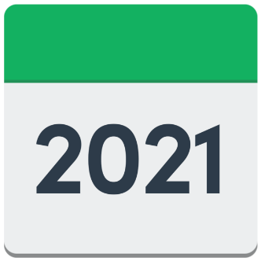
In 2021 Te Kāhui Tika Tangata - Human Rights Commission started an inquiry into housing with a report looking at the right to a decent home.

Te Kāhui Tika Tangata - Human Rights Commission is an organisation that works to make sure:
- human rights are followed in Aotearoa New Zealand
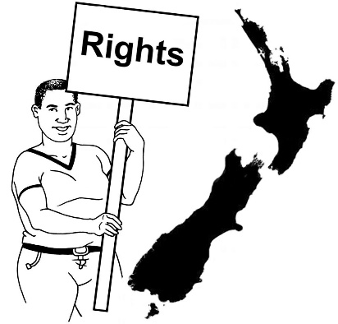
- people understand human rights
- people care about human rights.

The Human Rights Commission is also called the HRC.
Human rights are rights to make sure everyone:
- is treated fairly
- has what they need to live a good life.

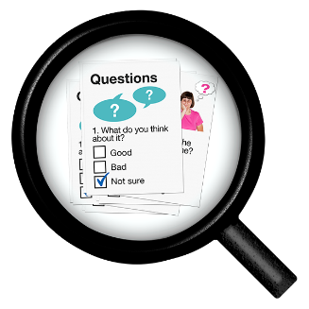
An inquiry is when we find out things about something by:

asking lots of questions

looking at how things are now.

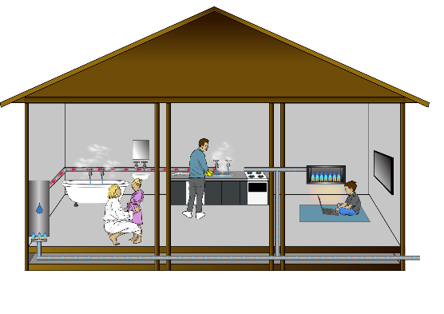
A decent home is a good place that is:
warm / dry
safe
does not cost too much money.
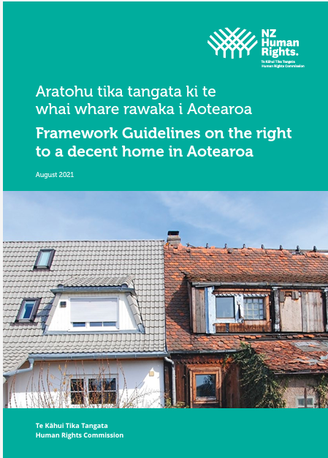
From that inquiry the HRC wrote a report about the things they found called:

Aratohu tika tangata ki te whai whare rawaka i Aotearoa – Framework Guidelines on the right to a decent home in Aotearoa

You can find this report on the HRC website:

https://tinyurl.com/5vxjh6p6

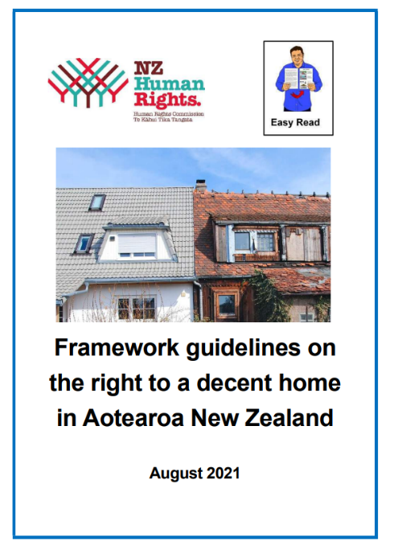
You can find a summary of the report in Easy Read on the HRC website at:

https://tinyurl.com/yvdjyncu

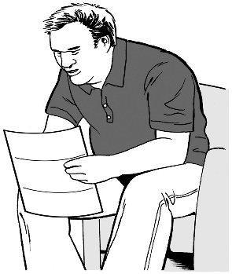
A summary is:

shorter than the full report

tells you the main ideas.

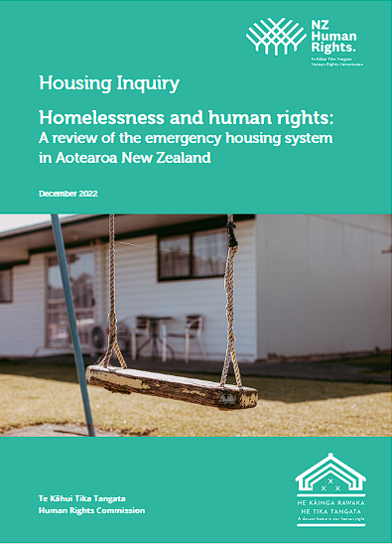
This Easy Read document is a summary of another HRC report called:

Homelessness and human rights: A review of the emergency housing system in Aotearoa New Zealand

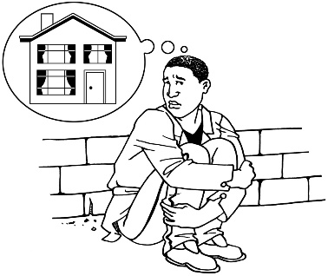
Homelessness is when people do not have a home to live in.

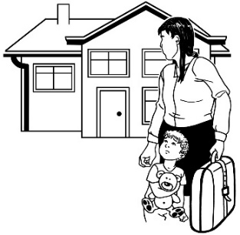
We will look at emergency housing on pages 11 to 14.

A review is when we look at what other people have written about something to find out things like:
is it working well?
how can it be made better?

You can find the full report on the HRC website:

https://tinyurl.com/45vw7ncz

In this Easy Read document when we say we / our this means the HRC.

The housing crisis

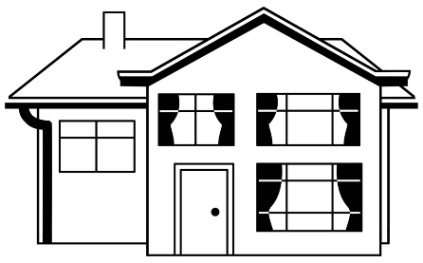
New Zealand has a housing crisis because governments over the years have not:
put money into building more housing for people
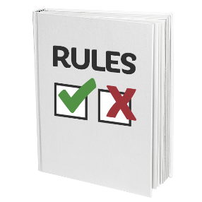
made sure that New Zealand has good rules about housing people.

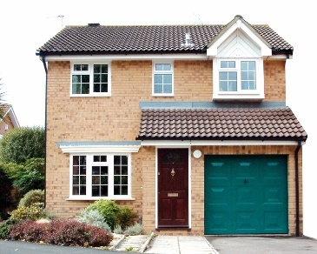
A housing crisis is a time when people are finding it hard to:

- have somewhere to live

- pay for the cost of housing.

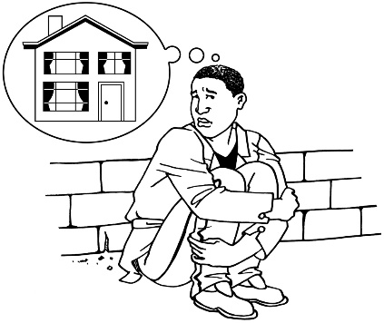
Some people become homeless during a housing crisis because they have nowhere to live.

Being homeless means not having a place to live.

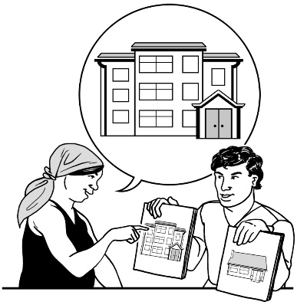
$
Somethings that have happened to make the housing crisis worse is past governments selling off public housing.

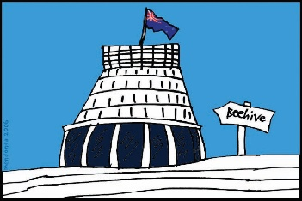
Public housing means houses that are:
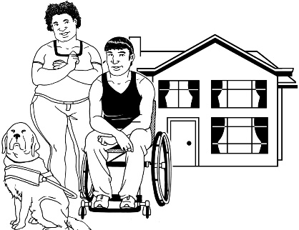
owned by the Government
for people who cannot find a house to live in
for people who do not have much money.
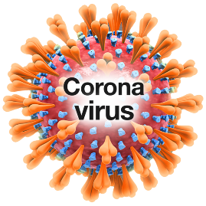
There are some things that make it harder for the Government to fix the housing crisis like:
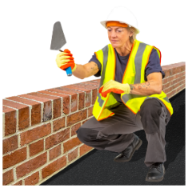
the COVID-19 pandemic
there not being enough things needed to build houses
the rest of the world also having problems with money which puts up the cost of housing.

These things have made it harder for people in New Zealand to live in a good home.

What is emergency housing?

Emergency housing is:
- a place for people to stay who are homeless
only for a short time such as 7 days
paid for by the Government.

You can find more information about emergency housing on the Work and Income website:

https://tinyurl.com/45fw2e3m

The information on the website is not in Easy Read.
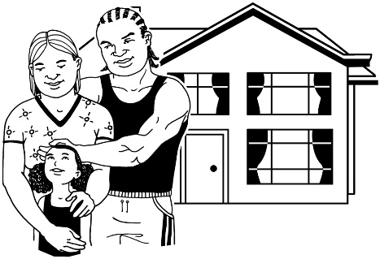
Some people may move from emergency housing to transitional housing.

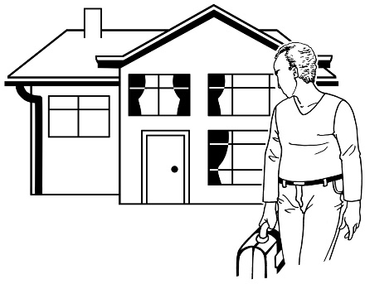
Transitional housing is for people who:

- do not have anywhere to live

and
- need a place to stay straight away.

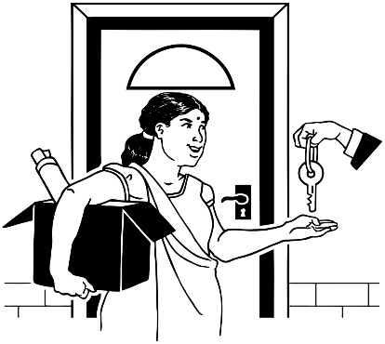
People in transitional housing:

- stay for about 12 weeks

- are supported to find a home to live in for a long time

- pay up to 25 per cent of their income towards the cost of rent.
Income is money that people are paid:
- for working
- as payments from the Government.

You can find more information about transitional accommodation on the Ministry of Housing and Urban Development website:

https://tinyurl.com/5euk7n9z

The information on the website is not in Easy Read.

In this Easy Read document when we say emergency housing we mean both:

- emergency housing
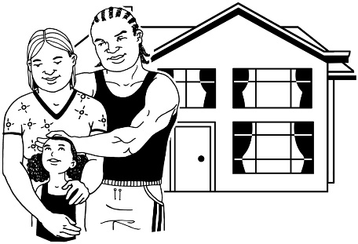
and

- transitional housing.

What we found out about

emergency housing
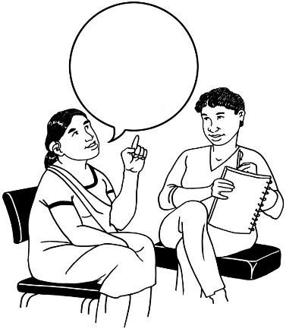

For this review we asked people to tell us about what it was like using emergency housing.

We found that emergency housing support has not worked for a lot of people because:

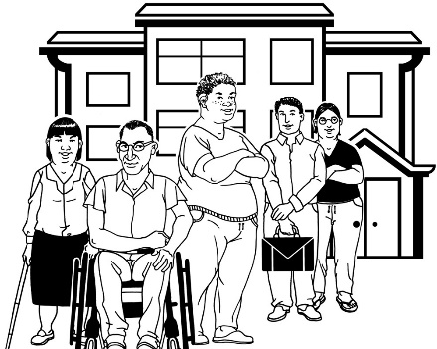
it has not supported the people who need it the most

it has not supported people to find places they can live in for a long time
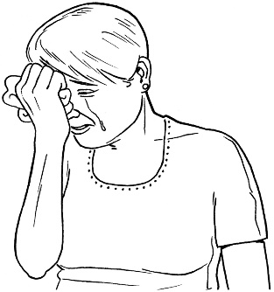
it can make bad experiences people have had a lot worse.

Some people said they went back to sleeping in their cars because they did not feel safe in the emergency housing.

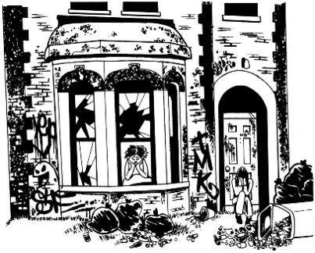
The Government has said in the past that it is better for people to be in emergency housing that is not very good than have no house at all.

Having an emergency housing system that makes people feel unsafe shows us that the system is not working for New Zealand.

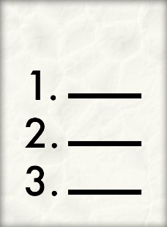
We found there are 3 important things the Government is not doing.

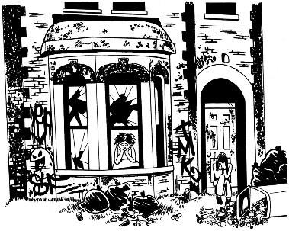
These 3 things are:

- most emergency housing is not good enough to be a decent home
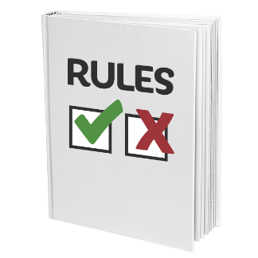
- there is no system to make sure that emergency housing is ok for people to stay in

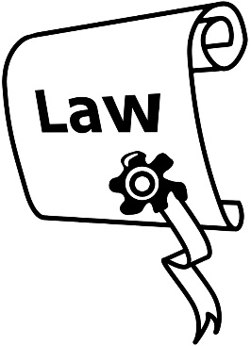
- the Government made the choice to not include emergency housing in the Residential Tenancies Act.

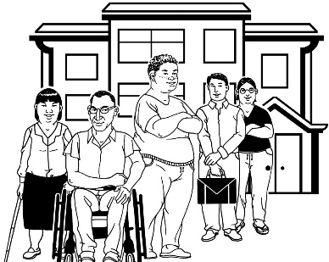
The Residential Tenancies Act is a law that tells everyone what the rules are about renting a house.

You can find out more about the Residential Tenancies Act on the Tenancy website at:

www.tenancy.govt.nz

The information on the website is not in Easy Read.

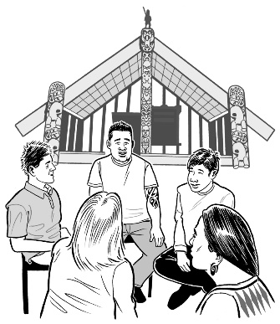
We also found lots of good work being done by community groups like:
iwi / hapu
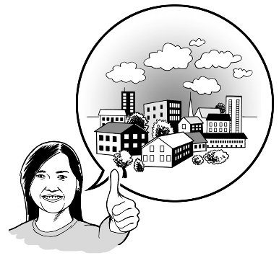
service providers
housing providers.

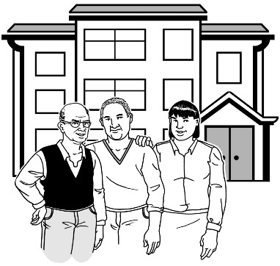
We have heard lots of good ideas about how the emergency housing system can be changed.

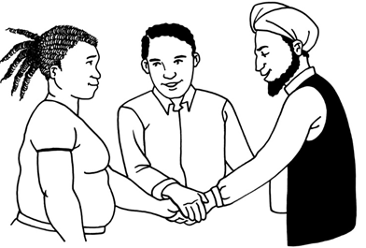
To stop people becoming homeless we need to:
work together
try new ideas.

Our recommendations

Recommendations are things we tell the Government they should do to make things better.

In our review we recommend ways that the Government can fix the problems in the emergency housing system.

We recommend that the Government creates 1 emergency housing system instead of having both:
emergency housing
transitional housing.

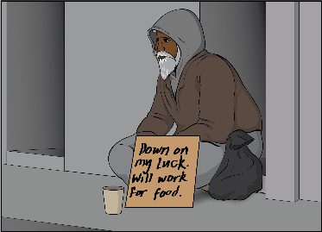
The emergency housing system needs to:

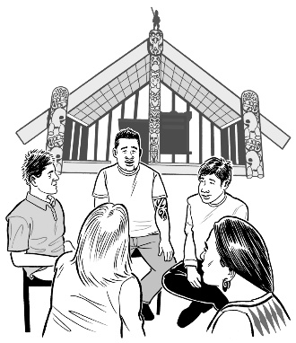
work for people who are homeless

respect what Māori need

support communities.
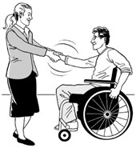
Respect means you think about how someone feels.
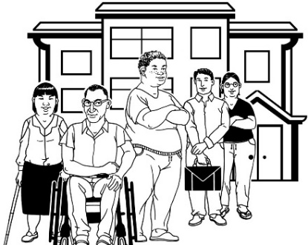
This emergency housing system needs to be created with:

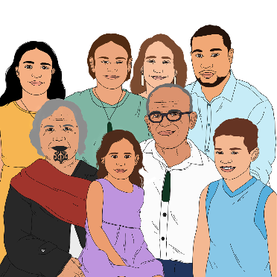
people who have experience of the emergency housing system

tangata whenua / Māori.

We recommend that the Government stops letting unregulated places:
offer emergency accommodation
get the emergency housing special needs grant that gives money to places offering emergency housing.

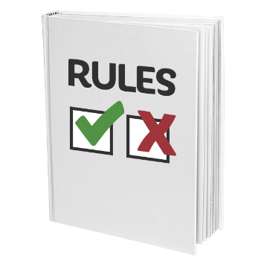
Unregulated means that there are no rules in place for places offering emergency housing.

Emergency housing special needs grant is money from the Government to pay for the cost of people staying in emergency housing.

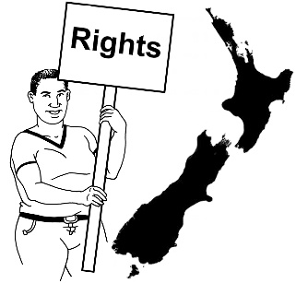
We also recommend that the Government protects the rights of people in emergency housing by:

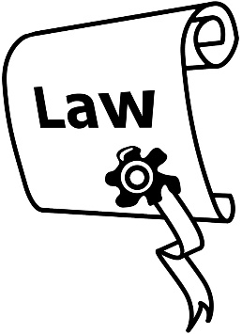
adding emergency housing to the Residential Tenancies Act

or
creating a system that will protect people in emergency housing.

We suggest the Government needs to create an independent advisory and advocacy group that:
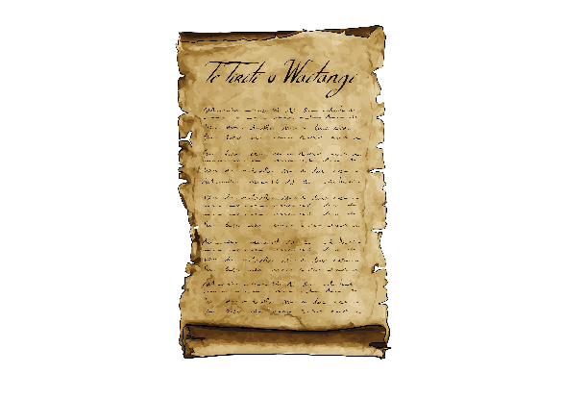
will protect the rights of people in emergency housing
follows Te Tiriti o Waitiangi / The Treaty of Waitangi.

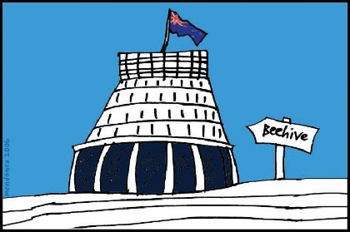
An independent advisory and advocacy group is a group of people who:
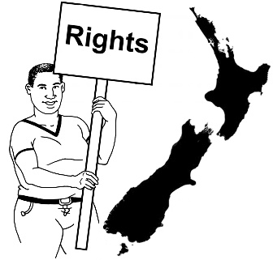
are not part of the Government
will make sure that the Government protects the rights of people in emergency housing.
Te Tiriti o Waitangi / The Treaty of Waitangi is an important agreement.

The agreement is about Māori and the New Zealand Government:
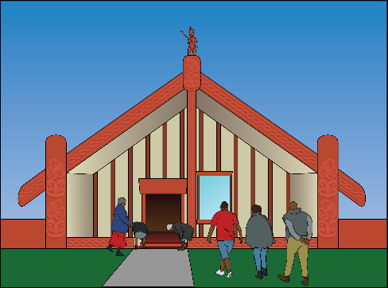
- making decisions together

- protecting things that are important to Māori.

How to contact the

Human Rights Commission

You can contact the housing inquiry team at the Human Rights Commission by:
phone: 0800 496 877
text: 021 0236 4253
email:

righttoadecenthome@hrc.org.nz

Please start your text or email with the words:
Housing Inquiry

You can also write to us at:

Te Kāhui Tika Tangata –

The Human Rights Commission

Attention: Housing Inquiry

PO Box 10424 The Terrace

Wellington 6143

You can find more information on our website at:

https://housing.hrc.co.nz

This information has been written by
Te Kāhui Tika Tangata - Human Rights Commission.

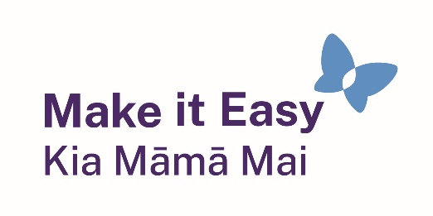
It has been translated into Easy Read by the Make it Easy Kia Māmā Mai service of People First New Zealand Ngā Tāngata Tuatahi.
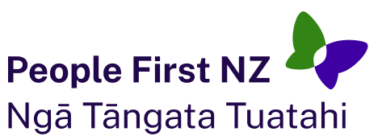
The ideas in this document are not the ideas of People First New Zealand Ngā Tāngata Tuatahi.
Make it Easy uses images from:

- Changepeople.org

            - Photosymbols.com

- SGC Image Works
- Huriana Kopeke-Te Aho
- T. Wood.
All images used in this Easy Read document are subject to copyright rules and cannot be used without permission.

