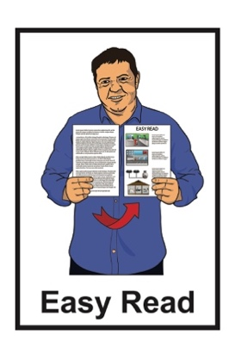
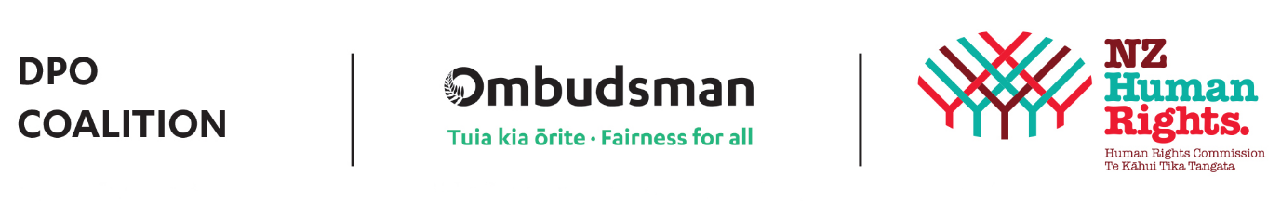

Disabled People’s


Organisations Coalition:
Key messages from May 2024

Published: July 2024

The Disabled People’s Organisations Coalition


The Disabled People’s Organisations Coalition is a group of people who come from different disability organisations.
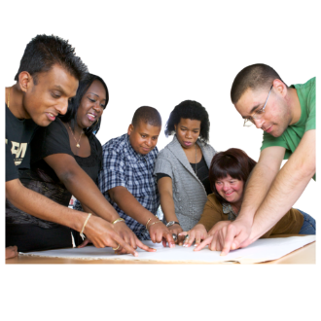

A coalition is a group of organisations that work towards shared goals.

The Disabled People’s Organisations Coalition is also called the DPO Coalition.


When you see the words we / us in this document it means the DPO Coalition.

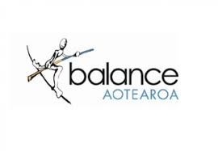
The DPO Coalition is made up of members from these 6 disability organisations:

Balance Aotearoa
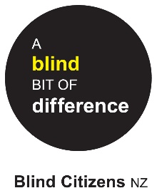

Blind Citizens New Zealand

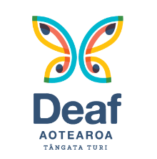
Deaf Aotearoa

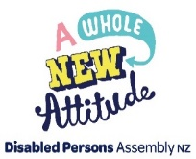
Disabled Persons Assembly NZ

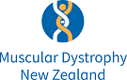
Muscular Dystrophy Association of New Zealand

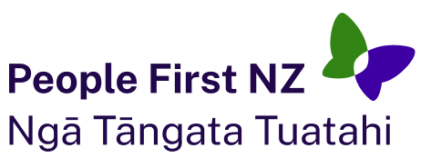
People First New Zealand – Ngā Tāngata Tuatahi.


The DPO Coalition meets about every 6 weeks to talk about important things.

The DPO Coalition speaks up about disabled people getting their human rights.

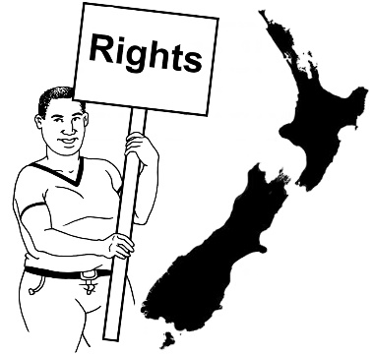
Human rights are things that the law says every person should:
have
be able to do.

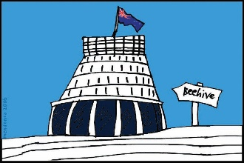
The DPO Coalition talks with the Government about things to do with disability.

What this document is about

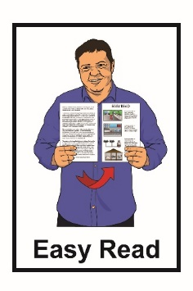
This is an Easy Read document about some of the key messages from the DPO Coalition meetings in May 2024.

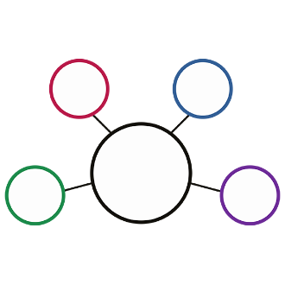
During these meetings the DPO Coalition met with lots of:
government agencies
other community organisations.

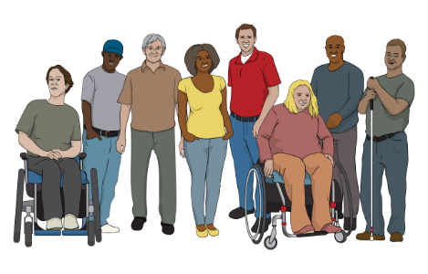
The meetings are to make sure the lives of disabled people in New Zealand are getting better.

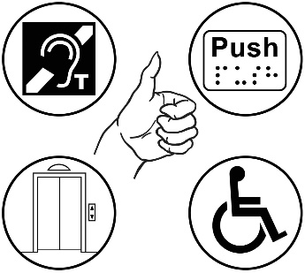
The 2 key things often talked about at DPO Coalition meetings are:
accessibility
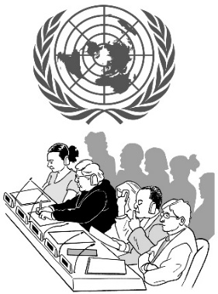
upholding the rights of disabled people under the United Nations Convention on the Rights of Person with Disabilities – the Disability Convention.
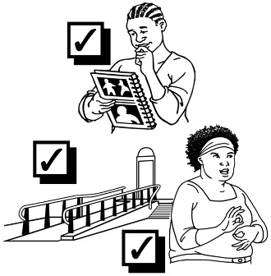

Accessibility means making things easier / safe for everyone to use.

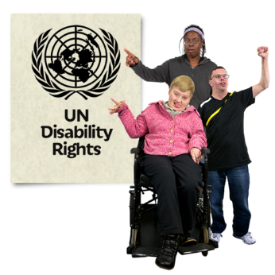
The United Nations Convention on the Rights of Persons with Disabilities / UNCRPD is a law lots of countries have agreed to.
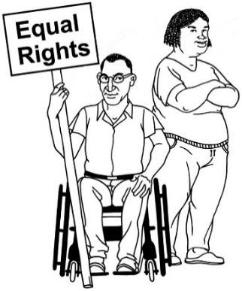

It says what governments must do to make sure disabled people get the same rights as everybody else.

Sir Robert Martin

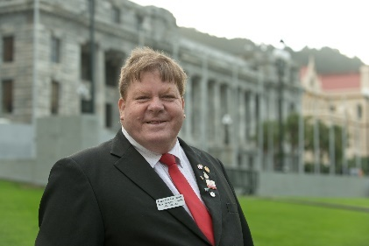
The DPO acknowledge the passing of Sir Robert Martin.

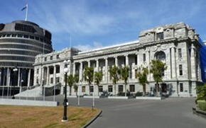
Louise Upston who is the Minister for Disability Issues honoured Sir Robert in Parliament by telling everyone about:
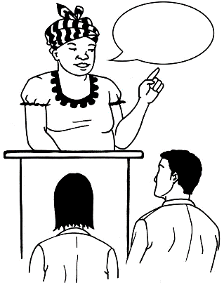
who he was
the important things he did for disabled people.

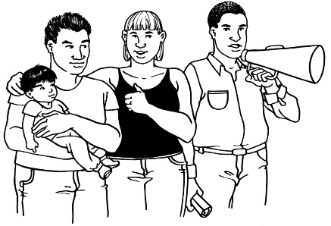
Sir Robert spent a lot of his life doing things to try to make life better for disabled people.

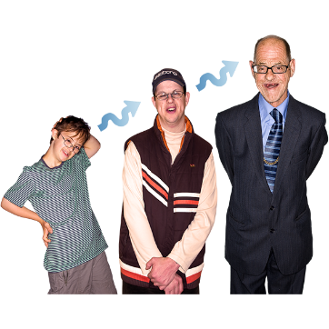
The things that Sir Robert went through as a disabled child affected the work he did as a disabled adult.

He was chosen to be a part of the United Nations Committee on the Rights of Persons with Disabilities in 2016.

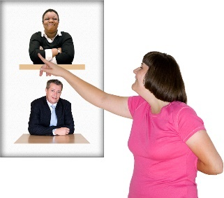
Sir Robert was the first person with learning disability to ever be chosen.

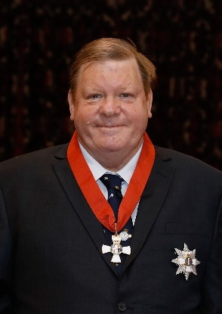
He was given a title called a knighthood in 2020 to honour everything he had done for people with disabilities.


Minister Upston said that the work Sir Robert did made the lives of many disabled people around the world much better.

Minister for Disability Issues

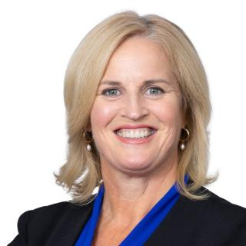
The new Minister for Disability Issues is Louise Upston.

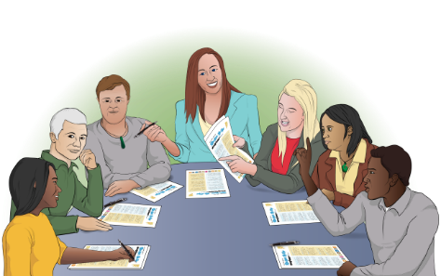
Minister Upston took some time to meet with us at our DPO Coalition meeting in May.

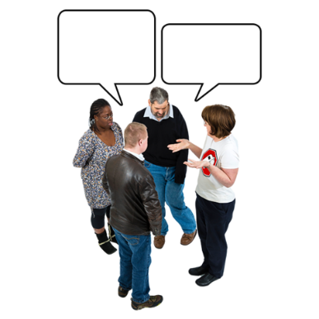
She spoke with the DPO Coalition about the work we do.

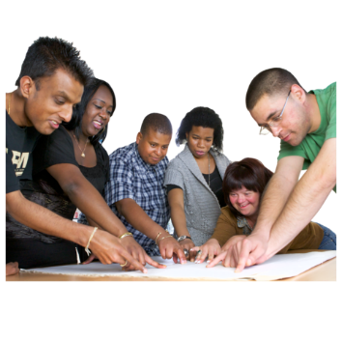
We are looking forward to working more with Minister Upston in the future.

The Independent Monitoring Mechanism

The Independent Monitoring Mechanism is also known as the IMM.

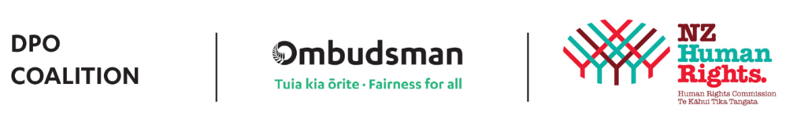
The IMM is made up of 3 groups:
DPO Coalition
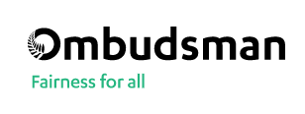
Office of the Ombudsman
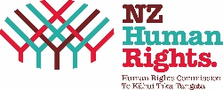
Human Rights Commission.

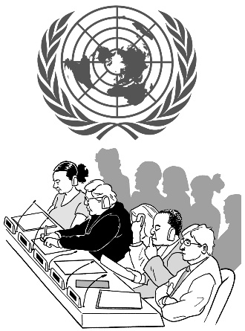
The IMM looks at what the Government is doing to follow the United Nations Convention on the Rights of Persons with Disabilities.

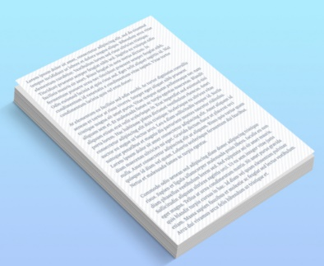
We met with the IMM to go over their updated Terms of Reference document.


Terms of Reference are like a set of rules that the IMM needs to follow.


We said that the new Terms of Reference are okay.


The document will be shared with everyone when accessible formats of the document have also been made.

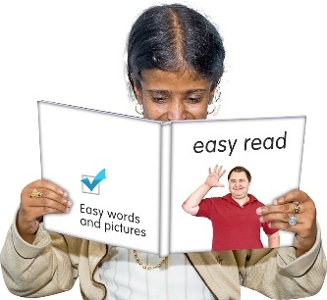
Accessible formats are things that make it easier for people with disabilities to get the information they need.


Accessible formats include things like:
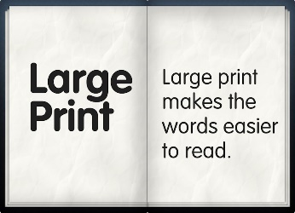
Braille
Large Print
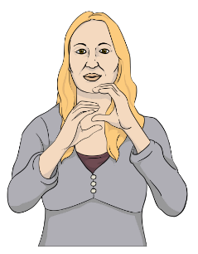
Easy Read
New Zealand Sign Language.

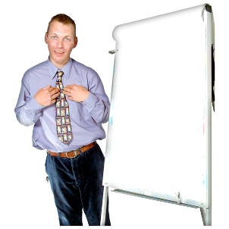

All the groups in the IMM take turns to be the Chair of the IMM for 6 months at a time.

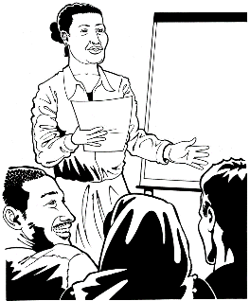
Being the Chair means you lead the group.

The next group to be the Chair of the IMM is the DPO Coalition.

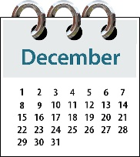
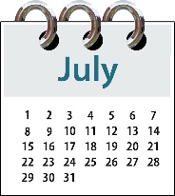
We have chosen Jonathan Godfrey to be the Chair of the IMM:
from July 2024
to December 2024.

Whaikaha – Ministry of Disabled People

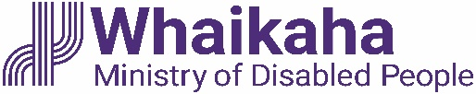
We met with 4 people from
Whaikaha – Ministry of Disabled People:
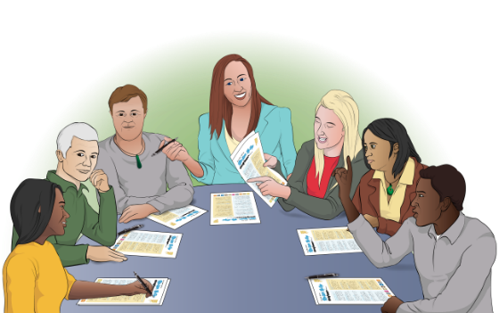
Ben O’Meara – Deputy Chief Executive of:
- policy
- strategy
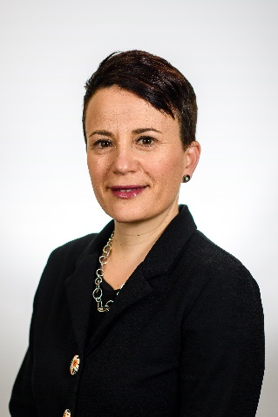
- partnerships
Paula Tesoriero – Chief Executive of Whaikaha
Sheryl Pinckney – Group Manager of Partnerships and Stewardship
Neil Melhuish – Policy Advisor.


We had a workshop with Ben O’Meara to talk about the new funding rules for disability.


We did not make any final decisions about the funding rules at the workshop.

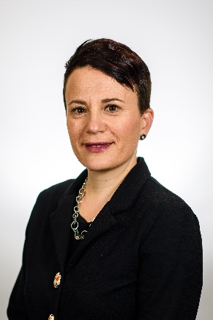
We met with Paula Tesoriero for the first time this year.

Paula told us that the things Whaikaha are working on first include:
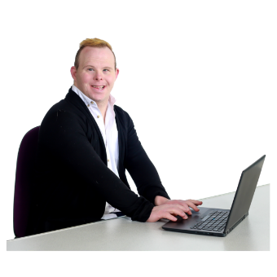
making Whaikaha as good as it can be
making sure the Human Resources part of Whaikaha is working well.
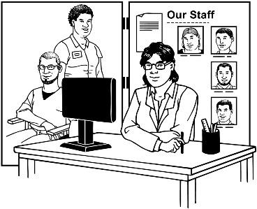
Human Resources is the part of an organisation that looks after the people who work there.


Whaikaha is also working on supporting the Minister for Disability Issues to review how well things are going at the organisation.

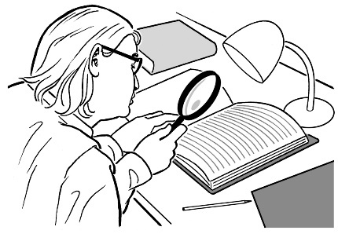
A review is when someone looks at something to see:
what things are working well
if any changes need to be made.

We met with Sheryl Pinckney and Neil Melhuish to talk about how we can be a part of an updated New Zealand Disability Strategy and Action Plan.

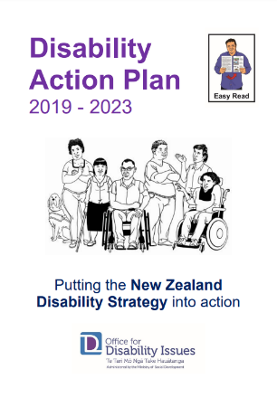
The Disability Strategy and Action Plan says what the Government needs to do so that disabled people have the same chances as everyone else to do the things that are important to them.

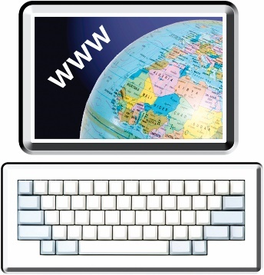
You can find Easy Read information about the current New Zealand Disability Strategy and Action Plan at:

https://tinyurl.com/ydpprvft

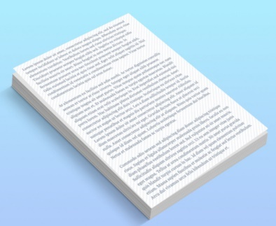
We were told that the Minister for Disability Issues will work with the DPO Coalition to put together a draft cabinet paper.

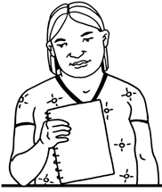
A cabinet paper has information in it that Cabinet needs to:
know
make a decision about.

Cabinet is a group of people called Ministers who work in Government.

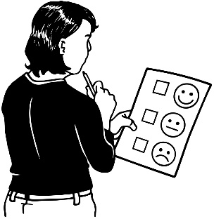

The cabinet paper will look at the things the UNCRPD said the New Zealand Government should do to make things better for disabled people.

Total Mobility Scheme review

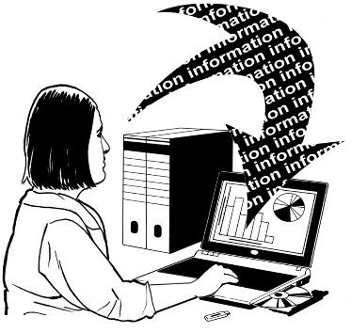
We met with Bridget Doran who is the Principal Researcher at MRCagney.

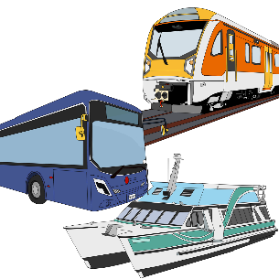
MRCagney is a business that supports councils to put together good transport systems.

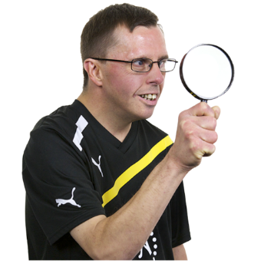
MRCagney is working with the Ministry of Transport to review the Total Mobility Scheme.


The Total Mobility Scheme is a government service that supports people with the funding they need to use public transport.

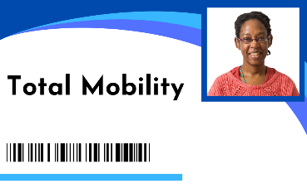
Bridget told us that the Ministry of Transport has made some changes to how the review of the Total Mobility Scheme is being done.

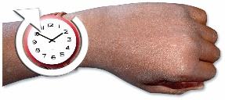

These changes mean the work MRCagney is doing will take a few more months to do.

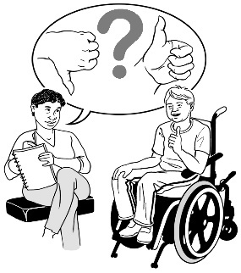
It also means it will take longer for them to talk about this work with:
disabled people
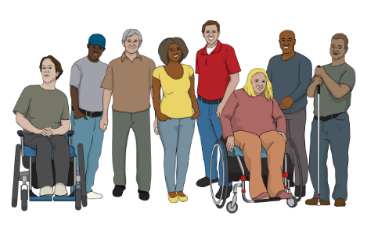
other people who use the Total Mobility Scheme.

1 of the changes means that documents that have already been done must now be sent to Cabinet so they can say yes to them.

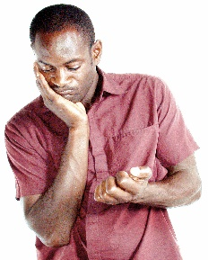

We think that some of these changes are taking too long.

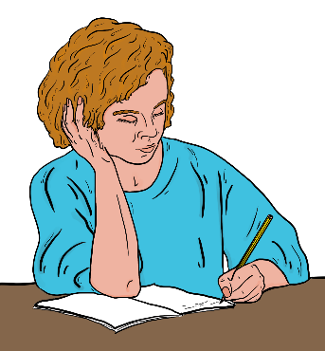
We are writing to Simeon Brown who is the Minister of Transport to ask him to make sure the review is done as soon as possible.

Donald Beasley Institute

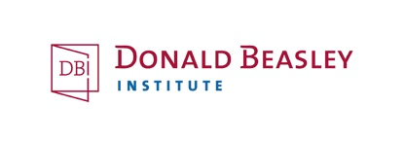
We met with:

Dr Robbie Francis Watene who is a researcher at the Donald Beasley Institute
the team that she works with.
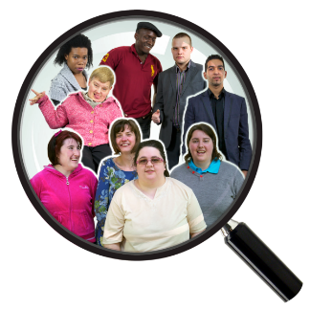
The Donald Beasley Institute / DBI does important research about a lot of different things.

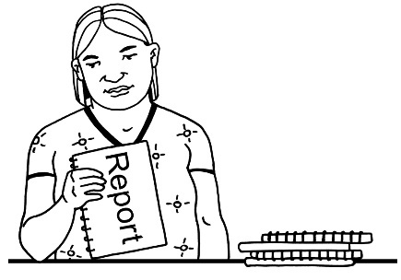
The DBI told us about a report they have been doing that looks at how people access disability support services.

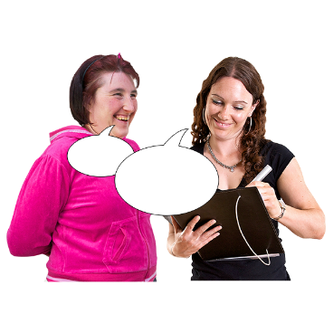
The DBI told us about the different ways they work with people to get their stories.

On 18 March 2024 Whaikaha – Ministry of Disabled People made changes to how funding can be used by disabled people / their carers.

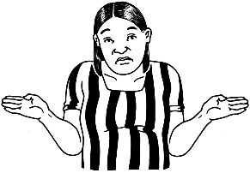
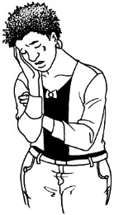
These changes surprised / upset a lot of people.

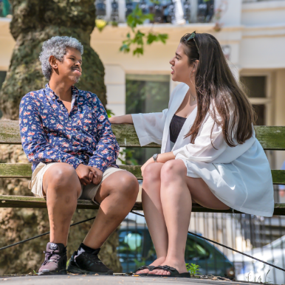
The DBI will listen to the stories that people share about how the funding changes have affected their services.

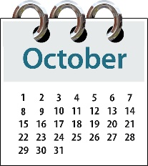
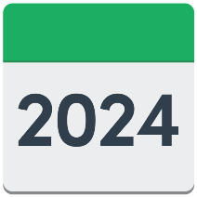
We will meet with the DBI again in October 2024 to talk about their report.

Law Commission

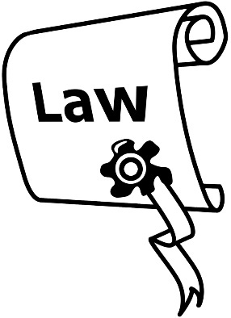
We talked with some people from the Law Commission including:
Geoff Shirtcliffe who is the Commissioner
the team that he works with.

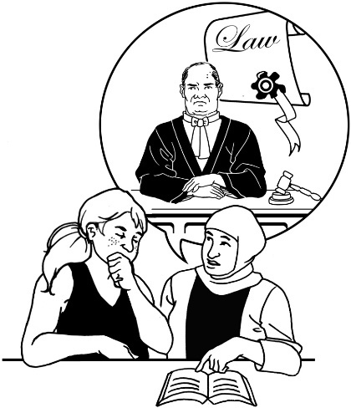
The Law Commission looks at New Zealand laws to see if they can be made better / more accessible.

The Commissioner works with government ministers to support them to make the laws better.

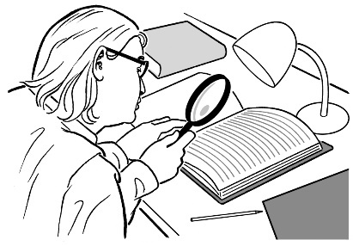
We had a long talk with the Law Commission about the work they are doing on the review of adult decision-making capacity law.

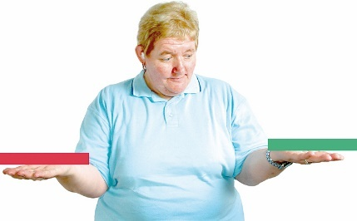
Decision-making capacity means if someone is able to make important choices / decisions for themselves.

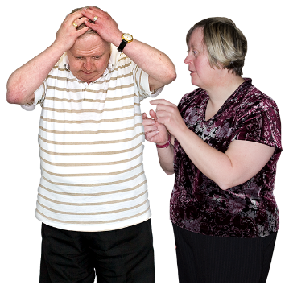
Things that might make it harder for someone to have decision-making capacity include:

dementia which is an illness that affects the brain
an injury to the brain
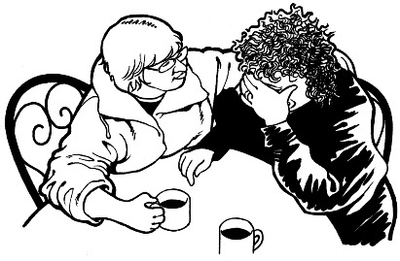
learning disability
having very bad mental health.

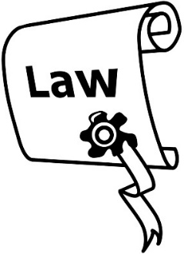
The review is to look at what the law should say about the Protection of Personal and Property Rights Act / the PPPR Act.


The PPPR Act says what needs to happen if someone is not able to decide things for themselves.

Commonwealth Disabled People’s Forum

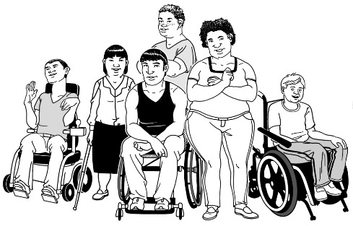
The Commonwealth Disabled People’s Forum works to support the rights of all disabled people who are part of the Commonwealth.


The Commonwealth is a group of 56 countries that work together to look after all the people who live in those countries.


The people in the DPO Coalition said yes to asking if we can be a part of the Commonwealth Disabled People’s Forum.

South Korea

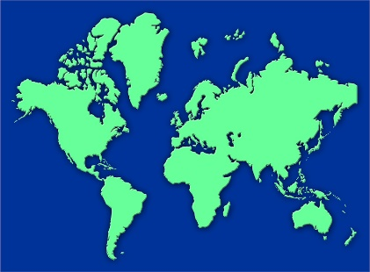

A small group of people from the IMM went to Seoul in May 2024 to meet Disabled Peoples’ International Korea / DPI Korea.

Disabled Peoples’ International / DPI is a group that includes lots of different disability organisations around the world.
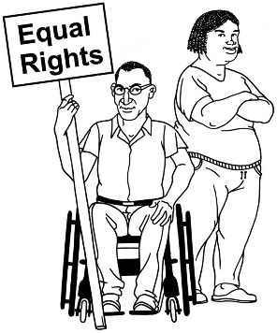

DPI does work to support disabled people to get their human rights.

In the meeting the IMM shared information with DPI Korea about:
how the IMM was put together
the kinds of work it does.


They also talked about how the IMM can work with DPI Korea to put together an IMM in South Korea.


The trip was paid for by DPI Korea.

Voice of disabled people

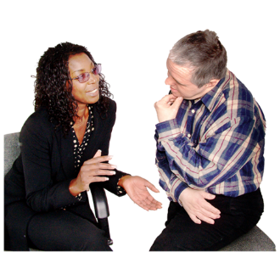
The Government meets with the DPO Coalition so that disabled people are able to have a say in the decisions being made.
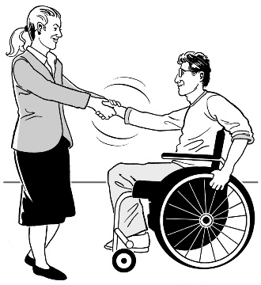

The DPO Coalition is always looking for new organisations to join us.

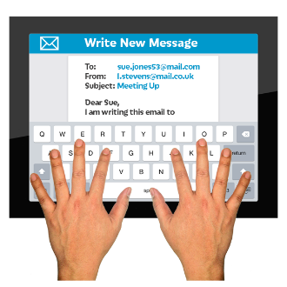
You can contact us by emailing us at:

us-dpo@groups.io

You can also contact us if you are interested in being a DPO Coalition representative on any advisory groups.
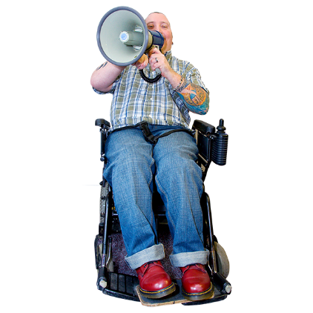

A representative is someone that speaks for a group of people about something important to them.

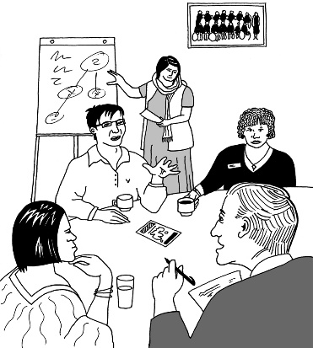
An advisory group is a group of people who give advice on something that they know a lot about.

This information has been written by the DPO Coalition.

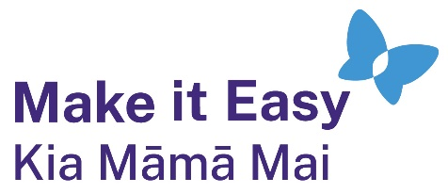
It has been translated into Easy Read by the Make it Easy Kia Māmā Mai service of People First New Zealand Ngā Tāngata Tuatahi.
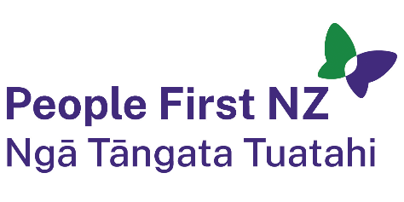
The ideas in this document are not the ideas of People First New Zealand Ngā Tāngata Tuatahi.
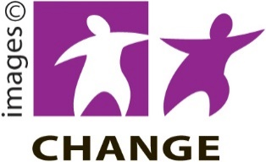
Make it Easy uses images from:


- Changepeople.org


            - Photosymbols.com
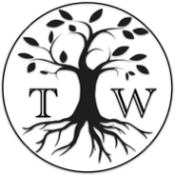
- SGC Image Works
- Huriana Kopeke-Te Aho
- T. Wood.

All images used in this Easy Read document are subject to copyright rules and cannot be used without permission.

