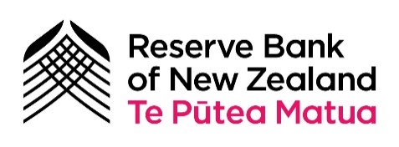
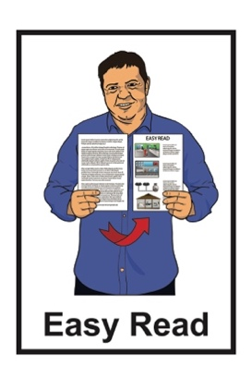

Digital Cash in New Zealand
Survey

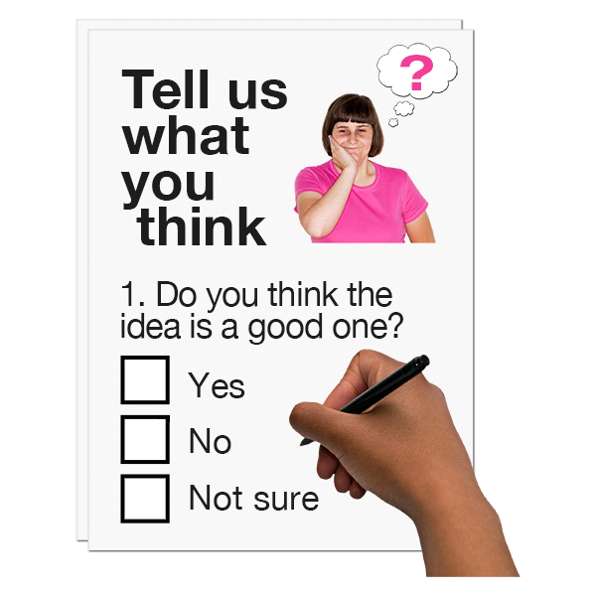
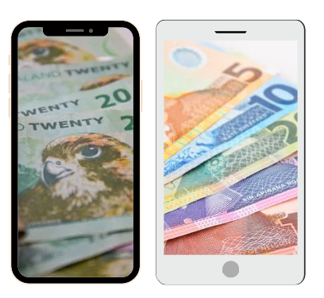

Published: August 2024

What is in here

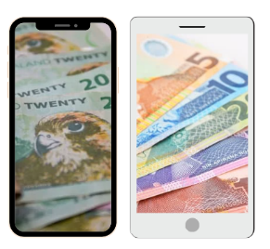
Page number:

What is this survey about? 3

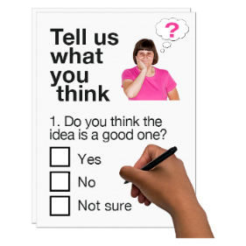
Answering the survey questions 6

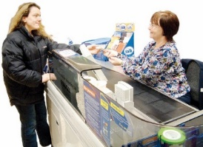
Why we are looking into
digital cash 8


What the Reserve Bank wants
to do with digital cash 10

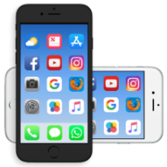
Features of digital cash 12
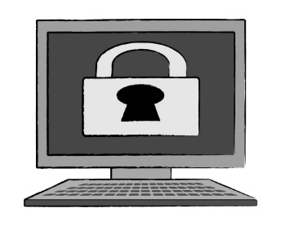

Security 26

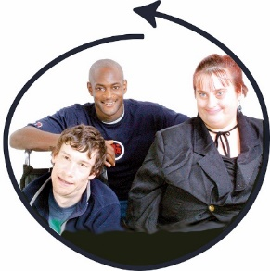
Page number:

Everyone can use digital cash 32
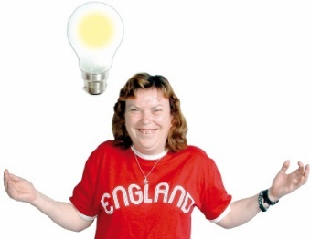

New ways of doing things 47

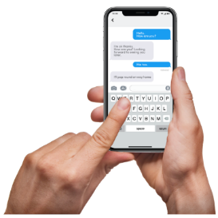
How to find out more 52

What is this survey about?

This survey is from the Reserve Bank of New Zealand Te Pūtea Matua.

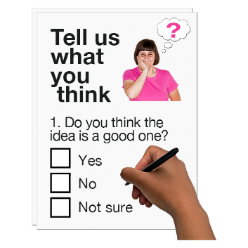
A survey is when we ask people lots of questions to find out information.

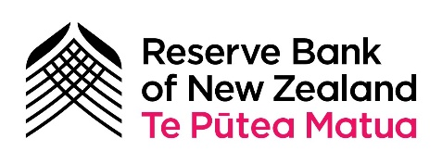
The Reserve Bank of New Zealand Te Pūtea Matua is the central bank of New Zealand.
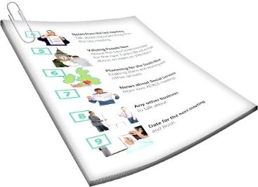

In this document we will call it the Reserve Bank.

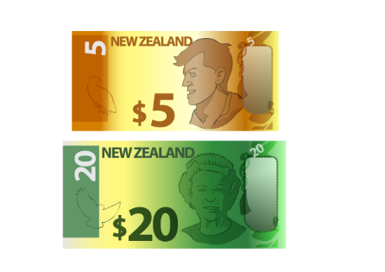
A central bank is the bank that
is in charge of making cash like coins / banknotes.

When we say we / our in this document we mean the Reserve Bank.

At the Reserve Bank of New Zealand we are looking at digital cash.

Digital cash is a new kind of money.
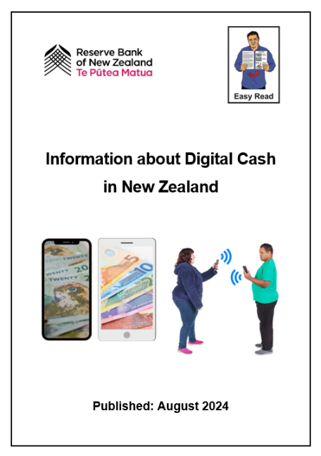

There is an Easy Read document that has more information about digital cash called:

Information about Digital Cash in New Zealand

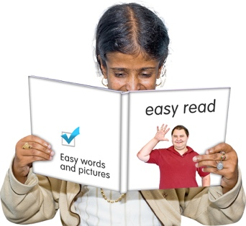
You should read that document before you do this survey.

Answering the survey questions

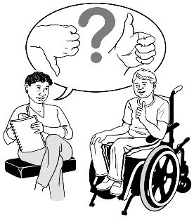
We want to know what you think about digital cash.

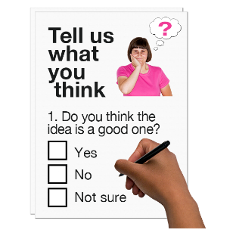
We have some questions about different things to do with digital cash.


These things may be:
important parts of digital cash

ideas we have for how we would make digital cash work

things other people think about digital cash
worries people might have about digital cash.

You can answer the questions in this survey to tell us what you think.

When you have filled in this survey you can send it to us:
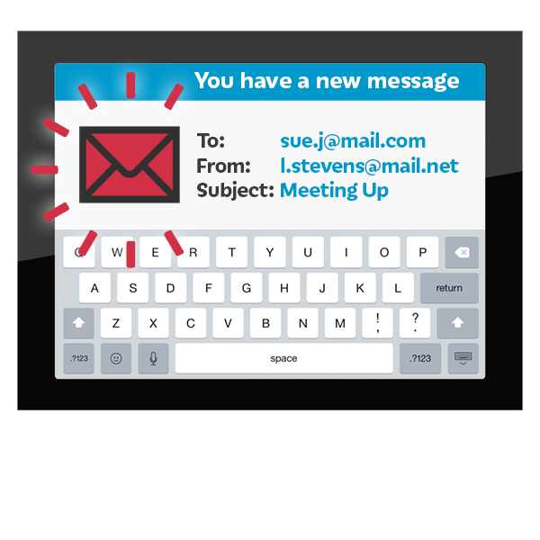
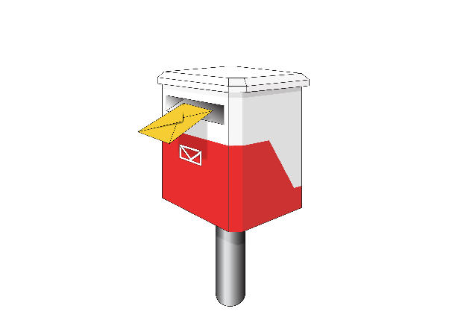
by post to:
Future of Money
Reserve Bank of New Zealand
PO Box 2498
2 The Terrace
Wellington 6140
by email to:
futureofmoney@rbnz.govt.nz
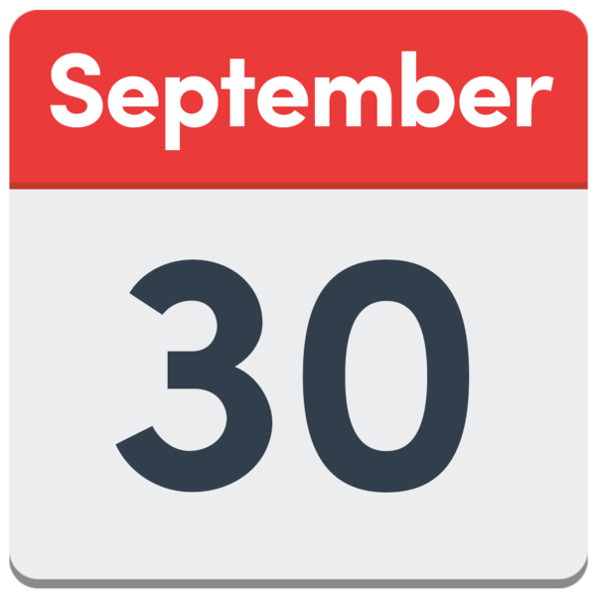
You need to send your answers to us by 30 September 2024.

Why we are looking into digital cash


We are looking into digital cash because we want you to:
keep trusting your money
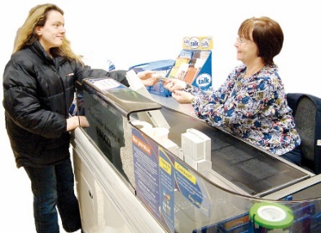
have a choice about how you pay for things.

Cash like banknotes / coins cannot be used on the internet.

We are looking at making a digital version that can be used online.

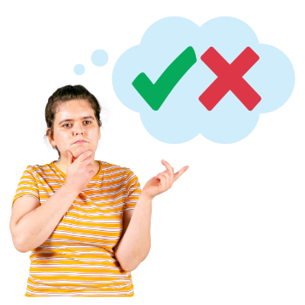
Do you agree with our reasons for looking into digital cash?

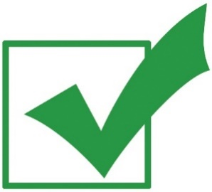
Tick the box next to the answer that is right for you:

yes

no

What the Reserve Bank wants to do with digital cash

How important to you is it that:
the Reserve Bank provides money that everyone can use?

Tick the box next to the answer that says how important this is for you:

very important

important

in the middle

not important

I am not sure

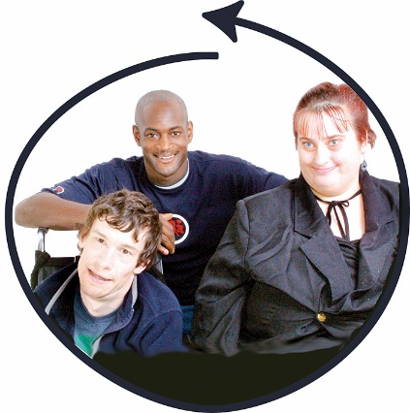
How important to you is it that:
people can use different kinds of money from the Reserve Bank like digital cash?

Tick the box next to the answer that says how important this is for you:

very important

important

in the middle

not important

I am not sure

Features of digital cash

Features of digital cash are:
important things about digital cash
things digital cash can do.


In these questions we want to know what features of digital cash are important to you.

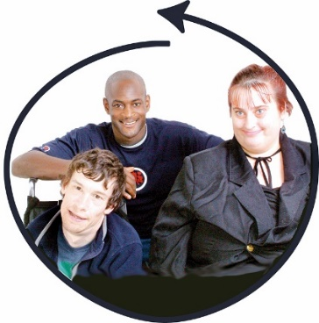
How important to you is it that:
everyone can use digital cash?

Tick the box next to the answer that says how important this is for you:
very important

important

in the middle

not important

I am not sure

How important to you is it that:
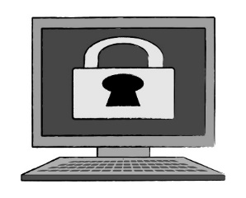
digital cash is a private way to pay for things?

Private means other people do not know what you are using it for.

Tick the box next to the answer that says how important this is for you:

very important

important

in the middle

not important

I am not sure

How important to you is it that:

the Government cannot control how people use digital cash?

Tick the box next to the answer that says how important this is for you:

very important

important

in the middle

not important

I am not sure

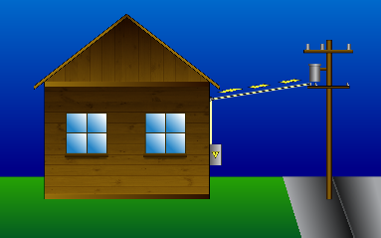
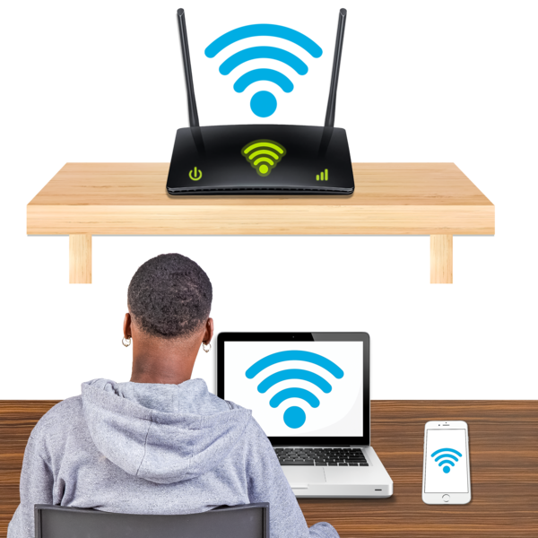

How important to you is it that:
digital cash can be used online as well as without:
- power
- internet?

Tick the box next to the answer that says how important this is for you:

very important

important

in the middle

not important

I am not sure

How important to you is it that:
digital cash gives you another choice of how to pay along with:
- cash
- other ways of paying like EFTPOS?

Tick the box next to the answer that says how important this is for you:

very important

important

in the middle

not important

I am not sure

How important to you is it that:

digital cash:
- can be used in new ways
- uses new ideas?

Tick the box next to the answer that says how important this is for you:

very important

important

in the middle

not important

I am not sure

How important to you is it that:
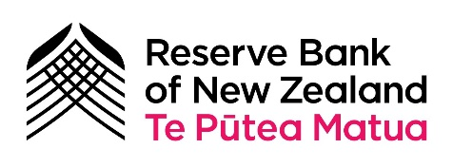
the Reserve Bank is in charge of digital cash which makes it safer?

Tick the box next to the answer that says how important this is for you:

very important

important

in the middle

not important

I am not sure

How important to you is it that:
digital cash does not cost money to use?

Tick the box next to the answer that says how important this is for you:
very important

important

in the middle

not important

I am not sure


What are your biggest worries about digital cash?

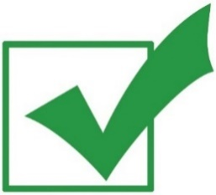
Tick all the boxes that are right for you:

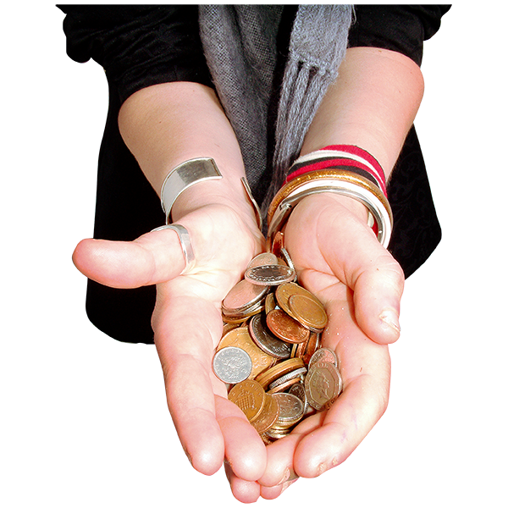
Having digital cash might make it harder for people to use banknotes / coins.

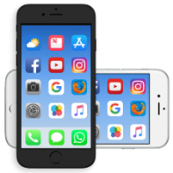
I might not be able to use digital cash because I find technology like phones hard.

The Government might use digital cash to look at or control what I spend.
If people use digital cash they might use other ways of spending money less.

It might be easier for my digital cash to be lost / stolen.
These are some more worries people might have about digital cash.

Tick all the boxes that are right for you:

I do not trust the Reserve Bank to be in charge of digital cash.

I have no worries about digital cash.

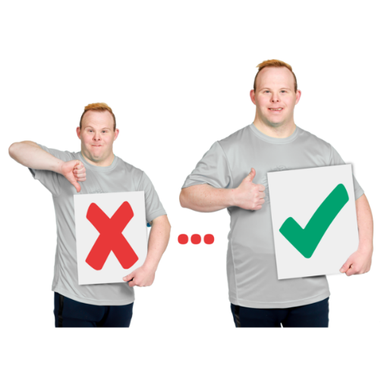
How important to you is it that New Zealand has a money / payments system that:
can try new ways to make payments:
- easier
- better?

Tick the box next to the answer that says how important this is for you:

very important

important

in the middle

not important

I am not sure


How important to you is it that New Zealand has a money / payments system that:
makes good use of what we have so it costs less for everyone?

Tick the box next to the answer that says how important this is for you:

very important

important

in the middle

not important

I am not sure

How important to you is it that New Zealand has a money / payments system that:
is able to be used by everyone?

Tick the box next to the answer that says how important this is for you:

very important

important

in the middle

not important

I am not sure

Security

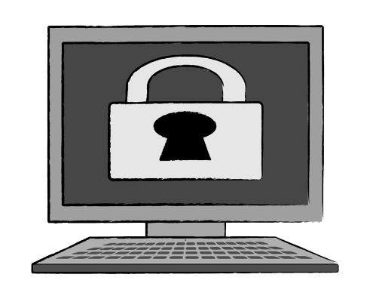
Security means:
keeping things safe
making sure only the right people can:
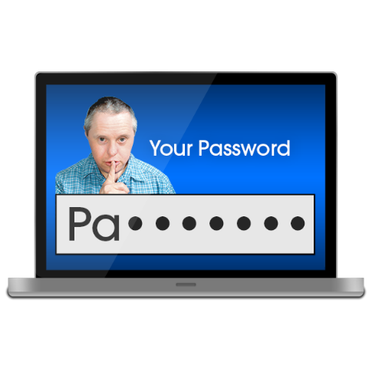
- see information
- make changes.

Which of these security features of digital cash are important for you?

Tick all the boxes that are right for you:

It is backed by the Reserve Bank which means the Reserve Bank will always be there to make sure 1 dollar in cash is still worth a 1 dollar coin.

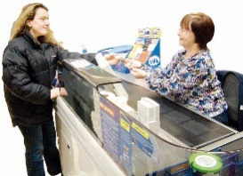
It can be used when power / internet is out.

It is a different way of paying.

People cannot steal it.

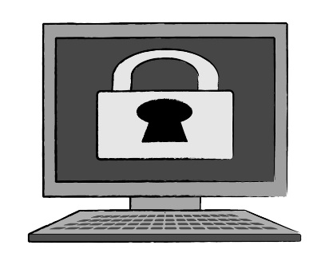
Information about me / what I do with my money is kept safe.

None of these features are important to me.
Do you think digital cash is safer than putting money in a bank account?

Tick the box that is right for you:

much safer

a bit safer

about the same

less safe

I am not sure

Do you think digital cash is safer than money from places that are not banks like:
credit unions
money transferrers?

Tick the box that is right for you:

much safer

a bit safer

about the same

less safe

I am not sure

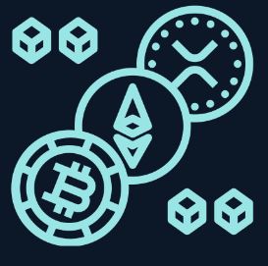
Cryptocurrency is another kind of digital money.

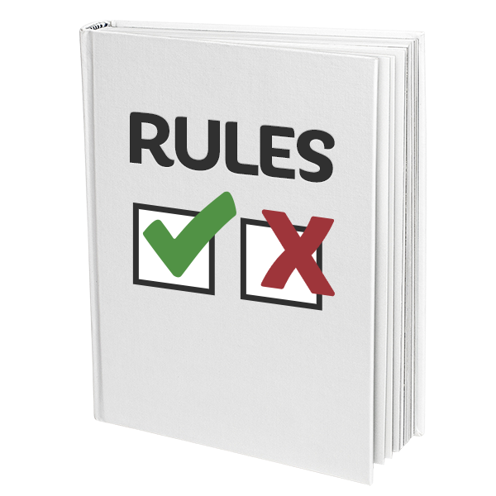
There are not many rules about cryptocurrency.


How much cryptocurrency is worth can go:
up quickly
down quickly.

Do you think digital cash is safer than cryptocurrency?

Tick the box that is right for you:

much safer

a bit safer

about the same

less safe

I am not sure

Everyone can use digital cash

It is important that everyone can use digital cash.

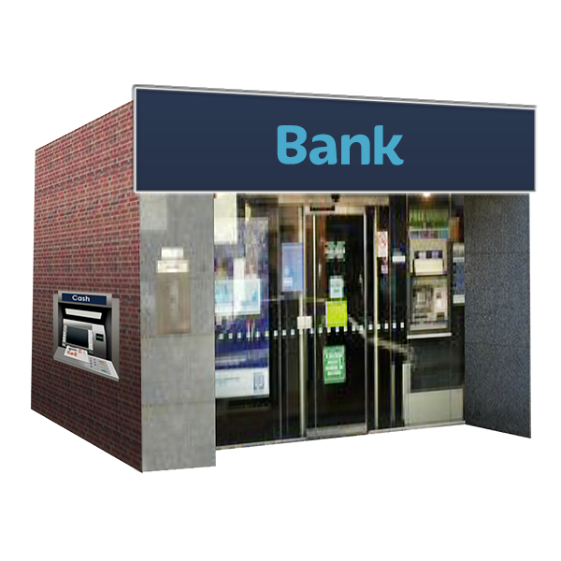
Most people in New Zealand have:
a bank account
an EFTPOS card.

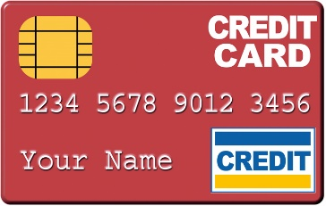
People often use digital forms of payment like:
- EFTPOS
- credit cards
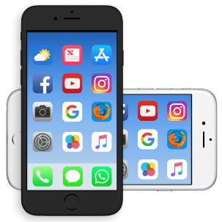
- an app on their phone.

People who do not have a bank account use cash like:
- bank notes
- coins.

People can use cash when there is no:
power
internet.

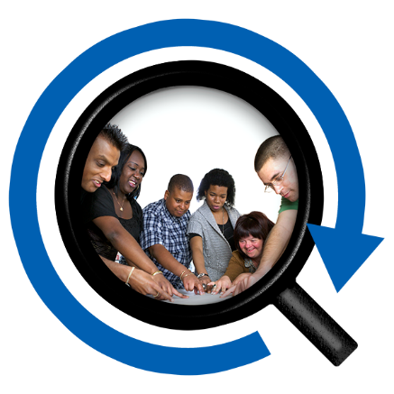
Cash is good for including everyone.

In these questions we want to know what parts of digital cash would be most important in your life.

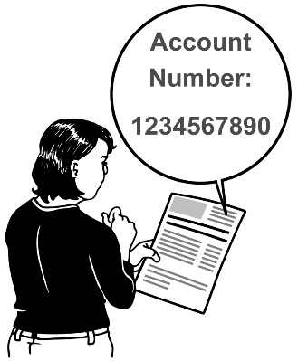
How important is it that you do not need a bank account to use digital cash?

Tick the box next to the answer that says how important this is for you:

very important

important

in the middle

not important

I am not sure

How important is it that digital cash does not cost a lot of money to use?

Tick the box next to the answer that says how important this is for you:

very important

important

in the middle

not important

I am not sure

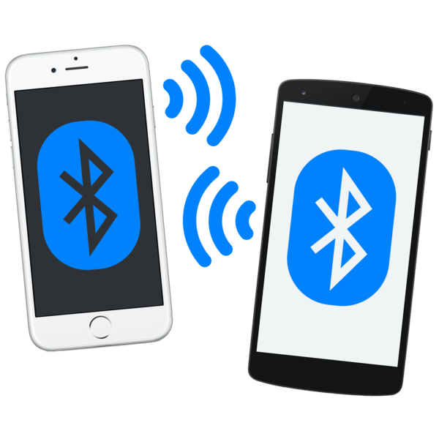
How important is it that digital cash can be used to make payments?

Tick the box next to the answer that says how important this is for you:

very important

important

in the middle

not important

I am not sure

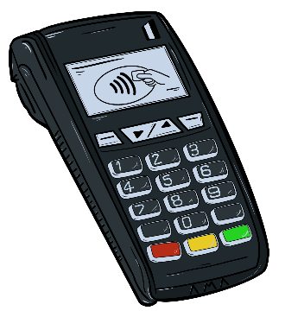
How important is it that disigtal cash is easier to use than other digital payments like EFTPOS?

Tick the box next to the answer that says how important this is for you:

very important

important

in the middle

not important

I am not sure

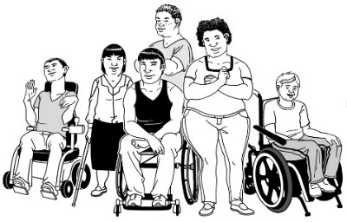
How important is it that digital cash is easy for these groups of people to use:

disabled people
older people
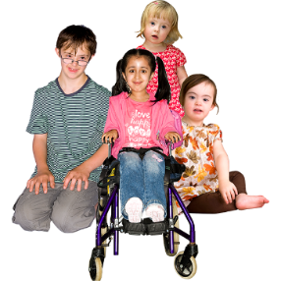
young children?

Tick the box next to the answer that says how important this is for you:

very important

important

in the middle

not important

I am not sure


How important is it that digital cash would make you feel good about using other digital payments?

Tick the box next to the answer that says how important this is for you:

very important

important

in the middle

not important

I am not sure

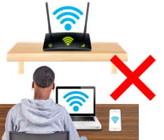
How important is it to be able to use digital cash:
with internet
without internet?

Tick the box next to the answer that says how important this is for you:

very important

important

in the middle

not important

I am not sure

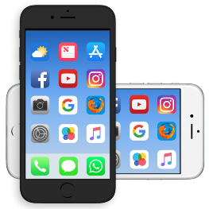
How important is it to be able to use digital cash without a smart phone?

Tick the box next to the answer that says how important this is for you:

very important

important

in the middle

not important

I am not sure

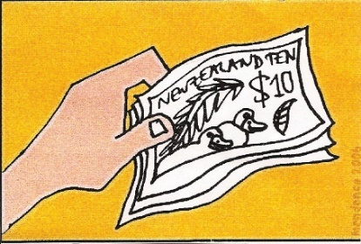
How important is it to be able to trust that your digital cash will still be worth as much?

Tick the box next to the answer that says how important this is for you:

very important

important

in the middle

not important

I am not sure

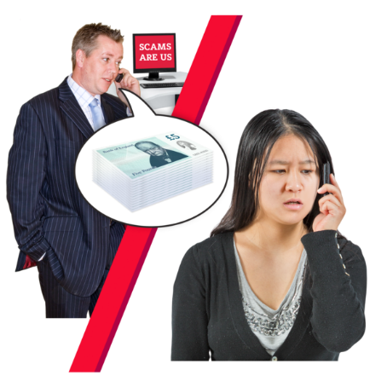
How important is it that you can trust you will get my money back if:
I lost it
there was a scam?

A scam is when someone lies to take your money from you.

Tick the box next to the answer that says how important this is for you:

very important

important

in the middle

not important

I am not sure
How important is it that you can get service in person like in a bank or shop if you need it?

Tick the box next to the answer that says how important this is for you:

very important

important

in the middle

not important

I am not sure

How important is it that digital cash does not cost you any money to use?

Tick the box next to the answer that says how important this is for you:

very important

important

in the middle

not important

I am not sure

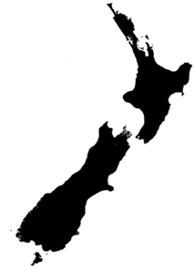
People could use digital cash if they were:
- from New Zealand
- living in New Zealand.

Are there other groups of people who should be able to use digital cash?

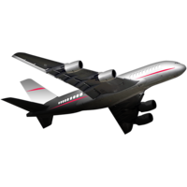
Tick the boxes for all the groups of people you think should be able to use digital cash.

People visiting New Zealand like for a holiday.

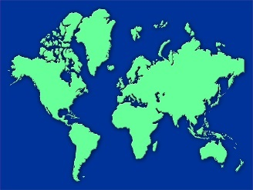
People in other countries that use the New Zealand dollar.

People in the rest of the world.

New ways of doing things


Digital cash would mean people could do things in new ways.

There could be new services to do with money that you could use.

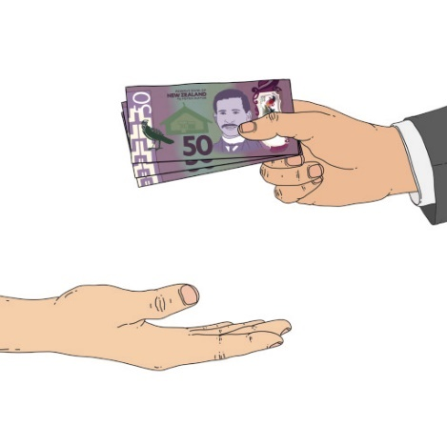
For example payments could be automated.

Automated payments are when you set up rules for payments to happen in the future.

For example you might set a rule that when you have 5 hundred dollars in your main account everything else goes to your savings account.
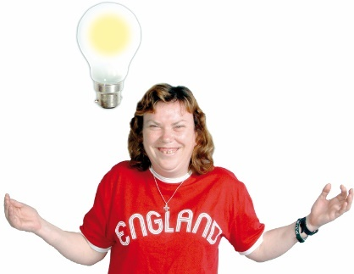
Which of these new ways of doing things would you like to happen?

Tick the boxes for all the things you would like to happen.

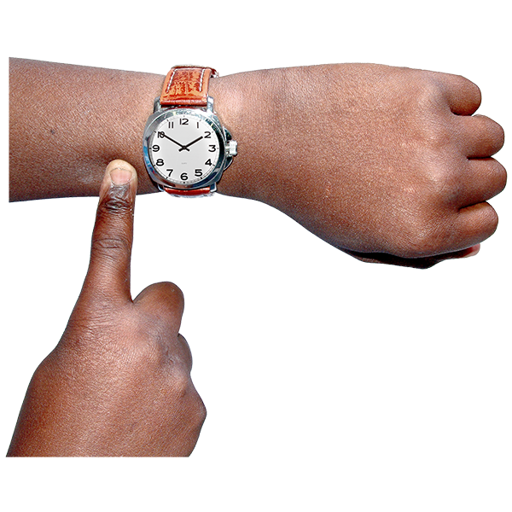
Payments happen straight away.
New services from banks or other places that do digital cash accounts.
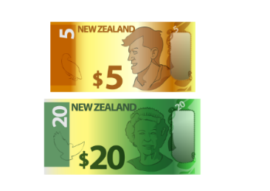
Automated payments.

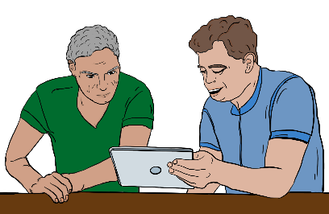
Information about your money / payments that shows what is going on right now.

I am not interested in any of these.


Do you think digital cash will mean people can make new things happen in NZ?

Tick the box next to the answer that is right for you:

Yes this is likely.

No this is not likely.

I do not know.

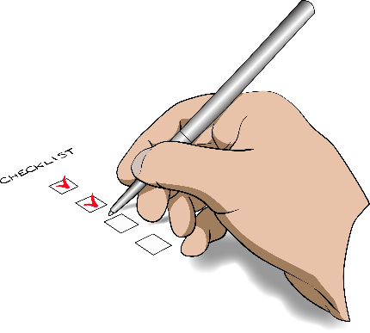
Do you think digital cash will make money / payments more reliable?

Reliable means you can be sure things happen when they should.

Tick the box next to the answer that is right for you:

Yes this is likely.

No this is not likely.

I do not know.


Do you think digital cash will change digital financial inclusion?

Digital financial inclusion is about everyone being able to use:
digital money
digital services to do with money like internet banking.

Tick the box next to the answer that is right for you:

Yes it will make digital financial inclusion better.

Yes it will make digital financial inclusion worse.

No it will not change digital financial inclusion much.

I do not know.

How to find out more

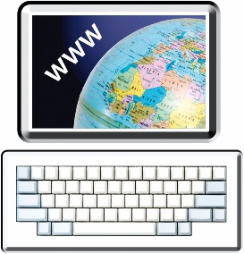
You can find more information on our website:

www.rbnz.govt.nz/money-and-cash/digital-cash-in-new-zealand/

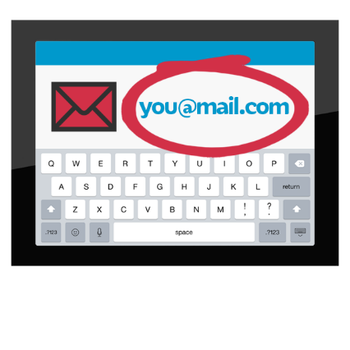
You can also contact us by:
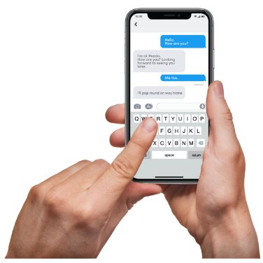
email at:
futureofmoney@rbnz.govt.nz
text to:
021 223 6062

phone on:
0800 7269 7269
It does not cost you any money to call us on this number.

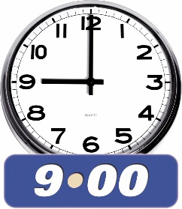
You can call us from Monday to Friday between:
9 in the morning
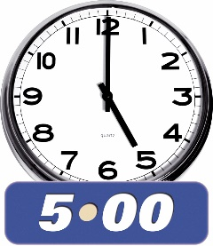
and
5 in the afternoon.


If you find it hard to use the phone the New Zealand Relay service is for people who are:

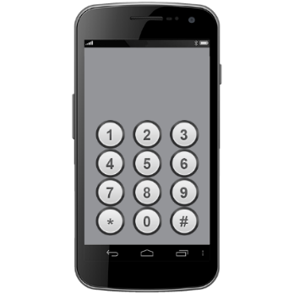
- Deaf / hard of hearing

- deafblind

- speech impaired / find it hard to talk.

You can find out more about the New Zealand Relay service at:

www.nzrelay.co.nz

This information has been written by the Reserve Bank of New Zealand Te Pūtea Matua.

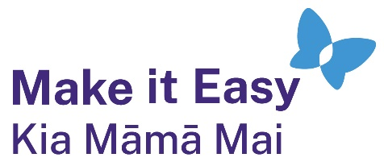
It has been translated into Easy Read by the Make it Easy Kia Māmā Mai service of People First New Zealand Ngā Tāngata Tuatahi.

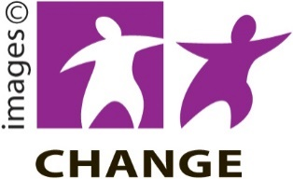
The ideas in this document are not the ideas of People First New Zealand Ngā Tāngata Tuatahi.

Make it Easy uses images from:


- Changepeople.org

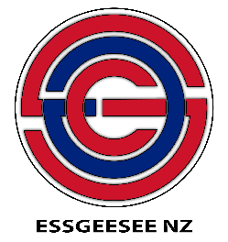
            - Photosymbols.com

- SGC Image Works
- Huriana Kopeke-Te Aho

- T. Wood.

All images used in this Easy Read document are subject to copyright rules and cannot be used without permission.

