
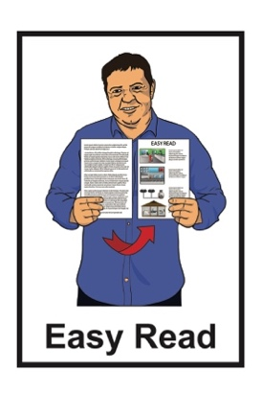


Easy Read guide to the Individual Employment Agreement
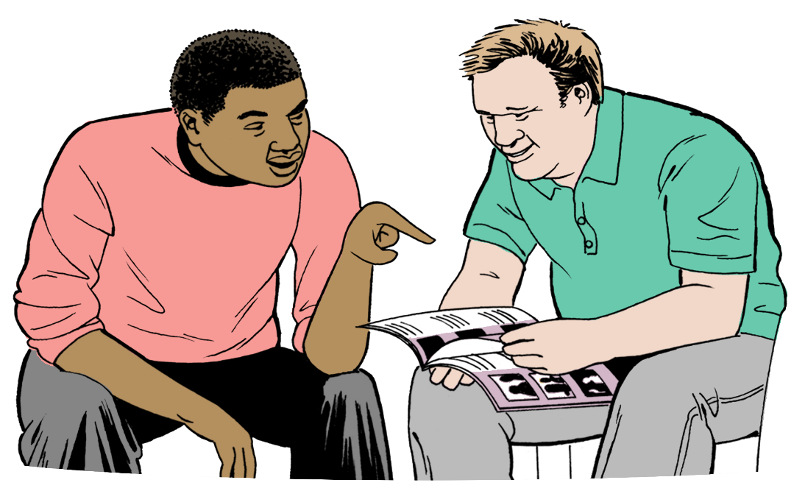

Published: August 2025

What you will find in here

Page number:
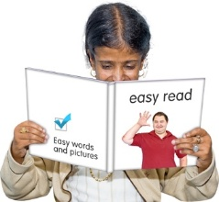

About this Easy Read 3

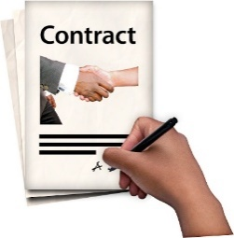
What is an Individual Employment Agreement? 4
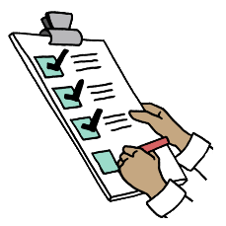

What is a template? 7


Filling in the agreement 10

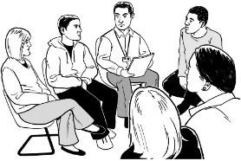
What is a union? 13

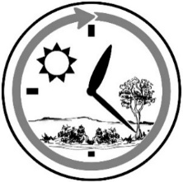
What is a trial period? 15

Page number:

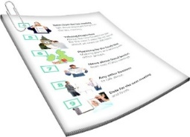
What might be added to an
Individual Employment
Agreement? 17
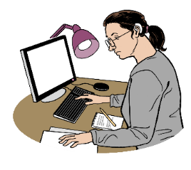

Types of employment 19

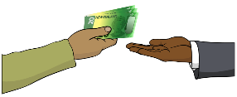
Extra pay 25

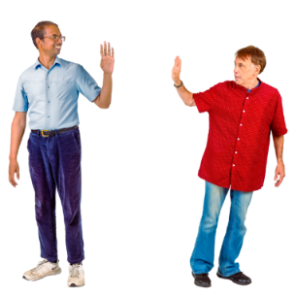
What other things can happen
when leaving a job? 27


Getting support at work 32

About this Easy Read

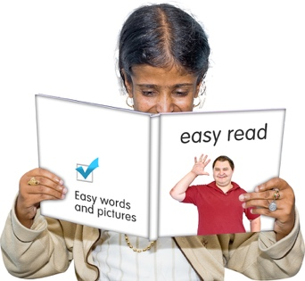
This is a guide to the Easy Read Individual Employment Agreement.


It supports you to understand employment:
words
rights.


Employment means doing a job where you get paid money.

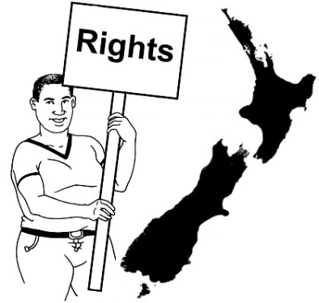
Here rights are things the law says need to happen to protect everyone at work.

What is an Individual Employment Agreement?


An Individual Employment Agreement is a legal contract between:

the employer who is the person hiring someone to do the work
the employee who is the person doing the work.

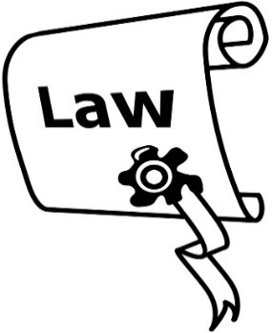
Here a legal contract is a document about work that explains:
what the law says
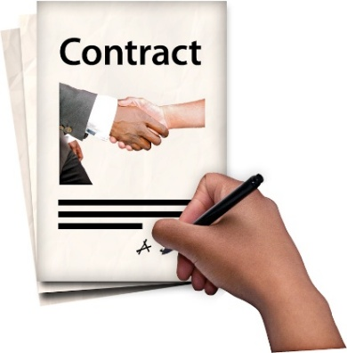
what agreements have been made between the:
- employer
- employee.

In this document the employer will be called the manager.

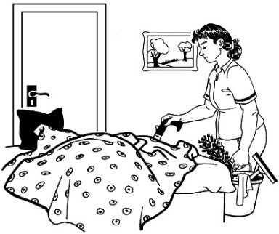
In this document the employee will be called the worker.

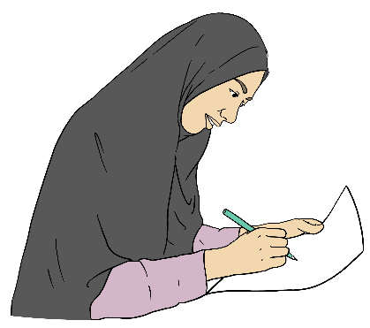
It is important to have the information about a job written down so the worker knows:
their legal rights
what they are doing
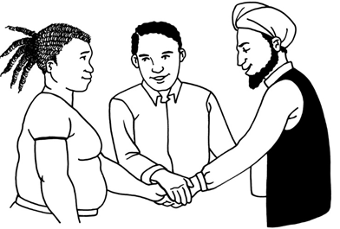
what support they can get
the rules of the job.




It is important to have the information about a job written down so the manager knows:
what they have asked the worker to do
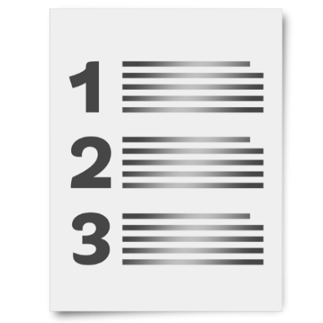
information about things like:
- pay
- leave
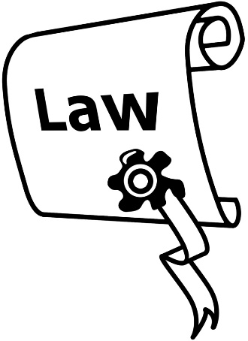
what they must do by law for the worker
other things that have been agreed
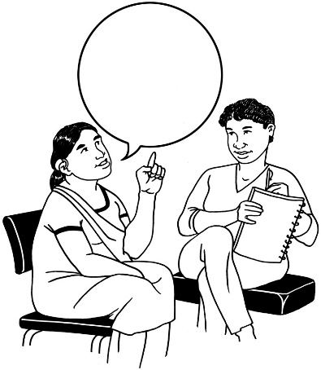
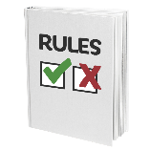
if the rules of the workplace have been talked about.

What is a template?

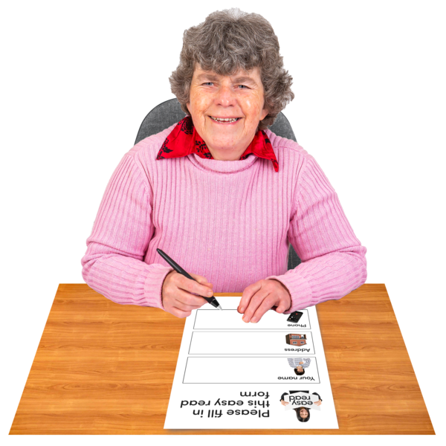
The Easy Read Individual Employment Agreement is a template.

A template is a kind of form that:

can be used:
- many times
- by different people
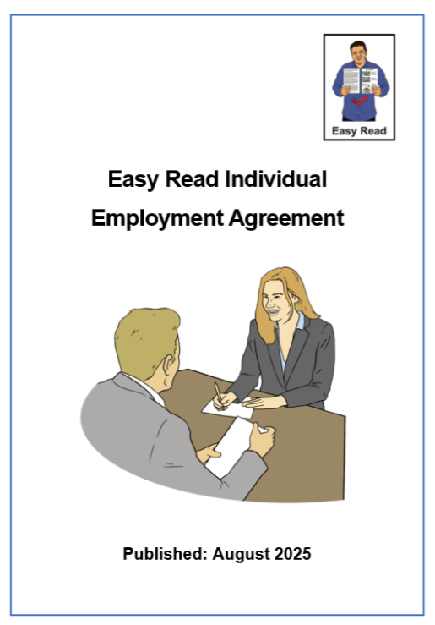
has all the important information.

You can find the Easy Read Individual Employment Agreement at:

www.peoplefirst.org.nz/easy-read-library/resource/employment-agreement
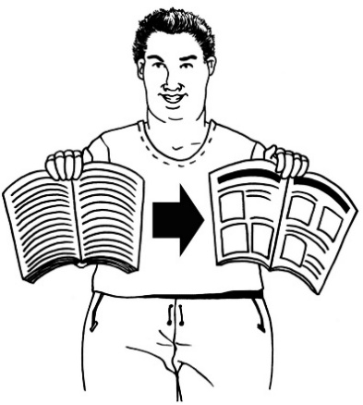
Sometimes an Individual Employment Agreement might need to:
be changed
have more information added to it.

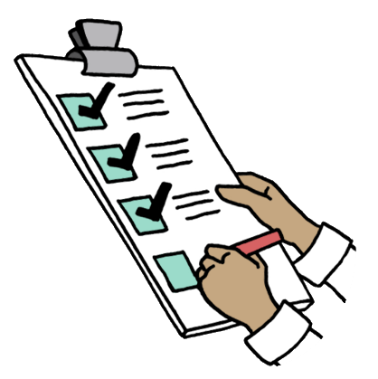
The Individual Employment Agreement template might:
be filled in again with the new information
have more pages added to it.


The manager must:
show the worker all the changes
give the worker a new copy of the agreement.

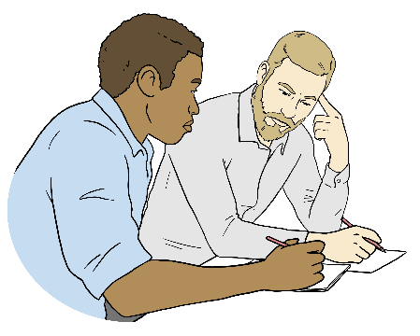
This is so the worker can:
read the changes
understand the changes

agree to the changes
ask for any other changes they might want.

Filling in the agreement


There are boxes in the Individual Employment Agreement where things will be written by the:
manager
worker.


The boxes where things will be written look like this:

You can write things in the box.

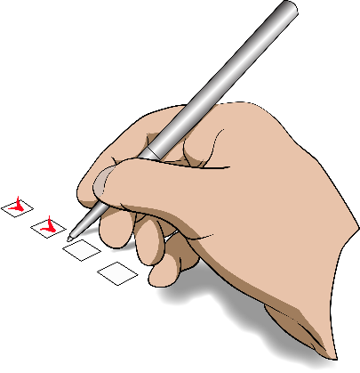
There are boxes in the Individual Employment Agreement where the manager will tick the right answer.


The tick boxes look like this:

Tick box


There might be some places in the Individual Employment Agreement that are not filled out.

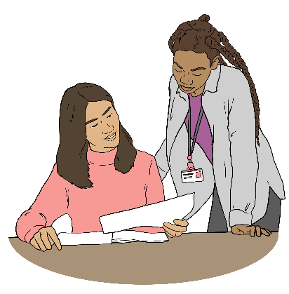
The worker can find out what that means by asking:
the manager
someone they trust.

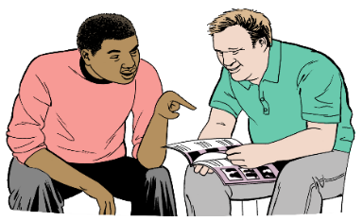
The worker can get support from someone they trust to:

understand the Individual Employment Agreement
write in the information they need to.

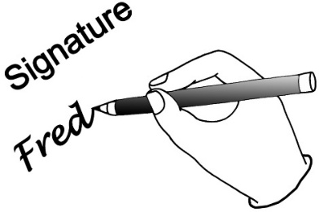
When the Individual Employment Agreement has all the correct information filled in it is signed by the:
manager
worker.

What is a union?


The Easy Read Individual Employment Agreement talks about unions.

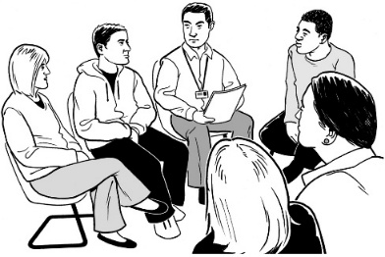
A union is an organisation that supports people in their jobs.


A worker pays money to the union to be part of their organisation.

The worker can choose if they join a union or not.

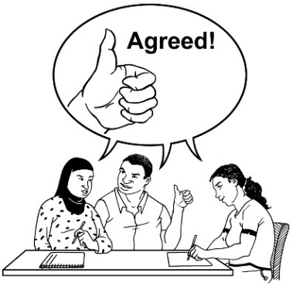
A worker can use someone from a union for support when:
making their job agreement
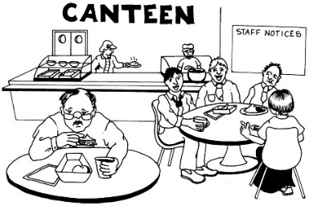
there are changes at work
there is a problem at work.


There are different unions for different types of jobs.

Sometimes 1 union supports lots of workers at the same workplace.

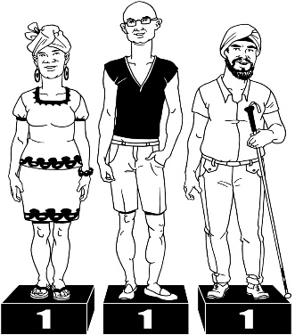
This supports:
the workers to be treated fairly

the workplace to make agreements that lots of workers can use at the same time.

What is a trial period?
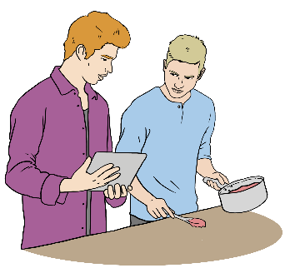

A job might have a trial period.


A trial period is when:
the worker starts work
the manager can find out if the worker is a good fit for the job.

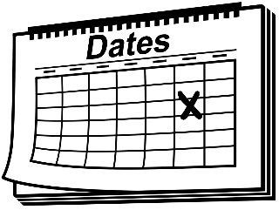
90
A trial period goes for up to 90 days.

The manager can decide on a different number of days for the trial period.


The number of days for the trial period must be written into the Individual Employment Agreement.


After the trial period the manager may ask the worker to:
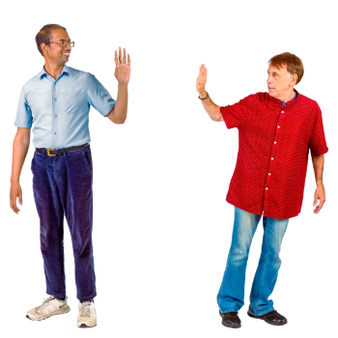
stay on at the job
leave the job.

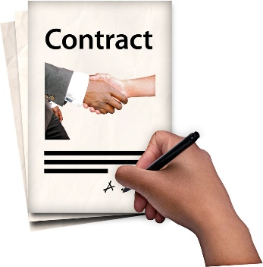

The manager might choose to end the employment agreement during the trial period.


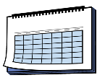
The amount of notice given during the trial period must be written into the Individual Employment Agreement.

Here giving notice means telling the worker when the job is ending.

What might be added to an Individual Employment Agreement?

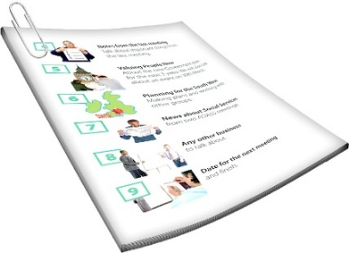
A manager might want to put more information in the Individual Employment Agreement about:
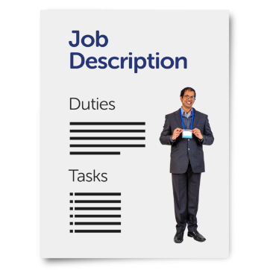
the workplace
the job.

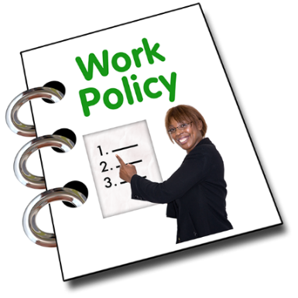
This is because different workplaces can have different:
rules
ways of doing a job.

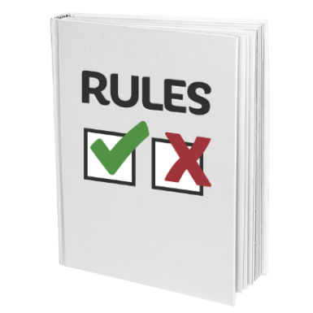
The manager might put in pages about things like:
rules like when the worker can use their phone
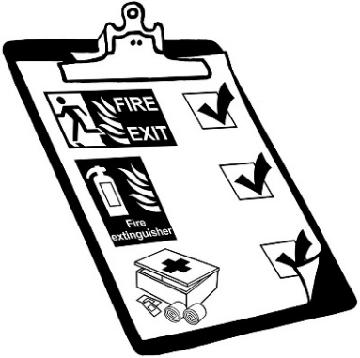
health and safety
uniforms
training

tools
who to go to for support at the workplace.


This information might also be put on posters on the walls at the workplace.

Types of employment

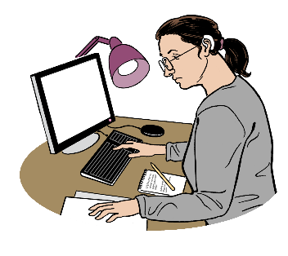
The different types of employment a worker might get are:

permanent employment
fixed term employment
casual employment.

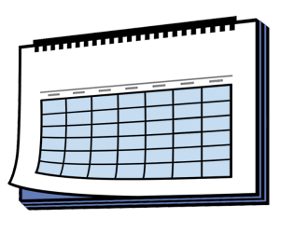
Permanent employment

Permanent employment is when the worker does a job that has no end date.


Permanent employment can be:
full time
part time.
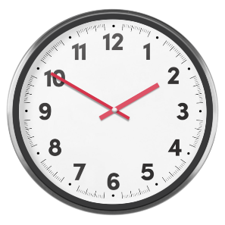
30

Full time work is 30 hours a week or more by Aotearoa New Zealand law.

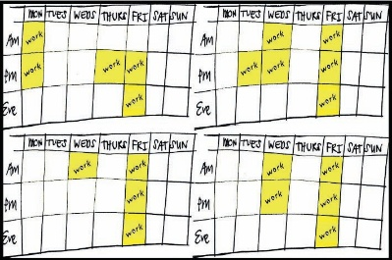
Part time work is a set number of hours fewer than 30.


The number of work hours might be:
advertised as part of the job
agreed to by the:
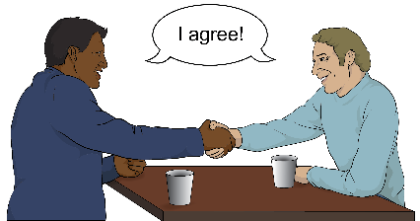
- manager
- worker.


Fixed term employment

Fixed term employment is when the worker does a job that has a date when it will end.


The reason why the job is fixed term must be written into the Individual Employment Agreement.

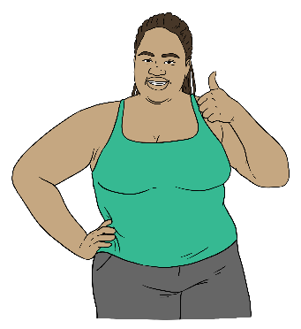
Having this reason written down supports everyone to know:
when the job will end
why the job will end.

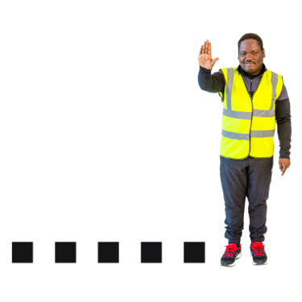
Some reasons for fixed term employment might be the job is:
seasonal like fruit picking
a project that must be finished.

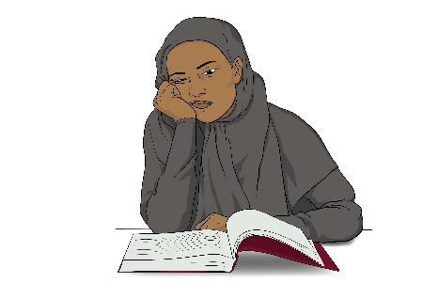
Fixed term employment might be ended early for reasons like there is not enough work to do.


If the fixed term employment ends early the manager must talk to the worker about the changes.

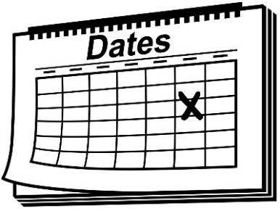
This is so they can agree on things like:
a new end date
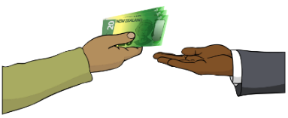
any money the worker needs to be paid.


Casual employment

Casual employment is a job where:
the worker will be asked to work when they are needed
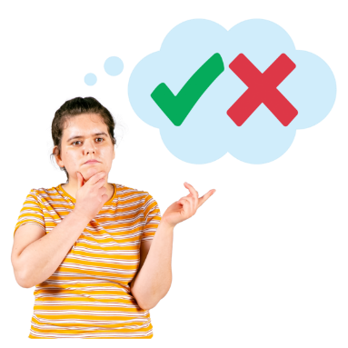
the worker can choose if they want to do the work
there is no promise the job will last for a long time.

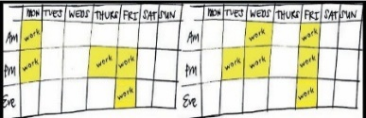

Casual employment is the worker doing work at different times when they are asked to by the manager.

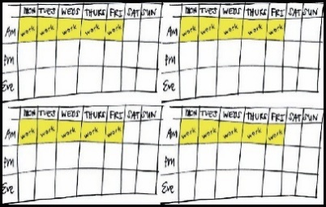

Casual employment is not working at the same time every week for example every weekday morning.

If the worker is asked to always work at the same time they must go on a permanent employment agreement.

Extra pay


If the worker is on an hourly wage they might get paid more money:
to make up for working on a public holiday
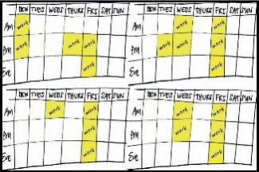
for working more hours than what is written in the Individual Employment Agreement.

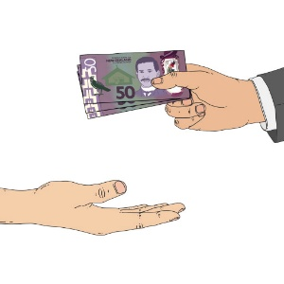
This extra money is called time and a half.

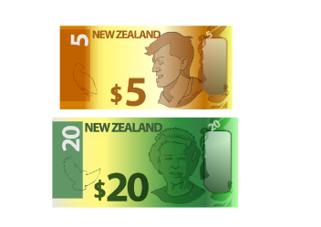
Time and a half means the worker gets paid:
their usual amount
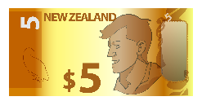
and

half of that usual amount.

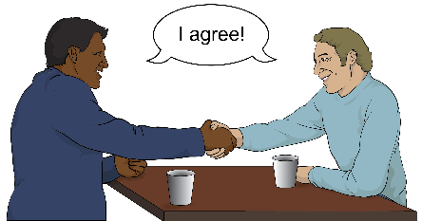
Getting paid time and a half must be agreed to by the:
manager
worker.

What other things can happen when leaving a job?

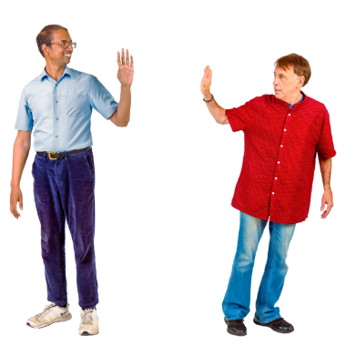
Some of the reasons a worker might leave a job are:
deciding to leave
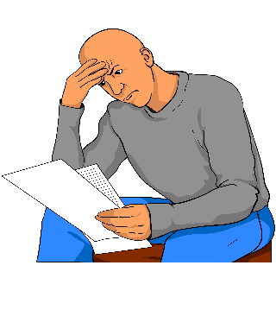
being given notice / fired
being made redundant
going into retirement.

Retirement

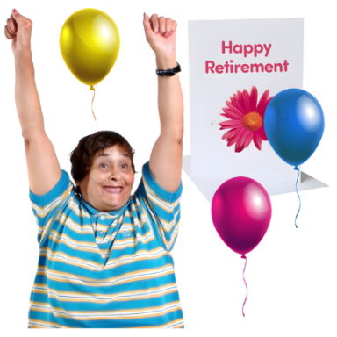
A worker might leave a job because they are going into retirement.

Retirement means a person stops working when they get older.
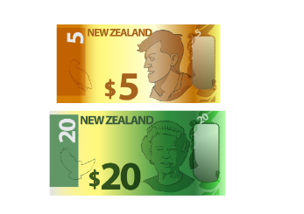
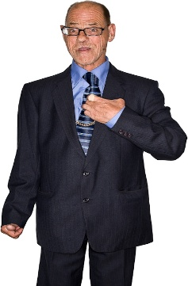
65 is the age people get superannuation.

Superannuation is a type of
benefit / money given to older people by the Government.


A person going into retirement might leave their job:
when they turn 65
or
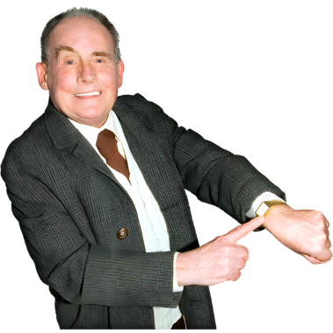
at another time they decide on after they turn 65.

References
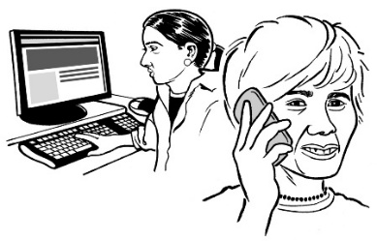
When a worker applies a new job the employer will often ask for references.


References are when people say how the worker did at other jobs.

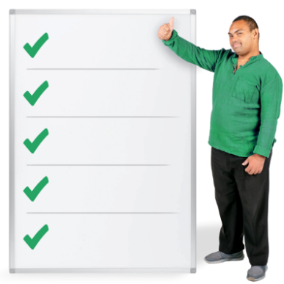
References might include things like:
the important things the worker did at the job
what people at the workplace liked about the worker.


Employers use references to decide who to give the job to.


Usually references are from employers the worker has had before.

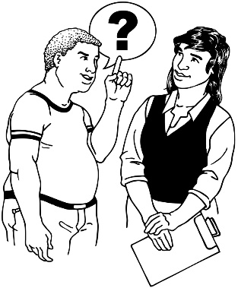
When a worker leaves a job they can ask people if they would be happy to give them references.

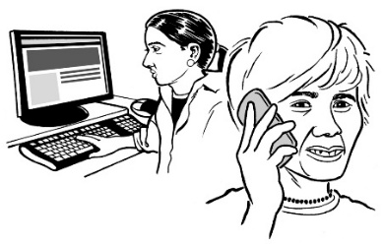
If they say yes the worker can give the contact information to people who want references from them.

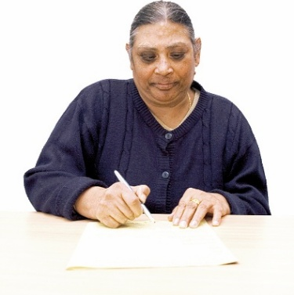
Sometimes when a worker leaves a job they might be given a letter of recommendation.


Here a letter of recommendation is a letter written about how well the worker did their job.

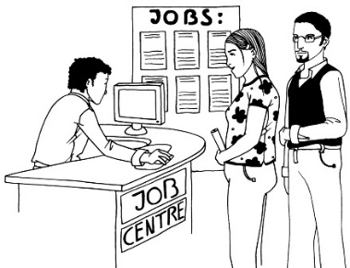
The worker can use a letter of recommendation:
when applying for another job

to show someone how good they are at a job
to show what work skills they have.

Getting support at work


The Individual Employment Agreement talks about getting support at work for things like:
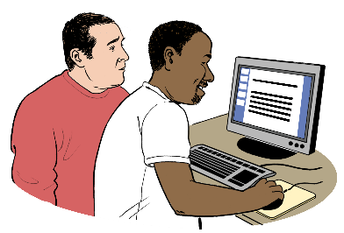
asking questions
dealing with problems.


The worker might also need support for things to do their job like:
tools

computer equipment
reasonable accommodations.

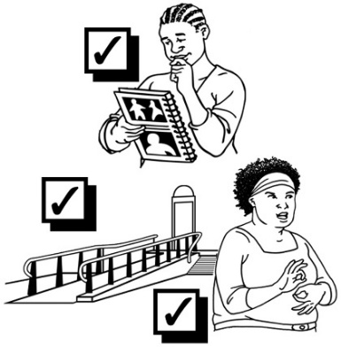
A reasonable accommodation is making a change at the workplace that:
a disabled person needs to do their job well
is not too hard to do.


The worker can tell the manager about the support they need when they fill in the Individual Employment Agreement.


The information about support can be:
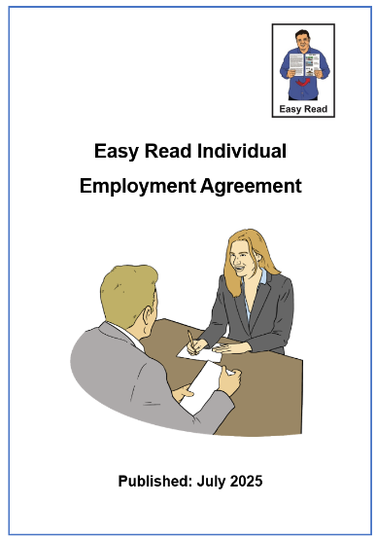
written on another page
added to the Individual Employment Agreement.


The manager can tell the worker which person to talk to at the workplace about different things like who:
does the pay
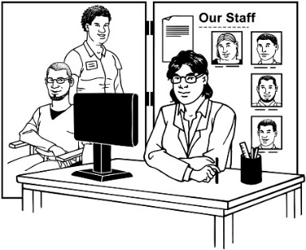
organises support
is the union representative if the workplace has 1.


The worker can tell the manager the name of someone they trust like their:
support worker

whānau / family member
friend.


This information has been written by:

- the Make it Easy service of People First New Zealand Ngā Tāngata Tuatahi

- IHC - Nicolina Newcombe.


All images used in this Easy Read document are subject to copyright rules and cannot be used without permission.

Make it Easy uses images from:


- Photosymbols

- Change Images

- Huriana Kopeke-Te Aho

- SGC Image Works

- T Wood

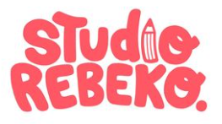
- Studio Rebeko

- Inga Kramer.

