**Easy Read Reporting Form**

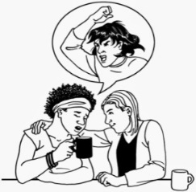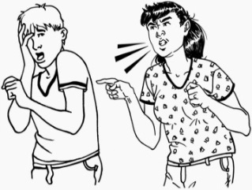

**Fill in this form to tell someone if something bad has happened to you or someone else**

**or someone else.**

**Do not fill in this form in an emergency.**

**If you need help quickly call 111 and ask for the Police**

**Report it here**

**Please tell us:**

**Name**

Your name ………………………………………..

Your date of birth……………………………………..

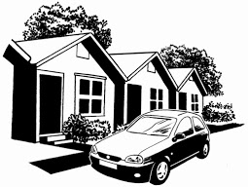  Where you live ….………………………………..

……………………………………………………….

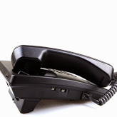 ……………………………………………………….

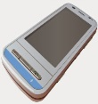 ……………………………………………………….

Your phone numbers ..……………………………

………………………………………………………

**If you are supporting someone to fill in this Form please tell us your:**

Name: …………………………………………………………………………………………………………………

Phone number(s): …………………………………………………………………………………………………….

Email: ………………………………………………………………………………………………........................

How you know the person making the report: …………………………………………………………………….

**Here is some information about how to fill in the Reporting Form**

**To tell us about what happened you can:**

* ****answer the questions by ticking the box that is right for you.



You may need to tick more than 1 box in each part of this Form.

* write down or draw what you want to say on the blank pages.

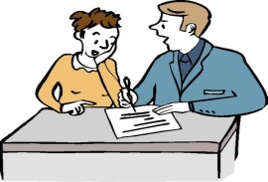

* It is best to use your own words to say what has happened if you can.
* ask someone to support you to fill in the Form.

**What you say is confidential.**

**Confidential** means it is up to you to say who can look at this form. It will only be shown to other people if:

* the law or a Judge says so
* you or someone else is in danger.

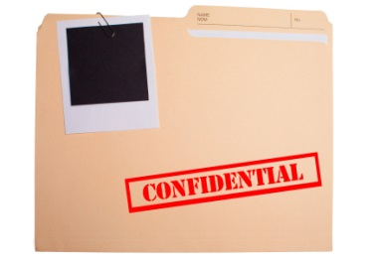



Do not leave this Form in a place where other people can see it.

**Here is some information about what is in the Reporting Form**

**This Reporting Form has 5 Parts:**

1. 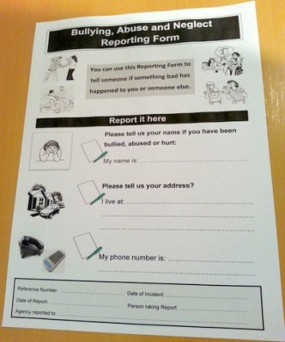**What** happened? Pages 5 to 17
2. **Where** did it happen? Pages 18 to 20
3. **Who** did It? Pages 21 to 28
4. **When** did it happen? Page 29
5. 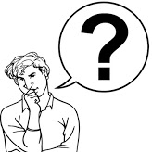**What** to do next. Pages 30 to 31

On **pages 4 to 27** there are questions

for you to answer.



**Keep a copy of your report.**

You can photocopy the form

or ask someone to make a copy for you.

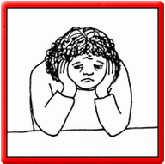**Please answer these questions**

**Tick the box that is right for you**

1. **Has something bad happened to you?**

I am a victim. This means it happened to you.

1. **Has something bad happened to someone else?**

I am a witness. This means that you saw or heard it happen

to someone else.

1. **Has someone:**

* **asked you to report it for them?**
* **told you about what happened and you want to report it ?**

Please tell us their name:

Name …………………………………………………………………………………….

You can contact them at: ..……………………………………………………………..

Phone number ….…………………………………………………............................

**Tick this box if the person who told you does not want you to tell other people their name.**

**Part 1: What happened?**



**Part 1 has 2 questions:**

1. **What did they say?**
2. **What did they do?**



1. **What did they say?**

If they did **not** say anything go to question 2

If someone said something to you write or draw what happened in the box on **page 6**.



You can also tick the box or boxes on **page 7 and 8** to tell us what they said. They may help you to tell us.



**What did they do?**

If someone did something to you write down or draw what happened in the box on **page 6**.

You can also tick the box or boxes on **page 9 to 13** to say what happened. They may help you to tell us.

 **You can say what happened here:**

* write down or draw what happened
* ask the person supporting you to write down what they said or did.

Tell us if it has happened before.

**If you have told us what they said or did on the last page (page 6) go to page 9**

**Tick the box that says what happened on pages 7 to 13**

**If nothing on this page is right for you tick the box at the bottom of the page**

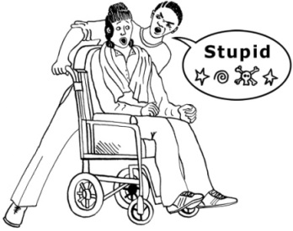**What did they say?**

* They said nasty names

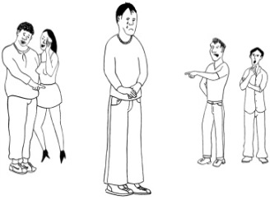……………………………………………..

* They said bad things

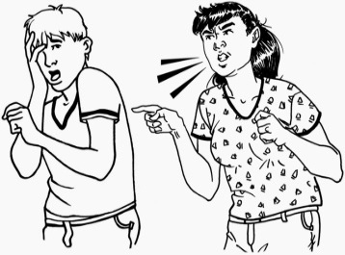………………………………………………

* They swore

………………………………………………….

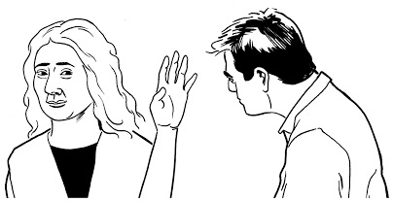

* They said they would do bad things

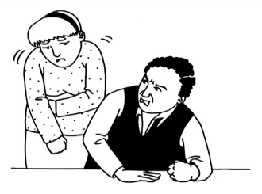…………………………………………………..

* They said they would take things

…………………………………………………..

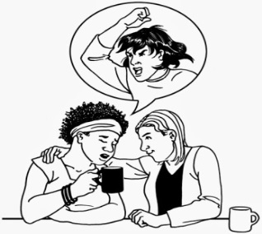

* They said they would hurt me

……………………………………………………

**Nothing on this page.** There are more things on the next page

* ****They said they would hurt someone else

Who did they say they would hurt?

.....................................................................

* 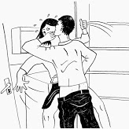They said they would make me do

sexual things

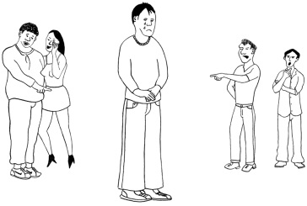 Tell us about what happened on **pages 13 and 14**

* They said things that were not true

.................................................................

………………………………………………



Did they say something else?

You can tell us more about this here.

**Nothing on this page.** There are more things on the next page

**If you have told us what they said or did on page 6 go to page 16**

**What did they do?**

**Tick the box that says what happened on pages 9 to 13**

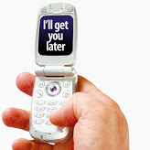**If nothing on this page is right for you tick the box at the bottom of the page**

* They sent nasty text messages / made

nasty phone calls

……………………………………………….

* 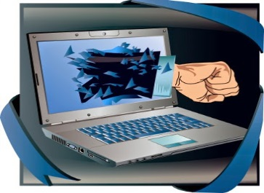They sent nasty emails

……………………………………………….

* They posted nasty things on

Facebook / other social networking sites

………………………………………………..

* 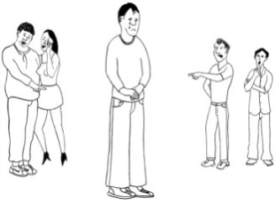They sent nasty letters

…………………………………………………

* They made fun

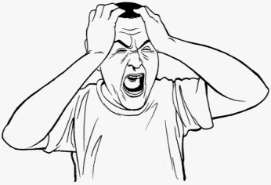

* They shouted

**Nothing on this page.** There are more things on the next page

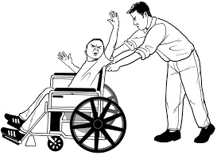

* They did not treat me well because of

my disability or because I am different

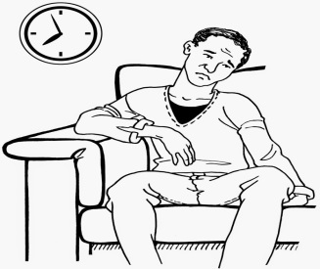 from them.

* They left me / them out

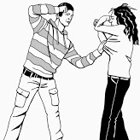

* They hit

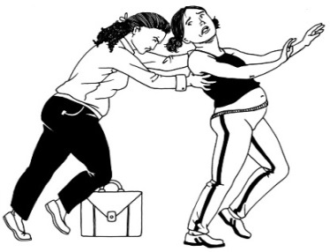

* They pushed

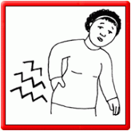

* They kicked

* 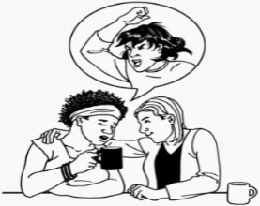They threw something
* 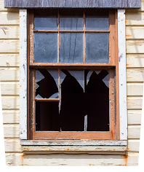They damaged things

**Nothing on this page.**  There are more things on the next page

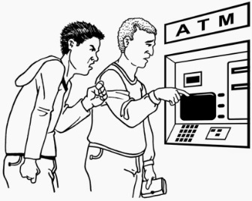**If nothing on this page is right for you tick the box at the bottom of the page**

* They took things / money



* They made me / them do things

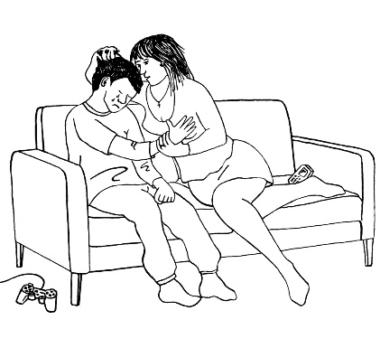

* They made me / them do sexual things

Tell us about what happened on pages **13 and 14**

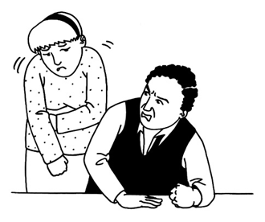

* They did not let me / them go out with

other people

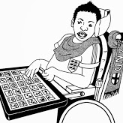

* They did not give me / them the support

needed

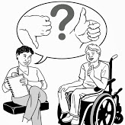

* They did not let me / them make choices

**Nothing on this page**  There are more things on the next page



* They left me alone for a long time

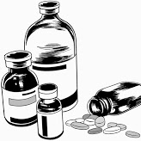

* They did not give me the right medicine

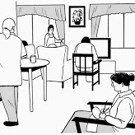

* They stopped me from doing things I like

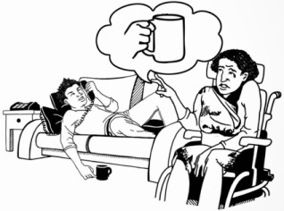

* They did not give me enough to drink or eat



Did they do something else?

You can tell us about this here.

**Nothing on this page**  More questions on the next page

**Here are more questions about sexual abuse**

**What did they do? Tick the box or boxes that says what happened. You can write or draw what happened on page 15**

**If nothing on this page is right for you tick the box at the bottom of the page**

* ****They touched me in a way that I did not like
* They kissed me when I did not want them to

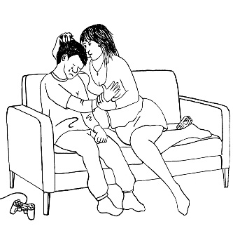

* They touched themselves in a sexual way in front of me

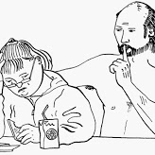

* They said sexual things to me that made me feel upset and uncomfortable

**Nothing on this page** There are more things on the next page

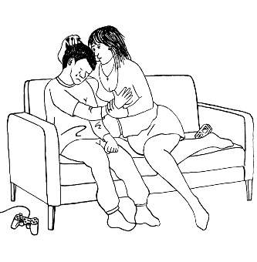

* They made me touch their body when I did not want to
* ****They had sex with me when I did not want to
* They tried to have sex with me when I did not want to

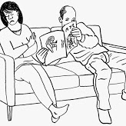

* They made me watch sexy DVDs
* They made me look at sexy pictures



* They took their clothes off and made me look at them
* They said they would give me money and presents if I would have sex with them / do sexual things

.

**Nothing on this page** You can tell us more on the next page

**You can say more here:**

* write down or draw what happened here
* ask the person supporting you to write down what happened

Tell us if it has happened before.

**Nothing on this page**

**Tell us how you feel** Your feelings are important



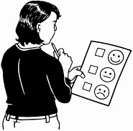The information below on pages 16 and 17 may help you to tell us more about how you are feeling.

**I feel:** Tick the box or boxes that are right for you

* 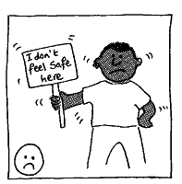afraid / scared
* in pain



* worried
* 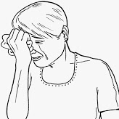shame
* upset

**Nothing on this page** There are more feelings on the next page



* stupid



* angry

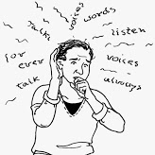

* confused
* 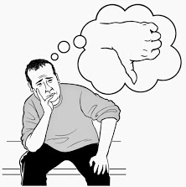frustrated
* helpless



* bored
* something else?.....................................

……………………………………………….

**Nothing on this page**

Go to next page to complete **Part 2: Where did it happen?**

**Part 2: Where did it happen?**



**You can tell us here:**

* write down or draw where it happened here
* ask the person supporting you to write down where it happened



There is a list places on pages 19 and 20 to help you tell us

**Nothing on this page**  You can tell us more on the next page

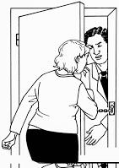**Tick the box to say where it happened**

* 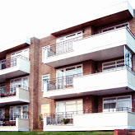at home
* 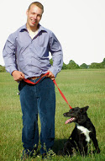at someone else’s house …………………..
* in the street or at the park …………………

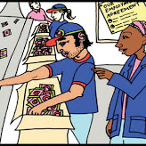

* at work ……………………………………….



* 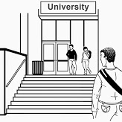at the shops ………………………………..
* a place where you learn …………………..



* ****at church / where you worship …………….
* at the day service …………………………..

**Nothing on this page** There are more things on the next page

* 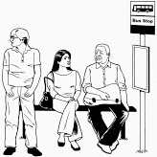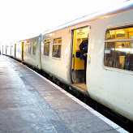on a bus / at the bus stop
* 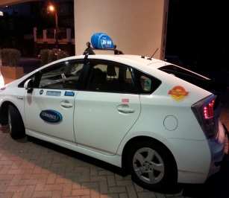on a train / at the station
* in a taxi

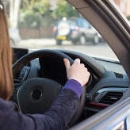

* in a car

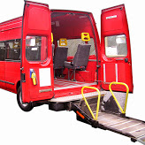

* in a van



* at the pub or at a hotel
* 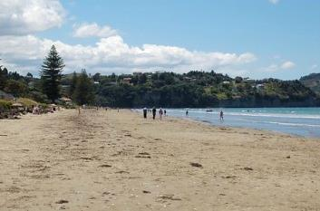at the movies
* at the beach

**Nothing on this page** ……………………………………………

Go to next page to complete **Part 3: Who did it?**

**Part 3: Who did it?**

**If you know the person or people who did this tick the box and tell us about them by answering the questions below.**

**If you do not know them please tick the box and go to the next page (page 22) and answer the questions**



1. What is their name or names? ……………………….

**Name**

……………………………………………………………….

………………………………………………………………

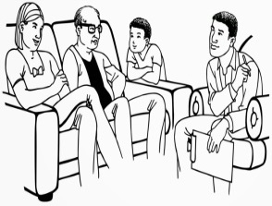

1. How do you know them? ………………………………

****…………………………………………………………….....

1. Where do they live / work? ……..…………………….

……………………………………………………………….

**Here are some questions for you to answer about the person or people who did it**



**How many people were there?**

* 1 person



* 2 people

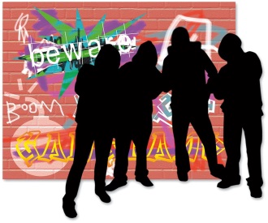

* a group of people

………………………….



Think about things you remember about them that stood out like

if they were wearing a cap, their trainers or a tatoo.

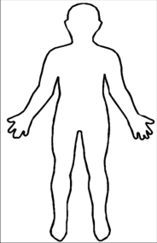

There are more questions on the next page

**Answer these questions to describe Person 1:**

****You can describe any other people on pages 25 and 26

 **Were they:**

* a man
* a woman

**How old were they?**

* an adult
* a teenager
* a child

**Were they:**

* Asian
* Māori
* Pasifika
* Pākehā
* I don’t know

If you do not know tell us what colour their skin was ?...............................

There are more questions on the next page

**How tall were they?**

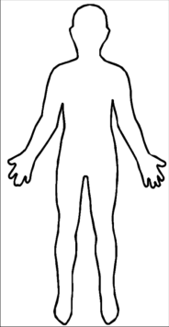

* shorter than me
* taller than me
* I don’t know

**What body type did they have?**

* 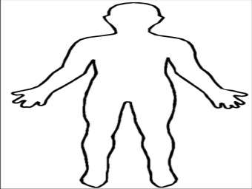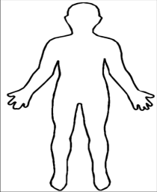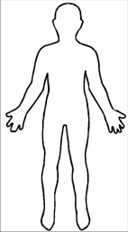small
* medium
* large

Anything else? ………………………………………………………………..

**What was their hair like?** Draw a circle around the right word

I do not remember Shoulder length Styled

Short Long Spiked No hair Curly Straight

White Blonde Red Brown Black Grey Different Colours

**What colour were their eyes** Draw a circle around the right word

I don’t know They were wearing glasses / sunglasses

Black Blue Green Hazel Grey Brown

**What else do you remember about them?**

They smelt They sounded different

………………………………. ……………………………………..

They had a beard / moustache They wore glasses

They wore jewellery They had piercings

They had scars / marks They had tatoos

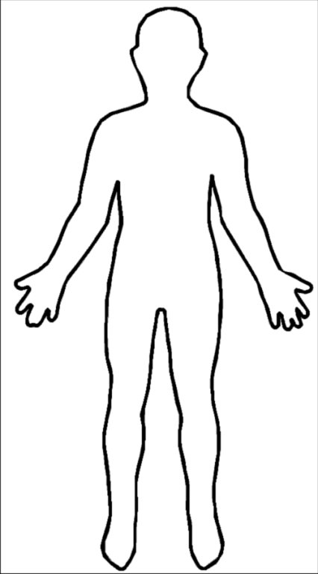**What were they wearing?**

………………………………………………

………………………………………………

………………………………………………

………………………………………………

………………………………………………

………………………………………………

………………………………………………

………………………………………………

You can draw on the picture to tell us what person 1 was wearing

**Were they carrying anything?**

What? ………………………………………………………………………………………………………………..

**Did they have a car or bike or something else**?

If yes, what did it look like?...............................................................

…………………………………………………………………………….

**If they had a car what was the number plate**?........................................

Which way did the car or bike go?...............................................................



**Is there anything else you want to tell us?**

If there was more than one person who did it please tell us about them on the next pages

**If there was more than 1 person who did this tell us about them here.**

You can write or draw here

**Person 2**



**Tell us about Person 3 here**

You can write or draw here



Go to next page to complete **Part 4: When did it happen?**

**Part 4: When did it happen?**

 It may help you to remember when it happened by thinking about

what you were doing before like watching TV or a place where

you go every week.

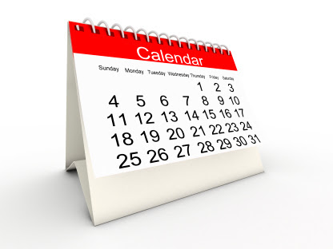

**What day of the week was it?**

**…………………………………………………….**

**What was the date?**

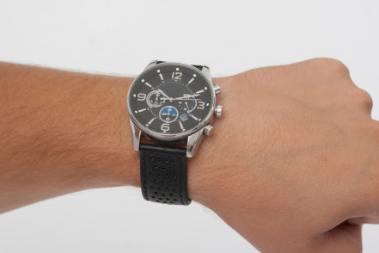**……………………..……………………………..**

**What was the time?**

**……………………………………………..**

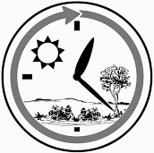**If you do not know what time can you tell us if it happened:**

* in the day

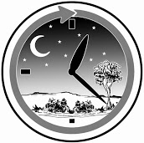

* at night

Go to next page to complete **Part 5: What to do next**

**Part 5: What to do next**

**It is up to you what to do next. You can choose who you want to tell about what happened.**

You can give the form to:

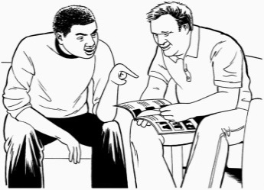

* someone you trust like a friend or

family member

* an Advocate



* a support worker
* a Connector
* a Health and Disability Advocate if it happened in a health and disability service

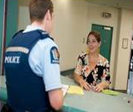

* the Police
* a lawyer
* a stopping violence service.

Tell the person you gave the form to what you want them to do. Ask the person you give the form to for a copy or a **reference number**. You may need to use this again.

**Support Person page**

If you are supporting someone to fill in this form please make sure you have completed the contact details questions on page 1 of this form and tell us :

1. What action, if any, you have taken so far
2. Anything else you want to say.

Your Name: …………………………………………………………………………………………………………

Your daytime phone number(s): ………………………………………………………………………………….

Your Address: ………………………………………………………………………………………………………………..............

…………………………………………………………………………………………………………………………

How you know the person making the report: ……………………………………………………………………

What action, if any, have you taken so far?………………………………………………………………………

……………………………………………………………………………………………………………………………………………………………………………….

……………………………………………………………………………………………………………………………………………………………………………….

……………………………………………………………………………………………………………………………………………………………………………….

………………………………………………………………………………………………………………………………………………………………………………

……………………………………………………………………………………………………………………………………………………………………………..

………………………………………………………………………………………………………………………………………………………………………………

………………………………………………………………………………………………………………………………………………………………………………

**Contacting the Police**

Only send the form to the Police if the person you are supporting wants you to inform the Police. If they or someone else is in danger call 111 and ask for Police.



This information has been developed

by People First New Zealand Inc.- Ngā Tāngata Tuatahi

Thank you to the **KSFS Working Group** for helping

People First develop this information.



