Memorial service for Sir Robert Martin, KNZM

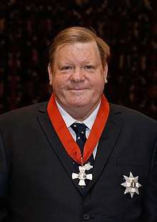**You are warmly invited to join us in remembering and celebrating**

**the life of Sir Robert Martin, KNZM.**

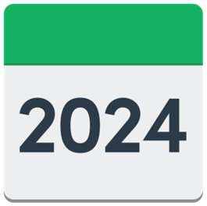**When:** Friday 7 June 2024 Arrive from 9**.**30 am

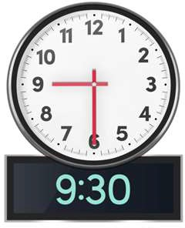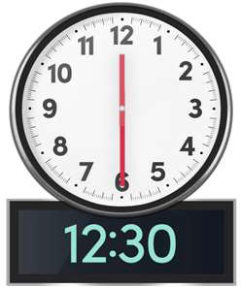

Service will be held 10 am to 11.30 am Followed by refreshments until 12.30 pm.

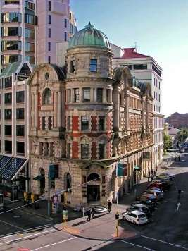**Where:** Public Trust Hall

131 – 135 Lambton Quay Wellington.

The Public Trust Hall is wheelchair accessible.

New Zealand Sign Language interpreters will be at the service.

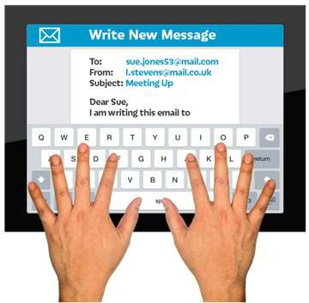

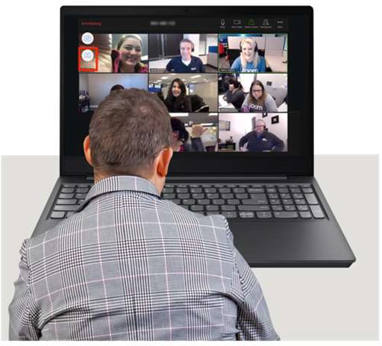We are hoping to livestream the service – these details are still being worked out.

**RSVP**: By Friday 31 May 2024 to:

Amelia Hedges at People First NZ

Email: [**ameliahedges@peoplefirst.org.nz**](mailto:ameliahedges@peoplefirst.org.nz)

Phone: **0800 20 60 70**

Please let Amelia know of any dietary or access needs.

Please contact Amelia if you would like the livestream details emailed to you.

This Easy Read invite uses images from Photosymbols.