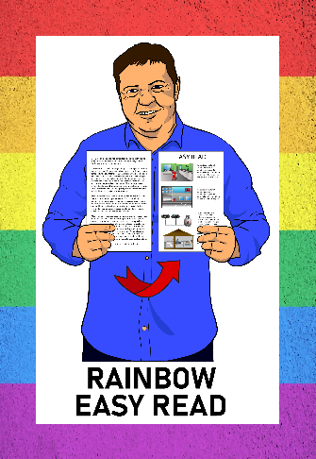
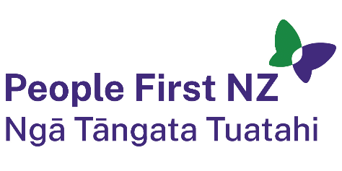
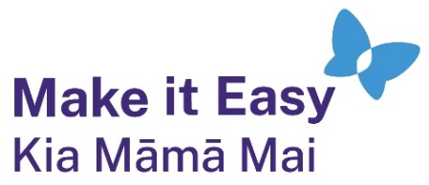

Rainbow Easy Read:
Finding support and community
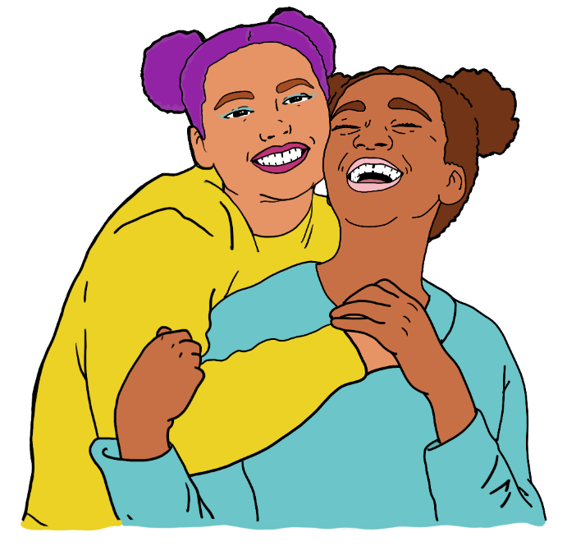

Published: February 2025

Before you begin


This is a long document.

It can be hard for some people to read a document this long.

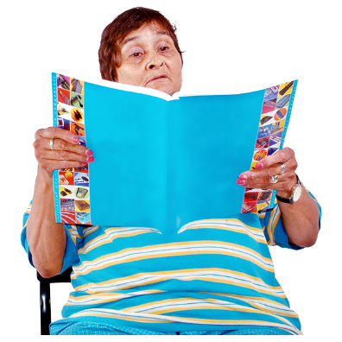
Some things you can do to make it easier are:
read it a few pages at a time
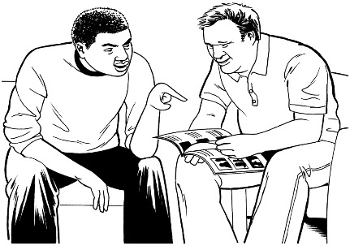
set aside some quiet time to look at it
have someone read it with you to support you to understand it.

What you will find in this document


Page number:

About this Easy Read 3
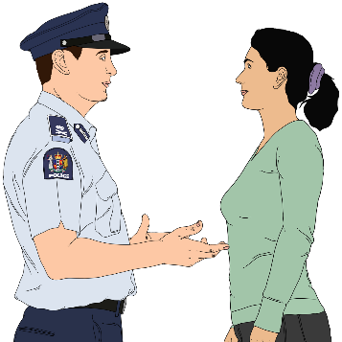

Emergencies and the police 5


Friends and family 9

Rainbow organisations 15

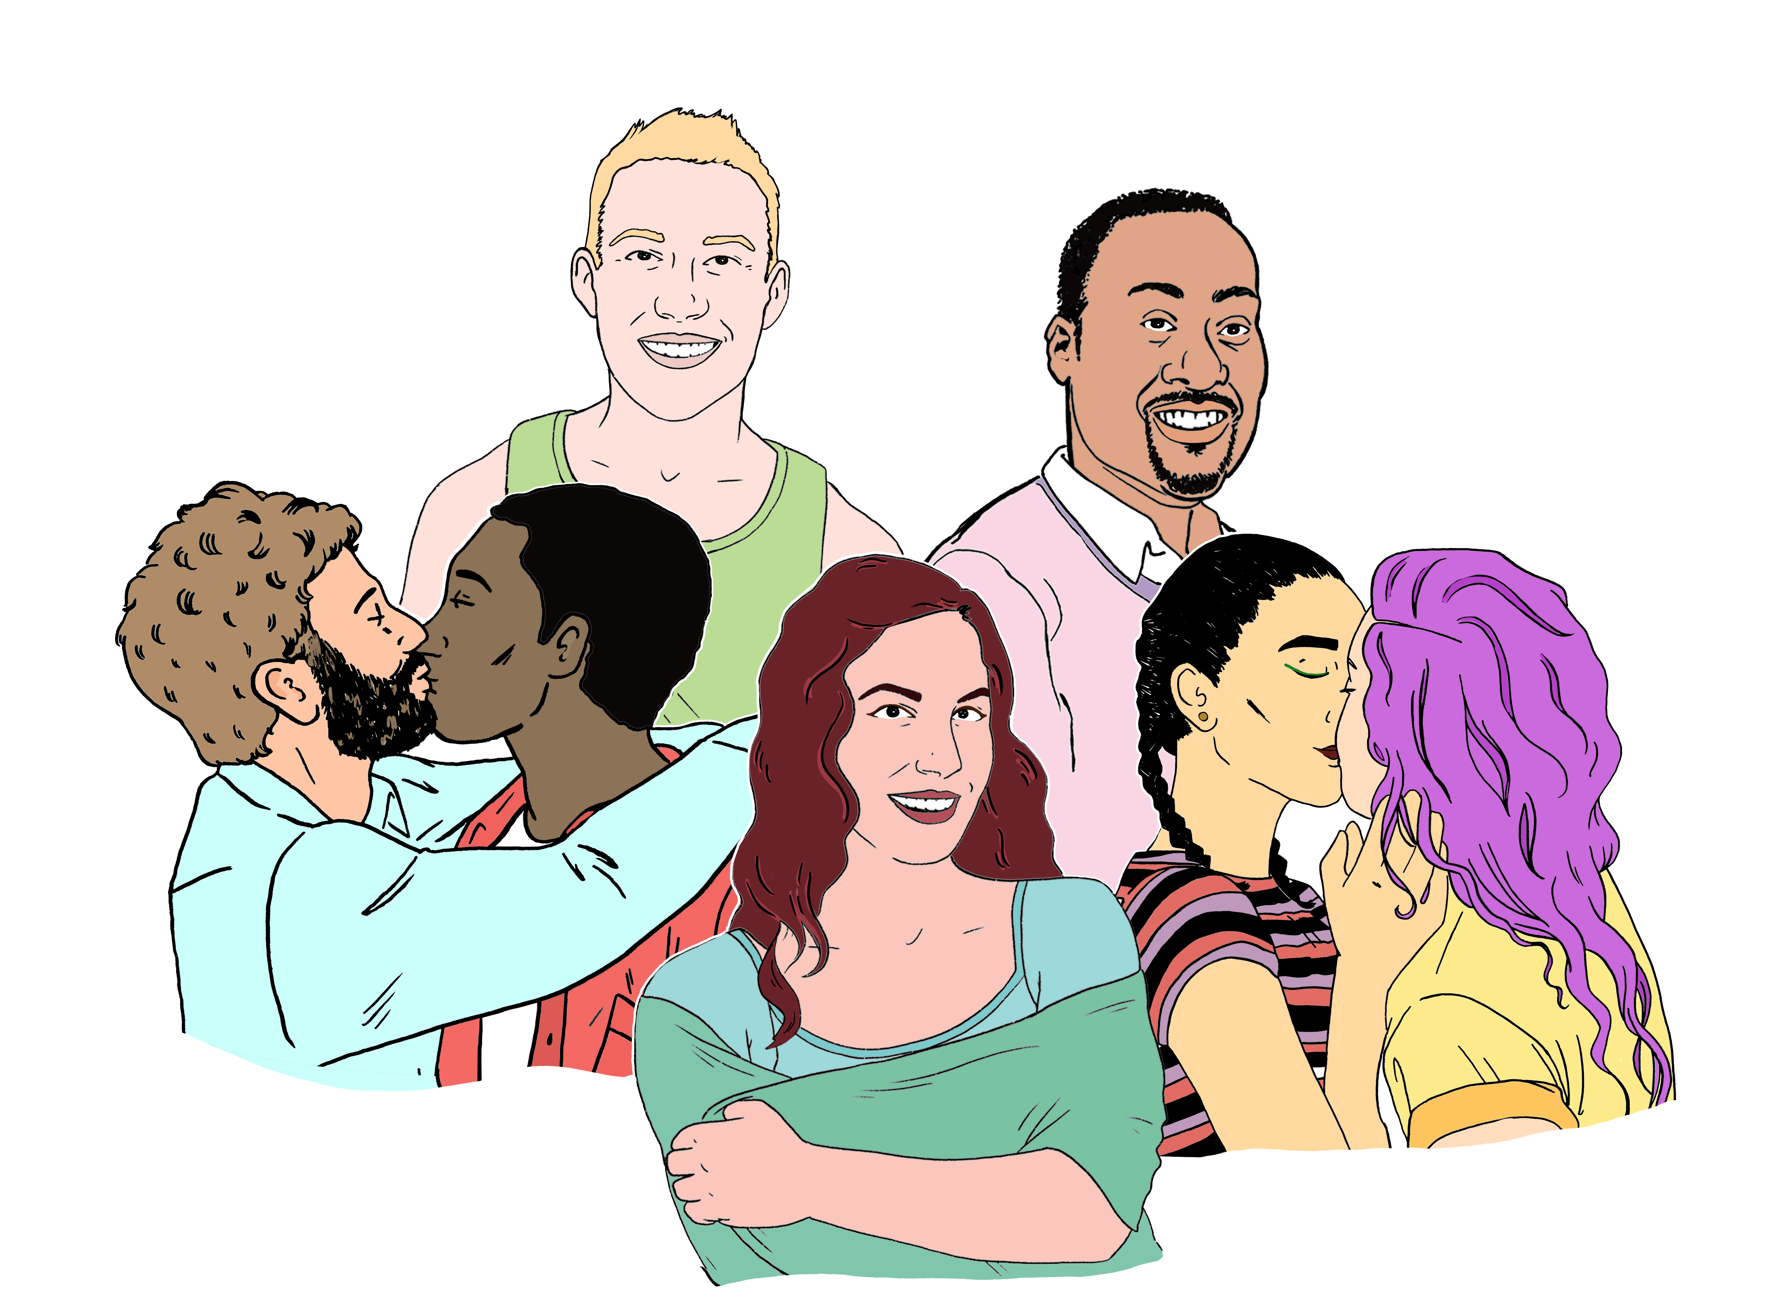
Mental health 34

Sexual health 44


Thank you 45

About this Easy Read


This is an Easy Read guide to getting support if you are part of the rainbow community.


The rainbow community is also sometimes called the LGBTQIA+ community.
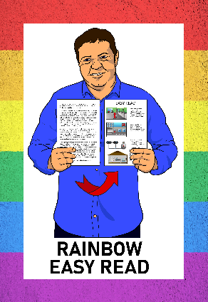

This guide is part of the Rainbow Resources Project.


You can find all the Rainbow Easy Reads at:

linktr.ee/rainboweasyread

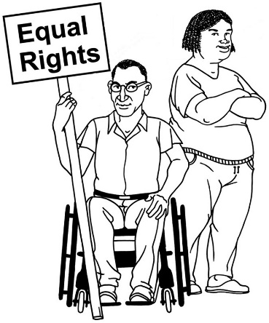
You might need support as a rainbow person for things like:
your human rights
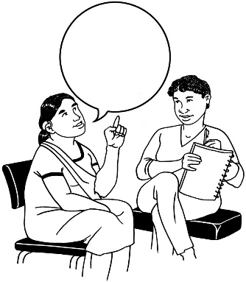


who to talk to when you want to know things about your rainbow identity
where to find people like you
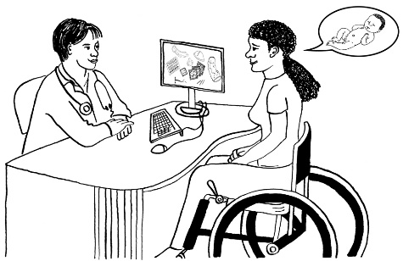
what to do in an emergency
knowing about your sexual health.

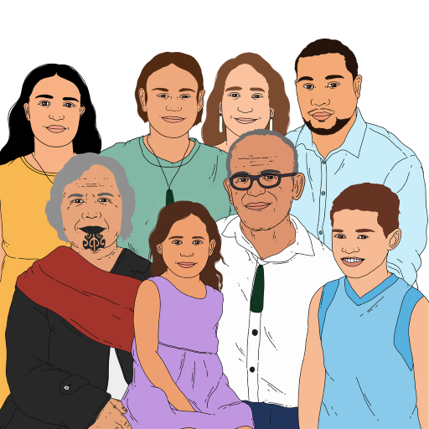
This support can come from:
whānau / family
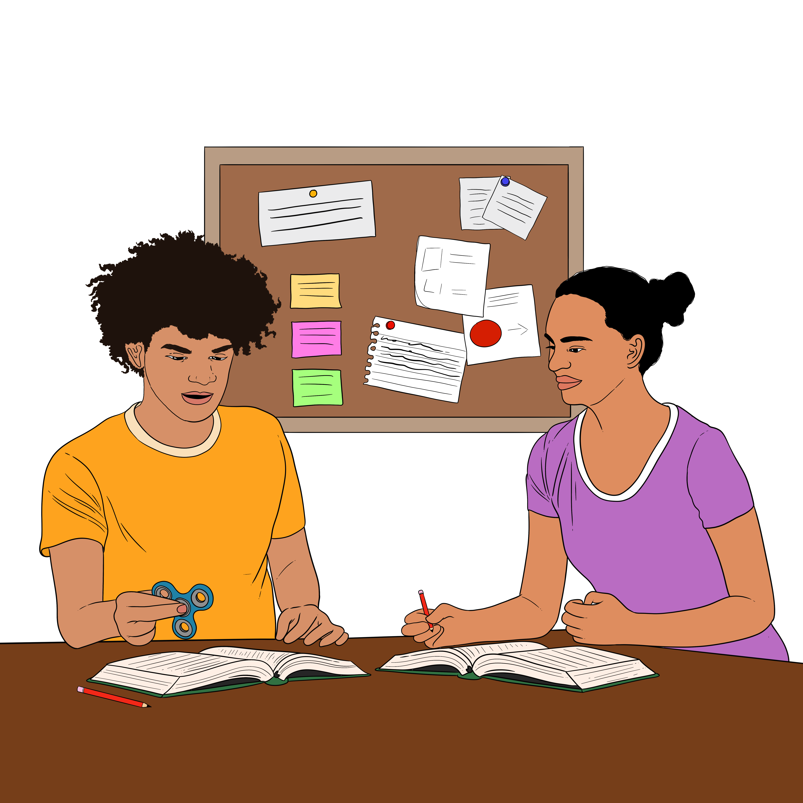
friends
rainbow organisations
healthcare providers.

Emergencies and the police
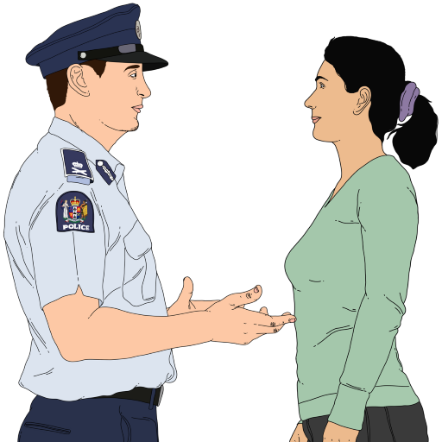

If an emergency happens phone the police on 111.


A rainbow person could have an emergency like:
violence like being:
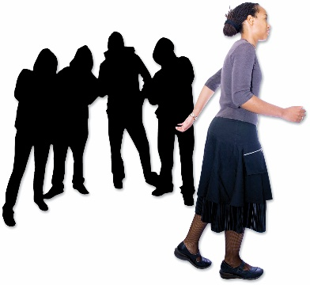
- hit
- held so you cannot move
being chased or followed
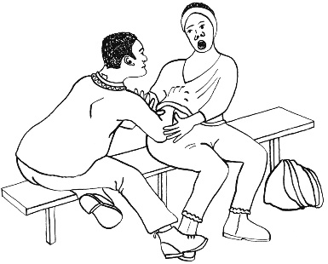
someone trying to make you have sex when you do not want to – this is rape
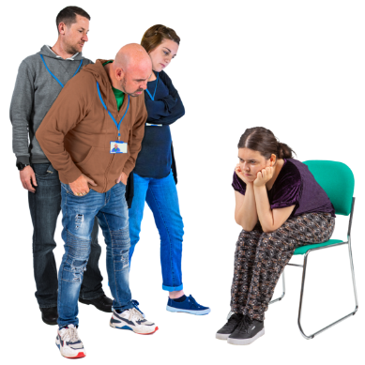
being taken to a place to do conversion practices without telling you what is happening.
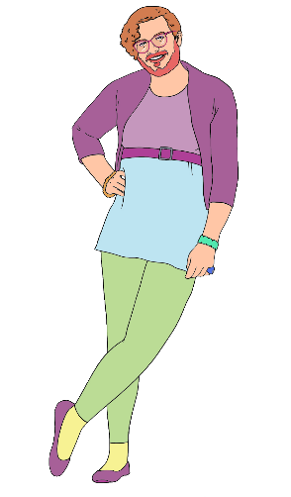

Conversion practices are things that are done to force a person to change their:
gender
sexual orientation.

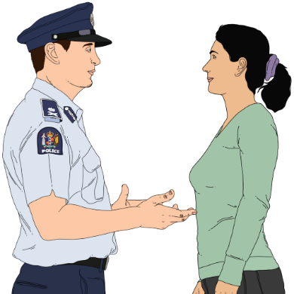
The police also have diversity liaison officers who support rainbow people with things that are not emergencies.

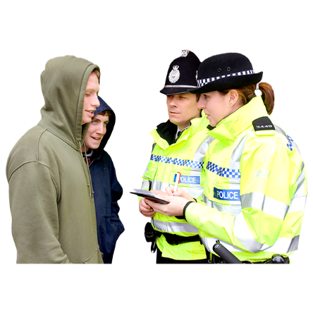
Police diversity liaison officers support contact between:
the police
and
the rainbow community.

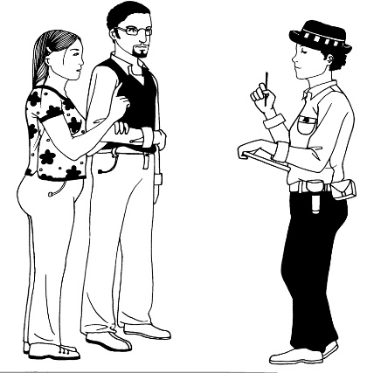

The police have some rainbow people working for them.

This supports the police to know what it is like to be a rainbow person.

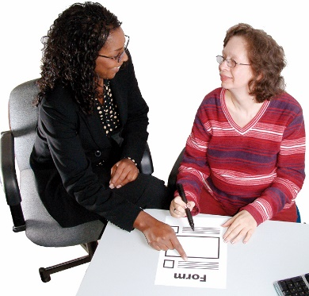
Police diversity liaison officers can:
support you to make a complaint about conversion practices
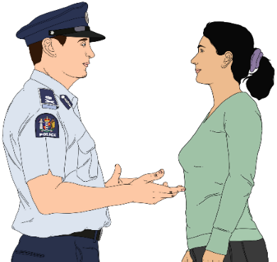
support you if there is violence happening in your rainbow relationship

give you information on how the police can work together with your rainbow group / organisation
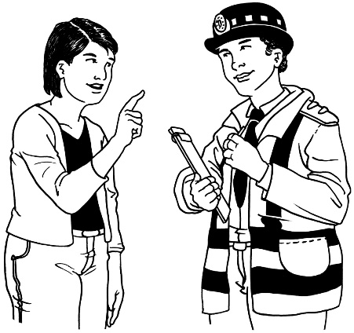

tell you how the police can support you with a problem
- at work
- in your community.

You can find information about police diversity liaison officers at this website:

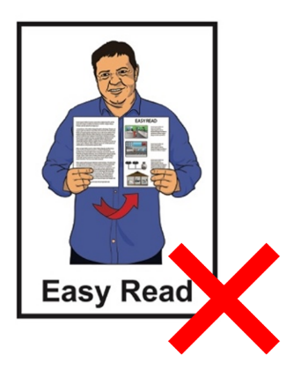
tinyurl.com/3vp6mx52

This website is not in Easy Read.

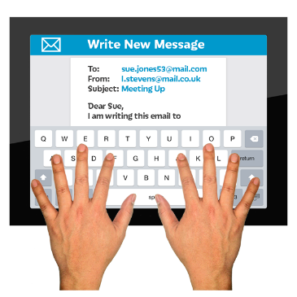
You can email the police diversity liaison officers at:

DLOs@police.govt.nz

Friends and family

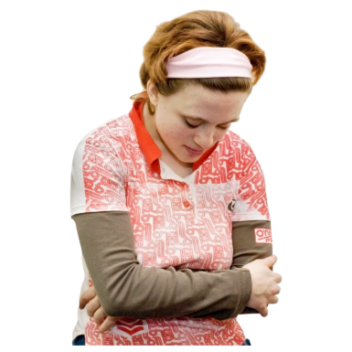
It can sometimes be hard to be a rainbow person.

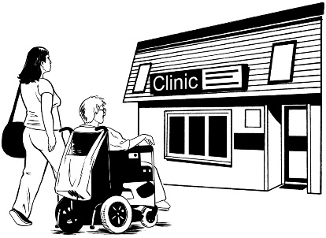
You might want support to:
get healthcare
go to a rainbow event
find other rainbow:
- people
- organisations
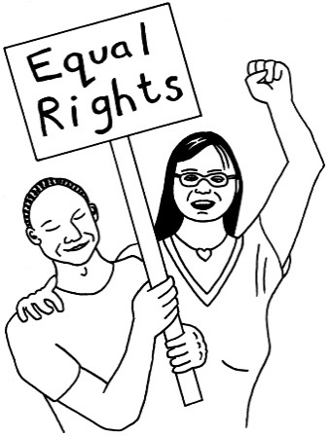
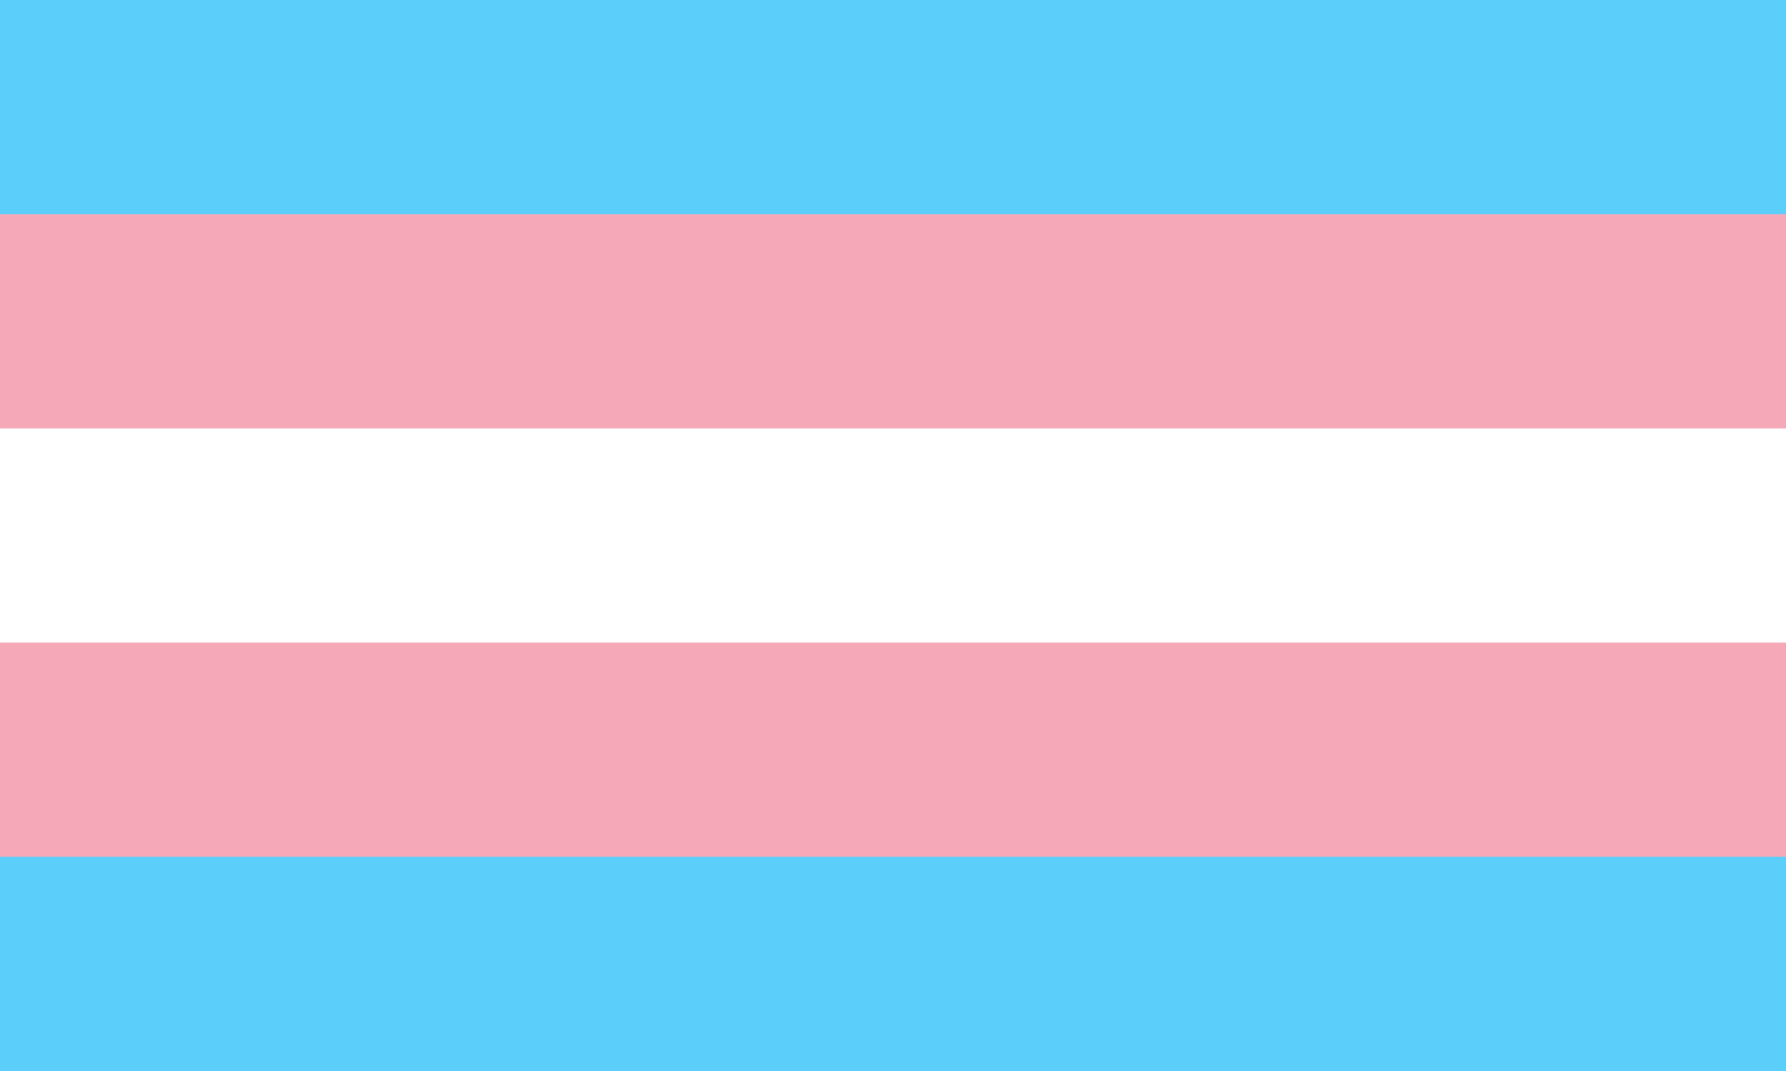
deal with:
- discrimination
- your rights.

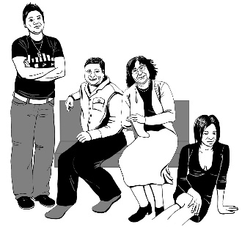
Here discrimination is when people are treated unfairly because of:
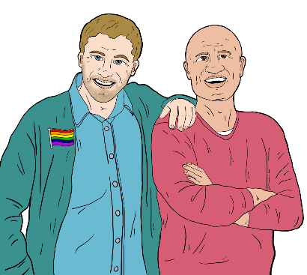
- their gender
- being transgender
- their sexuality.

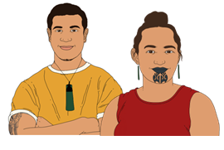
Gender is if you are a:
man
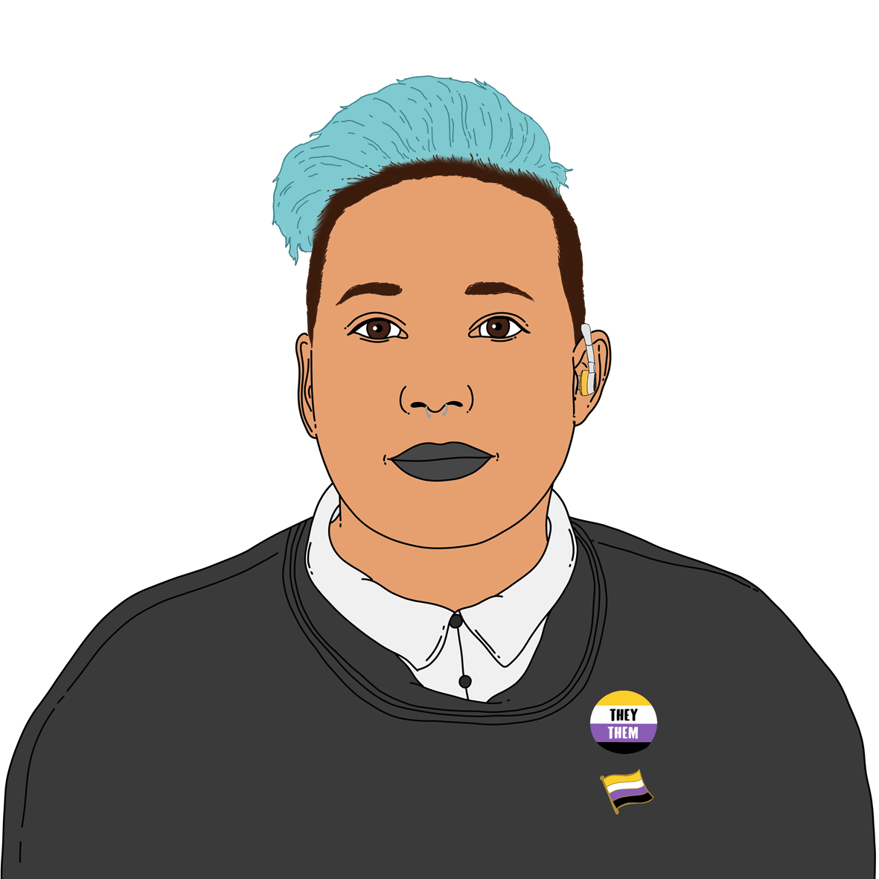
woman
another gender like non-binary.

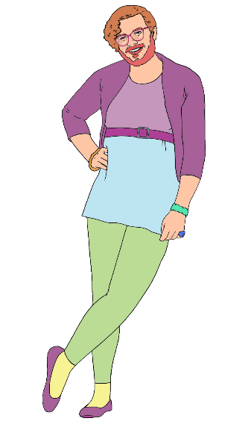
Non-binary is a term for people who are not just a:
man
or
woman.

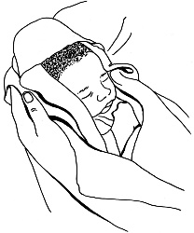
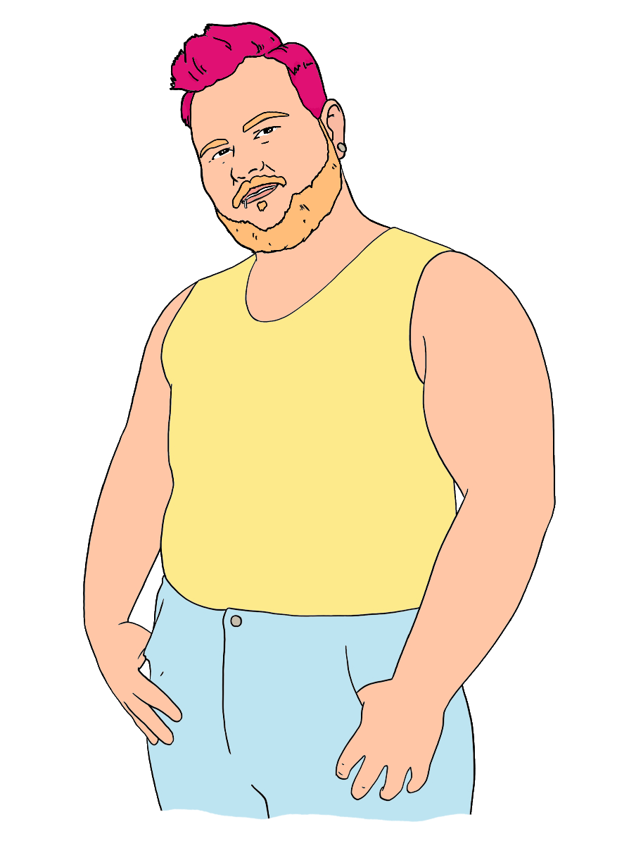
Transgender people have a different gender to the one people thought they were when they were born.

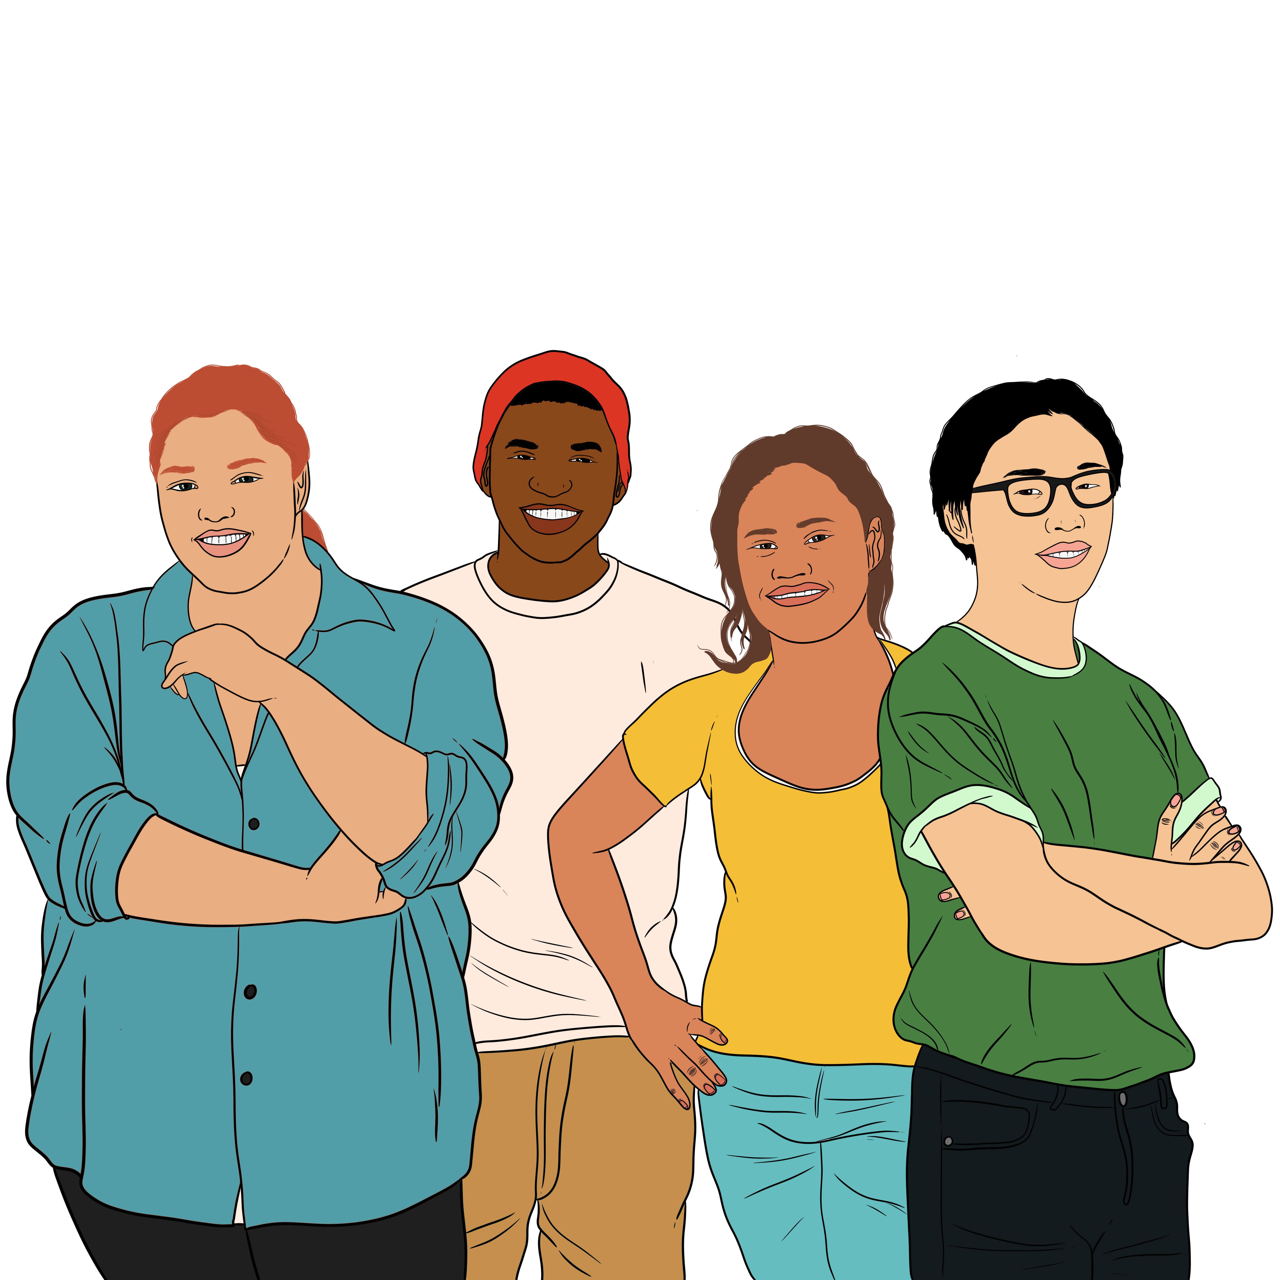

Sexual orientation is about the gender of the people you:

are attracted to
want to have sex with.

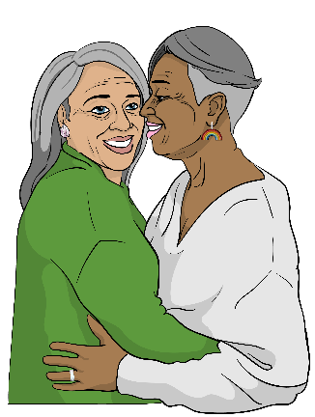
Some sexual orientations are:
gay / lesbian – being attracted to people who are the same gender as you
bisexual – being attracted to more than one gender.


You might find support from:
whānau / family

friends
support people

people you meet through rainbow:
- organisations
- events.

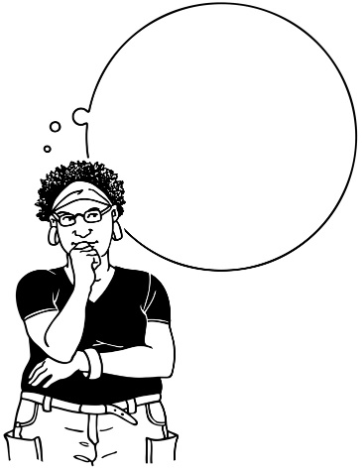

You might want to find out what someone thinks of rainbow people before you:
come out to them
ask them for support.


You might find out what someone thinks by listening to what they say about other rainbow people who are:
well known


in the news
on television
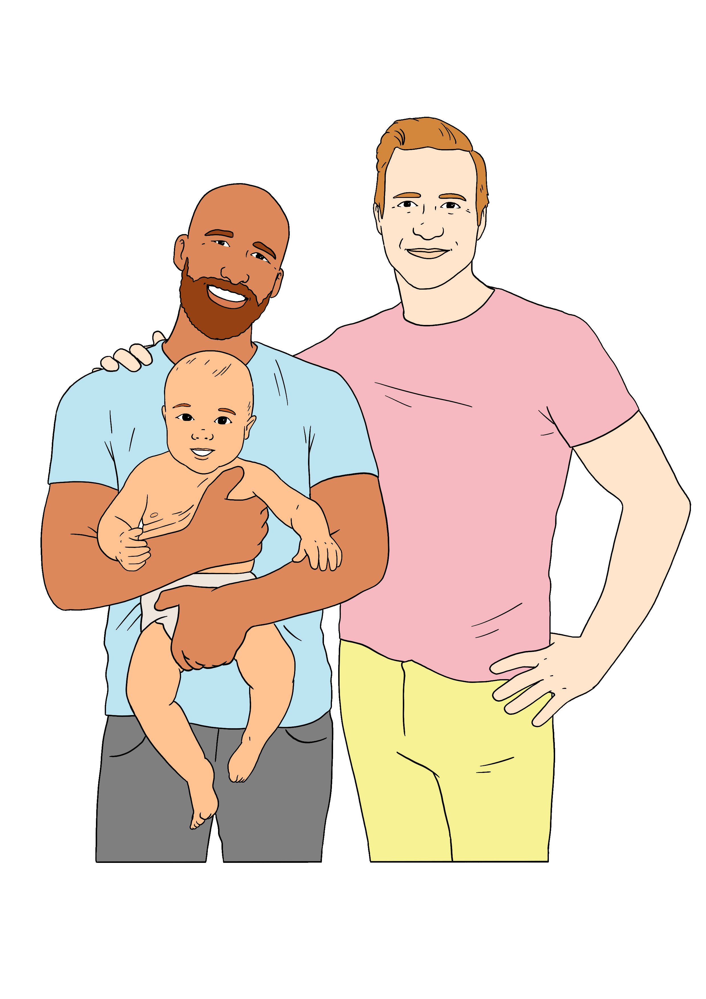
in movies
friends
family.

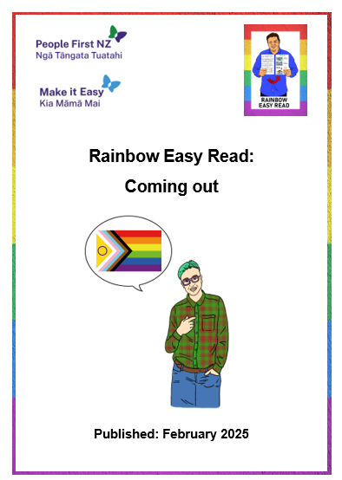
You can find out more about coming out in the Easy Read called:
Rainbow Easy Reads: Coming out:

You can find this Easy Read at:
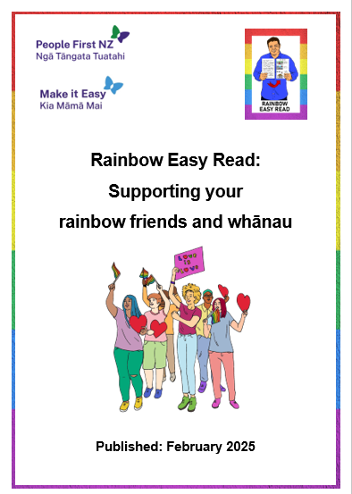
https://tinyurl.com/RERout

You can find out more about supporting rainbow people in the Easy Read called:
Rainbow Easy Reads: Supporting your rainbow friends and whānau:

You can find this Easy Read at:
https://tinyurl.com/RERsupport

Rainbow organisations

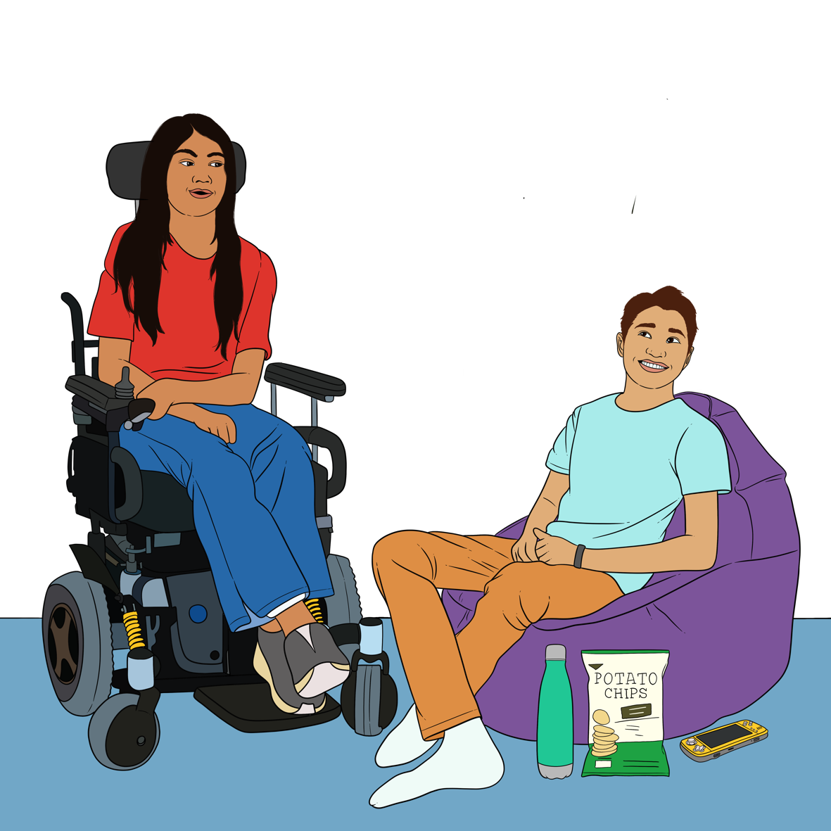
There are rainbow organisations in Aotearoa New Zealand who can support you with things like:
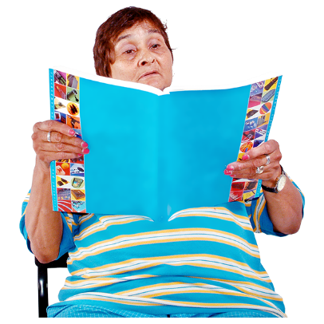

places to hang out / meet other rainbow people
getting information about being a rainbow person
heathcare
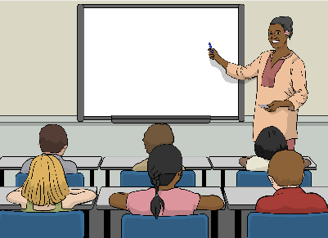

mental health
being a rainbow person at:
- school
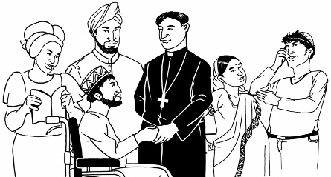
- work
- church.


There are also organisations who support:
rainbow people from other countries who now live in Aotearoa New Zealand
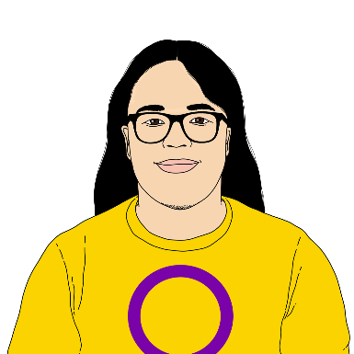
rainbow refugees and asylum seekers
intersex people.

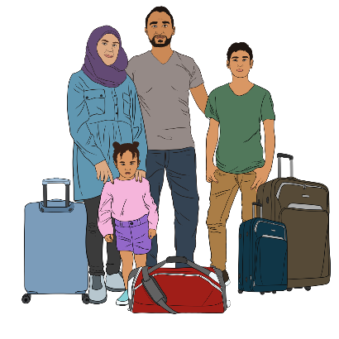
A refugee is a person who has had to leave their country because of something like a war.

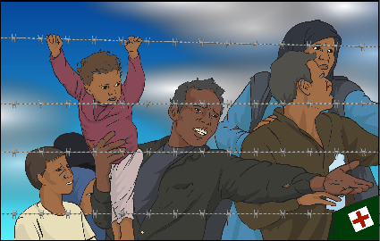
An asylum seeker is a person who is wanting protection in another country.

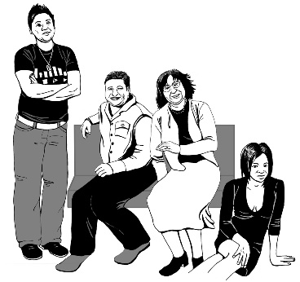
An asylum seeker might be wanting protection because of something like:
they are a rainbow person
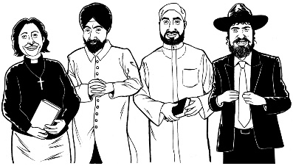
their religion is discriminated against where they came from.

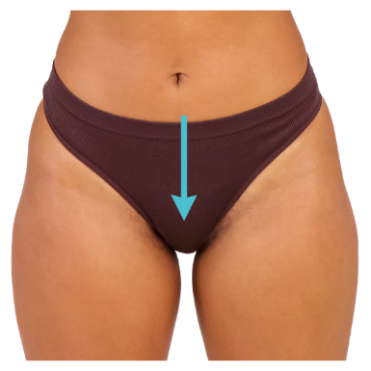
Intersex people have bodies with natural differences like in their:
private parts
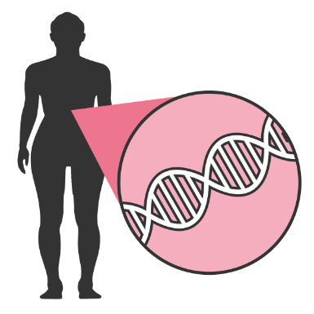
hormones
chromosomes.


Hormones are chemicals in the body which tell the body how it should work.

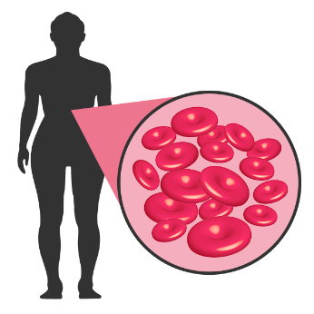
Chromosomes are types of cells in the body which tell the body how it should look.



This Easy Read talks about some of the rainbow organisations in Aotearoa New Zealand.



You might find other rainbow
organisations / groups in your community by:
asking people
looking on the internet.


RainbowYOUTH

RainbowYOUTH supports:
young rainbow people who are up to about 27 years of age
their whānau / families
teachers.

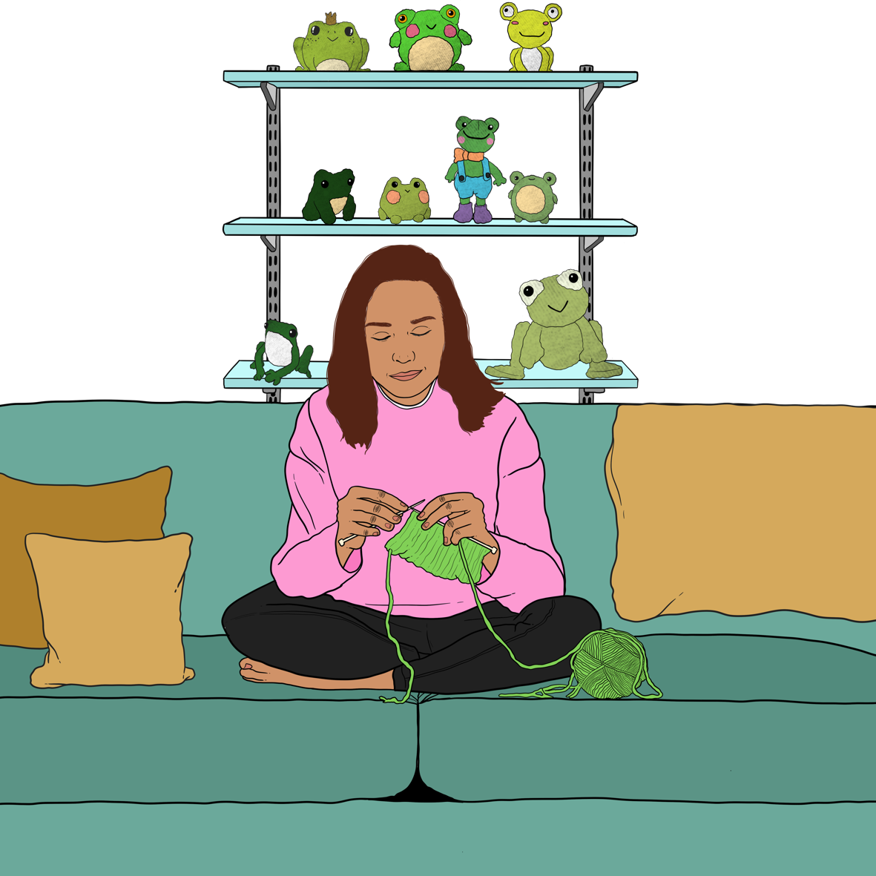
They have groups for many things like:
doing art and craft

social events like hanging out
learning about being a rainbow person.

There are RainbowYOUTH groups all over the motu / country.

You can find more information about RainbowYOUTH at their website:

www.ry.org.nz
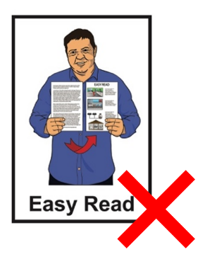

This website is not in Easy Read.


InsideOUT

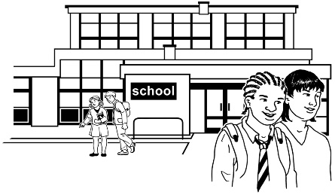
InsideOUT supports young people:
at school
at work.

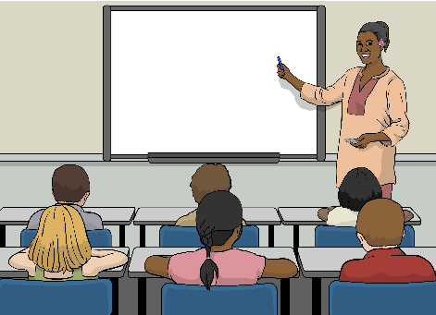

InsideOUT does things like:
meetings at schools to talk about rainbow issues with students
workshops for teachers on how to support their rainbow students

training for workplaces so they can:
- be safer for rainbow people
- include rainbow people.


InsideOUT also has things to share like:
books
videos.


You can find out more about InsideOUT at their website:

www.insideout.org.nz

This website is not in Easy Read.

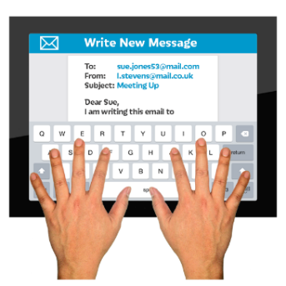
You can contact InsideOUT by email:

support@insideout.org.nz


You can also contact InsideOUT by phone:

027 331 4507

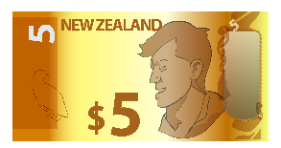

This phone number will cost money to call.

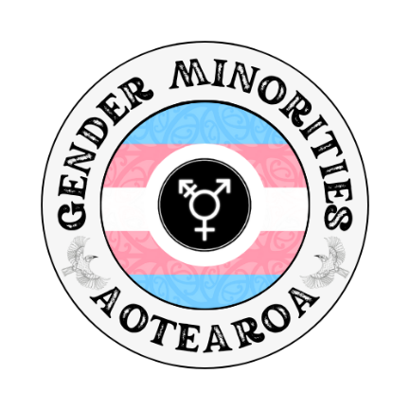
Gender Minorities Aotearoa

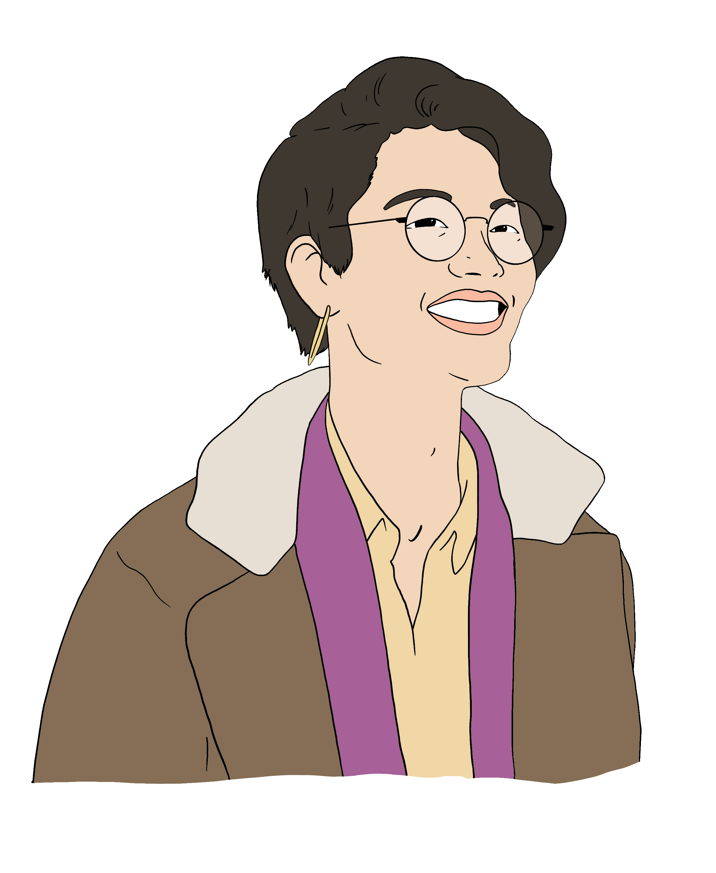
Gender Minorities Aotearoa supports transgender people including people who are:
trans men
trans women
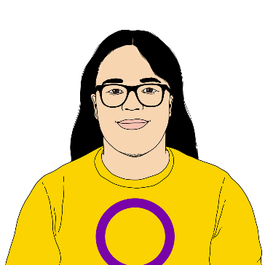
non-binary
takatāpui
intersex.

Takatāpui is a word only for Māori rainbow people.

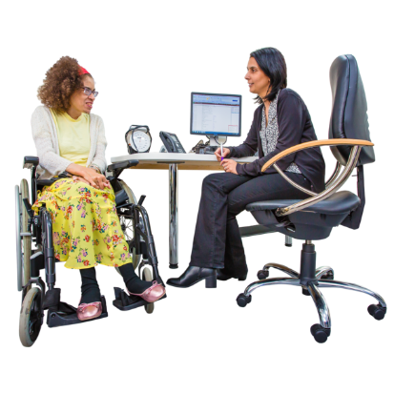
Gender Minorities Aotearoa has information for transgender people about:
healthcare
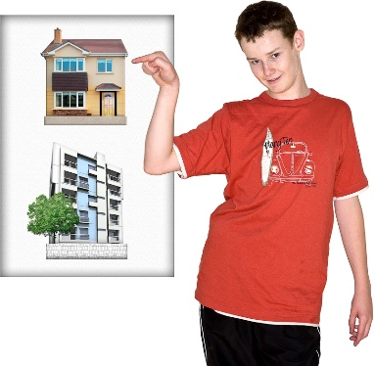
sexual health
mental health
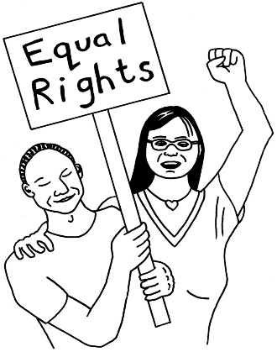
housing
jobs
human rights
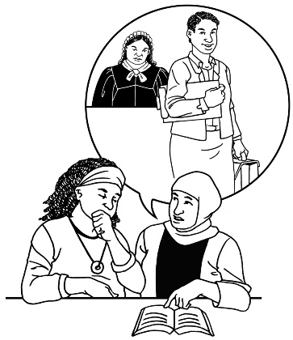
school
legal issues.

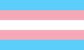
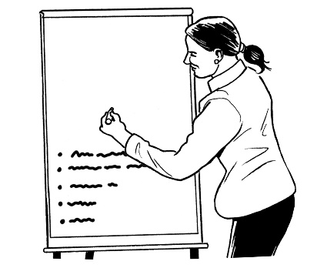
Gender Minorities Aotearoa supports transgender people with:
courses to learn about life as a transgender person
groups to:
- hang out with other rainbow people
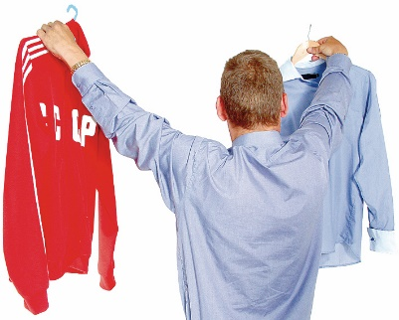
- do events together.
clothes.


You can find out more about Gender Minorities Aotearoa at this website:

www.genderminorities.com

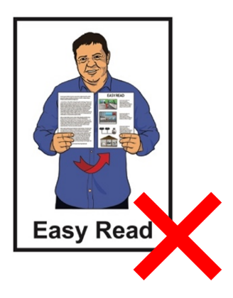
This website is not in Easy Read.


To Be Frank

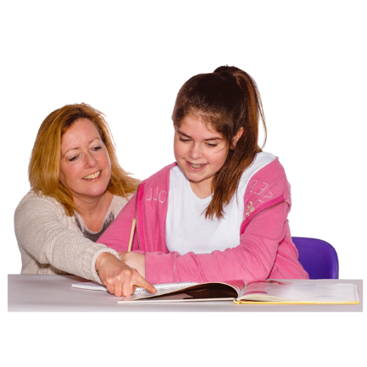
To Be Frank supports disabled people to learn about:
sexuality
gender.

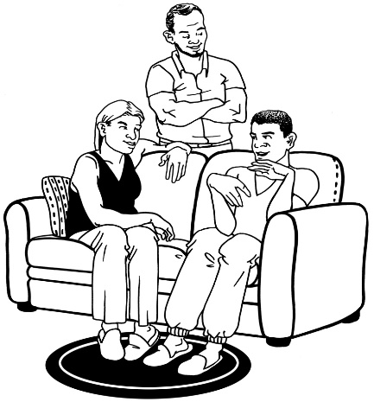
To Be Frank also works with
whānau / families to support them to understand the:
sexuality of a disabled person
gender of a disabled person.


To Be Frank does education sessions for:

just 1 person
groups of people.

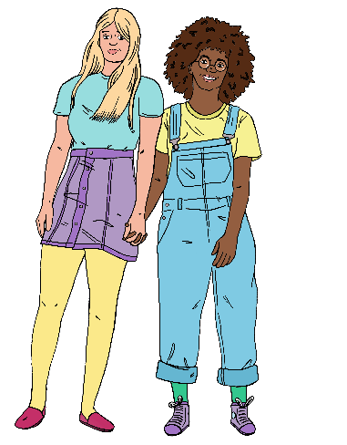
To Be Frank is a safe place to learn about things like:
rainbow community groups
dating

sex
consent.

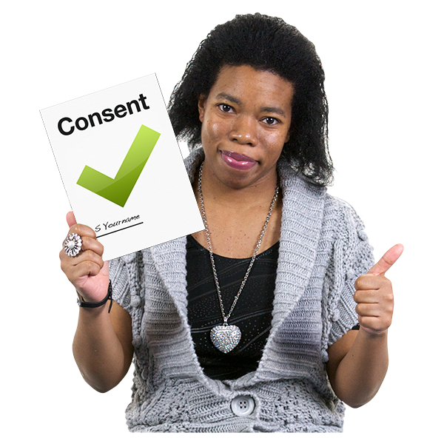
Here consent means knowing your rights about:
how people can touch your body
knowing if you would like sex
how you would like to have sex.

You can find out more about To Be Frank at this website:

www.tobefranknz.org.nz
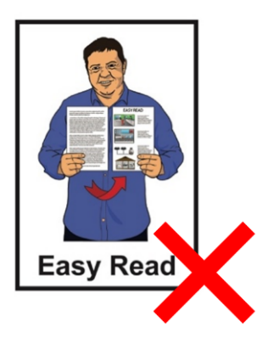

This website is not in Easy Read.



Diverse Church

There are rainbow affirming churches if going to church is important to you.

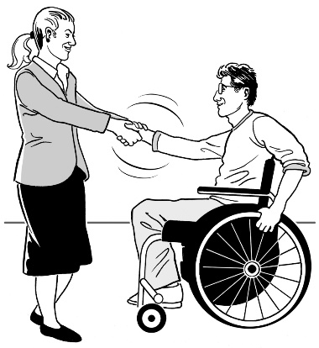
Here rainbow affirming means rainbow people are:
welcome at the church
treated with respect by the church.

You can find a rainbow affirming church at the Diverse Church website:

www.diversechurch.co.nz
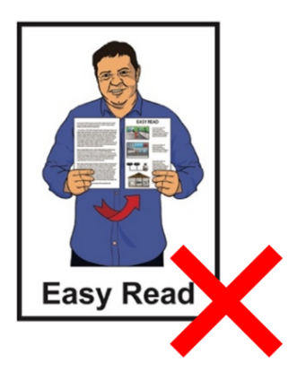

This website is not in Easy Read.

Rainbow Path NZ

Rainbow Path NZ is an organisation that supports rainbow:
refugees
asylum seekers.

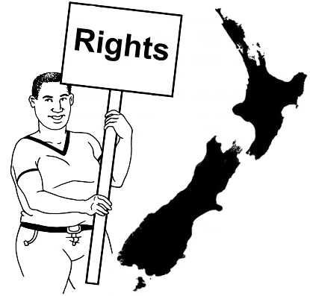
Rainbow Path NZ can support refugees and asylum seekers in Aotearoa New Zealand with:
human rights
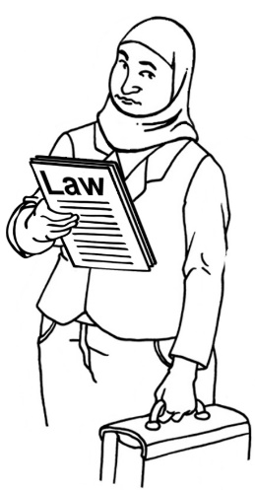
getting legal support like a lawyer
getting healthcare
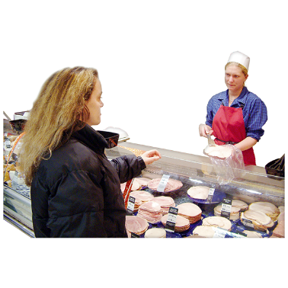
getting money to live like a benefit
housing
food.

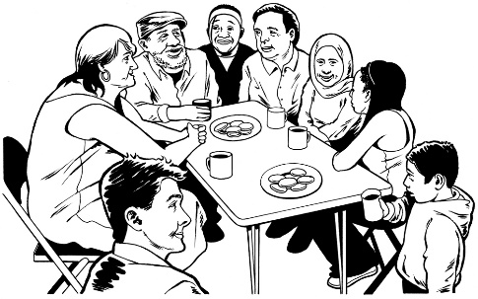
Rainbow Path NZ also connects rainbow refugees and asylum seekers with each other.


You can find out more about Rainbow Path NZ on their website:

www.rainbowpathnz.com
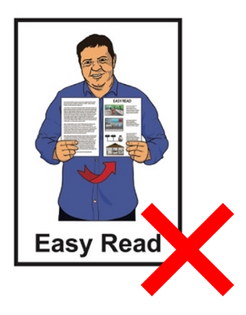

This website is not in Easy Read.

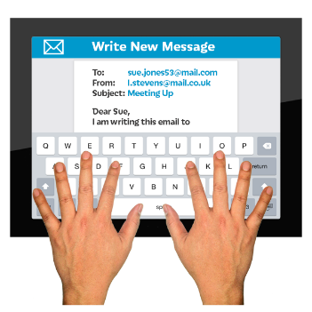
You can contact Rainbow Path NZ by email:

rainbowpath@protonmail.com

Intersex Aotearoa

Intersex Aotearoa is an organisation that supports intersex rainbow people.

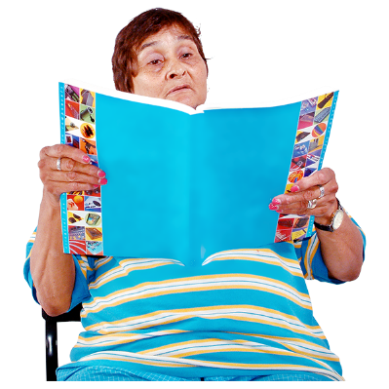
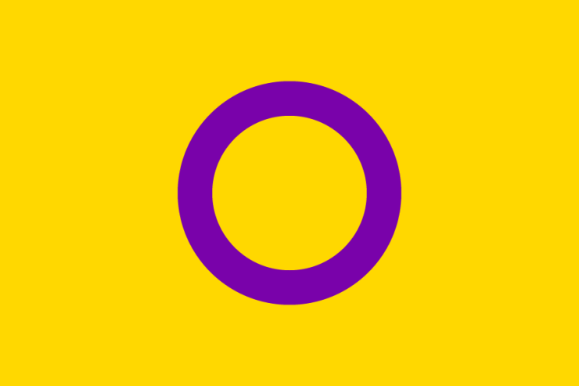
Intersex Aotearoa has information about:
what it is like to be intersex

healthcare
how they work with:
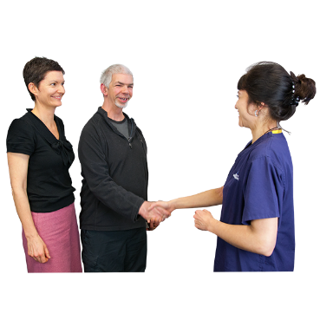
- the Government
- the health system
support for:
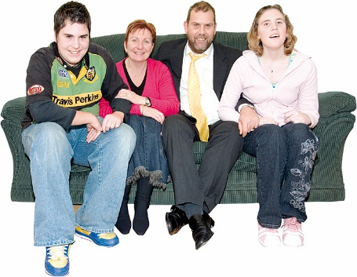
- intersex people
- family and friends of intersex people.

You can find out more about Intersex Aotearoa on their website:

www.intersexaotearoa.org
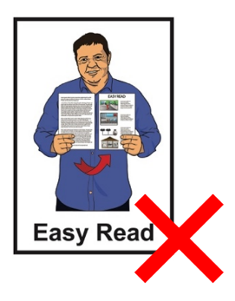

This website is not in Easy Read.

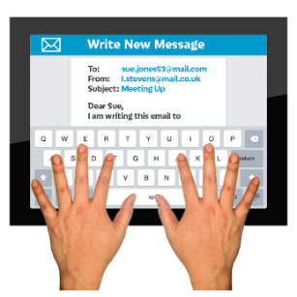
You can contact Intersex Aotearoa by email:

info@intersexaotearoa.org

Mental health
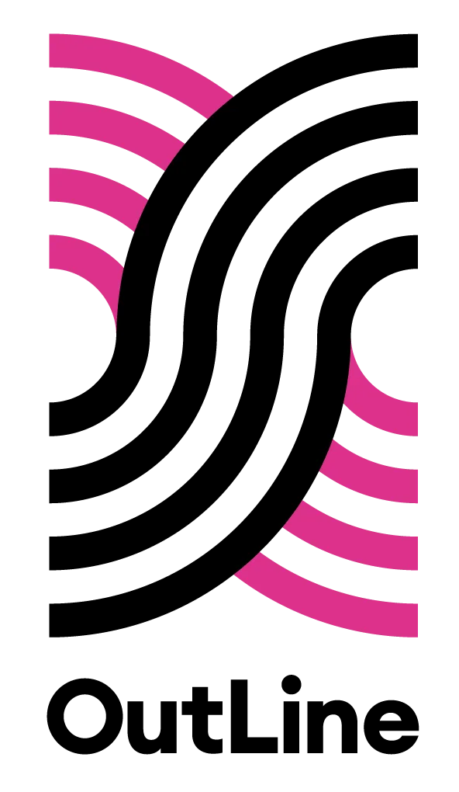

OutLine

OutLine has people who are trained to support the mental health of rainbow people.


You can contact OutLine every day between 6 pm and 9 pm in the evening:
by phone on:
0800 688 5463
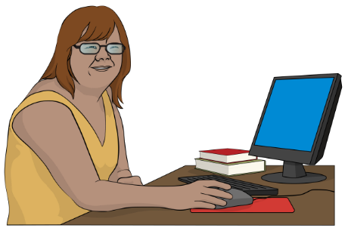
using the text chat on their website at:
outline.org.nz/chat
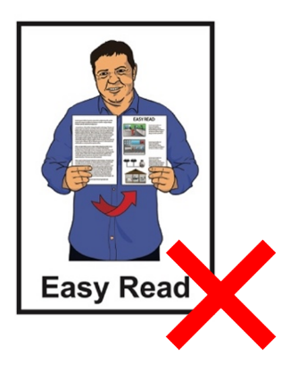

This website is not in Easy Read.

Sexual health

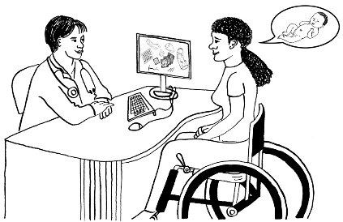
There are healthcare services in Aotearoa New Zealand that can talk to you about sexual health.

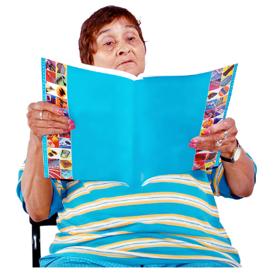
Here sexual health means knowing about:
having sex:
- as a rainbow person
- with other rainbow people
contraception like:
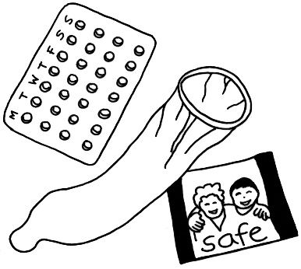
- condoms
- the Pill
sexually transmitted
infections / STIs.
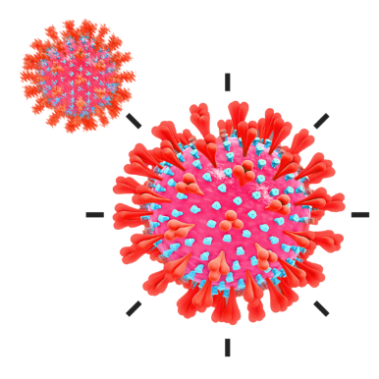
Sexually transmitted
infections / STIs are illnesses you can sometimes get from other people when you have sex.

Sexual Wellbeing Aotearoa

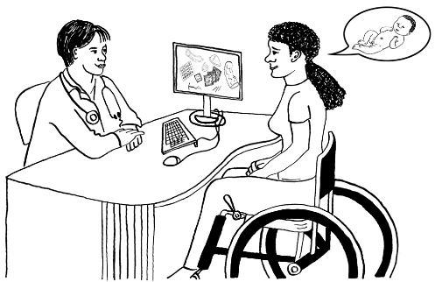

Sexual Wellbeing Aotearoa is a health service with:

information about sexual health
rainwbow people who work for them.





If you want an appointment with Sexual Wellbeing Aotearoa you can ask for a rainbow person who works there to support you.

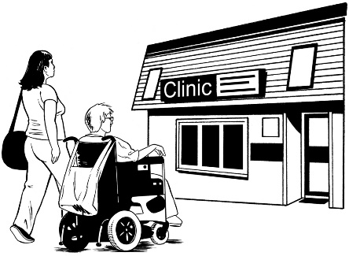
You can have an appointment:
at one of their clinics

over the phone.

You can contact Sexual Wellbeing Aotearoa through their website:

www.sexualwellbeing.org.nz/

This website is not in Easy Read.


You can contact Sexual Wellbeing Aotearoa by phone on:

07 810 6610

This phone number may cost you money to call.

Sexual Wellbeing Aotearoa uses the New Zealand Relay service for people who are:

- Deaf / hard of hearing
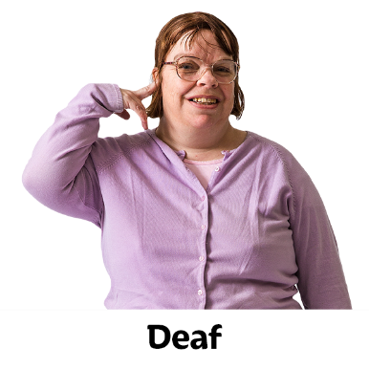
- deafblind

- speech impaired / find it hard to talk.


You can find out more about the New Zealand Relay service at:

www.nzrelay.co.nz

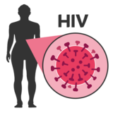
HIV

An illness that has been a big part of rainbow lives for a long time is the STI called Human Immunodeficiency Virus / HIV.

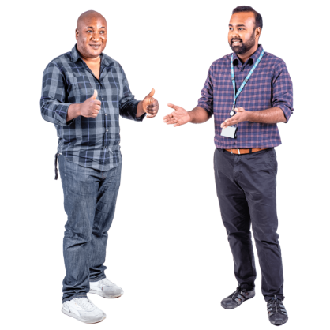
People who have HIV can live good lives if they have good treatment.

AIDS is short for Acquired Immune Deficiency Syndrome.

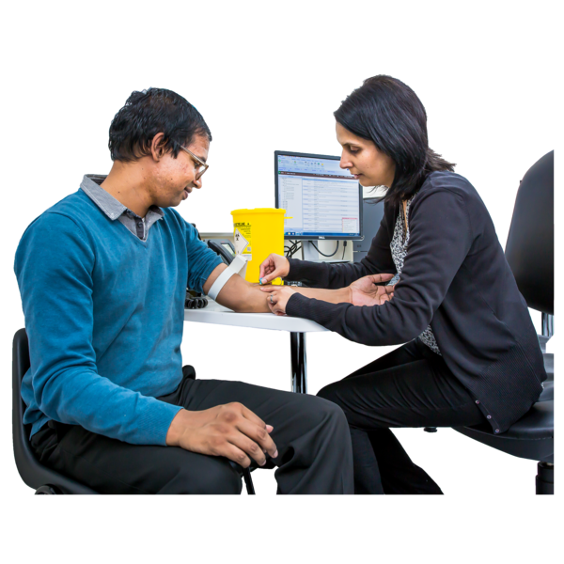
Some people who have HIV will get AIDS which means they are more ill.

Not everyone who has HIV will get AIDS.

There:

are ways to keep safe from getting HIV like contraception
is lots of information about HIV
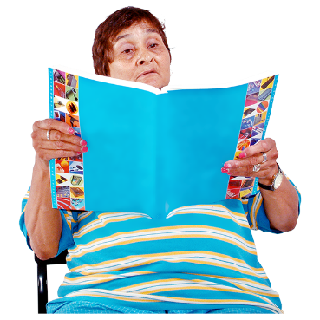
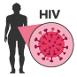
is support for people with HIV.

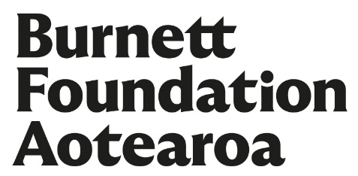
Burnett Foundation

The Burnett Foundation supports people in Aotearoa New Zealand with STIs like HIV.

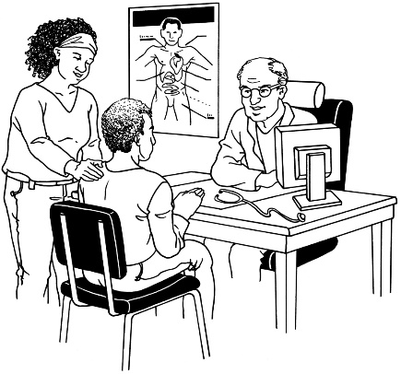
The Burnett Foundation has information about STIs like HIV including:
healthcare
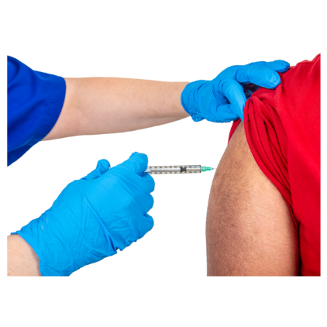
testing for STIs
vaccinations
contraception
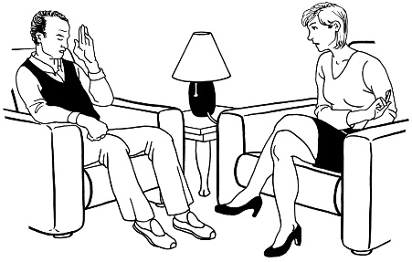
mental health support.


You can find out more at the Burnett Foundation website:

www.burnettfoundation.org.nz
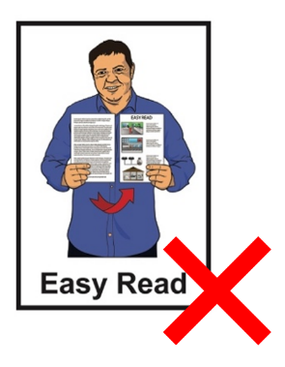

This website is not in Easy Read.


You can contact the Burnett Foundation by:
email:
contact@burnettfoundation.org.nz

phone:
0800 802 437

Thank you

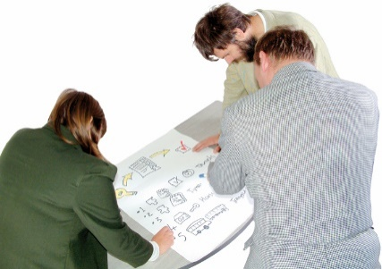
Lots of people worked together on the Rainbow Easy Reads.


Thank you to the Rule Foundation for giving us the money to make them.


Thank you also to:

- the People First NZ members who worked as advisors

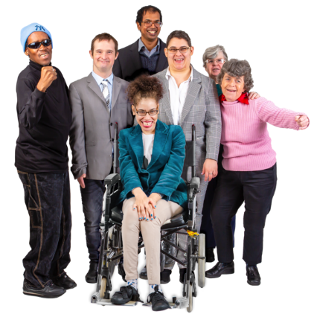
- the People First NZ staff who supported them

- everyone who has supported this mahi / work.

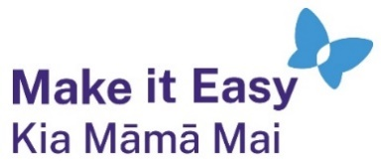
This information has been written by Make it Easy Kia Māmā Mai.

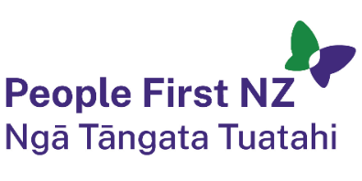
Make it Easy is a service of People First New Zealand Ngā Tāngata Tuatahi.


All images used in this Easy Read document are subject to copyright rules and cannot be used without permission.


Make it Easy uses images from:

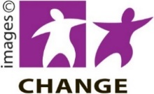
- Photosymbols


- Change Images

- SGC Image Works


- Huriana Kopeke-Te Aho


- T Wood

- Studio Rebeko

- Inga Kramer.

