
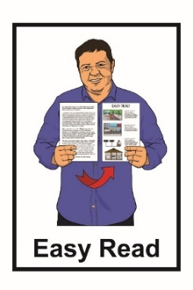

Easy Read information about the Accessibility Charter
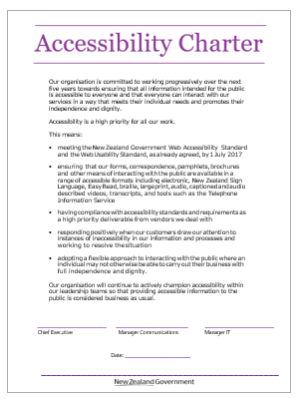

September 2021

What is the Accessibility Charter?


The Accessibility Charter is an agreement made by the Chief Executives of Government organisations like the Ministry of Health.


In each Government organisation the agreement will be signed by the:

- Chief Executive who is the top manager

- Information Technology Manager who is in charge of all the technology like computers and websites
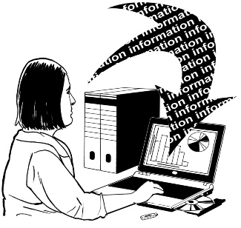
- Communications Manager who is in charge of information that is shared with people.

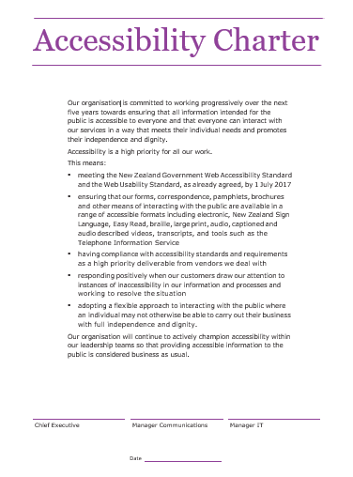
This is what the Accessibility Charter looks like:
_____________________ ______________________ _____________________
Chief Executive Manager Communications Manager IT

Date: ____________________

_______________________________________________
Our organisation is committed to working progressively over the next five years towards ensuring that all information intended for the public is accessible to everyone and that everyone can interact with our services in a way that meets their individual needs and promotes their independence and dignity.

Accessibility is a high priority for all our work.

This means:

    - meeting the New Zealand Government Web Accessibility Standard and the Web Usability Standard, as already agreed, by 1 July 2017

    - ensuring that our forms, correspondence, pamphlets, brochures and other means of interacting with the public are available in a range of accessible formats including electronic, New Zealand Sign Language, Easy Read, braille, large print, audio, captioned and audio described videos, transcripts, and tools such as the Telephone Information Service

    - having compliance with accessibility standards and requirements as a high priority deliverable from vendors we deal with

    - responding positively when our customers draw our attention to instances of inaccessibility in our information and processes and working to resolve the situation

    - adopting a flexible approach to interacting with the public where an individual may not otherwise be able to carry out their business with full independence and dignity.

Our organisation will continue to actively champion accessibility within our leadership teams so that providing accessible information to the public is considered business as usual.

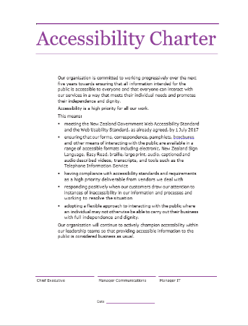
The Accessibility Charter is 1 of the ways the Government will follow the United Nations Convention on the Rights of Persons with Disabilities.

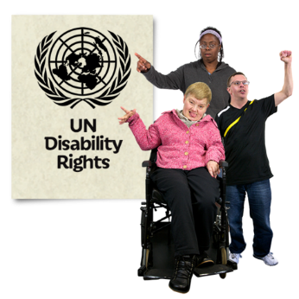
The United Nations Convention on the Rights of Persons with Disabilities is also called the UNCRPD.

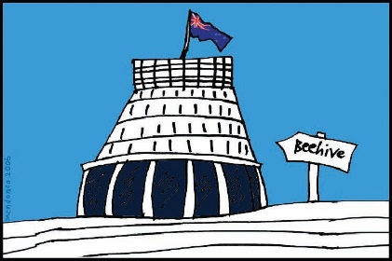
The UNCRPD is a law lots of countries have agreed to.

In 2008 the New Zealand Government said that we agree with the UNCRPD.
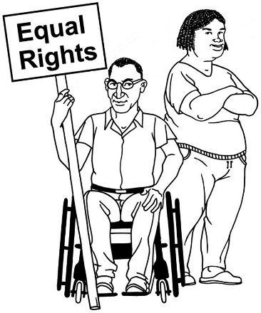

It says what governments must do to make sure disabled people get the same rights as everybody else.

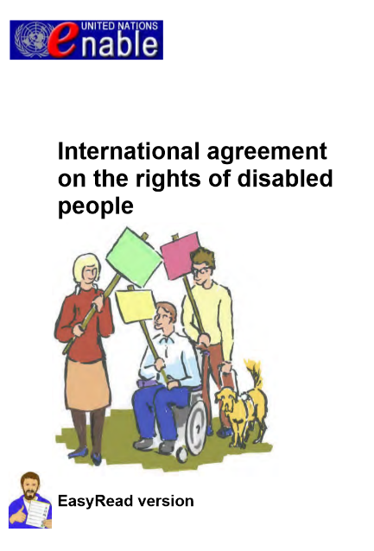
The Accessibility Charter will help the Government to follow Article 9 of the UNCRPD.

Article 9 explains what the Government needs to do to make things accessible to disabled people.
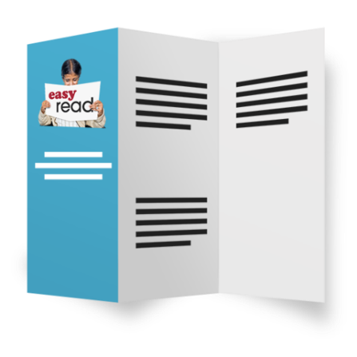

Accessible means that disabled people can:

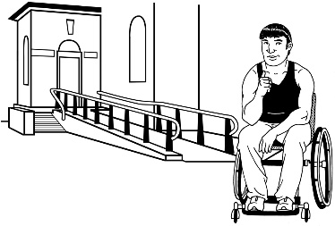
- get information in a way they can understand

- access information from websites or online

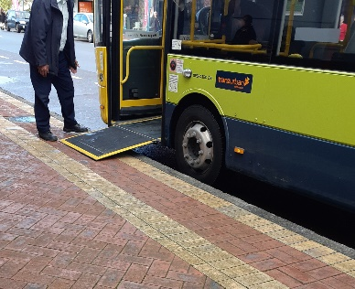
- use public services like get into buildings

- use transport like buses.

What does the Accessibility Charter say?

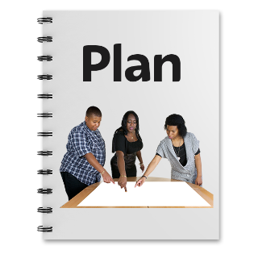
When a Government organisation signs the Accessibility Charter they are agreeing to:
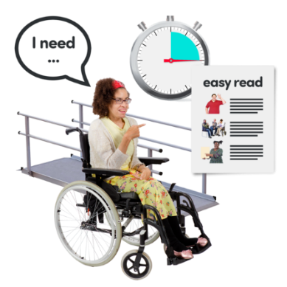
- making sure that everyone can use their services

- having their information accessible to everyone.


Information is things like:

- websites

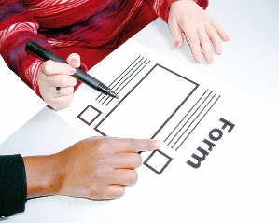
- forms

- letters
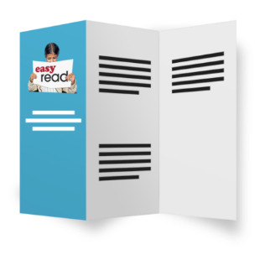
- pamphlets

- reports.

Accessible information means having information in ways that people can understand like:
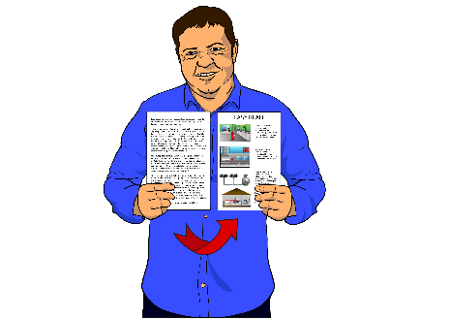
- New Zealand Sign Language

- Easy Read
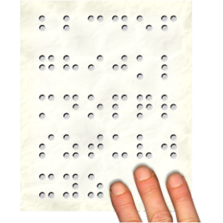
- braille

- large print

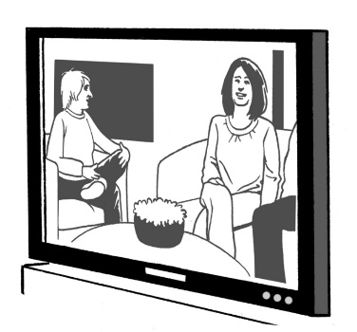
- audio
Good to talk to you

- captioned video

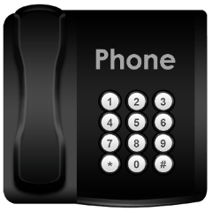
- audio described video

- Telephone Information Service.

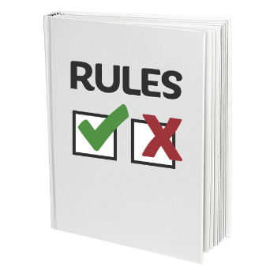
When a Government organisation signs the Accessibility Charter they are also agreeing to:

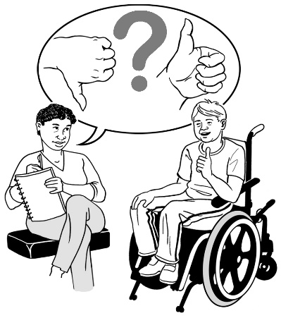
- asking other organisations they work with to follow these accessibility rules

- listening to people when they say they have a problem with the accessibility of their service

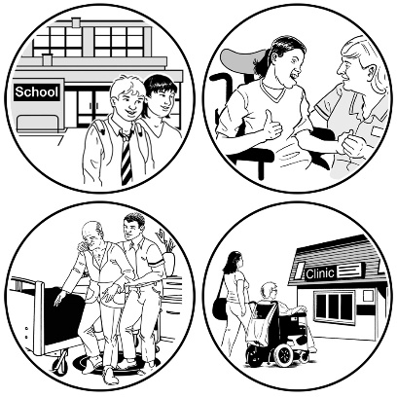
- looking at ways to fix these accessibility problems

- finding ways of providing their services so that everyone can use them in a way that works well for them
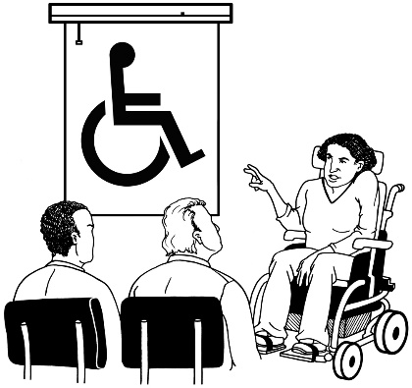
- making sure that all their managers encourage accessibility at all times.


The Accessibility Charter says that
Government organisations will do this work over the 5 years from the date they sign the Charter.

After that making things accessible should happen in all Government work.

Where to find more information

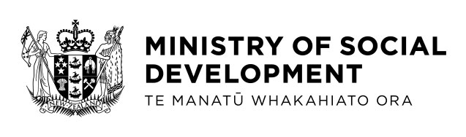
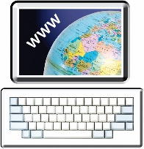
You can find more information about the Accessibility Charter on the Ministry of Social Development website:

www.msd.govt.nz/about-msd-and-our-work/work-programmes/accessibility/index.html

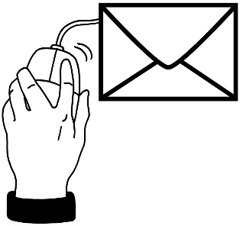
You can also email:

accessibility@msd.govt.nz

This information has been written by the Ministry for Social Development.
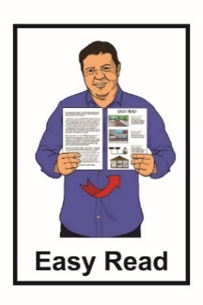
It has been translated into Easy Read by the Make It Easy service of People First New Zealand Inc. Ngā Tāngata Tuatahi.

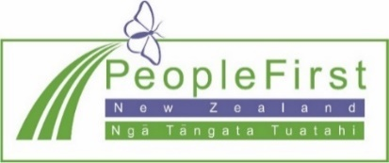
The ideas in this document are not the ideas of People First New Zealand Inc. Ngā Tāngata Tuatahi.
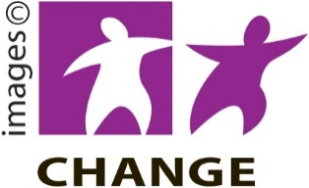
Make It Easy uses images from:
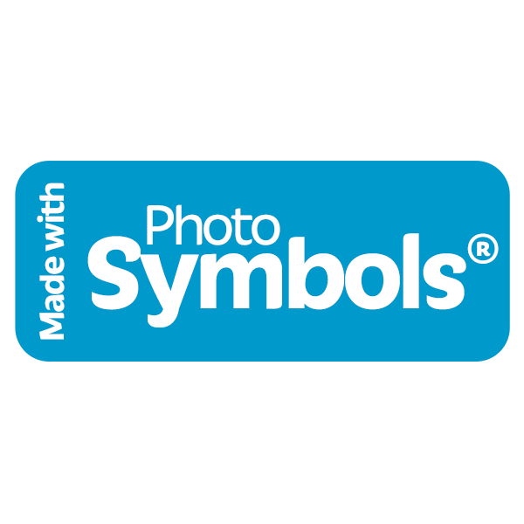
- Changepeople.org

- Photosymbols.com

- Sam Corliss.


All images in this Easy Read document are subject to copyright rules and cannot be used without permission.

