Local Group Assistant
Ōamaru
Part-time role – 8 hours a month

Are you interested in self-advocacy for people with a learning (intellectual) disability?
People First Ōamaru is looking for an assistant to work alongside people with learning disability to:
- hold monthly meetings
- perform the functions of a committee
- encourage learning about self-advocacy
- assist members to represent their peers in community forums
- promote the local group within the community.

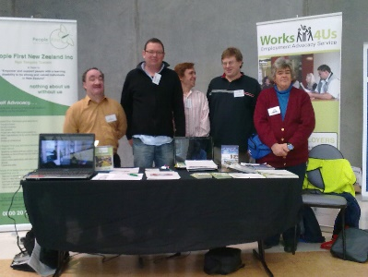
With your assistance, members will be able to:
- gain self-determination
- advocate for themselves
- develop leadership skills
- get involved in their community
- be a contributing member of New Zealand society.

For more information and to apply
Contact Lee-ann Wightman, Southern Region Coordinator: southern@peoplefirst.org.nz
The job description is online at:
www.peoplefirst.org.nz under Join us
Applications close: Monday 15 May 2023

