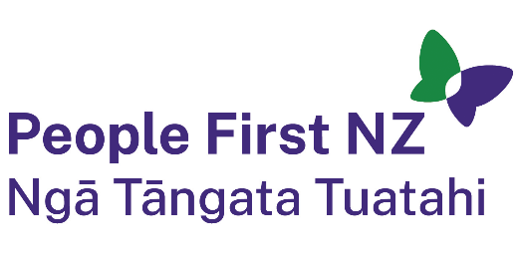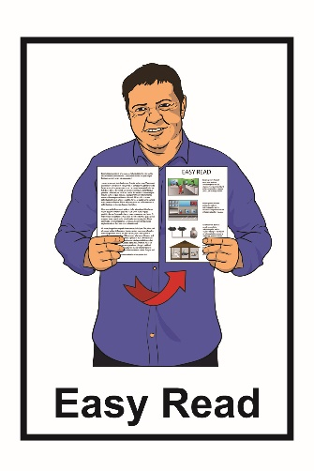

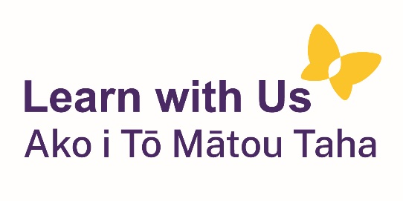

Information about scams and where to get help

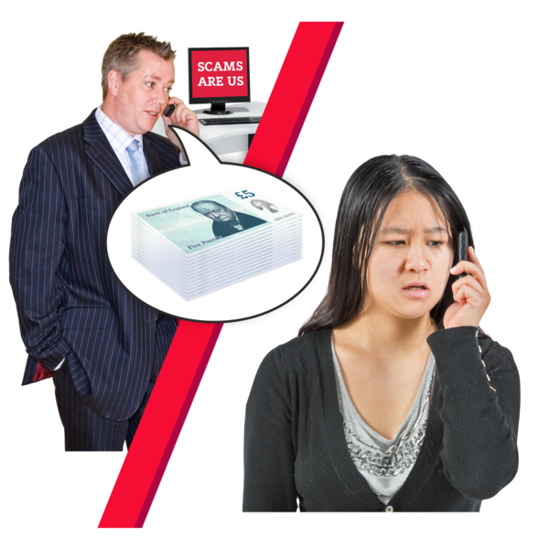

Published: October 2023

# What is a scam?

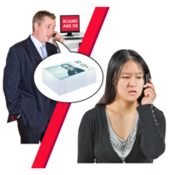A scam is a plan to trick people to get their:

money

information

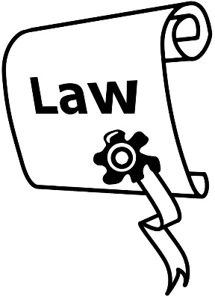other belongings.

Scams are against the law.

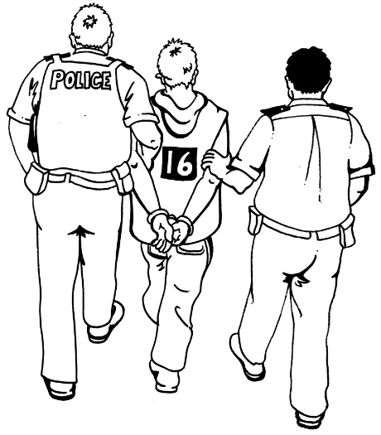People who run scams can be:

arrested

sent to prison

punished in other ways like having to pay money.

# Signs something might be a scam



These are some signs that something might be a scam.

It may be a scam if:

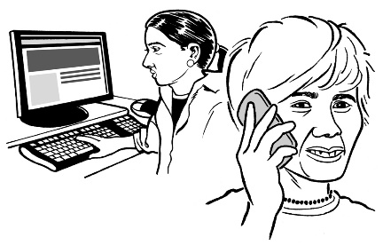you think you might not be dealing with a real company

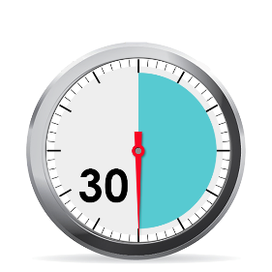someone you do not know gets in touch when you did not expect it

you have been told you have to send money quickly

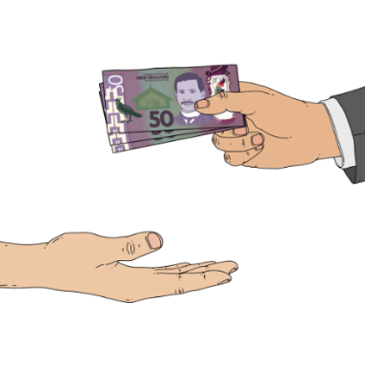it **seems too good to be true**.

Something that **seems too good to be true** might be something costing a lot less than you would expect.

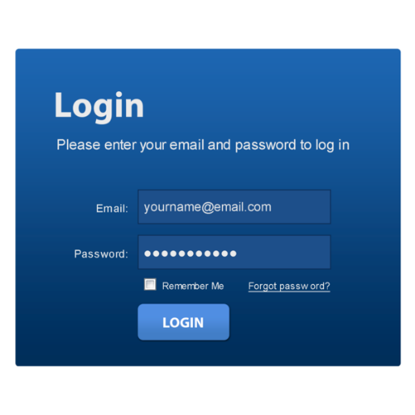It might be a scam if you have been asked to give away information like:

**passwords**

**PINs**.

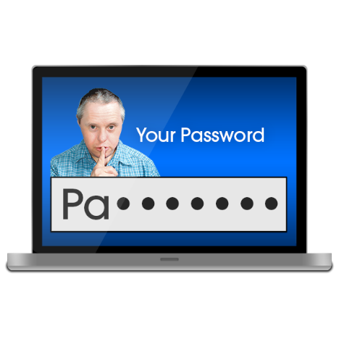

**Passwords** are like code words that you use to show it is usually you.

Passwords are usually a mix of:

letters

numbers

symbols like # % &.

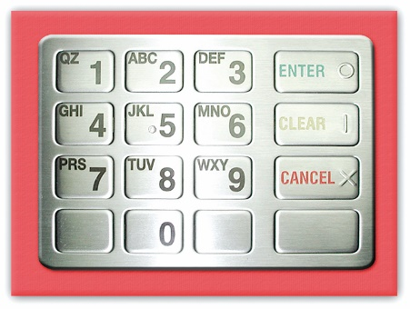

**PINs** are a kind of password that are used in places like ATMs / money machines.

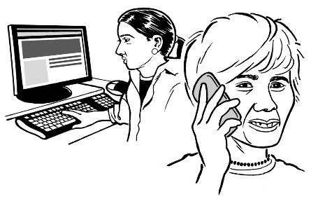

Real companies would never ask for your password.

# What to do if you think something

# might be a scam

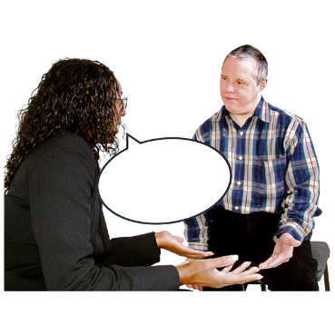

If you are not sure something is a scam you can ask someone you trust what they think.

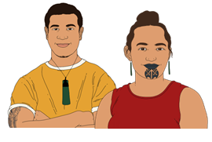

This might be a:

family member

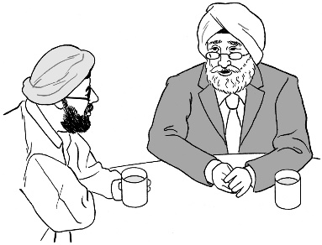friend

support person.

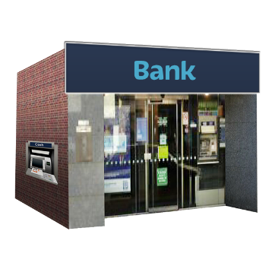

You should tell your bank / **financial institution** if the scam is about your:

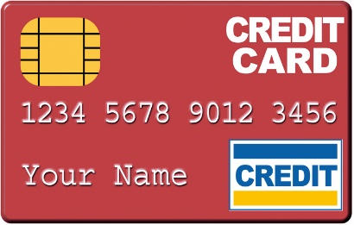bank account

credit card.

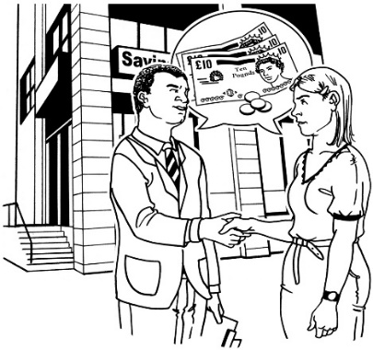A **financial institution** is place like a bank where you can:

store money in an account

borrow money from.

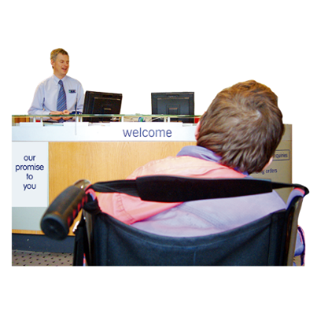

Your bank / financial institution can tell you what to do next.

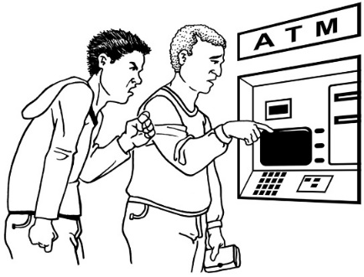

Do not feel pushed into giving away:

money

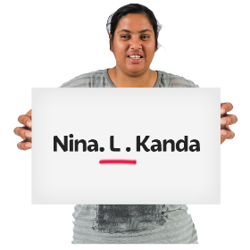personal information like your:

* middle name
* 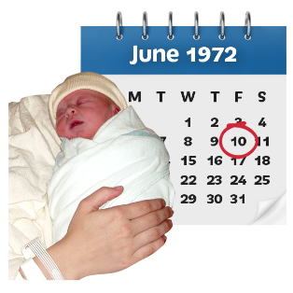date of birth.

# Where to get help?

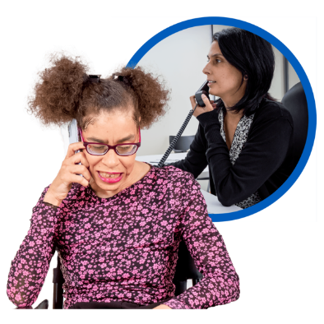

These are some of the places you can get support from.

## Netsafe

Netsafe is an organisation that can give you information about keeping safe on the internet.



Getting support from Netsafe:

does not cost any money

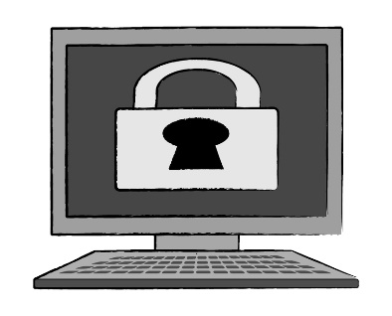is confidential which means they will not tell anyone your information.

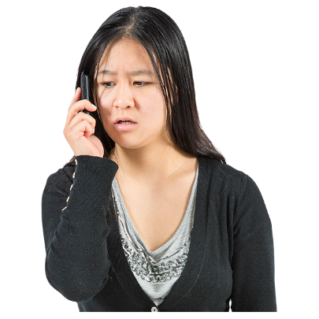 You can contact Netsafe by:

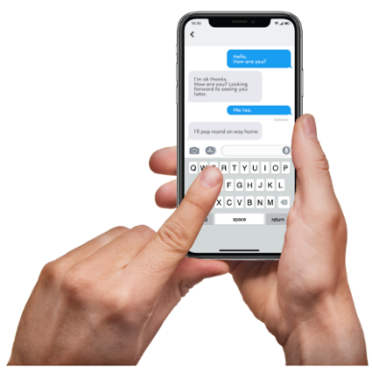phone on:  
  
**0508 638 723**

texting the word Netsafe to:  
  
**4282**

email to:  
  
**help@netsafe.org.nz.**

You can report something you think might be a scam online at:  
  
**report.netsafe.org.nz**

 Netsafe has a new tool called CheckNetsafe AntiScam.

You can use CheckNetsafe AntiScam to find out if a website address is a scam.



You can find CheckNetsafe AntiScam at:

**checknetsafe.nz**

1. 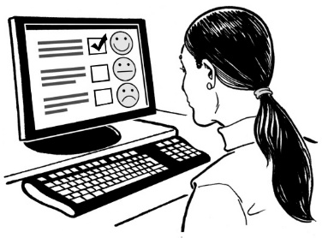**CERT NZ.**

CERT NZ has information about how to keep your information safe online.

You can also report problems to CERT like emails asking you for money.



There is an online form to report problems at:

**www.cert.govt.nz/individuals/report-an-issue/**



If you need support to fill in the form you can phone CERT on:

**0800 2378 69**



It does not cost any money to call this number.

You can also find CERT NZ on Facebook at:

**www.facebook.com/certnzgovt**

## Age Concern

Age Concern works to keep older people safe from scams.

You can also contact Age Concern by:

phone on   
  
**0800 65 2 105**

email at:

[**national.office@ageconcern.org.nz**](mailto:national.office@ageconcern.org.nz)

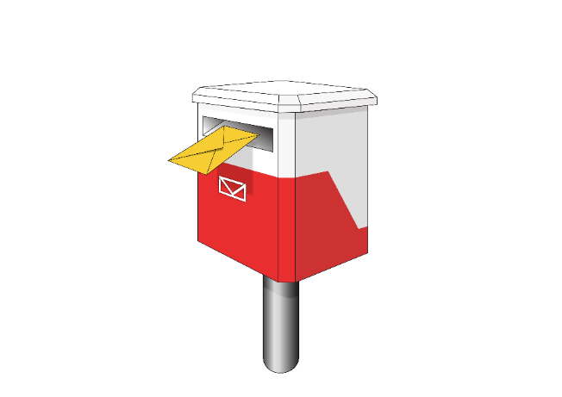

You can write to them at:

**PO Box 10-688**

**Wellington 6143**

1. 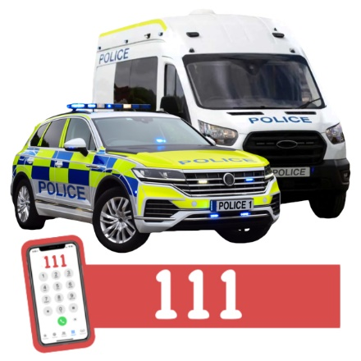**Nga Pirihimana O Aotearoa - New Zealand Police**

Call the police on **111** if:

someone is in danger right now

a crime is happening now.

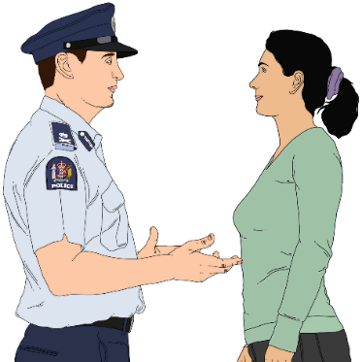

If you do not need the police right now you can call them on:

**105**

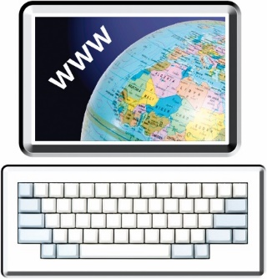

You can also find information at:

**www.police.govt.nz**

## Consumer Protection – Scamwatch

Scamwatch also gives information about scams.



You can call Scamwatch on:

**0508 426 678**

You can also find more information their website at:

**www.consumerprotection.govt.nz/general-help/scamwatch/**

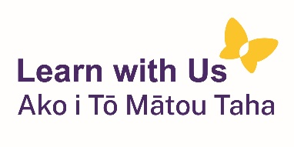This information has been written by Learn with Us Ako i Tō Mātou Taha

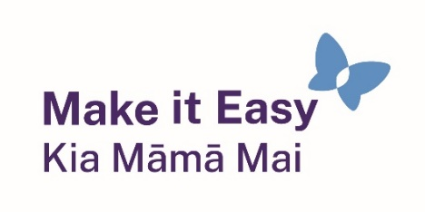

It has been translated into Easy Read by the Make it Easy Kia Māmā Mai service of People First New Zealand Ngā Tāngata Tuatahi.

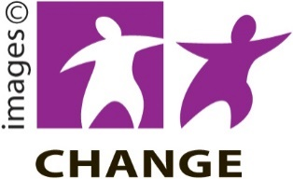

Make it Easy uses images from:

* Changepeople.org

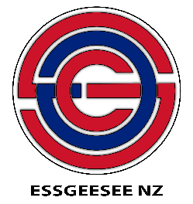Photosymbols.com

* SGC Image Works
* Huriana Kopeke-Te Aho



* T. Wood.

  
All images used in this Easy Read document are subject to copyright rules and cannot be used without permission.