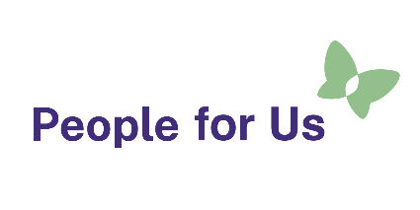

Job Title: Kaiārahi / Peer Worker
Organisation: People for Us – People First NZ
Locations:
- Wellington – 12 Hours per week
Work type: Part time
We are looking to hire disabled people as Kaiārahi / peer workers for a peer visiting service

About the service
People for Us is a new peer visiting service for disabled people and tāngata whāikaha Māori living in residential homes throughout Aotearoa New Zealand funded by Disability Support Services – Ministry of Social Development. This service is being delivered and run by People First NZ.

About the role
We are looking to employ Kaiārahi (Peer Workers) in several locations throughout the country to join our team.
In this role, you will be working with Kaiāwhina (Assistants) to visit people in residential homes. Together, you will have conversations with people about their safety, quality of support, and what a good life means for them.
If you have a disability and a passion to make sure disabled people and tāngata whaikaha Māori are leading their good life, are receiving quality services and are safe, we would like to hear from you.

Benefits
- Making a significant contribution to the safeguarding of disabled people who live in residential homes.
- Extensive training and professional development opportunities.
- Competitive remuneration and flexible working hours.
- Regular internal supervision and access to an Employee Assistance Programme (EAP).

Skills and experience
- A deep understanding of the experiences of disabled people.
- Ability to relate well to other people, good communication skills.

How to apply:
Along with your CV, we strongly recommend adding a cover letter to tell us how your experience as a disabled person equips you for this role.
We encourage you to apply for this role through the Seek advertisement channel. If you need any assistance, please contact us at info@peopleforus.org.nz.
End of: advertisement for Kaiārahi / Peer Worker, People for Us – People First NZ
This Large Print document is adapted by Blind Citizens NZ from the standard document provided by People for Us – People First NZ

