
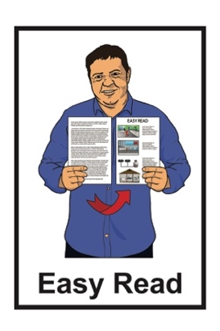

How to use Zoom

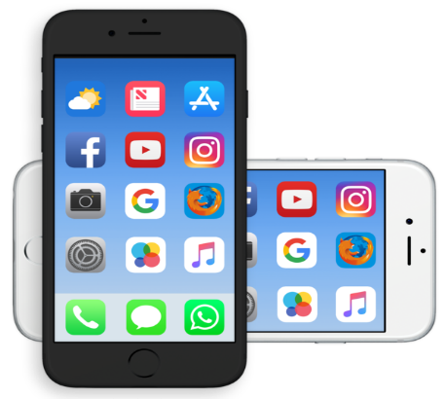

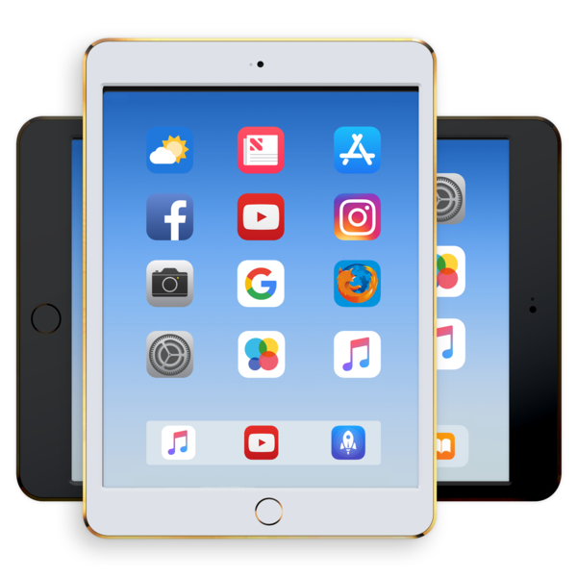
on your phone or tablet

Published: October 2025

Before you start

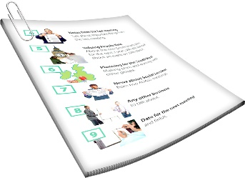
This is a long document.


It can be hard for some people to read a document this long.

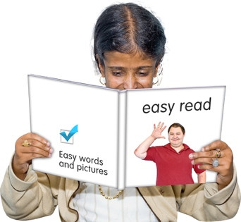
Some things you can do to make it easier are:
read it a few pages at a time
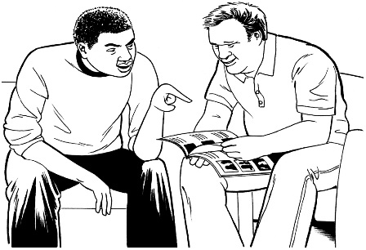
set aside some quiet time to look at it
have someone read it with you to support you to understand it.

What is in this document

Page number:
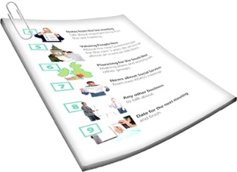

About this Easy Read 3

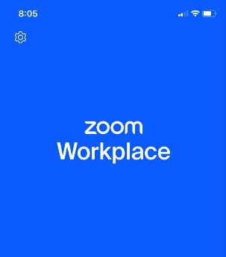
What is Zoom? 5

Connecting to the internet 8

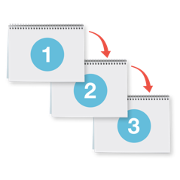
How to download Zoom 11

How to join a Zoom meeting 15


Using the Zoom controls 22

Tips for using Zoom 34

About this Easy Read

This Easy Read guide is about how to use Zoom.

It tells you:
what Zoom is
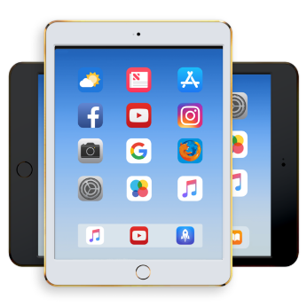
how to use Zoom on your:
- phone
- tablet.

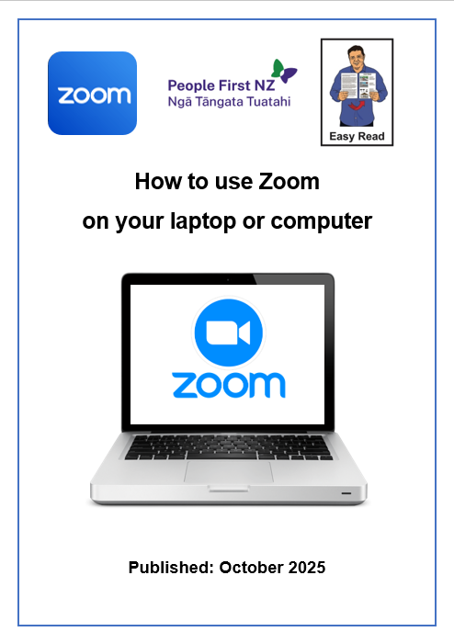
There is another Easy Read called How to use Zoom on your computer or laptop.

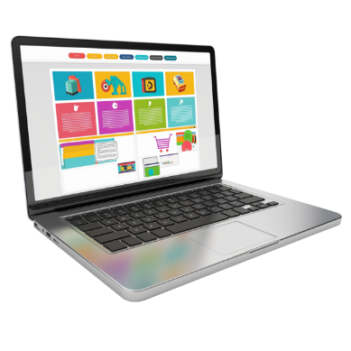
You can read How to use Zoom on your computer or laptop at this website:

https://tinyurl.com/ZoomPhoneTablet

This Easy Read has been made by People First NZ.

What is Zoom?

Zoom is an app that you can make video calls on.

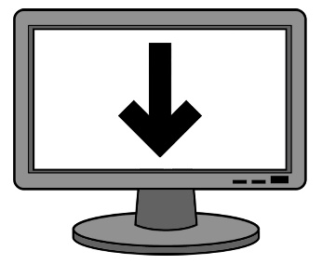
An app is a program that you can download to your device.

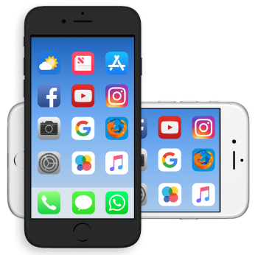
Here a device is a:
smartphone
tablet or iPad.

The full name of the Zoom app is Zoom Workplace.

It is usually called Zoom for short.


On Zoom you can meet up with:

1 person
lots of people



When you meet up using the Zoom app it is called a Zoom meeting.

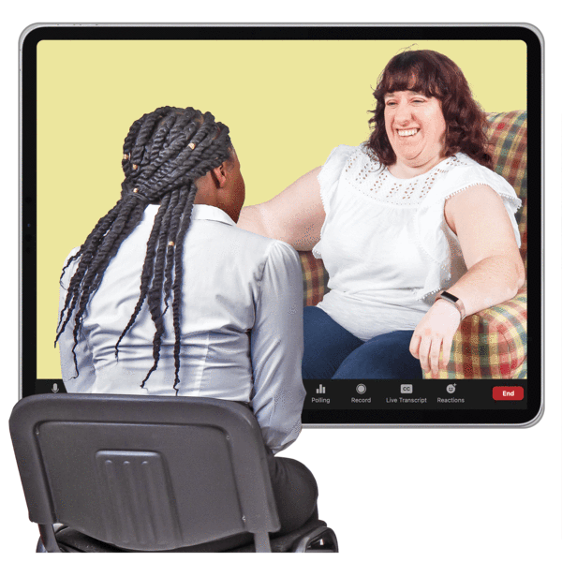
When you meet with other people on Zoom you can:
see them
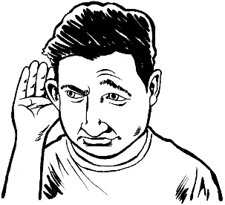
hear them
send them messages on
Zoom chat.

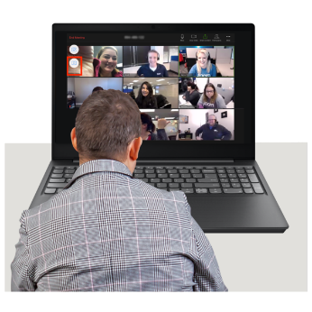
You can use Zoom for things like:
meetings
talking with your friends
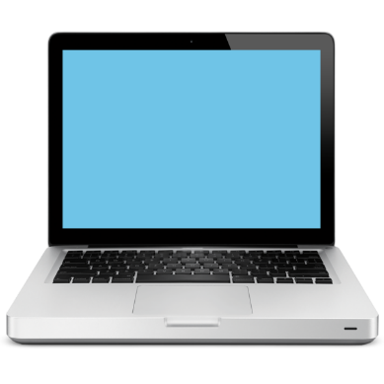
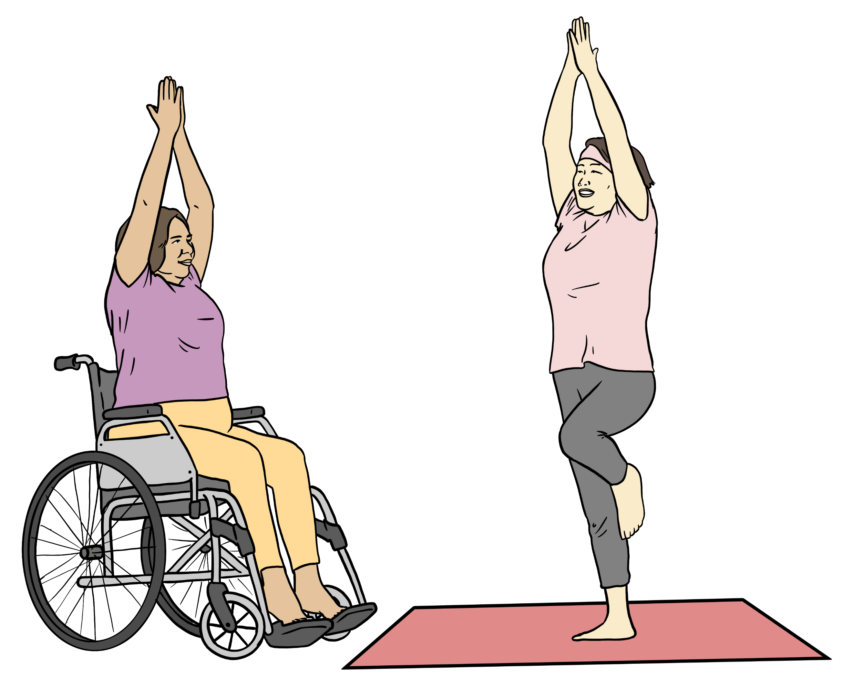
joining support groups
taking a class online to learn to do something.

Connecting to the internet


To use Zoom your device will need to be connected to the internet.

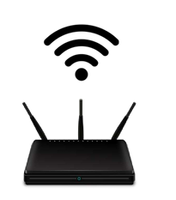
The internet is where you can:
find information online
share information online.

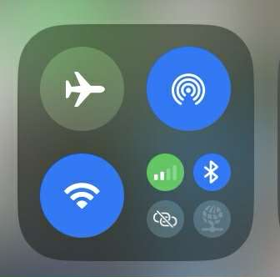
When you are at home you can connect your device to the internet by connecting to your home Wi-Fi.
When you are away from home you can connect your device to:
mobile data
or

to a public Wi-Fi network you:
- know
- trust.

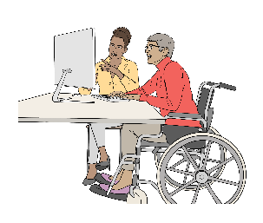
If you are using an internet router at home you may need to sit closer to it.

An internet router is a box that:
connects your devices to the internet
uses Wireless Internet / Wi-Fi.

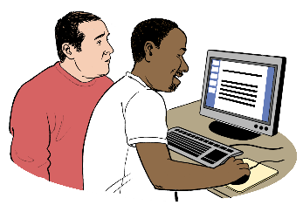
If you need support to connect to the internet you can ask:
a friend
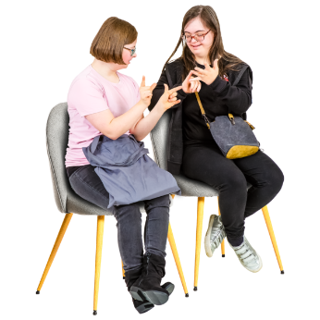
a whānau / family member
your support worker.

How to download Zoom
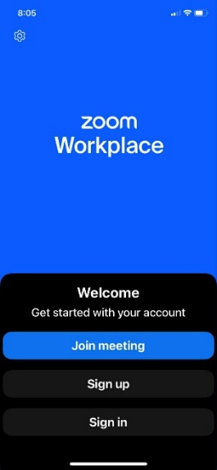
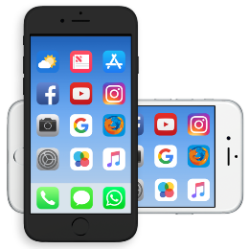

You need to download the Zoom Workplace app onto your device.

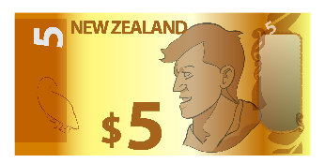

It does not cost you money to
do this.

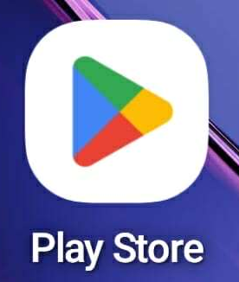
If you are using an Android device you can download the app from the Google Play Store.


If you are using an Apple device you can download the app from the App Store.

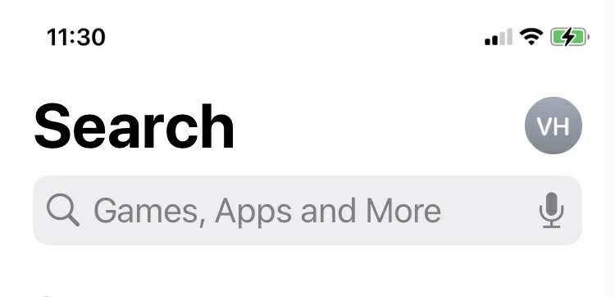
Go up to Search when you are in the:
Play Store
or
App Store.

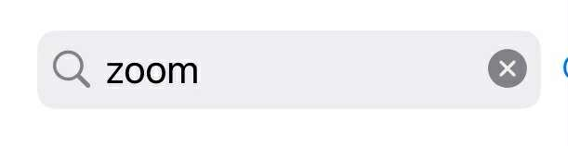

Type in Zoom in the search box.

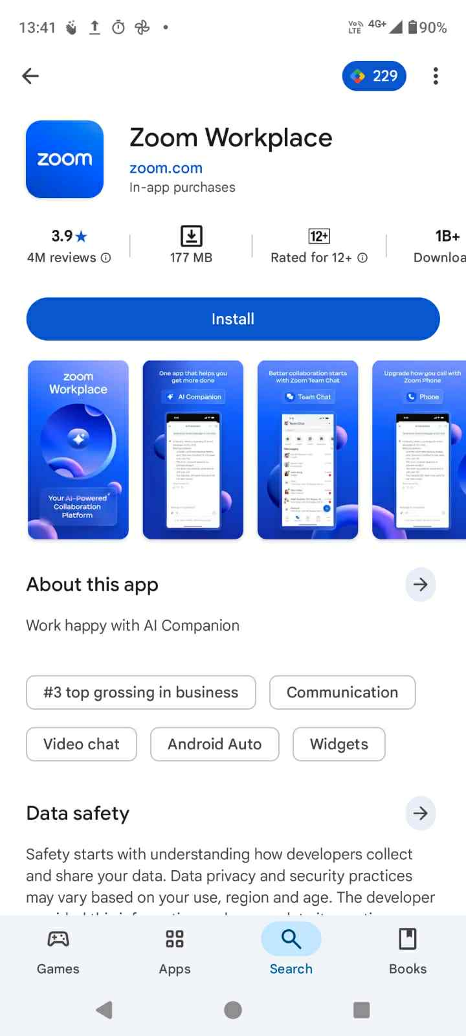

If using an Android device press Install Zoom Workplace store from the Google Play Store.
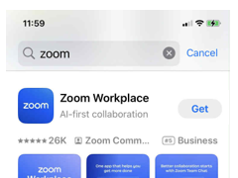

If using an Apple device press Get on the Zoom Workplace app from the App Store.


Wait for the Zoom app to download.

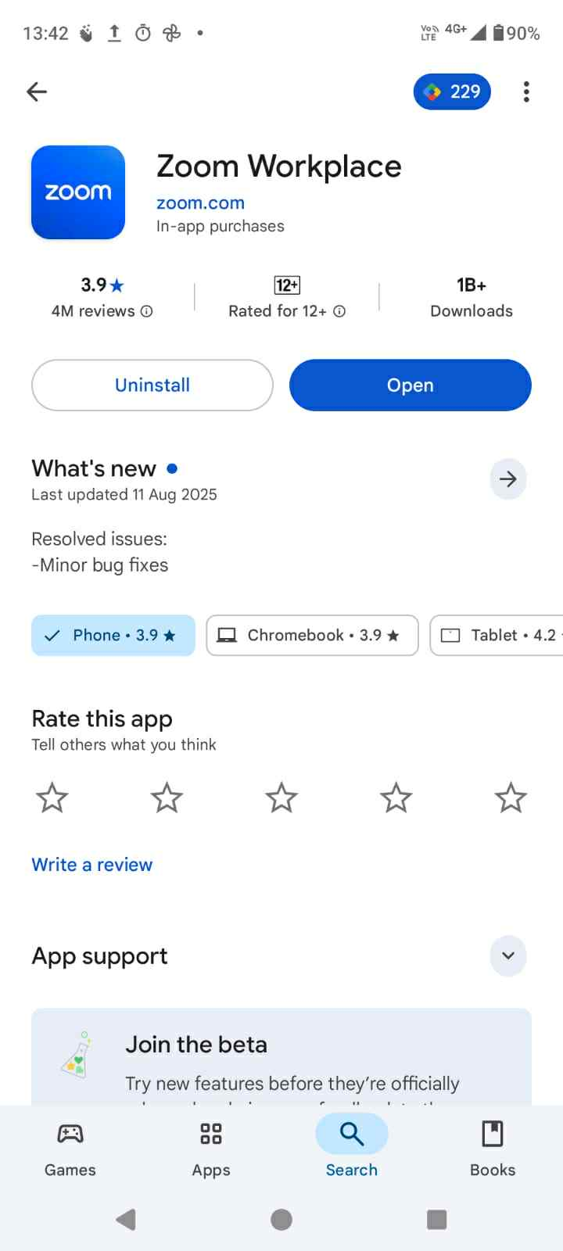

When the app has downloaded press Open.

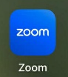
You will now have the Zoom app on your device.

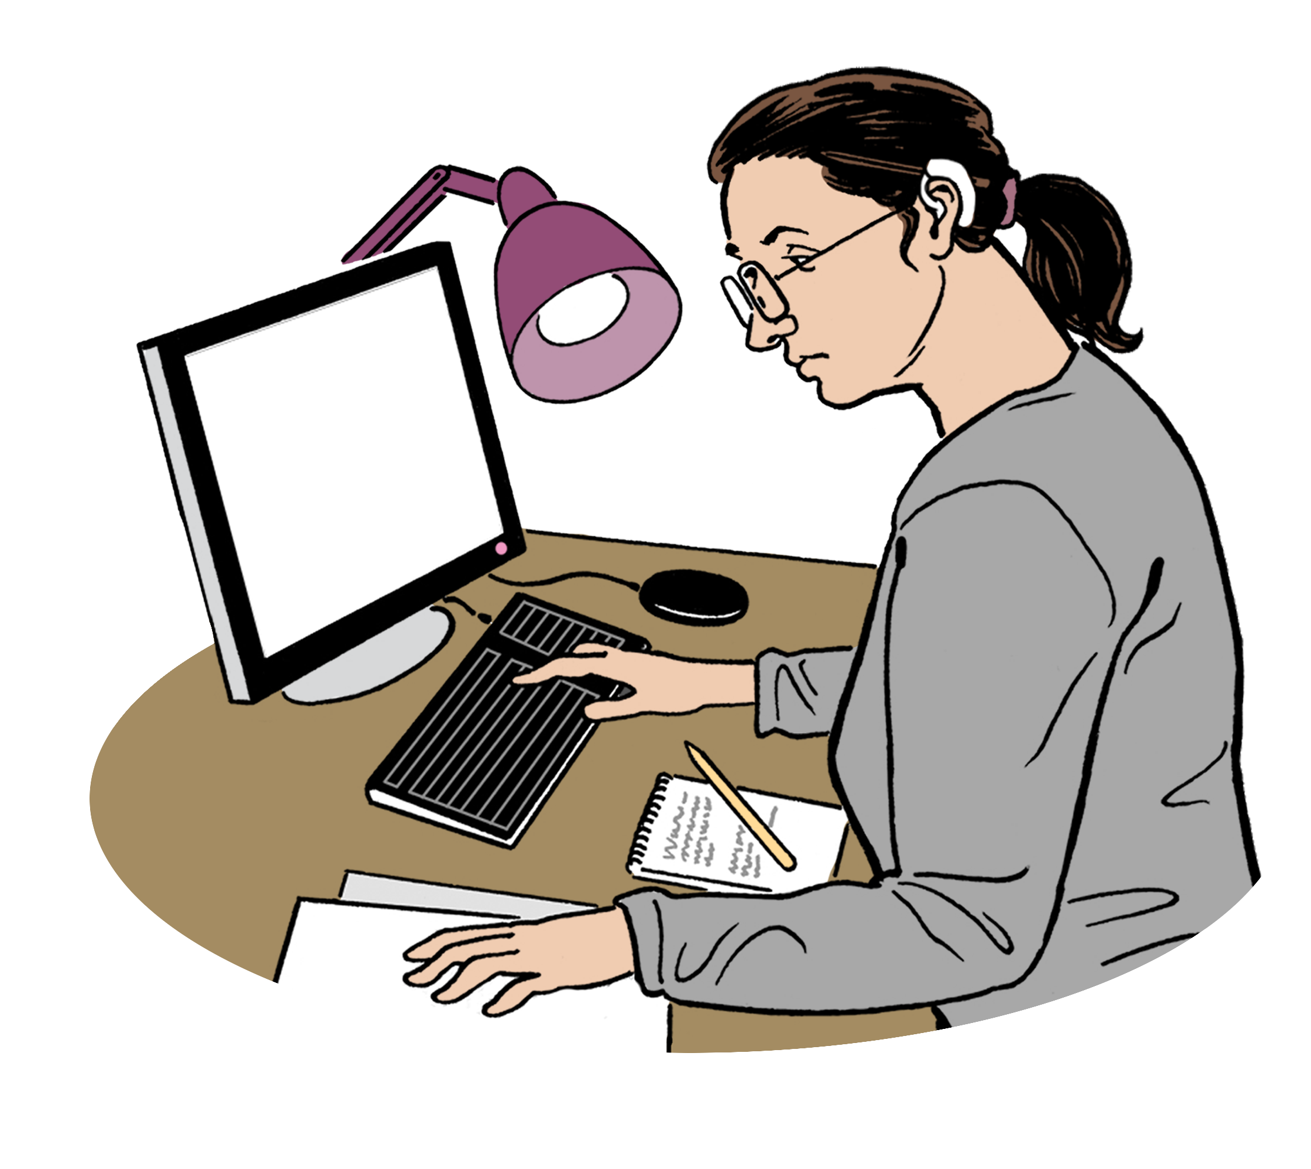
Find out more information about how to download Zoom at this website:
https://tinyurl.com/ZoomDLInfo
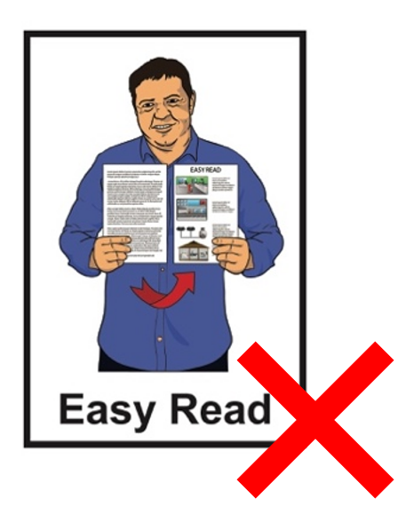

This website is not in Easy Read.

How to join a Zoom meeting

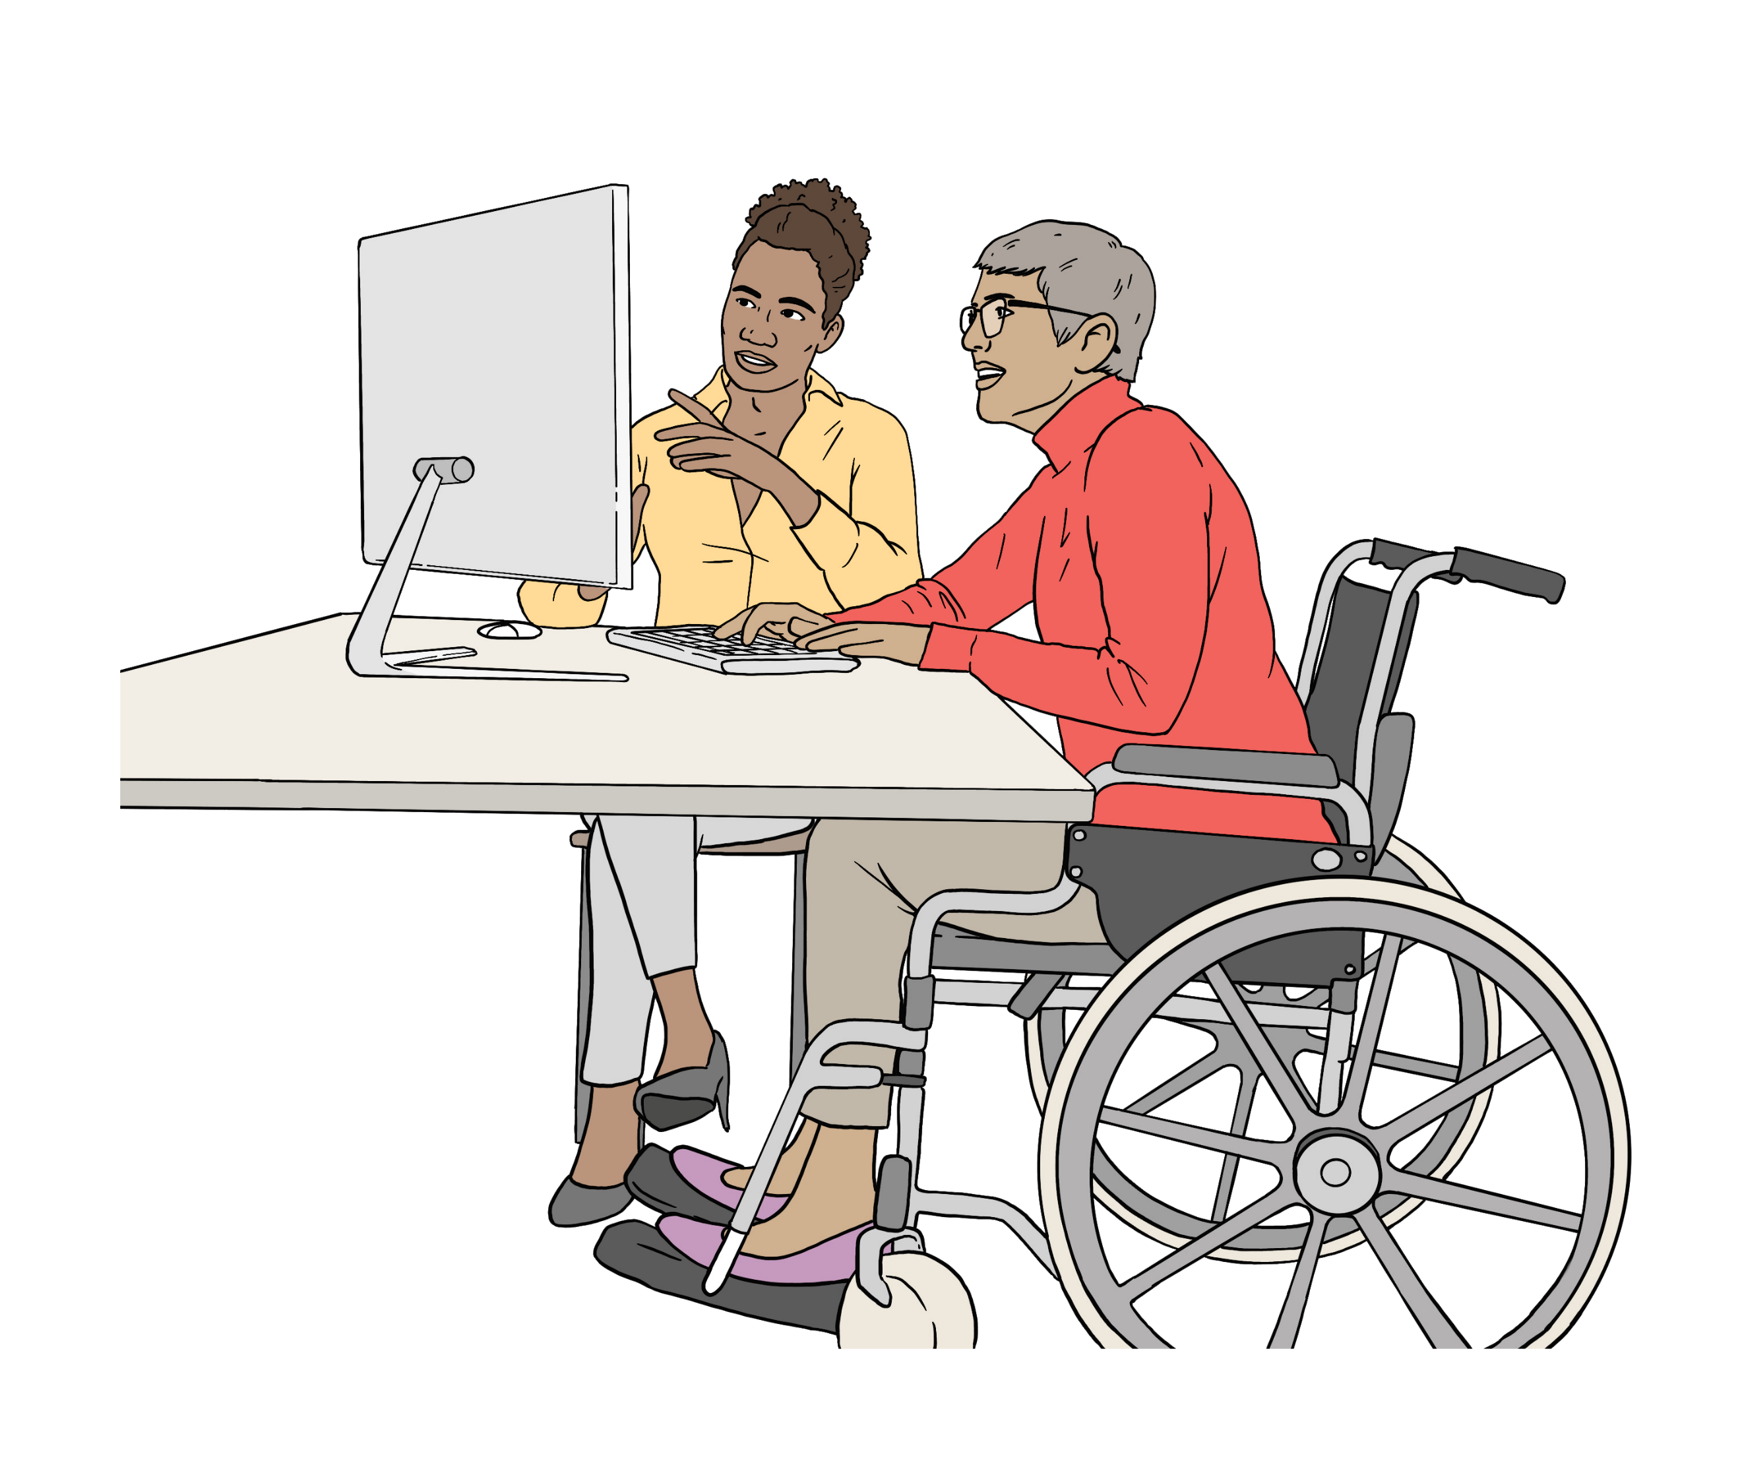
Someone will invite / ask you to join a Zoom meeting.

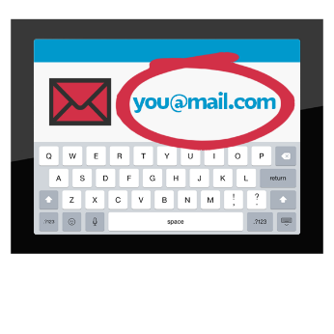
You will get a message with a link to a Zoom meeting in something like:
an email
a message


A link takes you to a website address like Zoom when you click on it.

We tell you some of the ways to join a Zoom meeting on the next pages.


Join using a meeting invite link

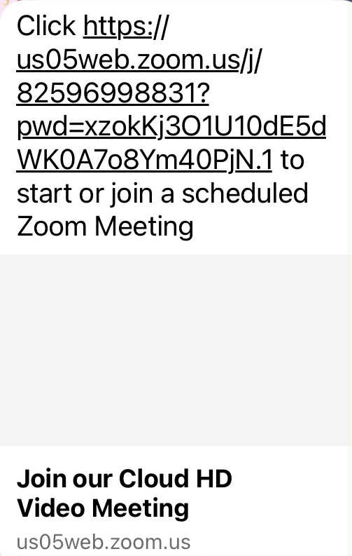
Join the Zoom meeting by pressing the link in the message / email.

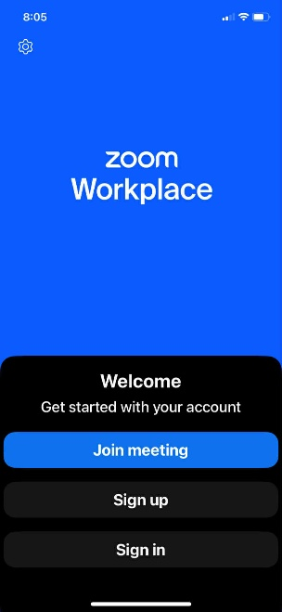
This will open Zoom on your device.

Press Join meeting.

Check the controls on your screen to make sure things like:

audio is on
video is on.


Audio means sound.

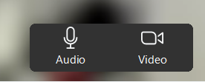
The microphone needs to be turned on for other people in the meeting to hear you.


Go to page 22 to find out more about Zoom controls.

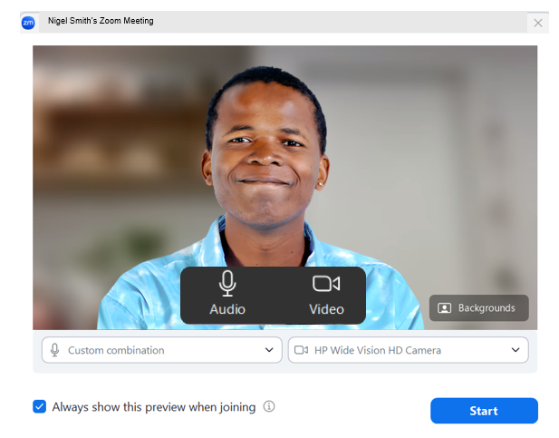
The meeting host will let you into the Zoom meeting.

The meeting host is the person who is running the meeting.

Join using the Zoom app

Open the Zoom app on your device.

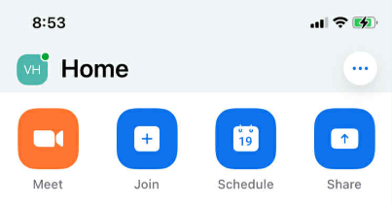

Press Join.

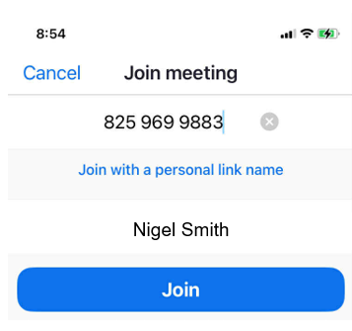

Put in the meeting ID if asked.

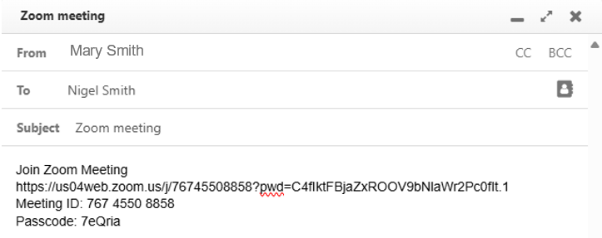

The meeting ID is a number code made up of 10 to 11 numbers you will find in the meeting invite.

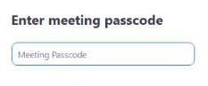

Put in the passcode if asked.

Here the passcode is made up of:
numbers
letters.


Using a passcode makes sure only people who are invited get into the meeting.

The passcode will be in the meeting invite.

Press the Join button to be in the meeting.

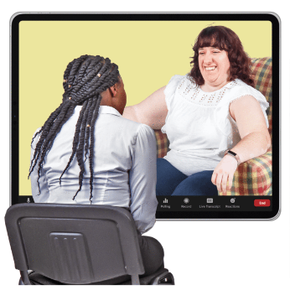
Find out more information about joining a Zoom meeting at this website:

https://tinyurl.com/JoinZmMtg
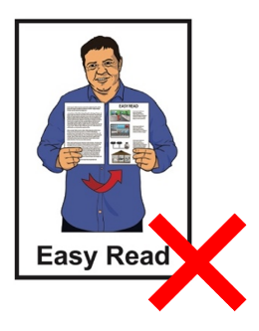

This website is not in Easy Read.

Using the Zoom controls

When you join a Zoom meeting you will see a lot of different control buttons on the screen.



You will see some on the control bar that is usually at the bottom of the screen.


The most important controls to know how to use are the:
microphone
video
switch views.

Other important controls to know how to use are the:
Zoom chat
reactions.


Here reactions are pictures that show how you feel about something that has happened in the meeting.

Using the microphone

The microphone is controlled by the Audio button on Zoom.

Press the Audio button to mute the microphone.

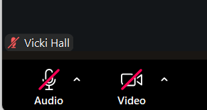
Mute is when your microphone is turned off.

When mute is turned off no one at the meeting can hear you.

There is a red line on the Audio button when the microphone is on mute.

Unmute your microphone when you want people at the meeting to hear you talk.
Unmute is when the microphone is on.

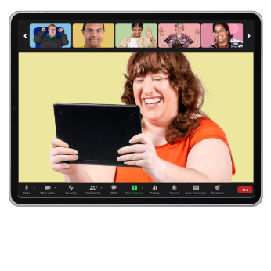
Using the video

The camera on your device is controlled by the Video button on Zoom.

Press the Video button to turn the camera on.

When your camera is off the Video button has a red line through it.



When you want people in the meeting to see you press the Video button.

When your camera is on there is no red line on the Video button.


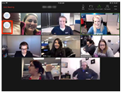
Using switch views

You can switch views in a Zoom meeting to see people in different ways on your screen.
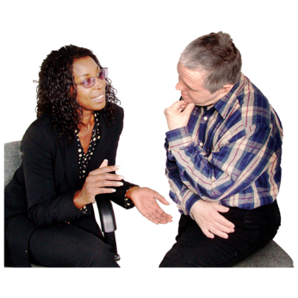

We tell you about 2 views.

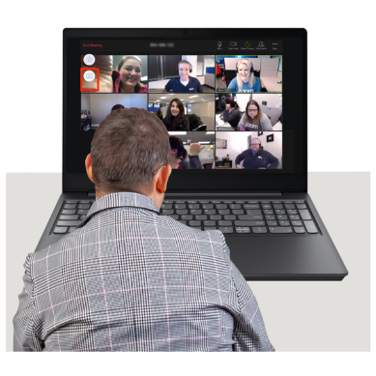
You can switch your view to:
the Speaker view
a Gallery view.


Speaker view is when the person shown on the screen:
is the person speaking
and
is shown in a bigger box.
Gallery view is when you can see the people at the meeting in small video squares.

You can switch views as many times as you like in a Zoom meeting.
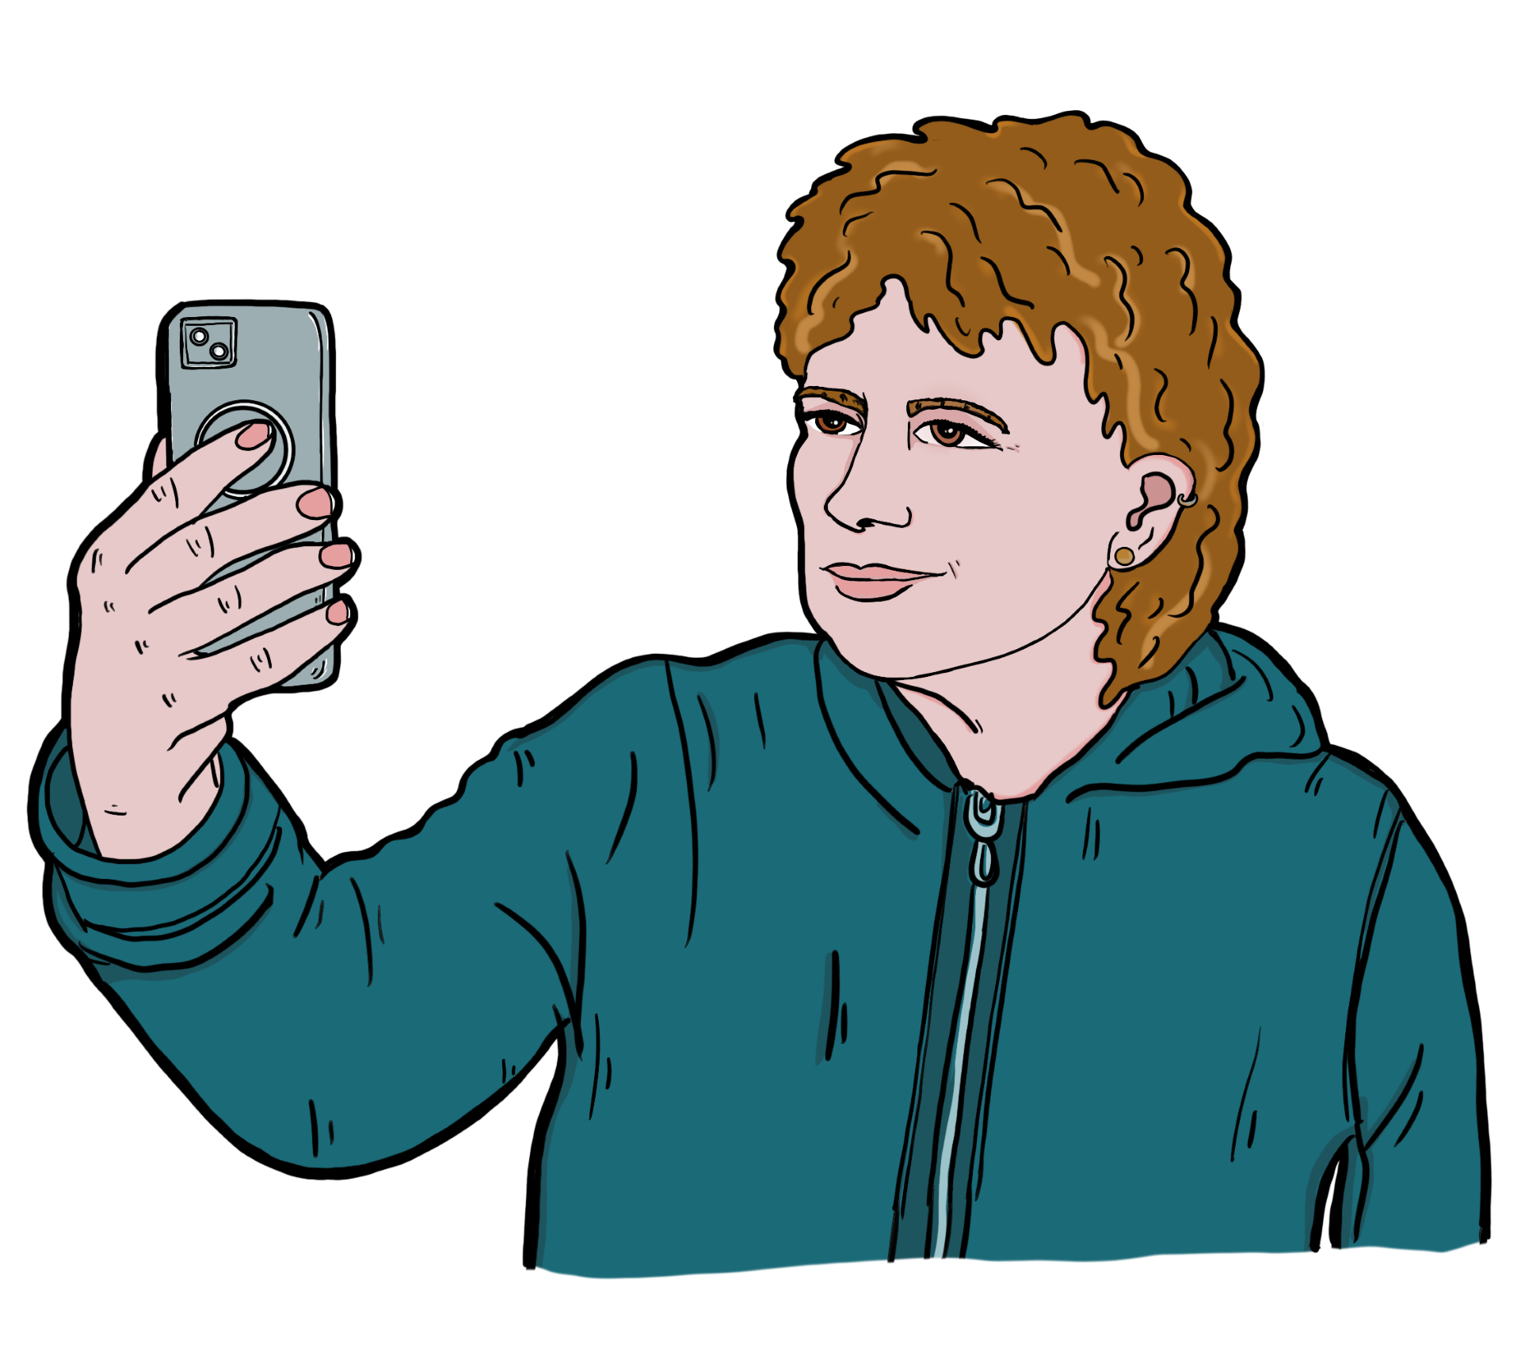

When you start Zoom on your device it will usually show Speaker view.


The Speaker view works well if you only want to see 1 person like a teacher on screen.

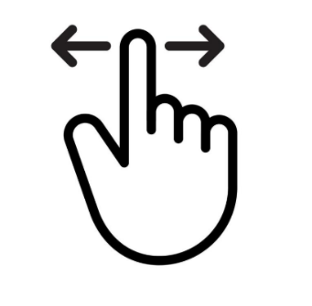
To switch to Gallery View swipe left on your device.

To go back to Speaker view swipe right.


If you have a hard time with the controls ask for support from:
a friend

a whānau / family member
your support worker.

The meeting host can control some things on your Zoom during the meeting like turning your:
video on
video off
audio on
audio off.

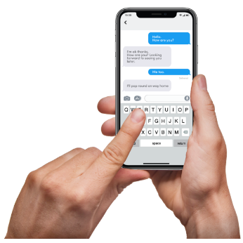
Using chat on Zoom

You can message other people during a Zoom meeting.

This control is called Chat.

You can send messages to:
1 person at the meeting
some people at the meeting
to everyone at the meeting.

People can send messages to you too.

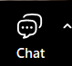

Press the Chat button to message others in the meeting.

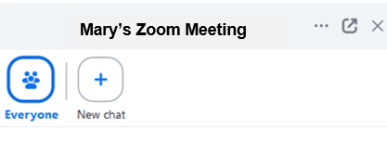


The chat window will pop up.

Choose the person / people you want to send a message to.

Check your message is being sent to the right person /people.

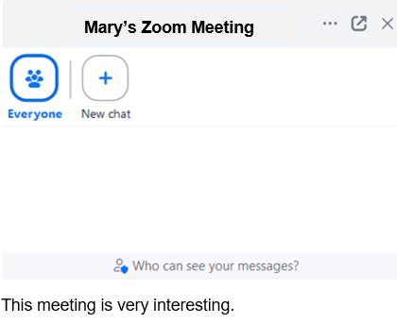

Type in your message.

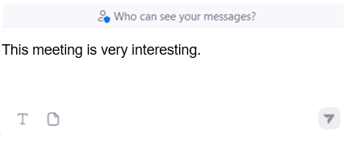

Press the Arrow button to send your message.

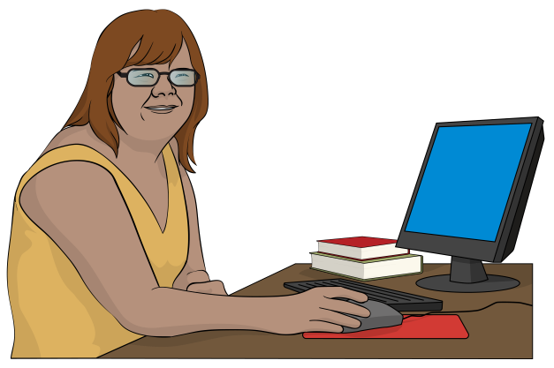
You can use Chat to message your meeting assistant for support during a Zoom meeting.


Reactions

Reactions look like emojis.

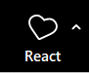


To choose a reaction press the React button.

Choose 1 of the reactions.

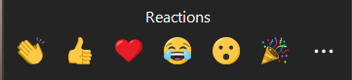

Press the 3 dots if you want to see more reactions.

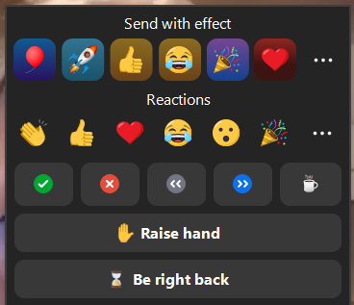

If you would like to ask a question use the Raise hand reaction.

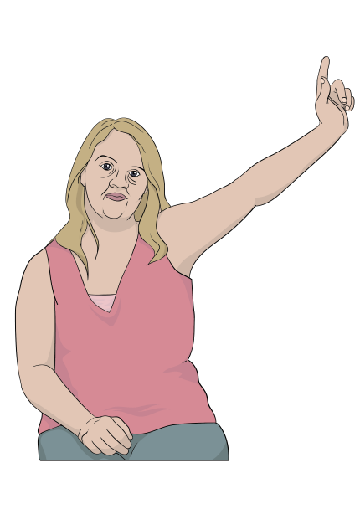
This is like raising your hand when you are at meeting in person.

Doing this lets the meeting host know you want to ask / say something.

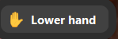
When you have spoken press the
Lower hand button at the bottom of the screen to turn it off.


You can leave the Zoom meeting by pressing the Leave Meeting button on your screen.

Tips for using Zoom
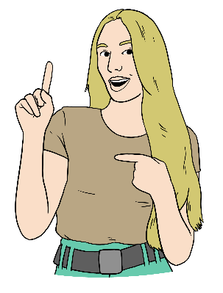

Here are some tips / ideas to support you to have a good Zoom meeting.


- It is important to keep safe on the internet.
Make sure you only join a Zoom meeting if it is:
with someone you know
a class or group you have signed up to.
- Mute your microphone when you are not talking.

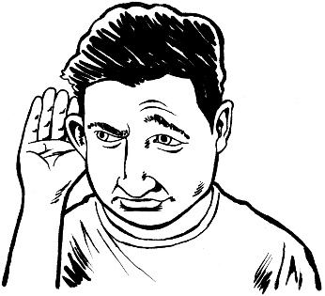
It can be hard to hear what is being said when there is a lot of noise.

- Turn off your video if you need to leave the meeting for a quick break.
Turn your video back on when you get back to the meeting.


This information has been written by
Make it Easy Kia Māmā Mai.

Make it Easy Kia Māmā Mai is part of
People First New Zealand Ngā Tāngata Tuatahi.


All images used in this Easy Read document are subject to copyright rules and cannot be used without permission.


Make it Easy uses images from:


- Photosymbols

- Change Images


- Huriana Kopeke-Te Aho

- SGC Image Works

- T Wood


- Studio Rebeko

- Inga Kramer.

