
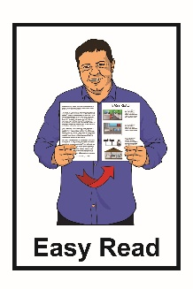

Job advert: National Administrator


This is an Easy Read job advert for a National Administrator at People First New Zealand Ngā Tāngata
Tuatahi / People First NZ.


People First NZ is:
a Disabled People’s Organisation

for people with learning disability
run by people with learning disability.


People First NZ makes sure people with learning disability:
know their rights
are included in their community.


Rights are things that the
law says every person should:
have
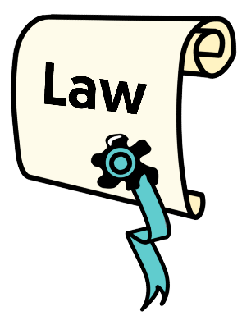
be able to do.

Rights are things like:

having a safe place to live
getting health care when you need it.


We are looking for a new National Administrator.

A National Administrator supports People First NZ by:
doing jobs in the office

giving people:
- assistance
- information.

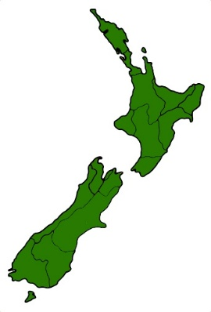
The job will be in the People First NZ office which is in central Wellington.

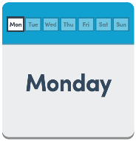
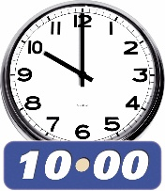

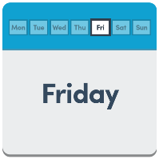
This job is part-time which means it will be:
20 hours each week
Monday to Friday
from 10 am to 2.30 pm.


The National Administrator deals with people:

in People First NZ
from outside People First NZ.

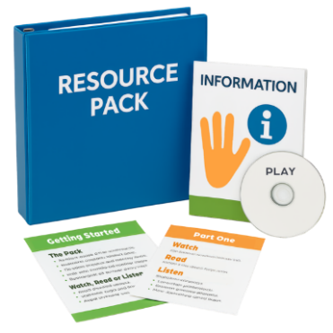
The National Administrator gives these people:
information
resources.


The National Administrator will organise:
travel
accommodation / places to stay.

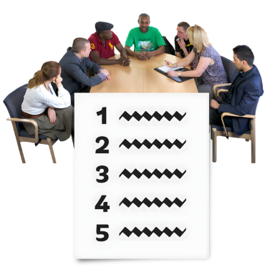
The National Administrator will get ready for team meetings by:
taking notes
doing tasks during meetings.

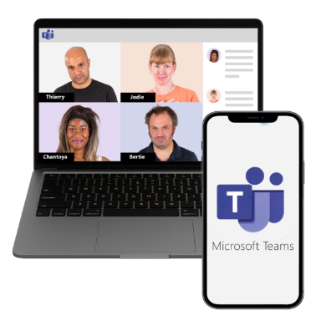
The National Administrator will do their work by using computer software like:
Microsoft Teams
Office 365.


We need someone who knows how to talk to many different people.


We need someone who:
can do many things at once

can solve problems
likes new challenges.

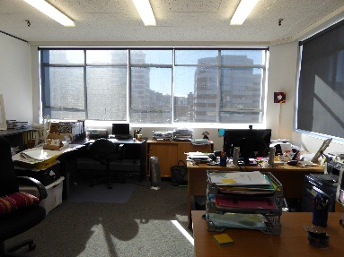
You will work:
in a small office that is busy
with a team that will support you.


You can read the full job description on the People First NZ website:

www.peoplefirst.org.nz/join-us


You can ask for the full job description in:
Easy Read

New Zealand Sign
Language / NZSL
large print
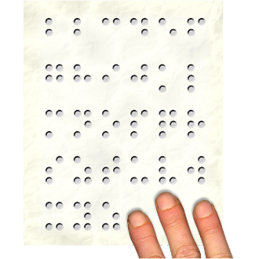
audio
Braille.


We want to make applying for jobs with People First NZ as easy for everyone as we can.


We want to hear from both:
disabled people
non-disabled people.

You can also contact People First NZ by email if you:
are interested in the job
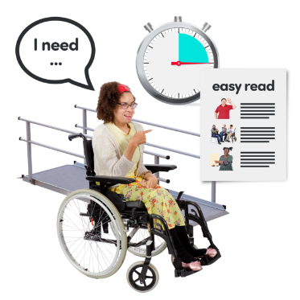
want to know more about the job
need a different way to apply instead of by email.

To apply please email us:
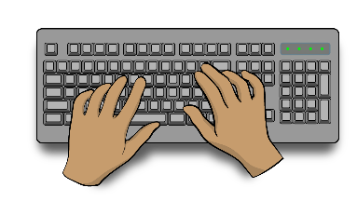
a letter telling us about you / why you would be good at the job

a CV / list of things you have done already like:
- jobs
- study / qualifications.


Our email address is:
ask@peoplefirst.org.nz

This information has been written by People First New Zealand Ngā Tāngata Tuatahi.

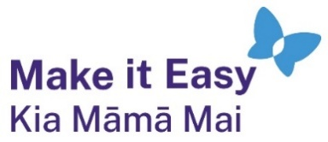
It has been translated into Easy Read by the Make it Easy Kia Māmā Mai service of People First New Zealand Ngā Tāngata Tuatahi.

All images used in this Easy Read document are subject to copyright rules and cannot be used without permission.


Make it Easy uses images from:


- Photosymbols

- Change Images


- Huriana Kopeke-Te Aho

- SGC Image Works

- T Wood


- Studio Rebeko

- Inga Kramer.

