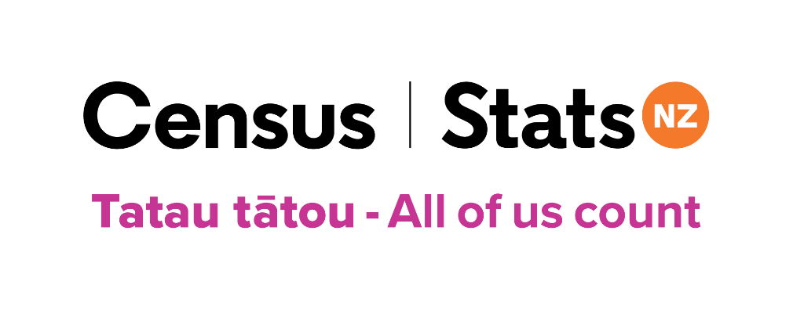
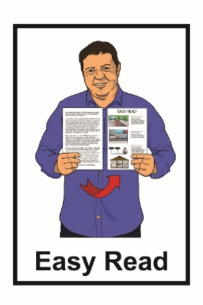

There is still time

to do the 2023 Census
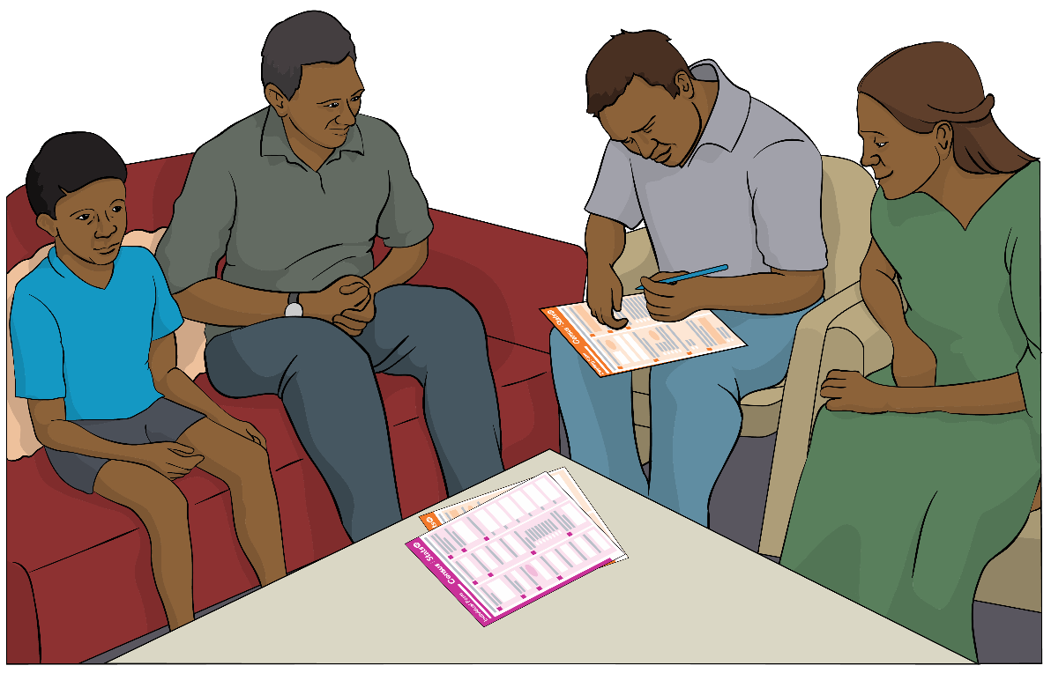

Tatau tātou – All of us count

What you will find in this booklet

Page number:

What this booklet is about……….… 3

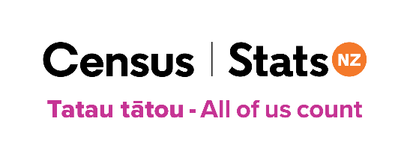
What is the census?.........................5

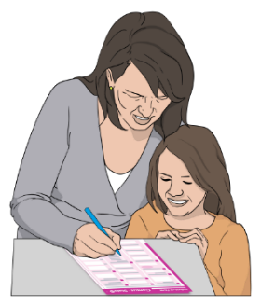
If you have you filled out your
census forms ..7

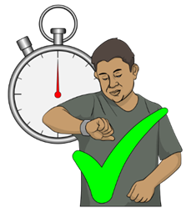
There is still time to do the census………………………………..9

Information about
Cyclone Gabrielle……………….….10
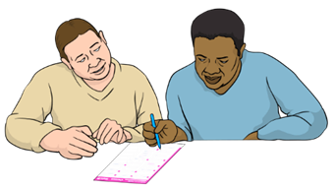

Getting support to fill out your
census forms 12
Page number:
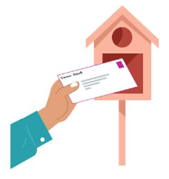

How you will get your
census forms 16

How to contact the census team 18

What this booklet is about

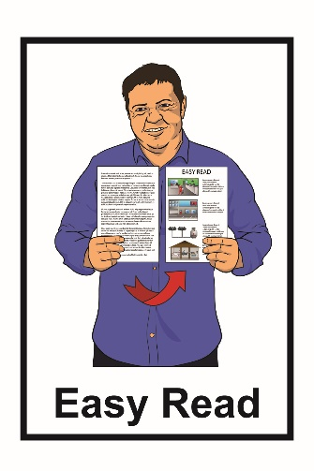
This Easy Read booklet tells you about:

          - what to do if you have not filled out the 2023 Census

          - changes to the 2023 Census because of Cyclone Gabrielle.

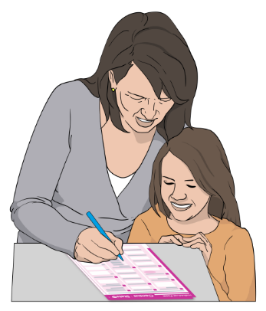
A census is when you are asked questions about things like:
- who you are
- how many people you live with.

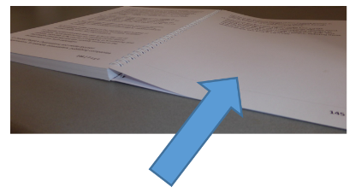
You can find more information about what the census is on pages 5 to 6 of this booklet.

The information has been written by Stats NZ.

Stats NZ is the government agency that runs the 2023 Census

What is the census?

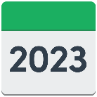
The census is:

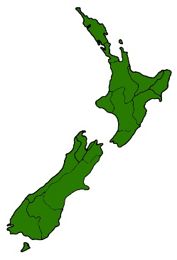
- done every 5 years

- how we find out things about people in New Zealand.

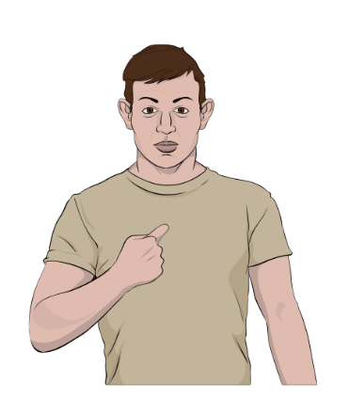
The census is done by using some forms that ask questions about:
- you
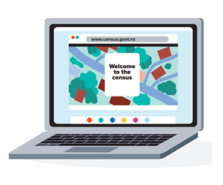
- where you live.

You can do the census by filling out:

- online forms

or

- paper forms.
Census information helps to plan things like:

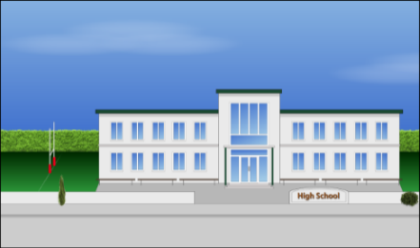
- healthcare
- schools
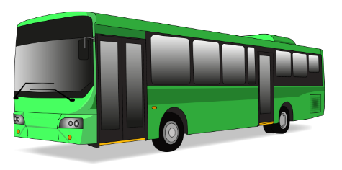
- housing
- public transport like buses
- building roads

- community buildings like libraries.

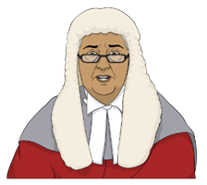
The law says everyone in
New Zealand needs to fill out the census.

If you have filled out your census forms
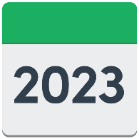
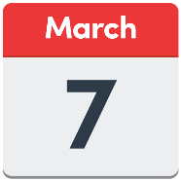

Census day was Tuesday 7 March 2023.
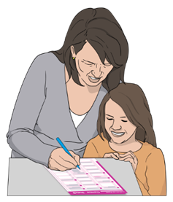
If you have filled out your census forms you do not need to do anything
else.

You may still get a reminder letter from Stats NZ.

Some reasons why you might get a reminder letter are that you:

- have not completed your census forms

- have posted back paper forms but Stats NZ have not yet counted them.
If you have already filled out your census forms:

- please ignore the reminder letter
- you do not need to do the census again.

There is still time to do the census

Census day was Tuesday 7 March 2023.

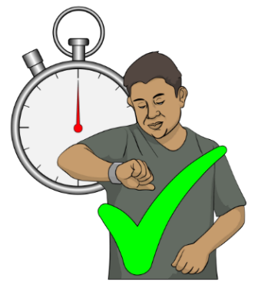

If you have not filled out your census forms there is still time to do the census.

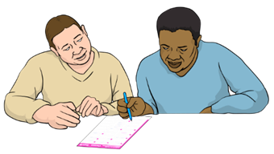

You can still fill out census forms after Tuesday 7 March 2023.

Answer the census questions about where you were staying on Tuesday 7 March 2023.

Information about Cyclone Gabrielle

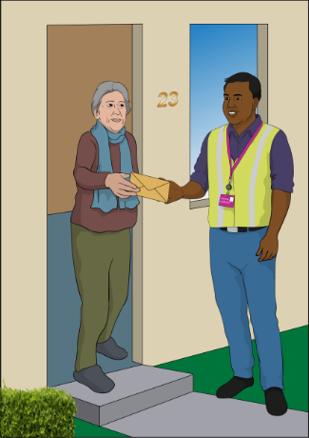
If you have been affected by Cyclone Gabrielle you will have:

- more time to do the census
- support to take part in the census.

Cyclone Gabrielle caused some very bad weather that happened in parts of the North Island in February 2023.

In parts of the North Island:
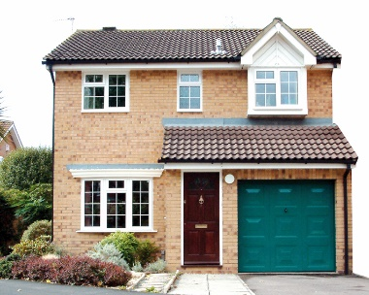
- many roads are still damaged

- some people have not been able to return to their home.

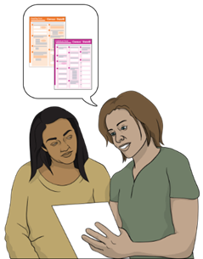
The census team can assist you to take part in the census when you are ready.

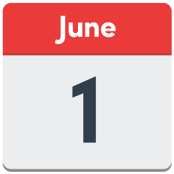
Census collectors will be visiting people in areas affected by Cyclone Gabrielle until 1 June 2023.

Iwi leaders and community groups will work with Stats NZ to offer support in each area.

There will also be places and events people can go to in the community to get support to do the census.

Getting support to fill out your census forms

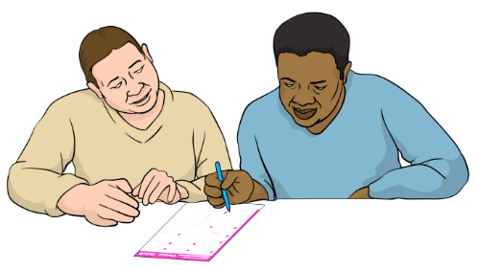
If you need support to fill out the census forms you can ask someone like a:
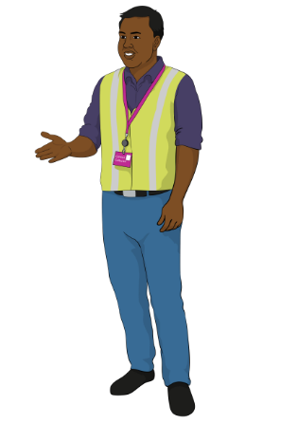
- friend
- family member
- census collector.

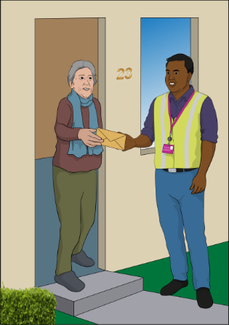
A census collector is someone who may be able to:

- come to your home

- support you to understand the information in this booklet

- support you to fill out your census forms.

These places can give you access to the internet and a computer to do the census online:

- the Library
- Citizens Advice Bureau

- Age Concern office

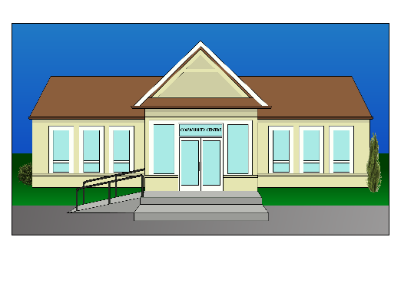
- Senior Net group

- I-Site information centre

- Deaf Aotearoa office.

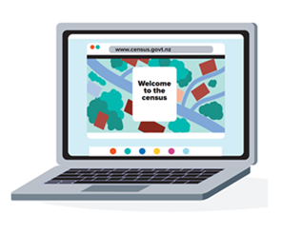
You can find out about the community places and events in your area by visiting the census website:

www.census.govt.nz/census-support

The census team will be at the community events.

The census team will have:

- paper forms for people who want to fill out the census on paper
- a device like a tablet / iPad for people who want to fill out the census online.

You do not need to bring anything with you.

We have everything you need to do the census.

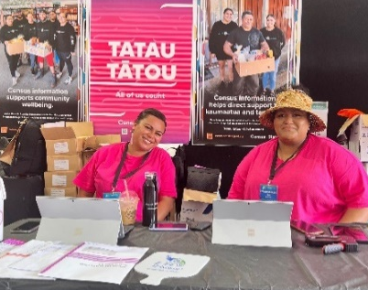
If you do have a census pack feel free to bring it with you to a community event if you want to.

A census pack may have things like:
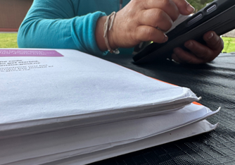
- a letter about the census

- your census forms

- information about census.

You can contact the census team to ask for a census collector to support you.

On pages 18 to 21 in this booklet you can find information about how to talk to the census team.

How you will get your census forms
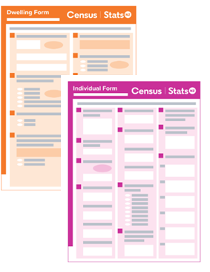
Most people have been sent their census pack in the mail.

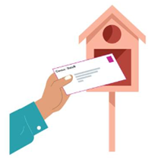
In some areas mail services may be slower than usual because of:
- flooding
- damage to roads.

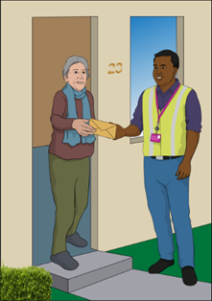
Some people will have their census packs delivered by a census collector.

Census collectors can still visit areas where it is safe for them to travel on the roads.

Please contact the census team if you:

- have not received a census letter or a census pack

- want paper forms

- want information in Easy Read or another format

- have questions about the census

- need support to fill out your census forms.

How to contact the census team

You can contact the census team by Freephone on:

0800 236 787

Freephone means that this number will not cost you any money to call.

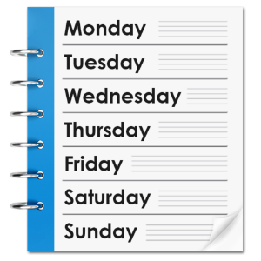
From 1 April to 30 June 2023 the phone line will be open:

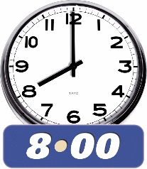
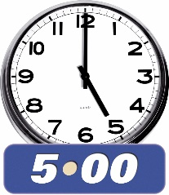
- 7 days a week / everyday

- 8 am in the morning to 5 pm at night.

If you speak a language that is not English then you can ask for someone who speaks:
- Te reo Māori
- Samoan
- Tongan
- Mandarin

- Cantonese

- Korean

- Hindi
- Punjabi.
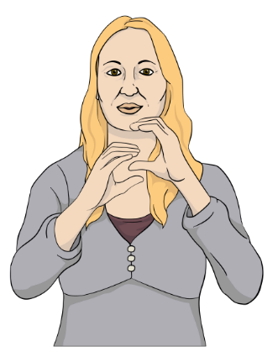
You can find information about the census in New Zealand Sign Language on our website:

www.census.govt.nz

If you find it hard to use the phone the New Zealand Relay service is for people who:

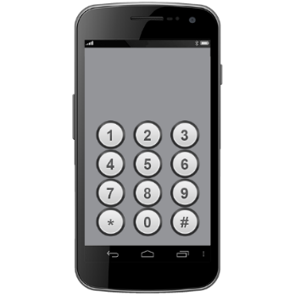
- are Deaf / hard of hearing

- are deafblind

- speech impaired / find it hard to talk.

You can find out more about the New Zealand Relay service at:

www.nzrelay.co.nz

You can also visit our website at:

www.census.govt.nz

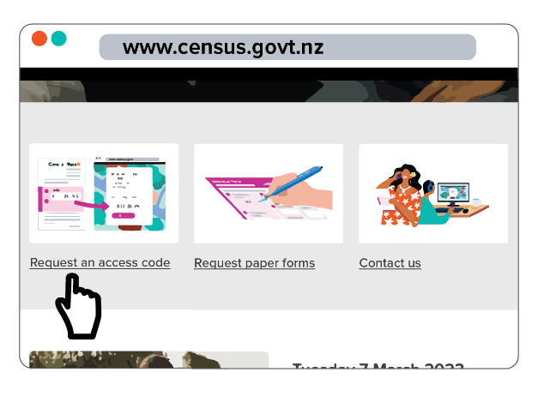
On our website you can:

- get a new access code by clicking on: Request an access code

- ask for paper census forms by clicking on: Request paper forms

- ask questions by clicking on: Contact us.

This information has been written by Stats NZ.

It has been translated into Easy Read by the Make it Easy Kia Māmā Mai service of People First New Zealand Ngā Tāngata Tuatahi.

The ideas in this document are not the ideas of People First New Zealand Ngā Tāngata Tuatahi.
Make It Easy uses images from:

- SGC Image Works

- Photosymbols.com.

This booklet also uses images supplied by Stats NZ.

All images used in this Easy Read document are subject to copyright rules and cannot be used without permission.

