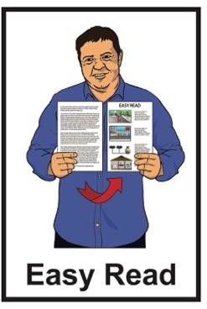

Disabled People’s Organisations Coalition:

Key messages from March 2024

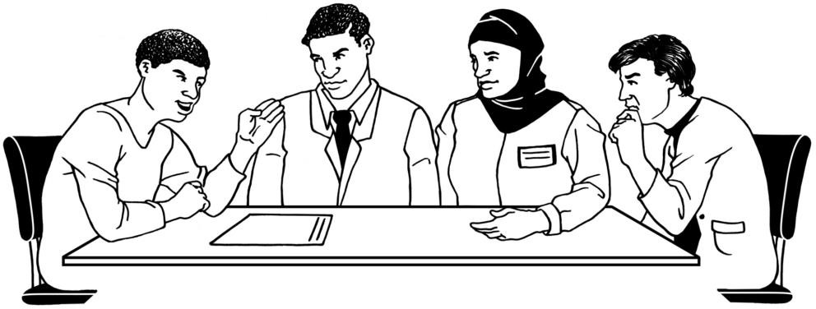

Published: May 2024


The Disabled People’s Organisations Coalition


The Disabled People’s Organisations Coalition is also called the DPO Coalition.
The Disabled People’s Organisations Coalition is a group of people who come from different disability organisations.

A coalition is a group of organisations that work towards shared goals.

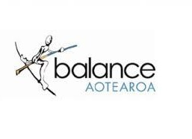
The DPO Coalition is made up of members from these 6 disability organisations:

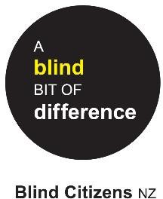
- Balance Aotearoa

- Blind Citizens New Zealand


- Deaf Aotearoa

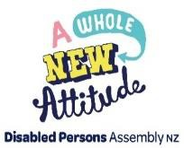
- Disabled Persons Assembly NZ


- Muscular Dystrophy Association of New Zealand

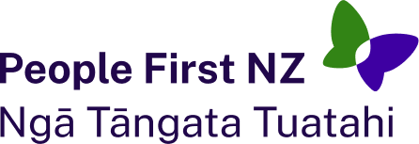
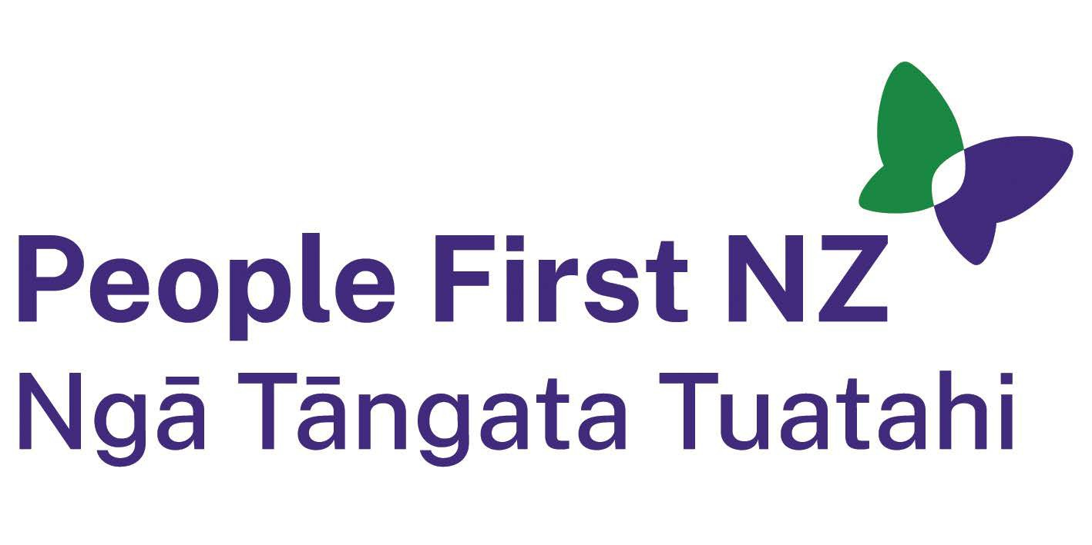
- People First New Zealand – Ngā Tāngata Tuatahi.


The DPO Coalition meets about every 6 weeks.

The DPO Coalition speaks up about disabled people getting their human rights.

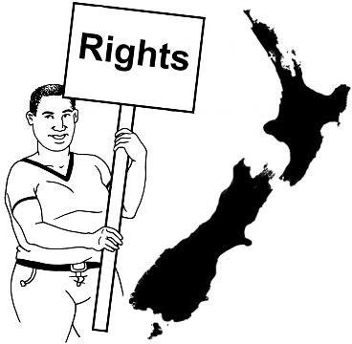
Human rights are things that the law
says every person should:
•
have
•
be able to do.

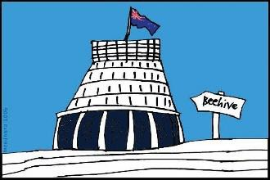
The DPO Coalition talks with the Government about things to do with disability.

What this document is about

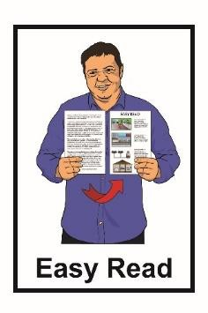
This is an Easy Read document about some of the key messages from the DPO Coalition meetings in March 2024.

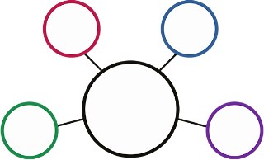
During these meetings the DPO Coalition met with lots of:

- government agencies

- other community organisations.

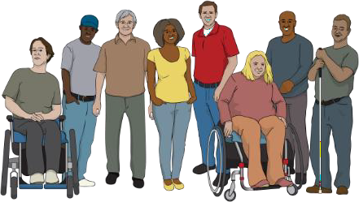
The meetings are to make sure the lives of disabled people in New Zealand are getting better.


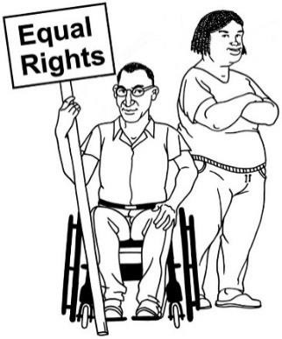
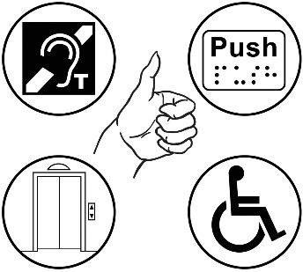
2 key subjects that are talked about often are:
The United Nations Convention on the Rights of Persons with Disabilities is a law lots of countries have agreed to.

It says what governments must do to make sure disabled people get the same rights as everybody else.

accessibility

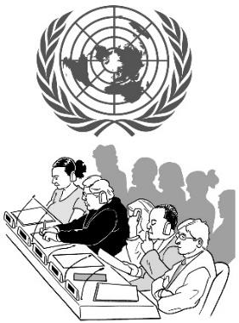
- making the rights of disabled people under the United Nations Convention on the Rights of Person with Disabilities – the Disability Convention real.

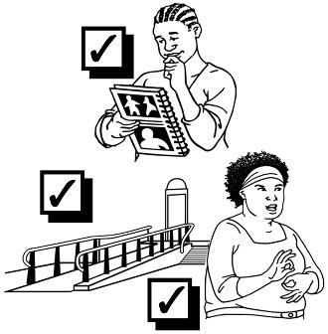
Accessibility means making things easier / safe for everyone to use.

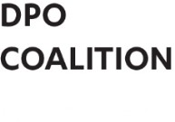


The Independent Monitoring Mechanism



The IMM looks at what the Government is doing to make the rights in the United Nations Convention on the Rights of Persons with Disabilities real.
The Independent Monitoring Mechanism is also known as the
IMM.
The IMM is made up of 3 groups:
•
DPO Coalition
•
Office of Ombudsman
•
Human Rights Commission.


We met with the IMM to go over their

Terms of Reference document.


A Terms of Reference is a set of rules that groups or organisations
follow.

Whaikaha – Ministry of Disabled People


We met with 2 people from Whaikaha – Ministry of Disabled People:

- Ben O’Meara - Deputy Chief Executive of


  - policy

  - strategy

  - partnerships

- Sheryl Pickney – Group Manager of Partnerships and Stewardship.

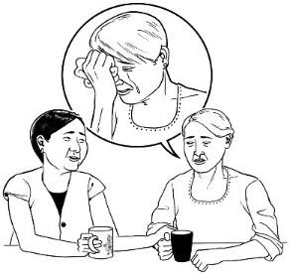
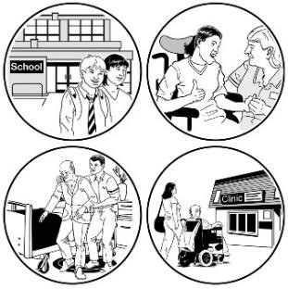
We told them how unhappy we were about the new funding rules for disability:

respite

- support.

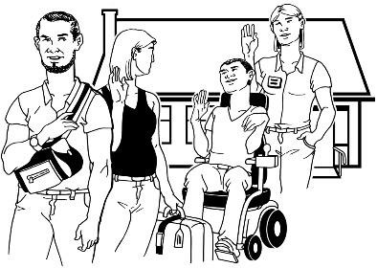
Respite is a way of giving
whānau / family a break from caring for someone.

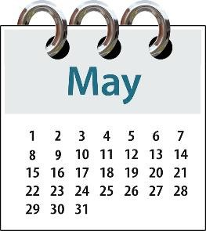
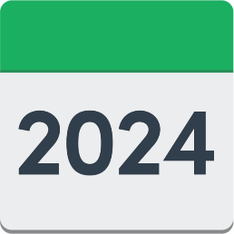
We are meeting with
Whaikaha – Ministry of Disabled People in May 2024 to talk about the new funding rules.

Statistics NZ


We met with 4 people from Statistics NZ.

We talked about:

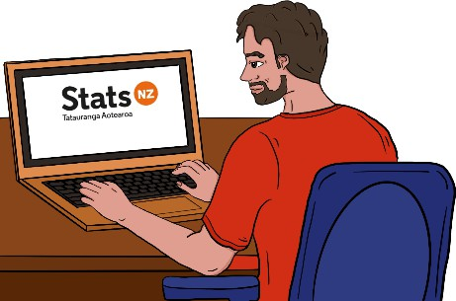
- what census will be doing in the future

- other ways a national census could be done.

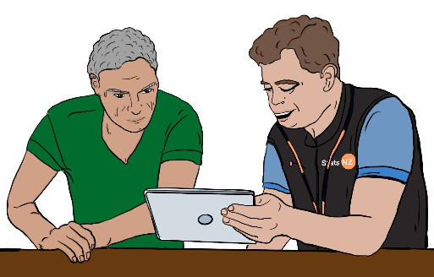
A census is when you are asked
questions about things like:
•
who you are
•
how many people you live with.

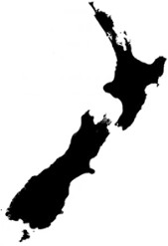
National means all around New
Zealand.
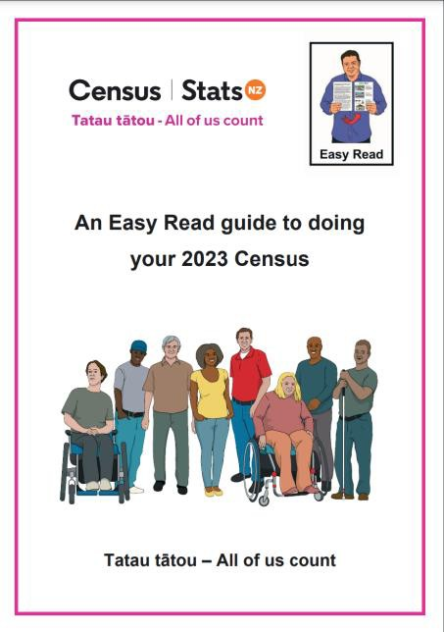
There is an Easy Read document called An Easy Read guide to doing your 2023 Census on the Census website:

shorturl.at/hjFJM

This document has more information about what a census is.

Disability Rights Commissioner

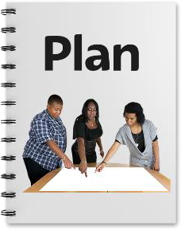
We met with Prudence Walker who is the Disability Rights Commissioner from the Human Rights Commission.

She talked about a new Strategic Plan that they are working on.

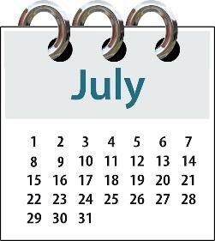
The new Strategic Plan will be available in July 2024.

The new plan covers:

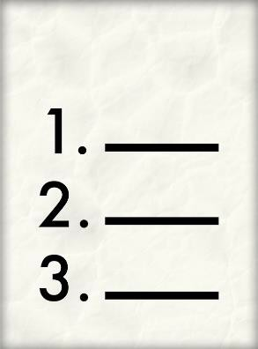
- violence and abuse

- poverty

- access to supports.

Oranga Tamariki

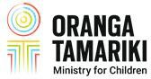
We met with people from Oranga Tamariki.

Oranga Tamariki is also called the Ministry for Children.

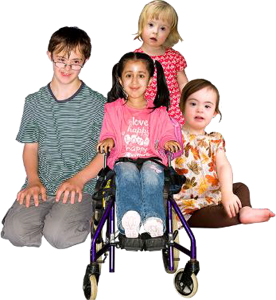
They are the part of the government that works on things to do with children.

We talked about the changes Oranga Tamariki are doing to the Oranga Tamariki Act and Residential Care Regulations.


Oranga Tamariki Act and Residential Care Regulations are the rules Oranga Tamariki follow about children who are in care.


You can read these regulations here:

shorturl.at/fqWZ1

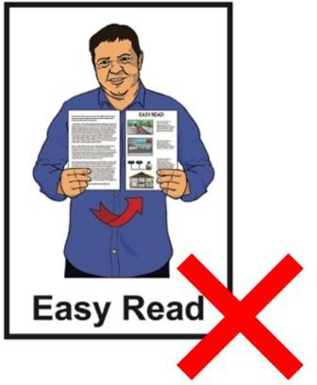
This document is not in Easy Read.

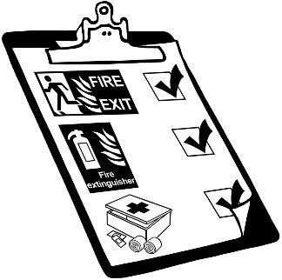
We also talked about safety issues in Oranga Tamariki residences like:


- exclusion / restraint – which means keeping children away from other people when it is not safe for them or others


- not making rules for children that are any harder than the rules for adults.

Residences are places for children / young people live when
there is nowhere else for them to live.

.

We also asked Oranga Tamariki:

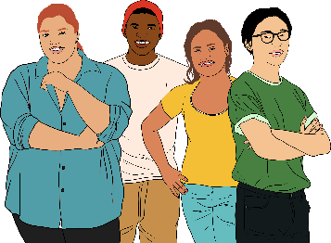
- to talk with youth groups more

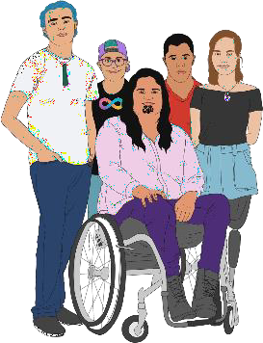
- to give more feedback to us about:

  - disabled people in their care

youth justice places.

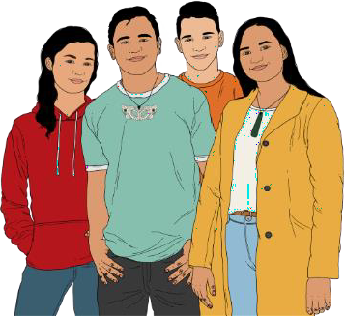
Youth justice places are for young
people who:
•
have done a crime
•
might have done a crime.

More information about youth justice places is available on the Oranga Tamariki website here:

shorturl.at/citvX

This information is not in Easy Read.

Voice of disabled people


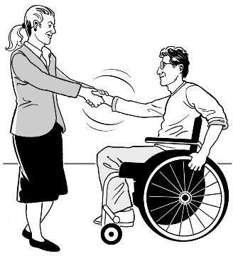
The Government meets with the DPO Coalition so that disabled people are able to have a say in the decisions being made.

The DPO Coalition is always looking for new organisations to join us.


You can contact us by emailing us at:

us-dpo@groups.io

You can also contact us if you are interested in being a DPO Coalition representative on any advisory groups.


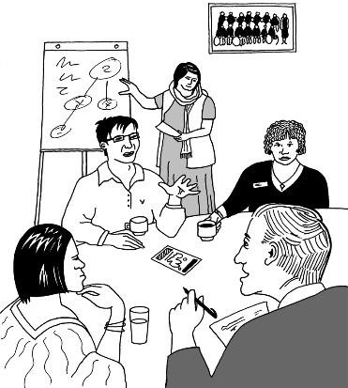
A representative is someone that speaks for a group of people about something important to them.
An advisory group is a group of people who give advice on something that they know a lot about.




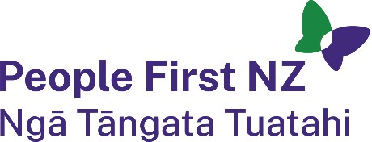
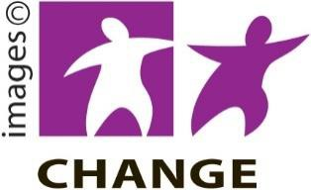

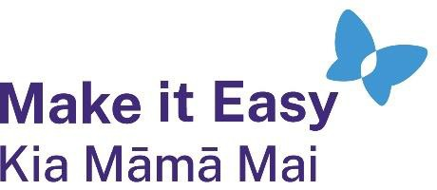
This information has been written by The DPO Coalition.

It has been translated into Easy Read by the Make it Easy Kia Māmā Mai service of People First New Zealand Ngā Tāngata Tuatahi.

The ideas in this document are not the ideas of People First New Zealand Ngā Tāngata Tuatahi.

Make it Easy uses images from:

- Changepeople.org

- Photosymbols.com

- SGC Image Works
- Huriana Kopeke-Te Aho
- T. Wood.

All images used in this Easy Read document are subject to copyright rules and cannot be used without permission.

