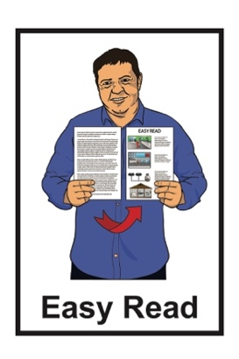


Changes to the mileage rate

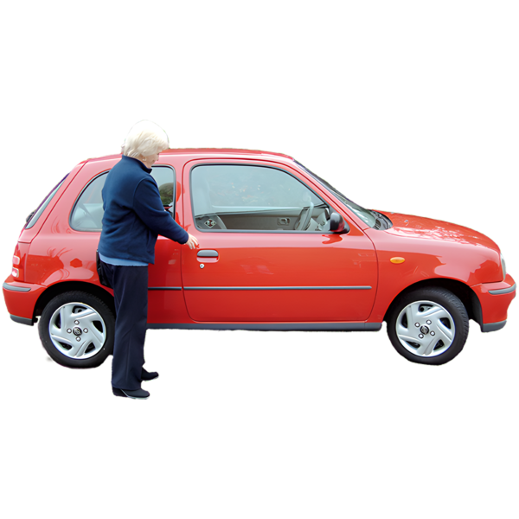
for support workers

Published: April 2026

About this Easy Read

This Easy Read is about changes to the mileage rate paid to home and community support workers.


The mileage rate is the amount of money people are paid for every kilometre they drive for work.


This money is to cover costs of driving like:

petrol
insurance
repairs to the car.


The cost of fuel has gone up.

Here fuel means things like:

petrol

diesel


This is because of war / fighting in the Middle East.

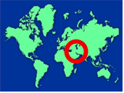
The Middle East is part of the world where a lot of fuel comes from.


The change in cost means everyday life costs more money.

Many home and community support workers need to drive to do their jobs.

What home and community support workers do

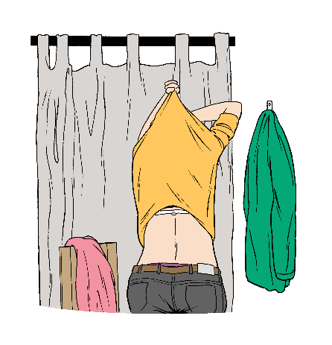
Home and community support workers assist disabled people with personal care like:
eating and drinking

getting dressed
getting up
going to bed
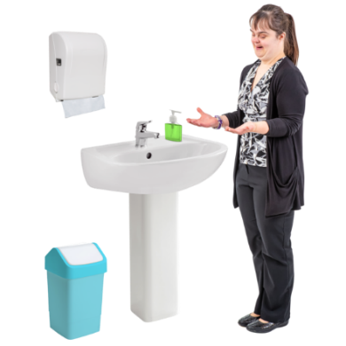
needs in the bathroom
moving inside their home.


Home and community support workers assist disabled people with household tasks like:
making meals

washing clothes
cleaning / tidying their home.

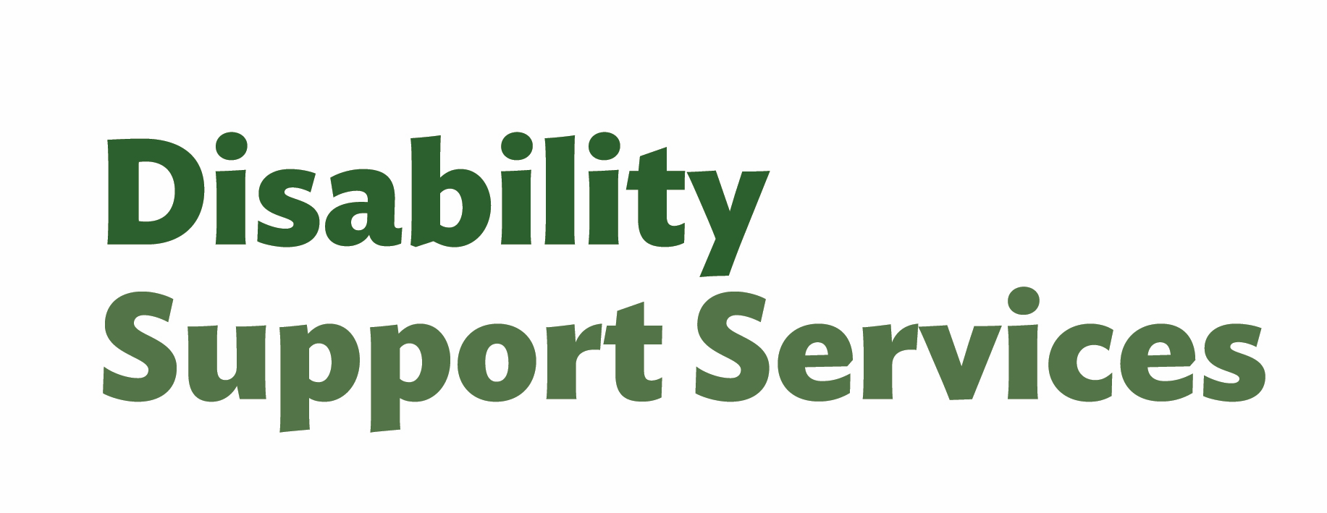
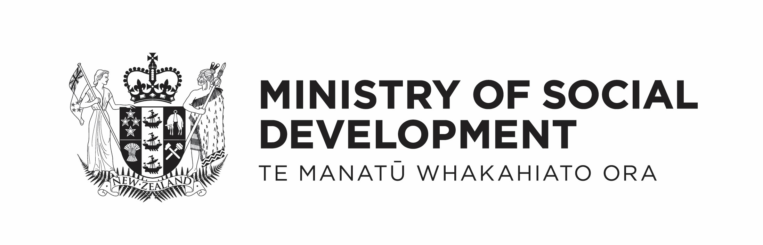
This support work is paid for by:
Ministry of Social Development – Disability Support Services

Health New Zealand – Te Whatu Ora

Accident Compensation Corporation / ACC.

What is changing?


The government is changing things so support workers are paid more for using their own cars.



This change starts from 2 April 2026.



The mileage rate is going from:
63.5 cents for every kilometre
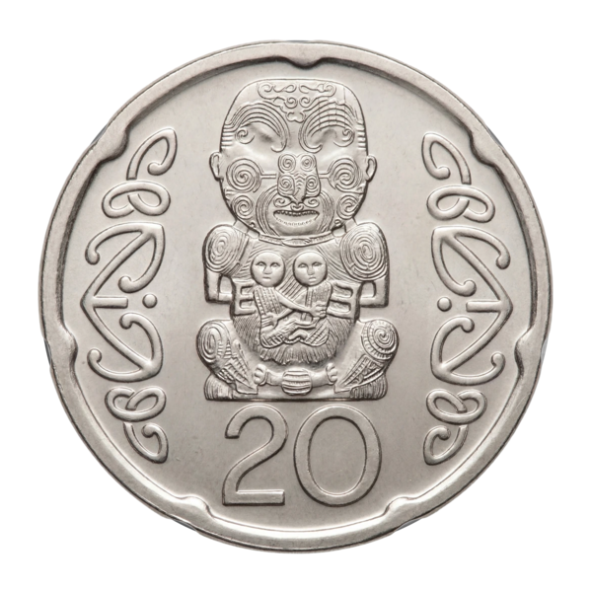
to
82.5 cents for every kilometre.


This change will make it easier for support workers to pay for fuel.

This change is temporary which means it is only for an amount of time.



The new mileage rate will go until:
31 March 2027
or
the cost of petrol is lower.



Here the cost of petrol being lower means 91 octane petrol is:
less than 3 dollars for every litre
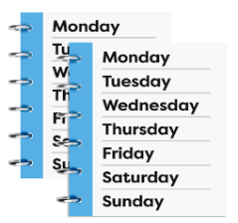
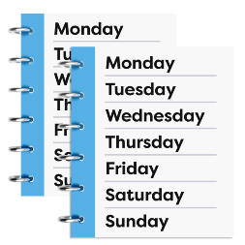
and
stays that way for 4 weeks in a row.

91 octane petrol is the kind of petrol most people use in their cars.


This change show that home and community support workers are important.


It means they can keep doing the important work of supporting disabled people.

More information
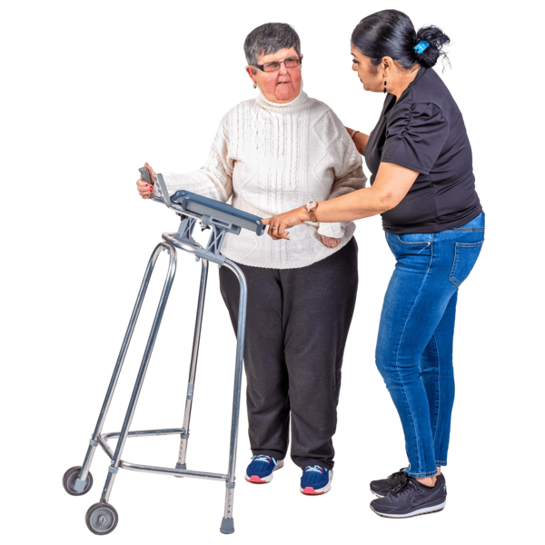

If you have a support worker talk to them first if you have any questions.

If you have any more question you can talk to the government agency that funds your support worker.

Ministry of Social Development – Disability Support Services


You can email Disability Support Services at:

info@disabilitysupport.govt.nz

You can phone Disability Support Services on:

0800 566 601

Disability Support Services are open for phone calls

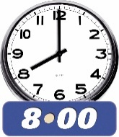
- from 8 in the morning
- to 5 in the afternoon on
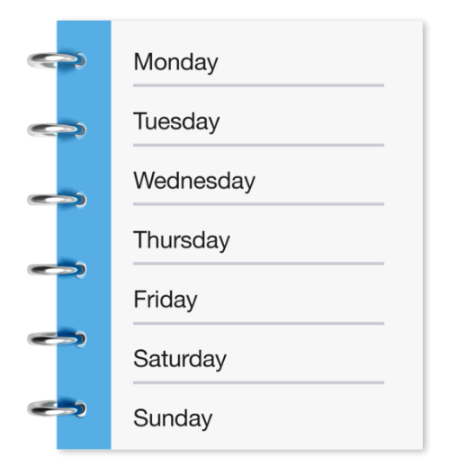
- Monday
- Tuesday
- Thursday
- Friday.

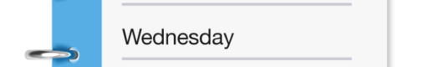
On Wednesdays they are open for phone calls from:
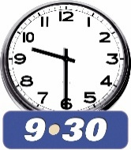
from 9:30 in the morning
until 5 in the afternoon.
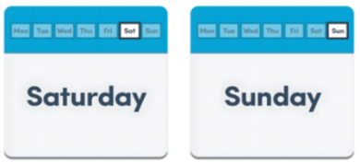


They are not open on weekends.
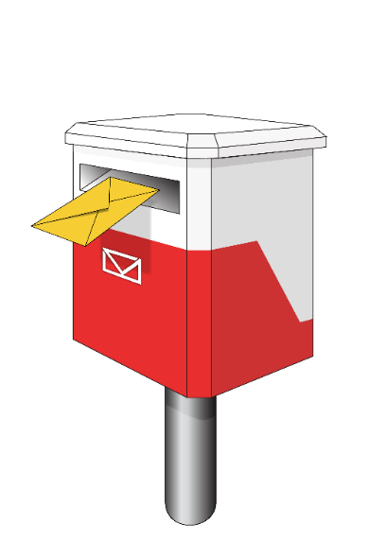

You can send a letter / post to
Disability Support Services at this address:

Disability Support Services

Ministry of Social Development

PO Box 1556

Wellington 6140


Health New Zealand

You can email Health New Zealand at:

customerservice@health.govt.nz


You can phone Health New Zealand on:

0800 855 066

Health New Zealand are open for phone calls
- from 8 in the morning
- to 5 in the afternoon on
- Monday
- Tuesday
- Thursday
- Friday.
On Wednesdays Health New Zealand are open for phone calls:
from 9:30 in the morning
until 5 in the afternoon.
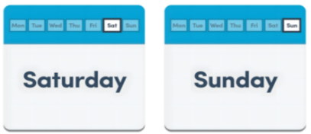

They are not open on weekends.

You can send a letter / post to Health New Zealand at this address:

Health New Zealand Te Whatu Ora

PO Box 793

Wellington 6140

New Zealand


ACC

If you get support from ACC you can contact your claim manager with any questions.

If you do not have a claim manager you can email:

claims@acc.co.nz


You can phone ACC on:

0800 101 996

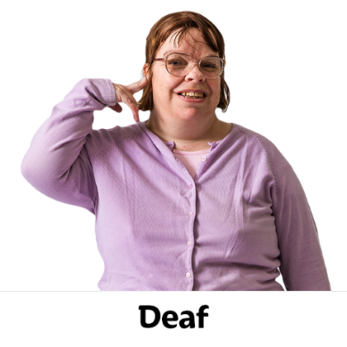
If you are Deaf you can also email:

deaf@acc.co.nz


There is also more information on the ACC website at:

www.acc.co.nz
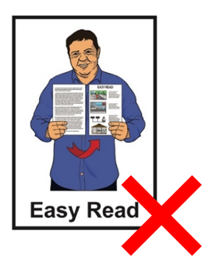

This website is not in Easy Read.


If you find it hard to use the phone the New Zealand Relay service is for people who are:


- Deaf / hard of hearing

- deafblind

- speech impaired / find it hard to talk.


You can find out more about the New Zealand Relay service at:

www.nzrelay.co.nz


This information has been written by Health New Zealand Te Whatu Ora.


It has been translated into Easy Read by the Make it Easy Kia Māmā Mai service of People First New Zealand Ngā Tāngata Tuatahi.

The ideas in this document are not the ideas of People First New Zealand Ngā Tāngata Tuatahi.

All images used in this Easy Read document are subject to copyright rules and cannot be used without permission.

Make it Easy uses images from:


- Photosymbols

- Change Images


- Huriana Kopeke-Te Aho

- SGC Image Works

- T Wood


- Studio Rebeko

- Inga Kramer

- iStock.

