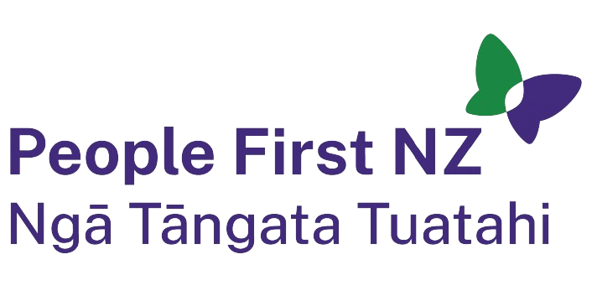

JOB DESCRIPTION

Title: National Administrator

Responsible to: Chief Executive Officer

Location: People First New Zealand national office, Wellington

Type of employment: This is a permanent part-time role of 20 hours a week to be worked in office hours.

The following guide all the activities of People First New Zealand.

Philosophy:
- People with learning (intellectual) disability should be respected, have full rights of citizenship in New Zealand and have the chance to be fully included in communities.

- We are committed to te Tiriti o Waitangi as a founding document of New Zealand.
- We are committed to upholding the rights in the United Nations Convention on the Rights of Persons with Disabilities (UNCRPD).

People First’s mission is to:
Assist people with learning disability to be strong and valued individuals in New Zealand.

People First NZ has these charitable purposes:
- Assist people with learning disability to know and understand their rights.
- Assist people to speak up about things that are important to them.
- Represent people with learning disability who cannot speak for themselves.
- Promote the rights of people with learning disability.
- Make sure that communities and society include people with learning disability.
- Promote the rights of all disabled people.

Purpose of the role: The National Administration provides essential operational, administrative and assistance to the national committee, the CEO and the wider team.

Key Responsibilities:

- General Administration
Key Tasks: To contribute to the effective and efficient operation of the organisation by maintaining strong connections with and providing administrative support to all levels of the organisation. Tasks include but not be limited to:

- Set up regular online and face to face team meetings, take minutes and monitor task actions
- Respond promptly to request for administrative tasks from staff
- Manage and record 0800 free phone number and Ask email send enquiries to relevant staff person
- Manage and record relevant incoming and outgoing correspondence
- Respond to requests for resources and information from the People First team and the public
- Assisting to maintain a record of current resources
- Book national & regional level travel, accommodation, rental cars, and catering
- Purchase stationery, and other bulk supplies for the National office
- Assist with national audit and contract reporting
- Create and maintain accurate files
- Providing financial information for travel, accommodation and work-related expense and petty cash etc each month to the Financial Manager
- Update and policy handbooks as required
- Assisting with updating social media and website
- Other administration matters as requested by National Manager

- National Committee
The National Administrator assists with the effective governance of People First NZ by maintaining strong connections with and providing administrative support. Tasks include but are not limited to:
- Communicate with national committee members by email, text or phone in regard to upcoming events, emails and travel
- Book travel and accommodation for meetings
- Develop draft agenda and gather papers for meetings
- Provide administration assistance to meeting including catering
- Write meeting minutes for national committee meetings and Annual General Meeting

Key skills and experience

- Understands Human Rights and works in a human rights model

- Has excellent written and oral communication skills and can communicate effectively with a range of people

- Can write in plain language

- Uses active listening

- Responds promptly to request

- Is reliable and well organised and can managing competing priorities

- Has a can-do attitude is flexible and uses initiative

- Has good interpersonal skills and shows patience and tolerance

- Can work independently or in a team

- Ability to use a range of computer programmes, in particular MS Teams, (Word, Excel, PowerPoint, SharePoint, Outlook and Trello) and open to learning new programmes

- Open to learning new skills

- Able to ask for support if required

Key relationships
This role works closely with and reports to the CEO and has key relationship with:
- National committee
- Senior management team
- Communications Lead
- Team Leader, Regional Coordinators
- People who contact People First NZ

