Your Health Passport
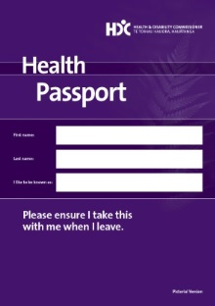

By the Health and Disability Commissioner

All about Health Passports
What is a Health Passport?
- A Health Passport is a booklet that has information about you.

- Your Health Passport belongs to you.

- You keep your Health Passport with you.

- You decide how much information you put in your Health Passport.

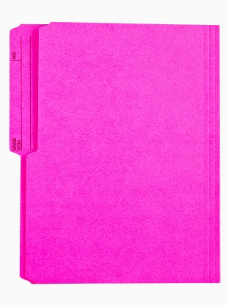
What kind of Health Passport should I get?
Remember, you can get a Health Passport in:
- plain language
- Easy Read with words and pictures
- big writing.

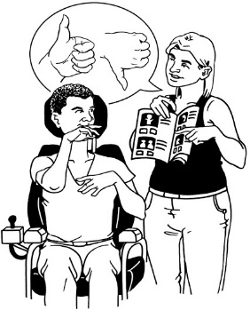
Who are Health Passports for?
Health Passports have been made for:

- disabled people

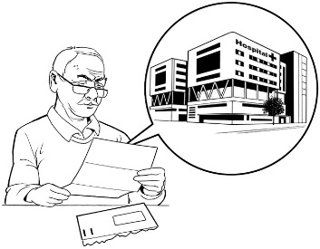
- people who communicate in different ways

- people who find it hard to talk about their health and support needs
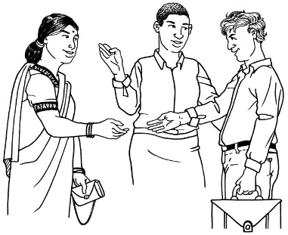
- people who go to hospital a lot

- people who do not speak English as their first language.

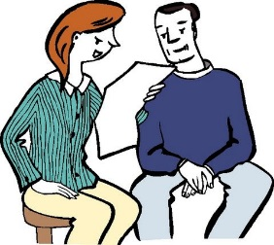
Who can read your Health Passport?
You can decide who reads your Health Passport.

Filling out your Health Passport
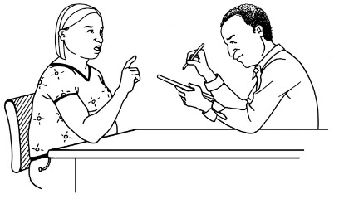
- You can fill out a Health Passport or you can get someone you trust to help you.

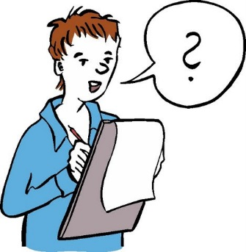
- You might ask a friend, a family member or a support person to help you.

- You decide if it needs to be changed or updated.

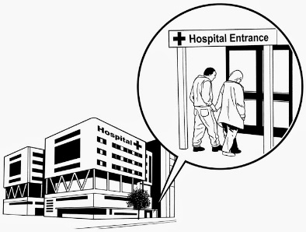
How do I use my Health Passport?

- You can take your Health Passport with you when you go to hospital.
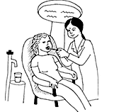
- You can take your Health Passport when you visit any health professional like a doctor or dentist.

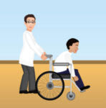
- Your Health Passport will help doctors, nurses and other people working in health services understand your health and support needs better.

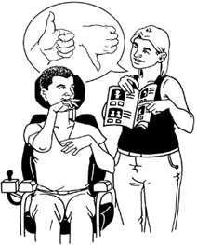
- Your Health Passport tells people things about you and things that are important to you, like:

  - how you communicate

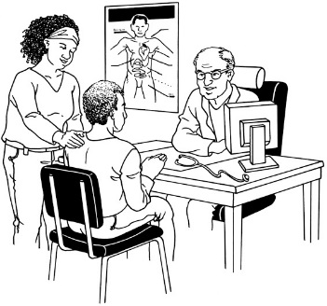
  - what you like, and what you do not like

  - how to work with you in a way that is respectful to you.
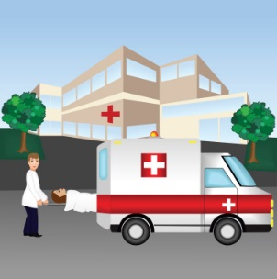

Health Passports are good in emergencies when it can be hard to speak.

How do I get a Health Passport?
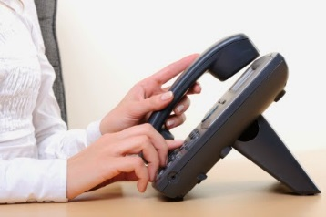
- You can ask People First New Zealand for an Easy Read Health Passport.

        - Ask your Regional Coordinator
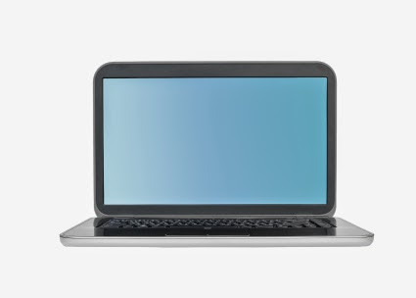
        - Call 0800 20 60 70

        - Email mail@peoplefirst.org.nz

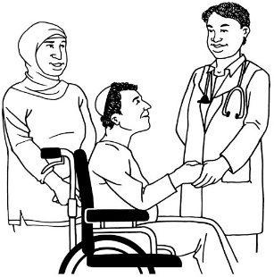
- You can ask for a Health Passport when you visit the hospital.

- You can ask the Health and Disability Commissioner for a Health Passport.
        - Call 0800 11 22 33

        - Email healthpassport@hdc.org.nz
        - Web www.hdc.org.nz

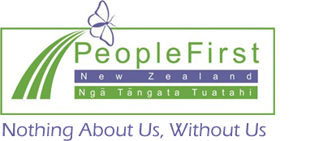

This information has been translated into Easy Read by People First New Zealand Inc. Ngā Tāngata Tuatahi

