Venues Nordic Battery Summit 2025:

All within walking distance in Lillestrøm (5-15 min)
1 Train station: Lillestrøm stasjon
2 Venue on September 24th: Folkets hus / Lillestrøm konferansesenter
Address: Storgata 38, Lillestrøm
3 Venue on September 25th: Lillestrøm Kultursenter
Address: Kirkegata 11, 2000 Lillestrøm
4 Venue for dinner: Thon Hotel Arena
Address: Nesgata 1, 2004 Lillestrøm

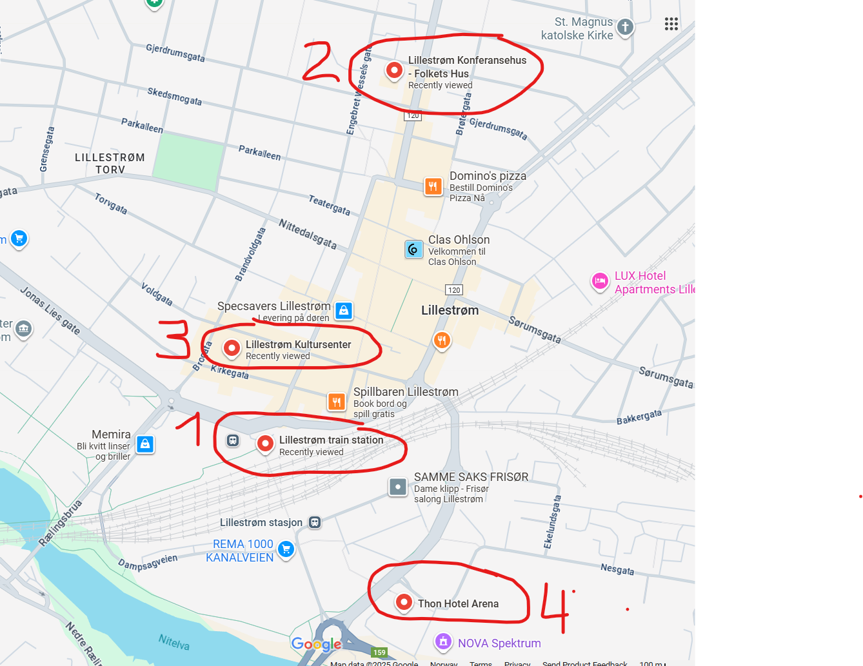

How to get there:
From Oslo Central Sation (Oslo S)
By Train (Recommended)
Vy Regional train (RE10, RE11, RE12, R14)
(destination Lillehammer, Eidsvoll or Kongsvinger)
- Departure: Oslo S (Central Station)
- Arrival: Lillestrøm stasjon
- Duration: 10-12 minutes
- Frequency: Every 10 minutes Vy | Train | Bus | Taxi | Book your trip at vy.no
- Cost: Typically NOK 70–100 depending on the train type Train tickets and bus tickets | Buy tickets online | vy.no
- Platforms: Most trains depart from Platform 10, 11 or 18

From the airport Gardermoen:
By Train (Recommended)
Vy Regional Train (R10/R11/R12) or Flytoget Airport Express (most efficient):
  - Departure Station: Oslo Lufthavn stasjon (located directly beneath the arrivals hall at Gardermoen). Make sure your go to the right platform as the Vy trains and the airport train are leaving from different platforms.
  - Arrival Station: Lillestrøm stasjon.
  - Duration: Around 10–12 minutes.
  - Frequency: Trains run frequently— 2 to 6 times per hour on weekdays depening on the train company.
  - Cost:
    - Vy: Approx. NOK 100. Train tickets and bus tickets | Buy tickets online | vy.no or download the Yy app
    - Airport express train: NOK 200. Buy tickets for Flytoget Airport Express train here! - flytoget.no or swipe your credit/debet card at the entrance.

