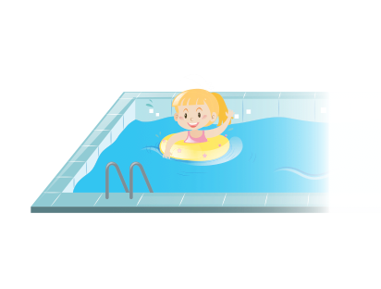
yesterday
at the weekend
on Friday
on Saturday
played Xbox
watched television
went swimming
went football training
home
friend’s house
swimming pool
park
park
Mammy
Daddy
brother
sister

