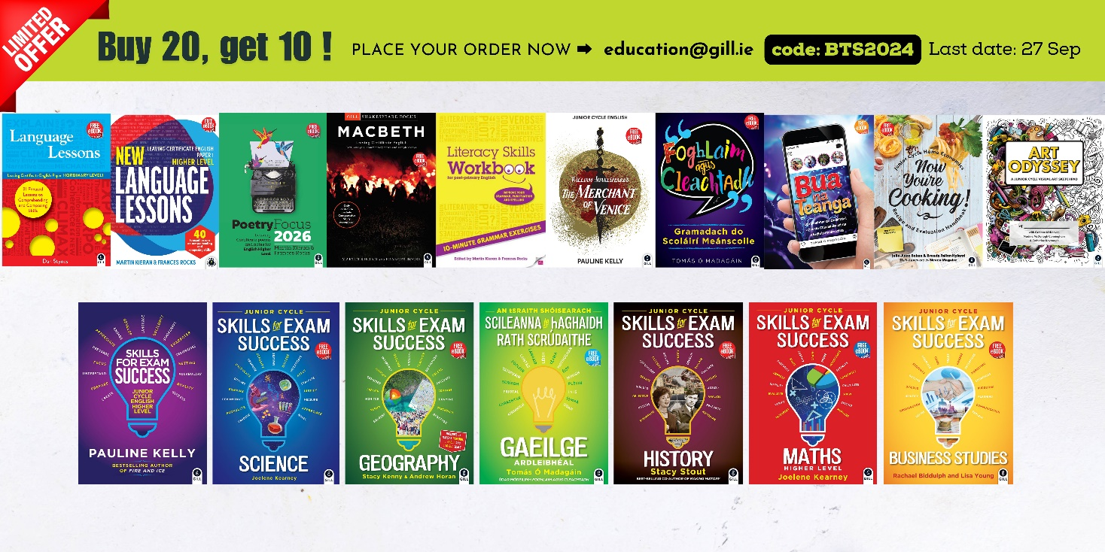

To: education.gill.ie
Subject: BTS24: Back to School offer
Hi there
We would like to order 20 copies of (each of) the following titles to avail of the 10 extra copies free in your limited back-to-school offer:
TITLE 1: | TITLE 11:
TITLE 2: | TITLE 12:
TITLE 3: | TITLE 13:
TITLE 4: | TITLE 14:
TITLE 5: | TITLE 15:
TITLE 6: | TITLE 16:
TITLE 7: | TITLE 17:
TITLE 8: | TITLE 18:
TITLE 9: | TITLE 19:
TITLE 10: | TITLE 20:

YOUR FULL NAME:
SCHOOL NAME:
SCHOOL ROLL NUMBER:
YOUR MOBILE NUMBER:
 | Gill Education
 | HUME AVENUE  PARK WEST  DUBLIN  D12 YV96 |  |  | t +353 1 500 9500  Customer support  www.gilleducation.ie

