NACYS FORMS AND TEMPLATES  Enrolment Forms | 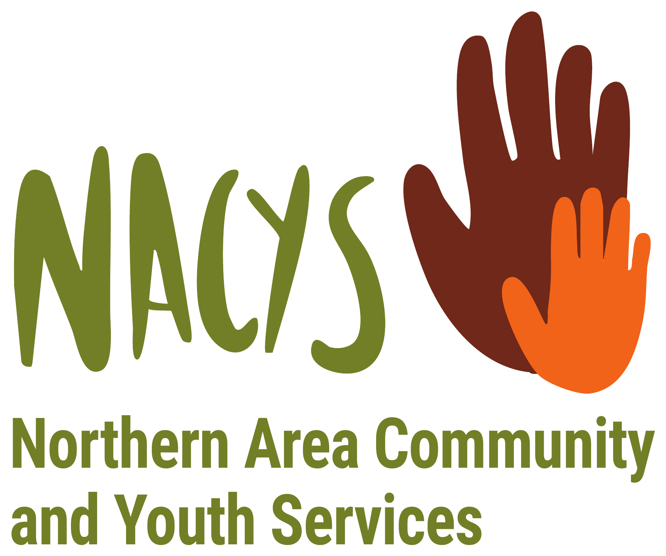

At NACYS, we see families as children’s first and most important teachers. The information you share on these forms helps us get to know your child and your family, so that we can provide care that helps your child feel safe, connected and valued.

Enrolment Form: Part 1
CONFIDENTIAL: RESTRICTED ACCESS
☐ | Flexible / Casual | ☐ | Fixed / Routine

Child
Family name |  |  |  |  |  | Gender
First name |  |  |  |  |  | Other
Known as |  |  |  |  |  | Primary language
Date of birth |  |  | Birth cert. cited |  | Yes / No |  | CRN
Address
Indigenous status |  | Aboriginal |  | Yes / No |  | Torres Strait Islander |  |  | Yes / No

Eligible Parent / Guardian and Billing Details
Name
Date of birth |  |  | CRN
Relationship to child |  | Contact priority |  | Primary language
Home address
Work address
Home phone |  | Work phone |  | Mobile phone
Email

Other Parent / Guardian (if applicable)
Name
Relationship to child |  | Contact priority |  | Primary language
Home address
Work address
Home phone |  | Work phone |  | Mobile phone
Email

Emergency Contacts and Collection Authorities
Name |  |  |  | Contact priority
Address |  |  |  | Relationship to child
Home phone |  | Work phone |  | Mobile phone

Name |  |  |  | Contact priority
Address |  |  |  | Relationship to child
Home phone |  | Work phone |  | Mobile phone
N.B. It is very important that you tell these people that you have nominated them. In nominating them you give them authority to act on the child’s behalf if neither parent can be located, to pick up the child in an emergency and care for the child until he or she can be returned home.

Collection Authorities Only
Name
Address |  |  |  | Relationship to child
Home phone |  | Work phone |  | Mobile phone

Name
Address |  |  |  | Relationship to child
Home phone |  | Work phone |  | Mobile phone
N.B. The people nominated here have been given approval only to collect the child and should NOT be contacted in case of an emergency.

Bookings
 | Mon | Tue | Wed | Thu | Fri | Sat | Sun
Arrive
Depart

From (date) |  | For (weeks) |  | Or until (date)
Or ongoing (tick) | ☐

Enrolment Form: Part 2
CONFIDENTIAL: RESTRICTED ACCESS
Child’s name

Medical and Health Information
Has the child received the following immunisations? (please tick)
 | Birth | 2 months | 4 months | 6 months | 12 months | 18 months | 3 yrs 6 mths to 4 yrs
Hepatitis B | ☐ | ☐ | ☐ | ☐
Diphtheria |  | ☐ | ☐ | ☐ |  | ☐ | ☐
Tetanus |  | ☐ | ☐ | ☐ |  | ☐ | ☐
Pertussis (whooping cough) |  | ☐ | ☐ | ☐ |  | ☐ | ☐
Haemophilus b (Hib) |  | ☐ | ☐ | ☐ |  | ☐
Poliomyelitis |  | ☐ | ☐ | ☐ |  |  | ☐
Meningococcal ACWY |  |  |  |  | ☐
Measles |  |  |  |  | ☐ | ☐
Mumps |  |  |  |  | ☐ | ☐
Rubella |  |  |  |  | ☐ | ☐
Pneumococcal |  | ☐ | ☐ | ☐ | ☐
Rotavirus |  | ☐ | ☐
Varicella (chickenpox) |  |  |  |  |  | ☐
Additional immunisations received for Aboriginal and Torres Strait Islander children in high risk areas? (please tick)
 | 6 months | 12 months | 18 months
Pneumococcal | ☐ | ☐
Hepatitis A |  | ☐ | ☐

I accept full responsibility if my child is not immunised.
Parent / guardian signature
Has the child any disabilities?
Please circle | Yes / No | Effective date
If yes, please record specifics:
Has the child any special needs?
Please circle | Yes / No | Effective date
If yes, please record specifics:
Does the child usually require regular medication or special aids?
If yes, please specify (e.g. glasses, hearing aid etc.):
Has the child suffered any illness that may re-occur?
If yes, please specify (e.g. chronic ear infection):
Has the child had any kind of allergic reactions or food intolerances?
Foods |  | Penicillin | Yes / No
Others (insects etc.)
Reaction
Usual medical attendant
Doctor’s name |  | Phone no.
Clinic name
Address
Usual dental attendant
Dentist’s name |  | Phone no.
Clinic name
Address

Medical benefits cover with
Ambulance cover with
Medicare number |  |  | Health Care Card number

Sleep Needs
Approx. time(s) and duration

Please circle | Cot | Bed | Special toy | Dummy | Bottle
How do you settle your child when he or she becomes distressed?

Diet / Feeding Information
Please circle | Bottle | Cup | Feed self | Spoon fed | Trainer / cup

Likes
Dislikes
Amount
Times

Enrolment Form: Part 3
CONFIDENTIAL: RESTRICTED ACCESS
Child’s name

Universal Access Data Collection
Does a parent, guardian or carer of this child have any of the following? (please circle)
Health Care Card | Yes / No
Pensioner Concession Card | Yes / No
Temporary Protection / Humanitarian Visa | Yes / No
Bridging Visa for an Asylum Seeker | Yes / No
Department of Veterans’ Affairs Gold Card | Yes / No

If this child attends another funded preschool program, please complete the following:
Name of other preschool / kindergarten
Hours of attendance at other preschool / kindergarten

Parenting Plans / Orders Relating to This Child

Is There Anything More We Need to Know?
e.g. any personal, religious or cultural practices or prohibitions that you would like the service to know.

Consents
Please initial next to each item to which you consent.
Consents | Initials
I consent for NACYS to email to me newsletters and other relevant information.
I consent for my child to watch G-rated videos / DVDs at the discretion of the Centre.
I consent for my child’s photos for promotion purposes. This includes being displayed within the Child Care Centre, on fence and other promotional ways.
I consent for my child’s photo to be displayed in other children’s learning journals, learning stories, shared observations, which means they will be taken home.
I consent for my child’s photo to be displayed on the NACYS web page and on the Facebook page. This includes being displayed within the Child Care Centre: floor books, displays in foyer as well as in rooms.
I consent for my child to participate in observation and documentation conducted by students.
I consent for my child to take part in supervised walking excursions within the local area as part of the Child Care Centre’s program.
I consent for my child’s photo to be used for programming and learning purposes.
I consent for Child Care Centre staff to apply sunblock onto my child.
I understand that my child will be taken by ambulance to the local hospital in the event of an emergency.
I consent for my child to watch PG-rated videos / DVDs at the discretion of the Centre.
I consent for my child’s hair to be checked for headlice.
I consent for my child’s hair to be treated for headlice should there be eggs or lice present in the event that parent(s) cannot be contacted.
I consent for my child to have a bath by a staff member should staff deem it necessary for the health and well-being of my child.

Agreements
I agree to pay the required fees for my child’s booked childcare hours and accept the policies and rules of the Service. I will be responsible for any additional costs associated with overdue fees including debt collection fees.
I agree that the staff of the Service may administer simple first aid to my child if the need arises.
I understand that if at any time the staff of the Service consider that my child requires emergency medical, hospital or ambulance assistance, they will have the local medical, hospital or ambulance service attend my child. I acknowledge that I will be liable for any medical, hospital or ambulance expenses incurred in the treatment of my child.
If any of my children have a medical condition, I agree to provide the service with the child’s healthcare management plan.
Parent / guardian signature |  | Date
Interviewed / accepted by |  | Date
I certify that the information entered upon this form is true to the best of my knowledge and I undertake to inform the Service if any of these details change.

Your Child
Child’s country of birth
Country of origin for your family
Year of arrival of your family (if not born in Australia)
Language spoken at home

Attendance: Reason for Childcare |  | Special Needs
☐ | Single parent: studying | ☐ | Hearing impairment
☐ | Single parent: working | ☐ | Visual impairment
☐ | Both parents: studying | ☐ | Physical disability
☐ | Both parents: working | ☐ | Speech and language disorder
☐ | One parent: working | ☐ | Behaviour disorder / Autism
☐ | One parent: studying | ☐ | Developmental delay
☐ | Respite purposes | ☐ | Health / medical condition
☐ | At risk / referral | ☐ | Intellectual disability
☐ | Self employed | ☐ | Severe multiple disability
☐ | Employed (parental leave) | ☐ | Attention Deficit Hyperactivity Disorder (ADHD)
☐ | Develop social skills | ☐ | Other (please state): ______________
☐ | Parent(s) seeking employment
☐ | Other (please state): ______________

Employment: Parent / Guardian 1 |  | Employment: Parent / Guardian 2
☐ | Employed (full-time) | ☐ | Employed (full-time)
☐ | Employed (part-time) | ☐ | Employed (part-time)
☐ | Employed (casual) | ☐ | Employed (casual)
☐ | Student | ☐ | Student
☐ | Unemployed | ☐ | Unemployed
☐ | Pension / benefit recipient | ☐ | Pension / benefit recipient
☐ | Employed in unpaid work | ☐ | Employed in unpaid work
☐ | Self employed | ☐ | Self employed
☐ | Employed (parental leave) | ☐ | Employed (parental leave)
☐ | Other (please state): ______________ | ☐ | Other (please state): ______________

Child Sleep / Rest / Relaxation Plan
This is a plan of your child’s sleep, rest and relaxation needs. It enables us to provide high quality care within a caring, stimulating and relaxing environment. We need to ask for your support and help in providing for your child’s needs.
Child’s name
Room
Please circle what your child does.
Does your child: | Sleep | Rest | Relax

How often does your child sleep?
How long does your child sleep for?
How long does your child rest for?
How long does your child relax for?
Does your child sleep with anything special?

If your child needs to rest or relax due to tiredness, what is the best way for your child to do so?

Any other relevant information you would like to share?

Bottle Information Chart
Child’s name
Child’s age
Does your child have cow’s milk or formula?
Name of formula
How often does your child have a bottle?
How much water is used per bottle when using formula?
How many scoops of formula are used per bottle?
How much cow’s milk per bottle?

Any further instructions

Educator’s notes

Signatures
Parent / guardian signature |  | Name
Educator’s signature |  | Name

Family Life
We would like to get to know a little bit more about your family.
The information you provide on this questionnaire will enable us to incorporate your family life, culture and traditions within our program and planning.
1. Who lives at home with your child? (parents, grandparents, siblings, uncles, aunts, etc.)
2. Are there any siblings in the family? What are their names and ages?
3. Do you have any pets? How many pets? What type of pets?
4. What are some activities you enjoy doing with your family? (cooking, bowling, movies, playground?)
5. What language is spoken at home? Can your child read or write in another language?
6. Describe your family’s cultural holidays, celebrations and/or practices.
7. What are some traditions or rituals your family participates in to help celebrate these days?

All About My Child
Name |  | Date

Please provide us with a brief overview about your child’s interests and strengths, which we can help support while your child is in care. This will enable us to get to know your child a little more and provide appropriate experiences to enhance their learning and development. We would also like your input on how you would like your child to develop to their full potential. Every piece of information is valuable to us!
My child’s interests are: | My child is really good at:
On the weekend I like to: | I would like my child to learn about:  1.  2.  3.  4.  5.

For educator use
Experiences / activities: | EYLF learning outcomes:

Permission to Write Your Child’s Name in the Program
Dear families,
During your child’s stay with us at NACYS Childcare Centre, it is a requirement of the National Quality Framework that they have development plans written on them. In order to do this, we do observations on your child that lead to extension of learning or intentional teaching, which are then written onto the program. In order to do this successfully we need to write the child’s name next to the appropriate planned experience.
Therefore, we are seeking permission to write your child’s name onto the program. At no time will your child’s last name be written onto the program. This process will assist you to see when experiences have been programmed for your child.
Please do not hesitate to speak with your child’s team leader regarding their development and any other topic that may arise, including programming and planning.

I give permission for my child’s name to be written onto the program.
Parent / guardian name
Child’s name
Signature |  | Date

Family Involvement
Dear families,
NACYS Childcare Centre is dedicated to offering high quality care to all children who attend our service. We strive to maintain a welcoming and supportive environment for all our families. We are very pleased when families want to be involved within the service in any way.
We would like to invite families to be involved in our centre, and encourage you to use some of your hidden talents such as spending time in the rooms telling stories, playing a musical instrument, informing the children about your culture through stories, discussions and photos, or being involved in our working bees.
If you would like to spend some time within the service, please come and see one of the management team.
Thank you.

Yes, I would like to become involved with NACYS Childcare Centre and I would like to:

Name
Child(ren)’s name

Work Placement Students: Nappy Changing Permission
Dear families,
Our service has partnerships with a range of Registered Training Organisations to have work placement students during each year. As this is a time for the students to gain experience within the childcare industry, it is part of this experience that they practise changing nappies. The students are supervised while changing nappies and at all other times during their placement with us.
We would like to ask your permission for your child/ren to take part in this experience with our student.

Please complete the following
Parent / guardian name
Child’s name

I give permission, or do not give permission, for my child to have their nappy changed by a work placement student.
☐ | Give
☐ | Do not give

Signature |  | Date

Information Sharing Consent Form
NACYS works closely with other services that support children and families in our community. To help us work together, we ask for your permission to share relevant information, such as developmental observations, attendance, and referral or support details, with the services below. We will only share what is relevant and necessary to support your child, and only with the services you consent to.

Child’s Details
Child’s full name
Date of birth
Room / group

Parent / Guardian Details
Parent / guardian full name
Relationship to child
Contact phone
Email

I give NACYS permission to share my child’s information with:
☐ | Kudos
☐ | CAFS (Child and Family Services)
☐ | NACYS Therapy
☐ | Swallowcliffe Primary School
☐ | Swallowcliffe Preschool

Any other services you use that we can share information with to support your child
☐ | Other service (please name):
☐ | Other service (please name):

Your Rights
This consent is voluntary. You can withdraw or change it at any time by contacting NACYS, without affecting your child’s enrolment. Information is shared in line with NACYS’s Privacy and Confidentiality Policy and relevant legislation, and de-identified information may be used for program evaluation and reporting.

Consent and Signature
I consent to NACYS sharing my child’s information with the service(s) I have ticked above, for the purpose of supporting my child.
Parent / guardian signature |  | Date

Childcare Fees
Session | Times | Fee from 1 September 2026
12 hour session (full time) | 6:00am to 6:00pm | $118
12 hour session (part time) | 6:00am to 6:00pm | $120
Morning session | 6:00am to 12:00pm | $74
Afternoon session | 12:00pm to 6:00pm | $74
10 hour session | 6:00am to 4:00pm | $114
10 hour session | 7:30am to 5:30pm | $114
10 hour session | 8:00am to 6:00pm | $114

Free financial counselling: every Tuesday at NACYS
We know that household budgets are stretched, and we want to make sure families are supported.
We are pleased to have Melissa from Lutheran Care joining us at NACYS each Tuesday to provide FREE onsite financial counselling services to local families and community members.
If you, or a family or community member you know, would benefit from financial counselling, please ask any of our team for the referral form and email it to financialcounsellors@lutherancare.org.au, or speak with any of our team and we can help you with the referral.

Questions
For any queries about your invoice or account, please contact Lisa Loch (lloch@nacys.asn.au). For any other questions, please come and talk to us or call us on 08 8252 2474.
Payment of Fees
It is NACYS policy that all childcare fees be paid in a timely manner and must be kept up to date.
To make this easier for families, we offer many ways to pay your fees.
We have EFTPOS facilities in our childcare centre and all staff can access this.
We encourage families to pay their fees by internet transfer. Our bank account details are:
BSB | 633 000 (Bendigo Bank)
Account number | 149127615
Account name | NACYS Inc
Reference | Your LAST NAME, then your FIRST NAME. If there is room, you can also put your child’s name.

If you have any issues regarding your account, or are finding it difficult to make payments, please come and talk to the manager.
Fee Policy
Child’s name

The fee policy is available in the front foyer for all families to access at any time. Below is a brief outline of the fee policy for you to read and sign. By signing the bottom of this form, you acknowledge that you have read the outline of the fee policy and will adhere to it at all times. Failure to follow this policy may result in cancellation of your child’s care.
- A refundable bond of $30.00 per family is payable before commencement at the service.
- Fees must remain in advance at all times for care to continue. Once fees have become in arrears, care will be cancelled.
- It is the responsibility of the family to have their eligibility for Child Care Subsidy assessed by Centrelink. You cannot commence care until we have this proof.
- Families will only be eligible for Child Care Subsidy if attendance records are accurately completed and signed by the parent / guardian.
- Be aware that if care is cancelled due to non-payment, there is no guarantee that your child’s place will be available when you do pay your account.
- Two weeks’ notice must be given in writing when a child is withdrawn from care. There are forms for this, or any other changes, available at all times in the office.
- If a child is absent during their two weeks’ notice period, Child Care Subsidy will not be paid and you will be charged full fees for each absent day.
- Information regarding prices of fees is available at all times.
- A late fee of $10 for every five minutes, per child, will be applied if parents / guardians arrive later than the closing time (6pm).

I have read and understood the information above. I understand that my childcare fees must be kept in advance at all times. I also understand that failure to do so will result in my child/ren’s care being cancelled.
Parent / guardian name
Signature |  | Date

Enrolment Checklist
What families need to know / have filled out on enrolment forms | Tick when told
Enrolled with Centrelink to receive CCS. Please ensure the enrolling family member or carer is the registered person with Centrelink. | ☐
CRN numbers have been filled out correctly for both the child and the registered person, as well as names and DOB. | ☐
$30 bond has been paid. | ☐
Ensure all of the enrolment form is filled in:  - Full names  - Birth dates  - Up to date on immunisations  - Customer Reference Number (CRN)  - At least 1 other emergency contact besides the enrolling guardian  - Any health care plans that need to be completed | ☐
Fees  Making regular payments to stay current with weekly fees. | ☐
You can pay your fees by bank transfer, or by Eftpos at the centre. | ☐
Late collection policy  $10 for every 5 minutes after 6pm. This is per child and you do not get Child Care Subsidy (CCS) for this amount. | ☐
Charged for a hat in the toddler room and kindy room when the child starts: $20. | ☐
Family is shown around the centre and orientation visits are offered. | ☐

Room checklist | Tick once completed
Families are introduced to primary carers. | ☐
Families are shown around the room. | ☐
Families are introduced to the room routines. | ☐
Families are informed about the children’s needs regarding bags:  - Spare clothes  - Bottles  - Nappies  - Drinks bottles  - Comforters | ☐

Any medicine or special requirements are addressed | Tick when done
Forms are filled out and items brought in with the necessary documentation, action plans and labels. | ☐

Sign-off
Guardian name |  | Guardian signature
Manager signature |  | Date

