Roger Kearns, Chief Executive Officer
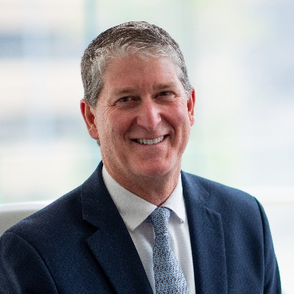
Roger brings over 40 years of global industry experience across Asia, the Middle East, Europe and the US. He previously served as President and CEO of NOVA Chemicals and as COO at Westlake (NYSE: WLK), and he has held senior operational and investment roles at Solvay. He has a strong track record in scaling businesses, establishing joint ventures and driving operational and financial performance.

Dr. Hasan Karam, Chief Operating Officer
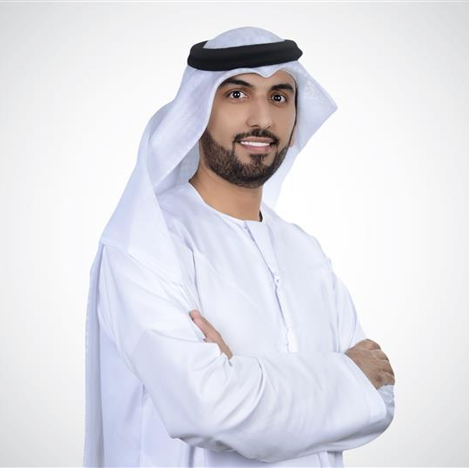
Dr. Karam, also Chief Operating Officer of Borouge Plc, brings three decades of experience in refining and petrochemicals, including senior roles at ADNOC Refining. At Borouge, he led transformation and operational excellence at the world’s largest single-site polyolefin complex, delivering record production and advancing efficiency through AI and digitalization.

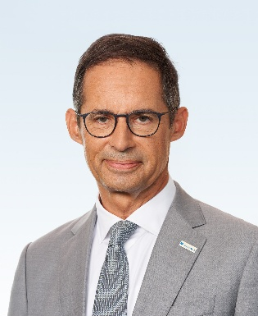
Dr. Stefan Doboczky, Chief Commercial Officer
Stefan most recently served as CEO of Borealis. Over a 30-year international career, he has spent more than a decade as CEO and Executive Board member of listed and private companies. He held senior leadership roles at Royal DSM across Europe and Asia, and was previously CEO of Lenzing AG before moving into private equity. Stefan holds a Ph.D. in Chemistry from the Vienna University of Technology, Austria and an MBA from IMD Lausanne, Switzerland.

Patrick Jany, Chief Financial Officer
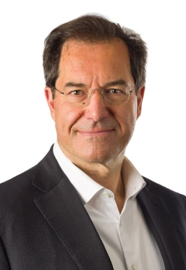
Patrick Jany is Chief Financial Officer of Borouge Group International AG. He brings more than three decades of international finance leadership across the industrial, logistics and chemicals sectors, including 20 years as CFO of publicly listed companies. He most recently served as Executive Vice President and CFO of A.P. Moller-Maersk, following senior finance and leadership roles at Clariant AG and Sandoz AG. He holds an MBA from ESCP Business School.

