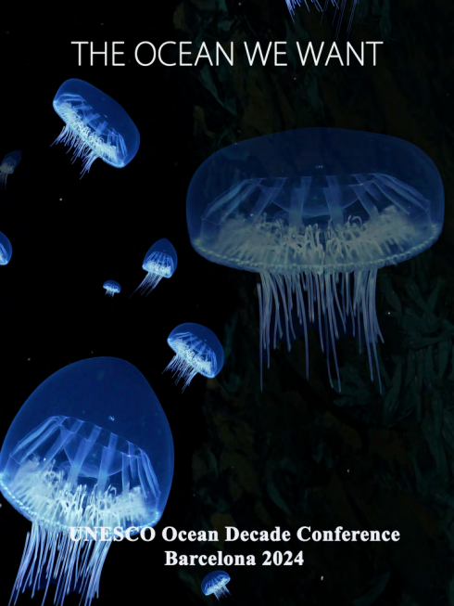
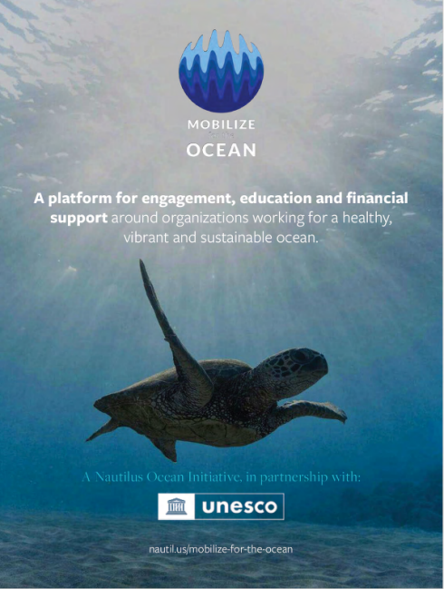
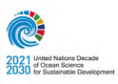
ARTIST-AT-SEA EXHIBITION CONCERT FOR THE OCEAN
OPENING RECEPTION
BARCELONA, SPAIN
WEDNESDAY APRIL 10, 2024
CO-HOSTED BY
 Cover photo by Schmidt Ocean Ins6tute
The Ocean We Want
By John Steele

The sea, that vast canvas upon which the drama of nature unfolds, presents us with a riddle wrapped in a mystery. It stands as a testament to the immense power inherent in the natural world, its roaring waves and mighty currents carving the very bones of our continents, shaping the breath of our climates. Yet, this same power belies a vulnerability, a delicacy that is all too easily disturbed by the subtle and not-so-subtle intrusions of nature's own creation, humankind.
The endeavor to safeguard the ocean's majesty is not a solitary quest but a symphony of collective action and innovation. It is a journey that commences with the awakening of our collective consciousness to the pivotal role that these waters play in the health of our planet and the myriad forms of life it cradles.
UNESCO and partners like Nautilus magazine and the Schmidt Ocean Institute, under the banner of the United Nations Decade of Ocean Science for Sustainable Development, have embarked on a mission to cast a light upon the ocean's grandeur and the perils that lie in wait. Through a marriage of art, science, fashion and music, unveiled at the 2024 Ocean Decade Conference, they delve into the profound bond that links humanity with the marine realm.
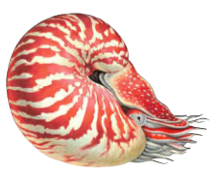
Beneath the ceaseless turmoil of the ocean's surface lies
a domain of unfathomable depth, a wilderness of blue that
blankets more than seventy percent of our earthly home.
This mysterious expanse, profound and inscrutable, thrives
with a mosaic of life, woven into a complex web of existence.
Coral reefs, those vibrant metropolises beneath the waves,
serve as cradles for a multitude of species, their dazzling hues
a testament to the life's richness hidden from our direct view.
Amidst the vast openness of the sea, grand migrations unfold,
with beings from the minuscule zooplankton to the majestic blue
whales embarking on monumental voyages over immense stretches of water.
The imprint of human actions—be it through the specter of climate change, the scourge of plastic pollution, the ravages of overfishing, or the destruction of habitats—is felt across the globe, in even the most secluded waters. The tales the ocean tells are of both resilience and frailty, of cycles that have endured through eons, now confronting challenges of an unprecedented scale.
Our bond with the ocean is not merely beneficial but essential, pivotal to our continued existence and that of our planet. As we gaze into the future, the destiny of these waters is indissolubly linked with our own. We are called to be the guardians of this magnificent domain, to ensure that its story—and, by extension, ours—unfolds across the vast expanse of time, for generations yet to come.
John Steele, Nautilus Publisher
AN EVENING OF OCEAN ART, SCIENCE AND MUSIC
Celebrate this unique confluence of art, science, and music, dedicated to amplifying the

message of ocean conservation and exploring the deep connections between humanity and

the marine world

April 10, 2024

Barcelona International Convention Centre 18:30 – Plenary Hall
UNESCO, Nau6lus and Schmidt Ocean Ins6tute Present
A Concert for the Ocean
Oud Maestro and UNESCO Ar6st for Peace
Nasseer Shamma
With
The Barcelona Guitar Trio
19:30 – Banquet Hall
Cocktail Recep6on
Entrance Hall
Ar>st at Sea
Presented by Schmidt Ocean Ins3tute

UNESCO / Nau5lus / Schmidt Ocean
Present
A CONCERT FOR THE OCEAN
With a special program performed by
Oud Maestro and UNESCO ArIst for Peace
Nasseer Shamma
With
The Barcelona Guitar Trio
The renowned Iraqi oud player Naseer Shamma was designated UNESCO Artist for Peace in February 2017, in light of his commitment to support the musical education of young people in Iraq and beyond.
Through his performances, Naseer Shamma carries a message of peace, respect and mutual understanding. In June 2008, he joined the World Refugee Concert organized by the United Nations High Commissioner for Refugees (UNHCR) in Baghdad. In addition, since 2012, Naseer Shamma organises concerts at Baghdad for the International Day of Peace, celebrated annually on 21 September.
In his capacity as a UNESCO Artist for Peace, Naseer Shamma aims to safeguard Iraq’s cultural heritage and its critical role in the transmission of memory and in inter communal dialogue.
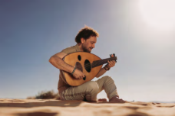
The Program
1- Qitaf
2- A World without Fear
3- Inscriptions
4- Garcia Lorca
5- Earth Call (Naseer Shamma Solo)
6- Shaqlawa
7- Ishraq
ARTIST AT SEA
Loca%ons
Barcelona Interna,onal Conven,on Centre
Entrance Hall
April 10th – 12th
Schmidt Ocean Institute
Artist-at-Sea Collection
The ocean in*luences and sustains all life. Schmidt Ocean Institute’s Artist-at-Sea program harnesses the power of art and science to motivate action for our planet and our shared future through transformative, immersive art experiences. Scientists illuminate processes fundamental to our lives here on Earth, and artists are potent storytellers, inspiring people to see and experience our world in new ways.
Schmidt Ocean Institute’s research vessel, Falkor (too), and our robotic guide to the deep, ROV SuBastian, are available at no cost to scientists working to understand our ocean. Life at the sea*loor is shrouded in mystery, but artists can transform these remote ecosystems into something tangible. With robust collaborations between artists and some of the world’s leading marine scientists, our science expeditions offer a range of unique technology-based ocean research ripe for artistic exploration.
“To stand at the edge of the sea, to sense the ebb and 0low of the
tides, to feel the breath of a mist moving over a great salt marsh,
to watch the 0light of shore birds that have swept up and down
the surf lines of the continents for untold thousands of years, to
see the running of the old eels and the young shad to the sea, is
to have knowledge of things that are as nearly eternal as any
earthly life can be.”
By Rachel Carson
Ar%sts
Taiji Terasaki
Rebecca Rutstein
Runa Ray
Gayil Nalls
TAIJI TERASAKI
Deepest Reveries (Sueños Profundos), 2024
UV printed foam core, metal brackets, UV printed vinyl decals, augmented reality components 32 x 30 feet (9.75 x 9.14 meters)
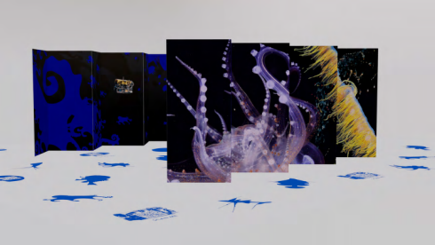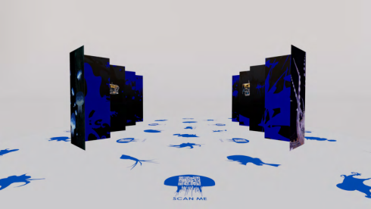
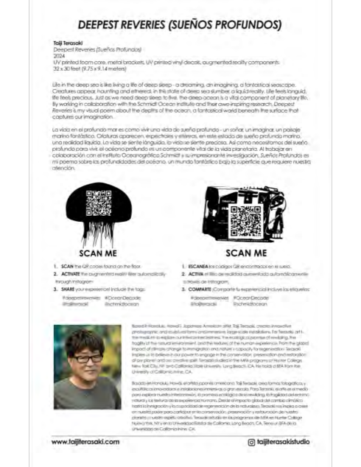
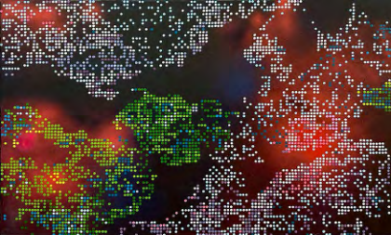REBECCA RUTSTEIN
Blue Dreams, Still #1, 2023 Acrylic
and spray paint on canvas 36" x 60"
Blue Dreams was created in collaboration with scientists from the Ocean Memory Project and supported by the National Academy of Sciences Keck Futures Initiative. Blue Dreams, which was recently on view at the National Academy of Sciences through the generous support of Schmidt Ocean Institute is an immersive video installation which integrates abstract imagery, rare deep sea video footage captured on an R/V Falkor expedition, and computer modeling to illuminate hidden microbial networks in the deep Ocean. These networks regulate global ocean chemistry and mediate the air we breathe. The video is meant to inspire curiosity, wonder and connection to the deep Ocean, which we rely on for our survival.
In part of the video, Rutstein worked with a computer modeler who “animated” a painting inspired by deep sea microbial networks, transforming her wireframe imagery into pixels that morph and grow. In the painting on display here, Rutstein comes full circle, using the video animation as inspiration for this new painting. Courtesy of Rebecca Rutstein and Bridgette Mayer Gallery.
Rebecca Rutstein sailed on R/V Falkor June 2016 on a mapping transit from Vietnam to Guam.
GAYIL NALLS
World Sensorium: OCEAN, 2023
Composition of marine and terrestrial plant essential oilsfrom around the globe 160 x 50ml Black Glass Bottle Mister
Gayil Nalls, PhD, created the olfactory artwork "World Sensorium: OCEAN" to offer a sensorial journey, ignite emotional connections, and delve into the aesthetic essence of the ocean.
Drawing inspiration from the ocean's largely unexplored chemically mediated ecosystem, Nalls portrays it as a pulsating, majestic eternity where chemical signals often orchestrate behaviors and processes. For her, the ocean symbolizes the birthplace of all life, a realm she consistently finds herself drawn back to. This artwork continues the World Sensorium project, endorsed by the United Nations Educational, Scientific and Cultural Organization (UNESCO) and the President’s Committee on the Arts and Humanities (PCAH).
To evoke the essence of the ocean and trigger memories associated with it, Nalls taps into her extensive research and countless olfactory encounters from her own life and experiences with the ocean in various locales. These include sensory impressions from the briny Mediterranean, the sulfurous scent of sargassum during low tide along diverse coastlines, and the mingling of soil and plant aromas blending into oceanic waters. She captures the essence of aromatic plants carried by ocean winds, merging, and dispersing across different global locations, reminding us of the deep connections we share with this vital ecosystem.
For more information visit worldsensorium.com/product/world-sensorium-ocean/
MAKING HUMANS AQUATIC
_{© Shutterstock.co}m
JOIN
THE
OCEAN
KNOWLEDGE KNOWLEDGE
REVOLUTION REVOLUTION
Scan for more Scan for more
information or visit information or visit
oceandecade.org oceandecade.org

