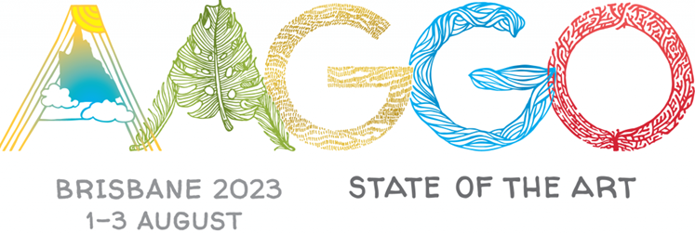
FORM 1

Payment method and registration notification – Round one

Please complete all sections on this form and forward, together with Form 2 and the completed Registration Forms for each delegate to:

Angela Butler at abutlercox@gmail.com

Or by mail to:

Angela Butler
Volunteer Guide/AAGGO Treasurer
QAGOMA
Stanley Place
South Brisbane 4101. Queensland

AAGGO Member Gallery
Gallery Address
AAGGO representative name
Person completing the enclosed documentation, (if different from above)
Email
Mobile
Number of places allocated
Number of delegates registering
TOTAL PAID | $
EFT payment
Date transferred
Payment reference | xxxx DEL FEES 23 (xxxx = abbreviation for your gallery)
Number of applicants on your waiting list
Signature
Name
Date

FORM 2

List of delegates

- Please list below each delegate registering from (INSERT THE NAME OF YOUR GALLERY)
- Please make additional copies of this form if space provided is inadequate
- Please keep a copy of this form and each guide’s registration form for your own records

 | First name | Last name | Amount paid
1.
2.
3.
4.
5.
6.
7.
8.
9.
10.
11.
12.
13.
14.
15.
16.
17.
18.
19.
20.
 | TOTAL PAID TO COMMONWEALTH BANK ACCOUNT

