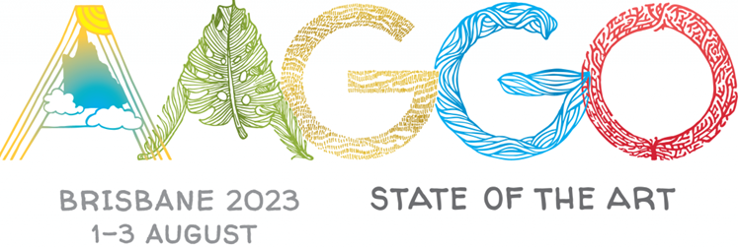
DELEGATE REGISTRATION FORM
Please complete this form and return it to your AAGGO Representative with your payment. Your representative will send it to the Conference Committee as one bulk application.

First Name |  | Last Name
Preferred name for name tag
Gallery
Mobile |  | Email
Emergency contact

Conference Registration |  |  | $450
Tuesday 1 August
- Welcome Drinks | Yes/No
Wednesday 2 August
- Conference Dinner |  | Yes/No

Afternoon tours
Your complimentary ticket to Michael Zavros and eX de Medici can be used at any time on any one day. You will be able combine a visit to the exhibitions with other excursions.
Wednesday 2 August |  |  | Select
- Michael Zavros and eX de Medici | At leisure
- GOMA collection storage | 1.30-2.00
- GOMA collection storage | 2.30-3.00
- QAG conservation framing studio | 1.30-2.00
- QAG conservation framing studio | 2.30-3.00
- State Library of Queensland | 1.30-2.30
- State Library of Queensland | 3.00-4.00
- Griffith University Art Gallery | 1.30-3.00
Thursday 3 August |  |  | Select
- Michael Zavros and eX de Medici |  | At leisure
- QUT/William Robinson Gallery |  | 1.30-4.00
- Museum of Brisbane |  | 1.30-4.00
- Art & Sculpture Walking Tour of Brisbane |  | 1.30-4.00

Full day tours
Please select your preferred option. If you would like to be offered another tour in the event your first choice is not available, please indicate your 2nd (and 3rd) preference.

Friday 4 August |  | Select
- Bond University and HOTA | $75 (+ lunch)
- The Paint Factory and Ipswich Art Gallery | $75 (+ lunch)
- Urban Arts Projects and Abbey Museum | $75 (incl. lunch)

TOTAL of Registration Fee + your first choice full day tour | $

Please indicate any dietary restrictions | Vegetarian, Vegan, Gluten free, Other

