Summary of Toitū NET carbonZero- CERTIFIED event operations

Business Events Industry Aotearoa Limited's MEETINGS 2023

*Business Events Industry Aotearoa Limited's MEETINGS 2023 meets the requirements of Toitū net carbonzero event operations certification having put in place a greenhouse gas emissions management plan prior to the event, estimated the event's life cycle emissions during the event, and neutralised the remaining unavoidable emissions excluding attendee travel emissions through cancellation of an appropriate number of verified carbon credits in respect of the event held at Tākina Wellington Convention & Exhibition Centre on 20 - 22 June, 2023.*

introduction[1]

Managed by Business Events Industry Aotearoa (BEIA), MEETINGS 2023 is New Zealand’s largest trade show for the business events sector. As the official association for the industry BEIA are committed to the long-term measurement, management and reduction of greenhouse gases associated with this event in order to support existing goals and to identify opportunities for future improvements.

event description[2]

Toitū net carbonzero certified event

* Scope: “event operations” scope[3]
* Functional unit: 0.159 tCO2e per delegate at the event
* Event date: 20/06/2023 to 22/06/2023
* Number of delegates: 1,003
* Boundaries: The measurement method follows the principles of life cycle approach focussing on the main emission sources for an event.

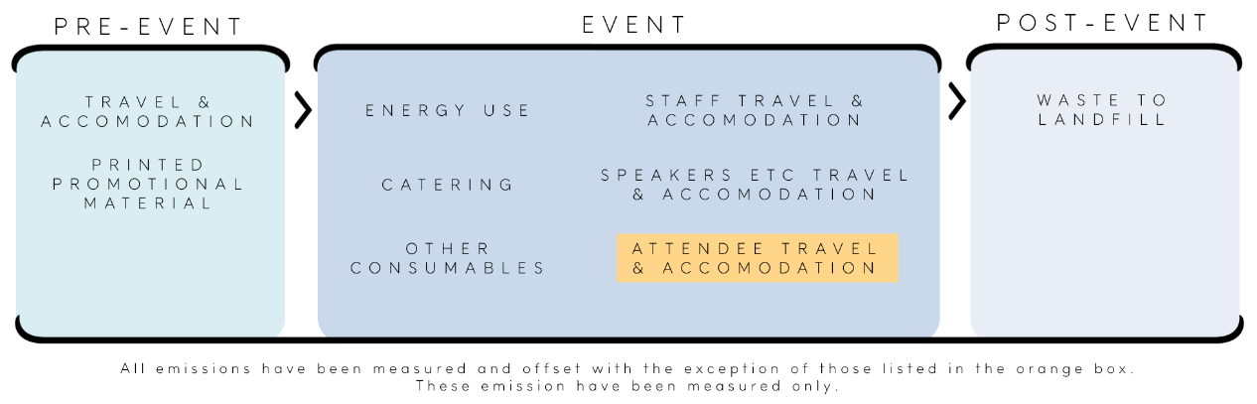

Figure 1: Emissions sources by event stage

# ghg emissions source inclusions

The event’s total emissions were:

|  |  |  |
| --- | --- | --- |
| Pre-event (organiser travel, printed material, freight infrastructure | 124.83 | tCO2e |
| Other travel and accommodation (speakers, sponsors, exhibitors, performers, artists, musicians, staff, crew, vendors) | 17.63 | tCO2e |
| Event – (energy, catering, waste) | 17.05 | tCO2e |
| **Event operations:** | **139.01** | **tCO2e** |
| Attendee travel and accommodation: | 20.49 | tCO2e |
| Total event emissions: | **159.51** | **tCO2e** |

exclusions

The following emissions sources were excluded from the inventory for this event:

* Day Buyer and exhibitor travel to the event, as this is not included in the Event Operations scope.
* Day Buyer and exhibitor accommodation, as this is not included in the Event Operations scope.’
* Hosted Buyer travel from home address to departure port.
* Exhibitor giveaways where material was unknown or insufficient information was provided to ascertain total quantity.
* Air travel offsets outside scope of hosted buyers and staff.

# GHG REDUCTION COMMITMENTS

The event has developed a GHG emissions reduction plan. Some projects in this plan include:

* Offset air travel of all hosted buyers and event staff.
* Encouraging exhibitors and day buyers to offset travel and freight emissions.
* Eradication of complimentary satchels and bags for buyers and encouraging attendees to bring their own reusable bags.
* Use of water coolers instead of bottled water and encouraging attendees to bring their own reusable water bottle.
* Encouraging reduction of printed material and use of digital assets by exhibitors, media partners BEIA.
* Ensuring the accurate ordering of food and beverage to reduce waste.
* Providing shared transport from airport to CBD for Hosted Buyers
* Encouraging walking to the venue from nearby hotels.
* Replacing physical Hosted Buyer gifts with donation to local good causes.

# OFFSET

130 credits from batch #0484, Birds, bees and business, have been cancelled on the Toitū Envirocare register and will be cancelled (or equivalent) on the relevant external registry within one month of certification. Specific details of cancellation, including serial numbers, will be available on the external registry: Gold Standard <https://registry.goldstandard.org/credit-blocks>.

Note: The 20.49 tCO2e from attendee travel were not required to be offset as this event is being certified to a “certified event operations” scope. A further 9.84 tCO2e was offset directly with the supplier.

# Certificate details

Verified by – Figure Eight Consulting

Certification status – Toitū net carbonzero certified “event operations”

Certificate number – 2023417

Valid for – 20/06/2023 to 22/06/2023

15-17 Hurstmere Road, Takapuna, Auckland, 0740 New Zealand  
Telephone: +64 (0)20 4063 7605. Email: chris.peak@beia.co.nz. Web: www.beia.co.nz

1. **Disclaimer:** This Disclosure Statement is a summary of the verified information considered for certification and the certification decision. It should not be taken to represent the full submission for certification. Whilst every effort has been made to ensure that the information in this Disclosure Statement is accurate and complete, Enviro-Mark Solutions Limited (trading as Toitū Envirocare) does not, to the maximum extent permitted by law, give any warranty or guarantee relating to the accuracy or reliability of the information.
2. For certification, these measurements undergo an independent verification for accuracy but no assurance can be given due to the inherent uncertainty around event data.
3. Certified “event operations” measures all emissions sources but does not offset those from attendee travel.