Part 91 Airspace Authorization Request
  - Operations Above UAS Facility Map Altitudes

Overview
[AGENCY NAME] has a need to conduct operations across [Airspace or Jurisdiction, e.g. the city of Fargo and FAR Class D] for the purpose of public safety and emergency response. The Operator proposes to operate above published UAS Facility Map altitudes within the requested areas, as depicted in the supporting graphics. We hold a Part 91 authorization from the FAA to conduct BVLOS operations.

Operations will be planned and conducted to remain clear of known aviation hazards and areas of increased aircraft activity. Where applicable, the Operator will use geographic boundaries, altitude limitations, and other operational mitigations to maintain a safe distance from aircraft arriving at or departing from nearby airports.

GIS files depicting the requested operational boundaries are included with the request for evaluation.

Proposed Flight Area
[INSERT PROPOSED FLIGHT AREA GRAPHIC HERE WITH ANY RELEVANT DESCRIPTION]
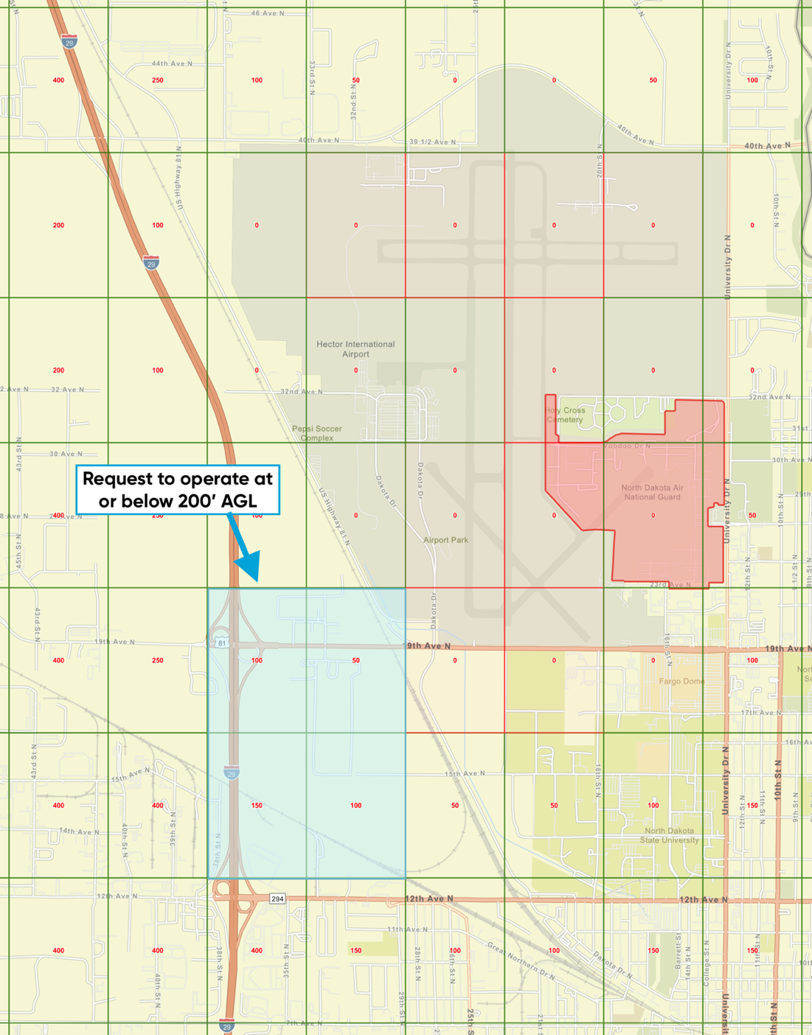

A KMZ/KML of the proposed area is included with the request.

Additional Safety Mitigations
The following section describes additional Skydio safety mitigations that will be used to remain a safe distance from crewed aircraft. These are additional layers on top of the proposed flight are being offset from low altitude operations.

Geofencing
Skydio Cloud includes geofencing capabilities, called Skydio Sites, that the Operator will use to keep the sUA in the intended flight area. The geofencing capabilities include both horizontal and vertical limits.
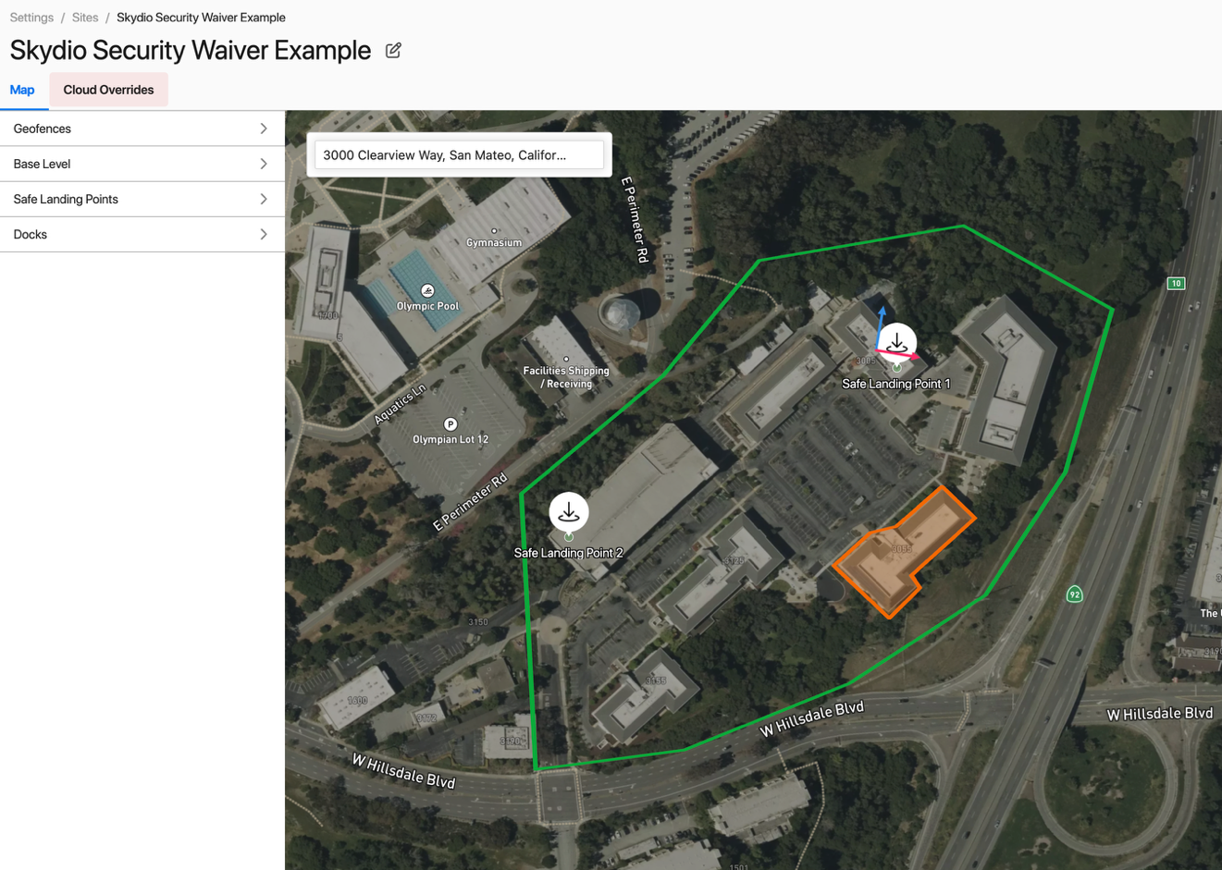
Figure 1 Geofencing capabilities example in Skydio Cloud (Sites)

Return (to Home) Behavior
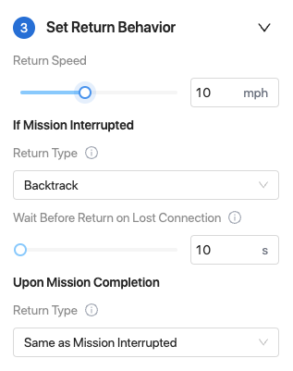
The Settings menu includes Return Behavior settings shown to the right. Obstacle avoidance is always on during these behaviors.
Figure 2 Return Behavior

The Lost Communication Timeout is a global setting that determines how long the sUA waits, after loss of C2 occurs, before executing the Return Behavior actions described below.

Up & Over Return Type
After the lost communication timeout, the drone will initiate a climb based on the Height Behavior and Return Height settings.
- If Absolute Height Behavior is set, the drone will climb to a target altitude of Takeoff Location Height + Return Height
  - If sUA Current Height is higher than the Takeoff Location + Return Height, the sUA will remain at its Current Height during the Return behavior.
- If Relative Height Behavior is set, the drone will climb to a target altitude of Current Height + Return Height

Then the sUA will fly laterally in a direct path to the Dock and execute an automated landing.

Backtrack Return Type
After the lost communication timeout, the drone will fly backwards along the flight path (laterally and vertically) that it took to get to its current location. The vehicle will trim loops off the flight path to shorten the amount of time it takes to reach Dock. Once it reaches Dock, it will execute an automated landing.

Use of ADS-B In to remain a safe distance from cooperative aircraft
At all times, the PIC monitors the airspace using ADS-B In data. ADS-B information is displayed to the Remote Pilot on the Remote Flight Deck. ADS-B traffic is filtered to declutter the display and ADS-B alerts are included to make it clear to the Remote Pilot when a low flying cooperative aircraft is nearby.

When a cooperative aircraft gets within 1.2 NM laterally and 1,000’ vertically of the sUA, an alert will display on the Remote Flight Deck to let the RPIC know he or she should check for ADS-B traffic and decide if a maneuver is necessary. This alert is shown below.

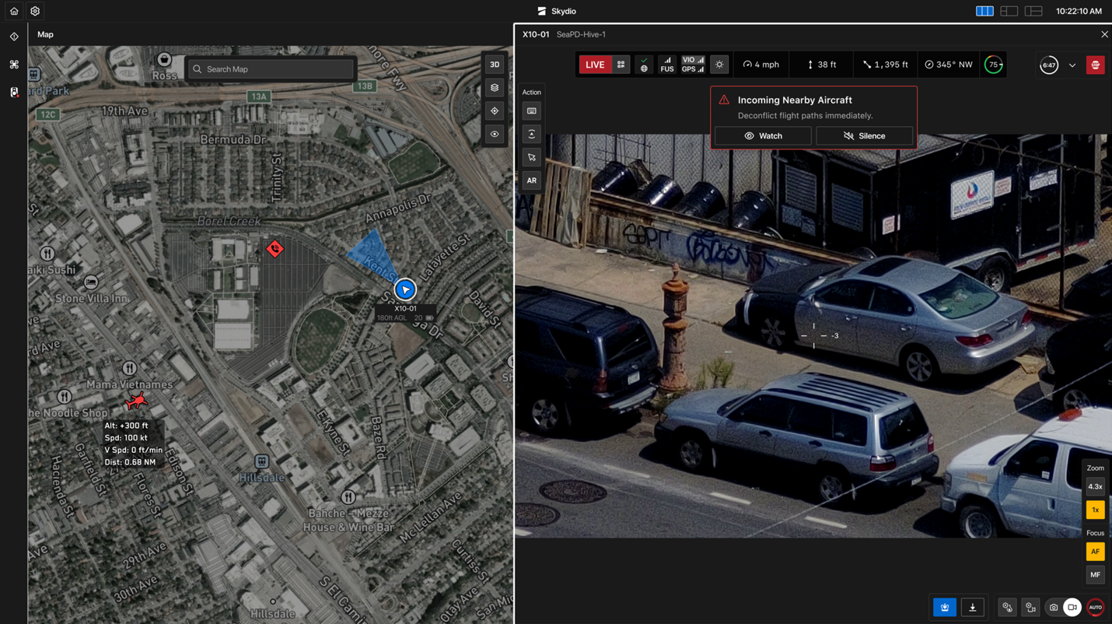
Figure 3 Traffic alert on Remote Flight Deck
If the Remote Pilot expects cooperative traffic to converge on the flight area within 2,000 ft laterally and ± 250 ft vertically, he or she will stop the mission and execute a safe state maneuver. The Remote Pilot will wait until the incoming traffic is diverging before continuing the mission or electing to Return to Dock.

Skydio Collision Avoidance Technologies
The PIC can safely operate at the low altitudes proposed (<200’ AGL or within 200’ of an object) using Skydio collision avoidance technology. Details about this system can be found at this website: https://www.skydio.com/skydio-autonomy.

Skydio X10 navigates using visual inertial odometry (VIO), meaning it sees in all directions from airframe and will automatically prevent the PIC from impacting objects and buildings.

In addition to Skydio VIO, Skydio Pathfinder is another feature that enables the sUA to intelligently and safely travel from a launch point to a designated destination—and return—while adhering to user-defined and environmental constraints.

When enabled, Pathfinder dynamically plans optimized flight paths by considering:
- Environmental context
  - Terrain elevation
  - Building heights and other objects
- Regulatory constraints
  - Altitude constraints (flight below 200’ AGL or within 100’ of structures)
- Customer-defined preferences
  - Preferred flight altitude AGL (also allows for flight plan deconfliction between drones)
  - Minimum distance to buildings (configured per Site)
  - Custom geofences that define no-fly zones
  - Routing preferences (e.g., fly around buildings instead of over them)
This advanced routing logic is applied to both outbound and return paths, including Return to Home (RTH) operations. By enabling Pathfinder, users equip their drones with a higher level of environmental awareness, resulting in smarter, faster, and safer flight.
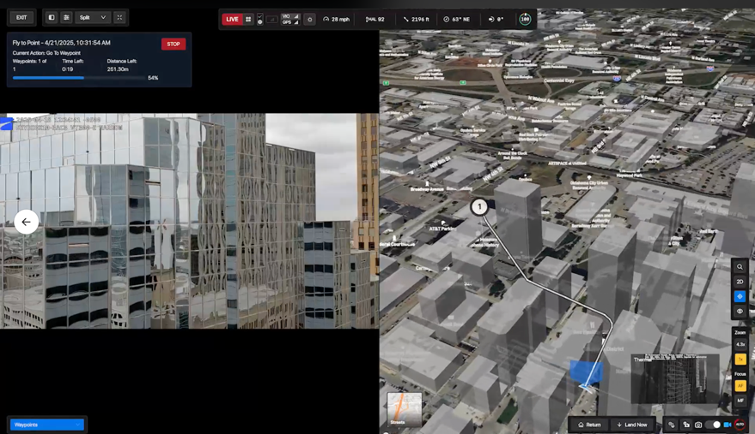
Figure 4 Pathfinder example showing X10 automatically routing

