Example 1: Solar System

Part 1: Make Sense of our Solar System
Take some time to explore these resources.
Video: How the Movement of Other Planets Affects Earth — Yes, Really
Article: Planet Movements Impact Earth

Discuss with your group the following questions.

- What might the motion of the planets tell us?

- What factors do you think influence the motion of the planets?

In the early 1600s, Johannes Kepler (1571–1630) studied the motions of the planets to find a good mathematical model for them. In 1619, he published his third law of planetary motion, which says how the orbital periods of the planets are related to their distances from the sun. In Kepler’s time, Uranus and Neptune had not been discovered, but in the table below are data for all 8 planets:

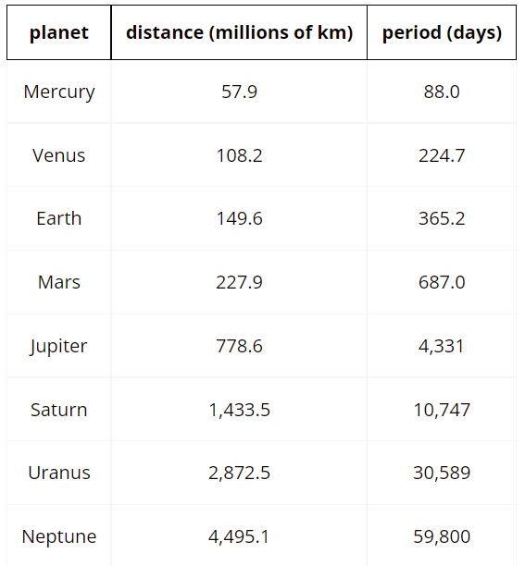 | Understanding the data:  What do you think the term “period” means here?  What do you notice about the distance and period? How would you describe the relationship between them?
What sort of function do you anticipate will fit this data? How did you arrive at that conclusion?
Part 2: Graphing
- Using Desmos, plot the distance (x) and period (y) of each planet.

- Find a polynomial model that best fits the data. You may have to experiment with both the degree of your polynomial function and the number of terms.

  - Let’s try a different approach. Make another plot that uses the square root of each distance.

  - Find a polynomial model that best fits the data.

  - Exploring other models
    - Jupiter has a lot of moons. Look up the periods and distances of some of them.

Jupiter Moon | Distance (km) | Period (days)

    - Use that data to make a polynomial model of the relationship between period and distance for Jupiter’s moons.

    - Use your model to predict the period of another one of Jupiter’s moons using the radius of its orbit.

    - How good was the prediction? What are some possible sources of error?

Part 3: Analyze
Kepler’s Third Law of Planetary Motion states: “The square of the orbital period of a planet is proportional to the cube of the semi-major axis of its orbit”.
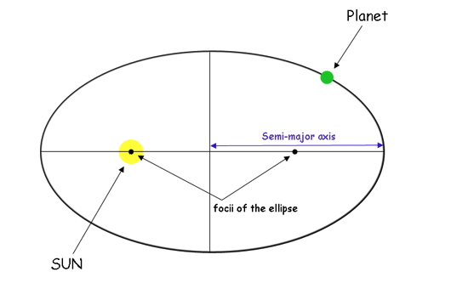

Keplers laws
- What does Kepler’s Third Law look like in terms of an algebraic equation? What do variables in that equation mean?

- How can you use the information you gathered in the table above to determine the value of the constant?

- Determine the value of the constant. Does the same constant hold for every planet? If there’s variation, why do you think that happened?

- How might knowing the value of the constant be helpful in determining what polynomial function models this relationship?

Part 4: Refine and Reflect
Jupiter has a lot of moons. Jupiter has a lot of moons. The Galilean moons were discovered in 1610, they are IO, Europa, Ganymede, and Callisto.

  - Another moon of Jupiter, number LXXI, was discovered in 2018. Its distance from Jupiter is 11,483 thousand km. According to your model, what should its period be?

  - The actual period of the moon (LXXI) is 252.0 days. How close was the prediction? What are some possible sources of error?

  - What is something you learned about the work of developing functions that model real-world phenomena?

Example 2: Equivalent But Not the Same

Part 1: Exploring Equivalent Equations
You have been given a polynomial graph with three equivalent equations. Analyze and make connections from the information in the questions below.

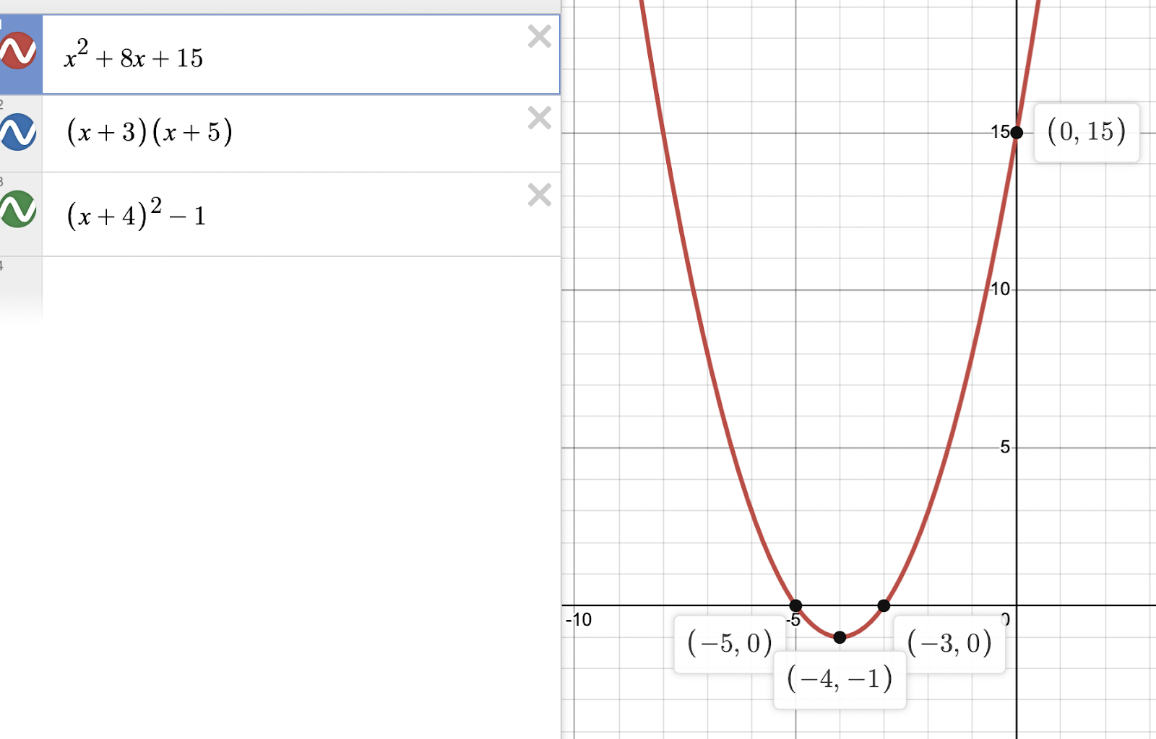
- Complete the chart below using the given graph and equations.
Write in each equation according to its form. | Explain the features of the equation connecting the graph to this form. | When would using this form of the equation be most useful?
Standard Form

Vertex Form

Factored

Part 2: Creating Equivalent Equations
- Now, you have been given the graph of a polynomial function, but the equations are missing.
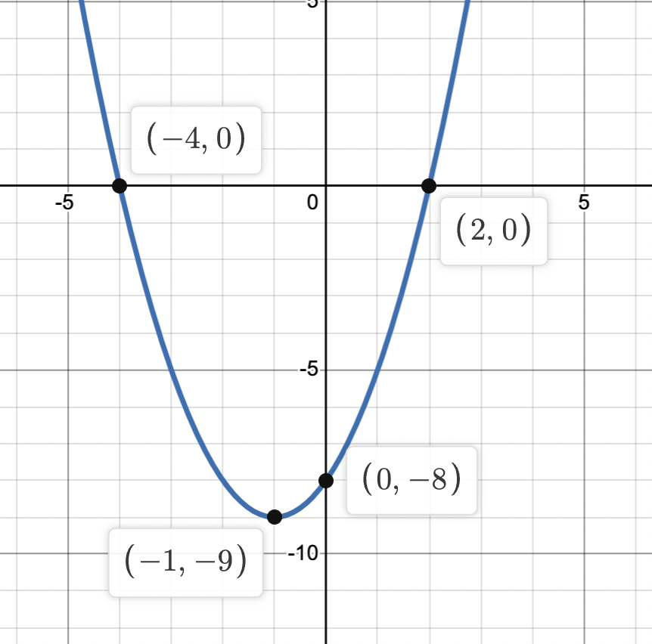
- Write an equation for the factored form. What do the values for x represent in this equation? Defend your thinking using mathematical and/or written justifications.

- Explain the process for developing the vertex form of the function. What does the value for x represent in this equation?

- Sketch the graph for your own polynomial equation using Desmos, linked here.
- From the graph, write the three equivalent equations that would produce this graph.

- Defend your thinking using mathematical and/or written justifications.

- Summarize the importance of three forms of a polynomial function.

