Example 1:Describe Your Transformations

In the two triangles pictured below, 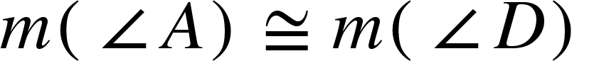 and 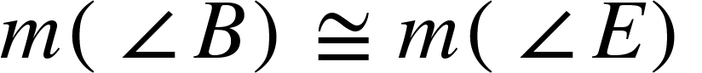):

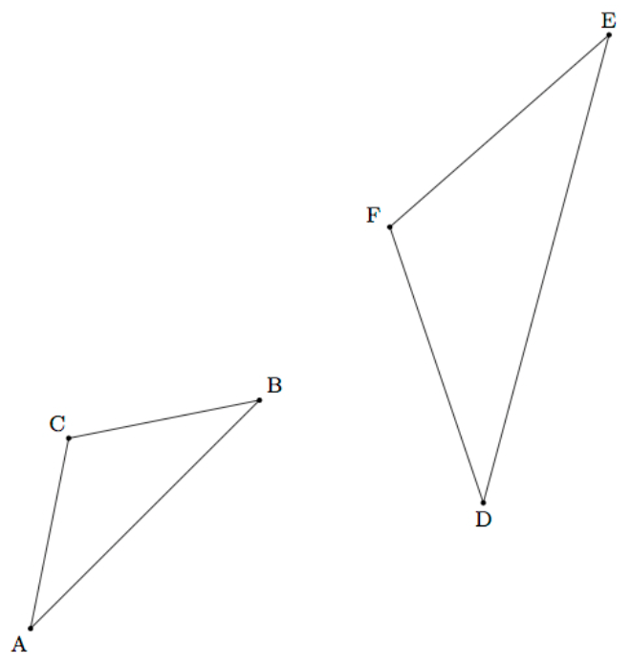

- Using a sequence of translations, rotations, reflections, and dilations, show that △ABC is similar to △DEF.

- Describe or list each move to transform the preimage △ABC onto the image △DEF.

(Illustrative Math task Similar Triangles, 2016)

- Technology extension: Use an online geometry tool to check your transformation steps. Did your transformation work? Why or why not? What would you change?

Example 2: Dilating Circles

The picture below depicts a dilation between Circle L and Circle M. A dilation is defined as, “A transformation that moves each point along the ray through the point emanating from a fixed center, and multiplies distances from the center by a common scale factor”
(Mathematics Glossary CSS ).

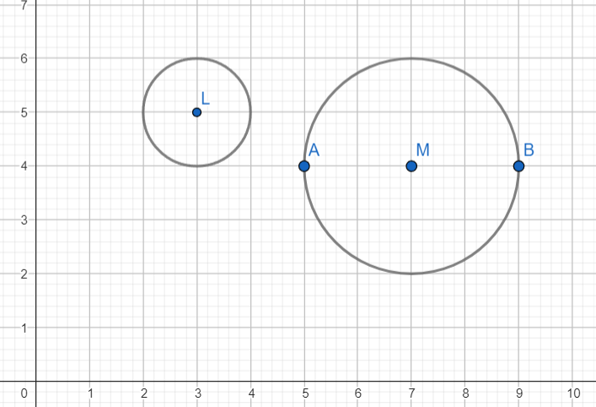
Using the image above, complete at least 4 out of 6 of the questions below.

- Given the position of the images, is Circle M a dilation from inside, on, or outside Circle L?

- Determine the scale factor of the dilation to produce Circle M.

- Use Geogebra or Desmos Geometry to recreate the image online. Then, find the center of dilation from Circle L to Circle M.

- Given a scale factor of 4 with Circle M as the preimage, what is the set of coordinates of the image of points A and B? What was the center of the dilation that resulted in those coordinates? Would a different center of dilation result in the same coordinates you found? Why or why not?

- Given a scale factor of 1/4, explain how Circle M would change. Under what conditions would this happen?

- Revisit the definition of a dilation: “A transformation that moves each point along the ray through the point emanating from a fixed center and multiplies distances from the center by a common scale factor.” How did you use parts of the definition to respond to the questions above?

