Baseline Professional Learning Handout
M215: Inference and Making Connections

Baseline Professional Learning Handout 1
Selected Common Core High School Standards for Mathematics 2
Data Science Big Ideas 2
M215 Content and Practice Expectations 3
M215 Content and Practice Expectations and Indicators 4
Let’s Investigate 6
EPA Regulations 6
Political Polling 7
Let’s do some math! Round 1 8
Task 1: Confidence Intervals 8
Learning Principles 10
Let’s do some math! Round 2 11
Task 2: Joy Milne’s Story 11
Criteria for Success 13

Selected Common Core High School Standards for Mathematics
Understand and evaluate random processes underlying statistical experiments
- Understand statistics as a process for making inferences about population parameters based on a random sample from that population.
- Decide if a specified model is consistent with results from a given data-generating process, e.g., using simulation. For example, a model says a spinning coin falls heads up with probability 0.5. Would a result of 5 tails in a row cause you to question the model?

Make inferences and justify conclusions from sample surveys, experiments, and observational studies

- Recognize the purposes of and differences among sample surveys, experiments, and observational studies; explain how randomization relates to each.
- Use data from a sample survey to estimate a population mean or proportion; develop a margin of error through the use of simulation models for random sampling.
- Use data from a randomized experiment to compare two treatments; use simulations to decide if differences between parameters are significant.
- Evaluate reports based on data.

Data Science Big Ideas

M215 Content and Practice Expectations
215.a | Use probability distributions to calculate p-values and interpret these p-values in context.
215.b | Use probability distributions to calculate confidence intervals in order to estimate population parameters and interpret these confidence intervals in context.
215.c | Conduct informal inference testing for quantitative and categorical data.
215.d | Use bootstrapping to estimate population parameters.
215.e | Make appropriate conclusions about study results using aspects of the study design.

M215 Content and Practice Expectations and Indicators

Content and Practice Expectations | Indicators  Choose an artifact where you…
215.a: Use probability distributions to calculate p-values and interpret these p-values in context. | i. produce a p-value using the appropriate probability distribution for a given scenario.
 | ii. interpret a p-value in context and state appropriate assumptions.
215.b: Use probability distributions to calculate confidence intervals in order to estimate population parameters and interpret these confidence intervals in context. | i. produce a margin of error for a parameter estimate and explain how to increase or decrease the margin of error.
 | ii. produce a confidence interval for a parameter estimate.
 | iii. interpret a confidence interval in context and state appropriate assumptions.
 | iv. interpret a confidence level in context.
215.c: Conduct informal inference testing for quantitative and categorical data. | i. describe a null and alternative hypothesis for a given scenario.
 | ii. check if appropriate conditions are met for conducting a hypothesis test.
 | iii. identify if a p-value supports the rejection of a null hypothesis.
215.d: Use bootstrapping to estimate population parameters. | i. use a sampling distribution generated by a bootstrap method to estimate a population parameter.
215.d: Use bootstrapping to estimate population parameters. | ii. demonstrate understanding of the effect that sample size has on the bootstrap distribution.
215.d: Use bootstrapping to estimate population parameters. | iii. demonstrate understanding of the effect that number of repeated samples has on the bootstrap distribution.
215.e: Make appropriate conclusions about study results using aspects of the study design. | i. describe Type I and Type II errors in the context of a given scenario.
 | ii. choose a significance level for statistical significance or confidence level by weighing the consequences of Type I and Type II errors and use that significance level to draw a conclusion about a hypothesis.
 | iii. use various significance or confidence levels to draw conclusions about a hypothesis.
 | iv. given a description of a study with or without random assignment, determine whether there is evidence to infer a causal relationship.
 | v. given a description of a study with or without random selection of a sample, determine whether results infer a generalization to the population.

Let’s Investigate

EPA Regulations
- List all the ways that you used your home’s water yesterday (e.g. shower).
  - Use this EPA database to look up if your city’s water system has violated any rules. Directions:
    - Click your state, type in your water system’s name, press Enter, select your water system
    - Look at the Health-Based Violations section of the report. If your water system has had any health-based violations, you should see the contaminant that was found and, below, whether the water system is now compliant.
  - Based on the report, do you believe your water is safe? Why or why not?

- An important EPA regulation is the Lead and Copper Rule: No more than 10% of households can have prominent lead levels (defined as >15 parts per billion) in their water. Lead contamination can cause heart problems, kidney failure, and even lower IQ. Imagine your water failed this rule, and the issue wouldn’t be fixed for several years. How would your life change?
Source: Skew the Script

Political Polling
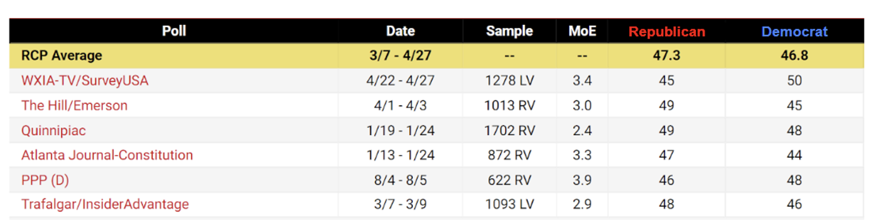

- Above is a table showing poll results in the lead-up to a recent Senate election in Georgia. Pay particular attention to the “MoE”, “Republican", and “Democrat” columns. What do you notice? What do you wonder?

- Today, you and your classmates will be pollsters! You are polling a large swing state (meaning the elections are often close). There are two candidates: one Democrat and one Republican. Assume all voters will vote for one of the two candidates. Using the Desmos activity, randomly poll n = 25 people and calculate the proportion who plan to vote for the Democrat. Do you believe the Democrat will win exactly this proportion of votes on election day? Why or why not?

- Provide a margin of error (MoE) around your sample proportion, to create an interval where you’re very confident you’ve captured the true proportion.

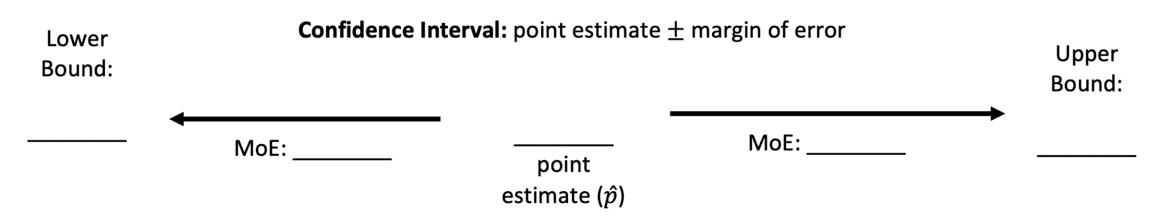

Source: Skew the Script

Let’s do some math! Round 1

Task 1: Confidence Intervals

In this activity, you will use the applet at www.tinyurl.com/appletCI to learn what it means to say we are “95% confident” that our confidence interval captures the true proportion. Set the population proportion to 0.5, the confidence level to 95%, and the sample size to 75. Click “Sample” to choose a simple random sample and display the resulting confidence interval. The confidence interval is displayed as a horizontal line segment with a dot representing the sample proportion in the middle of the interval. The true proportion (p) is the green vertical line.
- Did the first confidence interval capture the true proportion?
- Repeat this 10 times. How many of the intervals capture the true proportion?
With a partner, explore this applet by generating many confidence intervals for different confidence levels, then again for different sample sizes. Use the “Sample 25” button to generate many confidence intervals at once.
Sample Learning Experience
In this activity, students will use the Confidence Intervals applet to better understand the interpretation of a confidence level and also to discover how changing the confidence level and sample size will affect the confidence interval.
Students will pair up to explore this applet. Monitor for students who notice a relationship between the percentage of intervals that capture the true proportion and the confidence level percentage. Also look for students that recognize the length of the confidence intervals differing for various reasons. Intentionally call on these students during class discussion.
Have each pair of students combine with another pair of students to create groups of four. In their groups, ask students to discuss their findings. Conduct a class discussion with the following guiding questions:
- What did you notice?
- What do you still wonder?
- ​​What did your group mates notice that you and your original partner did not notice?
- How does the confidence level affect the confidence intervals?
- How does the sample size affect the confidence intervals?
After this discussion, ask students to estimate two confidence intervals by individually filling in the blanks to the following two sentences:
- I am 60% confident that tomorrow’s temperature will be between _____ and _____ degrees Fahrenheit.
- I am 95% confident that tomorrow’s temperature will be between _____ and _____ degrees Fahrenheit.
Ask students to discuss the differences in their two intervals in their groups. After some time, discuss as a class:
- Were our two intervals the same or different? Why?
- What did your groups notice about the relationship between confidence level and the intervals?
- If you are using confidence intervals to decide what clothing you are going to wear, do you feel that one of the intervals is more useful than the other? Why or why not?
Adapted from StatsMedic

Learning Principles
Engage with cognitively demanding tasks in heterogeneous settings (LP 1). Students should be given opportunities to grapple with multistep, non-routine tasks that promote mathematical rigor. These experiences should be differentiated so that all students engage in appropriate challenges—for example, through tasks with multiple entry points and solution pathways. These experiences should continue to integrate knowledge and skills developed in grades 6-8 at the level of sophistication of high school mathematics.

Engage in social activities (LP 2). Students should have opportunities to work independently and to communicate with one another about mathematics by engaging in collective and collaborative learning activities. Explaining and having opportunities to revise one’s thinking has excellent value in solidifying one’s knowledge.

Build conceptual understanding through reasoning (LP 3). Students should be given the opportunity to reason, justify, and problem solve with critical thinking, reading, writing, speaking, and listening. Through reasoning and work with multiple representations, students learn why procedures work and build a conceptual understanding of key mathematical ideas.

Have agency in their learning (LP 4). Students should be able to choose tasks and learning experiences that align with their interests and aspirations. All students have rich and varied experiences and home lives. Learning mathematics should bring students’ identities and interests to the fore and build on the strengths that they bring to the learning space.

View mathematics as a human endeavor across centuries (LP 5). Students should understand that mathematical ideas emanated over time from civilizations around the world and have opportunities to explore these contributions to mathematics. Students should develop an appreciation of mathematics as a human endeavor: one in which they feel a sense of belonging, where they see themselves as mathematicians, and one that offers opportunities to broaden their ideas about what mathematics is, how it is used, and who it is for.

See mathematics as relevant (LP 6). Students should engage with mathematics in ways that authentically involve real-world situations. Problem-solving contexts should allow students to perceive mathematics as a tool for addressing the questions that arise in everyday life, as well as the ways it can model our world and address global economic, social, and environmental challenges. Students should also engage with mathematics in ways that connect to academic disciplines and future careers by doing the mathematics used by artists, designers, engineers, and other professionals.

Employ technology as a tool for problem-solving and understanding (LP 7). Research indicates that technology is a powerful tool for learning deeper mathematics by improving calculation efficiency and enabling more sophisticated analysis. Students should learn to use technology, with emphasis put on widely used tools and software, such as calculators and spreadsheets, to make sense of models. Technology use should not be limited to supporting “doing mathematics,” but should also be used as a tool for displaying and communicating results to appropriate audiences.

Task 1: Confidence Intervals Student Work

Example 1:
Student work goes here

Example 2:
Student work goes here

Let’s do some math! Round 2

Task 2: Joy Milne’s Story
Part 1: Joy Milne’s Story
Take a couple of minutes to watch this video about Joy Milne. What questions surface for you as you listen to her story?

Part 2: A Simulation
Let’s investigate whether Joy’s result could have happened purely by chance, just by guessing. Working in pairs, you will simulate this study. One person will be the experimenter and one person will be Joy; then you will switch.

Important: the experimenter should not reveal the truth for each shirt. They should simply record whether the guess was correct or incorrect.

As the experimenter, keep track of the results:
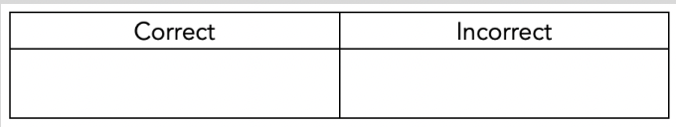

Count up the number of correct decisions. Write the number on a sticker dot and bring it to the dotplot poster at the front of the room. Discuss with your partner what you notice and wonder about the class dotplot.

Part 3: Reflecting on this experience During the class discussion, two terms were introduced: p-value and significance level.
- What do these things mean? Use examples from Milne’s story and the class experiment to illustrate.
- Why are these two ideas, p-value and significance level, important?

Sample Learning Experience
Part 1: Joy Milne’s Story
Begin class by showing this video about Joy Milne, a woman who claims she can smell Parkinson’s Disease. Ask the class:
- Why would it be important to know that someone can smell Parkinson’s disease?
- How many correct decisions would you expect Joy to get out of 12 if she couldn’t smell Parkinson’s and she was just guessing, and why?
- Do we have some evidence that Joy can smell Parkinson’s? Why?
- How many correct decisions out of 12 would it take to convince you that Joy really could smell Parkinson’s?

Part 2: A Simulation
After discussing these questions as a class, have students begin working on the simulation. Provide 12 cards: six that say “Parkinson’s” and six that say “no Parkinson’s.” Students should shuffle the cards, guess which label each card has, and tally the results. Once the class dotplot is complete, ask the students to discuss the following questions in pairs, then discuss them as a class:
- What assumption are we working under in this activity? Why is this important? (Tell students that this is their null hypothesis.)
- What hypothesis are we testing in this activity? (Tell students that this is their alternative hypothesis.)
- Based on the class simulation, what proportion of the simulations resulted in 11 or more correct identifications? Is this a particularly high or low amount? Is guessing 11 or more correct likely or unlikely? (Tell students that this proportion is called a p-value.)
- Based on these results, do we have convincing evidence that Joy can smell Parkinson’s? Explain. (Tell students that the standard cut-off, called a significance level, is typically about 5%. If the class’s p-value is below 5%, then they may call the results of this activity statistically significant: thus, it provides convincing evidence.)

Part 3: Reflecting on this experience
Give students an opportunity to reflect on their learning and to share with others. As needed, provide time for students to revise and refine their work. 3

Adapted from StatsMedic and MrTysonStats

Task 2: Joy Milne’s Story

Example 1:
Student work goes here

Example 2:
Student work goes here

Criteria for Success

Conference and Provide Revision Support | Accept with Revision | Accept
The student’s artifact shows an emerging understanding of the expectations of the indicator(s). After conferencing and additional instruction/learning, the student may provide a revised or different artifact as evidence of the indicator(s). | The student’s artifact is approaching a full understanding of the expectations of the indicator(s). The artifact may contain execution errors that should be corrected in revision. The student may revise the selected artifact or submit a different artifact. | The student’s artifact demonstrates evidence that they have met the expectations of the indicator(s).

