Example 1: Way Too Fast

Imagine you are driving a car. How do you know how fast you’re allowed to drive? What are some consequences for driving faster than you are supposed to?

In the next part of this task, you will examine the consequences associated with speeding in two different states: Massachusetts and New York.

Part A: Speeding in Massachusetts

A speeding ticket fine in Massachusetts is $100 for any speed up to 10 miles per hour above the posted speed limit. The fine increases by $10 for each additional mile per hour over the speed limit after the first 10.
[Source: Speeding Ticket FAQs | Massachusetts Speeding Ticket Lawyer]

- What does it mean that it is $100 for any speed up to 10 miles per hour above the posted speed limit? Give a specific example to support your response.

- On graph paper, create a graph of this situation where the number of miles per hour over the posted speed limit is on the horizontal axis and the cost of the ticket is on the vertical axis. Attach your graph.

  - Does this graph represent a function? How do you know?

  - What domain and range are reasonable for this function? How do you see these in the graph?

3. Suppose the posted speed limit is 65 miles per hour.
- Create an equation for the cost of the driver’s speeding ticket based on the speed they are driving at the time of the incident.

- Explain how the equation you created models this situation. What is the input? What is the output?

Part B: Speeding in New York
In New York, speeding penalties are determined as follows:
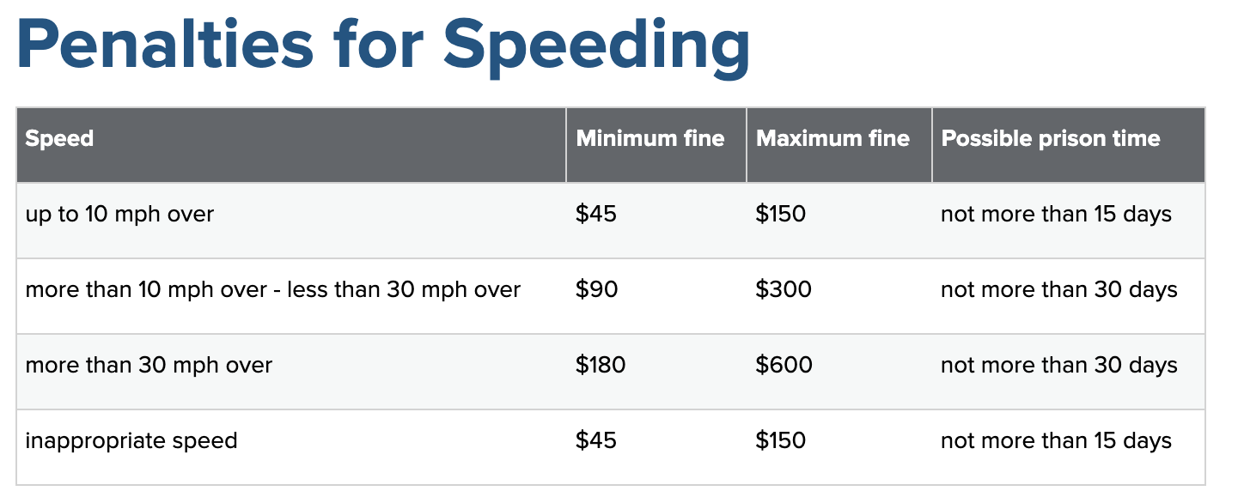
Source: Penalties for Speeding | Governor's Traffic Safety Committee

- On graph paper, create a graph of this situation that illustrates the relationship between quantities.

  - What is interesting about your graph?

  - What do some of the interesting features of the graph mean relative to the context?

2. How does New York’s Speeding Penalty system compare to Massachusetts’ system?

What are your thoughts about this?

Part C: Extending the learning:

Learn about your state’s or another state’s system for determining speeding penalties.
- Is it possible to represent the system graphically? Using an equation of some sort? Why or why not?

- How does your state’s or the other state’s system compare to the systems in New York and Massachusetts?

- What are your thoughts on this?

Example 2: Turn Up the Heat!

During the winter months, some schools shut down due to extreme cold conditions and the schools’ inability to adequately heat their buildings. According to the Capital Gazette and Bloomberg, the Baltimore City Public School System experienced this over the course of two winters in 2017 and 2018. In an effort to help, one college student started a GoFundMe campaign to purchase space heaters, raising about $84,000. One high school student reported near freezing temperatures of ${ 50}^{∘}F$ at the start of the day. With the use of a space heater, the classroom temperatures increased to ${65}^{∘}F$. In Maryland, the estimated cost to run a heater is about $0.20 per hour.

- Examine the image or explore the graph at the link here.
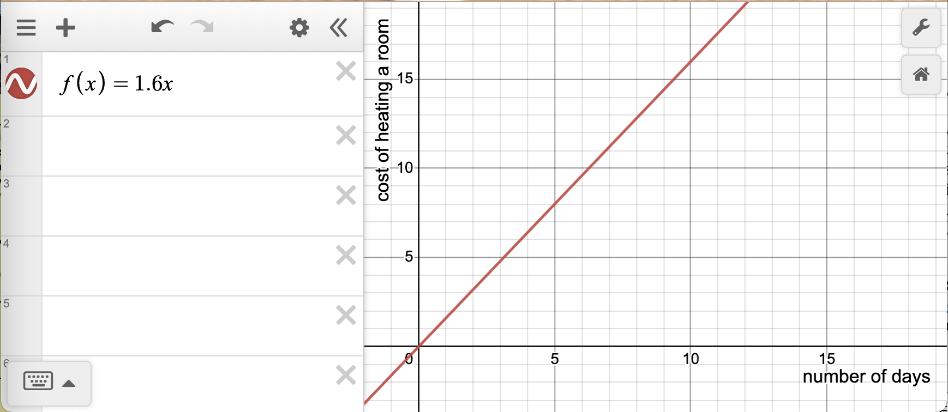

- Notice: How would you describe the relationship between the input and the output?

- Describe: What does this relationship tell you about the costs of heating a room?

- Making Connections:How do the variables, slope of the line, and the equation of the function capture that relationship?

- Applying: If a school has set up 40 classrooms each with a space heater, how would the function between the number of days and the cost of heating change? How does this impact the graph of the function? How does it impact the equation?

- Consider the following graph of $y=g(x)$.
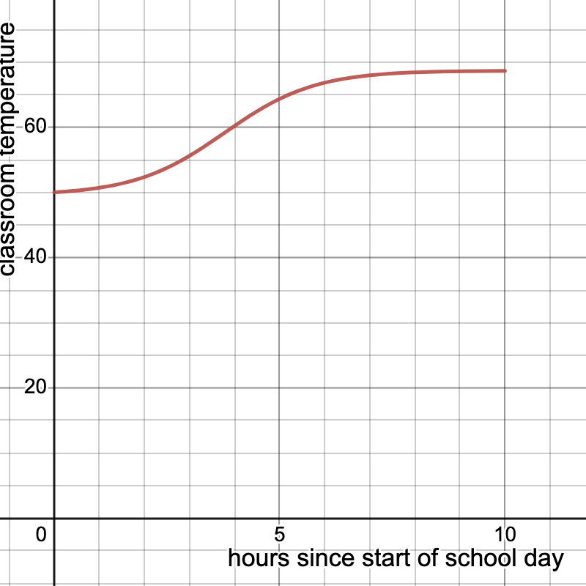

  - Notice: How would you describe the relationship between the input and the output?

  - Describe: What values of the input are part of the domain of this function? Why does that make sense?

  - Making Connections: What does the relationship represented below tell us about how a space heater works to warm a room?

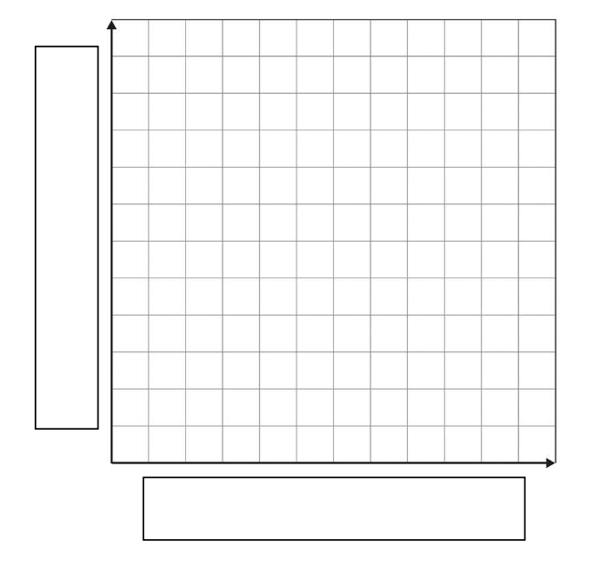
- Given the conditions, the school leadership team decides to have administrators who are already in the building two hours before the start time preheat all the classrooms and keep the heaters running until the end of the school day.

  - Visualize: Sketch a graph of the new function $h$, which gives the temperature in the school as a function of time.

  - Represent: Write an equation for $h$ in terms of $g$. Explain why your equation makes sense.

  - Decision time: How will the school leadership team’s decision to start heating rooms earlier impact their cost for heating the school?

Example 3: You Are a Winner!!!

Congratulations! You have just won the lottery! You are given a choice of how to receive the money. Would you rather receive a lump sum of $1,000,000 or annual payments spread out over several years?

Without doing any calculations, which option would you prefer and why?

Let’s learn more about how lotteries work and the options offered. Take a moment to read Jaime Johnson’s article “How lotteries work and 3 key steps to take if you win one” published November 1, 2022 on Business Insider. [How lotteries work and 3 key steps to take if you win one]

- If you choose the lump sum option and place the money in a savings account, we can use a function to represent the amount of money in the account after $t$ years. One such function is $f(t)=538200⋅1.0018{}^{t}$

- Based on what you learned from the article, explain what each of the parameters (variables and constants) in the function represent.

- What type of function is this? Why does it make sense to have this type of function in this case?

2.The option of having annual payments over time is referred to as an annuity. If you choose a lottery annuity, you agree to receive an initial upfront payment followed by yearly payments.

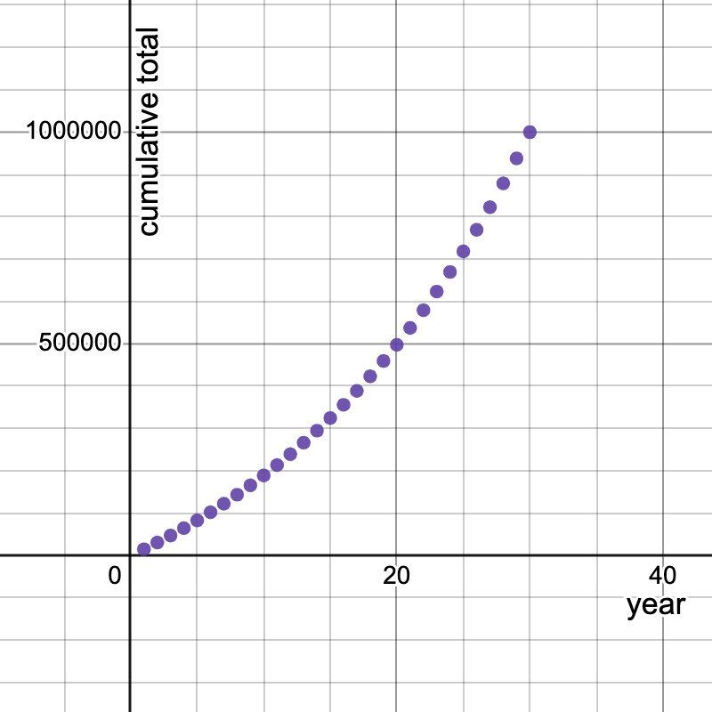
In the case of the Mega Millions lottery, winners agree to receive 29 yearly payments, where each payment grows by 5% from the previous year. The image below shows the cumulative total a winner of a $1,000,000 prize would have over the course of that period. You can also access the graph at this link: https://www.desmos.com/calculator/f6zy9mijdh.

- How would you describe the function that fits the annuity plan?

- Use the link provided or a Lottery Annuity Calculator, such as Lottery Annuity Calculator, to explore and identify a function that describes how the annuity program works. What do each of the components of your function mean in terms of the context?

- Which lottery choice is more lucrative? How do the insights gained from looking at the various mathematical representations help support your response?

