Example 1: Same Solutions?

Which of the following equations have the same solution as
$x+3=5x-4$?

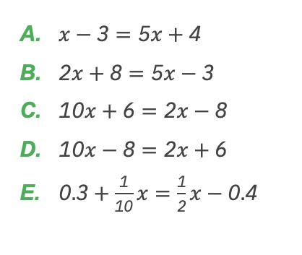
Prepare to share your responses.

- Explain how you could tell which equations have the same solution as the given equation without solving each one (and without substituting a value).

- Are there other equations on the list that share a common solution? Without solving, how could you tell?

- What do you notice about the structure of the equations? In what ways are they the same? In what ways are they different?

- What relationships do you notice in the parts that look similar?

Take some time to revise your work. Test additional pairs using the structure and relationship between the equations to determine which other sets of equations have the same solution.

Example 2: Finding Context

Consider the equation $0.75x=0.25x+1$

Consider the following questions:

Think about the expressions “$0.75x$” and “$0.25x+1.$”

Create a real-world situation that could be represented by each of these expressions.

Based on your situation, what could x represent?

Why would it make sense to have these two expressions be equal to one another based on the context?

How could you use technology to create a graphical representation that shows the solution to the equation $0.75x=0.25x+1$ ?

Use a graphing software to look at the graph of the equation.

What is the solution to $0.75x=0.25x+1$ ? What does the solution to the equation mean relative to the context you created?

What is another way you could have found the solution to $0.75x=0.25x+1$?

Select one question to reflect upon:
- What about this context makes sense to have two expressions that are equal to each other?

- What about the context you developed makes sense? What, if anything, needs to be modified so that it makes sense?

Be prepared to refine the context you developed if needed.

How might you represent equations with one solution, no solution, or many solutions graphically? Would you approach it differently if it was an inequality?

Reflect on these questions. Choose one that you can be prepared to share with a peer or the class:
What does it mean to solve an equation?

How might you use what you learned through this experience in other settings?
Example 3: Rainy Day Fund

Sandra works as a fitness manager at her local gym. She earns enough to pay for her living expenses and save $2000 per month to add to her savings account. She has already saved $12,000 for emergencies, which she estimates to be enough for 6 months of expenses.

- Write an equation to represent the balance in Sandra's account after x months.

- Graph this equation using Desmos.com or geogebra.org.

- Describe the key features of the graph, including slope and intercepts. Then, explain them in the context of Sandra’s savings.

Next, explore changes to the equation and graph as Sandra encounters different scenarios. Use sliders by typing in “y = m (x) + b and add “all” sliders on Desmos or refer to this video to see how to do it on GeoGebra.

- How does the equation and graph change if Sandra gets a raise and her salary increases? Explain how you know.

- How does the equation and graph change if Sandra changes the amount she saves every month? Explain how you know.

- What connections do you see between the equation you created in A above and the ones you’ve been exploring?

Extend your Learning:

Next, let’s build on this conversation and focus on the connection between equations and graphs. Select one of the following equations: or . Then, add “all” sliders to your chosen equation (see image).
- Use the sliders to explore the changes that occur in the graph when the values of m, a, and b are manipulated.
- How would you explain the impact that manipulating the value of has on the graph of the linear equation?

After reviewing and discussing with peers, is there anything you would revise in your thinking and/or your work?

