M104 Performance Task
Jellyfish Takeover!

The Modeling Cycle
There are many problems affecting the environment and the ecology of Earth. In this task, you will examine data associated with one of those environmental issues and apply the basic mathematical modeling cycle to make predictions, interpret information, and report your findings.
Mathematical models are used to make sense of ideas and phenomena in our world. As illustrated in the image below, the modeling cycle is a process of collecting data about an idea or problem, creating models of that data, analyzing the story told by those models, and reporting the results to the appropriate audience. In this task, you will be engaging with this mathematical modeling cycle to analyze data, evaluate findings, and identify trends in jellyfish populations.
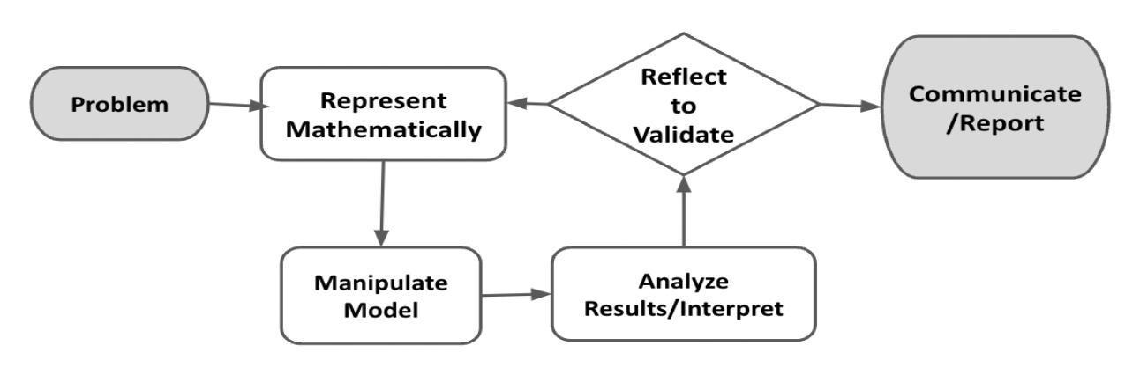
Figure 1. Diagram of Modeling Process. From “Progressions for the Common Core State Standards for Mathematics” [Draft manuscript], by Common Core Standards Writing Team, 2019, p. 6 (http://mathematicalmusings.org/wp-content/uploads/2022/05/modeling_02082019.pdf).

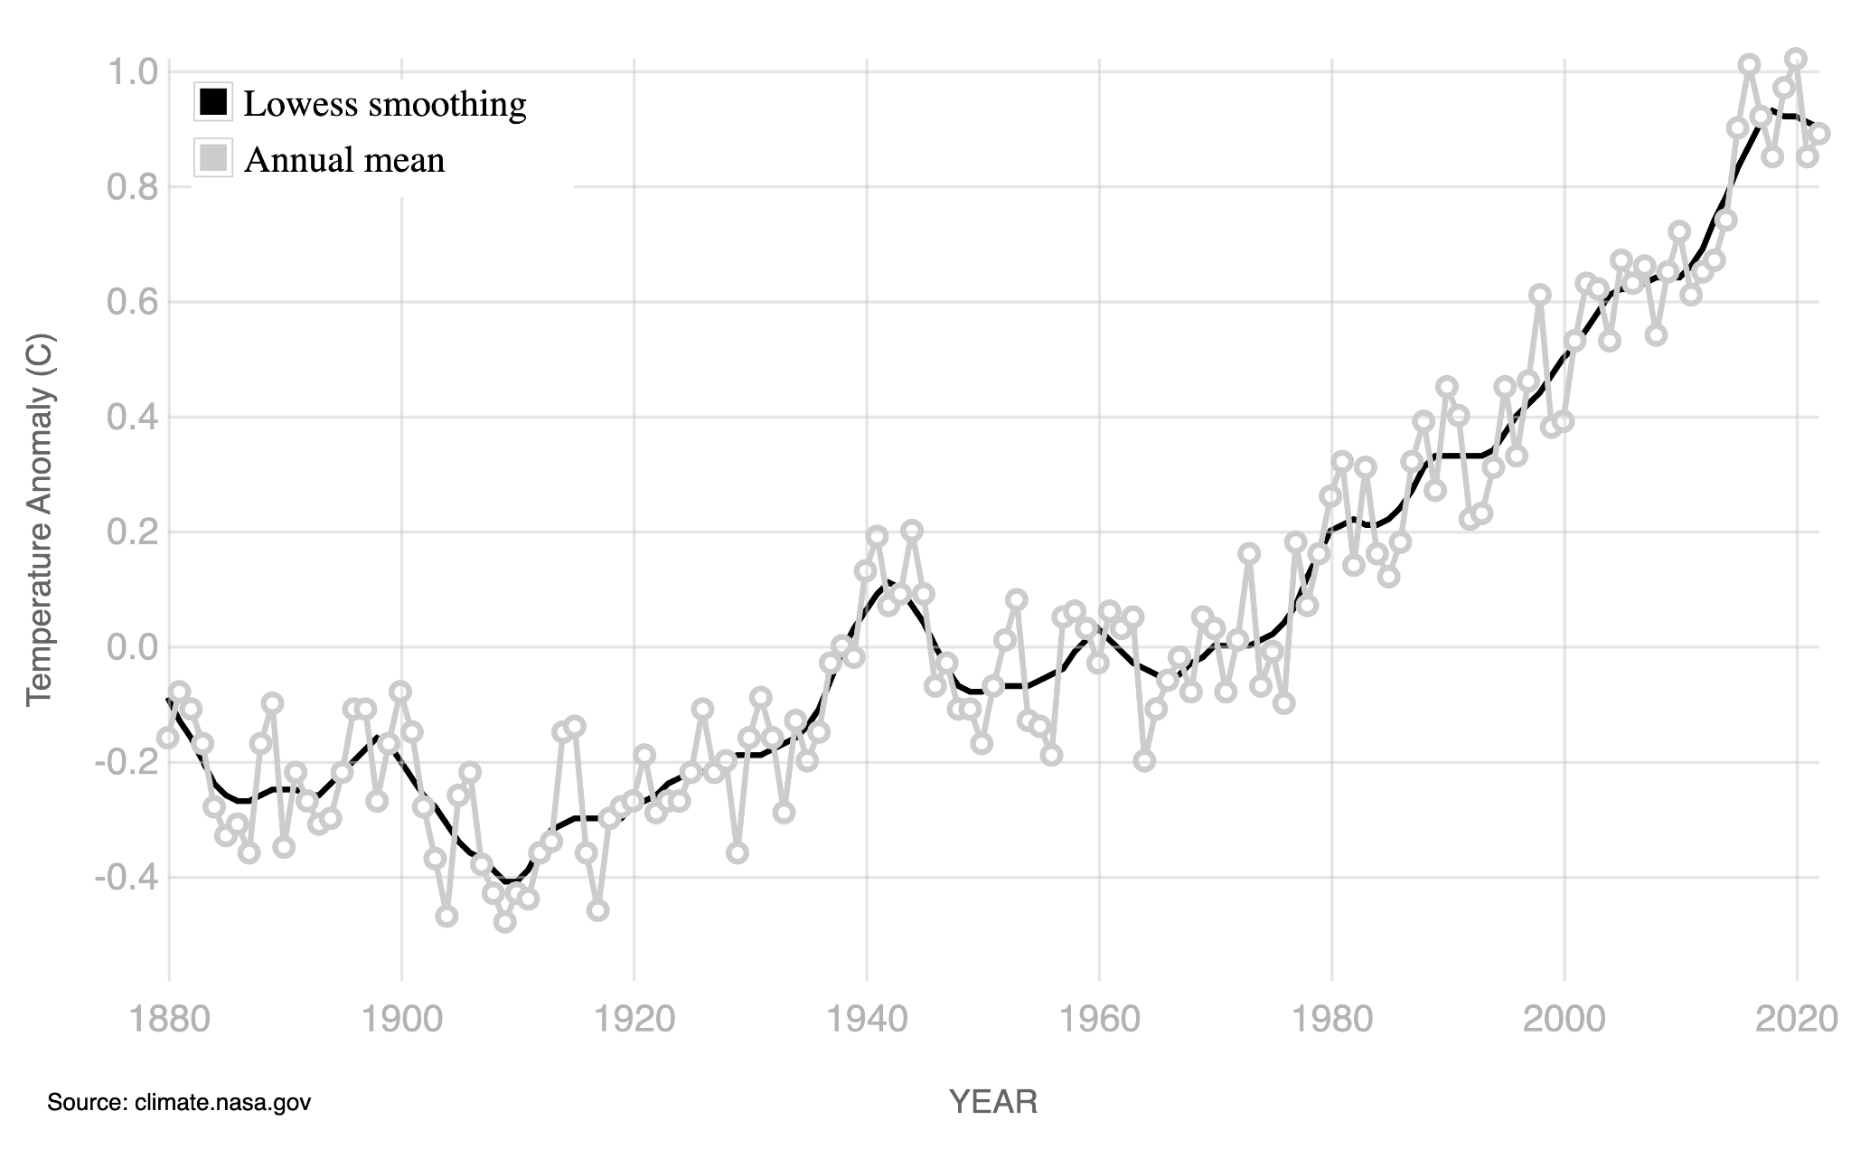
Global Average Surface Temperatures
Figure 1. Difference between expected average surface temperature and actual average surface temperature
GLOBAL LAND-OCEAN TEMPERATURE INDEX
Data source: NASA's Goddard Institute for Space Studies (GISS).
Credit: NASA/GISS
Launch
Since 1880, the year of the first global average-surface-temperature measurement, records show a general rising trend in average surface temperature, with 2016 and 2020 being the hottest years on record (NASA). This is alarming, as such rapid temperature changes are devastating ecosystems, destroying homes, and hurting people all over the world. In California, for example, heat waves and droughts are extending wildfire seasons, while in Florida, rising sea levels put people and their property at risk from flooding and storms (National Academies/Inside Climate News). Some South Pacific Islands have already disappeared due to rising sea levels (National Academies/Inside Climate News)!
The graph displayed shows the difference between the expected average surface temperature (57°F/13.9°C) and the actual average surface temperature of the earth since the year 1880. For example, in the year 1900, the actual average surface temperature was colder than the expected average surface temperature, which is why that value appears below the 0.0 line on the y-axis.

QUESTION 1
 | What do you notice about the shape of the above graph? What do you wonder about the graph? How might the global average surface temperature be changing over time?

QUESTION 2
If the trend in the data continues on a similar course as it is in the graph, in what year might you expect the temperature anomaly (shown on the y-axis) to rise above 2°C? Justify your answer.

Jellyfish Takeover!
Gulf of California—Jellyfish Populations
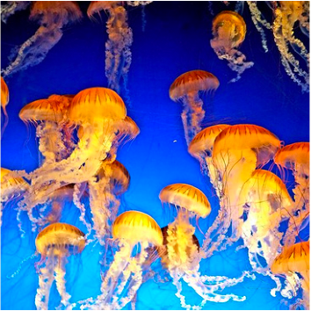
Scientists studying rising ocean temperatures have found something startling: While many species are unable to adapt to sudden changes in ocean temperatures, jellyfish are thriving! With their predators and competitors migrating to colder environments, jellyfish are able to reproduce faster than ever, causing a spike in jellyfish population numbers.
Your Task: Understand how jellyfish populations are changing over time as global surface temperature and ocean temperatures rise. Create a summary demonstrating your findings.
Role: In this scenario, you will take on the role of an oceanographer.
Scientists expect that jellyfish populations will increase as the ocean temperatures rise, but they aren’t sure what the specific rate of increase will be. A team of scientists at the Scripps Institute of Oceanography has gathered data on jellyfish populations in the Gulf of California over the past three years, along with the average ocean temperature during collection times. In this task, you will use these data to predict changes, identify a representative model, and develop an equation for changing jellyfish populations as a function of time.

In the Problem and Formulate sections, you will investigate data to determine how the number of jellyfish in an area is related to the temperature of the ocean over time; then you will evaluate this relationship to identify a model of best fit and create a related equation. The Problem Formulation Checklist can be used to ensure you have the necessary components before moving on to the remaining parts of the task.

Problem
QUESTION 1
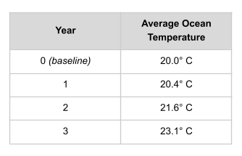
The table shows the average ocean temperature in a particular part of the Pacific Ocean at four different time points, each one year apart.
Based on the changes you see with the temperature over time in this part of the ocean, what might you expect to happen to the number of jellyfish in that same time period? You may use internet search engines to help you think through this question.

Formulate
QUESTION 2
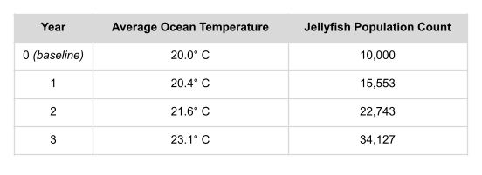
The table shows the jellyfish population count in the part of the Pacific Ocean where the temperature data was collected. Your task is to determine whether the jellyfish population is increasing linearly or exponentially over time in this location.
Use graphing software or graph paper to plot the data points for the year and the jellyfish population count. What do you notice about the shape of the graph?

QUESTION 3
Determine whether a linear or an exponential model fits the data better. What is an equation that you could use to model the relationship between the year and the jellyfish population count?

Problem Formulation Checklist
Requirement | Fulfilled?
I have made a prediction about changes in jellyfish population by time period. | ▢
I have accurately plotted the data points for year and jellyfish population count and described the shape of the graph. | ▢
I have identified an accurate model and created an accurate equation for relating the variables of time and number of jellyfish. | ▢
Teacher Consultation: | ______________

In the Compute and Interpret and Analyze sections, you will use your equation to make predictions about future jellyfish populations, evaluate your predictions against other factors, and consider the importance of and relationship among these variables in these kinds of analyses. The Compute, Interpret, and Analyze Checklist can be used to ensure you have the necessary components before moving on to the remaining parts of the task.

Compute
QUESTION 4
Based on your equation, how many jellyfish would you predict will be in that location in five years from the baseline data collection (Year 0)? What about in 10 years?

Interpret and Analyze
QUESTION 5
How confident are you that the predictions you made in Q4 are accurate? What other factors might affect the predictions produced by your equation?

QUESTION 6
Why is it important to examine the variable for ocean temperature in addition to analyzing the change in the jellyfish population? How are the two related?

Compute, Interpret, and Analyze Checklist
Requirement | Fulfilled?
I have used the equation to make predictions for five and 10 years after the baseline. | ▢
I have provided thoughtful, valid reasons for why the model will or will not be good at predicting five and 10 years out. | ▢
I have given a valid reason for needing to study the temperature variable in addition to time and number of jellyfish. | ▢
Teacher Consultation: | ______________
In the Validate and Report sections, you will identify ways to research and improve the accuracy and effectiveness of your equation; you will also create a product that appropriately demonstrates your conclusions. The Validate and Report Checklist can be used to ensure you have the necessary components before moving on to the remaining parts of the task.

Validate
QUESTION 7
What are some methods you might use to determine if the equation you developed is a good one? What additional data might you collect? Why?

Report
QUESTION 8
Product: Based on what you know, create a summary (either written, drawn, in a video, or in a PowerPoint, for example) that demonstrates your findings regarding the change in jellyfish populations and its relationship with rising ocean temperatures. Make sure it includes the following information:
- Describes the change in jellyfish populations over time
- Explains the relationship between jellyfish population change and ocean temperatures
- Refers to the equation you created, and identifies what it may mean for the future
- Provides evidence of your research—answering questions like: What are some actions that human beings might take to ensure that the jellyfish do not actually “take over”?

Validate and Report Checklist
Requirement | Fulfilled?
I have identified a method for validating the equation over time. | ▢
I have connected all of the variables studied in a clear, comprehensive summary and provided some possible actions to consider in tackling the challenge of a “jellyfish takeover.” | ▢
Teacher Consultation: | ______________

