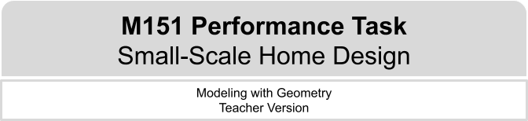
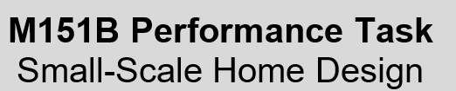

Design Notes
In this task, students will explore the space needed to make a place liveable and connect this to potential solutions for people experiencing housing insecurity. This performance task is structured to guide students through the process of simultaneously engaging in each component of the modeling cycle while developing a scaled drawing of a small home. Early in the process, students will consider minimally viable conditions for a living space to have. Students will need access to tools to aid them in constructing a scaled drawing, online or otherwise. The original idea for this task was developed after researching some of the newer attempts to address issues of housing insecurity, such as using shipping containers or other small structures to house people.
Student-teacher consultations have been built in to scaffold the process. Consider using those structured check-in points as places where select student(s) share their approach/findings with the class to support the collective learning of the class. This learning experience centers around the CCSSM modeling cycle as illustrated below:
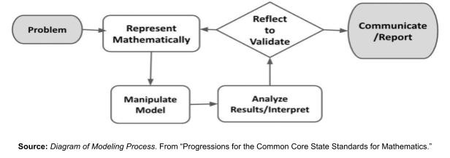

Connections to Learning Principles
Students will:
- design their homes after engaging in discussions with small groups or pairs or with ongoing feedback from peers and/or teacher (LP1 and LP2);
- deepen their understanding of how geometric shapes can be used to model real structures (LP3);
- demonstrate agency as they make decisions about how they will design their homes and what they want to include in their design (LP4);
- see mathematics as relevant and important in a real-world application, positioning them in the context of relating low cost options for building homes to the larger issue of housing insecurity (LP6); and
- have the opportunity to use online tools to create sketches and/or scale drawings for better visualization and understanding (LP7).

The Modeling Cycle
Shelter is considered a basic human need. In this task, you will consider the relationship between basic human needs and housing design. You will apply geometric principles to design, evaluate, and report your findings. While you work through this task, keep in mind that your report at the end will be a presentation, article, or short video in which you pitch your findings as a solution to potential investors. Gather ideas as you work to help inform how you decide to present your findings.
Mathematical models are used to make sense of ideas and phenomena in our world. As illustrated in the image below, the modeling cycle is a process of collecting data about an idea or problem, creating models of that data, analyzing the story told by those models, and reporting the results to the appropriate audience.

In this task, you will be engaging with this mathematical modeling cycle to help solve issues of housing insecurity. You will use the models and your takeaways from this task to create a presentation, article, short video, or other creative product to persuade city investors of a potential solution for housing insecurity. Your product will provide an explanation that is supported by evidence as well as visual renderings of your ideas and a discussion of their applicability in helping solve the problem.

Introduction: Small-Scale Home Design
What does a person need to survive? How much space do they need? What makes a shelter adequate to meet these needs? What happens when resources are not available to help meet these human needs? Consider a person’s physical, psychological, and socio-cultural needs, and then respond to the questions below.

QUESTION 1
 | What items does a home need to be livable for 1 person? Create a list.
Answers will vary. Possible student responses:
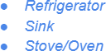
- Bed
- Toilet
- Bathroom
Note: Students may have differing perceptions of these questions globally. It will be important to ensure that students' lived experiences are treated with sensitivity and fully embraced in the way that they decide to navigate the task.
Consider having a conversation with students about what it means for a space to be “livable.” Students should be thinking about wants vs. needs where wants is a desired living condition and needs are what is absolutely necessary, making a space “livable.” It can also be helpful to have students rank the items they come up with in order of importance to help them make decisions to minimize the list to those only absolutely necessary for survival.
For this question and similar ones that follow, consider offering students various ways to share their ideas/list with the class: pair-share, chart, or whole group.

QUESTION 2
What do you think is the smallest space that is livable?

Answers will vary. Possible student responses:
- An RV or mobile home
- 200 sq ft
- A van
- A shed
- Tiny home

The rationale for this question is to give students an opportunity to think about spaces and how much one would need to be considered livable. Student responses can be numerical, vehicles, small buildings or outbuildings, and likely more creative than we have listed here!
If needed, consider helping guide students toward the context of livable as being what is minimally essential for survival. There are some accounts on social media dedicated to the remodeling of vans and buses that may give students a visual.
Problem and Formulate
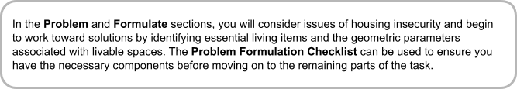
Problem

QUESTION 3
Use online search engines to help you summarize the following information:
- What is housing insecurity?
- What percent of people experience housing insecurity?
- How could small homes provide a potential solution for housing insecurity?
Answers will vary. Possible student response:
- Housing insecurity is when, for many reasons, a person is in danger or is already experiencing homelessness.
- In the US, 10-15% of Americans are experiencing housing insecurity.
- Small homes are more affordable and take up less space.
The second bulleted question has been intentionally left more open-ended. You may consider encouraging students to think about this question more locally (e.g., within the state or region) if needed/desired.

Formulate

QUESTION 4
Refer back to your response to Question 1. Decide whether to add or remove any items from your original list and make those changes in Question 1. Remember you are designing this for 1 person. Then answer these questions:
- Explain why you added and/or removed any items from your list.
- Add your final items, their approximate dimensions (with units), and any notes in the table below.

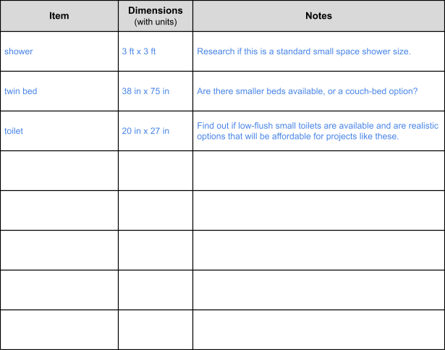
Answers will vary. Possible student response:
- I removed the sofa because it is not absolutely necessary and it takes up a lot of space.

QUESTION 5
What rooms would you require in a house for the items on your final list? What other considerations are there for figuring out how big each room needs to be?
Answers will vary. Possible student responses:
- A house needs a bathroom and a bedroom.
- Are there storage options? Shared living spaces? Dorm style living?
Taping off a section of the classroom showing students what a certain square footage might look like, can help them with their spatial recognition.

Problem Formulation Checklist
Requirement | Teacher Notes: For each Requirement, what are some specific things that came up in that part of the task?
I can define housing insecurity and identify the percent of people experiencing it. | (Teachers, please add your notes here.)
I have hypothesized how small homes could provide a potential solution for housing insecurity. | (Teachers, please add your notes here.)
I have evaluated my original list of housing items and refined it accordingly. | (Teachers, please add your notes here.)
I have determined the dimensions of essential living items and identified the necessary rooms and required space for a livable area that contains these items. | (Teachers, please add your notes here.)
(Teachers, please add your notes here.)

Model
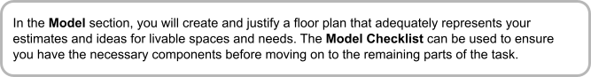

ACTION 1
 | A floor plan is a scale drawing that shows the different rooms in a home.  Using your work from Question 4, create a scale floor plan showing how you would structure the rooms within a small home. Assume 1 person living in the space.  - Show the dimensions of each room in your drawing.  - Show how the items would fit into the space you design.  - Label each item or use drawings that clearly show what the items are.  Here are some ideas to help with this task:  - Use graph paper, pencils, and rulers  - https://www.smartdraw.com/  - GeoGebra  - Any other helpful online floor plan creator platform you can find!  - Creating and manipulating shapes in Google Draw, Google Slides, or Microsoft PowerPoint
Answers will vary. Possible student response:
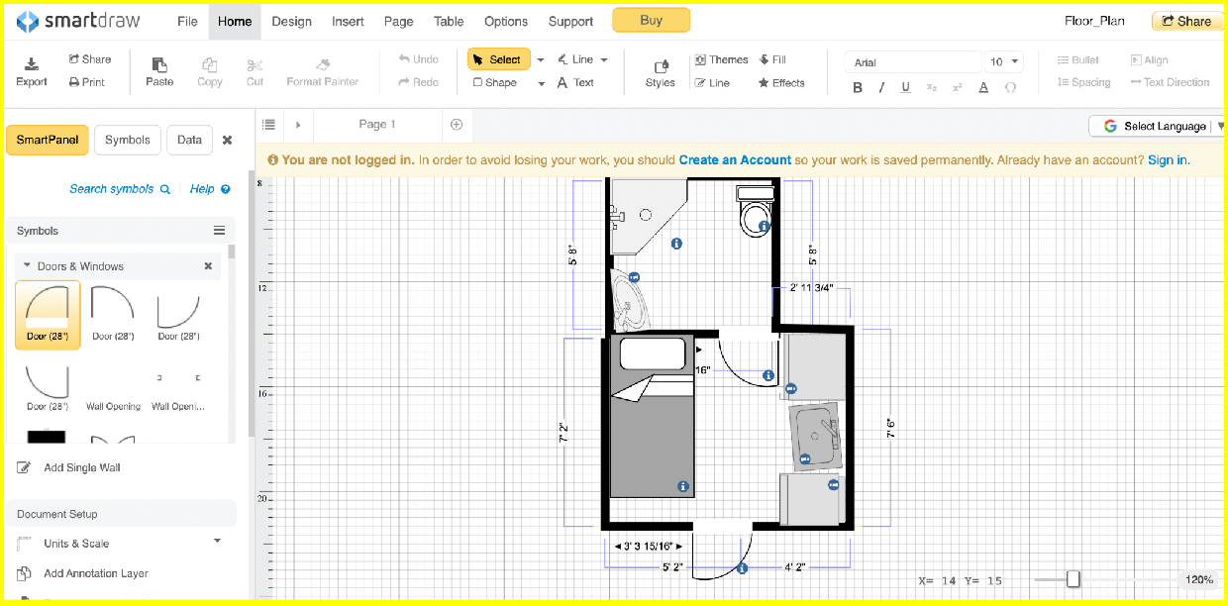

Notes to add?

QUESTION 6
What is the approximate area (in square feet) of the small home you designed? Show how you determined your answer.
Answers will vary. Possible student response:
The approximate area of the little home I made is 130 square feet. I was able to make the bedroom and bathroom combined walls add up to about 13 feet and then the other side of the house is the sum of the bathroom and the bedroom and is about 10 feet. Assuming an approximate rectangular shaped house, the product of these lengths gives an area of 130 square feet.

Model Checklist
Requirement | Teacher Notes: For each Requirement, what are some specific things that came up in that part of the task?
I created and labeled a scaled floor plan with room dimensions and item placement for a small home big enough for 1 person. | (Teachers, please add your notes here.)
I demonstrated how each room’s dimensions are appropriate for the necessary home items and can be considered a livable space. | (Teachers, please add your notes here.)
I computed an approximate total area of the home. | (Teachers, please add your notes here.)
(Teachers, please add your notes here.)

Analyze and Validate
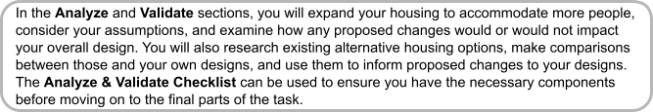
Analyze

QUESTION 7
How would your design change for 4 people living in the space? What would remain the same? How would the area of the space be different than with just one person? State any assumptions.
Answers will vary. Possible student response:
Four people could still have just one bathroom and one kitchen. If it’s like my family, there is a grandma, my mom and my brother so we would want 3 bedrooms because 2 of us could share. So I would add two little bedrooms which might be another 84 feet. I made each little room to measure 6 feet by 7 feet and then multiplied that by two. I think you could have bunk beds in one room so the room could stay small. The whole house would be about 130 + 84 = 214 square feet.
Students may make assumptions about who the people are who are living together (within the contexts of family, hierarchy, relationships, etc.) based on their own experiences. These may inform how they individually change the design.
To help stimulate student interest/engagement/connections to their personal lives, consider encouraging students to analyze their own family living situation at home and use that number of family members to consider how to expand their design. If students have a particularly large family (12, for example), direct them to expand their design to 8 first, as a bridge toward 12.

Validate

ACTION 2
Research some different “small spaces” that are used to house people. Some ideas may include shipping containers, tiny homes, studio apartments, and recreational vehicles (RVs).
- What are the dimensions or square footage of some of these small living spaces?
- How do they compare to the total area of the space you created? Are any smaller?
- Would you change anything about your design based on your research?
Answers will vary. Possible student responses:
I found a list of homes (https://matthewjamestaylor.com/small-house-definition) that said they can be these sizes:
Micro Home: Under 175 square feet Compact Home: Under 220 square feet Mini Home: Under 275 square feet Tiny Home: Around 300 square feet
My home that I built would be a micro home because it is really small and has only the things I thought somebody would need with a little bit of room to walk around. But I didn’t put anything extra like cupboards. I might make my little home just a little bit bigger based on this list. I might add like a foot or two in each direction because I don’t think that would change the cost and then I could move around better.
The third bulleted question is intentionally open, but if students need to, encourage them to focus on their design for a specific number of people (1, 4, etc.) as context to help them address this question.
Analyze & Validate Checklist
Requirement | Teacher Notes: For each Requirement, what are some specific things that came up in that part of the task?
I described how my design would or would not change after expanding it to 4 people. | (Teachers, please add your notes here.)
I identified the dimensions and square footage of existing alternative housing options and made comparisons across these and my own designs. | (Teachers, please add your notes here.)
I evaluated my designs against these parameters and proposed any appropriate changes. | (Teachers, please add your notes here.)
(Teachers, please add your notes here.)

Reflect

QUESTION 8
Reflect on what you learned about how professional designers create small spaces for housing. What surprised you from your research? What ideas of yours were affirmed by the research?
Answers will vary. Possible student responses:
- Professionals use all open space for things like storage.
- Use of smaller appliances.
- A home can be as small as 100 sq ft.
Report

QUESTION 9
Create a presentation, article, or short video for city investors to pitch your design as a potential solution for eliminating housing insecurity for its people.

In your product:
- Explain how creating smaller living spaces can help reduce or eliminate housing insecurity.
- Cite any applicable research or resources.
- If your product is primarily visual, include an outline or brief script to accompany it.
- If desired, research a particular city and include city-specific data as available.
- Include your own design as part of your argument.

For this extension, you get to keep thinking like a designer! Ponder the following question, then choose one or more of the bulleted questions below to tackle:
How do professionals use what they know to improve their designs, make production more efficient, and apply equations to inform how big or how small to make their spaces?
Now, use a search engine to research and respond to one or more of the following:
- What is the average family size? Is there a standard tiny home size? Are these two values related in any way?
- Is there an ideal size for tiny homes that are mass-produced? What is the ideal ratio of size to number of people being housed? Is there a constant rate in which each person being housed gets a certain amount of square footage? How do designers efficiently and economically create homes for people they don’t know?
- Write an equation that represents the relationship between the size of the space and the number of people being housed. The number of people should be one of the variables that changes. How can you apply this equation to help refine the solutions you proposed earlier to combat housing insecurity?

References

GeoGebra. “GeoGebra for Teaching and Learning Math.” GeoGebra Math Resources, GeoGebra, https://www.geogebra.org/?lang=en.
SmartDraw. “Easy and Powerful Floorplan Creator.” SmartDraw, SmartDraw, https://www.smartdraw.com/. Accessed 29 July 2023.
Taylor, Matthew James. “What is Considered a Small House? (Handy Size Guide).” Matthew James Taylor, Matthew James Taylor, 13 January 2023,
https://matthewjamestaylor.com/small-house-definition.

